SUPPLEMENTARY TABLES AND FIGURES

SUPPLEMENTARY TABLES

Supplementary Table 1. Description and count of participants per study included in the analysis.
Please see the enclosed Excel file.

Supplementary Table 2. Descriptive characteristics of all study participants by case-control status, who had study- and sex-specific quartile physical activity data available.

Characteristics | Cases  (N=17,293) | Controls  (N=25,309) | P-value
Age (median imputed)
Mean (SD) | 64.9 (±9.4) | 63.4 (±8.4) | <0.001
Sex
Female | 9,043 (52%) | 12,733 (50%) | <0.001
Male | 8,250 (48%) | 12,576 (50%)
Total energy intake (kcal/day; mean imputed)^{a,b}
Mean (SD) | 1,987 (±724) | 1,943 (±698) | <0.001
BMI (kg/m²)^{b}
Mean (SD) | 27.2 (±4.7) | 26.8 (±4.5) | <0.001
Family history of colorectal cancer^{b}
No | 11,132 (64%) | 14,355 (57%) | <0.001
Yes | 2,420 (14%) | 2,814 (11%)
Education level (highest completed)^{b}
Less than High School | 3,509 (20%) | 4,190 (17%) | <0.001
High School/GED | 3,513 (20%) | 3,461 (14%)
Some College | 3,678 (21%) | 6,213 (25%)
College/Graduate School | 5,695 (33%) | 8,721 (34%)
Ever smoking^{b}
No | 7,323 (42%) | 12,077 (48%) | <0.001
Yes | 9,709 (56%) | 12,945 (51%)
NOTE: Data might not add to 100% because of rounding.
Abbreviations: SD, standard deviation; BMI, Body-Mass-Index; GED, General Educational Development Test.
ª Calculations exclude individuals with missing total energy intake information.
^{b} Missing values due to non-response not shown.
P-values < 0.05 are statistically significant.

Supplementary Table 3. Associations between physical activity and colorectal cancer risk stratified by study design, sex, and tumor site.

Characteristics |  | Total N | Cohort Studies  [OR (95% CI)  P-value] | Case-Control Studies  [OR (95% CI)  P-value] | All Studies  [OR (95% CI)  P-value]
All |  | 39,992  (Ca=16,383, Co=23,609) | 0.88 (0.83-0.93)  P_{het}=0.91; I²=0% | 0.75 (0.66-0.85)  P_{het}=0.36; I²=9% | 0.85 (0.81-0.90)  P_{het}=0.64; I²=0%
Sex | Female | 20,253^{b}  (Ca=8,677,  Co=12,005) | 0.89 (0.83-0.96)  P_{het}=0.91; I²=0% | 0.74 (0.61-0.91)  P_{het}=0.67; I²=0% | 0.87 (0.81-0.94)  P_{het}=0.86; I²=0%
Sex | Male | 19,310  (Ca=7,706,  Co=11,604) | 0.85 (0.77-0.94)  P_{het}=0.87; I²=0% | 0.77 (0.65-0.90)  P_{het}=0.17; I²=34% | 0.83 (0.76-0.90)  P_{het}=0.56; I²=0%
Tumor Siteª | Proximal Colon | 28,627^{b}  (Ca=5,625,  Co=23,609) | 0.87 (0.80-0.95)  P_{het}=0.86; I²=0% | 0.74 (0.63-0.87)  P_{het}=0.13; I²=39% | 0.84 (0.78-0.91)  P_{het}=0.46; I²=0%
Tumor Siteª | Distal Colon | 26,966^{b}  (Ca=4,370,  Co=23,609) | 0.80 (0.72-0.89)  P_{het}=0.48; I²=0% | 0.71 (0.60-0.83)  P_{het}=0.82; I²=0% | 0.77 (0.71-0.84)  P_{het}=0.64; I²=0%
Tumor Siteª | Rectal | 25,392^{b}  (Ca=4,480,  Co=23,609) | 0.97 (0.87-1.08)  P_{het}=0.16; I²=27% | 0.82 (0.64-1.04)  P_{het}=0.81; I²=0% | 0.94 (0.85-1.04)  P_{het}=0.27; I²=15%
Abbreviations: Ca/Co, case/control; OR, odds ratio; 95% CI, 95% confidence interval.
Physical activity categorized as active (≥8.75 MET-h/wk) vs. inactive (<8.75 MET-h/wk; reference category).
ª N=1,908 had missing tumor site information.
^{b} Due to small sample sizes within study, the following number of cases/controls were not included in the meta-analysis:
(429 female cases), (604 controls, 3 proximal cases), (1,011 controls, 2 distal cases), (2685 controls, 12 rectal cases).

Supplementary Table 4. Association between physical activity and colorectal cancer risk stratified by study design.

Characteristics |  | Total N | Cohort Studies  [OR (95% CI)  P-value] | Case-Control Studies  [OR (95% CI)  P-value] | All Studies  [OR (95% CI)  P-value]
All |  | 42,602  (Ca=17,293,  Co=25,309) | 0.93 (0.91-0.96)  P_{het}=0.94; I²=0% | 0.92 (0.89-0.95)  P_{het}<0.001; I²=74% | 0.93 (0.91-0.95)  P_{het}=0.06; I²=30%
Sex | Female | 21,776  (Ca=9,043,  Co=12,733) | 0.94 (0.91-0.97)  P_{het}=0.98; I²=0% | 0.93 (0.88-0.98)  P_{het}<0.001; I²=74% | 0.94 (0.91-0.96)  P_{het}=0.06; I²=33%
Sex | Male | 20,826  (Ca=8,250,  Co=12,576) | 0.93 (0.90-0.96)  P_{het}=0.67; I²=0% | 0.91 (0.87-0.95)  P_{het}=0.20; I²=28% | 0.92 (0.90-0.95)  P_{het}=0.45; I²=0%
Tumor Siteª | Proximal Colon | 30,648^{b}  (Ca=5,946,  Co=25,309) | 0.93 (0.90-0.96)  P_{het}=0.94; I²=0% | 0.92 (0.87-0.96)  P_{het}<0.001; I²=70% | 0.93 (0.90-0.95)  P_{het}=0.10; I²=26%
Tumor Siteª | Distal Colon | 28,841^{b}  (Ca=4,632,  Co=25,309) | 0.91 (0.87-0.94)  P_{het}=0.52; I²=0% | 0.94 (0.89-0.98)  P_{het}=0.06; I²=47% | 0.92 (0.89-0.94)  P_{het}=0.18; I²=20%
Tumor Siteª | Rectal | 27,879^{b}  (Ca=4,743,  Co=25,309) | 0.98 (0.94-1.02)  P_{het}=0.11; I²=30% | 0.89 (0.85-0.94)  P_{het}=0.004; I²=69% | 0.95 (0.92-0.98)  P_{het}<0.001; I²=54%
Abbreviations: Ca/Co, case/control; OR, odds ratio; 95% CI, 95% confidence interval.
Physical activity, assessed as study- and sex-specific quartiles, was modeled as a continuous variable (Q1-Q4).
ª N=1,972 had missing tumor site information.
^{b} Due to small sample sizes within study, the following number of cases/controls were not included in the meta-analysis: (604 controls, 3 proximal cases), (1,093 controls, 7 distal cases), (2,172 controls, 1 rectal case)

Supplementary Table 5. Associations between the identified SNPs and physical activity for colorectal cancer risk stratified by study design, sex, and tumor site.

SNP (Locus) | Parameters | OR (95% CI)
SNP (Locus) | Parameters | All | Cohort | Case-Control | Female | Male | Distal colon | Proximal colon | Rectal
 |  | Ca=16,383,  Co=23,609 | Ca=10,301,  Co=18,860 | Ca=6,082,  Co=4,749 | Ca=8,677,  Co=12,005 | Ca=7,706,  Co=11,604 | Ca=4,370, Co=23,609 | Ca=5,625, Co=23,609 | Ca=4,480, Co=23,609
rs4779584  (15q13.3) | C allele | 1.00  (0.93, 1.08) | 1.01  (0.93, 1.10) | 0.93  (0.78, 1.12) | 1.04  (0.95, 1.15) | 0.93  (0.82, 1.06) | 0.92  (0.82, 1.05) | 1.03  (0.93, 1.15) | 1.06  (0.92, 1.22)
 | Active (vs. inactive)ª | 0.79***  (0.74, 0.85) | 0.83***  (0.77, 0.89) | 0.66***  (0.57, 0.76) | 0.83***  (0.76, 0.90) | 0.75***  (0.68, 0.83) | 0.71***  (0.64, 0.79) | 0.78***  (0.72, 0.86) | 0.87*  (0.78, 0.98)
 | C allele x Active | 1.19***  (1.09, 1.30)  p=9.16x10⁻⁵ | 1.16**  (1.05, 1.28)  p=4.19x10⁻³ | 1.32**  (1.08, 1.61)  p=6.03x10⁻³ | 1.15*  (1.03, 1.29)  p=1.59x10⁻² | 1.27**  (1.10, 1.46)  p=1.04x10⁻³ | 1.24**  (1.08, 1.43)  p=2.69x10⁻³ | 1.19**  (1.05, 1.34)  p=7.02x10⁻³ | 1.17  (1.00, 1.36)  p=5.37x10⁻²
 |  | Ca=17,293,  Co=25,309 | Ca=10,781,  Co=19,643 | Ca=6,512,  Co=5,666 | Ca=9,043,  Co=12,733 | Ca=8,250,  Co=12,576 | Ca=4,632,  Co=25,309 | Ca=5,946,  Co=25,309 | Ca=4743,  Co=25,309
rs56906466  (20q4.5) | T allele | 0.66***  (0.56, 0.78) | 0.63***  (0.52, 0.77) | 0.73*  (0.54, 0.98) | 0.72**  (0.58, 0.90) | 0.60***  (0.57, 0.76) | 0.69**  (0.53, 0.89) | 0.62***  (0.49, 0.79) | 0.74*  (0.57, 0.95)
 | Quartiles^{b} | 0.91***  (0.89, 0.93) | 0.92***  (0.89, 0.94) | 0.90***  (0.87, 0.94) | 0.92***  (0.90, 0.95) | 0.90***  (0.87, 0.93) | 0.90***  (0.87, 0.93) | 0.90***  (0.87, 0.93) | 0.93***  (0.90, 0.96)
 | T allele x Quartiles | 1.18***  (1.11, 1.54)  p=3.48x10⁻⁸ | 1.20***  (1.11, 1.28)  p=7.73x10⁻⁷ | 1.16*  (1.03, 1.29)  p=1.04x10⁻² | 1.12**  (1.04, 1.22)  p=5.12x10⁻³ | 1.25***  (1.15, 1.37)  p=5.30x10⁻⁷ | 1.14**  (1.04, 1.26)  p=7.10x10⁻³ | 1.22***  (1.12, 1.33)  p=6.29x10⁻⁶ | 1.17**  (1.07, 1.29)  p=1.01x10⁻³
Abbreviations: OR, odds ratio; 95% CI, 95% confidence interval; Ca/Co, case/control.
*P<0.05; **P<0.01; ***P<0.001.
ª Physical activity categorized as active (≥8.75 MET-h/wk) vs. inactive (<8.75 MET-h/wk; reference category).
^{b} Physical activity, assessed as study- and sex-specific quartiles, was modeled as a continuous variable (Q1-Q4).

SUPPLEMENTARY FIGURES

Supplementary Figure 1. Forest plot showing the association between physical activity and colorectal cancer risk for studies included in the gene-physical activity interaction analysis, adjusted for age at diagnosis or enrollment, sex, and total energy consumption (kcal/day, when available). A: Dichotomized physical activity (i.e., active: ≥8.75 MET-h/wk vs. inactive: <8.75 MET-h/wk). B: Physical activity assessed as study- and sex-specific quartiles (treated as continuous variable).

A)

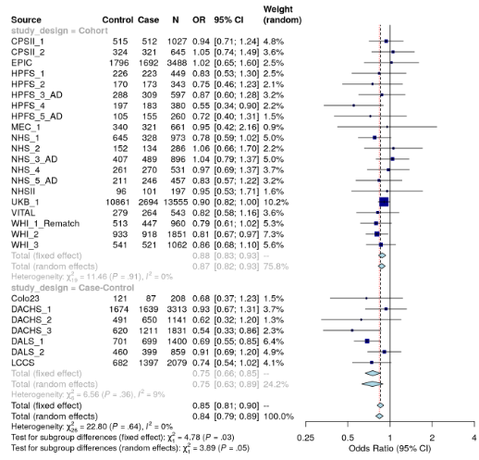

B)

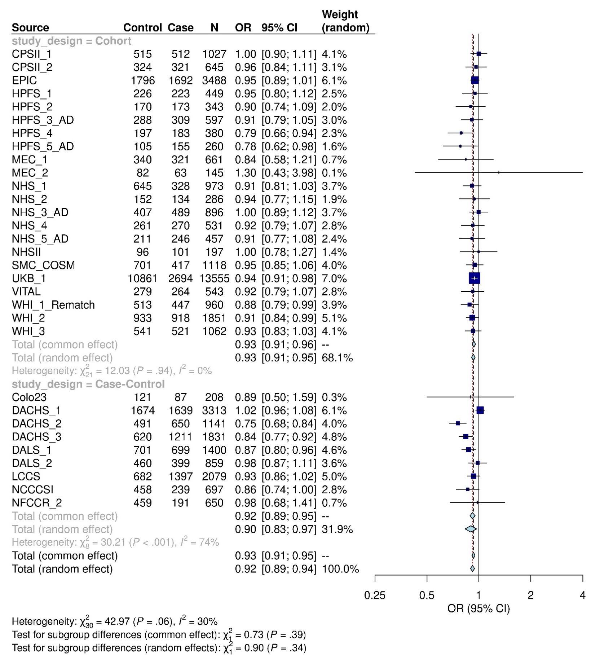

Supplementary Figure 2. Quantile-Quantile (Q-Q) plots for the traditional 1-d.f. interaction tests of physical activity for colorectal cancer risk. A: Dichotomized physical activity (i.e., active: ≥8.75 MET-h/wk vs. inactive: <8.75 MET-h/wk). B: Physical activity assessed as study- and sex-specific quartiles (treated as continuous variable).

A)

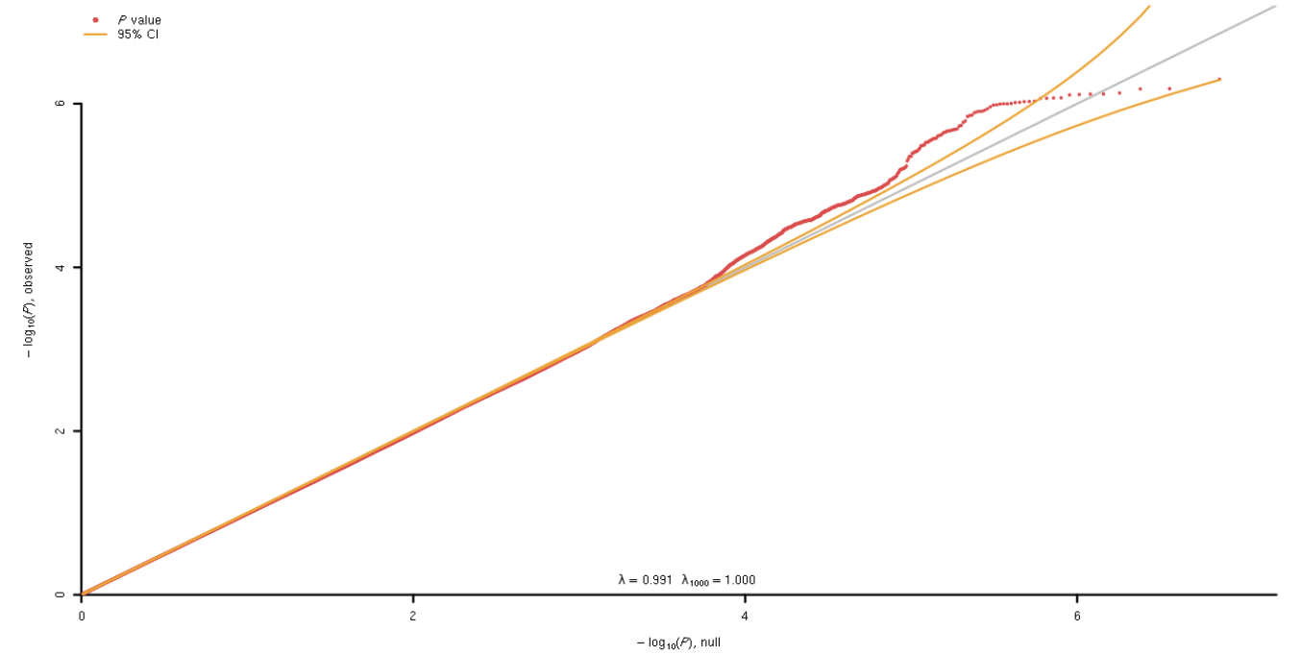

B)

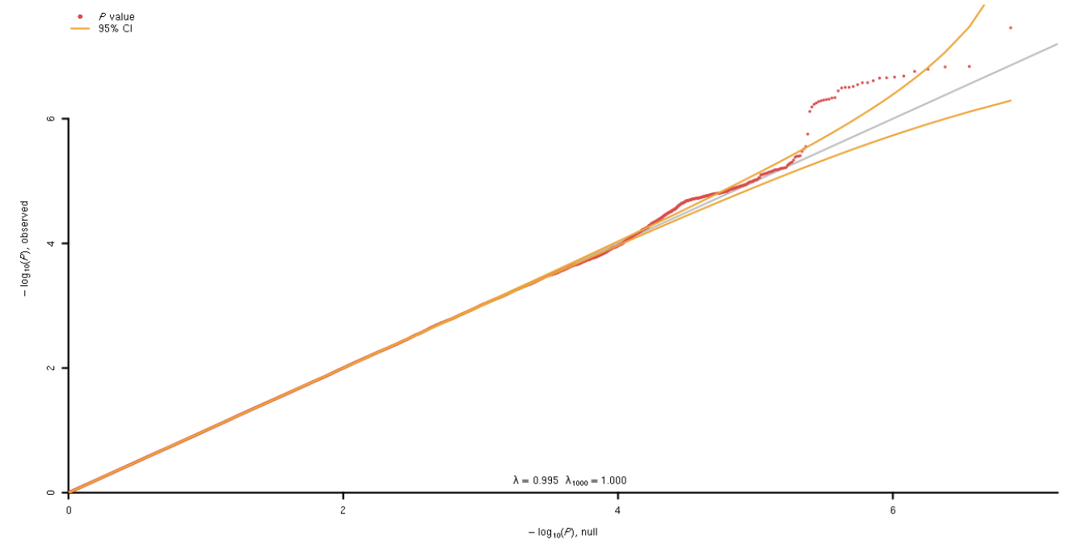

Supplementary Figure 3. Manhattan plots for the traditional 1-d.f. multiplicative interaction tests of SNPs with physical activity for colorectal cancer risk, adjusted for age, sex, study, total energy consumption (kcal/day, when available), and the first three principal components. A: Dichotomized physical activity (i.e., active: ≥8.75 MET-h/wk vs. inactive: <8.75 MET-h/wk). B: Physical activity assessed as study- and sex-specific quartiles (treated as continuous variable).

A)

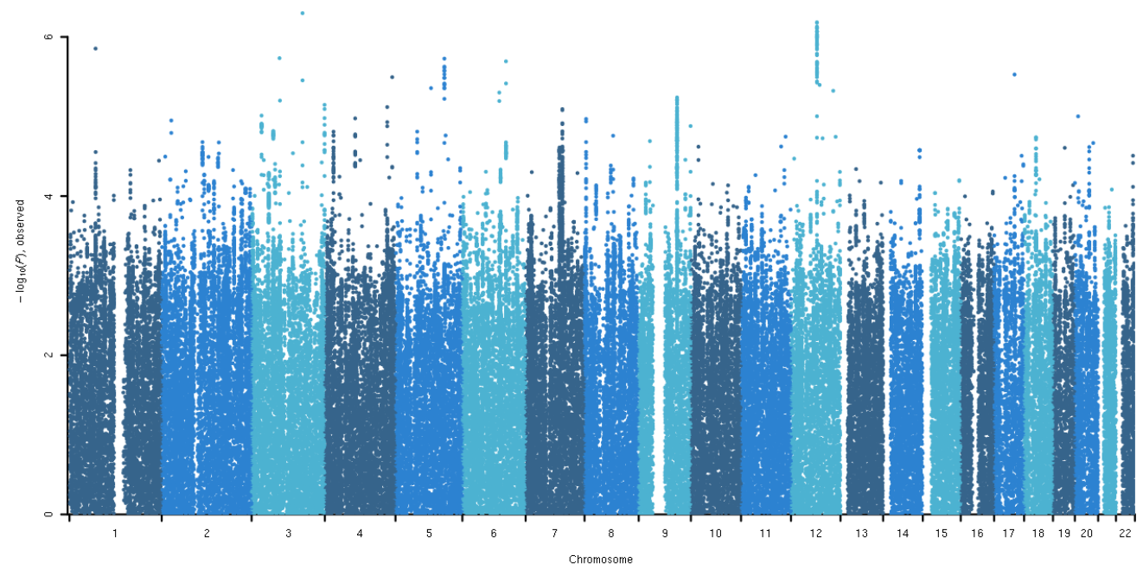

B)

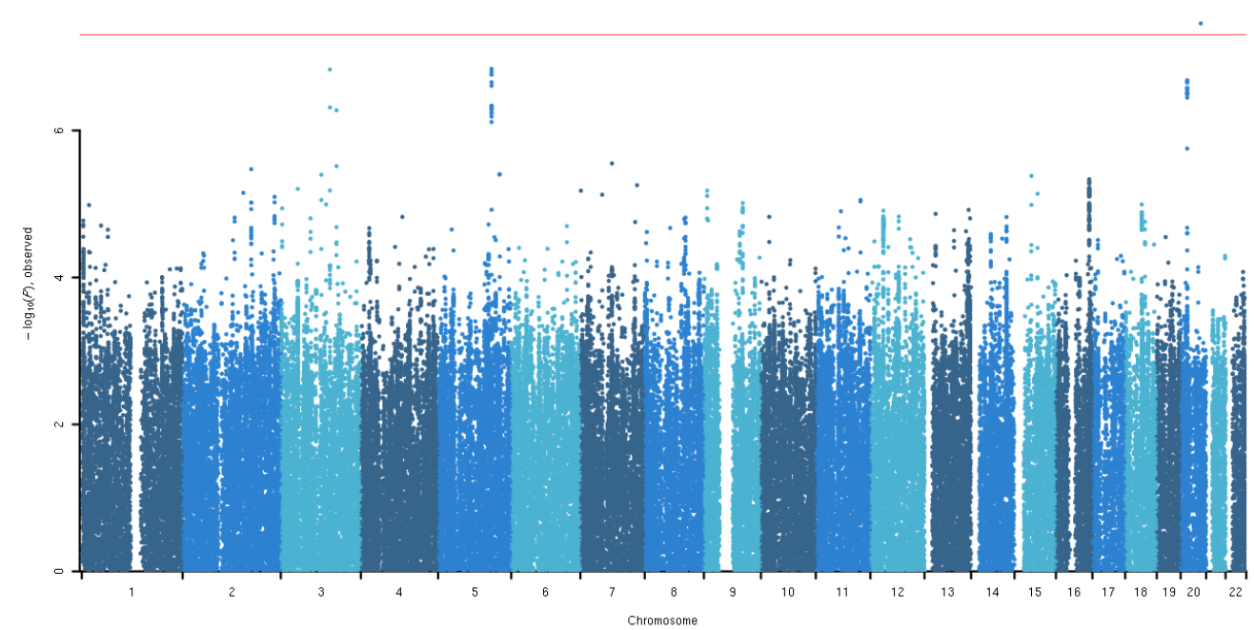
Supplementary Figure 4. Regional (LocusZoom) plots for interaction result of SNPs x physical activity for colorectal cancer risk. A: Dichotomized physical activity (i.e., active: ≥8.75 MET-h/wk vs. inactive: <8.75 MET-h/wk). B: Physical activity assessed as study- and sex-specific quartiles (treated as continuous variable).

A)
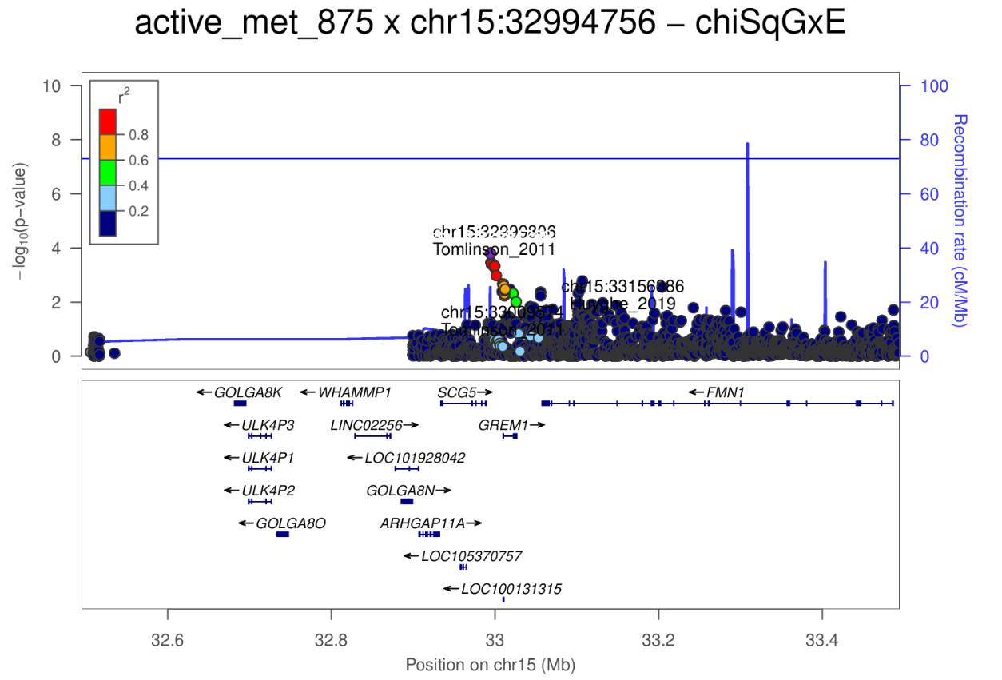

B)
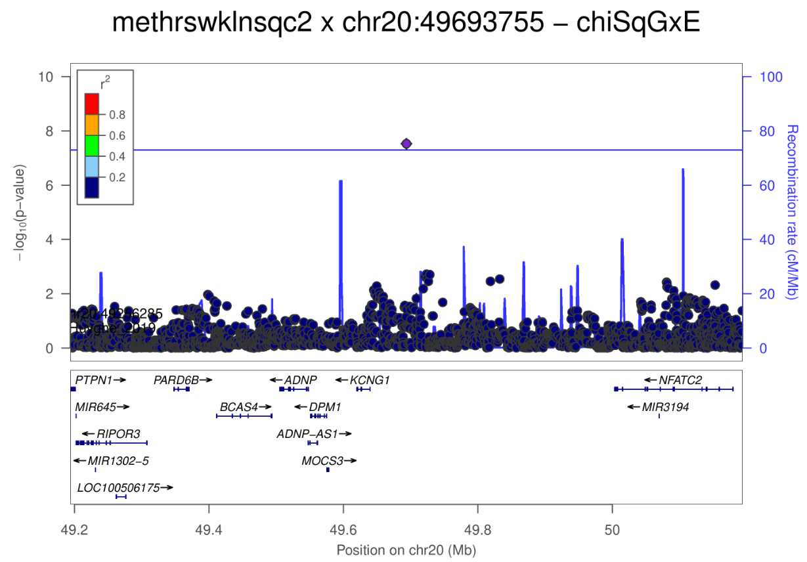
Supplementary Figure 5. Functional annotation plots showing chromatin accessibility for genetic regions that showed significant interaction with physical activity for colorectal cancer risk. A: rs4779584/GREM1 region. B: rs56906466/KCNG1 region. Top panel indicates GENCODE reference genes (GRCh37).

A) Active: ≥8.75 MET-h/wk vs. Inactive: <8.75 MET-h/wk

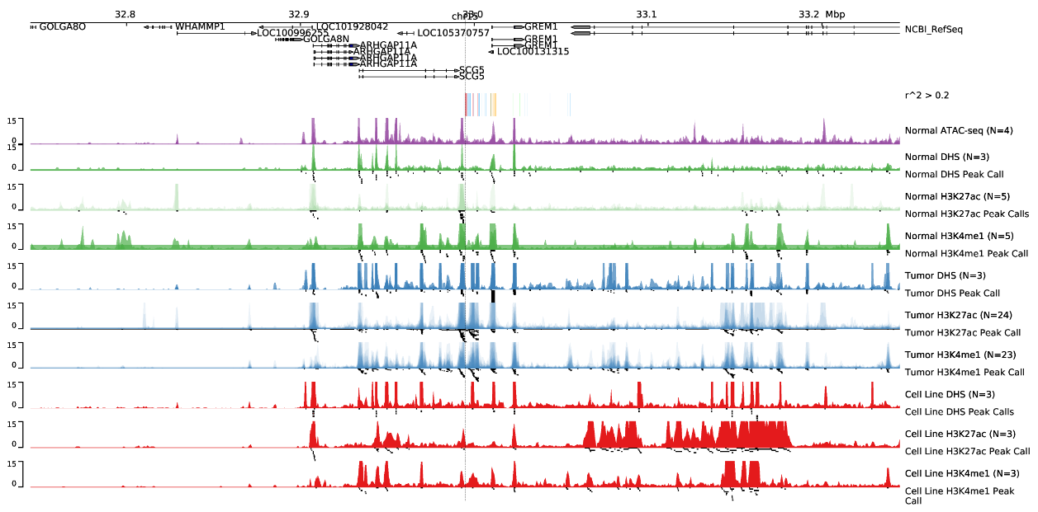

B) Study- and sex-specific quartiles

