Appendix

Image 1. Chest radiograph parenchymal lesions
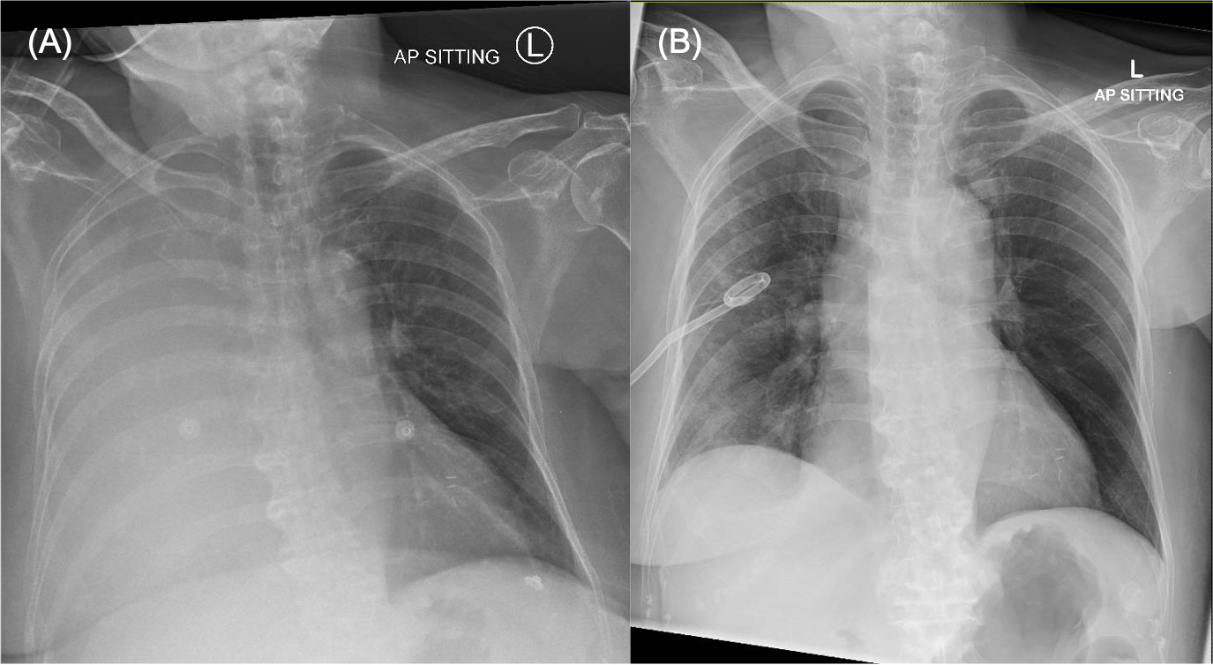
(A): Chest radiograph of a patient with TB pleuritis who has a massive right pleural effusion before pleural intervention; (B) Chest radiograph of the same patient after chest drain was inserted, showing right upper zone nodular opacities

Image 2. CT Active Parenchymal Changes
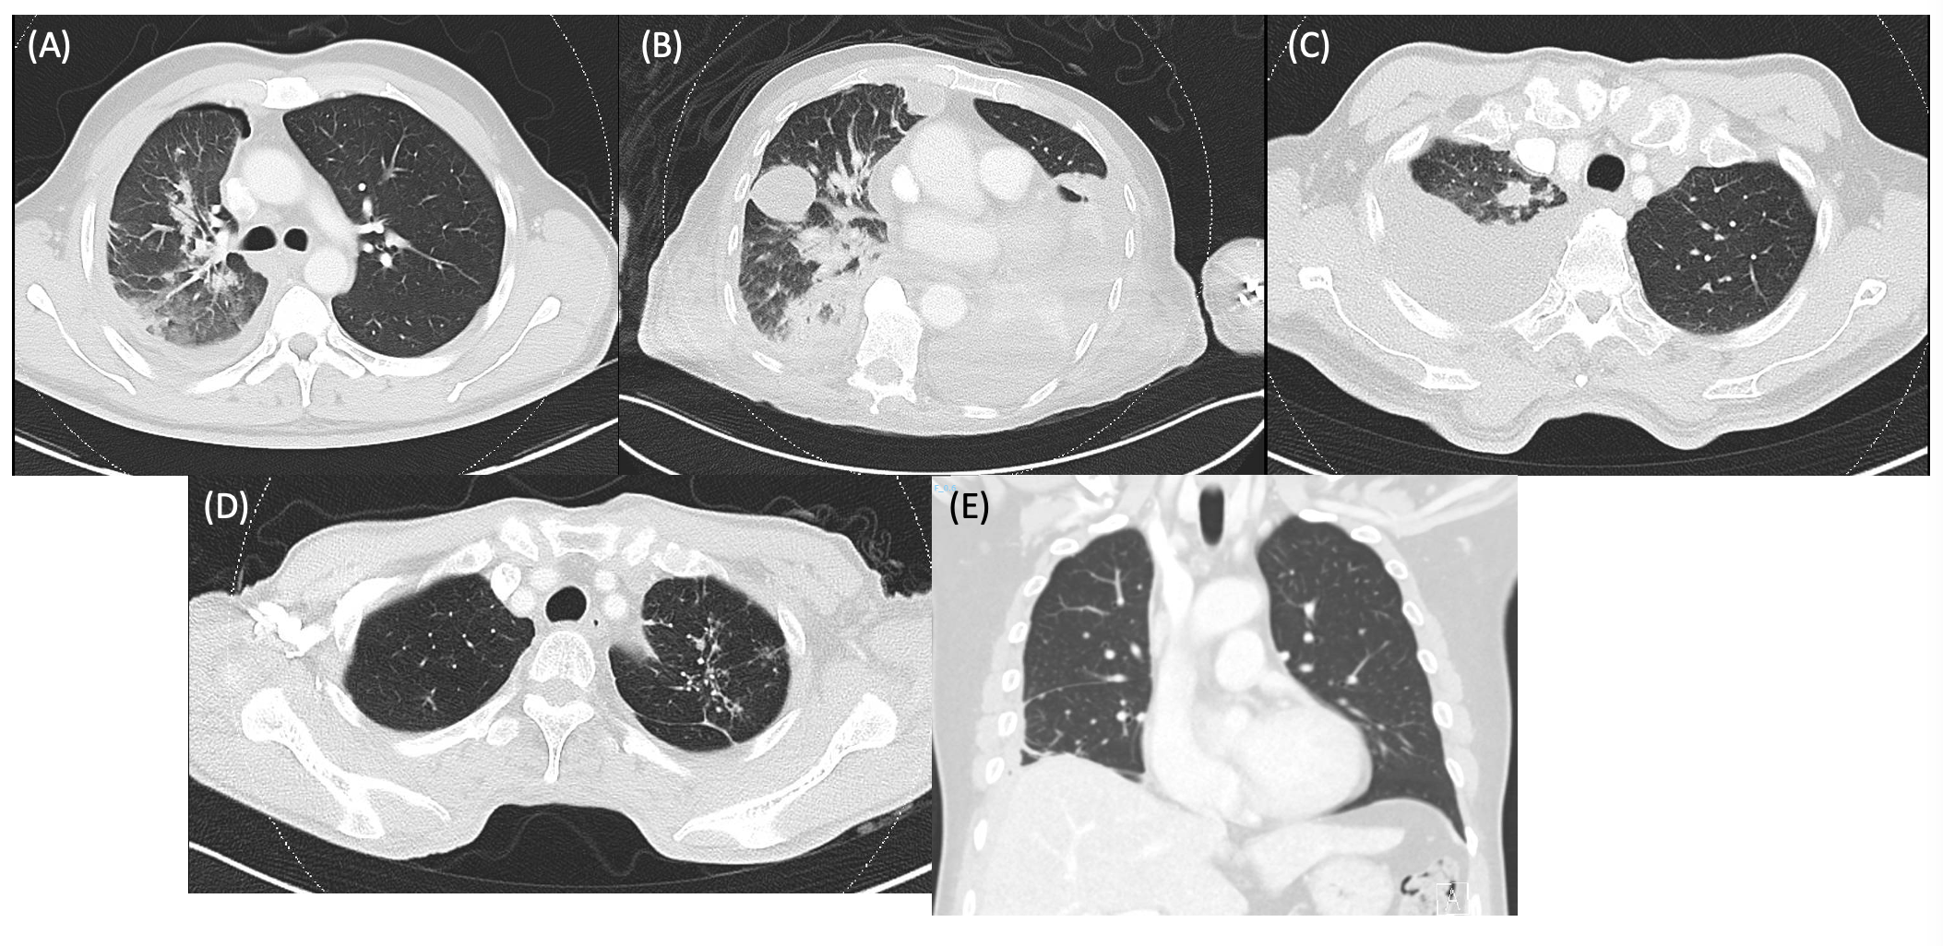
(A): Right upper lobe consolidation; (B): Right lower lobe consolidation; (C): Right upper lobe nodule; (D): Left upper lobe tree-in-bud nodularities; (E): Perifissural nodules along right horizontal fissure

Image 3. CT Pleural Changes
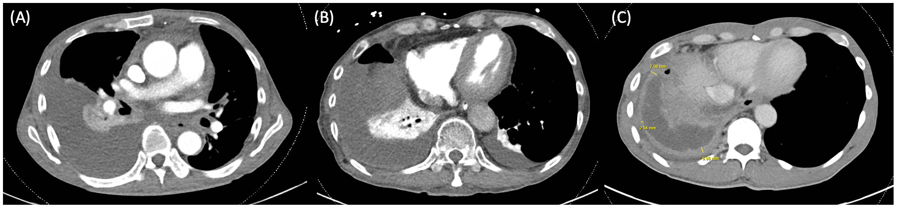
(A): Absence of pleural abnormality (Pleural fluid was mycobacterial culture positive in this patient); (B): Diffuse thickening and enhancement of right parietal pleura; (C): Irregular and nodular thickening and enhancement of right parietal pleura

