Supplementary Materials
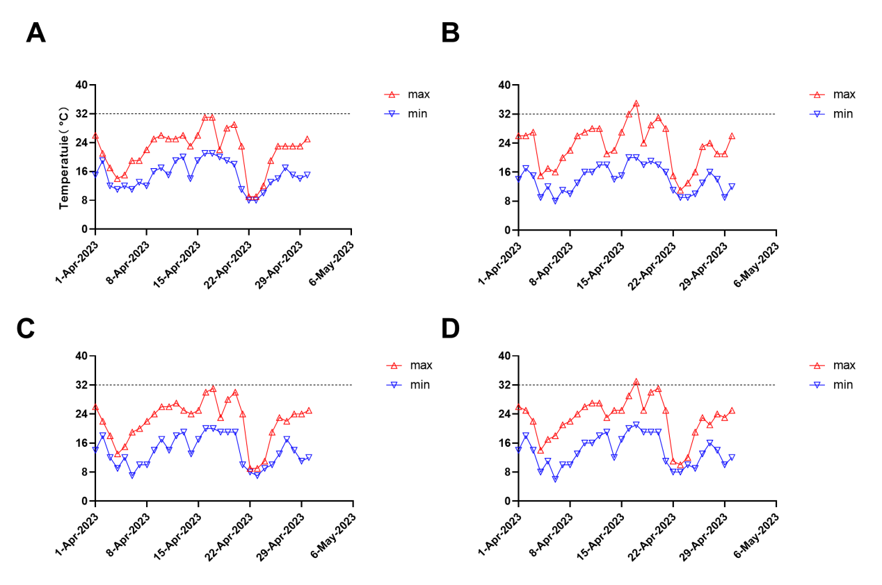
Figure S1. Recorded temperature every day in April of 2023. A-D, The temperature distribution in April 2023 for the cities of Gongan (A), Huangshi (B), Qianjiang (C), and Xiaogan (D). Dates with daily maximum temperatures exceeding 32 ° C will be reflected above the dotted line.
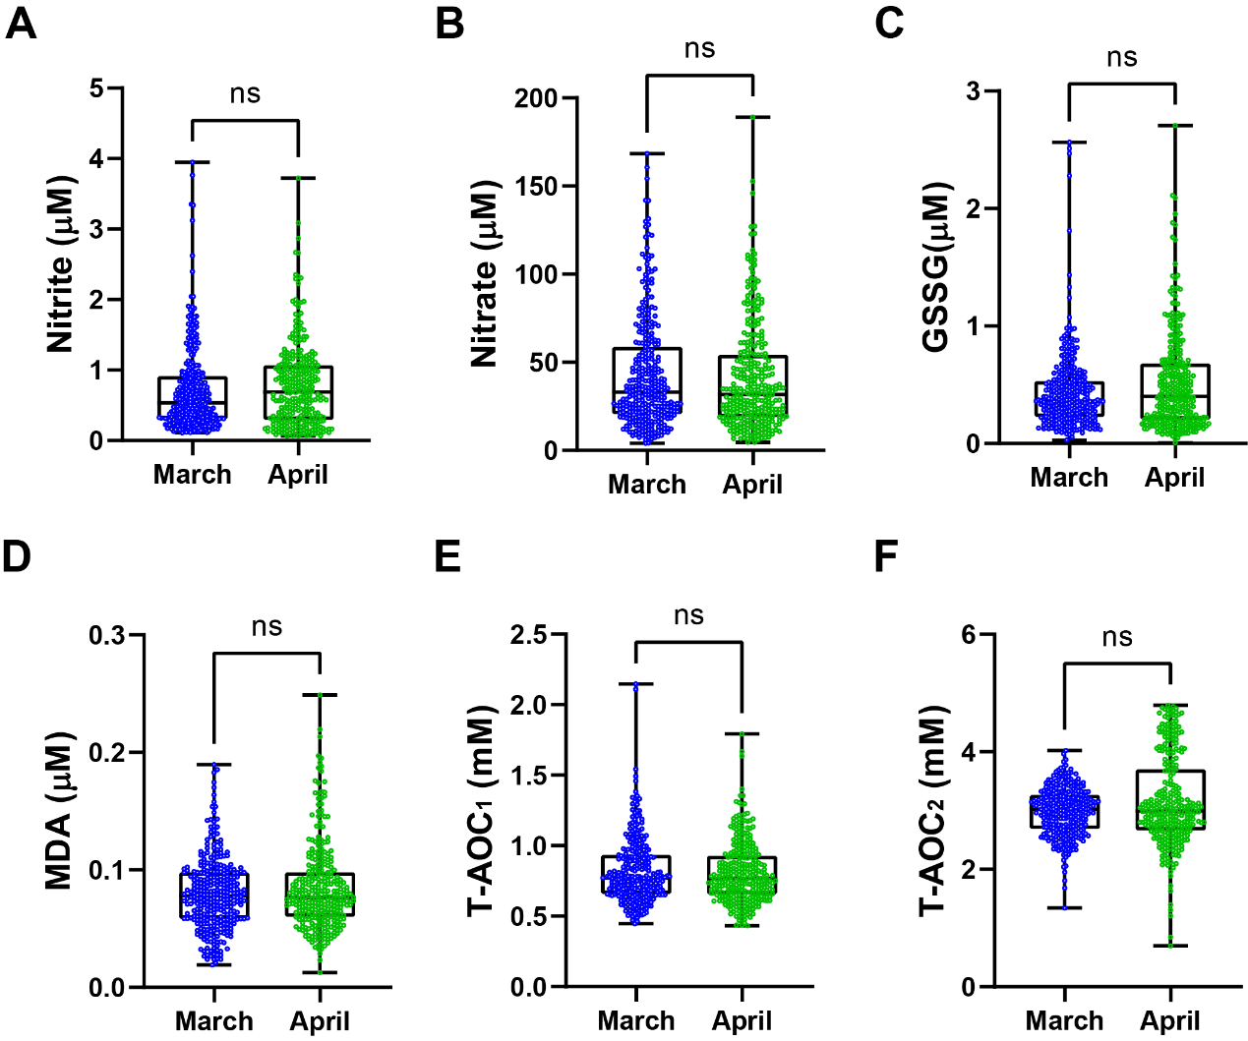Figure S2. Effect of temperature in April on serum redox markers in volunteers. (A-F) there were NO significant changes in serum levels of nitrite (A), nitrate (B), GSSG (C), MDA (D), T-AOC₁ (E) and T-AOC₂ (F) between April and March. Data are presented as violin plots, including median and interquartile ranges. Statistical significance: ****p≤0.0001; ***p≤0.001; **p≤0.01; *p≤0.05; ns: not significant.

Table S1. Meteorological characteristics of the study region during 2023
City | Average Temperature (℃) |  | Average High Temperature (℃) |  | Average Low Temperature (℃)
City | Mar | Aug | Mar | Aug | Mar | Aug
Gong'an | 14 | 29.1 | 17 | 31 | 10 | 25
Huangshi | 14 | 29.4 | 18 | 33 | 9 | 25
Qianjiang | 13.6 | 29 | 17 | 32 | 9 | 24
Xiaogan | 13.8 | 29.5 | 18 | 32 | 9 | 24
Table S2. Compared to March, the overall trend of redox changes in August.
volunteers | nitrite | nitrate | GSSG | MDA | T-AOC₁ | T-AOC₂
all | ***↓ | ns | *↓ | ****↑ | **↑ | ****↑
male | *↓ | ns | ns | ****↑ | *↑ | ns
female | *↓ | ns | ns | *↑ | ns | ****↑
****p ≤ 0.0001; ***p ≤ 0.001; **p ≤ 0.01; *p ≤ 0.05; ns: not significant.

