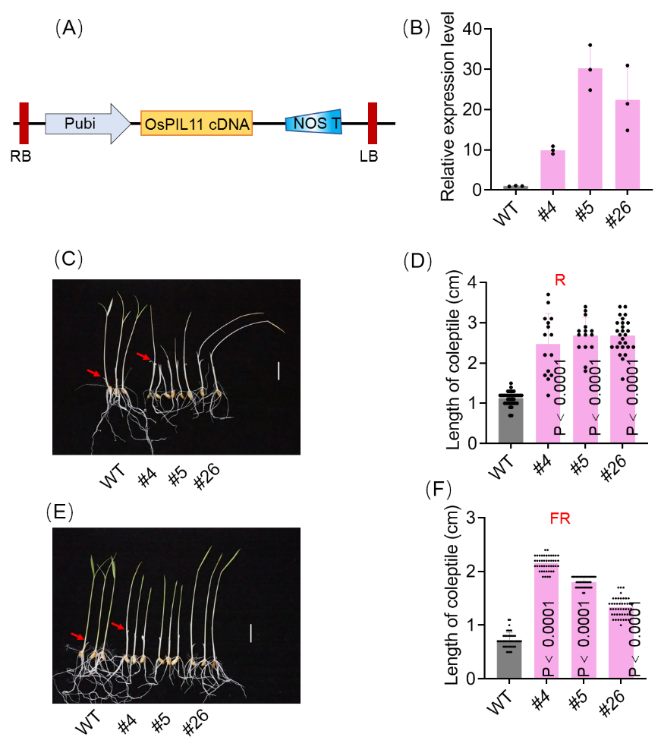
Fig.S1 OsPIL11 plays important roles in red light-mediated signal transduction pathways. (A) Schematic diagrams show the construct used for overexpression transformation. (B) The relative expression level of OsPIL11. (C) The phenotype of seedlings with red light treatment. (D) The length of coleoptile with red light treatment. (E) The phenotype of seedlings with far-red light treatment. (F) The length of coleoptile with far red light treatment. R: red light, FR: far red light. The red arrow indicates the coleoptile position.
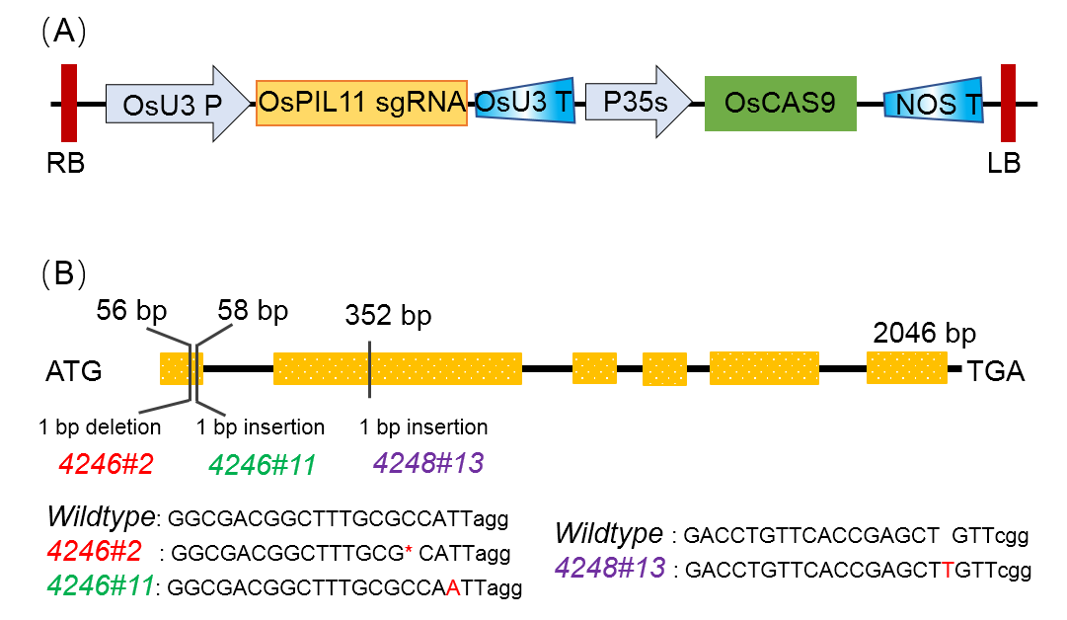
Fig. S2 Development of the knock-out (KO) lines of OsPIL11. (A) Schematic diagrams of the construct used for developing OsPIL11 KO lines. (B) Schematic representation of OsPIL11 mutations in the three independent KO lines.

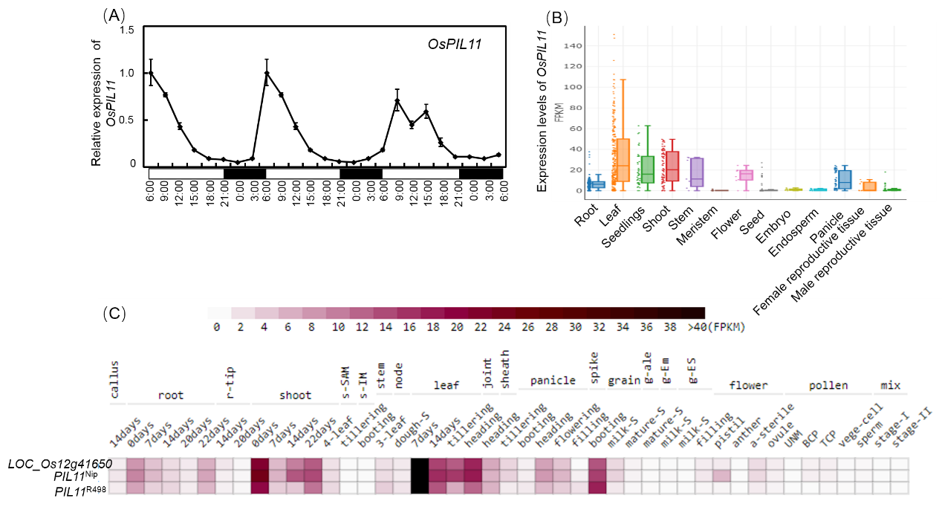
Fig. S3 Expression patterns of OsPIL11 in rice. (A) Relative expression of OsPIL11 in photoperiodic conditions. (B) Expression levels of OsPIL11 among different tissues from REPD. (C) Expression levels of OsPIL11 among different tissues from Rice RNA-seq Database.

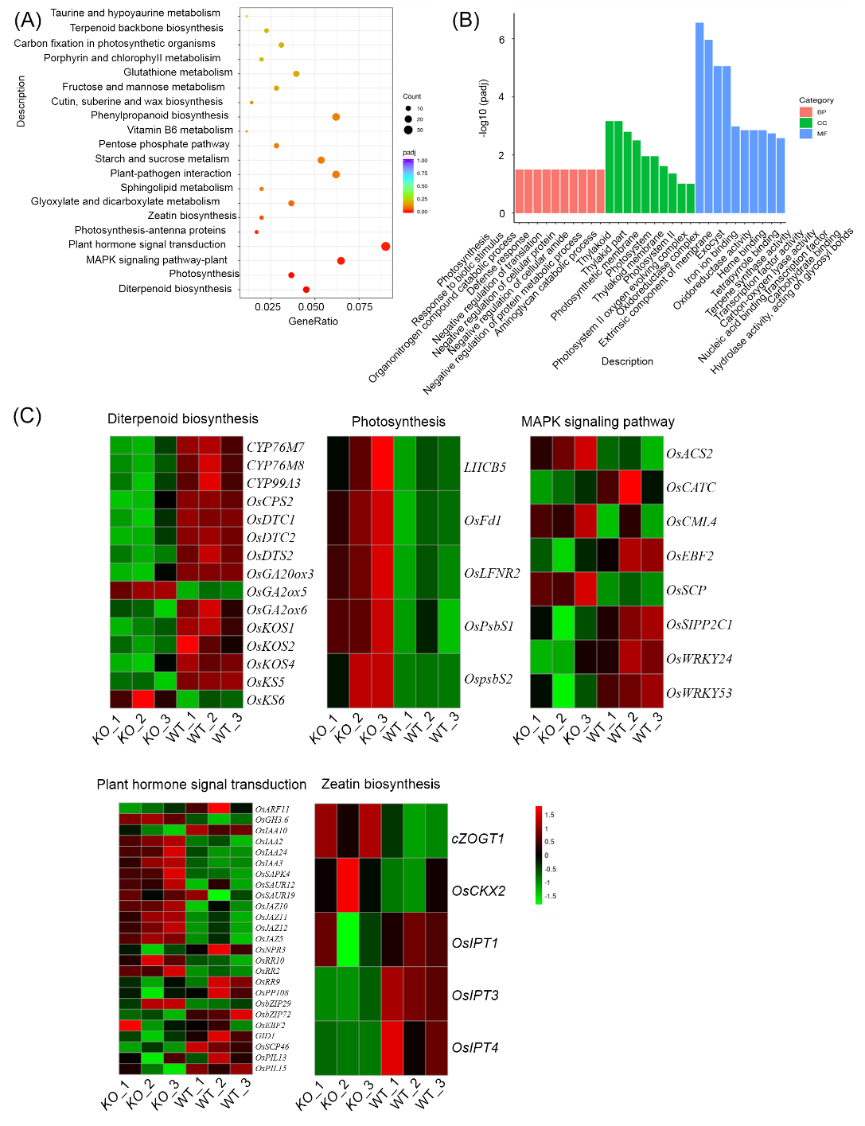
Fig. S4 Deﬁciency of OsPIL11 results in changes in several biological processes. (A) KEGG analysis of DEGs. (B) GO analysis of DEGs. (C) Expression levels of OsPIL11 among different tissues from Rice RNA-seq Database. Expression levels of various genes regulated by OsPIL11. Heatmaps show the fold changes in expression of gene involved in diterpenoid, photosynthesis, MAPK signaling pathway, plant hormone transduction. Log2 (fold changes) are represented by a colour scale from green (down-regulated expression) to red (up-regulated expression).

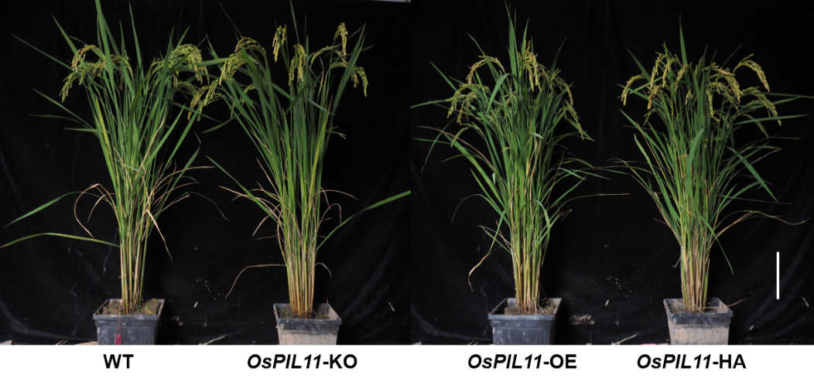
Fig.S5 Phenotypes of OsPIL11 OE and HA transgenic lines. Bars (A) = 10 cm.
Fig.S6 Quantitative real-time (qRT)-PCR analysis of several potential target genes from chromatin immunoprecipitation.
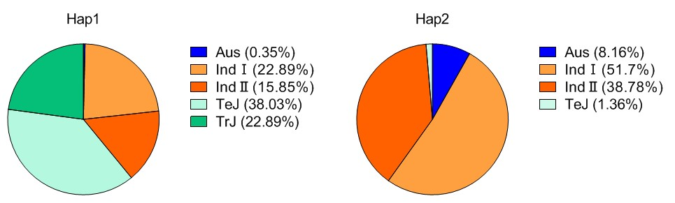
Fig.S7 Distribution frequency of cultivated rice subpopulations across the different haplotypes.
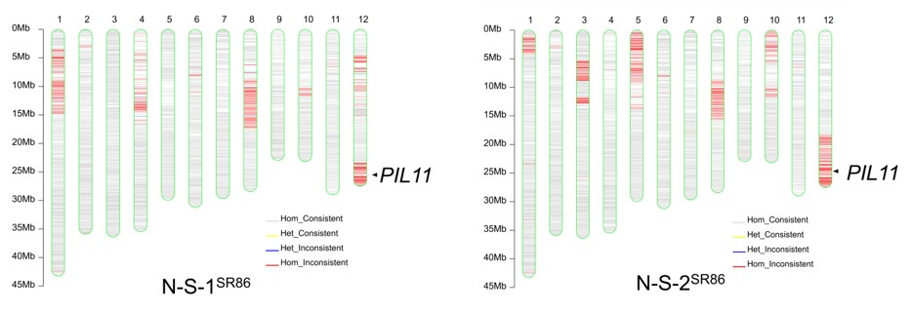
Fig.S8 The schematic drawing of two CSSLs with substitution segments of HD86. The gray and yellow lines represent NIP genomic homozygous and heterozygous fragments, respectively. The red and blue lines represent SR86 genomic homozygous and heterozygous fragments, respectively. The arrows represented location of OsPIL11.

Table.S1 Several DEGs related to grain size and panicle development.
Table.S2 DEGs list related to complex regulatory networks influencing rice grain yield.
Table.S3 Primers used in this study.

