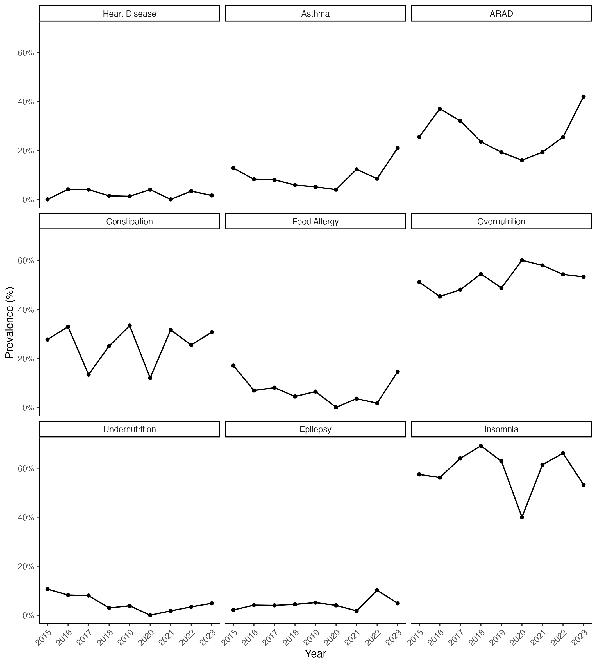
Supplementary Figure 1. Annual prevalence of all recorded medical comorbidities at ASD diagnosis (2015–2023), by condition. Each panel depicts the yearly prevalence for one comorbidity, calculated as the number of affected children divided by all ASD diagnoses in that year. Conditions include Heart Disease, Asthma, ARAD (allergic rhinitis/atopic dermatitis), Constipation, Food Allergy, Overnutrition, Undernutrition, Epilepsy, and Insomnia. The 2020 reduction corresponds to the COVID‑19 pandemic. Panels share identical axes to facilitate visual comparison; no statistical smoothing or inference is implied.

