SUPPLEMENTARY MATERIALS

Supplementary Figure 1. Clustering output plots. (A) Two-dimensional multidimensional scaling (MDS) representation of the similarity matrix. Each dot represents a subject, with distances reflecting the similarity of their cortical and subcortical patterns. (B) Hierarchical clustering dendrogram. The horizontal axis indicates the distance between subjects based on random forest similarity, while the vertical axis shows the hierarchical grouping structure. Colors represent different subtypes, as indicated in the legend.
Supplementary Figure 2. Gray matter clusters. The five identified patterns of cortical thickness (left) and subcortical volume (right) compared to the sample mean.
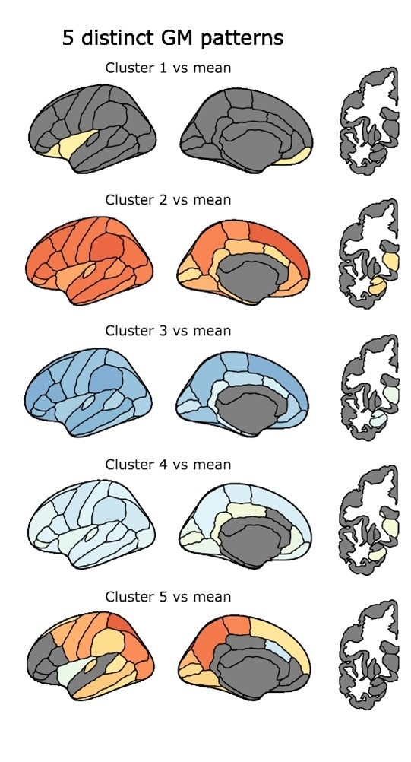
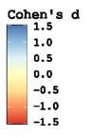

Supplementary Figure 3. Cortical ROI rankings based on Cohen’s d effect sizes (averaged across hemispheres) for pairwise comparisons between each cluster and Cluster 1. The plot highlights the three brain regions (ROIs) with the strongest discriminative power for differentiating participant clusters.

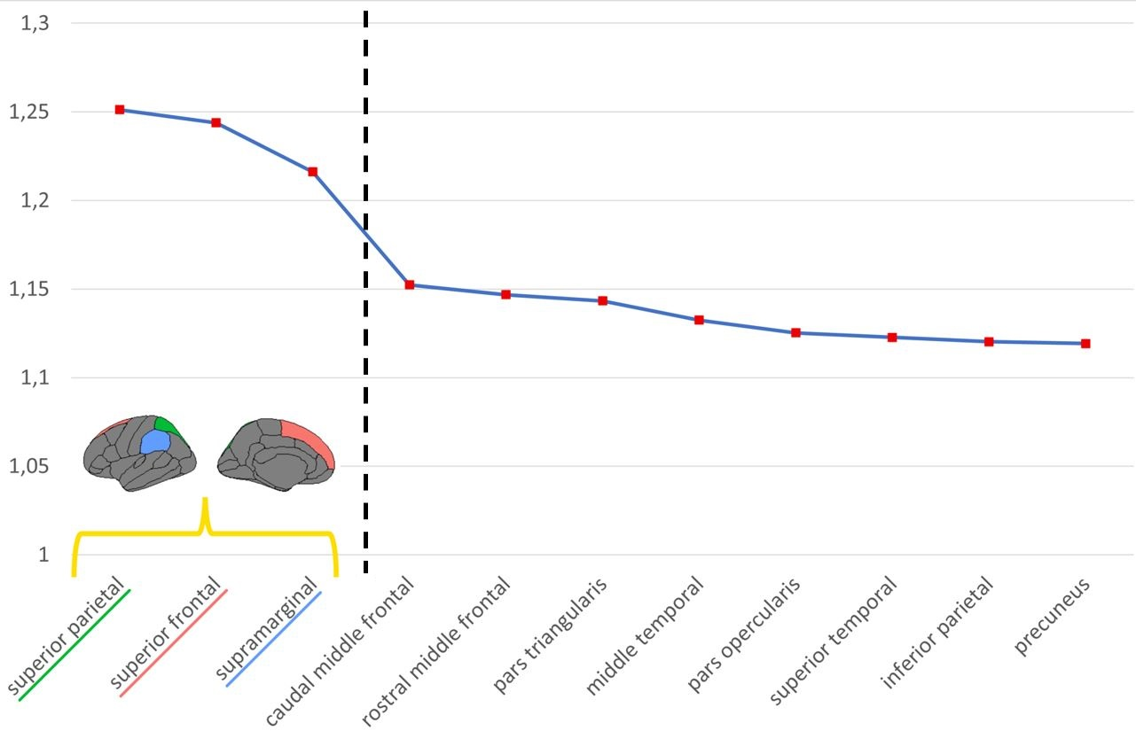

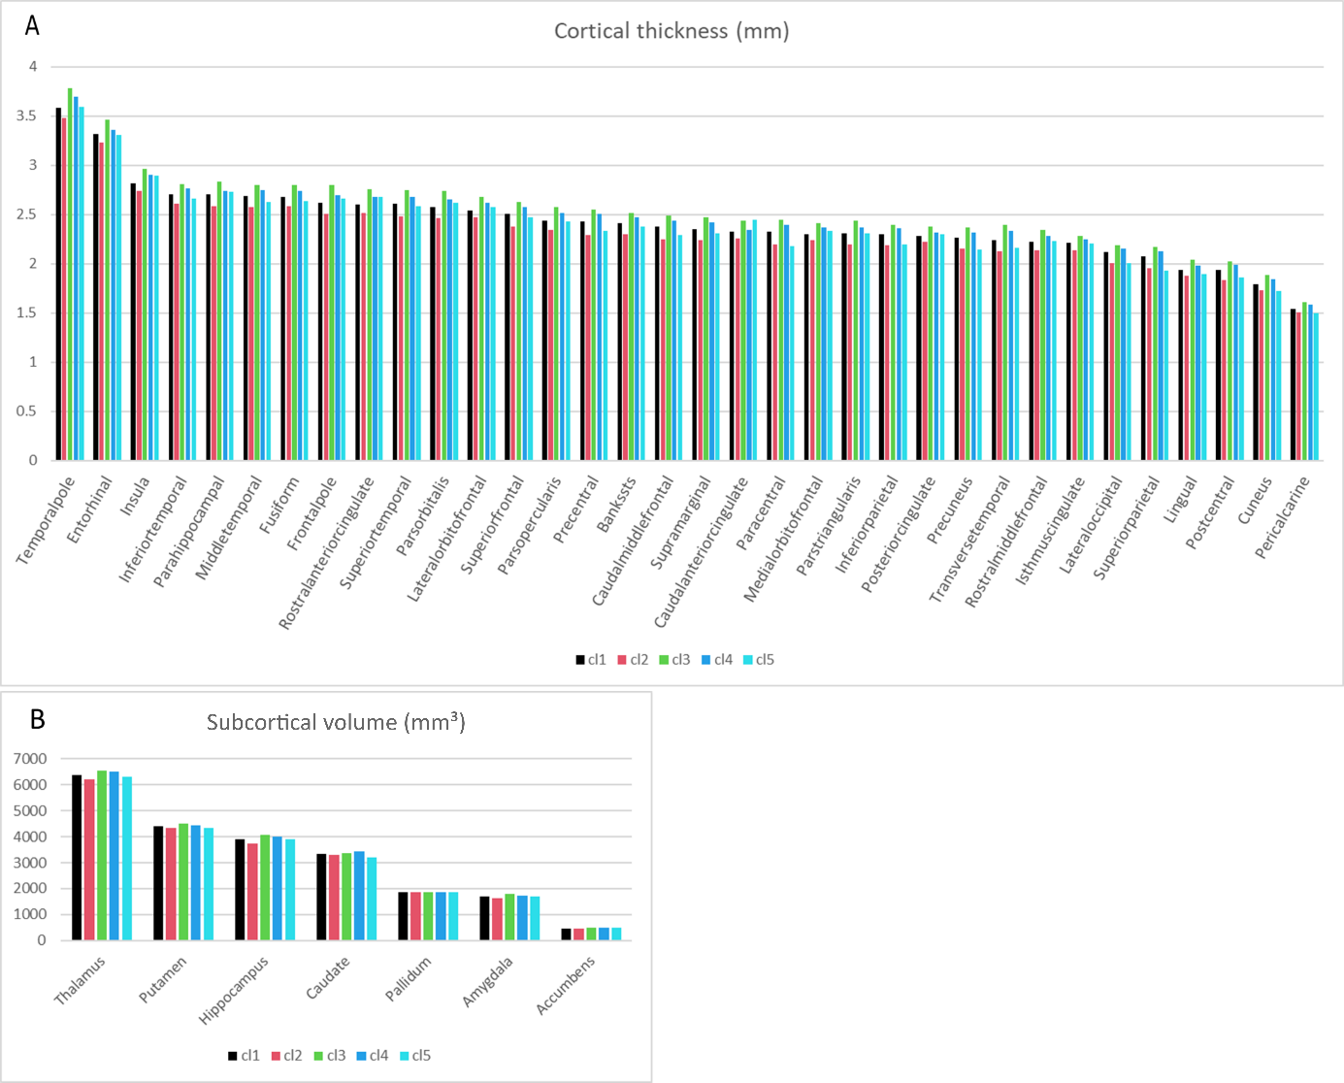
Supplementary Figure 4. Baseline brain ROI values by cluster. (A) Cortical thickness (mm) across all cortical regions. (B) Subcortical volumes (mm³) across all subcortical regions. All values are averages across hemispheres.

Supplementary Table 1. Baseline CSF biomarkers of Alzheimer’s disease in a sub-sample of 286 participants from the Gothenburg H70– Birth Cohort 1944 by cluster.

 | Cluster 1 (N=103) | Cluster 2 (N=59) | Cluster 3 (N=45) | Cluster 4 (N=60) | Cluster 5 (N=19) | Total (N=286) | p *
Aβ 1-42 positive | 50 (49.0) | 24 (42.1) | 18 (40.0) | 29 (49.2) | 10 (52.6) | 131 (46.5) | 0.750
Total tau positive | 30 (29.1) | 14 (23.7) | 14 (31.1) | 22 (36.7) | 11 (57.9) | 91 (31.8) | 0.204
p-tau 181 positive | 6 (5.8) | 2 (3.4) | 1 (2.2) | 5 (8.3) | 2 (10.5) | 16 (5.6) | 0.750

Note. Data are presented as numbers (percentage) for categorical variables. Pathological cut-off values for biomarker positivity were defined as follows: β-amyloid 42 (Aβ42) ≤ 530 pg/mL, total tau (t-tau) ≥ 350 pg/mL, and phosphorylated tau at threonine 181 (p-tau181) ≥ 80 pg/mL.
Abbreviations: CSF, cerebrospinal fluid.
Missing data: Amyloid-β 1-42 (n=4).
*p value <0.05.

Supplementary Table 2. Comparison of baseline characteristics between participants with and without CSF data in the Gothenburg H70– Birth Cohort 1944.
 | CSF subsample (N=286) | CSF not available (N=460) | Total (N=746) | p *
Sociodemographic and genetic factors
Sex |  |  |  | 0.231
Men | 147 (51.4) | 206 (44.8) | 353 (47.3)
Women | 139 (48.6) | 254 (55.2) | 393 (52.7)
Education, years |  |  |  | 0.189
Primary school | 33 (11.5) | 49 (10.7) | 82 (11.0)
Secondary school | 159 (55.6) | 209 (45.5) | 368 (49.4)
Higher education | 94 (32.9) | 201 (43.8) | 295 (39.6)
APOE ε4 (one/two) | 102 (36.2) | 138 (30.8) | 240 (32.9) | 0.307
MMSE score | 28.98 ± 1.23 | 29.16 ± 1.11 | 29.09 ± 1.16 | 0.047
Cardiovascular risk factors
Current/former smoking | 177 (62.1) | 279 (60.9) | 456 (61.4) | 0.811
Alcohol risk consumption | 83 (29.1) | 152 (33.1) | 235 (31.6) | 0.490
Physical inactivity | 8 (2.8) | 17 (3.8) | 25 (3.4) | 0.626
Overweight/obese (BMI ≥25 kg/m²) | 143 (52.0) | 257 (59.6) | 400 (56.7) | 0.192
Elevated triglycerides | 94 (32.9) | 179 (39.2) | 273 (36.7) | 0.231
Reduced HDL cholesterol | 27 (9.4) | 59 (12.9) | 86 (11.6) | 0.307
LDL cholesterol |  |  |  | 0.857
T1 (≤3) | 95 (33.2) | 160 (35.1) | 255 (34.4)
T2 (3.1-3.9) | 99 (34.6) | 156 (34.2) | 255 (34.4)
T3 (≥4) | 92 (32.2) | 140 (30.7) | 232 (31.3)
Hypertension (≥140/90 mmHg) | 210 (73.4) | 309 (67.3) | 519 (69.7) | 0.231
Medical conditions
Heart disease | 40 (14.0) | 92 (20.0) | 132 (17.7) | 0.189
Stroke/TIA | 14 (4.9) | 43 (9.3) | 57 (7.6) | 0.189
Diabetes |  |  |  | 0.626
Normoglycemia | 124 (43.4) | 189 (41.2) | 313 (42.0)
Prediabetes | 126 (44.1) | 197 (42.9) | 323 (43.4)
Diabetes | 36 (12.6) | 73 (15.9) | 109 (14.6)
Depression (major/minor) | 26 (9.1) | 33 (7.2) | 59 (7.9) | 0.571
Traumatic brain injuries | 99 (34.6) | 143 (31.1) | 242 (32.4) | 0.566
Blood biomarkers
Homocysteine > 13 µmol/L | 104 (36.6) | 167 (37.4) | 271 (37.1) | 0.856
C-reactive protein ≥ 8 mg/L | 20 (7.1) | 36 (8.1) | 56 (7.7) | 0.745
Neuroimaging biomarkers
Mean cortical thickness (mm) | 2.35 ± 0.08 | 2.35 ± 0.08 | 2.35 ± 0.08 | 0.269
Average Fractional Anisotropy |  |  |  | 0.626
T1 (<0.3) | 85 (31.4) | 152 (34.6) | 237 (33.4)
T2 (0.3 - 0.4) | 89 (32.8) | 148 (33.7) | 237 (33.4)
T3 (>0.4) | 97 (35.8) | 139 (31.7) | 236 (33.2)
WMHV (mm³) |  |  |  | 0.626
T1 (<2.7) | 97 (34.0) | 151 (33.0) | 248 (33.4)
T2 (2.7 – 5.5) | 101 (35.4) | 147 (32.1) | 248 (33.4)
T3 (>5.5) | 87 (30.5) | 160 (34.9) | 247 (33.2)
Cerebral microbleeds | 25 (8.8) | 56 (12.3) | 81 (10.9) | 0.307
Lacunes (3-15 mm) | 27 (9.5) | 25 (5.5) | 52 (7.0) | 0.189
Large infarctions | 5 (1.8) | 10 (2.2) | 15 (2.0) | 0.785
Enlarged PVS CS |  |  |  | 0.189
0-10 | 63 (22.2) | 133 (29.1) | 196 (26.5)
$≥$11 | 221 (77.8) | 324 (70.9) | 545 (73.5)
Enlarged PVS BG |  |  |  | 0.626
0-10 | 219 (77.1) | 364 (79.6) | 583 (78.7)
$≥$11 | 65 (22.9) | 93 (20.4) | 158 (21.3)
Note. Data are presented as Mean ± Standard deviations for continuous variables or number (percentage) for categorical variables. Abbreviations: APOE-ɛ4, apolipoprotein E gene-ɛ4 allele; MMSE, Mini-Mental State Examination; BMI, body mass index; HDL, High-density lipoprotein; LDL, Low-density lipoprotein; TIA, transient ischemic attack; MRI, Magnetic Resonance Imaging; AD, Alzheimer’s Disease; DTI, diffusion tensor imaging; FA, fractional anisotropy; WMHV, white matter hyperintensities volume; PVS, perivascular spaces.
Missing data: Education (n=1), APOE-ɛ4 (n=16), MMSE (n=4), Smoking (n=3), Alcohol consumption (n=2), Physical activity (n=15), BMI (n=2), Elevated triglycerides (n=3), Reduced HDL cholesterol (n=4), LDL cholesterol (n=4), Hypertension (n=1), Heart disease (n=1), Prediabetes/diabetes (n=1), Depression (n=2), FA (n=36), Homocysteine (n=16), C-reactive protein (n=16), WMHV (n=3), Cerebral microbleeds (n=6), Lacunes (n=3), Large infarctions (n=4), Enlarged PVS Centrum semiovale (n=5), Enlarged PVS Basal ganglia (n=5). * p value <0.05.

Supplementary Table 3. Odds ratios (ORs) and 95% confidence intervals (CIs) from four multinomial regression models (clinical, neuroimaging, inflammation, and CSF), comparing baseline clusters with Cluster 1 as the reference. CSF analyses were performed in a subset of 286 participants. Asterisks (*) indicate statistical significance.

 | Cluster 2 |  |  |  | Cluster 3 |  |  |  | Cluster4 |  |  |  | Cluster 5
 | OR |  | 95% CI |  | OR |  | 95% CI |  | OR |  | 95% CI |  | OR |  | 95% CI
Clinical model
Sex
Men | Reference |  |  |  | Reference |  |  |  | Reference |  |  |  | Reference
Women | 1.13 | 0.70 |  | 1.83 | 1.16 | 0.71 |  | 1.88 | 1.20 | 0.76 |  | 1.90 | 1.50 | 0.74 |  | 3.03
Education
Primary/lower secondary | Reference |  |  |  | Reference |  |  |  | Reference |  |  |  | Reference
Higher secondary | 1.27 | 0.64 |  | 2.54 | 2.06 | 0.84 |  | 5.04 | 2.14 | 0.94 |  | 4.86 | 0.63 | 0.23 |  | 1.73
Higher education | 0.93 | 0.44 |  | 1.99 | 2.13 | 0.84 |  | 5.38 | 2.52* | 1.08 |  | 5.87 | 1.09 | 0.39 |  | 3.02
APOE ε
No ε allele | Reference |  |  |  | Reference |  |  |  | Reference |  |  |  | Reference
One/two ε allele | 1.19 | 0.74 |  | 1.92 | 0.95 | 0.57 |  | 1.57 | 1.16 | 0.73 |  | 1.84 | 1.19 | 0.59 |  | 2.40
Current/former smoking | 1.08 | 0.67 |  | 1.74 | 0.86 | 0.54 |  | 1.38 | 0.62* | 0.40 |  | 0.95 | 0.79 | 0.40 |  | 1.56
Alcohol risk consumption | 1.83* | 1.13 |  | 2.97 | 1.12 | 0.67 |  | 1.86 | 0.93 | 0.57 |  | 1.53 | 2.09* | 1.05 |  | 4.16
Physical inactivity | 0.62 | 0.20 |  | 1.99 | 0.55 | 0.11 |  | 2.66 | 0.48 | 0.10 |  | 2.35 | 1.82 | 0.43 |  | 7.63
Overweight/obese (BMI ≥25 kg/m2) | 1.09 | 0.67 |  | 1.79 | 0.57* | 0.35 |  | 0.94 | 1.04 | 0.65 |  | 1.66 | 0.89 | 0.43 |  | 1.83
Elevated triglycerides | 1.06 | 0.63 |  | 1.79 | 0.91 | 0.52 |  | 1.57 | 0.55* | 0.32 |  | 0.95 | 0.46 | 0.20 |  | 1.06
Reduced HDL cholesterol | 0.90 | 0.44 |  | 1.83 | 0.82 | 0.36 |  | 1.89 | 1.20 | 0.59 |  | 2.43 | 0.97 | 0.32 |  | 2.91
LDL cholesterol
T1 (≤3) | Reference |  |  |  | Reference |  |  |  | Reference |  |  |  | Reference
T2 (3.1-3.9) | 0.89 | 0.50 |  | 1.56 | 0.71 | 0.39 |  | 1.29 | 1.19 | 0.68 |  | 2.08 | 1.05 | 0.43 |  | 2.59
T3 (≥4) | 0.73 | 0.40 |  | 1.31 | 0.83 | 0.46 |  | 1.49 | 0.99 | 0.55 |  | 1.76 | 1.80 | 0.75 |  | 4.30
Hypertension (≥140/90 mmHg) | 1.10 | 0.65 |  | 1.89 | 1.02 | 0.61 |  | 1.70 | 1.00 | 0.62 |  | 1.62 | 1.04 | 0.49 |  | 2.18
Heart disease | 0.77 | 0.40 |  | 1.49 | 1.27 | 0.65 |  | 2.48 | 1.70 | 0.92 |  | 3.15 | 3.44* | 1.48 |  | 8.01
Stroke/TIA | 1.18 | 0.53 |  | 2.62 | 0.94 | 0.36 |  | 2.46 | 0.93 | 0.38 |  | 2.24 | 1.20 | 0.35 |  | 4.09
Diabetes
Normoglycemia | Reference |  |  |  | Reference |  |  |  | Reference |  |  |  | Reference
Prediabetes | 1.00 | 0.59 |  | 1.68 | 1.13 | 0.68 |  | 1.88 | 0.91 | 0.56 |  | 1.47 | 1.25 | 0.60 |  | 2.63
Diabetes | 2.54* | 1.27 |  | 5.06 | 0.85 | 0.36 |  | 2.02 | 1.06 | 0.49 |  | 2.28 | 1.50 | 0.48 |  | 4.72
Depression (major/minor) | 0.67 | 0.31 |  | 1.45 | 0.77 | 0.35 |  | 1.69 | 0.17* | 0.05 |  | 0.56 | 0.93 | 0.32 |  | 2.66
Traumatic brain injuries | 1.27 | 0.79 |  | 2.04 | 1.04 | 0.63 |  | 1.71 | 1.34 | 0.85 |  | 2.13 | 0.86 | 0.41 |  | 1.78
Neuroimaging model
DTI’s Average FA
T1 (<0.3) | Reference |  |  |  | Reference |  |  |  | Reference |  |  |  | Reference
T2 (0.3 - 0.4) | 0.58 | 0.34 |  | 1.01 | 1.20 | 0.64 |  | 2.23 | 1.62 | 0.93 |  | 2.80 | 0.96 | 0.44 |  | 2.10
T3 (>0.4) | 0.46 | 0.26 |  | 0.83 | 1.59 | 0.87 |  | 2.91 | 1.43 | 0.82 |  | 2.52 | 0.53 | 0.22 |  | 1.28
WMHV, mm3
T1 (<2.7) | Reference |  |  |  | Reference |  |  |  | Reference |  |  |  | Reference
T2 (2.7 – 5.5) | 0.86 | 0.48 |  | 1.53 | 0.45* | 0.26 |  | 0.77 | 0.54* | 0.33 |  | 0.88 | 0.72 | 0.35 |  | 1.47
T3 (>5.5) | 1.30 | 0.72 |  | 2.36 | 0.50* | 0.27 |  | 0.91 | 0.65 | 0.38 |  | 1.12 | 0.23* | 0.08 |  | 0.64
Cerebral microbleeds (presence) | 0.68 | 0.34 |  | 1.34 | 0.96 | 0.47 |  | 1.96 | 0.75 | 0.37 |  | 1.51 | 0.15 | 0.02 |  | 1.19
Lacunes 3-15 mm | 0.35 | 0.14 |  | 0.84 | 0.54 | 0.21 |  | 1.39 | 0.18 | 0.05 |  | 0.63 | 0.62 | 0.17 |  | 2.31
Large infarctions | 4.91 | 0.96 |  | 25.23 | 2.06 | 0.18 |  | 24.16 | 1.52 | 0.13 |  | 17.86 | 17.44 | 1.95 |  | 156.15
Enlarged PVS in centrum semiovale
0-10 | Reference |  |  |  | Reference |  |  |  | Reference |  |  |  | Reference
≥11 | 1.23 | 0.72 |  | 2.10 | 1.38 | 0.81 |  | 2.35 | 1.18 | 0.73 |  | 1.91 | 1.96 | 0.87 |  | 4.44
Enlarged PVS in basal ganglia
0-10 | Reference |  |  |  | Reference |  |  |  | Reference |  |  |  | Reference
≥11 | 1.52 | 0.88 |  | 2.62 | 1.02 | 0.54 |  | 1.91 | 1.37 | 0.79 |  | 2.39 | 1.32 | 0.57 |  | 3.05
Inflammation model
Homocysteine > 13 µmol/L | 1.01 | 0.66 |  | 1.52 | 0.76 | 0.48 |  | 1.19 | 0.82 | 0.55 |  | 1.24 | 0.40* | 0.19 |  | 0.84
C-reactive protein ≥ 8 mg/L | 1.69 | 0.83 |  | 3.47 | 1.32 | 0.59 |  | 2.95 | 0.68 | 0.28 |  | 1.66 | 2.02 | 0.76 |  | 5.37
CSF model
Amyloid-β 1-42 ≥ 530 pg/mL | 0.76 | 0.39 |  | 1.45 | 0.69 | 0.34 |  | 1.41 | 1.01 | 0.53 |  | 1.91 | 1.16 | 0.43 |  | 3.08
Total tau ≥ 350 pg/mL | 0.76 | 0.36 |  | 1.58 | 1.10 | 0.51 |  | 2.35 | 1.41 | 0.72 |  | 2.77 | 3.35* | 1.22 |  | 9.14
Phosphorylated tau ≥ 80 pg/mL | 0.57 | 0.11 |  | 2.91 | 0.37 | 0.04 |  | 3.14 | 1.47 | 0.43 |  | 5.04 | 1.90 | 0.35 |  | 10.2

Note. Abbreviations: APOE-ɛ4, apolipoprotein E gene-ɛ4 allele; BMI, body mass index; HDL, High-density lipoprotein; LDL, Low-density lipoprotein; TIA, transient ischemic attack; DTI, diffusion tensor imaging; FA, fractional anisotropy; WMHV, white matter hyperintensities volume; PVS, perivascular spaces; CSF, cerebrospinal fluid. * p value <0.05.

Supplementary Table 4. β (beta estimates) of a panel of the six Generalized Linear Models (GLM) (global cognition, episodic memory, attention and perceptual speed, executive function, verbal fluency, visuospatial abilities) between clusters. Cluster 1 is set as reference for prediction measures. Asterisks (*)indicate statistical significance.

Cluster 2
Cognitive Domain | β (Estimate) | SE | t value | p-value
Global cognition | -0.122 | 0.063 | -1.943 | 0.052
Episodic memory | -0.190 | 0.077 | -2.472 | 0.014 *
Attention/Speed | -0.119 | 0.081 | -1.476 | 0.140
Executive function | -0.157 | 0.082 | -1.910 | 0.057
Verbal fluency | 0.017 | 0.088 | 0.190 | 0.849
Visuospatial abilities | -0.209 | 0.103 | -2.022 | 0.044 *
Cluster 3
Cognitive Domain | β (Estimate) | SE | t value | p-value
Global cognition | 0.079 | 0.067 | 1.177 | 0.239
Episodic memory | 0.070 | 0.083 | 0.851 | 0.395
Attention/Speed | 0.078 | 0.087 | 0.902 | 0.367
Executive function | 0.005 | 0.088 | 0.055 | 0.956
Verbal fluency | 0.161 | 0.094 | 1.714 | 0.087
Visuospatial abilities | 0.053 | 0.110 | 0.481 | 0.631
Cluster 4
Cognitive Domain | β (Estimate) | SE | t value | p-value
Global cognition | 0.158 | 0.061 | 2.575 | 0.010 *
Episodic memory | 0.155 | 0.075 | 2.059 | 0.040 *
Attention/Speed | 0.076 | 0.079 | 0.973 | 0.331
Executive function | 0.068 | 0.080 | 0.846 | 0.398
Verbal fluency | 0.237 | 0.086 | 2.771 | 0.006 **
Visuospatial abilities | 0.222 | 0.099 | 2.229 | 0.026 *
Cluster 5
Cognitive Domain | β (Estimate) | SE | t value | p-value
Global cognition | -0.036 | 0.096 | -0.373 | 0.709
Episodic memory | -0.011 | 0.118 | -0.096 | 0.924
Attention/Speed | -0.070 | 0.123 | -0.565 | 0.572
Executive function | -0.122 | 0.125 | -0.976 | 0.329
Verbal fluency | 0.096 | 0.134 | 0.716 | 0.474
Visuospatial abilities | -0.070 | 0.159 | -0.436 | 0.663

Supplementary Table 5. Full model outputs (raw values) from mixed-effects models predicting (A) cognitive subdomains, (B) MMSE, (C) WMHV, and (D) GM outcomes. Cluster 1 serves as the reference category for all cluster comparisons. Estimates reflect fixed effects for intercepts (ref = Cluster 1) and interactions with time (baseline vs 2 years). Asterisk (*) indicates what remains significant after Bonferroni correction.

A) | Attention/  Speed |  |  | Executive Function |  |  | Verbal Fluency |  |  | Visuospatial |  |  | Global Cognition
A) | β | SE | p | β | SE | p | β | SE | p | β | SE | p | β | SE | p
Intercept | -0.696 | 0.128 | 0.000 | -0.772 | 0.127 | 0.000 | -1.220 | 0.145 | 0.000 | -0.870 | 0.135 | 0.000 | -0.915 | 0.108 | 0.000
Time | -0.293 | 0.062 | 0.000 | -0.290 | 0.059 | 0.000 | -0.197 | 0.048 | 0.000 | -0.270 | 0.106 | 0.011 | -0.267 | 0.034 | 0.000
Cluster 2 | -0.025 | 0.107 | 0.813 | -0.155 | 0.107 | 0.145 | 0.121 | 0.115 | 0.291 | -0.142 | 0.133 | 0.286 | -0.029 | 0.086 | 0.734
Cluster 3 | 0.191 | 0.106 | 0.070 | 0.134 | 0.105 | 0.203 | 0.171 | 0.113 | 0.130 | 0.067 | 0.131 | 0.612 | 0.145 | 0.085 | 0.091
Cluster 4 | 0.193 | 0.098 | 0.049 | 0.115 | 0.096 | 0.233 | 0.297 | 0.104 | 0.004 | 0.282 | 0.119 | 0.018 | 0.234 | 0.078 | 0.003
Cluster 5 | 0.189 | 0.169 | 0.265 | 0.210 | 0.166 | 0.206 | 0.245 | 0.179 | 0.170 | 0.039 | 0.207 | 0.850 | 0.173 | 0.135 | 0.198
Education (yrs) | 0.045 | 0.008 | 0.000 | 0.055 | 0.008 | 0.000 | 0.066 | 0.009 | 0.000 | 0.065 | 0.008 | 0.000 | 0.059 | 0.007 | 0.000
Female sex | 0.014 | 0.066 | 0.827 | -0.040 | 0.064 | 0.531 | 0.320 | 0.075 | 0.000 | -0.175 | 0.065 | 0.007 | 0.042 | 0.056 | 0.452
Time × Cluster 2 | 0.034 | 0.110 | 0.755 | 0.096 | 0.105 | 0.361 | -0.226 | 0.085 | 0.008* | -0.127 | 0.187 | 0.497 | -0.084 | 0.060 | 0.163
Time × Cluster 3 | 0.037 | 0.108 | 0.732 | 0.084 | 0.103 | 0.415 | -0.116 | 0.082 | 0.156 | 0.130 | 0.186 | 0.485 | 0.031 | 0.060 | 0.598
Time × Cluster 4 | -0.027 | 0.100 | 0.790 | -0.002 | 0.095 | 0.982 | -0.162 | 0.077 | 0.036 | -0.124 | 0.170 | 0.467 | -0.092 | 0.055 | 0.093
Time × Cluster 5 | 0.023 | 0.173 | 0.894 | -0.175 | 0.162 | 0.281 | -0.239 | 0.131 | 0.068 | 0.139 | 0.292 | 0.635 | -0.077 | 0.095 | 0.417

Note. Bonferroni-corrected p-values (min p per Time × Cluster terms, adjusted for 5 models):
attention/speed = 1.000, executive function = 1.000, verbal fluency = 0.034, visuospatial = 1.000, global cognition = 0.463.

B) MMSE |  | β |  | SE |  | p
Intercept | 0.000 |  | 28.259 |  | 0.179 |  | 0.000
Time | 0.000 |  | -0.324 |  | 0.121 |  | 0.008
Cluster 2 | 0.734 |  | 0.009 |  | 0.146 |  | 0.952
Cluster 3 | 0.091 |  | 0.209 |  | 0.148 |  | 0.158
Cluster 4 | 0.003 |  | -0.023 |  | 0.136 |  | 0.868
Cluster 5 | 0.198 |  | 0.293 |  | 0.232 |  | 0.206
Education (yrs) | 0.000 |  | 0.053 |  | 0.011 |  | 0.000
Female sex | 0.452 |  | 0.252 |  | 0.092 |  | 0.006
Time × Cluster 2 | 0.163 |  | -0.448 |  | 0.212 |  | 0.035 *
Time × Cluster 3 | 0.598 |  | -0.049 |  | 0.212 |  | 0.816
Time × Cluster 4 | 0.093 |  | 0.326 |  | 0.195 |  | 0.094
Time × Cluster 5 | 0.417 |  | -0.316 |  | 0.336 |  | 0.347

C) WMHV | β | SE | p
Intercept | 5.431 | 1.118 | <0.001
Time | 2.954 | 0.357 | <0.001
Cluster 2 | 2.841 | 0.928 | 0.002
Cluster 3 | –1.011 | 0.910 | 0.267
Cluster 4 | –1.685 | 0.841 | 0.045
Cluster 5 | –2.935 | 1.440 | 0.042
Education (yrs) | 0.027 | 0.068 | 0.693
Female sex | –1.060 | 0.569 | 0.063
Time × Cluster 2 | 1.843 | 0.635 | 0.004 *
Time × Cluster 3 | –0.418 | 0.616 | 0.498
Time × Cluster 4 | –1.000 | 0.568 | 0.078
Time × Cluster 5 | –1.007 | 0.967 | 0.298

D) | Superior frontal |  |  | Superior parietal |  |  | Supramarginal |  |  | AD signature |  |  | Resilience signature |  |  | Hippocampal volume |  |  | Mean thickness
 | β | SE | p | β | SE | p | β | SE | p | β | SE | p | β | SE | p | β | SE | p | β | SE | p
Intercept | 2.494 | 0.012 | 0.000 | 2.140 | 0.014 | 0.000 | 2.374 | 0.011 | 0.000 | 2.717 | 0.011 | 0.000 | 2.549 | 0.011 | 0.000 | 3815.370 | 60.674 | 0.000 | 2.373 | 0.006 | 0.000
Time | 0.002 | 0.006 | 0.711 | -0.022 | 0.005 | 0.000 | -0.005 | 0.004 | 0.253 | 0.010 | 0.005 | 0.041 | -0.002 | 0.005 | 0.754 | -158.484 | 11.852 | 0.000 | -0.011 | 0.004 | 0.003
Cluster 2 | -0.101 | 0.010 | 0.000 | -0.107 | 0.011 | 0.000 | -0.089 | 0.009 | 0.000 | -0.091 | 0.009 | 0.000 | -0.094 | 0.009 | 0.000 | -200.595 | 45.385 | 0.000 | -0.089 | 0.005 | 0.000
Cluster 3 | 0.125 | 0.009 | 0.000 | 0.089 | 0.011 | 0.000 | 0.113 | 0.008 | 0.000 | 0.103 | 0.009 | 0.000 | 0.129 | 0.009 | 0.000 | 177.739 | 44.928 | 0.000 | 0.104 | 0.005 | 0.000
Cluster 4 | 0.067 | 0.009 | 0.000 | 0.046 | 0.010 | 0.000 | 0.075 | 0.008 | 0.000 | 0.051 | 0.008 | 0.000 | 0.067 | 0.008 | 0.000 | 110.863 | 41.407 | 0.007 | 0.056 | 0.004 | 0.000
Cluster 5 | -0.031 | 0.015 | 0.037 | -0.132 | 0.017 | 0.000 | -0.043 | 0.013 | 0.001 | -0.029 | 0.014 | 0.033 | -0.012 | 0.014 | 0.371 | 86.806 | 71.226 | 0.223 | -0.042 | 0.007 | 0.000
Education (yrs) | 0.001 | 0.001 | 0.276 | 0.000 | 0.001 | 0.816 | 0.000 | 0.001 | 0.666 | 0.000 | 0.001 | 0.519 | 0.000 | 0.001 | 0.529 | 1.565 | 3.788 | 0.679 | 0.000 | 0.000 | 0.783
Female sex | 0.038 | 0.006 | 0.000 | 0.008 | 0.007 | 0.263 | 0.022 | 0.006 | 0.000 | -0.003 | 0.006 | 0.569 | 0.037 | 0.006 | 0.000 | -33.142 | 31.278 | 0.289 | 0.011 | 0.003 | 0.001
Time × Cluster 2 | -0.020 | 0.010 | 0.050 | 0.002 | 0.008 | 0.810 | -0.009 | 0.007 | 0.242 | -0.016 | 0.008 | 0.055 | -0.018 | 0.009 | 0.051 | -8.355 | 20.576 | 0.685 | -0.010 | 0.006 | 0.115
Time × Cluster 3 | 0.001 | 0.010 | 0.916 | -0.012 | 0.008 | 0.126 | -0.011 | 0.007 | 0.133 | 0.003 | 0.008 | 0.748 | 0.002 | 0.009 | 0.787 | 1.851 | 20.955 | 0.930 | -0.004 | 0.006 | 0.528
Time × Cluster 4 | -0.016 | 0.009 | 0.080 | -0.009 | 0.007 | 0.200 | -0.013 | 0.007 | 0.058 | 0.003 | 0.007 | 0.714 | -0.012 | 0.008 | 0.132 | -11.871 | 18.781 | 0.527 | -0.008 | 0.006 | 0.166
Time × Cluster 5 | 0.016 | 0.016 | 0.324 | 0.033 | 0.013 | 0.010 | 0.025 | 0.012 | 0.030 | 0.027 | 0.013 | 0.038 | 0.016 | 0.014 | 0.270 | 54.136 | 32.170 | 0.092 | 0.019 | 0.010 | 0.044

Note. Bonferroni-corrected p-values (min p per Time × Cluster terms, adjusted for 7 models):
superior frontal = 0.352, superior parietal = 0.067, supramarginal = 0.211, AD signature = 0.267, resilience signature = 0. 355, hippocampal volume = 0.647, mean thickness = 0.307.
Supplementary Table 6. Odds ratios (ORs) and 95% confidence intervals (CIs) for mortality and study dropout across clusters, using Cluster 1 as the reference. Mortality (n = 33) and dropout (n = 123) were compared to participants who remained active in the study (n = 590). No associations reached statistical significance.

 | Cluster 2 |  |  |  | Cluster 3 |  |  |  | Cluster4 |  |  |  |  | Cluster 5
 | OR |  | 95% CI |  | OR |  | 95% CI |  | OR |  | 95% CI |  |  | OR |  | 95% CI
Active (n=590) | Reference |  |  |  | Reference |  |  |  | Reference |  |  |  |  | Reference
Deceased (n=33) | 2.18 | 0.93 |  | 5.11 | 0.57 | 0.15 |  | 2.08 | 0.59 | 0.19 |  | 1.90 | 1.67 |  | 0.44 |  | 6.28
Dropout (n=123) | 0.87 | 0.50 |  | 1.49 | 0.59 | 0.32 |  | 1.09 | 0.68 | 0.39 |  | 1.17 | 1.15 |  | 0.54 |  | 2.48

