Assessment of potential side effects related to RAB27A gene therapy in stem cells
-Supplemental data
Özgür Doğuş Erol, Mehmet Emin Şeker, Şimal Şenocak, Necef Özbek, Hasan Basri Kılıç, Çetin Kocaefe, Merve Gizer, Petek Korkusuz, Niek P. van Til, Fatima Aerts-Kaya

Table S1. List of antibodies used
Antibody | Catalog Number | Brand, Location
CD10 | 347503 | BD Bioscience, New Jersey, USA
CD14 | 367104 | Biolegend, California, USA
CD16 | 302008 | Biolegend
CD29 | 303008 | Biolegend
CD33 | 555450 | BD Pharmingen, New Jersey, USA
CD34 | 343504 | Biolegend
CD38 | 303506 | Biolegend
CD43 | 343244 | Biolegend
CD44 | 17044182 | eBioscience, California, USA
CD45 | 555485 | BD Pharmingen
CD73 | 344004 | Biolegend
CD90 | 328108 | Biolegend
CD105 | 12105742 | eBioscience
CD106 | 551146 | BD Pharmingen
RAB27A | #4D3F11 | Thermo Scientific, Massachusetts, USA
RAB27A | #STJ25258 | St John’s laboratory, London, UK
IgG2b | #11-4220-82 | eBioscience
OCT3/4 | #2840 | Cell Signaling, Massachusetts, USA
SOX2 | #3579 | Cell Signaling
NANOG | #4903 | Cell Signaling
c-MYC | #5605 | Cell Signaling
LIN28A | #3695 | Cell Signaling
GAPDH | #MA5-15738 | Invitrogen, Massachusetts, USA
Anti-rabbit | #R-05072-500 | Advansta, California, USA
CD9 | ab263019 | Abcam, Cambridge, UK
CD63 | ab134045 | Abcam
CD81 | ab109201 | Abcam
Calnexin | ab133615 | Abcam

Table S2. Confirmed RAB27A mutations in GS-2 patients
clone | Patient | Mutation | Exon | characterization
YF BM-MSC | GS-2 | c.148-149delinsC | 3 | [1]
İK BM-MSC | GS-2 | c.514-518delCAAGC | 7 | [1]
AB BM-MSC | GS-2 | c.T217G | 5 | This paper
AB #2 iPSC | GS-2 | c.T217G | 5 | This paper
AB #4 iPSC | GS-2 | c.T217G | 5 | This paper
Control iPSC line& | healthy | -- | -- | This paper
&ABMGood #T1020

Table S3. Sequences of forward and reverse RT-PCR primers used
Gene | Forward sequence (5’3’) | Reverse sequence (5’3’) | Amplicon
GAPDH | CATCACTGCCACCCAGAAGAC | TGACCTTGCCCACAGCCTTG | 122
RAB27A Exon 3 | GAGACTCTGGTGTAGGGAAGA | GATCCCAACCTTTGTCCTCCT | 209
RAB27A Exon 7 | ATCAAGAGCAAAGGTCACTCTC | GGGCCACCTGAACTACTATG | 301
RAB27Aco | AGTACGGCATCCCTTATTTCG | ATCCAAGACTTGTCCACGCA | 121
Sry | CATCGGAGGGCTAAAGTGTCAC | TGGCATGTGGGTTCCTGTCC | 103
B2M | CCGTGTGAACCATGTGACTTT | CCTCCATGATGCTGCTTACA | Probe
ALPL | AGAACCCCAAAGGCTTCTTC | CTTGGCTTTTCCTTCATGGT | Probe
RUNX2 | GCCTAGGCGCATTTCAGAT | CTGAGAGTGGAAGGCCAGAG | Probe
PPARG | GACAGGAAAGACAACAGACAAATC | GGGGTGATGTGTTTGAACTTG | Probe
SCD | CCGGGAGAATATCCTGGTTT | AGGAGTGGTGGTAGTTGTGGA | Probe

Table S4. CFU capacity of HSPCs before and after overexpression of RAB27A
Colonies/10³ cells | BFU-e | CFU-GM | CFU-GEMM
Before td | 7,3 | 33,6 | 6,4
After td | 3,6 | 22,7 | 1,8

Figure S1. RAB27Aco plasmid maps after cloning of PGK, UCOE and SFFV promoter
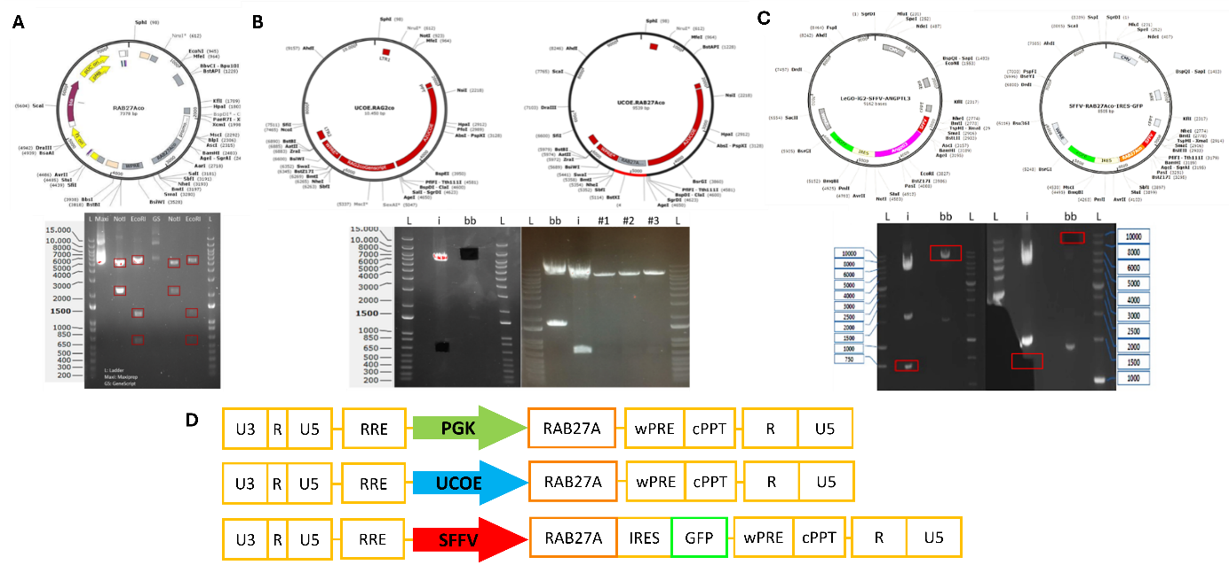
A) Upper panel: PGK-RAB27Aco plasmid map using GenScript, DNA fragments after plasmid transformation of RAB27Aco and correction of the cloning process, Lower panel: EcoRI cuts the plasmid into 3 pieces, whereas NotI cuts into 2 pieces. B) Upper panel: The original UCOE-RAG2co plasmid map, RAB27Aco plasmid cloned under control of the UCOE promoter, Lower panel: PGK-RAB27Aco and UCOE-RAB27Aco plasmids after digestion with AgeI and SbfI restriction enzymes (the image was taken after the bands were cut out of the agarose gel, as visible by the black holes), Confirmation of correct ligation of the UCOE backbone and RAB27Aco fragments (#1, #2 and #3), C) Upper panel: LeGO-ANGPTL3-IRES-GFP backbone plasmid, Lower panel: Cloned SFFV-RAB27Aco-IRES-GFP plasmid, backbone and insert plasmids after digestion with AgeI and SbfI restriction enzymes. D) Transfer plasmids design, RAB27Aco LV vector plasmids were cloned under the control of PGK, UCOE, and SFFV promoters.

Figure S2. Transgene expression after LV vector transduction with different promoters
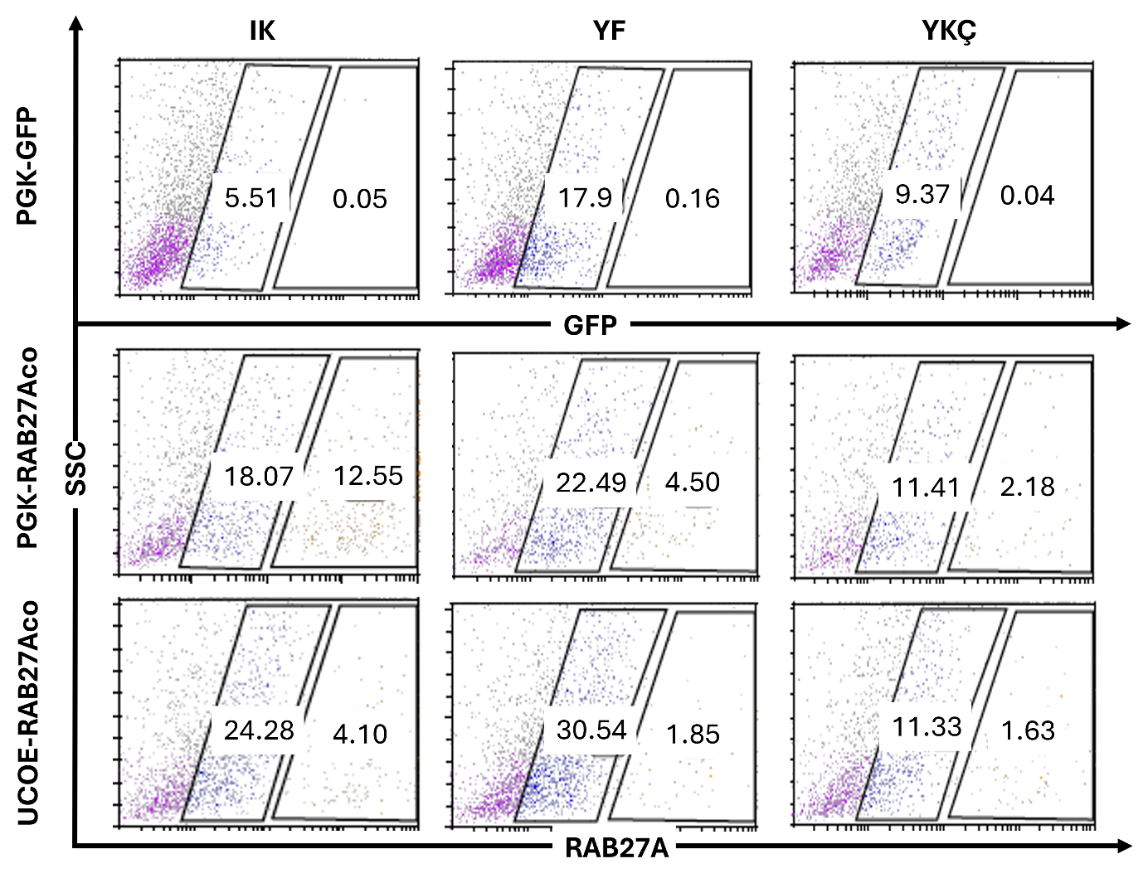
RAB27A expression after transduction with PGK-RAB27Aco, UCOE-RAB27Aco, and PGK-GFP of GS-2 patient (IK, YF, YKÇ) BM-MSCs at MOI:10. RAB27A expression was assessed using flow cytometry.

Figure S3. AB/iPSCs differentiation to iHSC and neutrophils before and after transduction
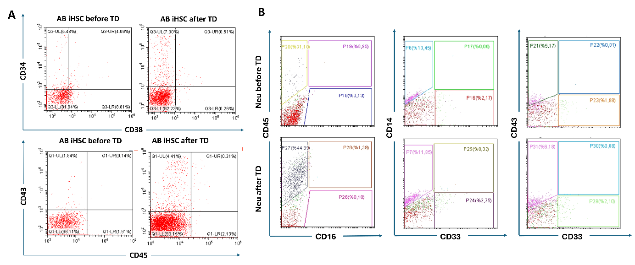
Non-transduced and PGK-RAB27Aco transduced AB/iPSCs were differentiated towards hematopoietic lineage (iHSCs) for 14 days and assessed flow cytometrically. Left: Representative flow cytometry analysis of AB/iPSCs differentiation before and after PGK-RAB27Aco transduction. iHSCs were evaluated for expression of CD34, CD38, CD43 and CD45. Right: Neutrophil differentiation of iHSCs for 21 days. Myeloid differentiation was assessed using CD16, CD14, CD33, CD43 and CD45.

Figure S4. Endogenous RAB27A expression in different cell lines
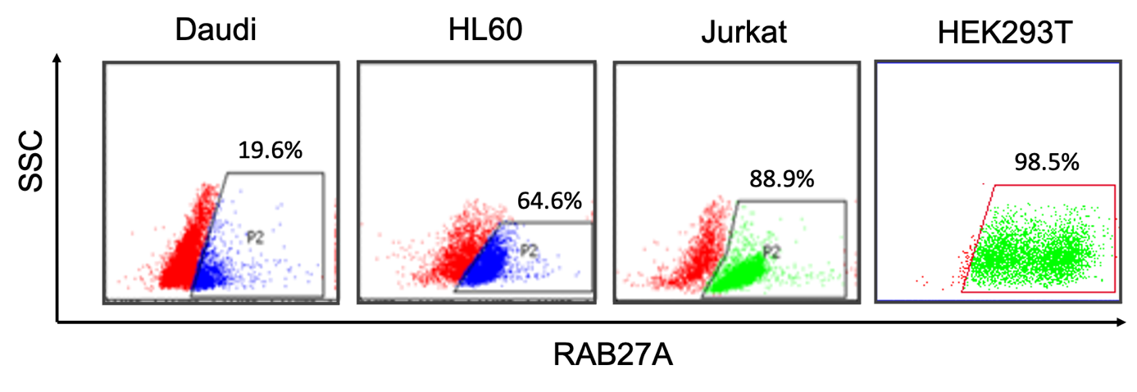
Endogenous RAB27A protein expression was determined using flow cytometry in three different leukemic cell lines (Daudi, HL60 and Jurkat) and the healthy human embryonic kidney cell line (HEK293T). All cell lines showed high, but variable levels of RAB27A expression.

Figure S5. Characterization of healthy donor BM-MSCs
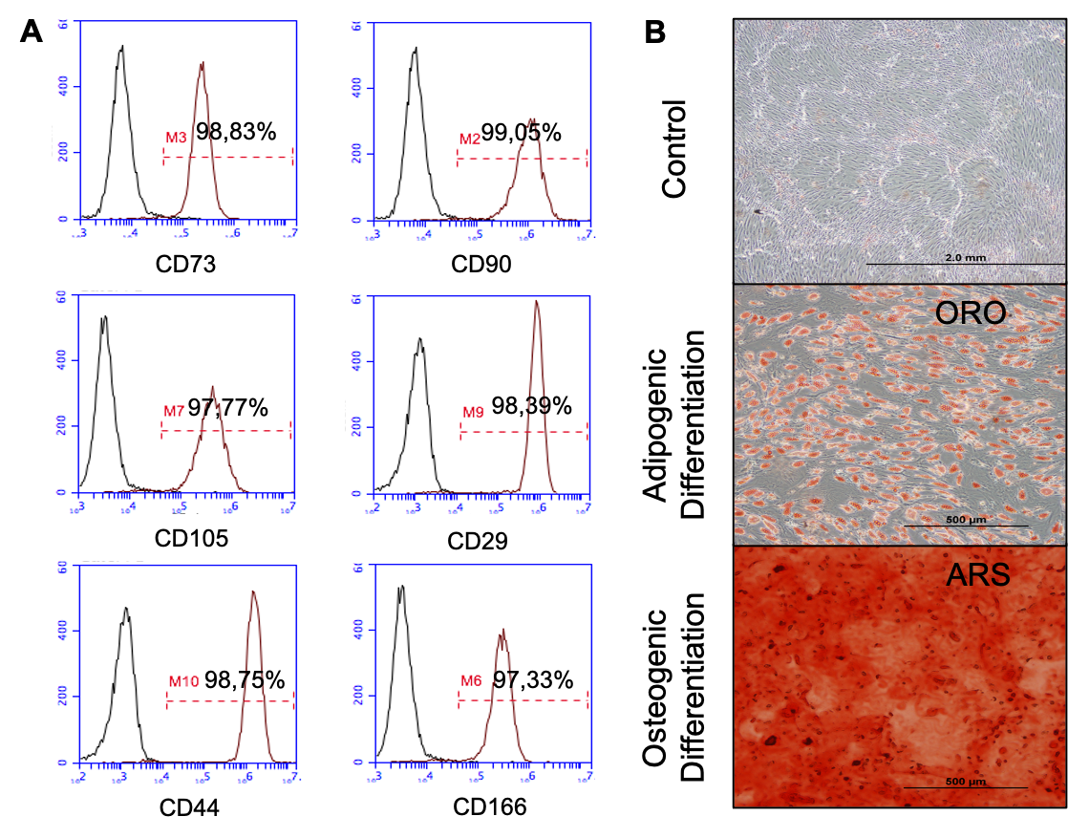
For transduction and transplantation experiments healthy donor bone marrow-derived mesenchymal stem cells (BM-MSCs) were used. The BM-MSCs were characterized at passage 3 and used for immunophenotyping (A) and differentiation assays (B). The cells displayed high expression of typical MSC markers, including CD29, CD44, CD73, CD90, CD105 and CD166. Differentiation assays were performed for adipogenic and osteogenic lineages. After 21 days of differentiation cells were stained with Oil Red O (ORO) or Alizarin Red S (ARS) and compared with unstained control wells. After confirmation of immunophenotype and differentiation potential, the BM-MSCs from this donor were used in further experiments.

Figure S6. RAB27A expression does not affect the differentiation potential of HSPCs
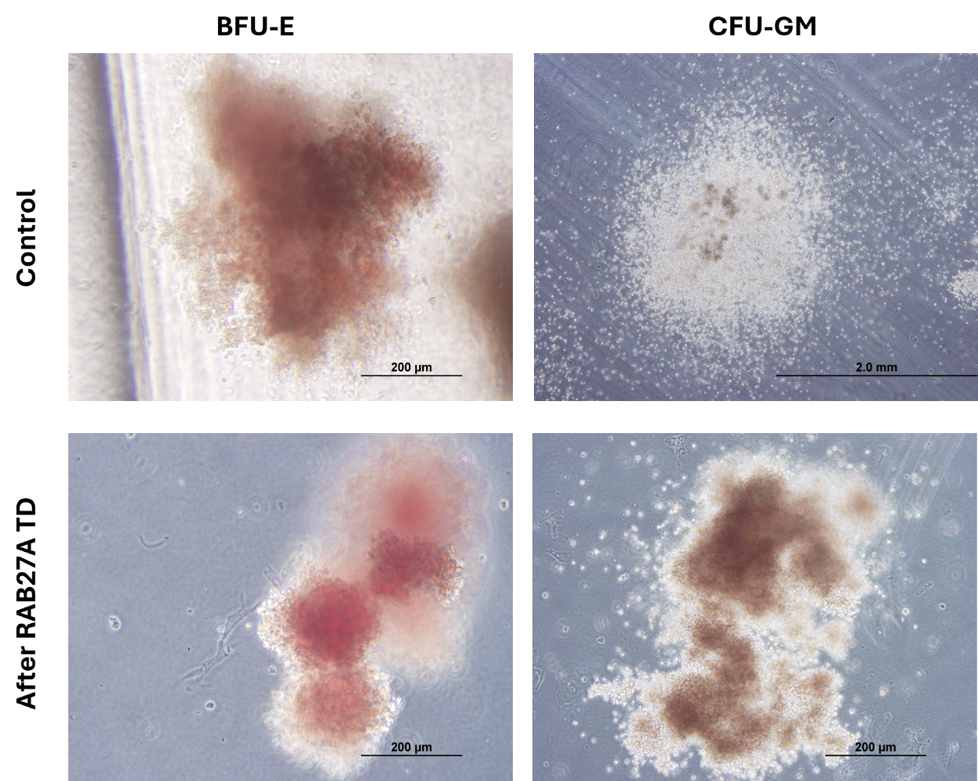
Myeloid differentiation of CD34+ HSPCs before and after transduction was assessed using colony-forming unit assays. (A) Control and SF-RAB27Aco transduced CD34+ HSPCs were assessed for Erythroid (BFU-E) and Granulocytic/Monocytic (CFU-GM) colony formation

Figure S7. Peripheral blood smears of mice transplanted with non-transduced or SF-RAB27Aco transduced BM-MSCs
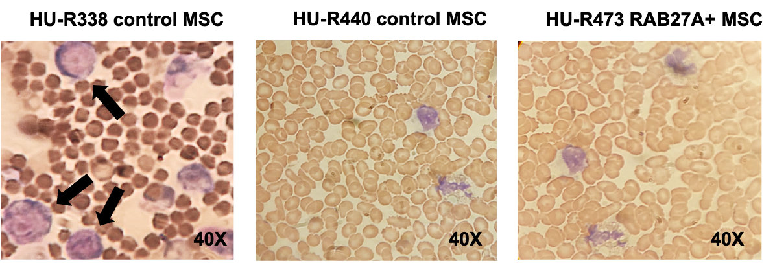
Rag2 mice were transplanted with non-transduced control BM-MSCs (n=3) or SF-RAB27Aco transduced MSCs (n=3) and followed for 3 months. A: mouse HU-R338 received control BM-MSCs and showed clinical signs of leukemia (shortness of breath, failure to thrive), as well as the presence of myeloid blasts (black arrows) in the peripheral blood smear, highly indicative for acute myeloid leukemia (AML); B: mouse HU-R440 was transplanted with the same batch of control MSCs, but lived throughout the experiment without signs of leukemia or other sequelae; C: mouse HU-R473 received RAB27A transduced BM-MSCs and showed no signs of any discomfort, nor abnormalities in its peripheral blood smear. The peripheral blood smears from HU-R440 and HU-R473 are representative for the other mice in their groups, no other adverse events were observed in any of the other mice.

Figure S8. RAB27A expression 6 months after transplantation
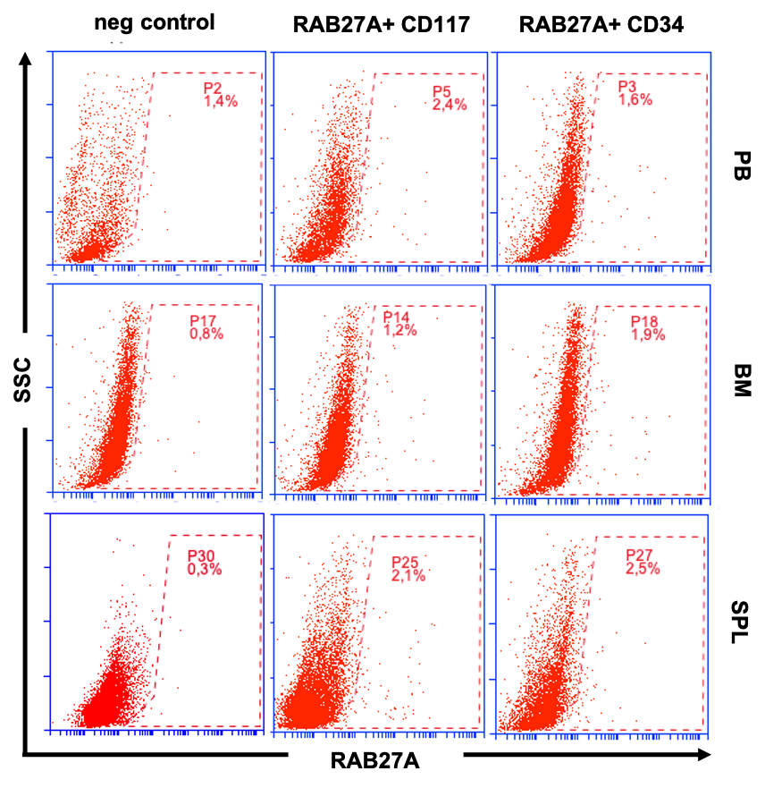
Rag2 mice were transplanted with murine SF-RAB27Aco transduced CD117 cells (n=3) or human SF-RAB27Aco transduced CD34 cells (n=3) and followed for 6 months. Upon sacrifice, peripheral blood (PB, upper panel), bone marrow (BM, middle panel) and spleen (SPL, lower panel) total nucleated cells were collected and assessed for intracellular RAB27A expression. Despite high levels of RAB27A expression in the transplanted cells, RAB27A expression was barely detectable using FACS analysis at 6 months post transplantation. Representative plots from each group are shown.

References

Guney-Esken, G., Erol, O. D., Pervin, B., Gurhan Sevinc, G., Onder, T., Bilgic, E., Korkusuz, P., Gunel-Ozcan, A., Uckan-Cetinkaya, D., & Aerts-Kaya, F. (2021). Development, characterization, and hematopoietic differentiation of Griscelli syndrome type 2 induced pluripotent stem cells. Stem Cell Res Ther, 12(1), 287. https://doi.org/10.1186/s13287-021-02364-z

