Additional File 1
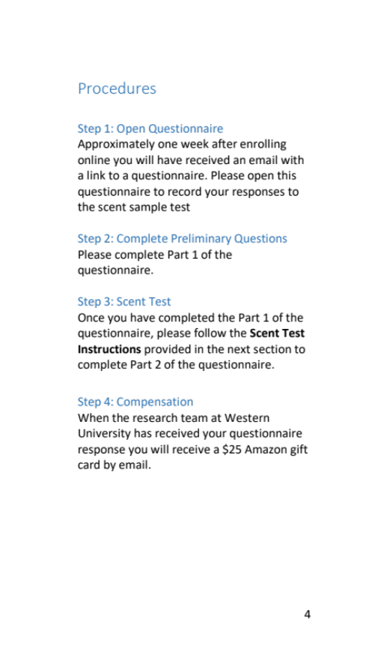
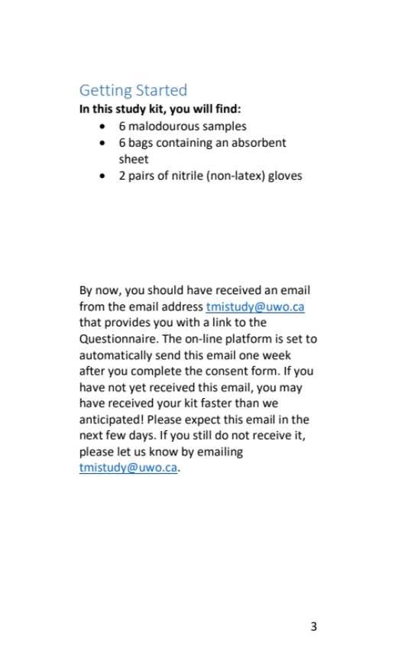

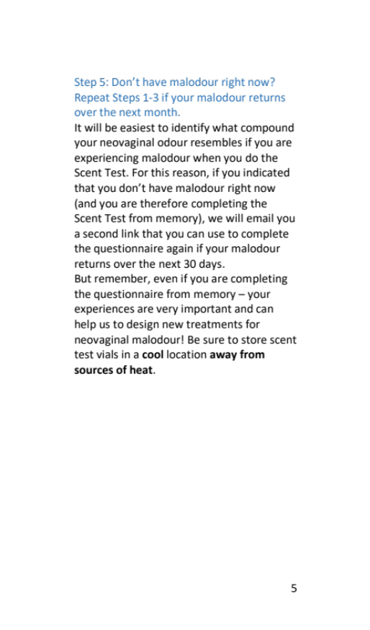
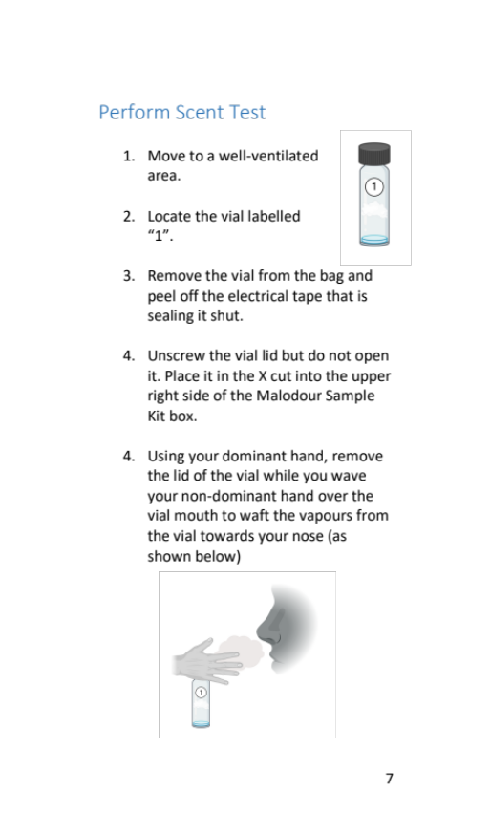
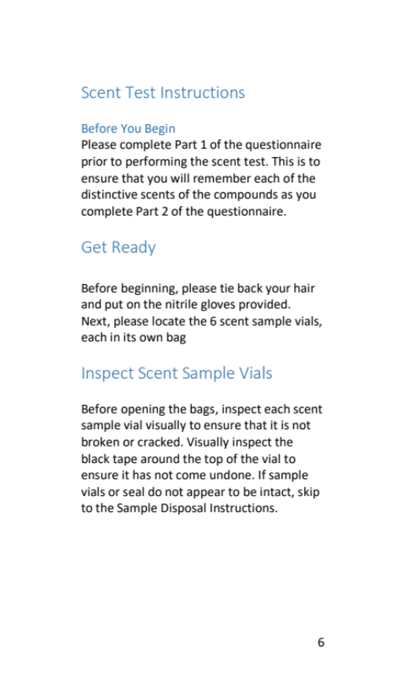
Scent Test Instruction Booklet
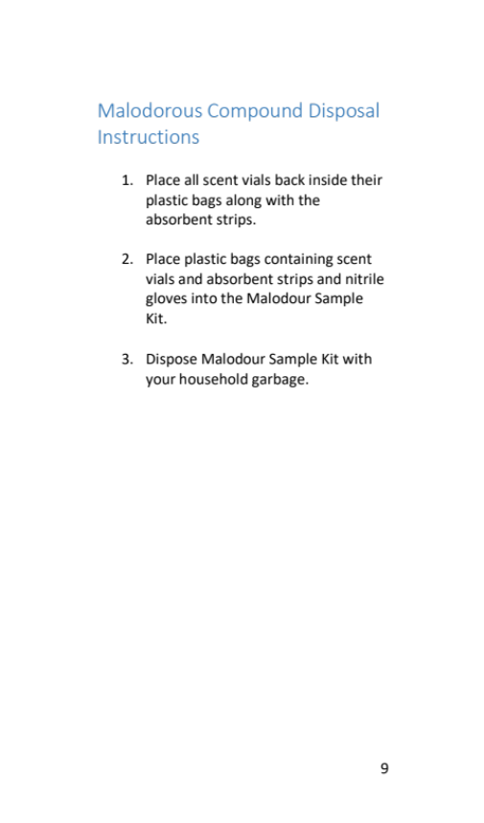
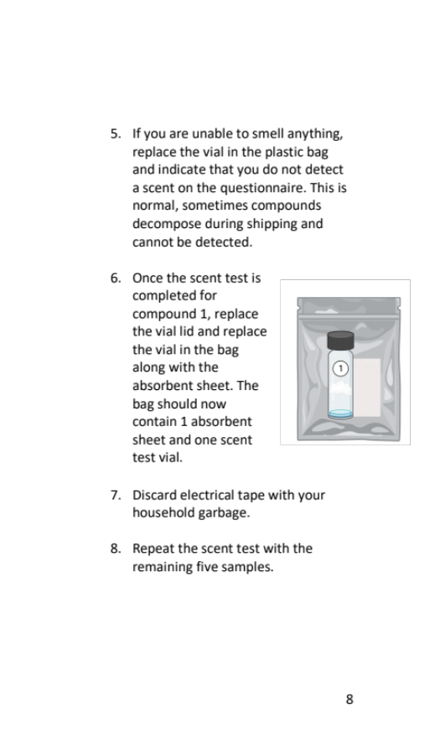

Additional File 2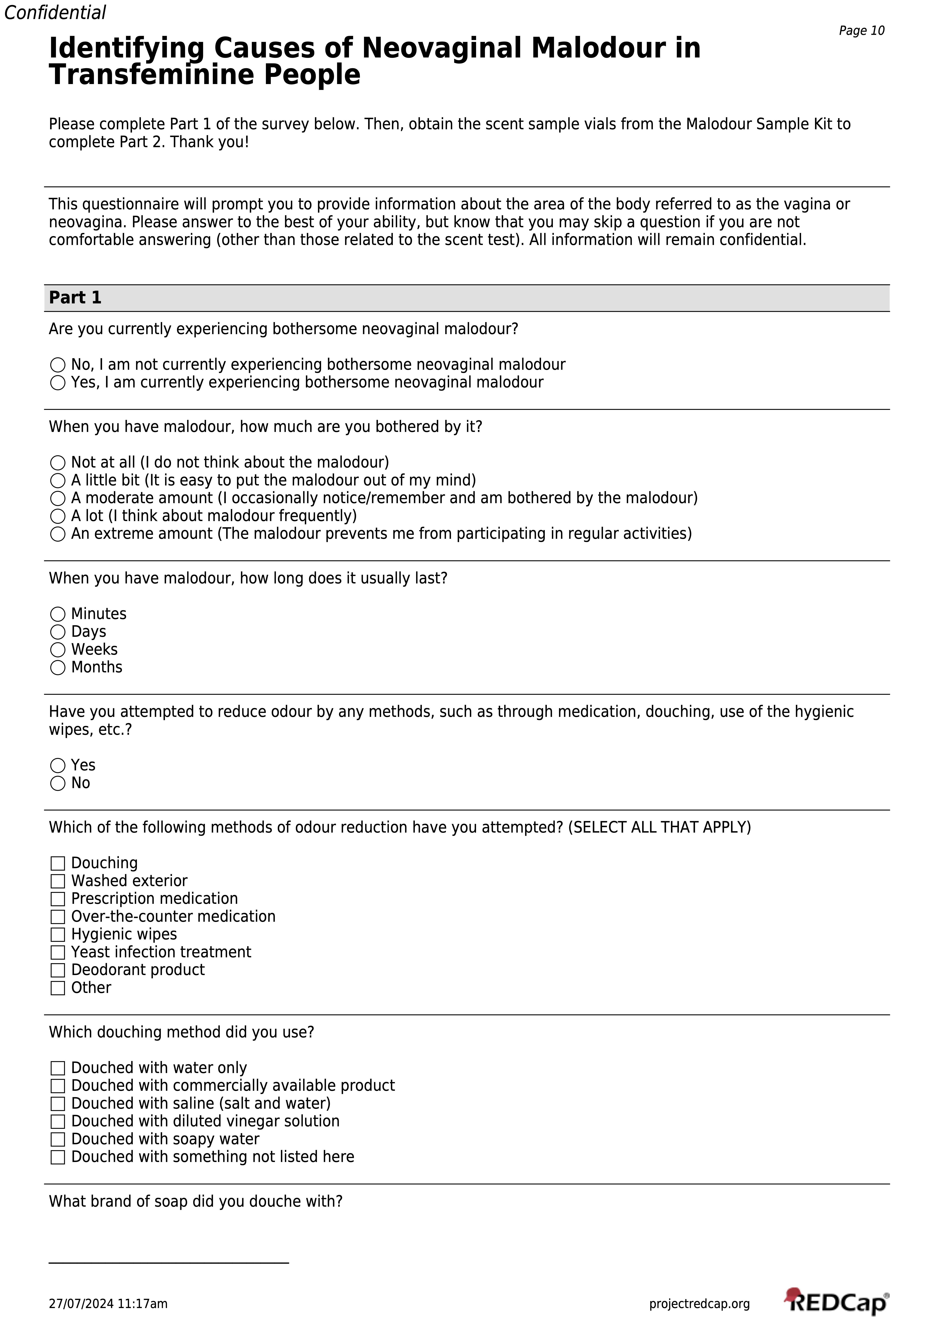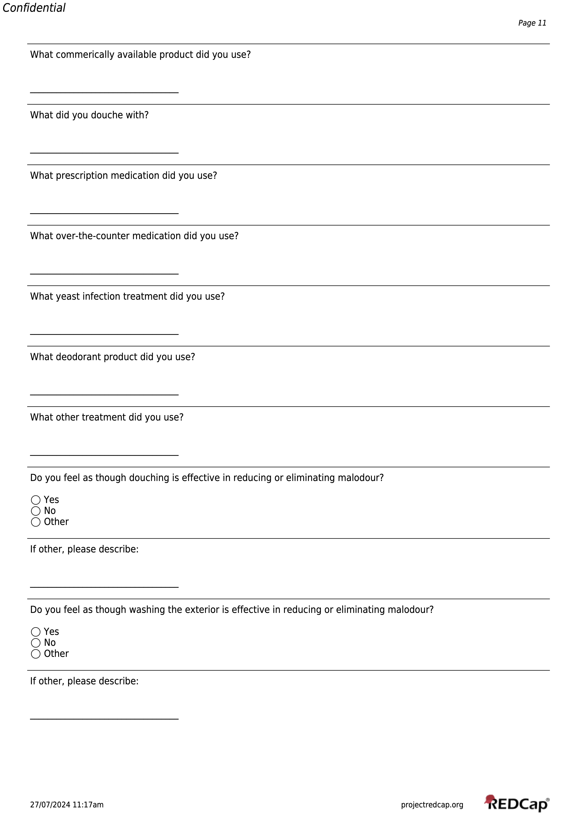
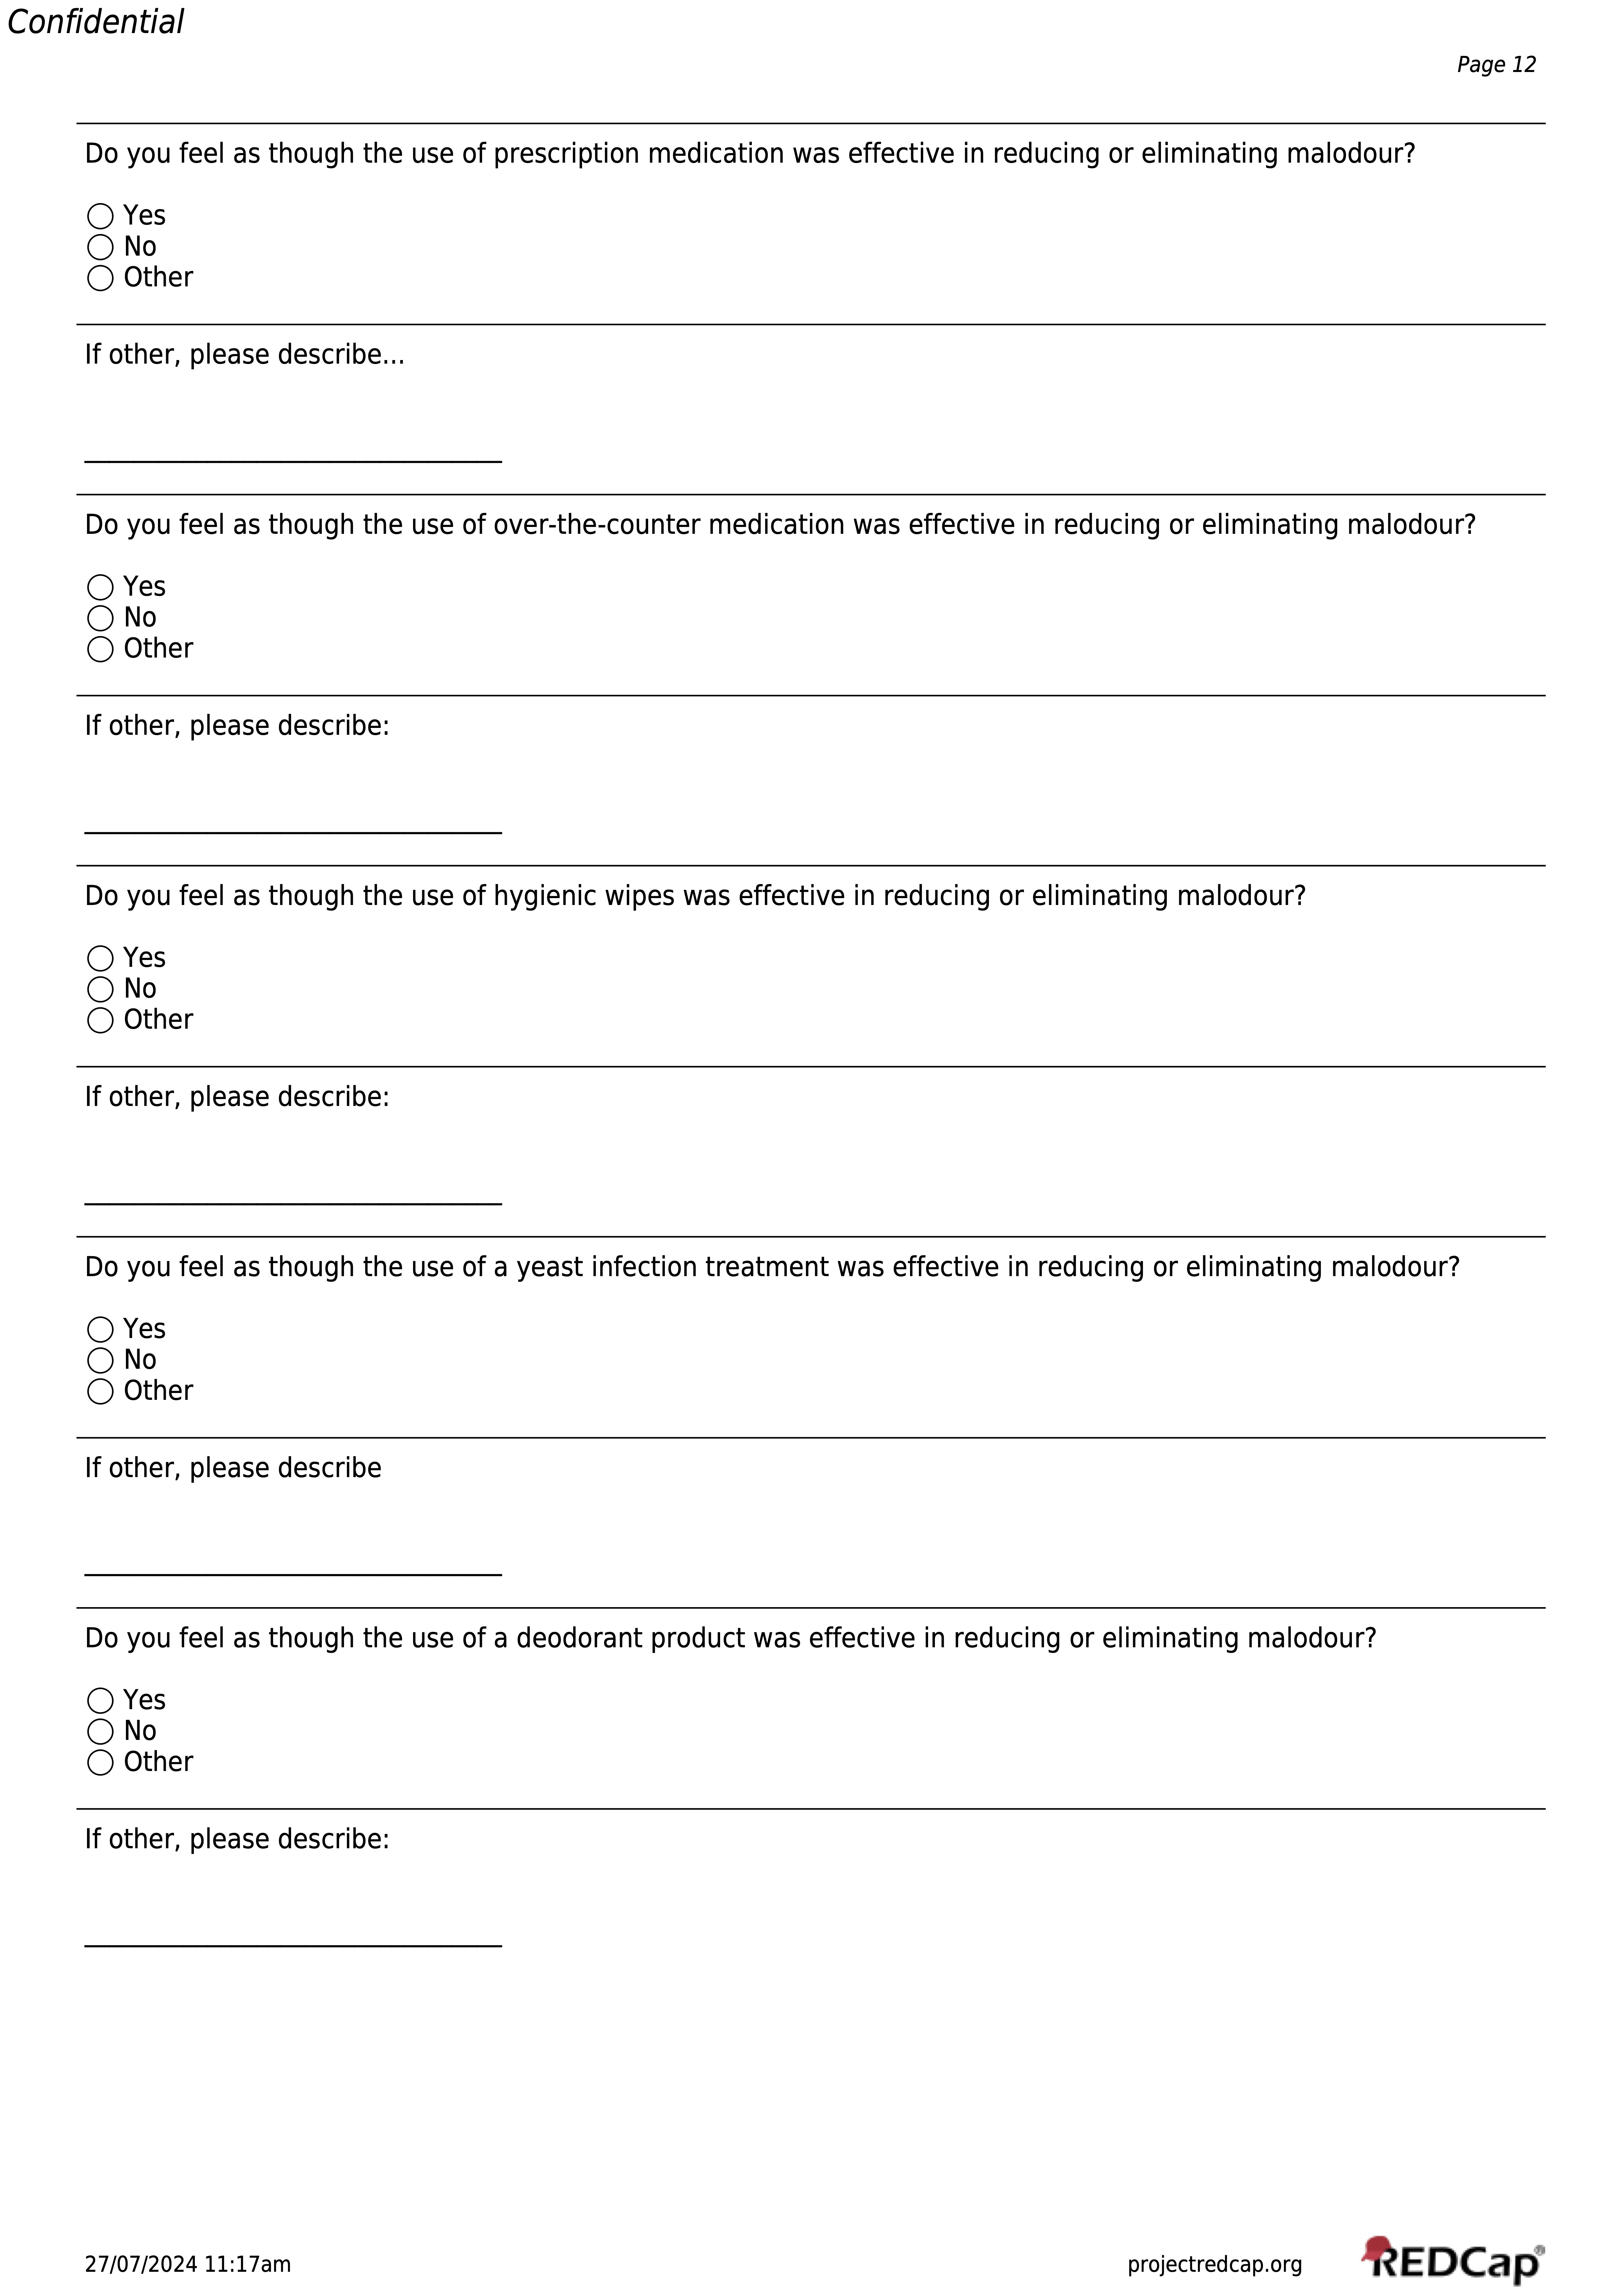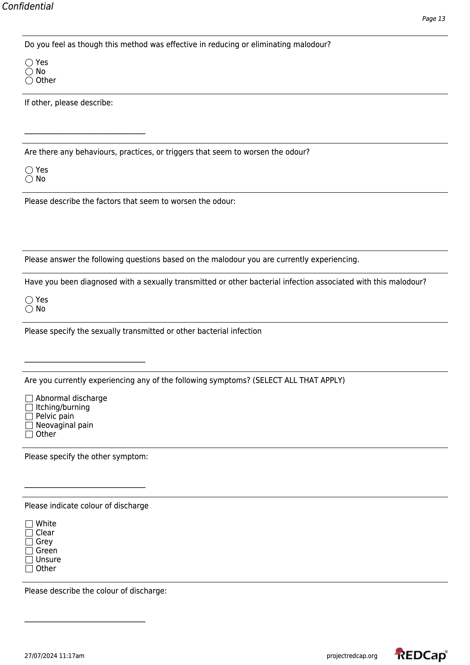
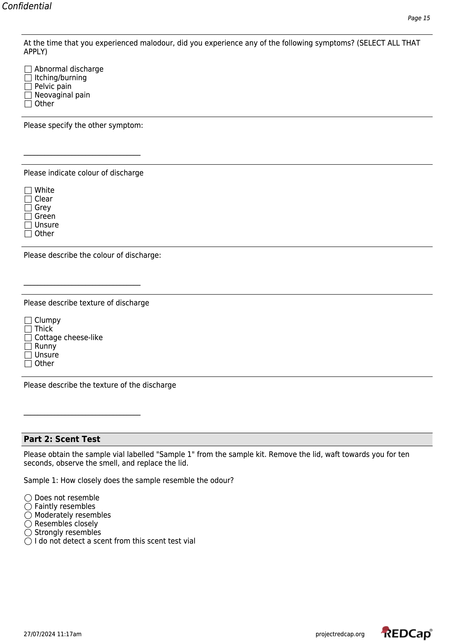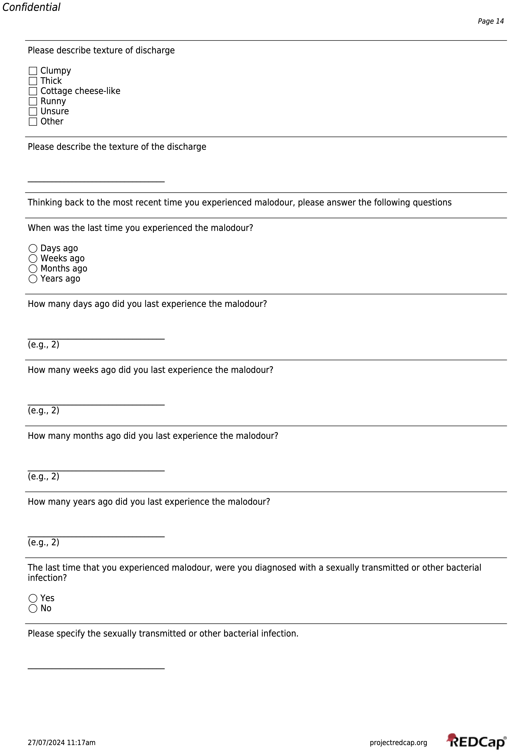

Additional File 3

Additional File 3. Thematic analysis code tree
Code | Definition
Successful management | Describes successful management of neovaginal malodor through medication use or hygiene practices
Unsuccessful management | Describes unsuccessful management of neovaginal malodor through medication use or hygiene practices
Intermittence | Management strategies are described as being effective sometimes and not other times, no direct mention of temporary resolution and recurrence
Recurrence | Describes temporary management of neovaginal malodor that results in reoccurrence of malodor
Persistence | Odor is described as persisting for long periods of time despite attempted management strategies
Odor diversity | Multiple malodor typologies are described
Exacerbating factors | Assigned to participant comments on exposures or behaviours that increase malodor
Symptoms | Assigned to participant comments on symptoms including neovaginal pain, itching, and burning as co-occurring alongside malodor
Unpleasant odor | Odor is described as unpleasant
Non-bothersome odor | Odor is described as inoffensive and/or normal
Delayed onset | Odor results from a specific, identified source after a delayed period

Additional File 4

Additional File 4. Descriptions and symptom reports on neovaginal malodor experienced by TF by code
Code | Number of comments (n = 64), n (%)ª | People that commented (n=16), n (%)^{b}
Successful management | 8 (12.6%) | 4 (25.0%)
Unsuccessful management | 2 (3.1%) | 2 (12.5%)
Intermittence | 2 (3.1%) | 1 (6.3%)
Recurrence | 3 (4.7%) | 3 (18.9%)
Persistence | 4 (6.3%) | 3 (18.9%)
Odor diversity | 4 (6.3%) | 3 (18.9%)
Exacerbating factors | 22 (34.4%) | 13 (81.2%)
Symptoms | 3 (4.7%) | 2 (12.5%)
Unpleasant odor | 5 (7.8%) | 3 (18.9)
Nonbothersome odor | 8 (12.5%) | 5 (31.0%)
Delayed onset | 3 (4.7%) | 2 (12.5%)
ª A comment is defined as a specific written remark describing a transfeminine participant’s neovaginal malodor and/or related exacerbating factors and management practices.
^{b} Transfeminine participants who provided comments that fell under multiple subcodes were counted once per code.

