Supplemental Material

Microbial impacts on post-fire tundra ecosystem recovery over the 21st century

Nicholas J. Bouskill^{1*}, Zelalem Mekonnen¹, Qing Zhu^{1,2}, Robert Grant³, William J Riley¹
¹Climate and Ecosystem Sciences Division, Lawrence Berkeley National Laboratory, Berkeley, CA, 94720.
²Berkeley Institute of Data Science, University of California, Berkeley, CA, 94720.
³Department of Renewable Resources, University of Alberta, Edmonton, Canada

*Contact: (njbouskill@address.gov)

Supplemental Materials and Methods.

The interdependent physical, hydrological and biological processes governing the ecosystem response to warming are simulated by the mathematical model, Ecosys. Appendices describing the model equation have been published previously (Grant, 2015; Grant et al., 2017). In brief, Ecosys is an hourly time-step land model with multiple canopy and soil layers and fully coupled carbon, energy, water, and nutrient cycles solved at an hourly time step (Robert F Grant, 2001). Surface energy and water exchanges drive soil heat and water transfers to determine soil temperatures and water contents. These transfers drive soil freezing and thawing and, hence, active layer depth, through the general heat flux equation. Carbon uptake is controlled by plant water status calculated from convergence solutions that equilibrate total root water uptake with transpiration⁹. Atmospheric warming increases surface heat advection, soil heat transfers, and hence active layer depth. Finally, ecosys represents fully coupled plant-microbe-soil carbon and nutrient cycling driven by the energetics and kinetics of aerobic and anaerobic oxidation-reduction reactions, fully prognostic dynamics of permafrost and its effects on active layer hydrology driven by basic processes for transfer and transformation of energy and water, and acclimation of all biological processes to warming.

A recent application of ecosys at a tundra site in Utqiaġvik, Alaska, USA (71.3°N, 156.5°W) showed concordance between modeled and observed processes (Grant et al., 2019), including CO₂ (R² = 0.7-0.9) and CH₄ (R² ~ 0.9) fluxes, LAI (|bias| = 0.01-0.35 m² m⁻²), and plant biomass (|bias| = 0.08 – 19.6 gC m⁻²); landscape-scale latent (R² = 0.71 – 0.77), and sensible (R² = 0.78 – 0.88) heat fluxes; soil temperatures (R² = 0.92); active layer depth (RMSE = 2 – 5 cm), and soil moisture (RMSE = 0.05 – 0.09 m³ m⁻³). We also analyze 25 km resolution simulations across the North America (NA) tundra in which ecosys accurately reproduced observed inter-annual variability in LAI spatial patterns (R2 = 0.71), long-term mean annual GPP (R² = 0.78) (41), and active layer depth from 28 Circumpolar Active Layer Monitoring (CALM) sites (R²=0.63; RMSE = 10 cm) (Mekonnen et al., 2021).

Supplemental table 1: Parameterization values for microbial traits.

Functional group | Specific oxidation rate (h⁻¹)* | Metabolic substrate affinity constant  (K_{M}, g m⁻³) | Energy yields**  (KJ g C⁻¹) | Reaction stoichiometry  (g g⁻¹) | Biomass stoichiometry (C:N/ C:P)^{α}
Aerobic heterotrophic bacteria | 0.1¹ | 12¹,  12⁶ | 37.5¹,  8.5⁶ | 0.4¹²,  0.43¹³ | 4.5/ 71
Saprotrophic fungi | 0.1¹ | 12¹,  12⁶ | 37.5¹,  8.5⁶ | 0.5¹⁴ | 8.3/ 106
Denitrifier | 0.1¹ | 1.4¹⁰,  1.4³,  0.014¹¹ | 10^{3,10,11} | 0.5¹⁵,  0.7¹⁶,  0.85¹⁷,  0.85¹⁸,  0.429¹⁹ | 4.5/ 71
Ammonia oxidizer | 0.25² | 2x10⁻³ ⁴,  0.15⁷,  0.32⁹ | - | 0.3²⁰ | 4.5/ 71
Nitrite oxidizer | 0.25³ | 1.4³,  0.1⁷,  0.32⁹ | - | 0.1²¹ | 4.5/ 71
Aerobic diazotroph | 0.1¹ | 0.14⁸ | 37.5¹,  8.5⁶ | 0.5²²,  0.2²³ | 4.5/ 71
Anaerobic diazotroph | 0.1¹ | 0.14⁸ | 37.5¹,  8.5⁶ | 0.5²⁴,  0.02²⁵ | 4.5/ 71
Fermenting bacteria | 0.1¹ | 12¹,  12⁶ | 1.03 | 0.53²⁶, | 4.5/ 71
Methane oxidizer | 0.25⁴ | 1.2x10⁻⁴ ⁴,  0.32⁹ | - | 0.75²⁷ | 4.5/ 71
Acetoclastic methanogen | 0.1¹ | 0.01⁶ | 1.03⁶ | 0.97²⁸ | 4.5/ 71
Hydrogenotrophic methanogen | 0.1⁵ | 0.01⁵,  0.32⁹ | 0.22^{5,7} | 0.97²⁸ | 4.5/ 71
*For target compounds: ¹DOC (Proteins, carbohydrates, cellulose, lignin), ²NH₄⁺, ³NO₂⁻, ⁴CH₄, ⁵H₂, ⁶Acetate, ⁷CO₂, ⁸N₂, ⁹O₂,¹⁰NO₃⁻, ¹¹N₂O.
**Tied to organic matter decomposition. Parameter values derived from (Madigan et al., 2006)
Ratio: ¹²DOC oxidized: DOC allocated to biomass under aerobic conditions; ¹³Acetate oxidized: Acetate allocated to biomass; ¹⁴DOC oxidized: DOC allocated to biomass under aerobic conditions; ¹⁵DOC oxidized: DOC allocated to biomass under aerobic conditions; ¹⁶DOC oxidized: DOC allocated to biomass under anaerobic conditions; ¹⁷DOC oxidized: NO₃⁻ reduced; ¹⁸DOC oxidized: NO₂⁻ reduced; ¹⁹DOC oxidized: N₂O reduced; ²⁰CO₂ fixed: NH₄⁺ oxidized; ²¹CO₂ fixed: NO₂⁻ oxidized; ²²DOC oxidized: DOC allocated to biomass under aerobic conditions; ²³Calculated as the ratio between the energy yield from DOC oxidation coupled to O₂ reduction (37.5 KJ g C⁻¹) relative to the energy cost of N2-fixation (187.5 KJ g C⁻¹); ²⁴DOC oxidized: DOC allocated to biomass under anaerobic conditions; ²⁵Calculated as the ratio between the energy yield from DOC oxidation coupled to DOC reduction (4.4 KJ g C⁻¹) relative to the energy cost of N₂-fixation (187.5 KJ g C⁻¹); ²⁶Acetate oxidized: Acetate allocated to biomass; ²⁷CO₂ fixed: CH₄ oxidized. ²⁸Methanogenesis: Biomass gain.
Note: All microbes take up N/P at the same rates: NH₄⁺ max uptake: 5x10⁻³ g m⁻² h⁻¹; K_{M}: 0.4 g m⁻³; PO₄⁻ max uptake: 1x10⁻³ g m⁻² h⁻¹; K_{M}: 0.075 g m⁻³
^{α}(Mouginot et al., 2014)

Supplemental Figures

Figure S1: Trajectory of distinct microbial groups over the RCP8.5 scenario disaggregated by microbial group. Each subplot shows one microbial group over time and over different soil depth ranges. The colorbars to the right of each plot depict the absolute biomass carbon in gC m⁻². Note the hydrogenotrophic methanogens are not represented in this figure as they were outcompeted and failed to develop appreciable biomass.
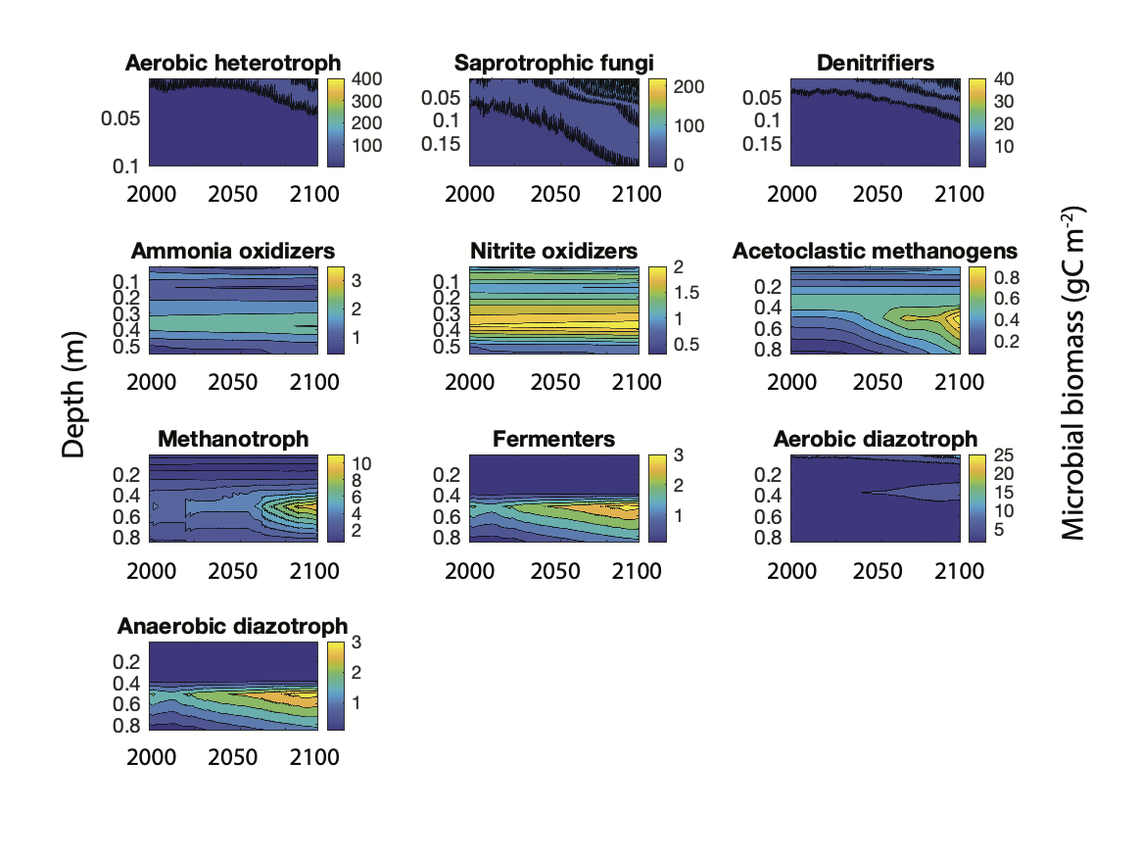

Figure S2: (a) Observed (Bret-Harte et al., 2013) and modeled NPP for the Anaktuvuk site (Note: annual measurements of bryophyte NPP were not made for this site). (b) Model comparison to measured active layer depths for unburned and burned sites at Anaktuvuk (Jandt et al., 2013).

(a)
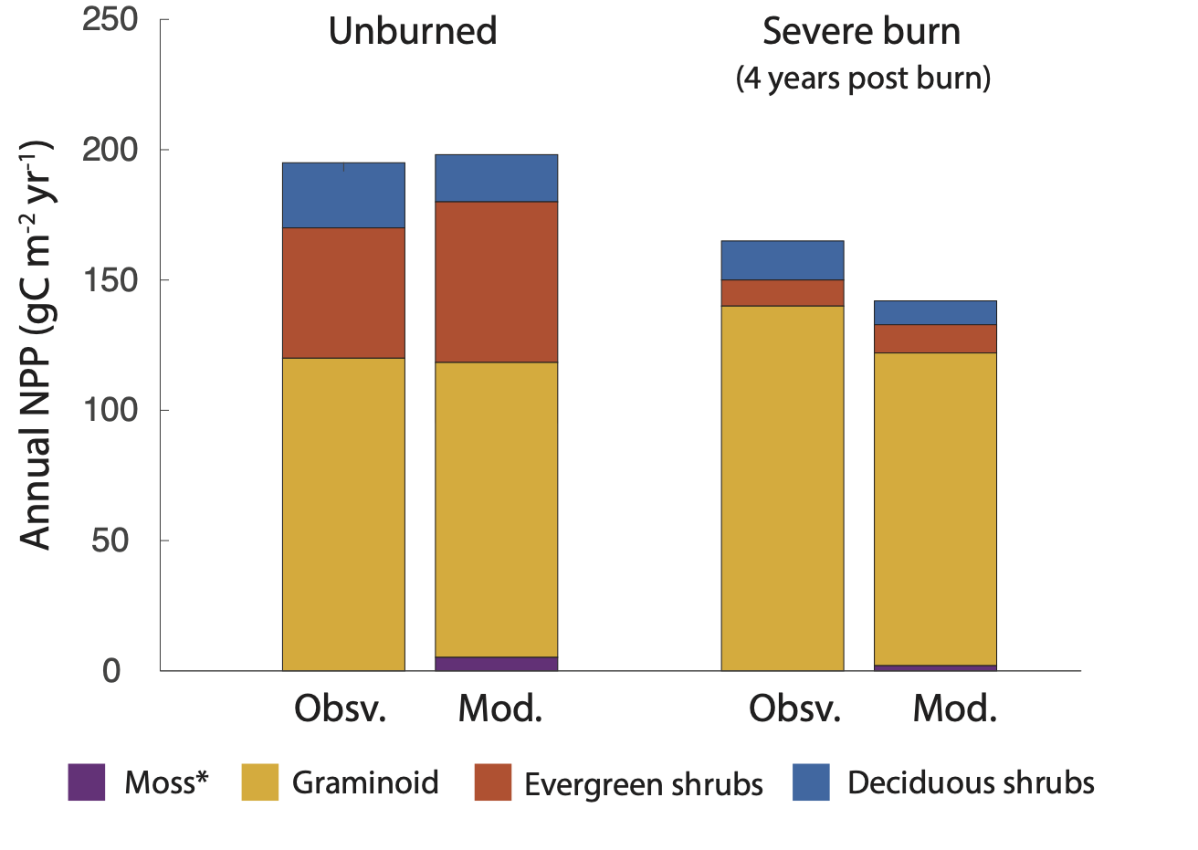
(b)
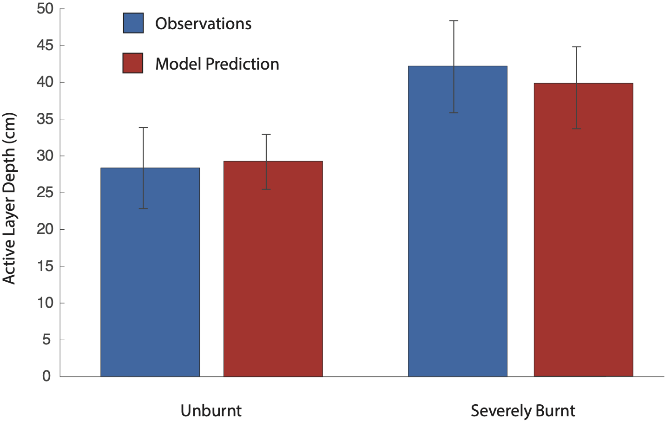

Figure S3: The most significant interacting factors determining ecosystem trajectory as calculated by a transfer entropy (TE) approach for the RCP8.5_no-fire scenario in two time frames ((a) 2007-2028 and (b) 2080-2100), for mild fires in the same time frames ((c) 2007-2028 and (d) 2080-2100), and severe fires in the same time frame ((e) 2007-2028 and (f) 2080-2100). Names of nodes within these panels represent the following variables: AH1/2: Aerobic heterotrophic microbial biomass at 0.1 and 0.5 m depth (g C m⁻²); ALD: Active layer depth within the soil (m); T_{a}: Air temperature (℃); MB1/2: Microbial Biomass at 0.1 and 0.5 m depth (g C m⁻²); NH₄: Soil NH₄⁺ (g N m⁻²); NPP (total): Community NPP (g C m⁻²); NO₃: Soil NO₃⁻ (g N m⁻²); N-up: Vegetation nitrogen uptake: P-up: Vegetation phosphorus uptake; SAP1/2: Saprotrophic fungal biomass at 0.1 and 0.5 m depth (g C m⁻²); SC: Soil carbon concentration (g C m⁻²); SM-1/2/3/4: Soil moisture at 0.1 m, 0.5 m, 0.7 m, and 1 m (m³ m⁻³); Snowpack: Depth of snowpack (m); ST-S: Soil temperature at the surface; ST-1 (℃): Soil temperature at 1 m (℃). The TE calculates directional information flow from one variable to another within the complex interactive network. The magnitude and significance of the directional information transfer reflects the non-linear cause-effect relationship. The approach is described in greater detail in the methods section of the main text.

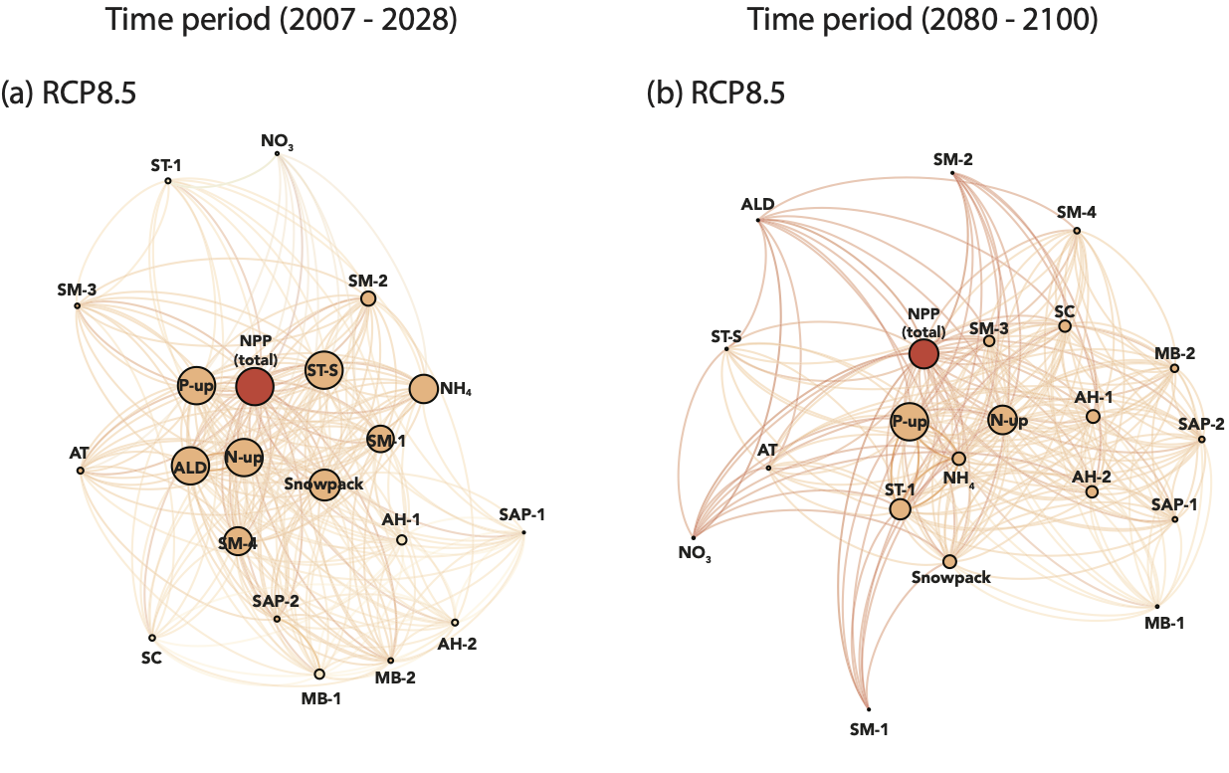
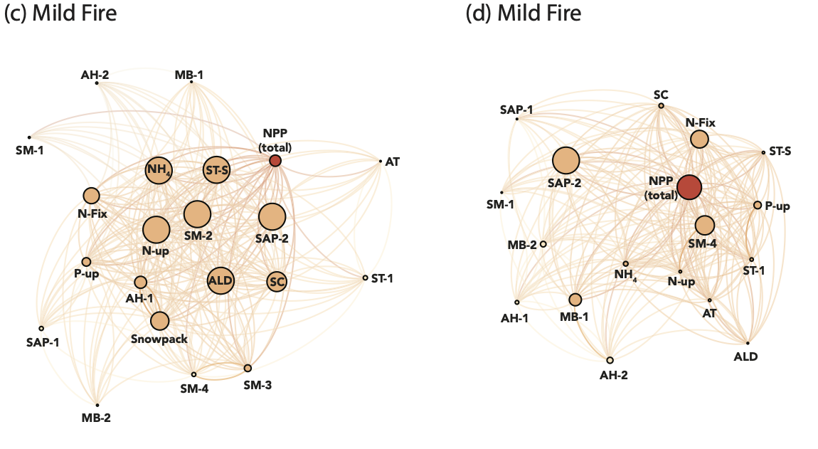
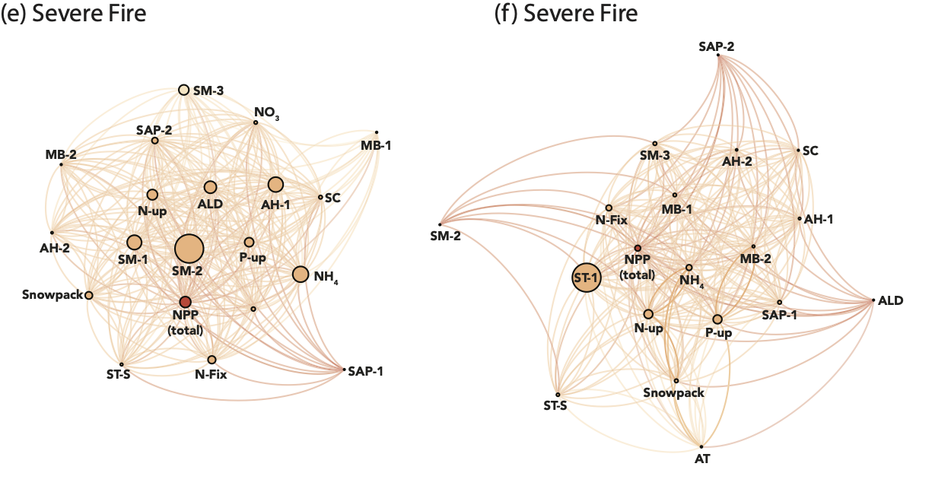

Figure S4: Panels a - d show the gross information production (GIP) values for the ten variables most important in shaping NPP in the 20 years after varying severity fires. The gross information production represents the overall contribution of one variable to the dynamics of the whole system.

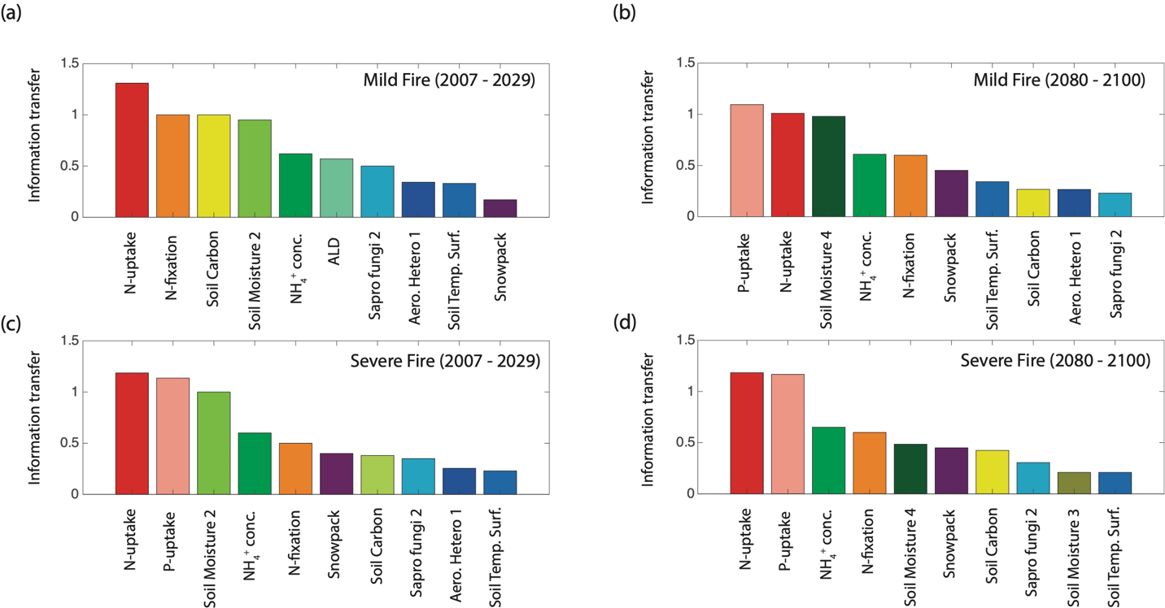

Figure S5: Differences in the trajectories of physical and hydrological properties post-wildfire compared to the baseline simulation (i.e., Scenario value – Baseline value). Illustrated here are the active layer depth (m), soil moisture (m³ m⁻³), and soil temperature (ºC) for the period 20 years post-wildfire. The panels represent (a) the early fire initiated in 2007, and (b) the late fire, initiated in 2080, for fires of different severity.

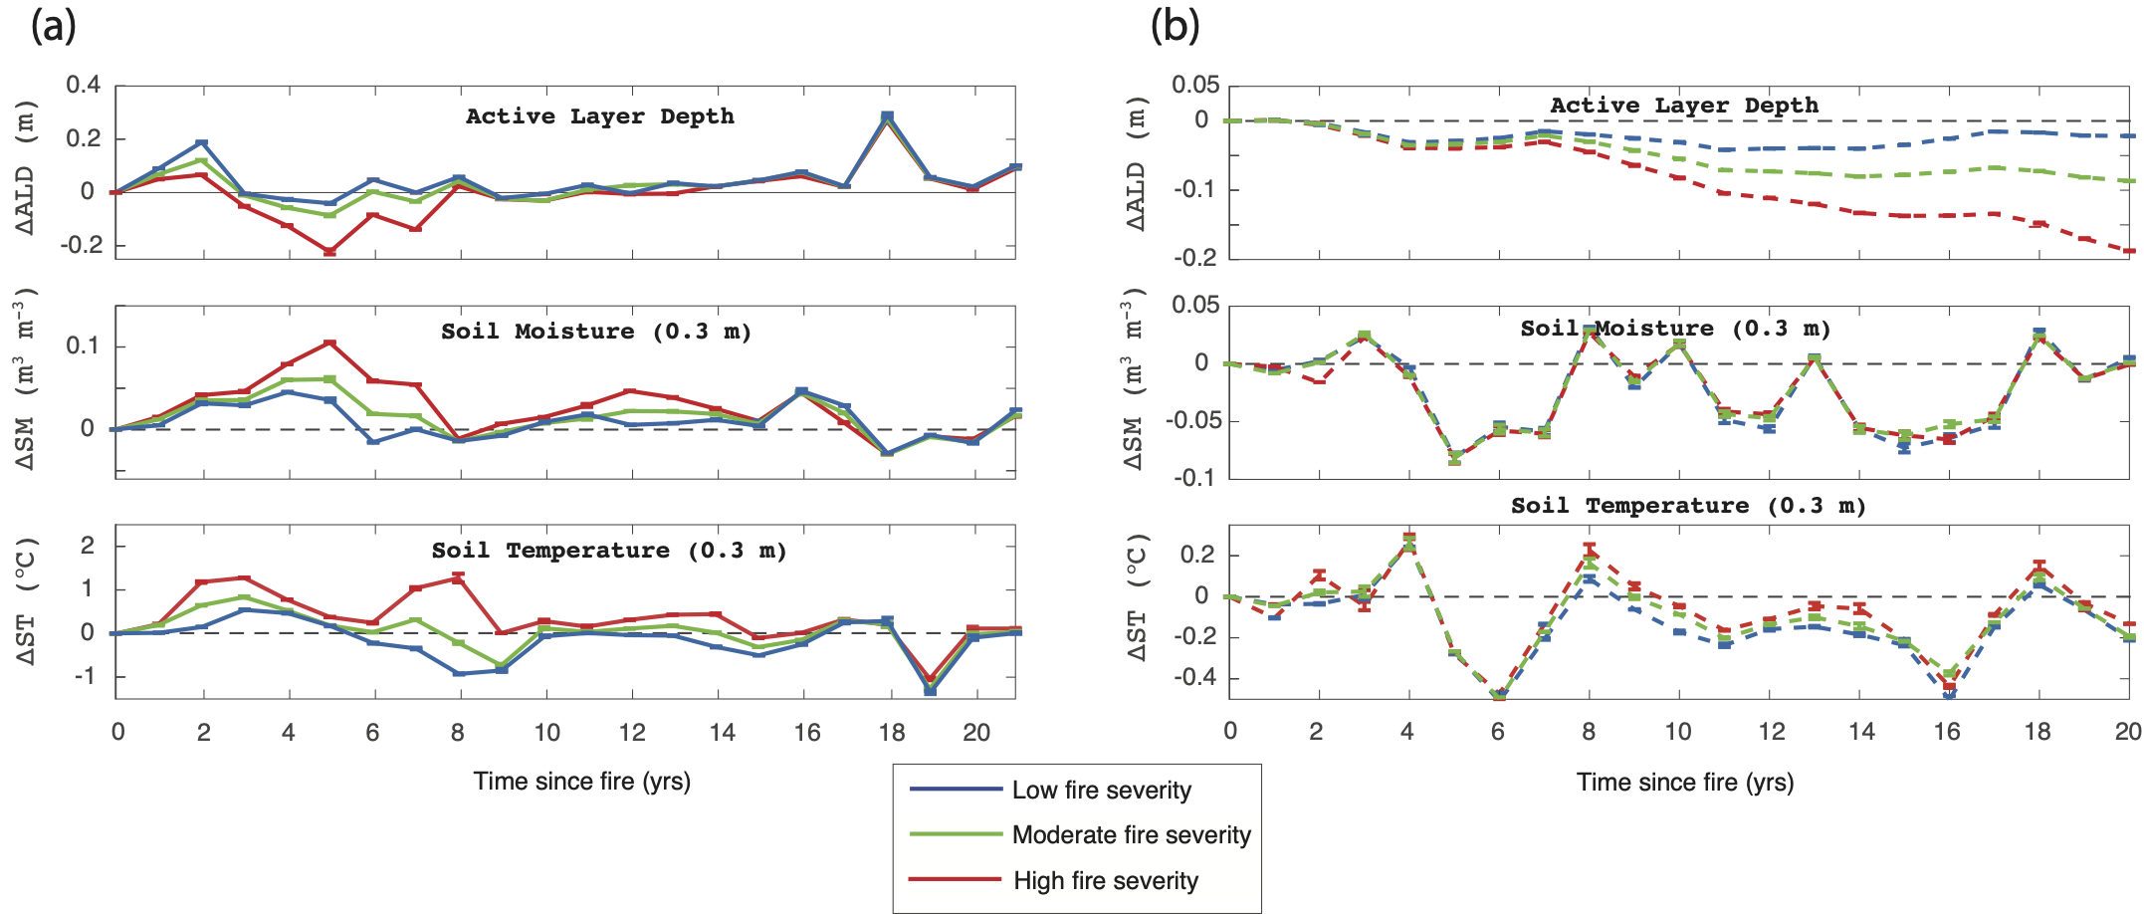

Figure S6: Total microbial biomass carbon: nitrogen ratio over time.

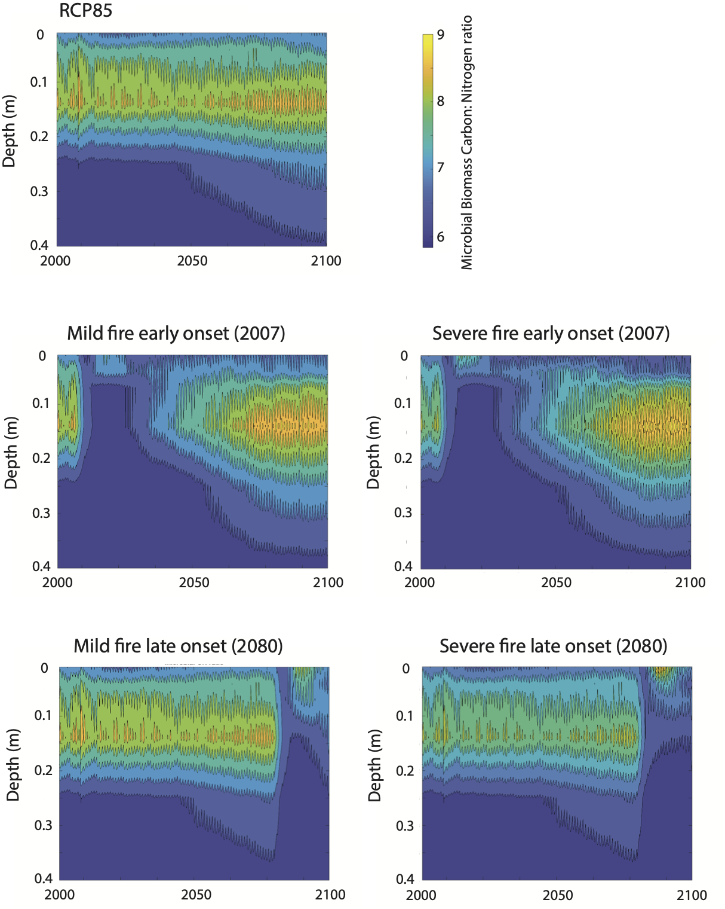
Figure S7: Organic and inorganic nitrogen responses to early and late fire. (a) soil ammonium (gN m⁻²) across the depth profile, (b) soil ammonium (gN m⁻²) from specific depths between the surface soil and 0.8 m, (c) inorganic and organic nitrogen fluxes, including gaseous loss as NH₃ volatilization, and horizontal (surface) runoff and lateral (subsurface) fluxes of both dissolved inorganic nitrogen (DIN: NH₄⁺ + NO₃⁻), and dissolved organic nitrogen (DON).

(a)

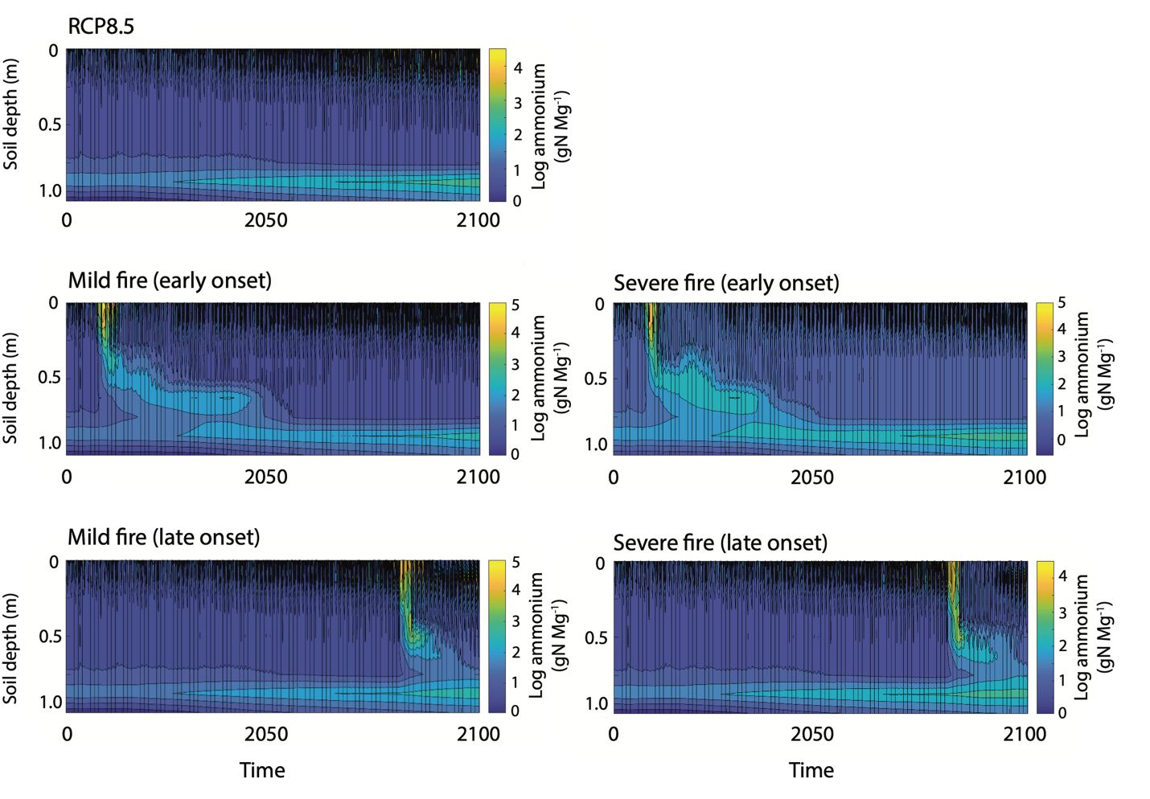

(b)

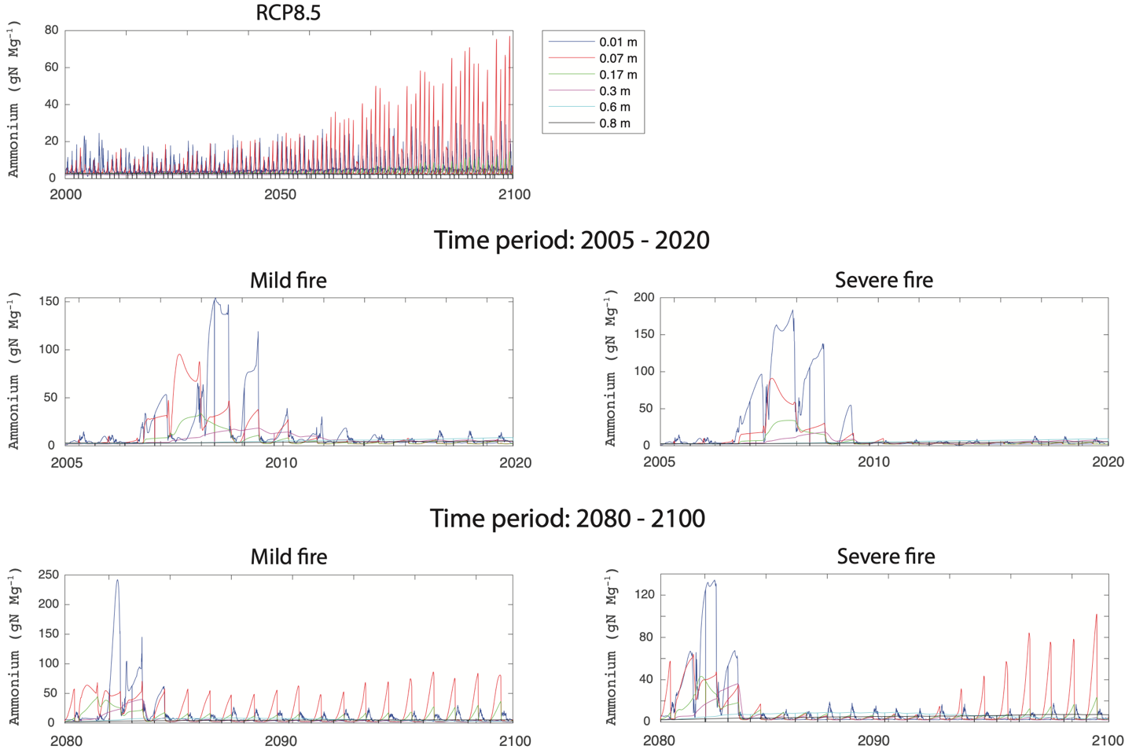

(c)

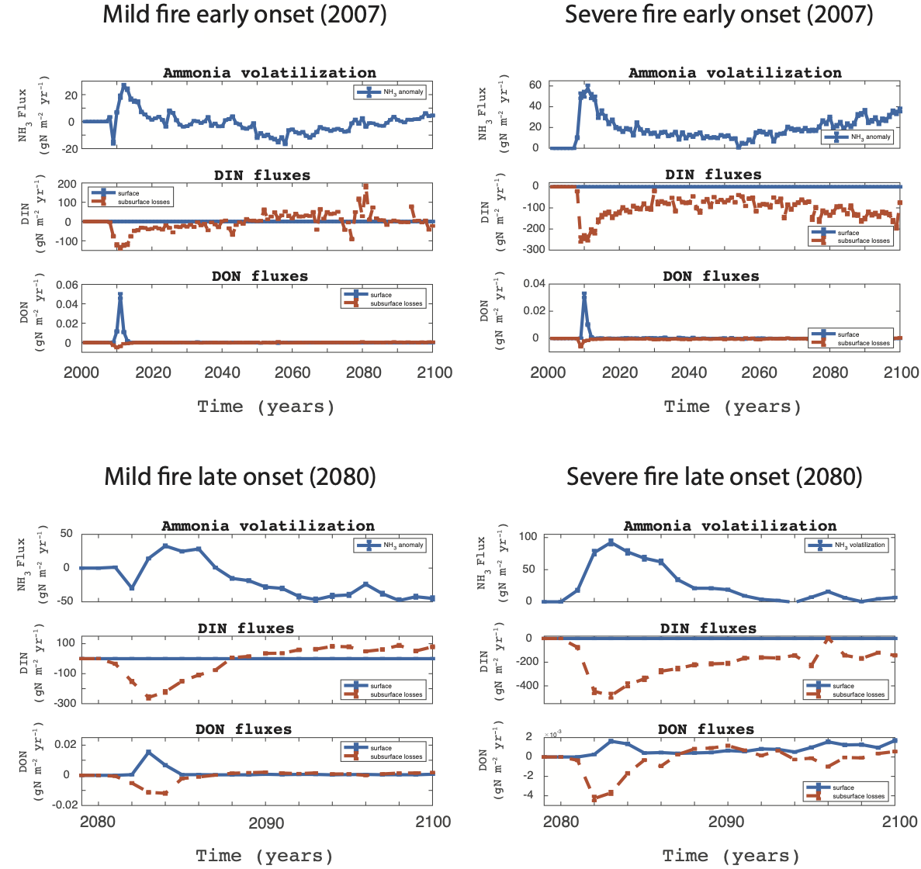

Figure S8: Organic and inorganic phosphorus responses to early and late fire. Panel (a) depicts the phosphate concentration (log gP m⁻²) down a soil depth gradient before and after the onset of fires of varying severities, (b) Soil phosphate concentrations (g m⁻²) at specific depths over time. Note, both the x- and y-axes vary by subplot, and (c) shows soil phosphate concentrations and horizontal and lateral fluxes of dissolved organic phosphorus (DOP).

(a)

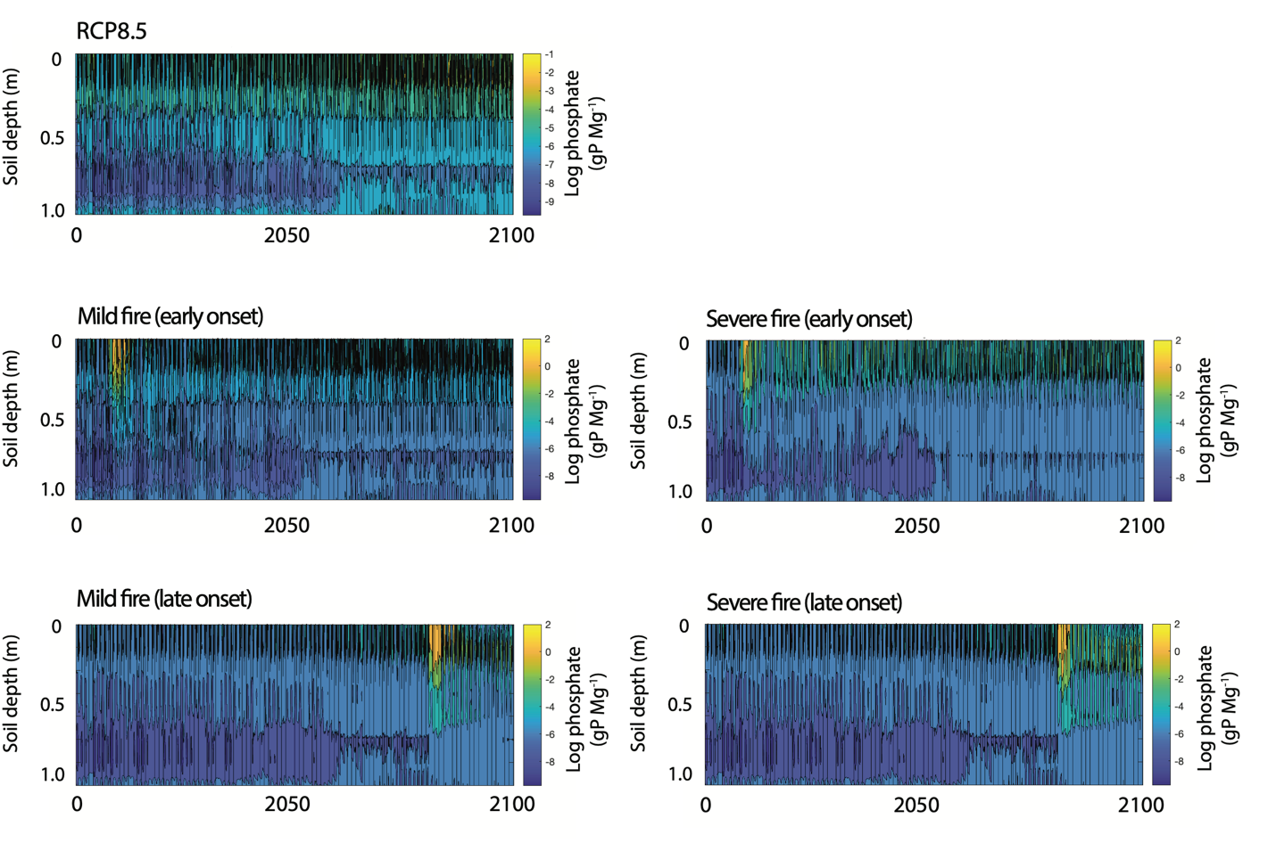

(b)

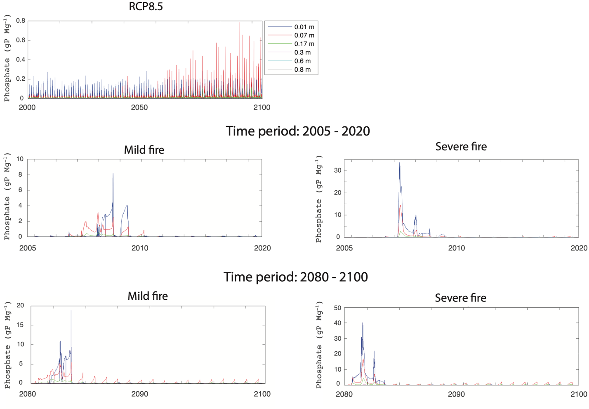

(c)

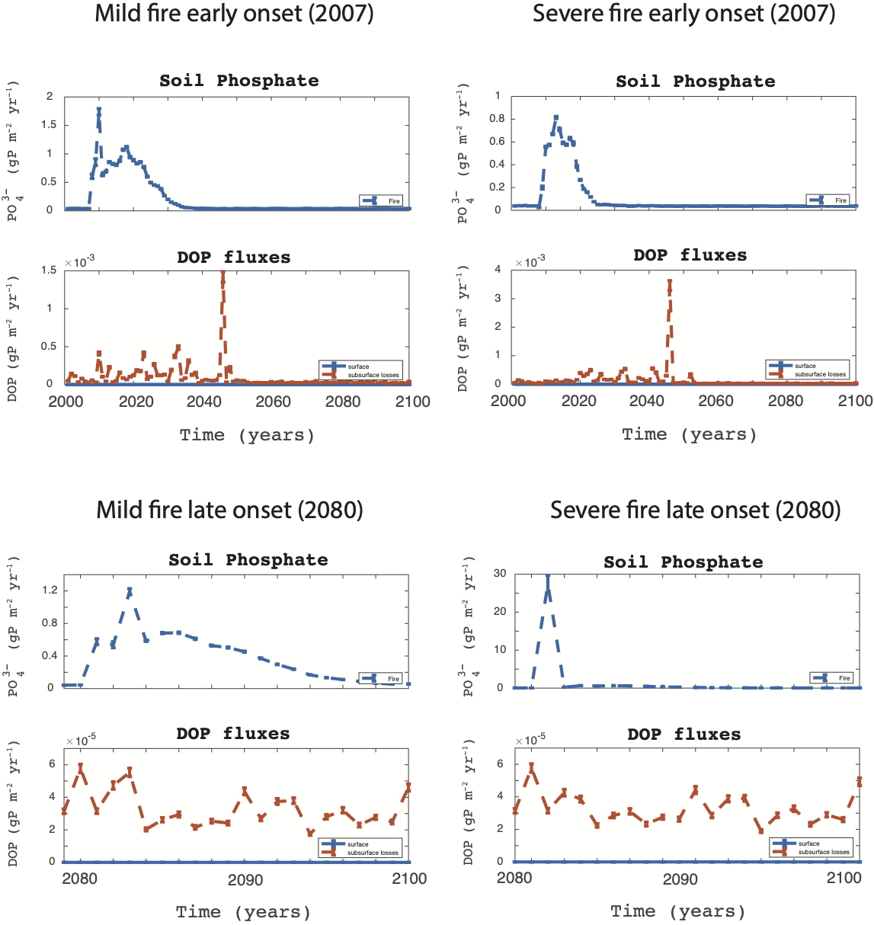

Figure S9: Nitrogen fixation rates (gN m⁻² yr⁻¹) pre-fire and the two decades following fire reported as differences from the RCP8.5-no_fire scenario. Positive differences in the dashed lines indicate higher fixation rates in the scenario that excluded fire during that period.

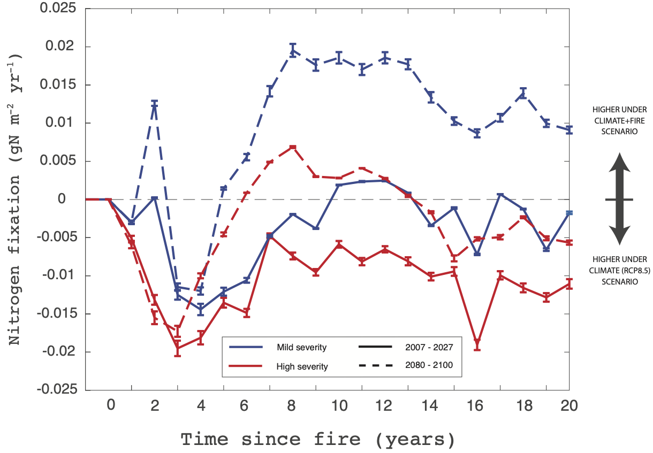

Figure S10: Plant assimilation of nitrogen and phosphorus post-fire. Each panel (a-d) shows the mild or severe fire ignited either early in the century or later.

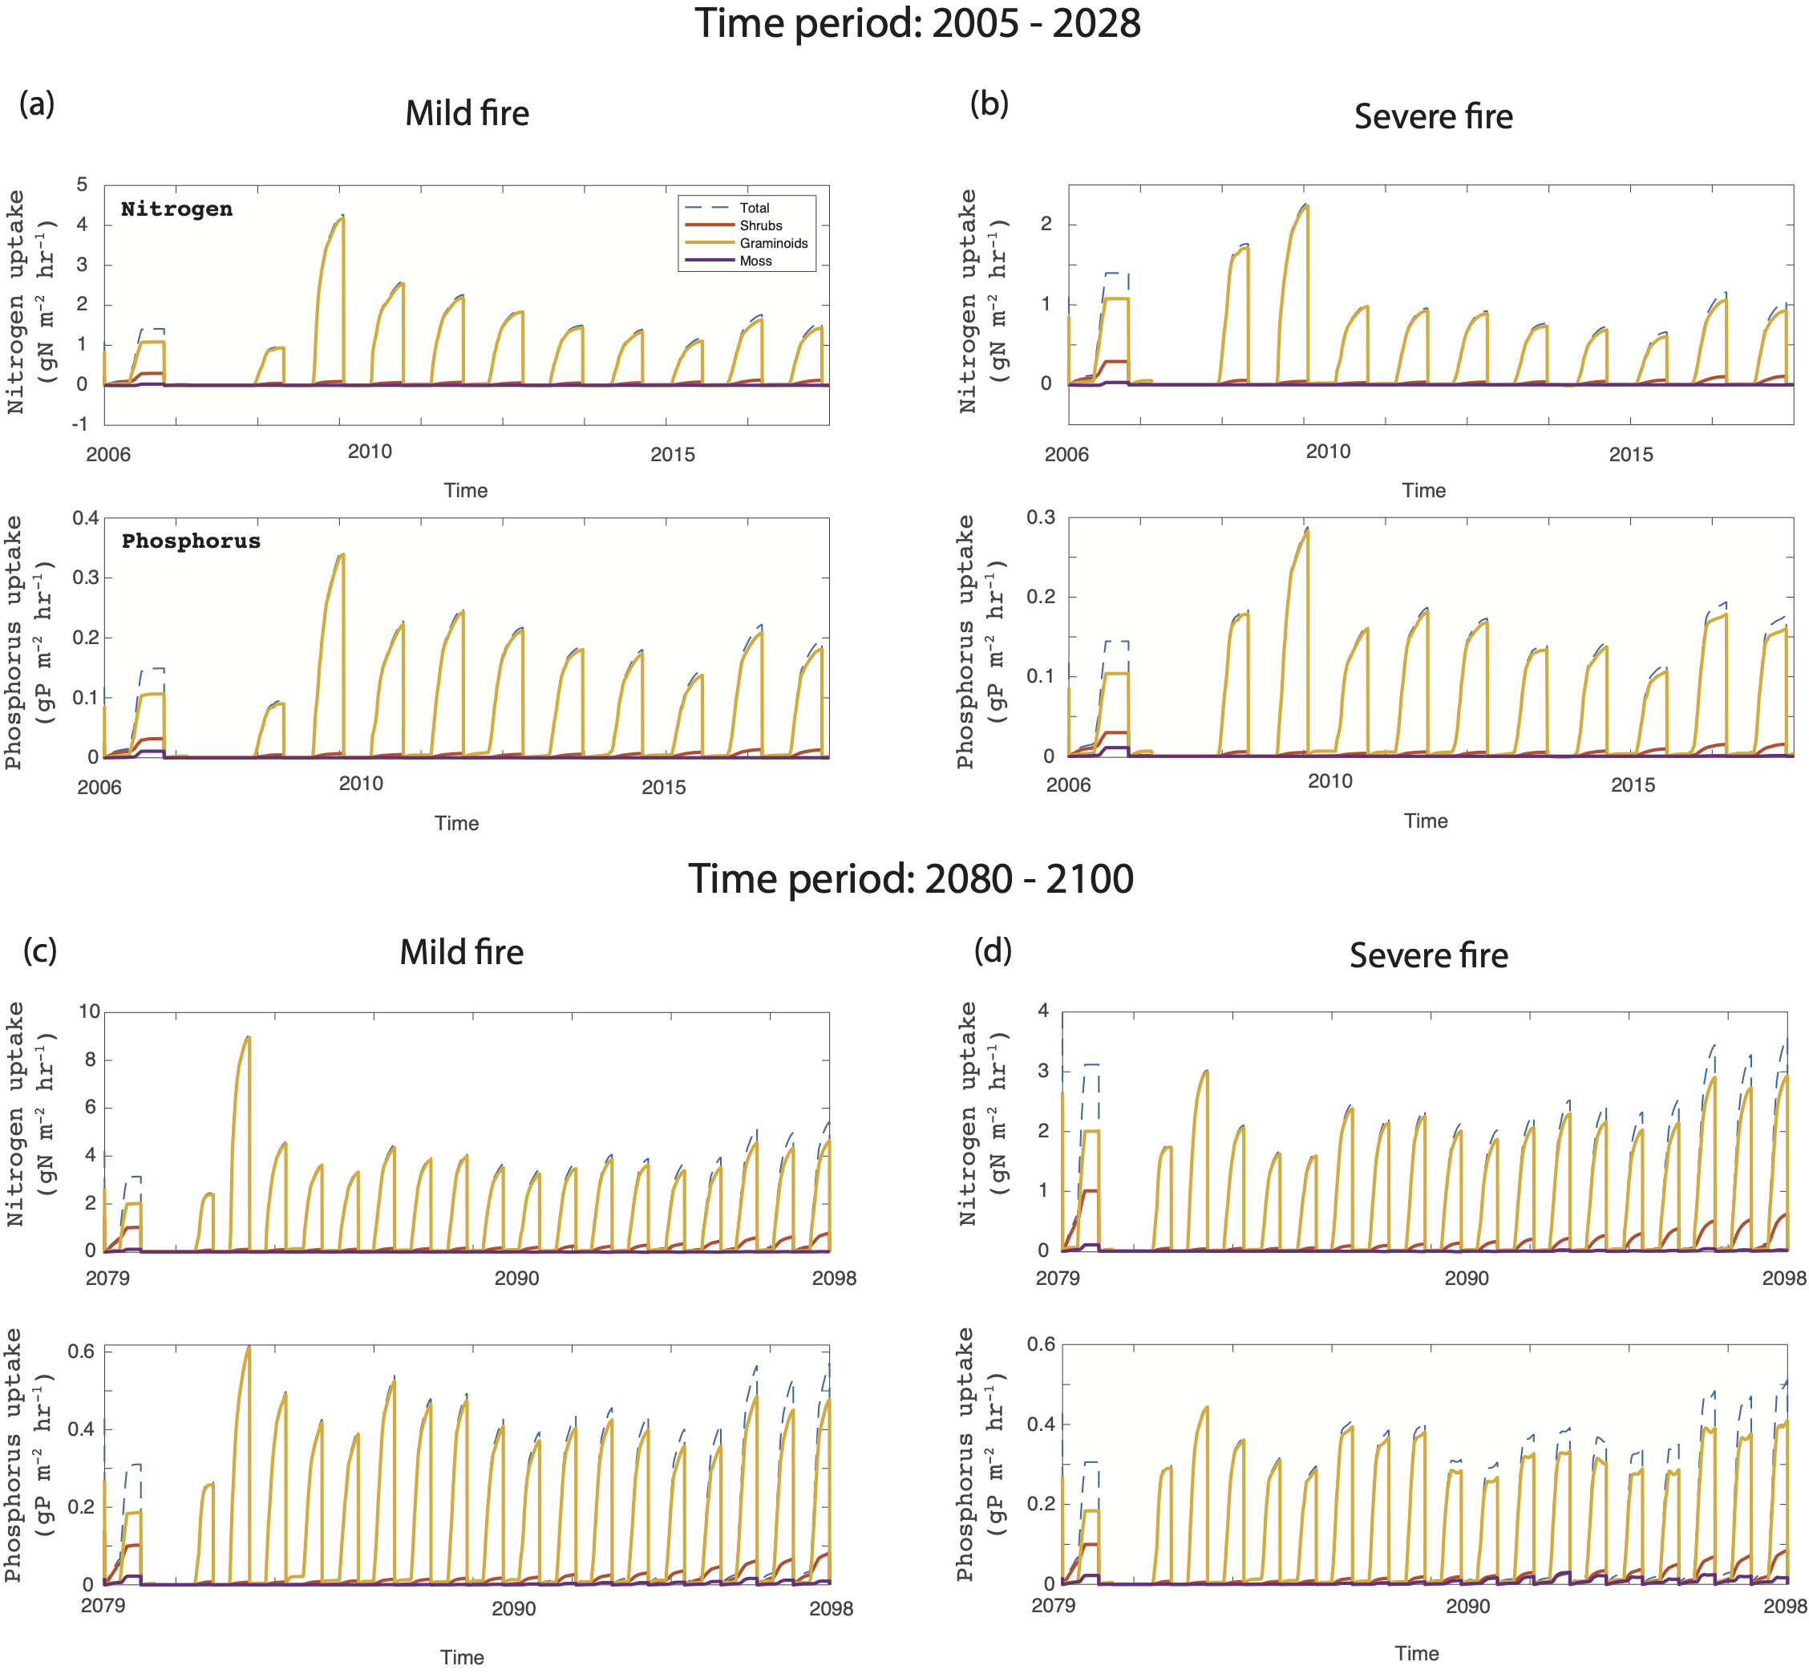

References
Bret-Harte, M. S., Mack, M. C., Shaver, G. R., Huebner, D. C., Johnston, M., Mojica, C. A., Pizano, C., & Reiskind, J. A. (2013). The response of Arctic vegetation and soils following an unusually severe tundra fire. Philosophical Transactions of the Royal Society B: Biological Sciences, 368(1624), 20120490. https://doi.org/10.1098/rstb.2012.0490
Grant, R. F. (2015). Ecosystem CO ₂ and CH ₄ exchange in a mixed tundra and a fen within a hydrologically diverse Arctic landscape: 2. Modeled impacts of climate change: CO ₂ and CH ₄ exchange in the arctic. Journal of Geophysical Research: Biogeosciences, 120(7), 1388–1406. https://doi.org/10.1002/2014JG002889
Grant, R F, Mekonnen, Z. A., & Riley, W. J. (2019). Modeling Climate Change Impacts on an Arctic Polygonal Tundra: 1. Rates of Permafrost Thaw Depend on Changes in Vegetation and Drainage. Journal of Geophysical Research, 124, 1308–1322.
Grant, R F, Mekonnen, Z. A., Riley, W. J., Arora, B., & Torn, M. S. (2019). Modeling Climate Change Impacts on an Arctic Polygonal Tundra: 2. Changes in CO2 and CH4 Exchange Depend on Rates of Permafrost Thaw as Affected by Changes in Vegetation and Drainage. Journal of Geophysical Research, 19.
Grant, R. F., Mekonnen, Z. A., Riley, W. J., Wainwright, H. M., Graham, D., & Torn, M. S. (2017). Mathematical Modelling of Arctic Polygonal Tundra with Ecosys: 1. Microtopography Determines How Active Layer Depths Respond to Changes in Temperature and Precipitation: Active Layer Depth in Polygonal Tundra. Journal of Geophysical Research: Biogeosciences, 122(12), 3161–3173. https://doi.org/10.1002/2017JG004035
Grant, Robert F. (2001). A Review of the Canadian Ecosystem Model—Ecosys. 91.
Jandt, R. R., Miller, E. A., Yokel, D. A., Bret-Harte, M. S., Kolden, C. A., & Mack, M. C. (2013). Findings of the Anaktuvuk River Fire Recovery Study, 2007-2011. https://www.sciencebase.gov/catalog/item/5a3946c7e4b0d05ee8b407a0
Madigan, M. T., Martinko, J. M., & Brock, T. D. (2006). Brock biology of microorganisms (6th ed.). Pearson Prentice Hall.
Mekonnen, Z. A., Riley, W. J., Grant, R. F., & Romanovsky, V. E. (2021). Changes in precipitation and air temperature contribute comparably to permafrost degradation in a warmer climate. Environmental Research Letters, 16(2), 024008. https://doi.org/10.1088/1748-9326/abc444
Mouginot, C., Kawamura, R., Matulich, K. L., Berlemont, R., Allison, S. D., Amend, A. S., & Martiny, A. C. (2014). Elemental stoichiometry of Fungi and Bacteria strains from grassland leaf litter. Soil Biology and Biochemistry, 76, 278–285. https://doi.org/10.1016/j.soilbio.2014.05.011

