Supporting Information

Quantification of Xanthates Chemisorbed on Solid Mining Wastes by Evolved Gas Analysis Hyphenation Techniques

Eric R. Dionne^{1,}*, Claude Marengo²

¹ Département de chimie, Montreal Area Platform for Electrochemical Systems (MAPLES), Université de Montréal, C.P. 6128, succursale Centre-ville, Montréal, QC H3C 3J7 CANADA
² Artelia Canada Inc., 7101 Park Avenue, bureau 100, Montréal, Québec, H3N 1X9, CANADA (claude.marengo@arteliagroup.com).

*Corresponding author (eric.r.dionne@umontreal.ca)

Table of Contents

S1. Description of the hyphenated system. 1
S2. Analytical strategies using the hyphenated TGA-IR-GC/MS system. 3
S3. Characterisation of a washed control sample aliquots. 6
S4. Corelation between the PAX concentration and the AX⁻ concentration in the calibration samples. 7
S5. Exemple of a field sample aliquot ready for analysis. 8
S6. TGA-MS profiles of PAX, PEX and DIX. 9
S7. Identification of the evolved products on PAX, PEX and DIX by TGA-GC/MS experiments. 10
S8. PAX recovery assays and detection limit calculation. 12
S9. Pentanol evolution monitoring. 13
S10. Pentene evolution monitoring. 15

- Description of the hyphenated system.

i) Thermogravimetric analyser (TGA): In this system, the TGA acts like a headspace module: The sample is decomposed thermally, and the volatilized species migrate through the transfer lines to reach an infrared spectrophotometer, a gas-phase chromatograph, and ultimately, a mass spectrometer. The purge gas choice and its flow rate have a great influence on how the sample will decompose.
ii) Infrared Spectrophotometer (IR): The infrared spectrophotometer is equipped with a heated “zero-gravity” (ZG) cell. The ZG cell design allows for transport of high molecular weight components through the cell by the main control module. The infrared spectrophotometer does not have to be activated each time the system is used.
iii) Gas Switching Valves (GSV): The injection of the thermally generated products into the gas chromatographer (GC) oven is carried out through the GSV. The GSV activation is triggered via a control through the TGA software interface.
iv) Gas chromatograph (GC) / Mass spectrometer (MS): The two instruments are controlled by the same software. Two modes are possible when the MS is involved: The TGA-(IR)-MS analysis and the TGA-(IR)-GC/MS analysis. The “(IR)” symbol implies that the IR is optional to the two modes.
(v) Transfer Lines Control Module (TL9000e): This hyphenated system works under dynamic control instead of a static one. Because the flow between the instruments composing this system can be tuned, reproducible experiments can be achieved and permits quantification of analytes. The TL9000e controls also the temperature applied on the transfer lines and at their junctions (i.e., TGA valve, IR cell and the GSV). This module also assured the application of the trigger signals sent by the TGA to the GSV valves.

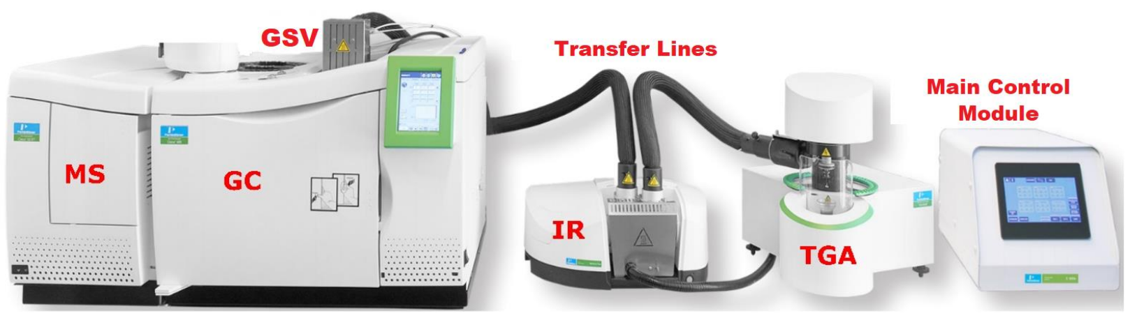

Fig. S1 Components of the hyphenated TGA-IR-GC/MS system used in this study.

- Analytical strategies using the hyphenated TGA-IR-GC/MS system.

i) TGA-MS Mode: The information that a TGA-MS analysis provides is two-fold: First the resulting profile will indicate how many decomposition events are occurring during the heating of the sample in the TGA furnace. Secondly, a total ion mass spectrum is obtained that can be used to quickly screen the main ions evolved. Figure S2 (A) shows an ideal thermogram that demonstrates a single decomposition event. The minimum of the derivative (figure S2 (B)) of the thermogram is used to visualize at which temperature the weight loss (i.e. production of gaseous material) is maximal. A continuous injection of the evolved material into the MS will provide an illustration of all the decomposition events occurring while the sample is heated. Ideally, the number of decomposition events should be equal to the number of bell-shaped curves visible on the MS profile. Figure S3 (B) shows such a TGA-MS profile. Because no chromatographic column is involved in a TGA-MS experiment, we can’t call it a chromatogram even though its acquisition is the same. To obtain the complete and well defined TGA-MS profile, as schematize by the figure S3 (B), the MS acquisition time must be long enough to empty the transfer lines to permits all the evolved gases to migrate to the MS.

If the MS and the TGA are activated simultaneously, the thus obtained profile depicts the time at which the evolved material arrives in the MS. The transfer lines pumping rate value should be set at 70% of the total of the TGA purge rates (sample compartment and balance). The migration time of the evolved gas between the TGA and the MS will therefore be influenced by those settings and the viscosity of the chosen purge gas. There is no relationship that considers those variables to determine when the evolved material shall arrive at the injection valves (GSV). This is problematic when one wants to inject on the chromatographic column (vide infra). The MS profile is therefore a valuable tool to determine when an injection should occur. The moment of injection on the column is arbitrary but it is normal to consider when the quantity of evolved material at the TGA is maximal. Therefore, one needs to inject at the time corresponding to a maximum on the MS profile (figure S3 (B)).

Fig. S2: (A) Idealized TGA thermogram implying a single decomposition event. (B) Mathematical derivative of the thermogram shown in (A). The asterisk locates the on the thermogram where the slope change occurs, i.e. where the concentration of compounds in the evolved gas, per unit temperature, is the highest.

Fig. S3: (A) Thermogram derivative (form figure S2) compared to the corresponding TGA-MS profile, with the MS signal plotted against the duration of the MS method (B). The apex of the TGA-MS profile in (B) represents the moment when the GSV must be activated to proceed with the injection onto the GC column (t_{injection}) of the most concentrated part of the thermally generated sample.

ii) TGA-GC/MS Mode: If the objective is to separate the components evolved at the TGA for chemical identification, one needs to inject onto the chromatographic column. The parameters (TGA method, purge and transfer lines settings) optimized during the TGA-MS analyzes are used without modification for the TGA-GC/MS characterisation of the sample. The sample weight in the TGA crucible should be also similar. In a TGA-GC/MS, the GC oven and the MS method must be programmed to assure the separation of the evolved gas components and assure an optimal recording of ions for chemical identification respectively. The resulting chromatogram gives the chemical information from a specific part of the TGA-MS profile, therefore the corresponding picture of the species evolved in the TGA at a specific temperature. As for the TGA-MS mode, the thermal method and the MS acquisition starts simultaneously. The injection time on the chromatographic column is set in the TGA controlling software. The GSV valves are activated through the trigger box linking the TGA to the TL9000e.

- Characterisation of a washed control sample aliquots.
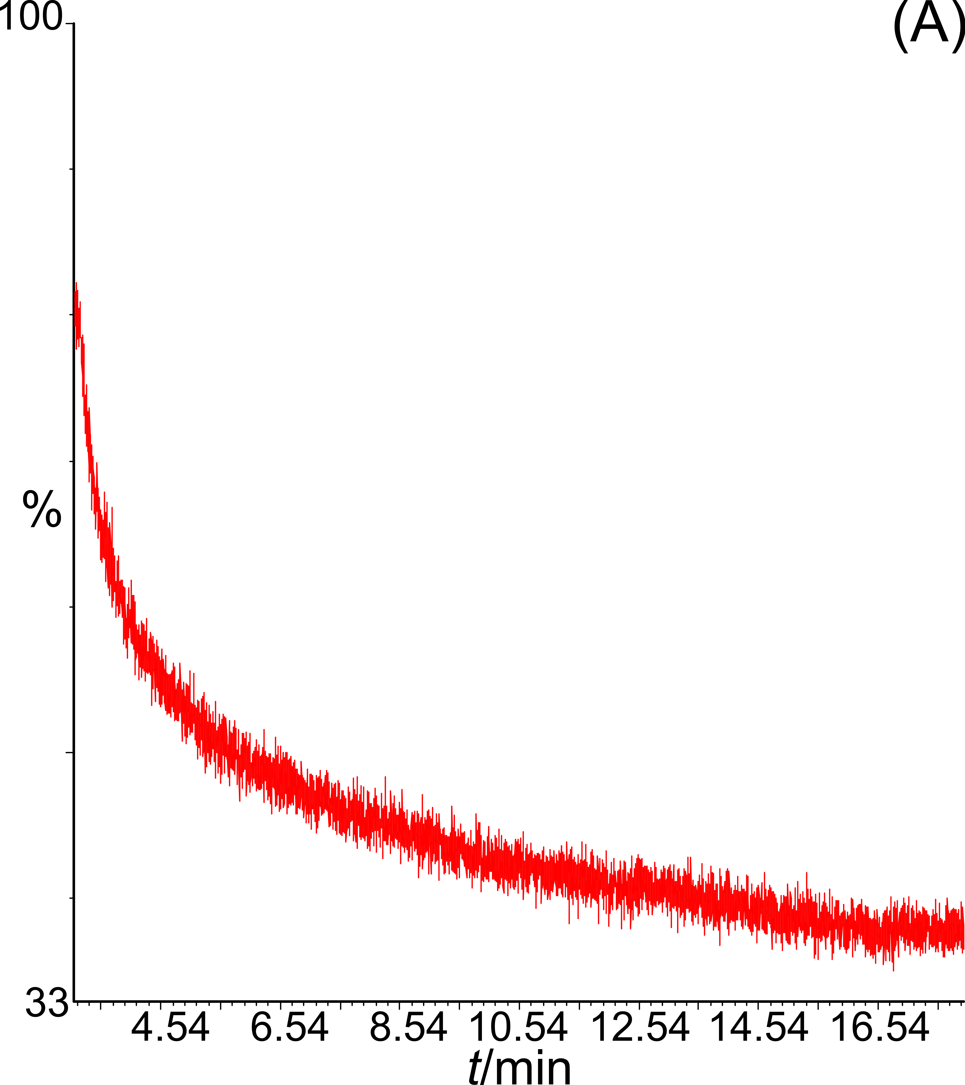
m/z = 76

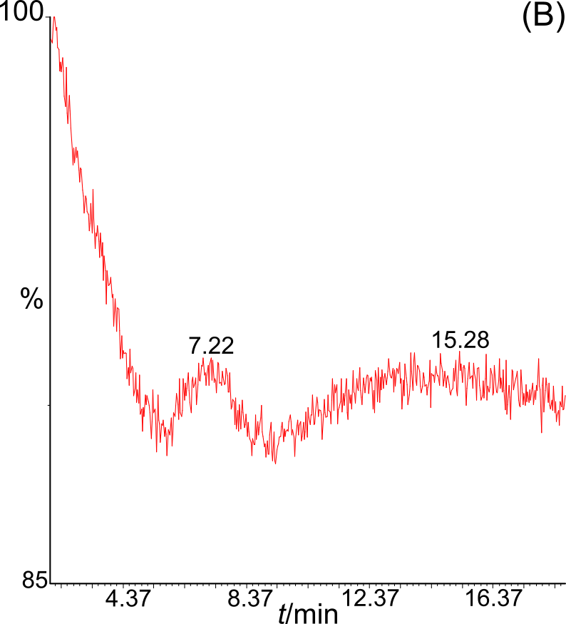
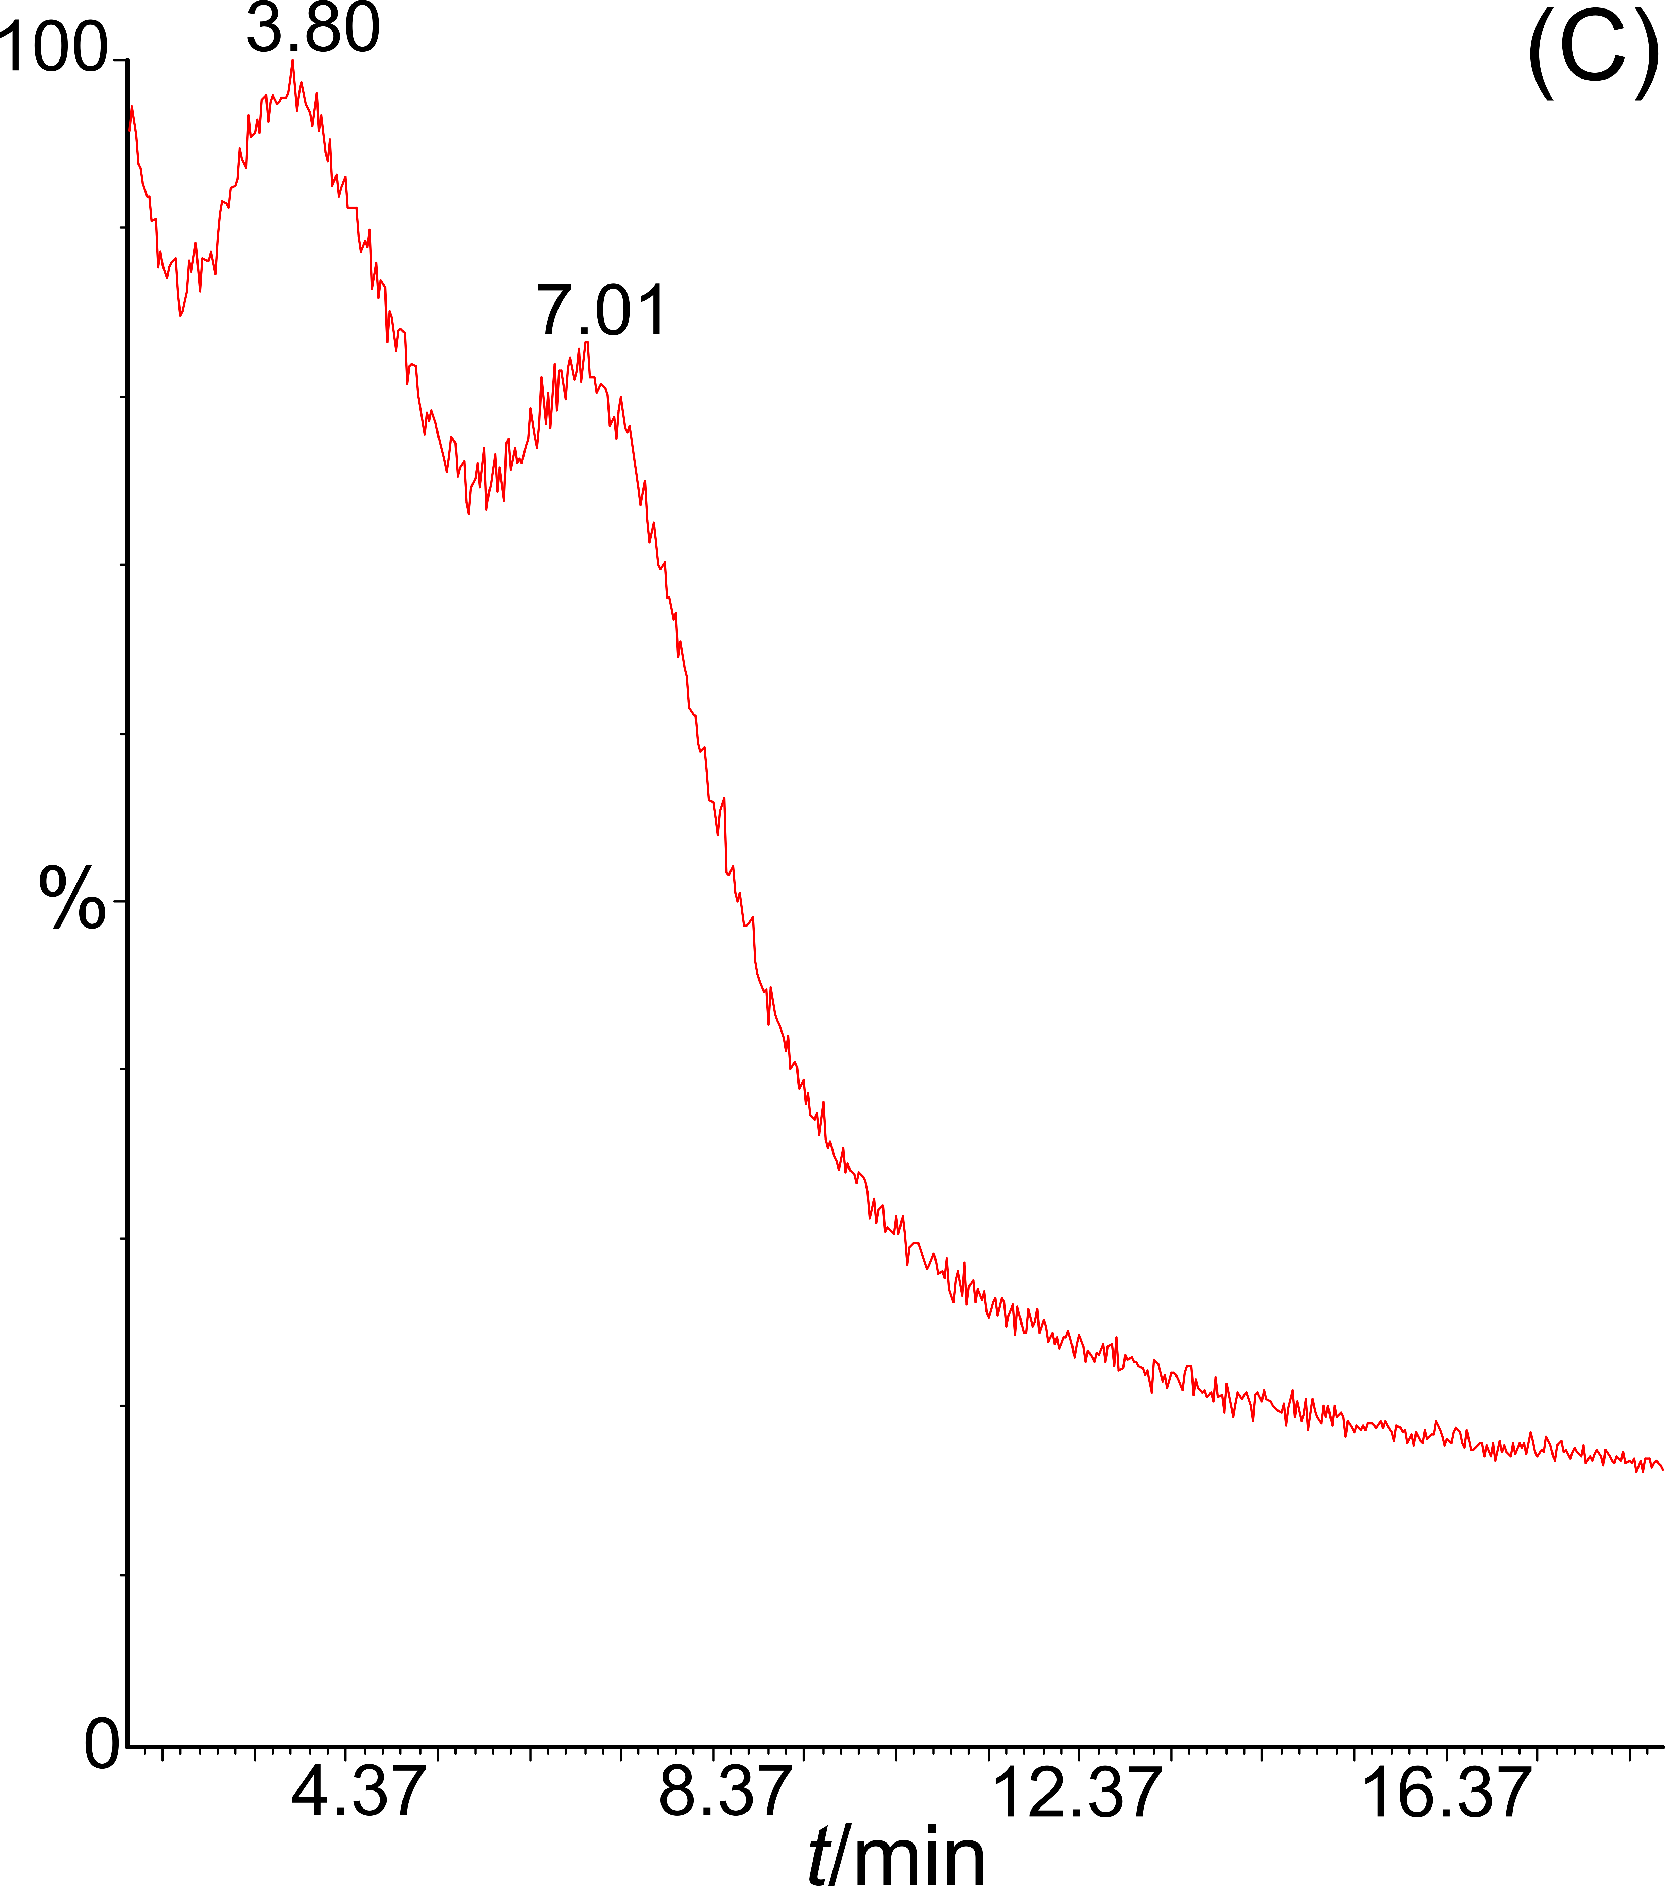
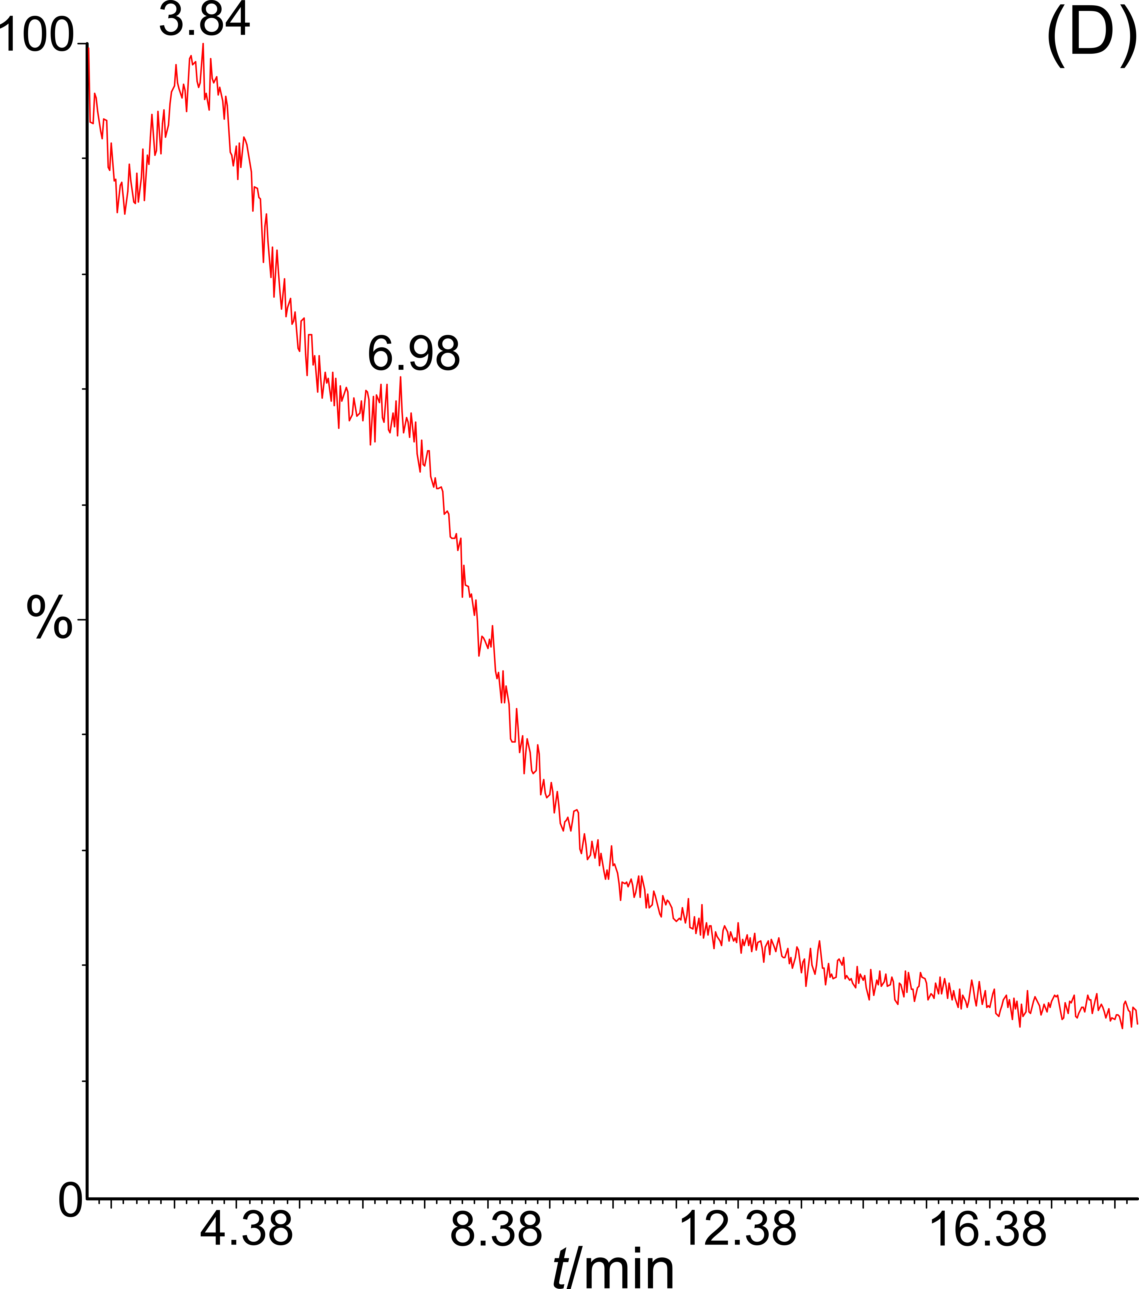
m/z = 42
m/z = 55
m/z = 70

Fig. S4: TGA-MS results on washed control sample aliquots before any AX⁻ spiking. (A) Profile acquired in MS-SIM, m/z = 76 with a TGA heating rate of 20 °C/min. TGA-MS profiles acquired in MS-SIM for ions (B) m/z = 42; (C) m/z = 55; (D) and m/z = 70. Profiles of figures (B) to (D) were acquired simultaneously in a single TGA run with a heating rate of 60 °C/min.

- Corelation Between the PAX Concentration and the AX⁻ Concentration in the Calibration Samples.

Table S1: Calibration samples prepared from an addition of 500 μL of PAX mother solution to a 2.00 g control sample aliquot.
Control sample aliquot weight: 2.00 g | PAX daughter solutions / ppm | Corresponding calibration sample concentration / μg AX⁻/g
Control sample aliquot weight: 2.00 g | 245 | 49.50
Control sample aliquot weight: 2.00 g | 125 | 25.25
Control sample aliquot weight: 2.00 g | 15 | 3.03
Control sample aliquot weight: 2.00 g | 5 | 1.01

- Exemple of a field sample aliquot ready for analysis.

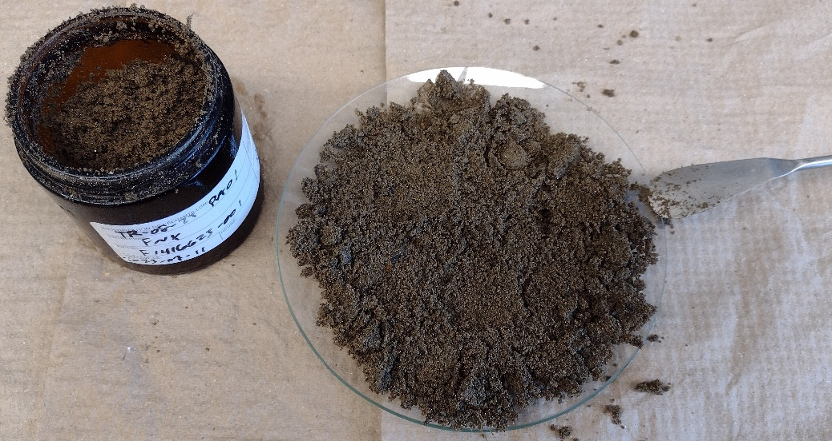
1
2
3
4
5
6
7
8
9
10
(A)

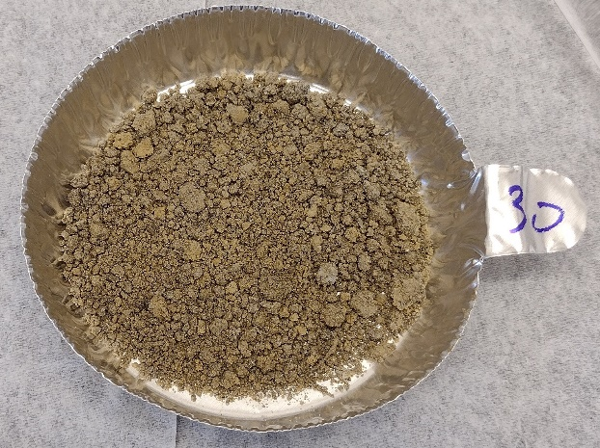
(B)

Fig. S5: (A) Fraction of the tawed field sample (≈ 80 g, wet) on a watch glass. The numbers indicate the spots where samples were taken to constitute the analytical aliquot of ≈ 4.0 g. (B) Aliquot after vacuum drying at room temperature. Only the fraction that demonstrates a particle size ≲ 0.5 mm was transferred to the TGA crucible for a hyphenated experiment.

- TGA-MS profiles of PAX, PEX and DIX.

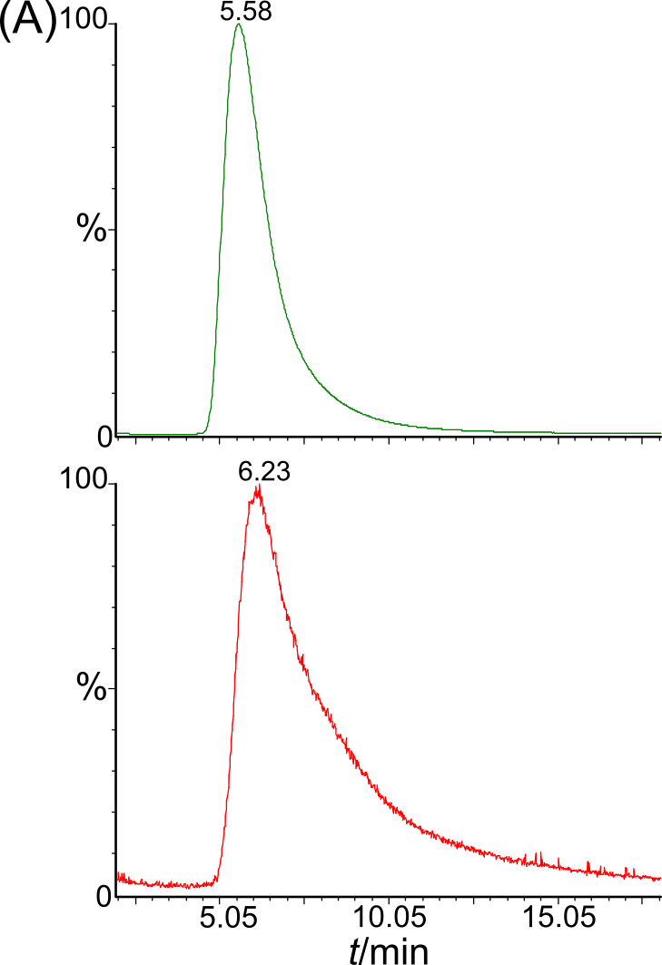
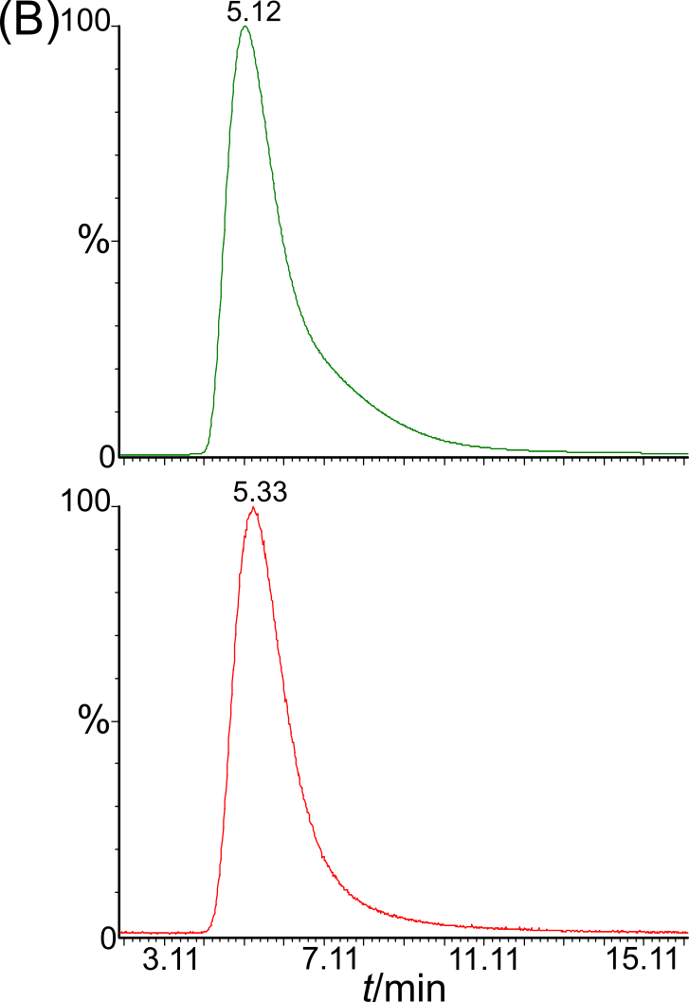

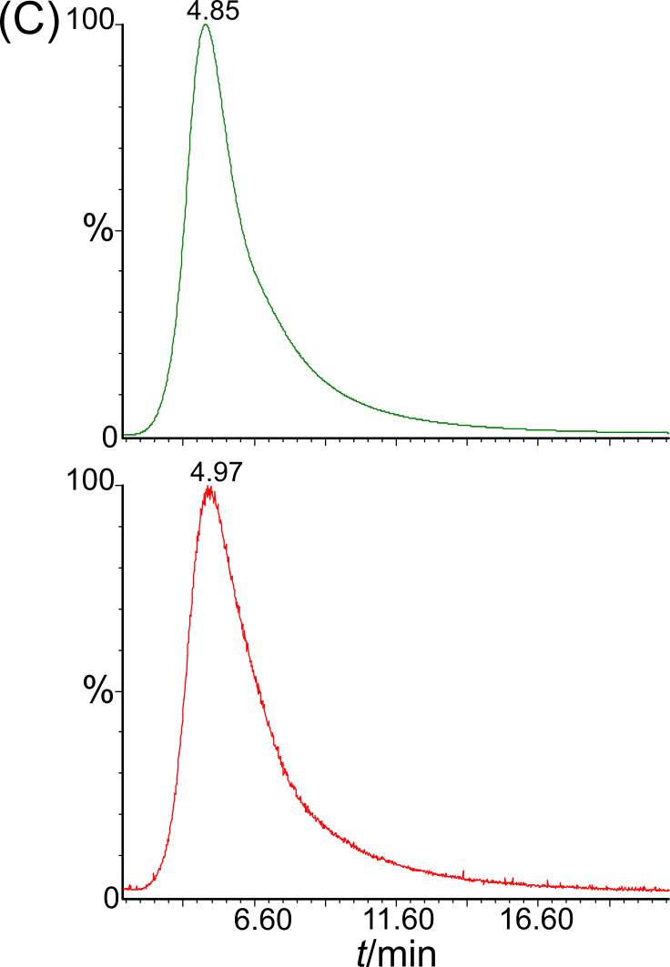

Fig. S6: TGA-MS profiles of pure (A) PAX, (B) PEX and (C) DIX. Top graph represents the profile obtained with a SIM MS method (m/z = 76). Bottom graphs were obtained with a scan MS method (m/z = 45-300). Insert: Corresponding thermogram (solid trace). The dashed line represents the derivative of the thermogram.

- Identification of the evolved products on pax, pex and dix by tga-gc/ms experiments.

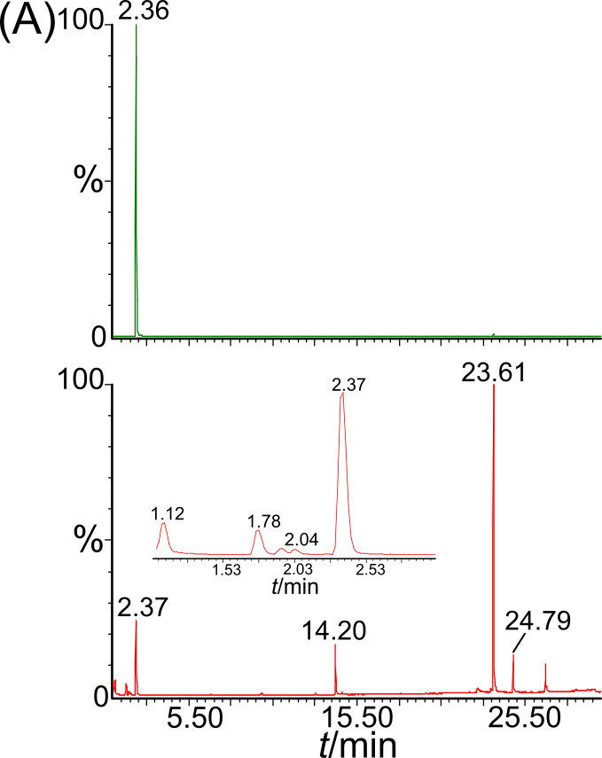
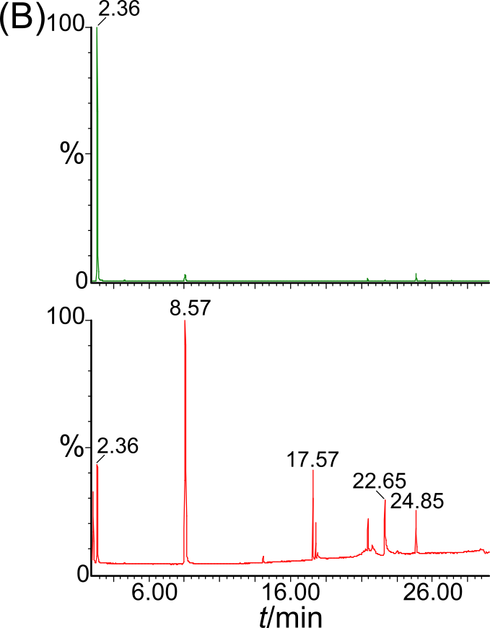

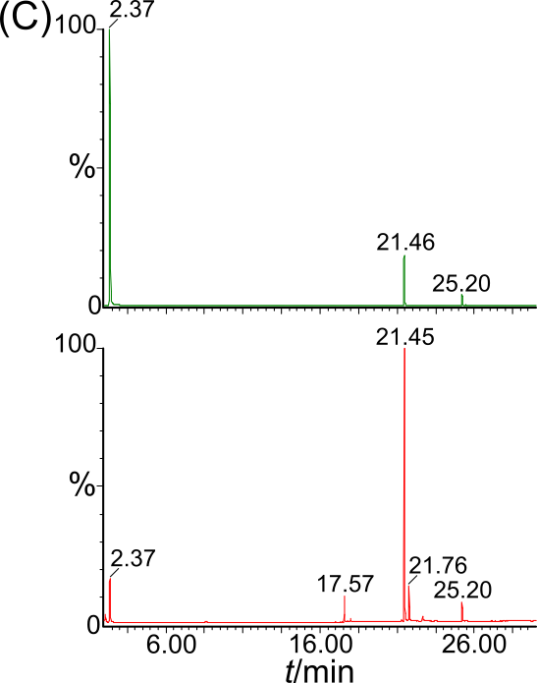

Fig. S7: TGA-GC/MS chromatograms obtained with pure xanthates (TGA heating rate: 60°C/min, p_{He} = 20 psi). Top trace: MS-SIM, m/z = 76. Bottom trace: MS-Scan. The insert represents the chromatogram between 1 and 3 min. (A) PAX. (B) PEX. (C) DIX. A mass of ≈ 1.0 mg was deposited in the TGA crucible. A carrier pressure of 20 psi was chosen to keep the GC ramping method < 30 minutes.

Table S2: Evolved products identification from figure S7.
 | t_{r} / min | Match  factor | Reverse  match factor | Peak area  / a. u. | Normalized  peak area % | Chemical identification
Potassium amyl xanthate  (PAX) | 1.12 | 954 | 954 | 1596965 | 14.7 | Sulfur dioxide
Potassium amyl xanthate  (PAX) | 1.78 | 927 | 927 | 1559927 | 14.4 | 1-Pentene
Potassium amyl xanthate  (PAX) | 1.94 | 924 | 932 | 348580 | 3.21 | 2-Pentene
Potassium amyl xanthate  (PAX) | 2.04 | 830 | 865 | 332261 | 3.06 | 2-Pentene
Potassium amyl xanthate  (PAX) | 2.37 | 977 | 978 | 10847941 | 100.0 | Carbon disulfide
Potassium amyl xanthate  (PAX) | 9.85 | 896 | 919 | 597487 | 5.51 | Pentanal
Potassium amyl xanthate  (PAX) | 13.03 | 916 | 922 | 251513 | 2.32 | Methylthiophene
Potassium amyl xanthate  (PAX) | 14.20 | 933 | 933 | 5108308 | 47.1 | Pentanol
Potassium amyl xanthate  (PAX) | 14.63 | 816 | 857 | 226315 | 2.09 | Pentanethiol
Potassium amyl xanthate  (PAX) | 23.61 | 934 | 935 | 25263628 | 232.9 | Diamyl sulfide
Potassium amyl xanthate  (PAX) | 24.79 | 870 | 878 | 3517114 | 32.4 | Dipentyl carbonate
Potassium amyl xanthate  (PAX) | 26.70 | 851 | 865 | 3268244 | 30.1 | Pentyl disulfide
Potassium ethyl xanthate  (PEX) | 2.08 | 939 | 944 | 8079099 | 6.38 | Ethanethiol
Potassium ethyl xanthate  (PEX) | 2.36 | 940 | 941 | 126554546 | 100.0 | Carbon disulfide
Potassium ethyl xanthate  (PEX) | 8.57 | 955 | 955 | 46346996 | 36.6 | Diethyl sulfide
Potassium ethyl xanthate  (PEX) | 14.06 | 839 | 872 | 574220 | 0.45 | Diethyl carbonate
Potassium ethyl xanthate  (PEX) | 17.57 | 938 | 943 | 6294055 | 4.97 | Diethyl disulfide
Potassium ethyl xanthate  (PEX) | 17.78 | 636 | 646 | 2236102 | 1.77 | 3-(Ethylthio)-propionic acid
Potassium ethyl xanthate  (PEX) | 21.45 | 816 | 906 | 2339391 | 1.85 | Diethyl xanthate
Potassium ethyl xanthate  (PEX) | 22.65 | 904 | 923 | 10335356 | 8.17 | 2-(2-Butoxyethoxy)-ethanol
Potassium ethyl xanthate  (PEX) | 24.85 | 715 | 878 | 3534817 | 2.79 | Diethyl trithiocarbonate
Diethyl dixanthate  (DIX) | 2.08 | 905 | 905 | 2867060 | 13.4 | Ethanethiol
Diethyl dixanthate  (DIX) | 2.37 | 940 | 941 | 21340940 | 100.0 | Carbon disulfide
Diethyl dixanthate  (DIX) | 17.57 | 933 | 938 | 6174298 | 28.9 | Diethyl disulfide
Diethyl dixanthate  (DIX) | 21.45 | 861 | 915 | 77947088 | 365.2 | Diethyl xanthate
Diethyl dixanthate  (DIX) | 21.76 | 785 | 849 | 8479617 | 39.7 | Diethyl trisulfide
Diethyl dixanthate  (DIX) | 25.20 | 695 | 724 | 5541445 | 26.0 | Diethyl dixanthate

- PAX recovery assays and Detection limit calculation.

Table S3: AX⁻ recovery of different aliquots of pure PAX determined from a calibration curve of spiked control samples with TGA-MS assays at heating rate of 20°C/min.
PAX in TGA pan  / mg | AX⁻ equivalent in TGA pan  / μg AX⁻ g⁻¹ | AX⁻ recovered ª  / μg AX⁻ g⁻¹ | AX⁻ recovered  %
0.158 | 1820 | 2153 | 118.3
0.092 | 1060 | 1007 | 95.0
0.015 | 173 | 165 | 95.3
0.013 | 150 | 164 | 109.4
0.038 | 438 | 461 | 105.2
2.17 × 10^{-3 b} | 25 | 25.7 | 102.8
4.34 × 10⁻³ ^{c} | 50 | 57.5 | 115.0
 |  | Average | 106
 |  | Standard deviation | 9

ª Calibration curve used: y = 1551.06x + 1085.98, based on spiked control samples. ^{b} The PAX comes from the addition of 35 μL of an aqueous solution (pH = 10) of 50 μg/ml in AX-. ^{c} The PAX comes from the addition of 28 μL of an aqueous solution (pH = 10) of 250 μg/ml in AX⁻.

Table S4: TGA-MS profile (m/z = 76) integration values considered for the determination of the AX⁻ detection limit.
TGA-MS profile integration / a. u.ª |  |  |  |  |  |  |  |  | Average | Standard Deviation
2891 | 1856 | 902 | 1683 | 2684 | 1384 | 669 | 1736 | 2237 | 1782 | 745

ª Calibration curve used to calculate the detection limit: y = 1551.06x + 1085.98, based on spiked control samples.

- Pentanol Evolution Monitoring.

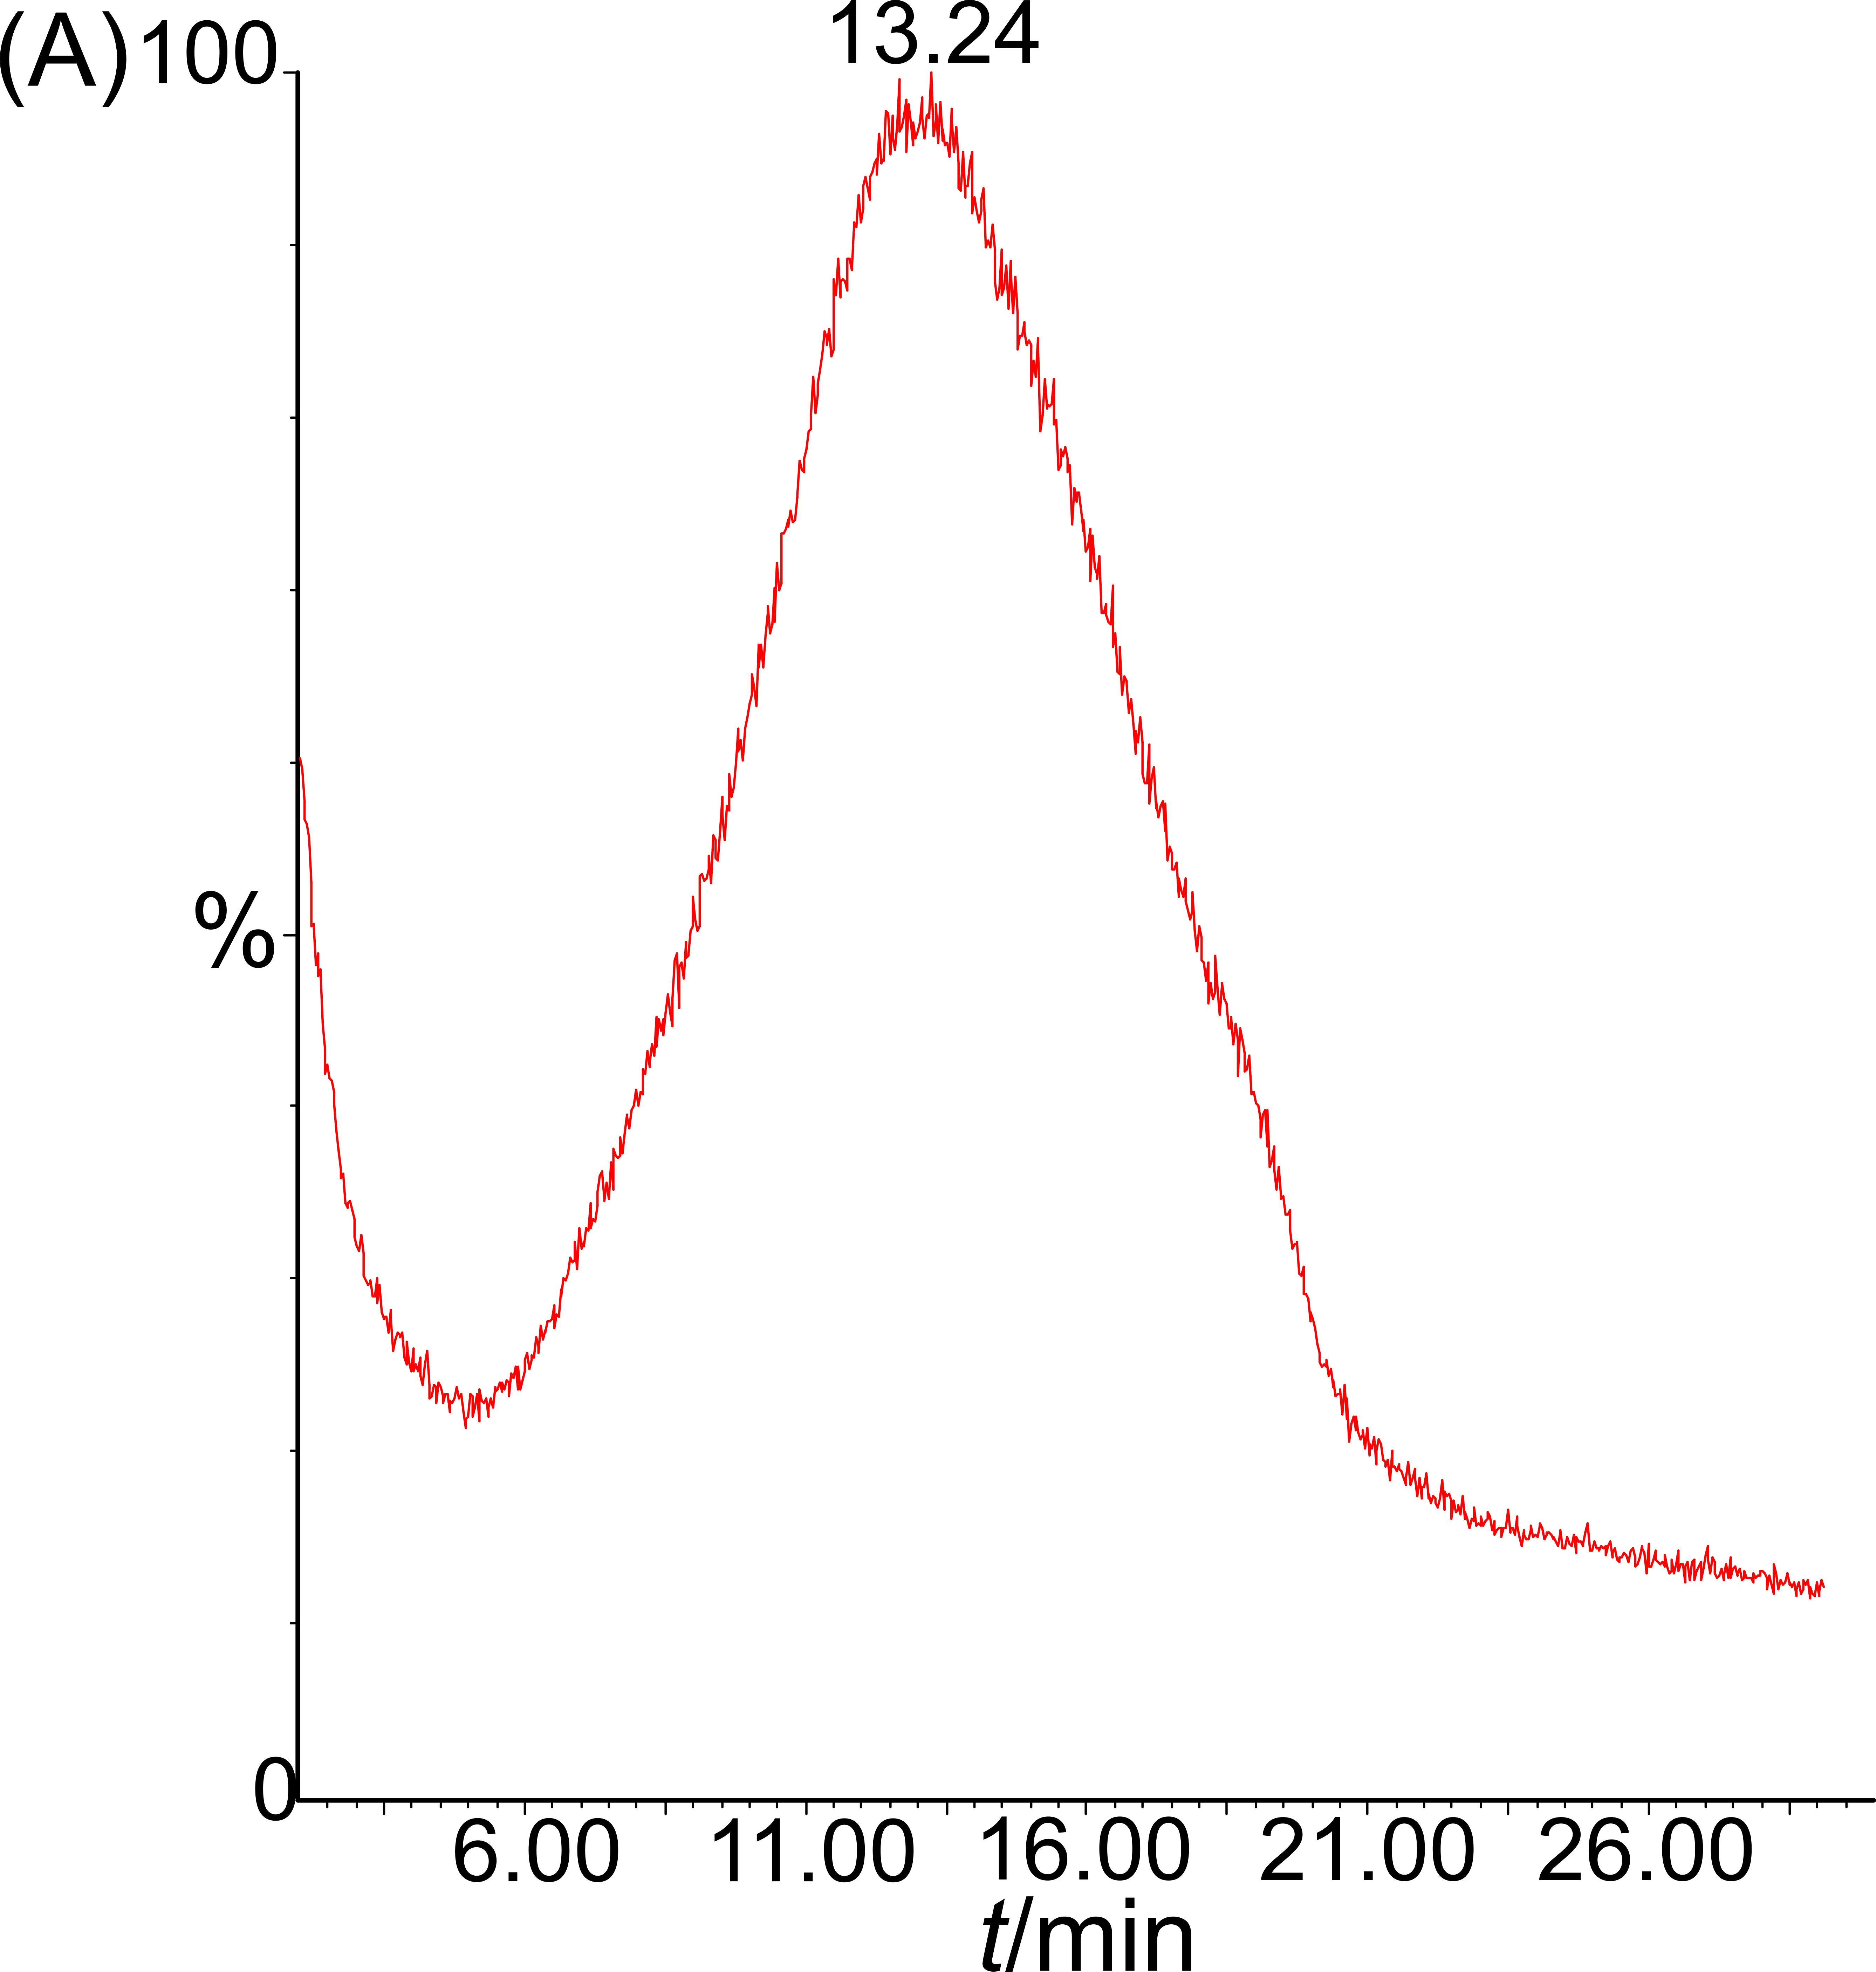
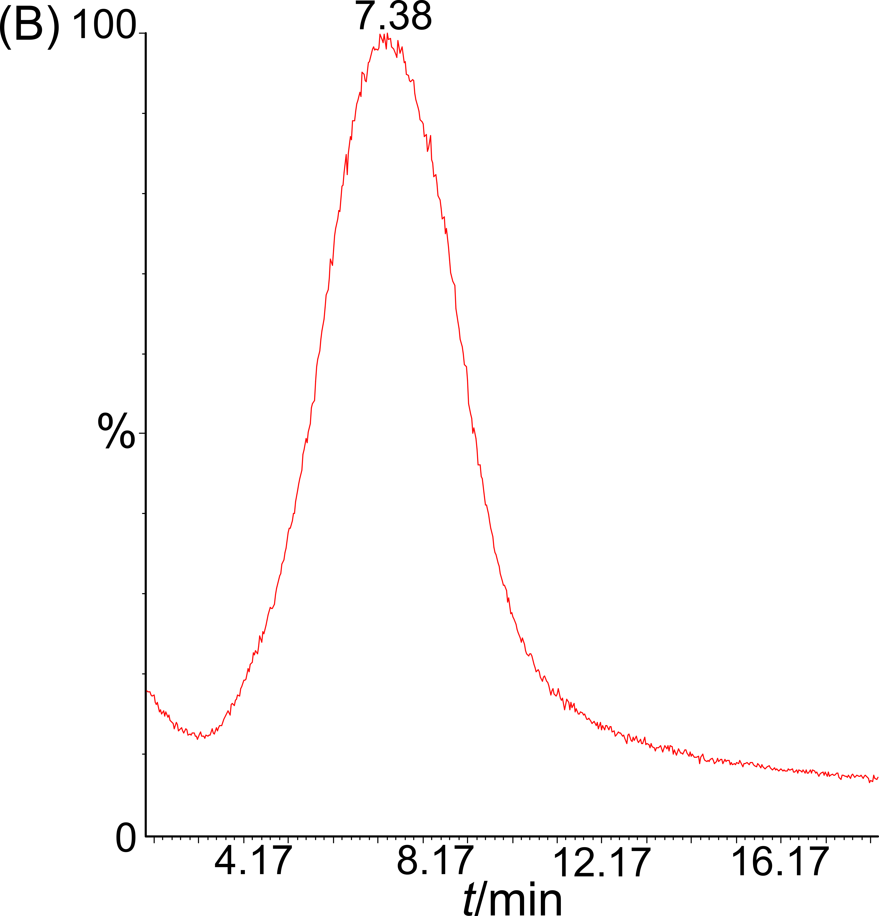
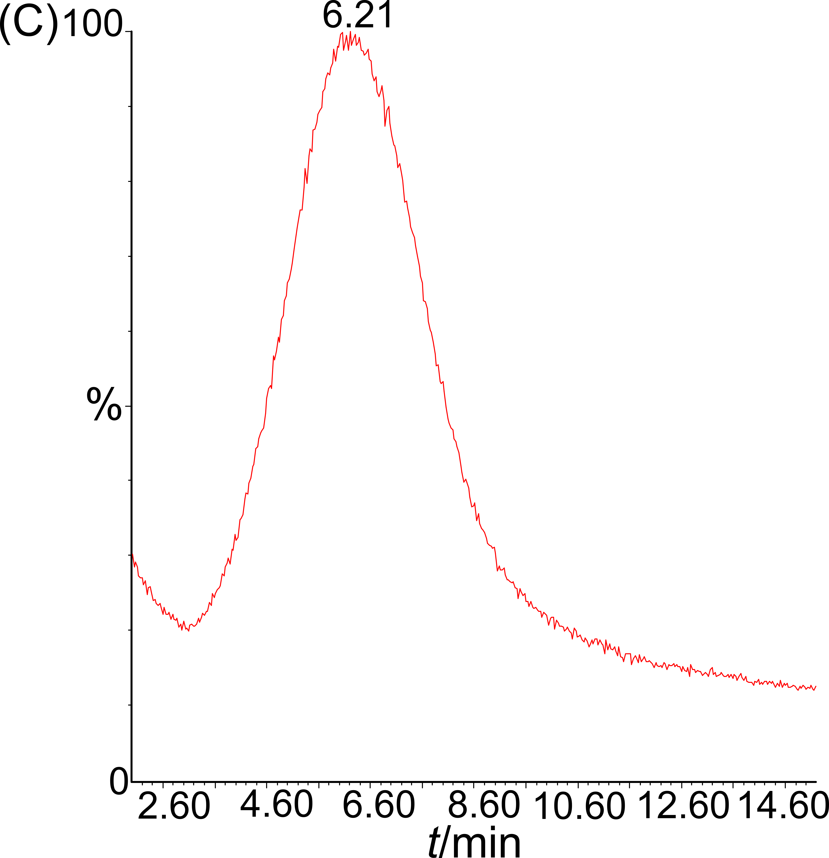

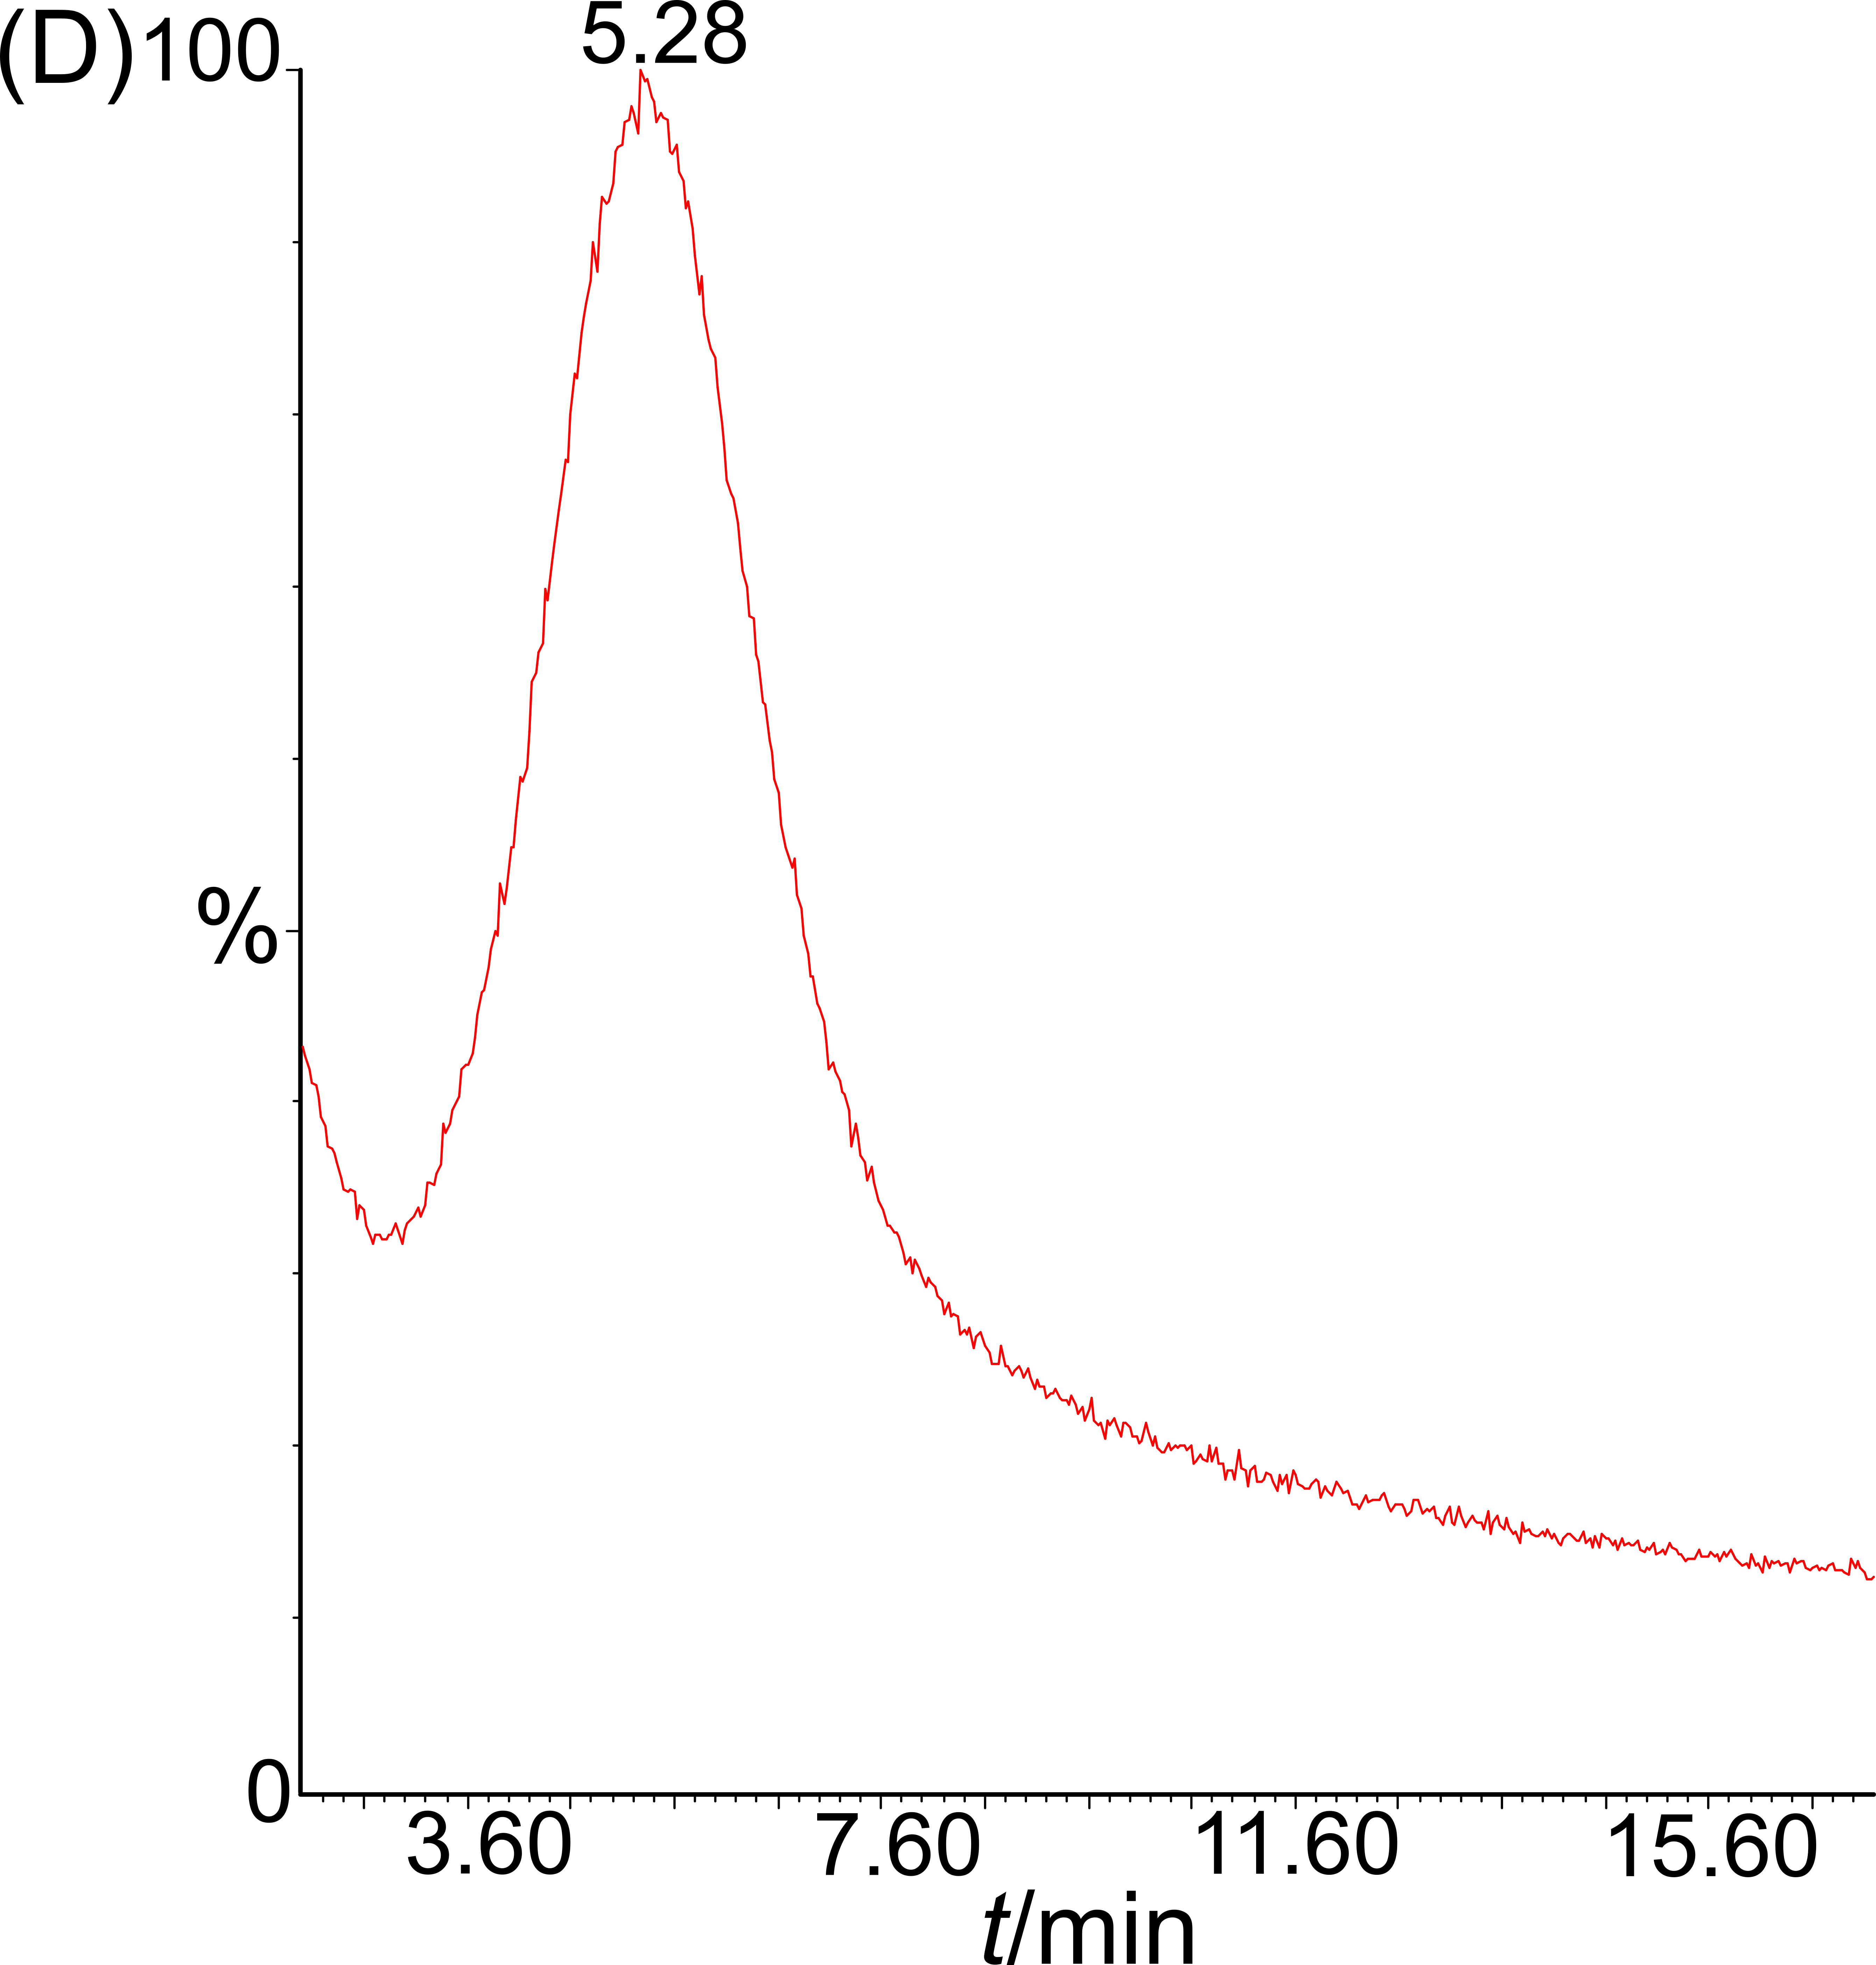
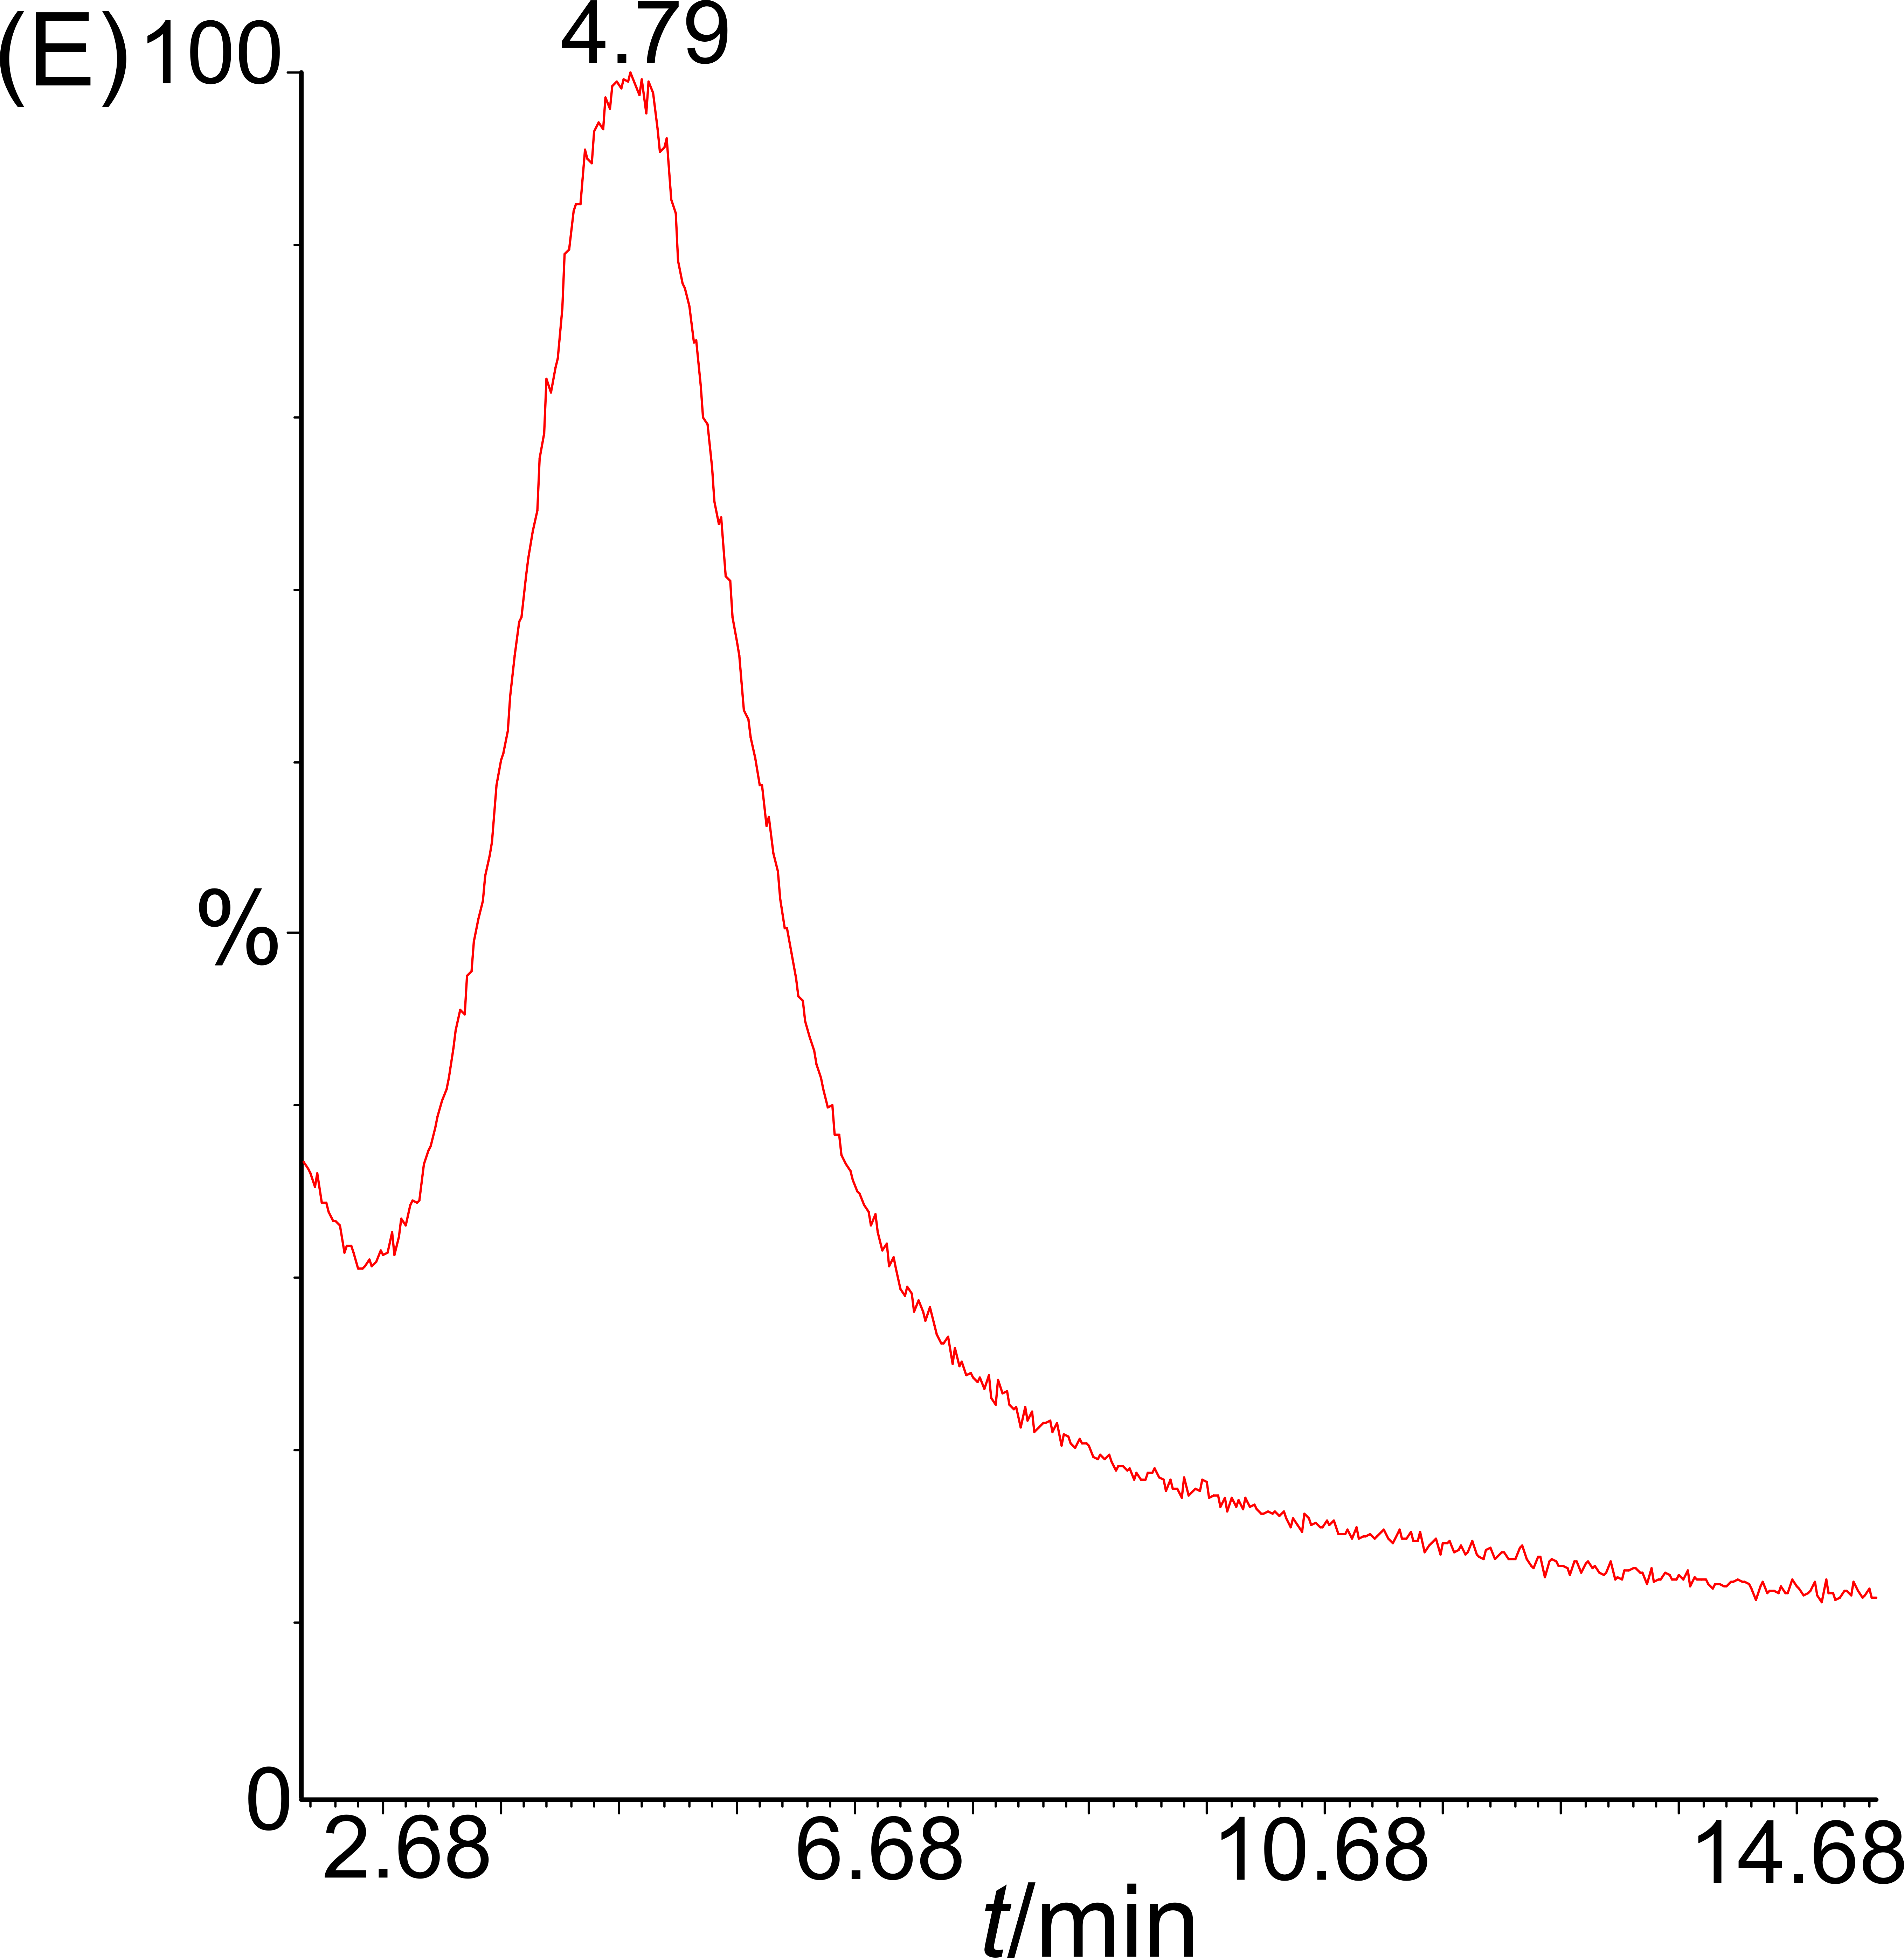

Fig. S8: TGA-MS profiles (m/z = 55) obtained with the calibration sample of 252.3 μg AX−/g realized at various TGA heating rates. (A) 20 °C/min, (B) 50 °C/min, (C) 60 °C/min, (D) 80 °C/min and (E) 100 °C/min. (F) Plot of the profile apex in function of the heating rate. The dotted line is a guide for the eye.

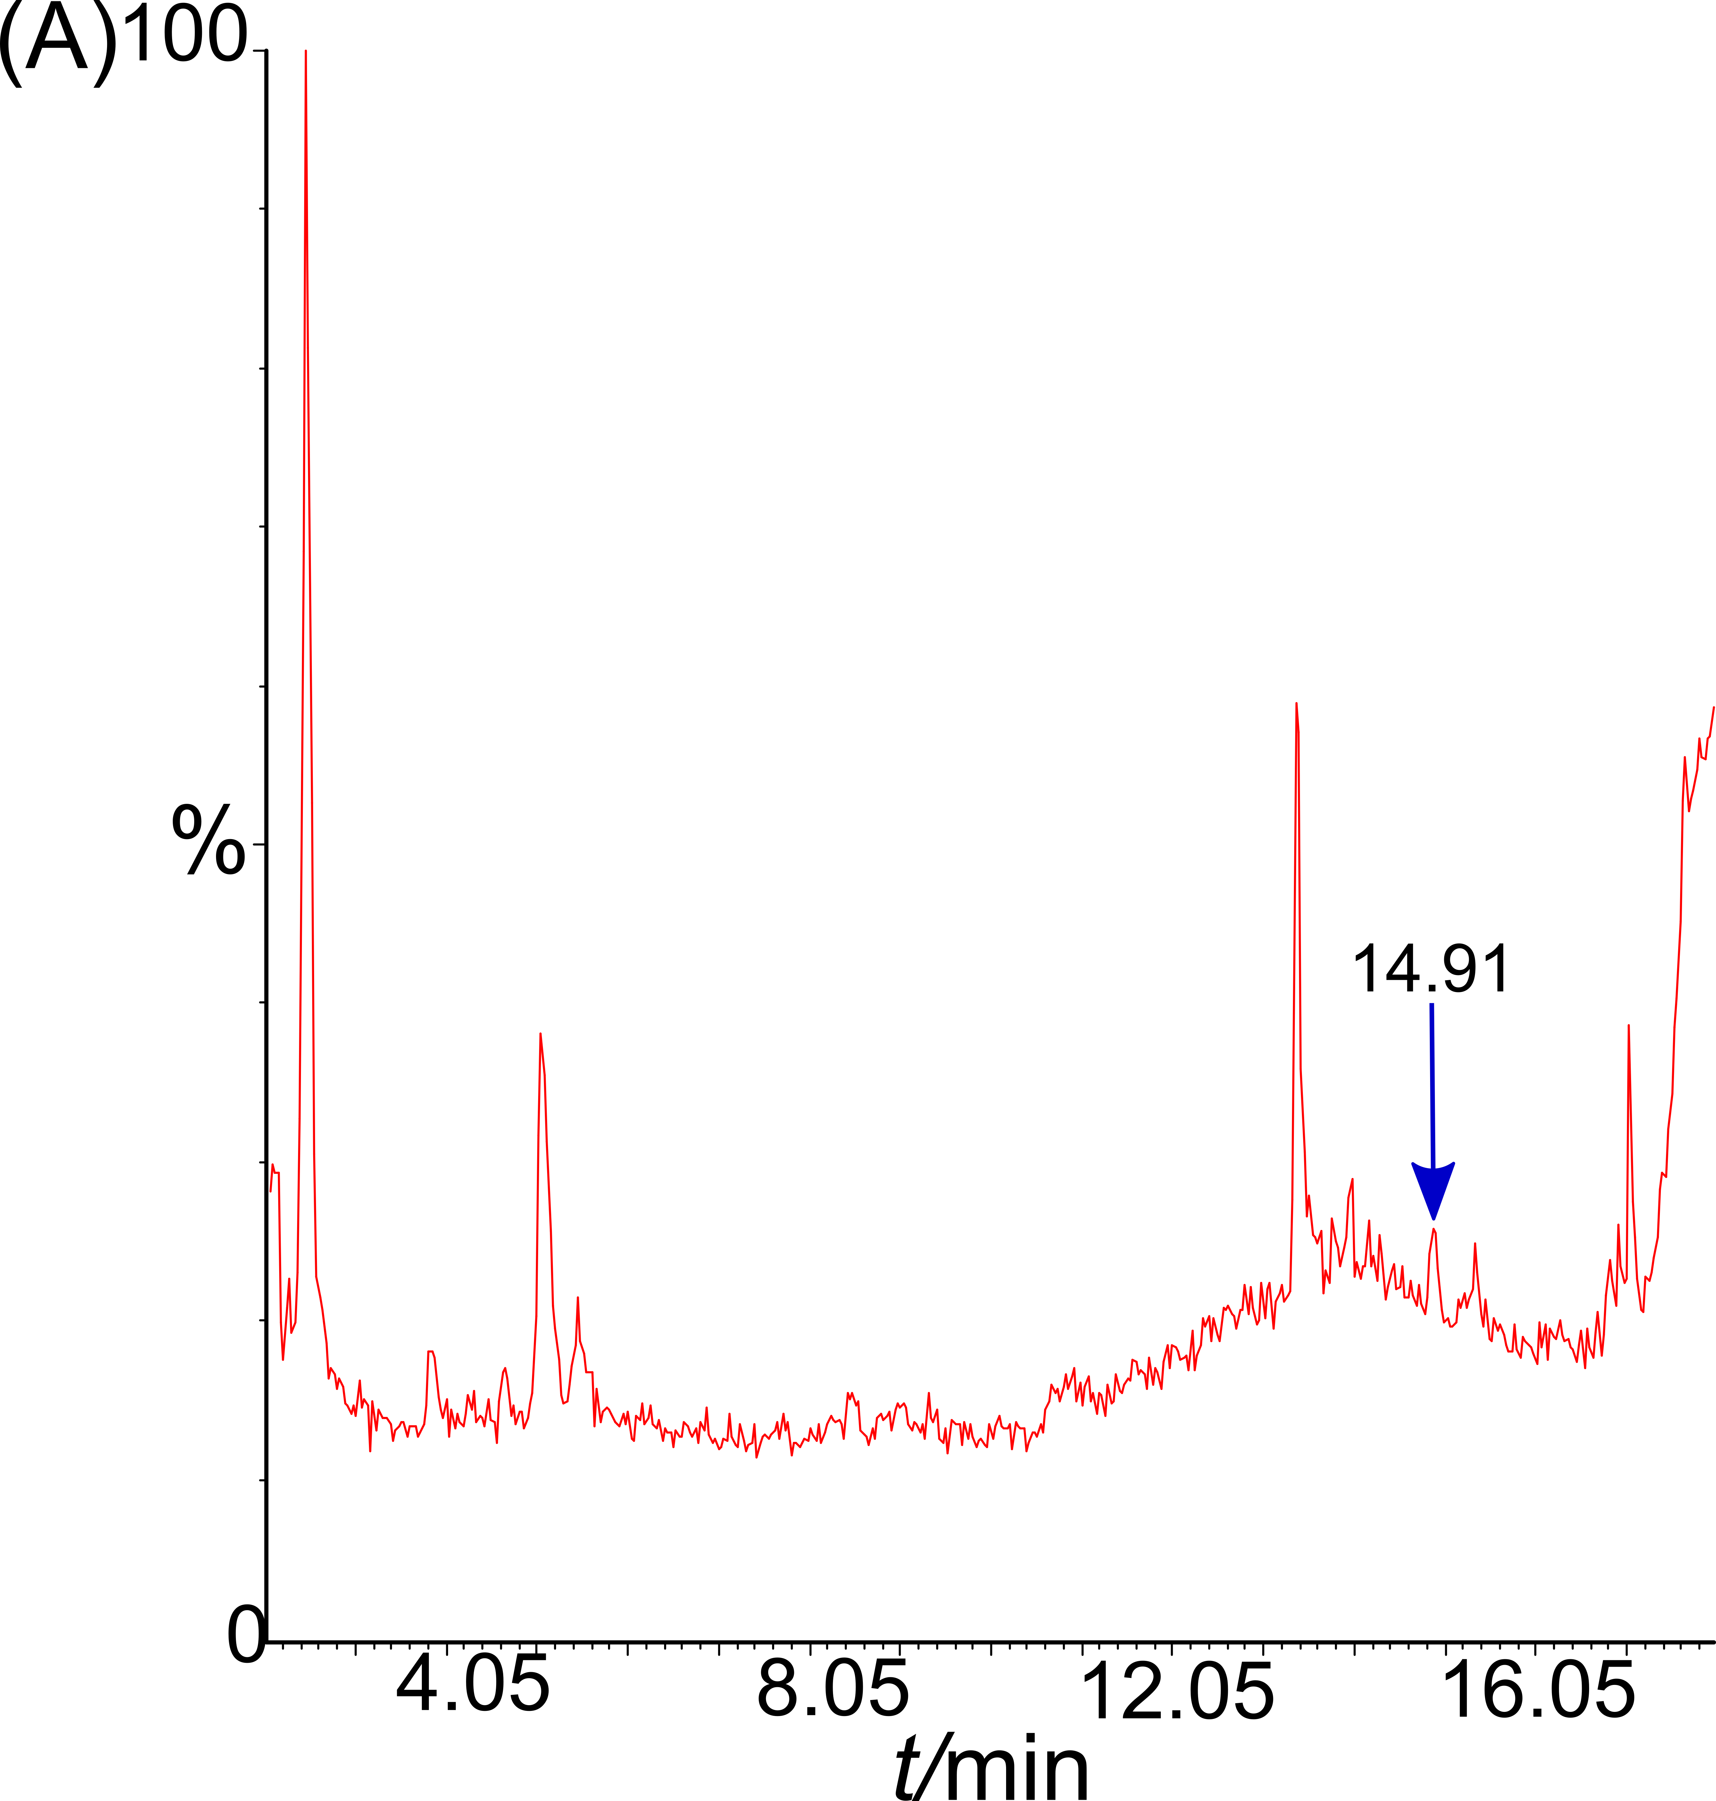
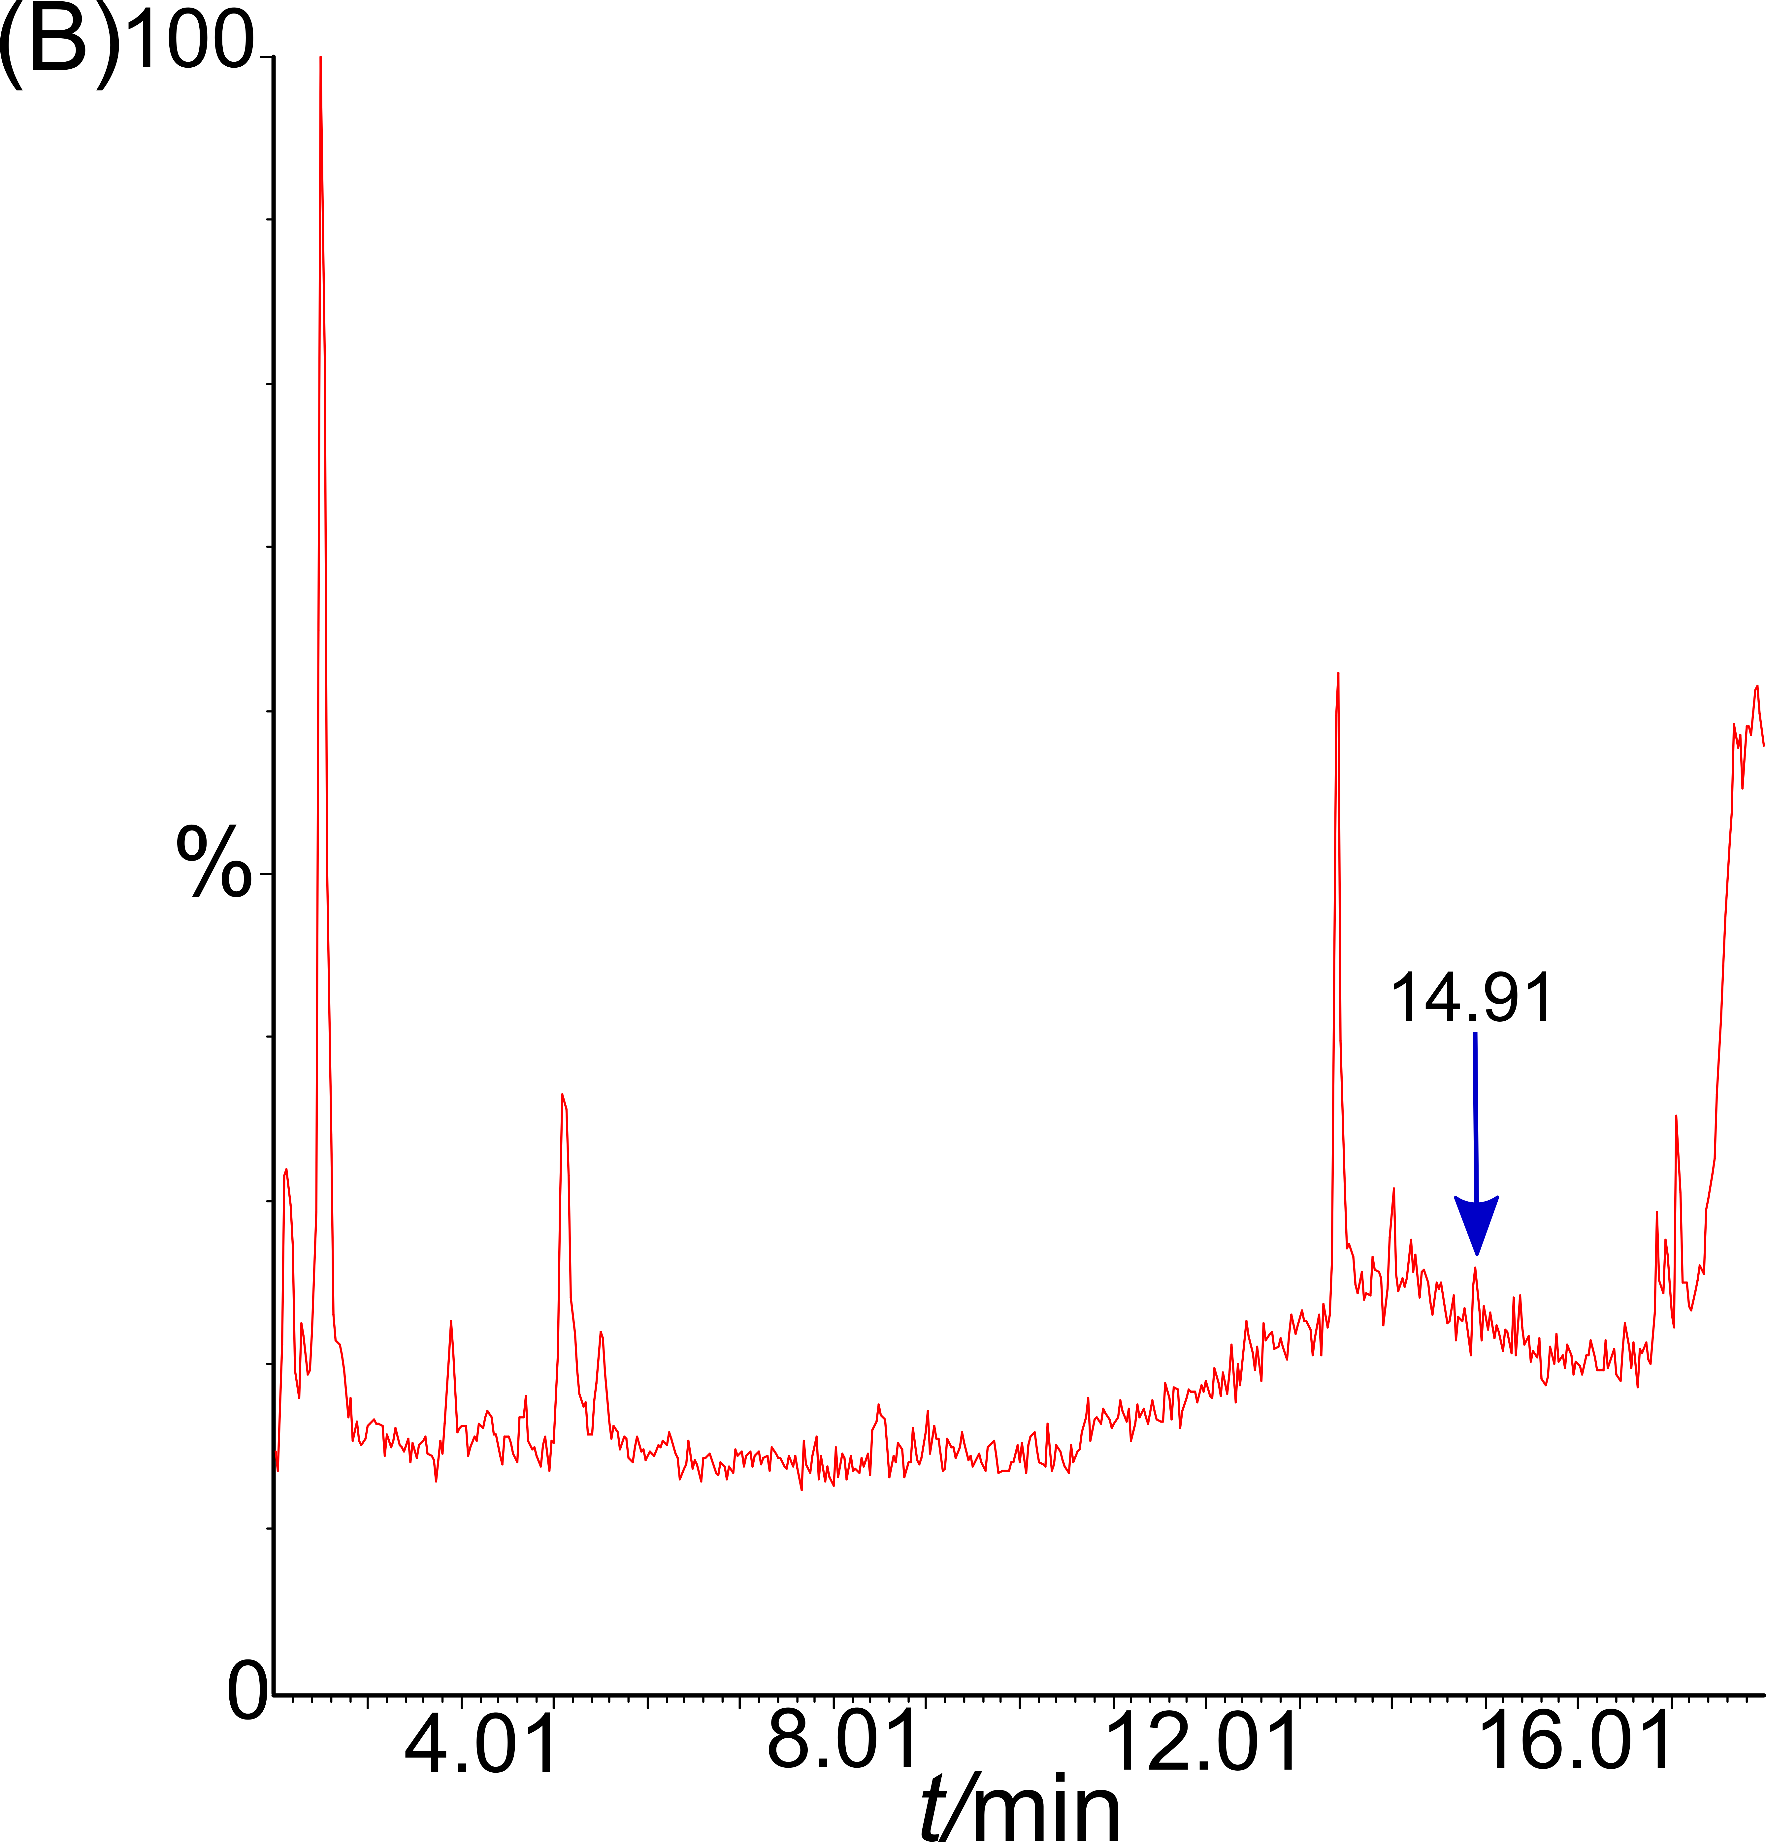
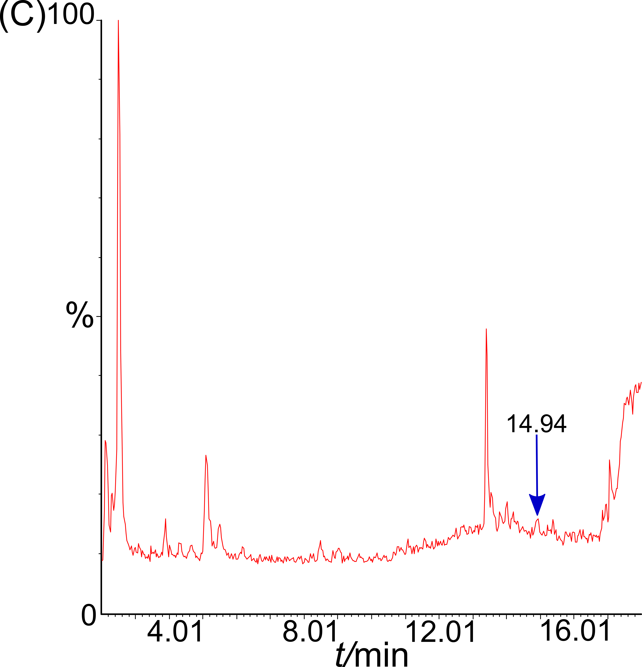
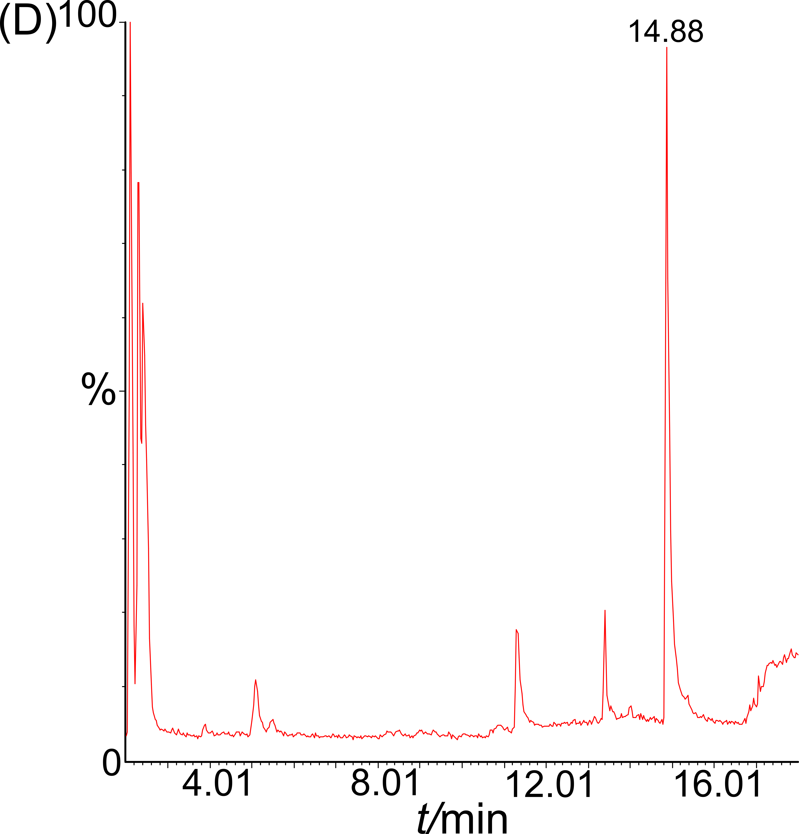

Fig. S9: TGA-GC/MS chromatograms obtained with the calibration samples and acquired with a SIM method (m/z = 55). p_{He} = 20 psi and TGA heating rate at 60 °C/min. (A) 1.01 μg AX− / g, (B) 3.03 μg AX− / g, (C) 25.23 μg AX− / g and (D) 252.3 μg AX− / g. The arrow, centered at 14.9 min, serves as a guide to identify the peak likely related to pentanol. (E) Integration values ​​of the chromatographic peak at 14.9 min as a function of AX‒ concentration. The dotted line serves as a guide for the eye.

- Pentene Evolution Monitoring.

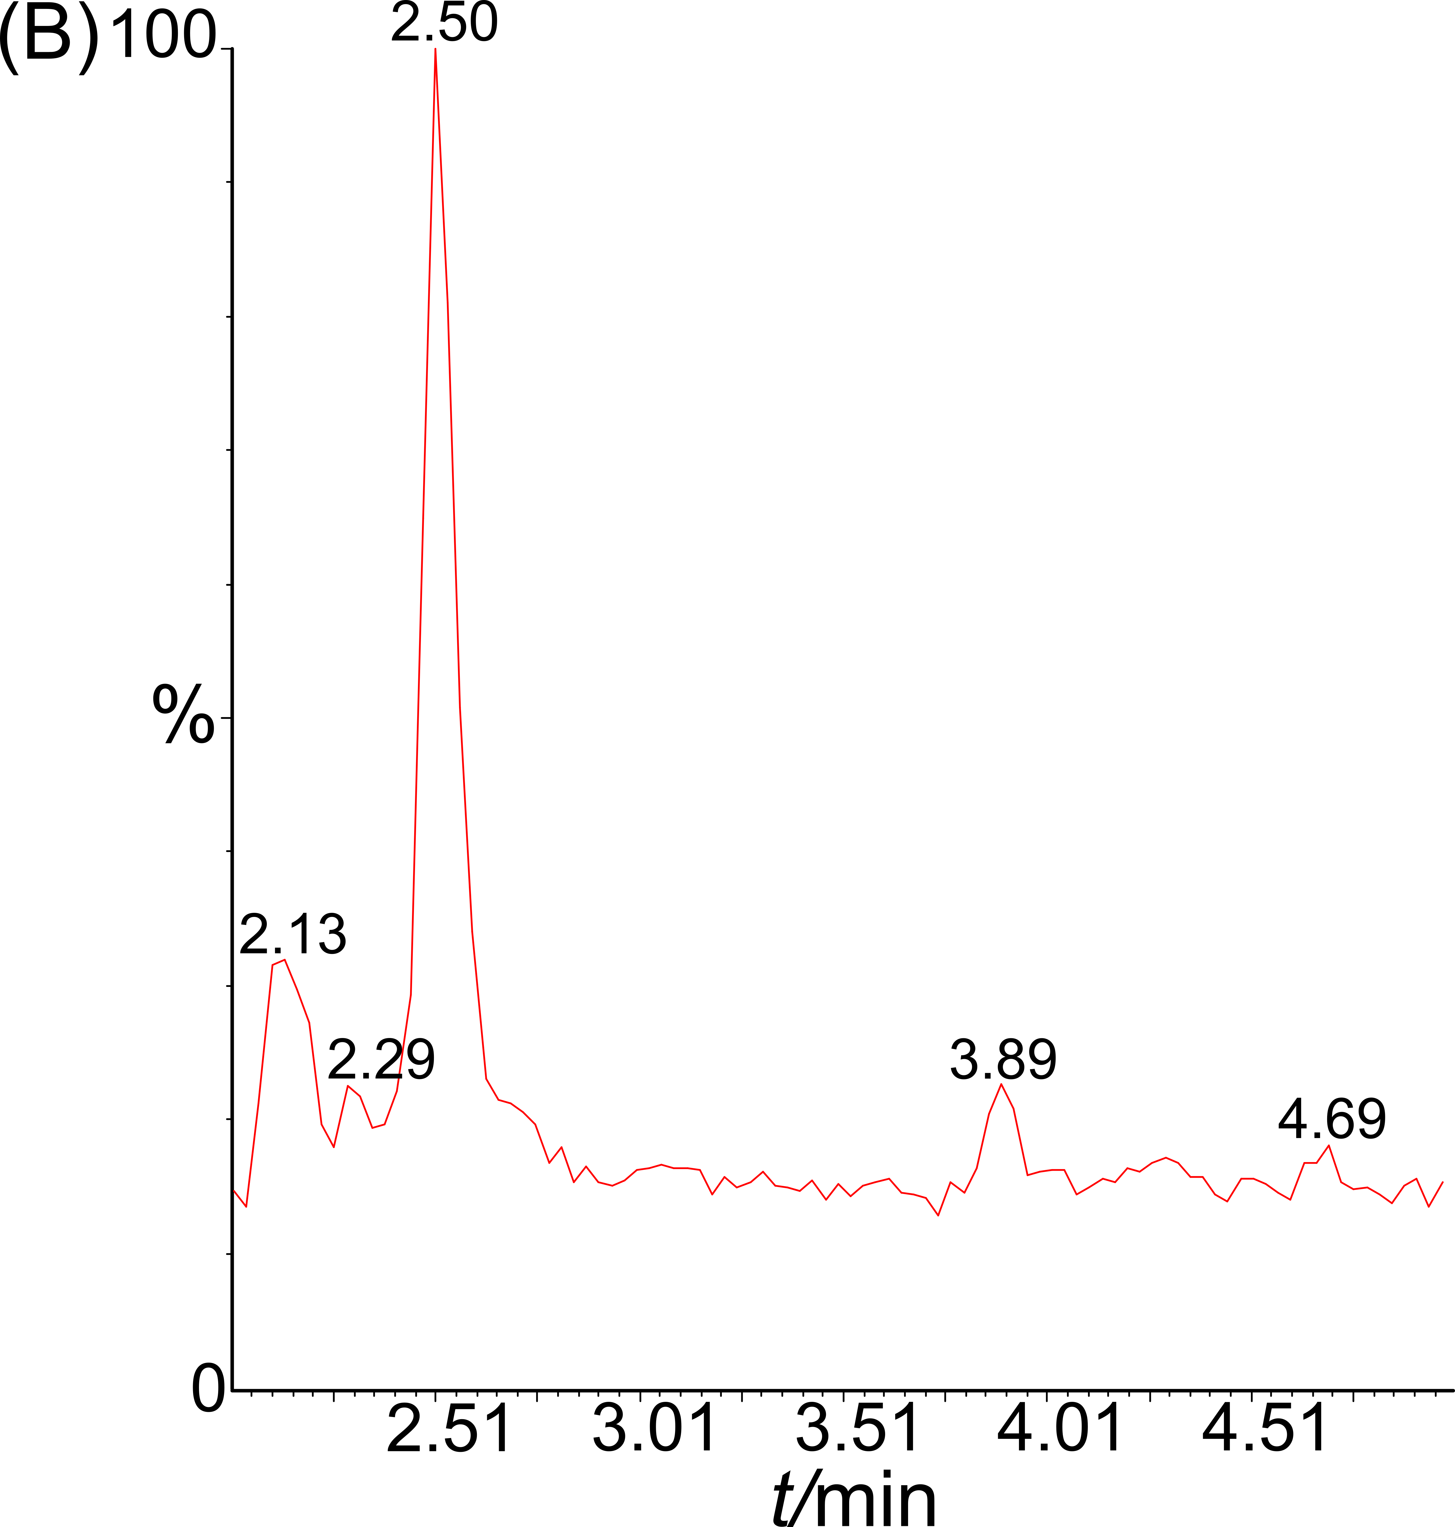
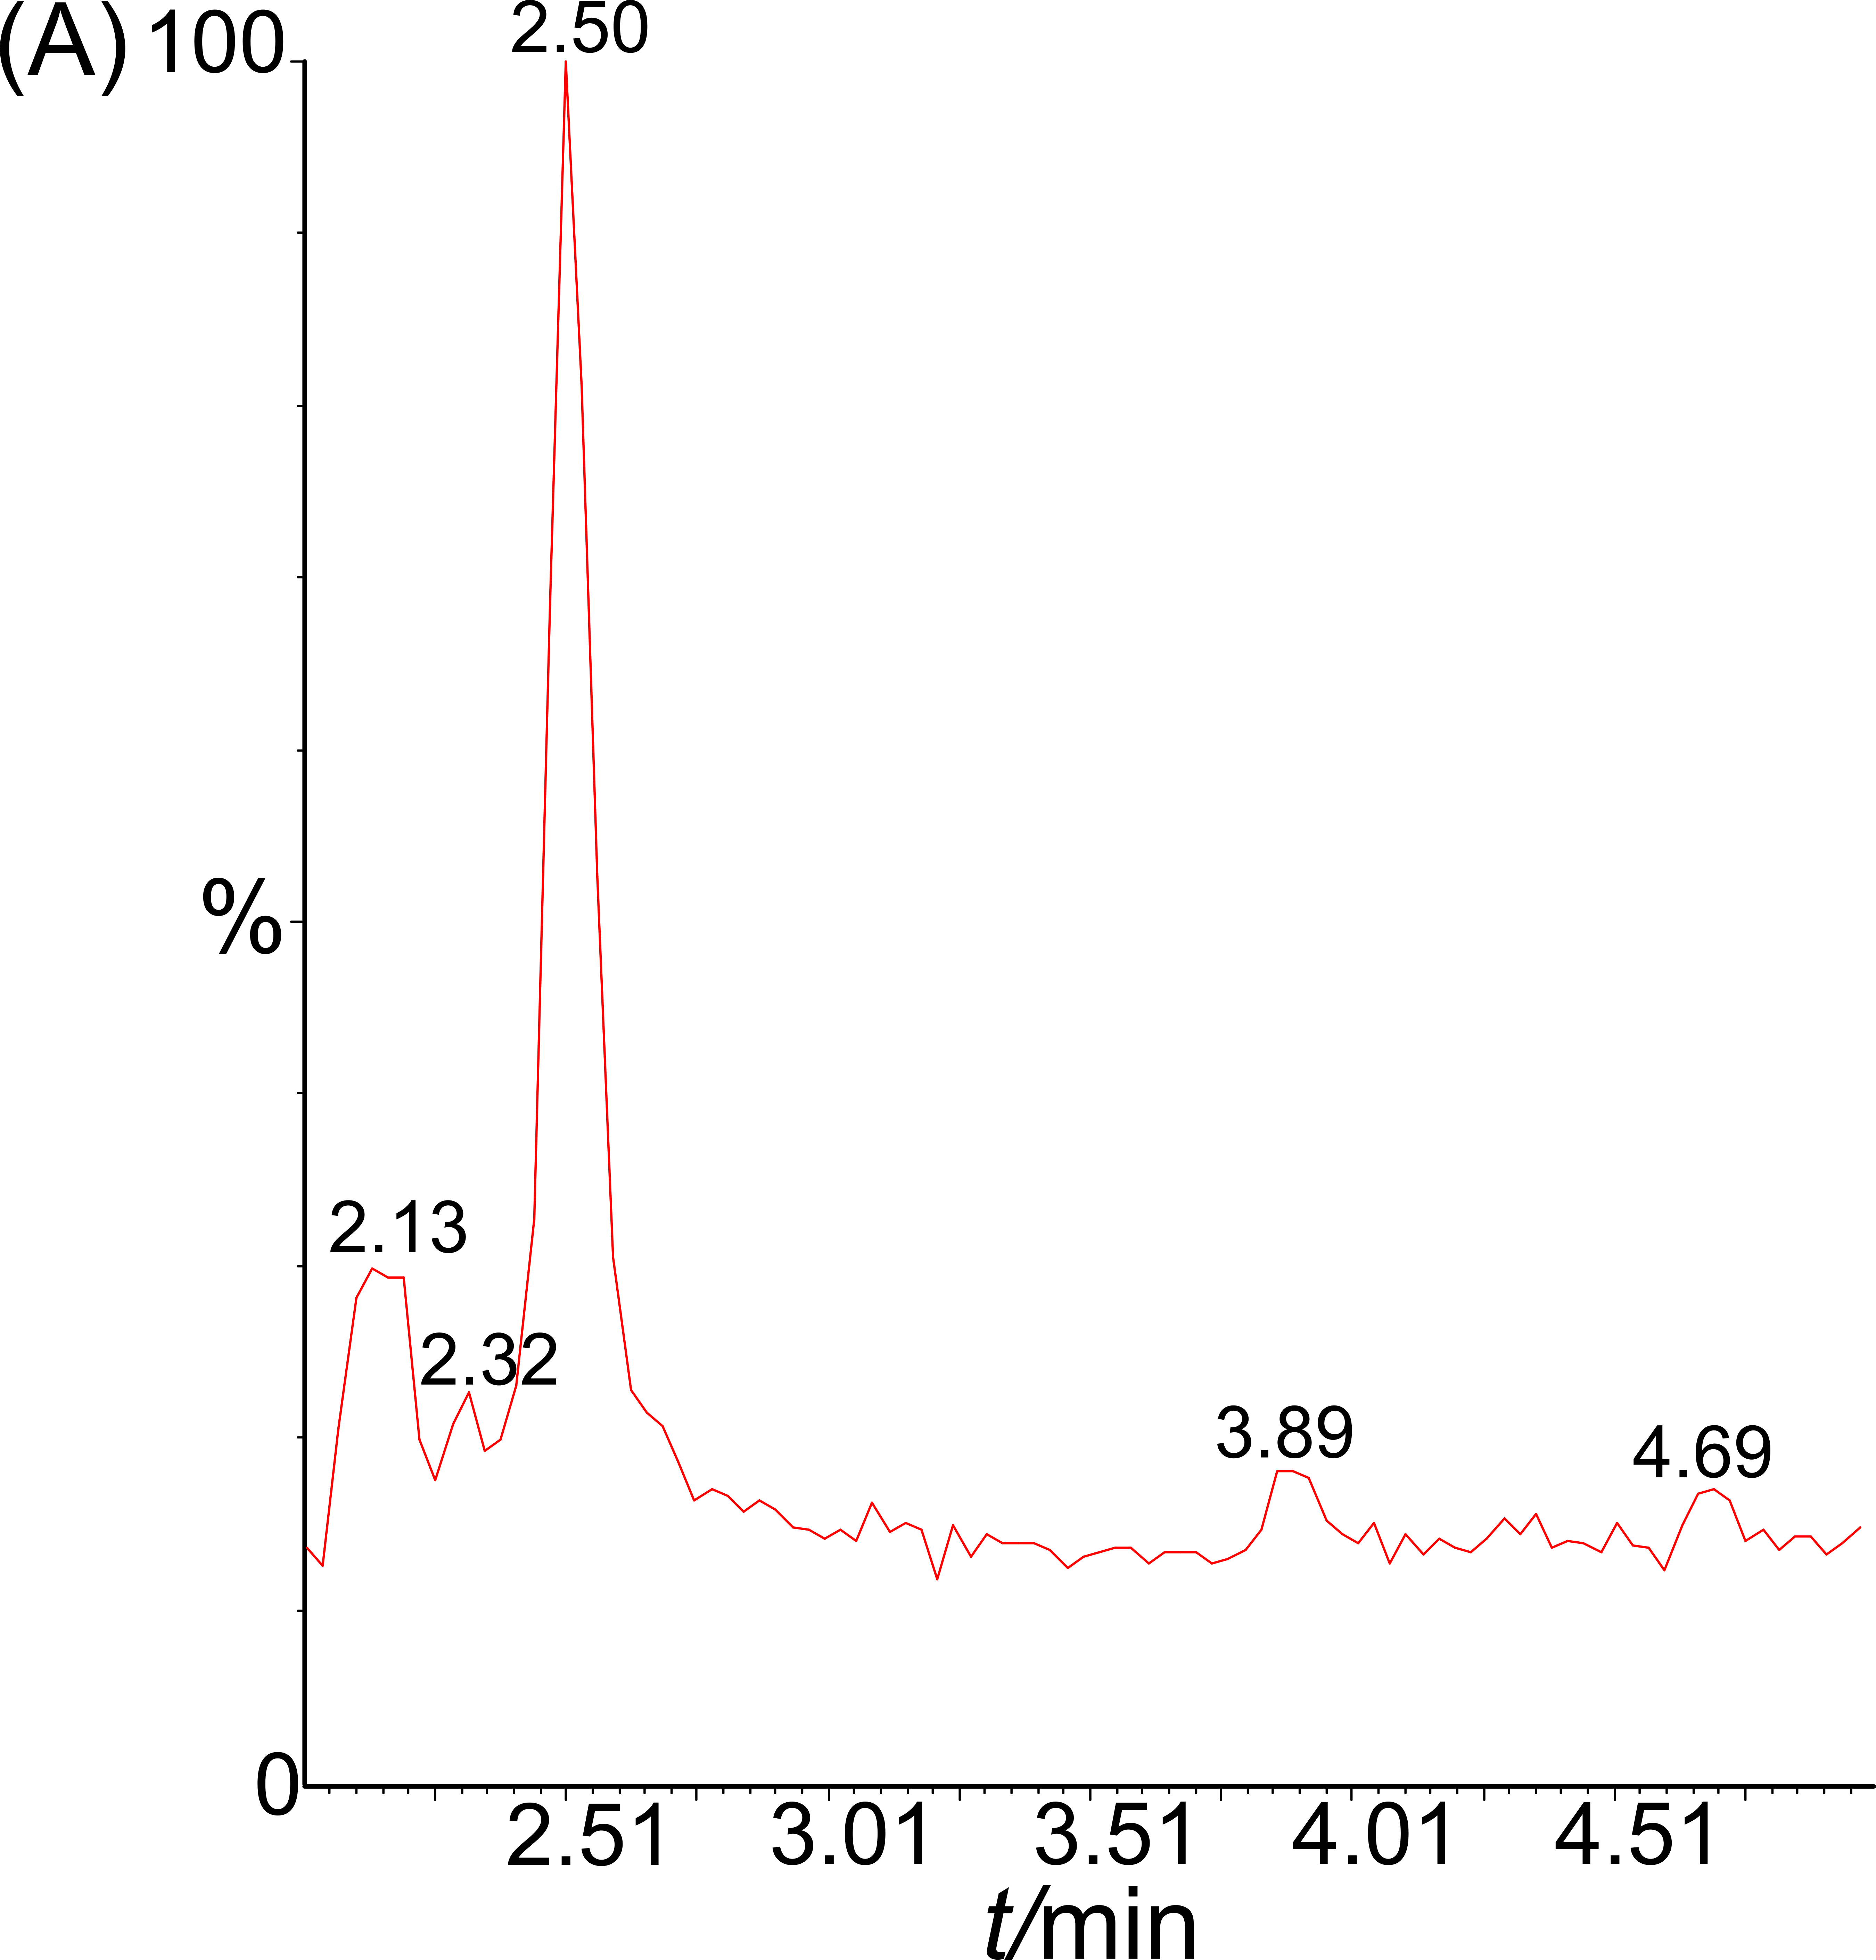
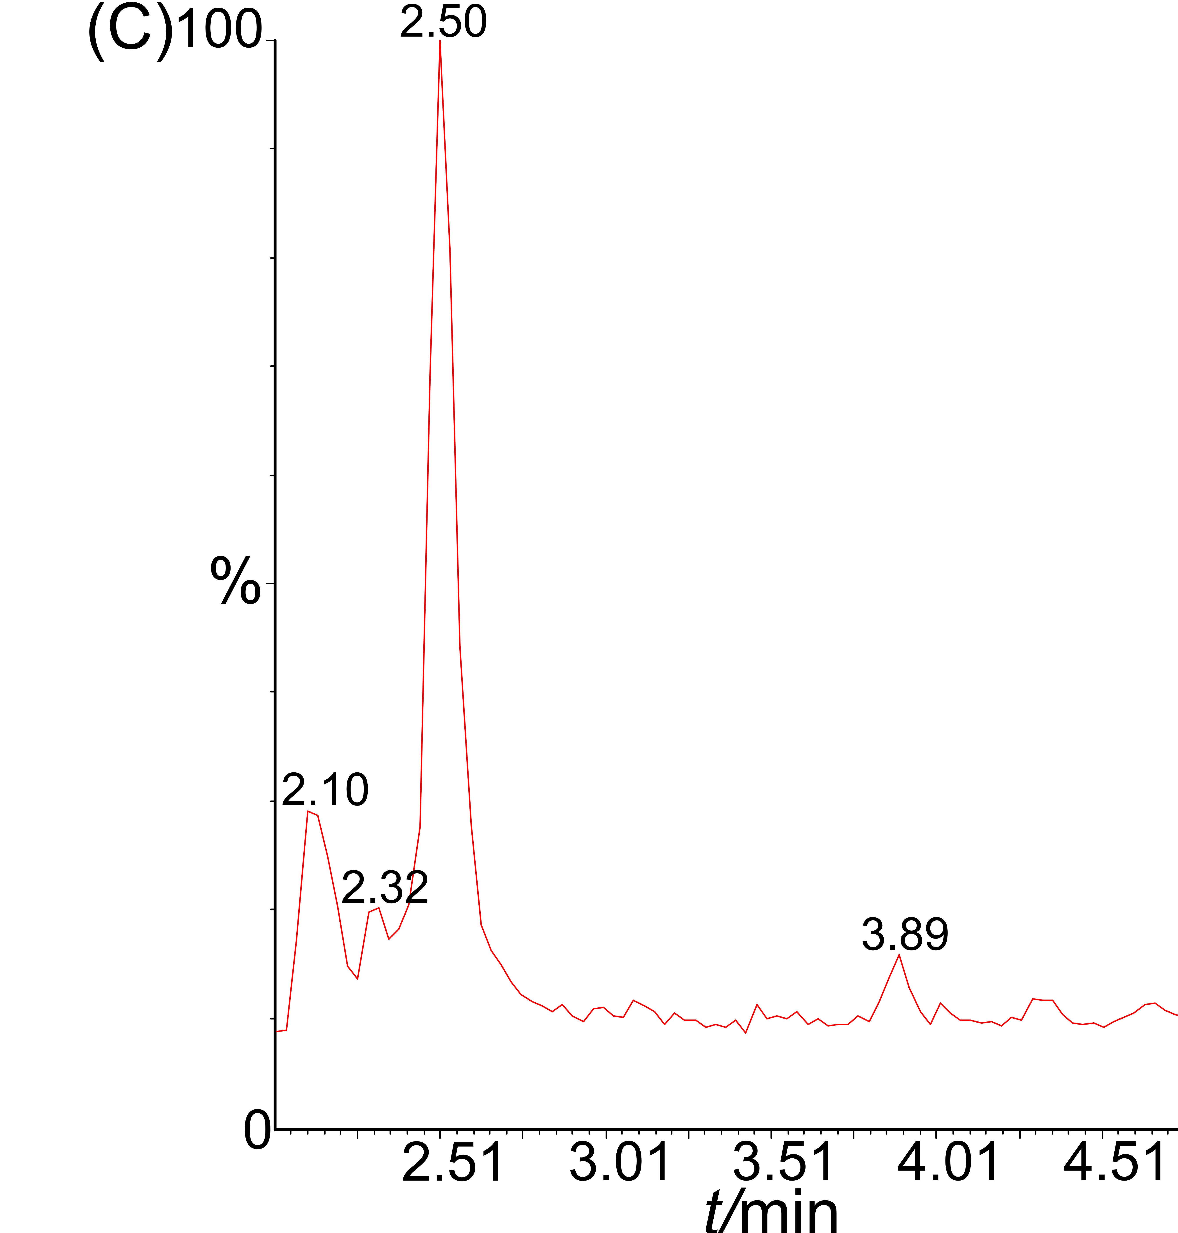
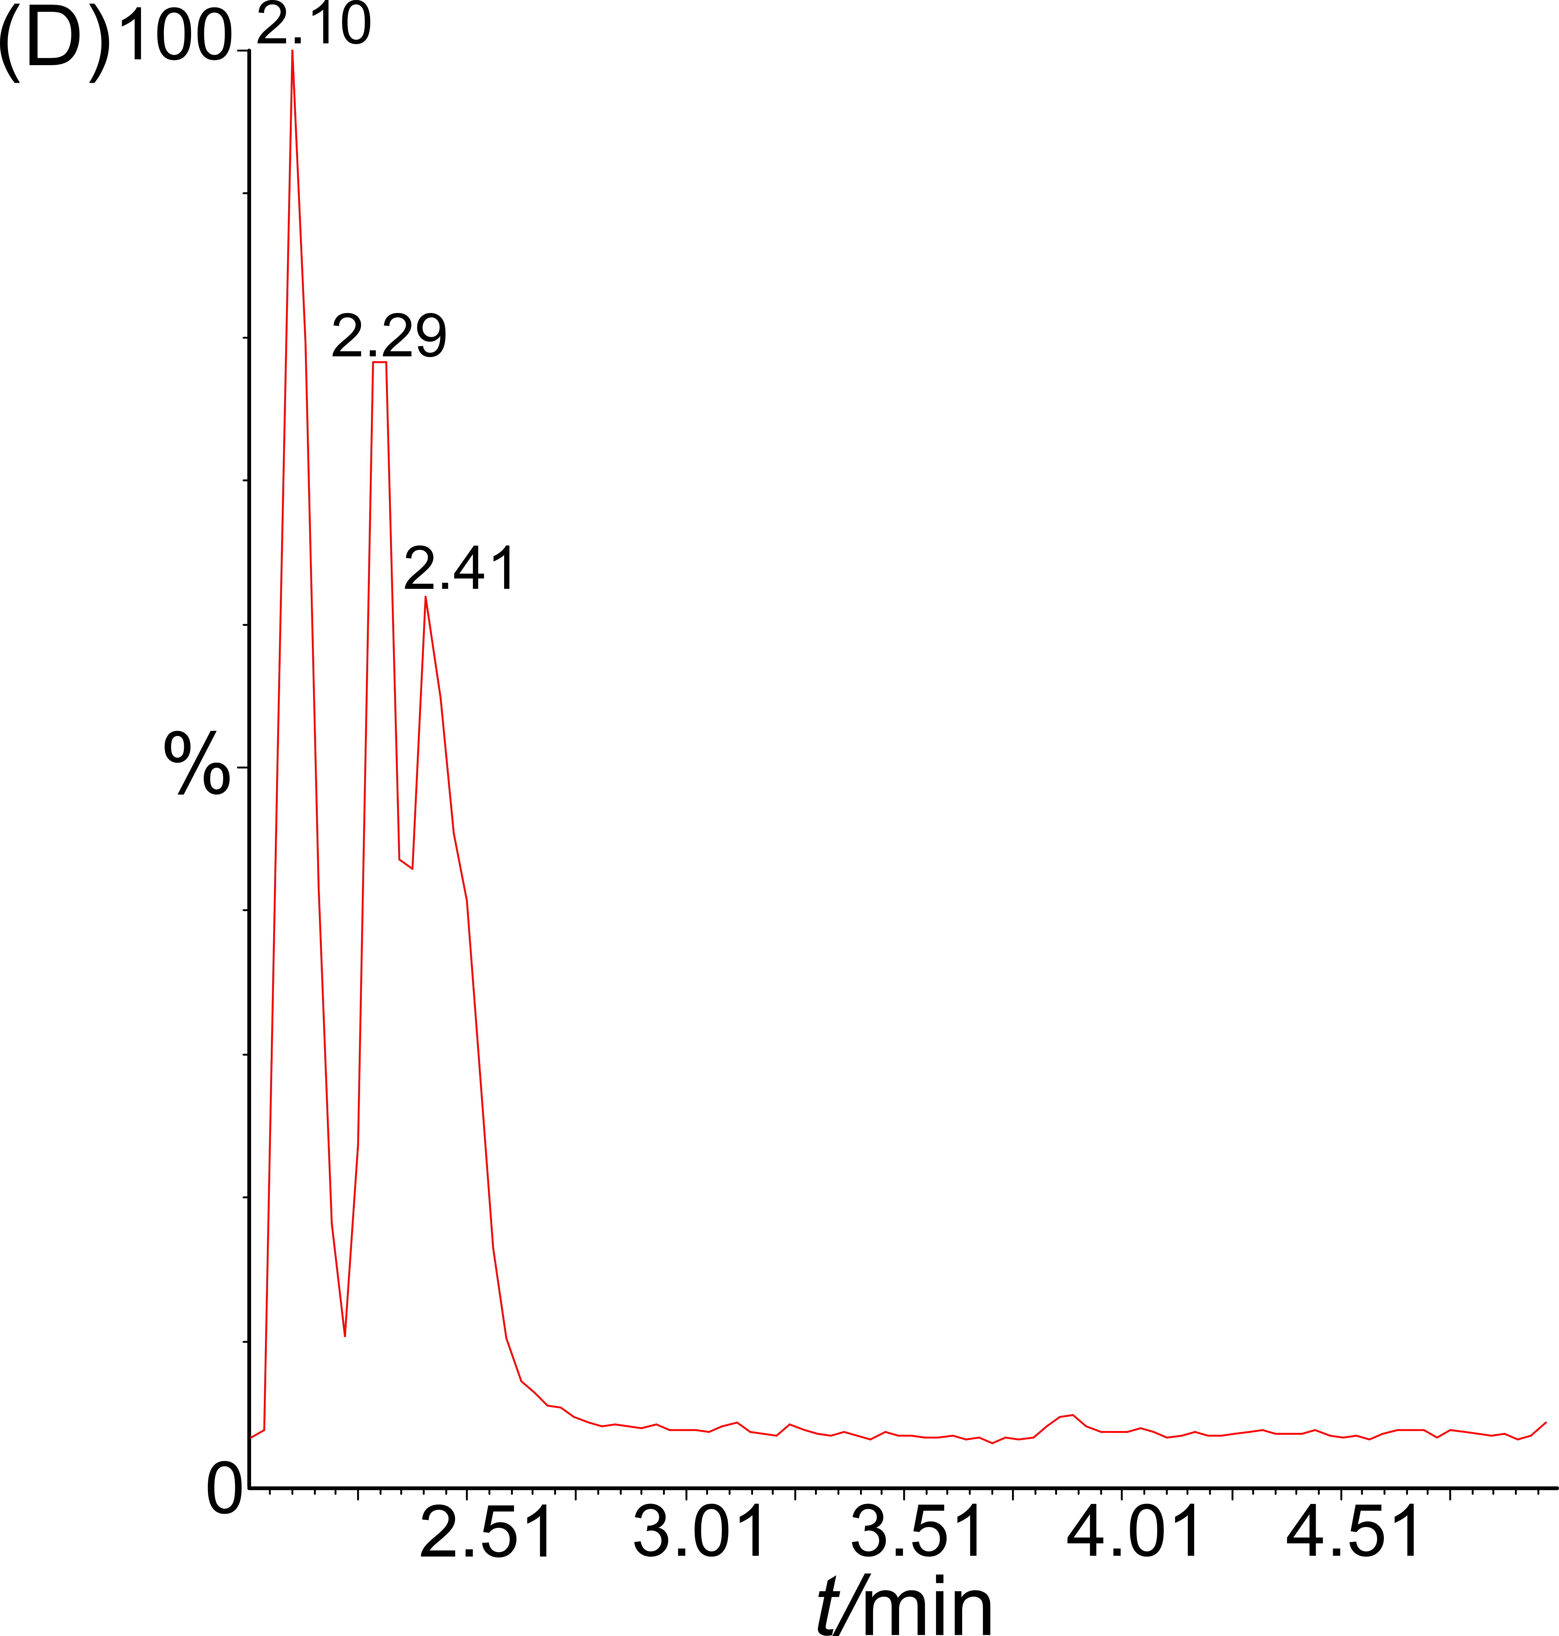

Fig. S10: Magnification, between 2.0 and 5.0 minutes, of the chromatograms showed at figure S9.

