First insight into the artistic materials of Willi Baumeister´s paintings using non-destructive multianalytical methods

Eva Mariasole Angelin¹, Simon Mindermann¹, Roland Lenz², Wibke Neugebauer², Clarimma Sessa¹*

¹ Chair for Conservation-Restoration, Art Technology and Conservation Science, Technical University of Munich, Oettingenstraße, 15, 80538 Munich, Germany, clarimma.sessa@tum.de
² Staatliche Akademie der Bildenden Künste, Am Weißenhof 1, Stuttgart, Germany

Supplementary material

Table S1. List of organic materials used for comparison in the interpretation of ER-FTIR.
Product type | Trade name | Supplier company | Category
Animal Skin Glue | Rabbit-Skin glue | Kremer Pigmente #63025 | Natural
Gum Arabic | Gum Arabic concentrated | Schmincke #50 302 | Natural
Mastic Gum | Mastic from Chios, Greece, best quality | Kremer Pigmente #60050 | Natural
Buttermilk | Milbona Reine  Buttermilch  (max. 1% Fett) | Hohenloher Molkerei eG | Natural
Linseed oil | Kremer Linseed Oil Varnish | Kremer Pigmente #73100 | Natural
Cellulose Lacquer | Zapon Lacquer | Kremer Pigmente #79550 & 79570 | Semi-synthetic
Acrylate Resin | ParaloidTM B72 | Kremer Pigmente #67400-67409 | Synthetic
Alkyd Resin | Alkyd Resin AM | Kremer Pigmente #79163 | Synthetic
Ketone Resin | Laropal® K-80 | BASF | Synthetic
PVA-Dispersion | Mowilith D50 | Celanese | Synthetic
PVA | Raviflex BL 5S - A | Vinavil | Synthetic

Table S2. List of the multi-band images with their nomenclature, technical features (illumination and acquisition) and acronym used through the paper.
Nomenclature | Detection spectral range | Camera filters | Reflectance / Luminescence | Light source induction | Emission spectral range of the light source | Light source | Illumination source filter | Acronym*
Vis-reflected images | VIS | Schott BG38 with Baader UV /IR-Cut L | R | VIS | 380 nm – 750 nm | Halogen lamps 1000W | --- | VIS-R_vis
Vis-induced IR luminescence | IR | Schott RG830 | L | VIS | 380 nm – 750 nm | LED | Schott BG38 | IR-L_vis
UV-induced IR luminescence | IR | Schott RG830 | L | UV | 365 nm (max) | UV LED from Dr. Hönle AG | Schott MUG2 | IR-L_uv
UV-induced Vis luminescence | VIS | Schott BG38 with Baader UV /IR-Cut L | L | UV | 365 nm (max) | UV LED from Dr. Hönle AG | Schott MUG2 | VIS-L_uv
IR False Color |  |  |  |  |  |  |  | IRFC
UV False Color |  |  |  |  |  |  |  | UVFC
*The acronym was developed by Annette T. Keller and Roland Lenz and is discussed in Keller, A. T., et al. Exploring the Ultraviolet Induced Infrared Luminescence of Titanium White Pigments. In: Fuster López L, Stols-Witlox M, Picollo M, editors. UV-Vis Lumi-nescence imaging techniques/ Técnicas de imagen de luminiscencia UV-Vis: Editorial Universitat Politècnica de València; 2019. p. 201–232. Basically, the spectrum captured with the camera is indicated with capital letters (UV, VIS, IR), after the hyphen the type of recording method in capital letters (R for reflection, L for luminescence) and after the underscore in lower case letters the spectral range of the radiation source.

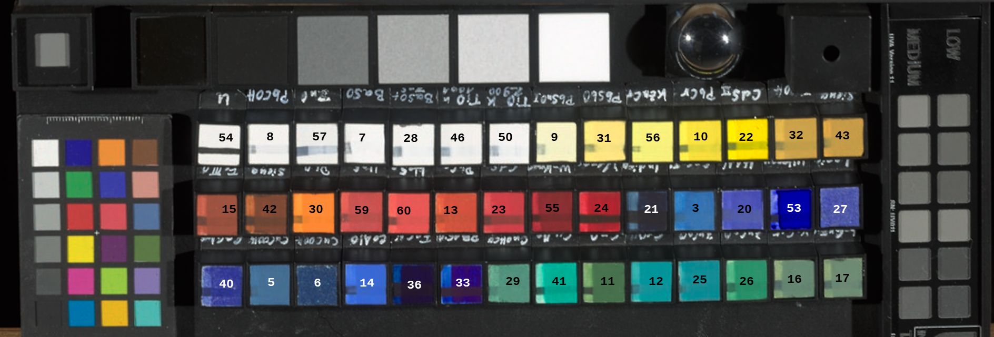
Figure S1. Calibration targets and pigment targets used for the multi-band technical imaging. List of the pigments is reported in Table S3.

Table S3. List of pigments used to prepare the pigment targets for the multi-band technical imaging. The origin or manufacturer are also listed for each pigment.
Number | Name | Provenance
54 | Primer made of calcium carbonate without pigment coating, black line of iron oxide black | Calcium carbonate from Kremer Pigmente
8 | Lead White | Collection Lenz (old painters' stock)
57 | Zinc White | Kremer Pigmente #46300
7 | Barium sulfate (natural) | Kremer Pigmente #58700
28 | Lithopone | Kremer Pigmente #46100
46 | Titanium White (Anatase) | Kronos #1001
50 | Titanium White (Rutile) | Kronos #2900
9 | Lead-Tin Yellow | Collection Lenz, probably Kremer
31 | Naples yellow | Collection ABK Stuttgart/Esslingen (old painters' stock)
56 | Zinc Yellow | Collection Lenz (dated around 1928)
10 | Chrome yellow | Collection Lenz (dated around 1928)
22 | Cadmium Yellow | Kremer Pigmente #21040
32 | Ochre | Deffner & Johann #1011000, Collection ABK Stuttgart/Esslingen
43 | Sienna natural | Kremer Pigmente #17050
15 | Red Iron Oxide | Collection Lenz, Kremer Pigmente (around 1992)
42 | Burnt Sienna | Kremer Pigmente #40430
30 | Red Lead | Kremer Pigmente #42500
59 | Cinnabar (natural) | Kremer Pigmente #10620
60 | Cinnabar (synthetic) | Collection Lenz (Atelier Ingenhoff)
13 | Chrome Red | Collection ABK Stuttgart/Esslingen, #307
23 | Cadmium Red | Kremer Pigmente #21130
55 | Madder Lake | Collection ABK Stuttgart/Esslingen
24 | Madder Lake (Krapplack) | Collection Lenz (Atelier Ingenhoff)
21 | Indigo | Sammlung Halle Esslingen, Aufschrift "Indigo echt" von Helmut Reichwald
3 | Egyptian Blue | Kremer Pigmente #10060
20 | HAN-Blue | Kremer Pigmente # 10072
53 | Ultramarine Blue | Collection ABK Stuttgart/Esslingen
27 | Lapislazuli | Afghanistan lapis lazuli
40 | Smalt | Kremer Pigmente #10000
5 | Azurite | Kremer Pigmente #1021
6 | Azurite | Collection ABK Stuttgart / Esslingen,in-house production, coarsest grain size
14 | Cobalt blue | Cobalt blue #2R, former Bayer production, Kremer (special item)
36 | Prussianblue | Collection Lenz, (Aterlier Ingenhoff)
33 | Phthalocyanine Blue | Kremer Pigments #23050
29 | Malachite | Kremer Pigmente #10300
41 | Verdigris | Collection Lenz
11 | Chrome Green | Collection ABK Stuttgart/Esslingen
12 | Chrome oxide hydrate green | Collection ABK Stuttgart/Esslingen
25 | Cobalt green II | Kremer Pigmente # 44151
26 | Cobalt green I | Collection Lenz, Schminke
16 | Veronese Green Earth | Collection ABK Stuttgart/Esslingen
17 | Bohemian Green Earth | Kremer Pigmente # 40810

Table S4 – List of the identified elements per each color observed in fragment V_005. One representative spot measurement was selected per color. Elements are listed in order of relative abundance, from left (most abundant) to right (least abundant). Elements likely responsible for the visible color are highlighted in bold.
Color | Point of analysis | Identified elements
Red | R21 | Zn, Ba, Ti(?), Se, Fe, Cd, Pb, Ca, S?, Hg(tr)
Red | R3 | Zn, Ba, Ti(?), Ca, Fe, Pb, Se, Cd, S?
Blue | B1 | Zn, Ba, Ti(?), Fe, Ca, Pb, S?
Grey | Gy19 | Zn, Ti, Ba, Fe, Ca, Pb, S?, K
Black | Bk16 | Zn, Ti, Ba, Ca, Fe, Mn, Pb, S?
Brown | Br4 | Zn, Ba, Ti, Fe, Ca, Pb, Mn, S?, K
Yellow | Y18 | Zn, Ba, Ti, Ca, Fe, Pb, S?, K
White | W6 | Zn, Ba, Ti, Ca, Pb, Fe, S?
Background | Bkg17 | Zn, Ca, Pb, Ti, Ba, Fe, S?

Figure S2. Results of the elemental distribution for map4 of V_005 Fragment. From left to right: stitched image and distribution of selected elements considering one X-ray line. The scale of intensity per each elemental distribution is independent and considers the maximum and minimum counts collected for the X-ray line considered. Only elements relevant to the discussion are displayed.

Table S5 – List of the identified elements per each color observed in fragment V_006. One representative spot measurement was selected per color. Elements are listed in order of relative abundance, from left (most abundant) to right (least abundant). Elements likely responsible for the visible color are highlighted in bold.
Color | Point of analysis | Identified elements
Black | Bk5 | Ca, Zn, Ba, Ti?, Fe, Pb, Se, Cd?, S?
Orange | O6 | Ca, Zn, Ba, Ti?, Fe, Pb, Se, Cd, S?
Orange | O3 | Ca, Zn, Ba, Ti?, Fe(+), Pb, Se, Cd(tr), S?
White | W1 | Ca, Ti, Ba, Zn, Fe, Pb, Se, Cd?, S?

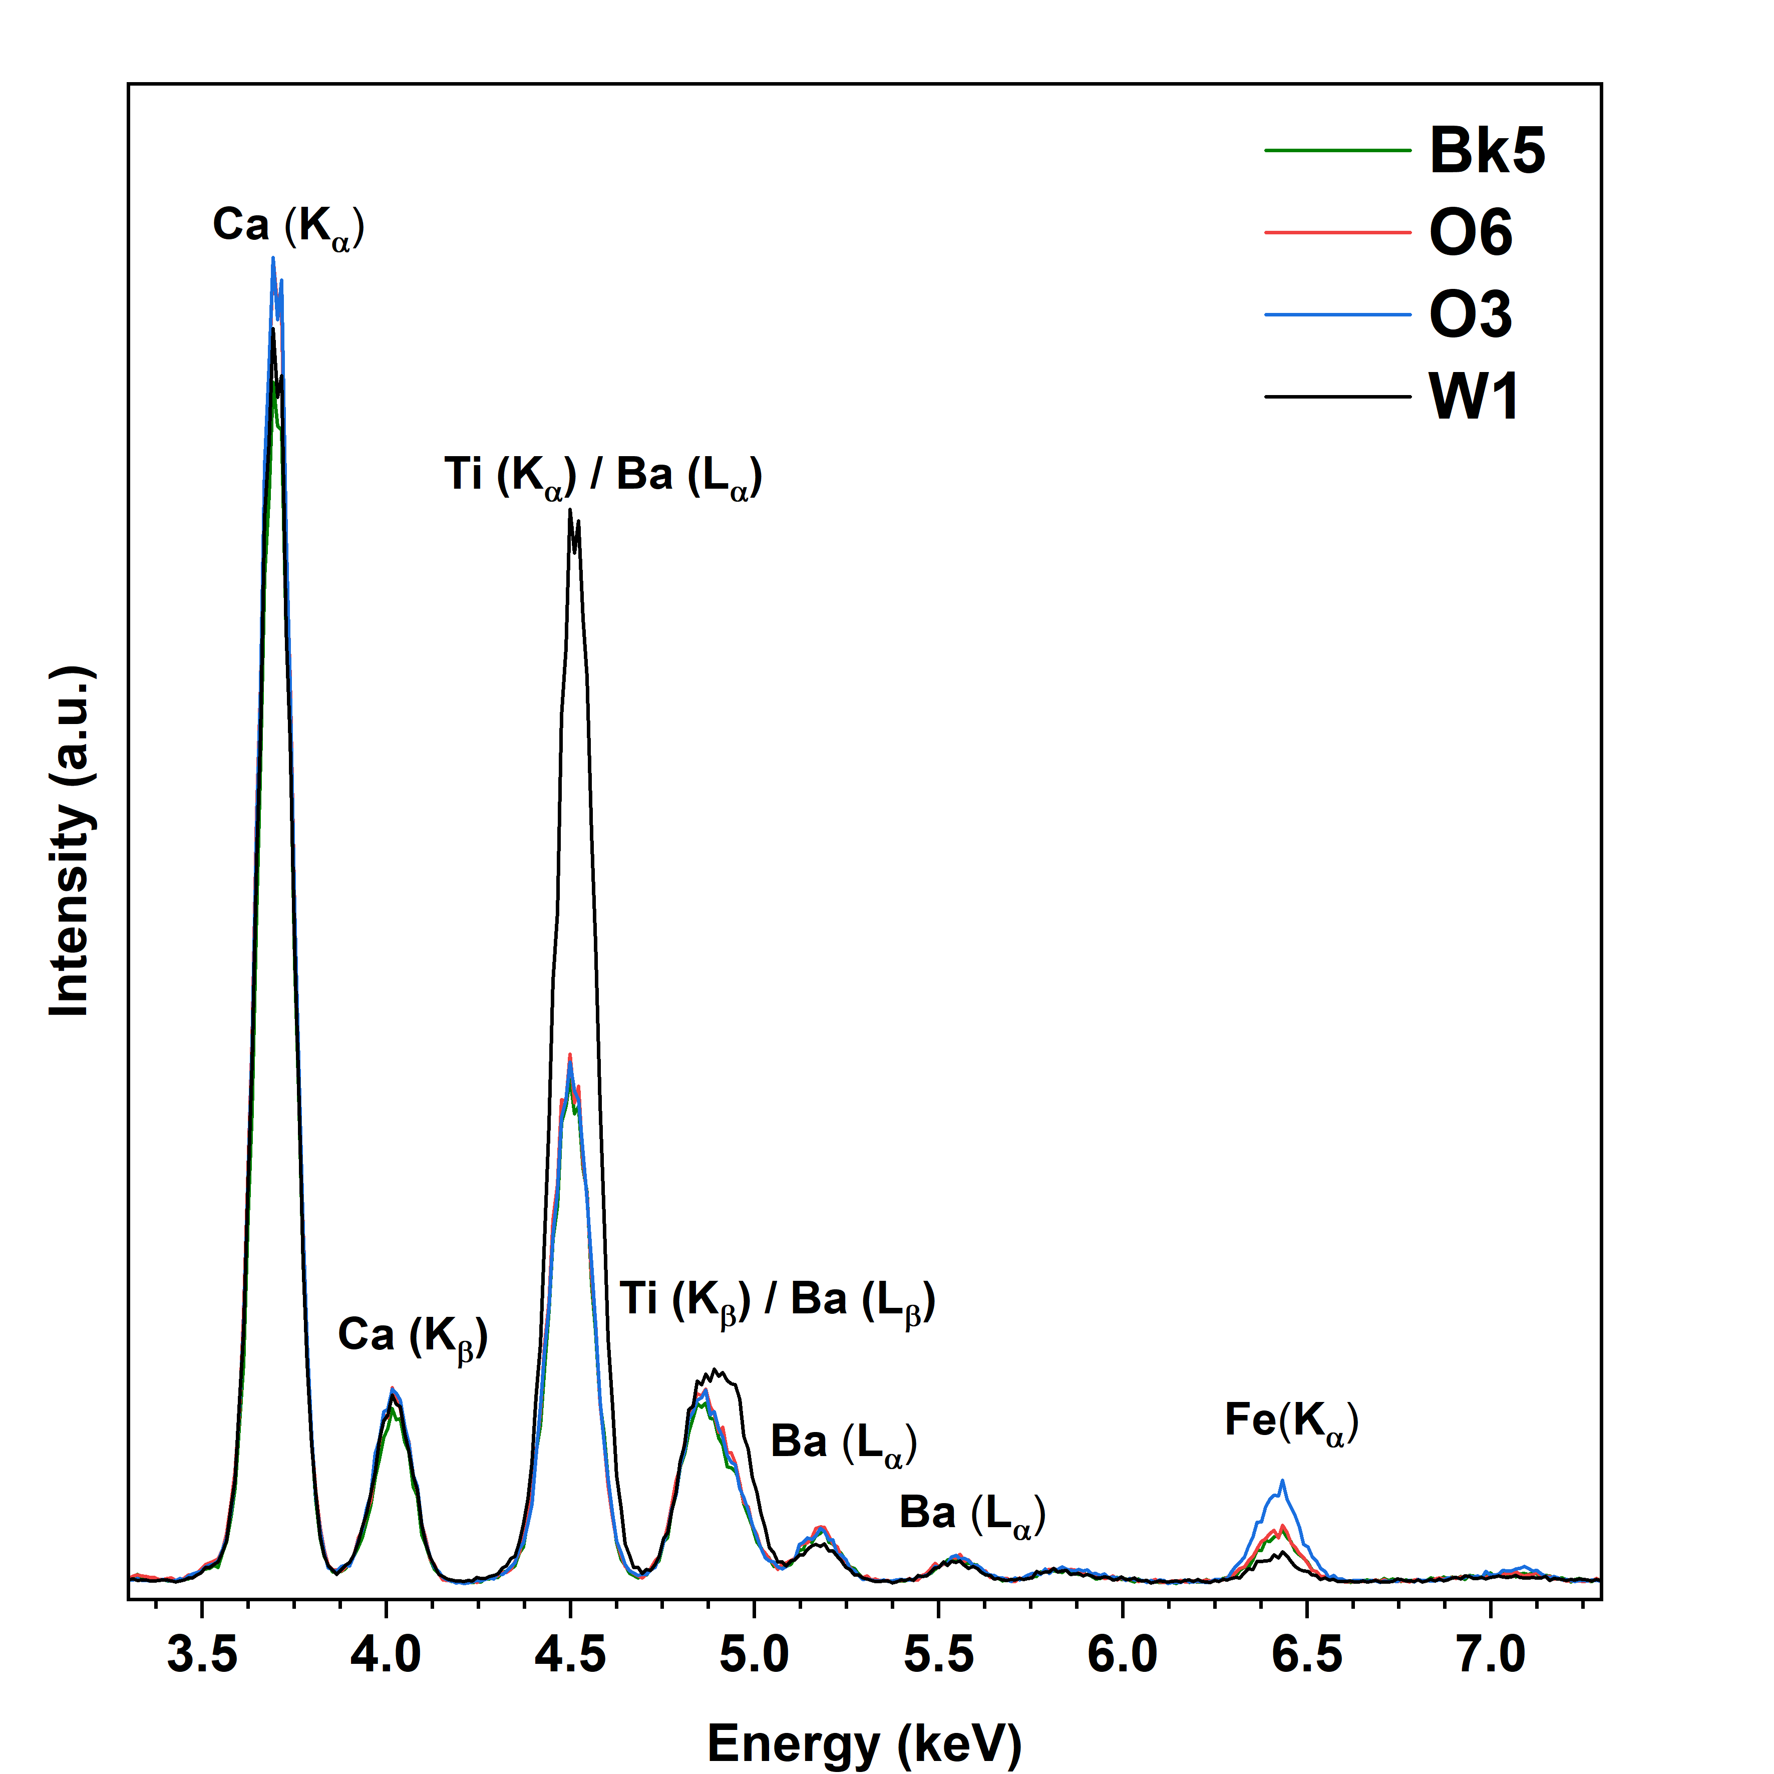
Figure S3. XRF spectra of a selection of spot analysis of the fragment V_006. Location of the spot analysis see Figure 4a.

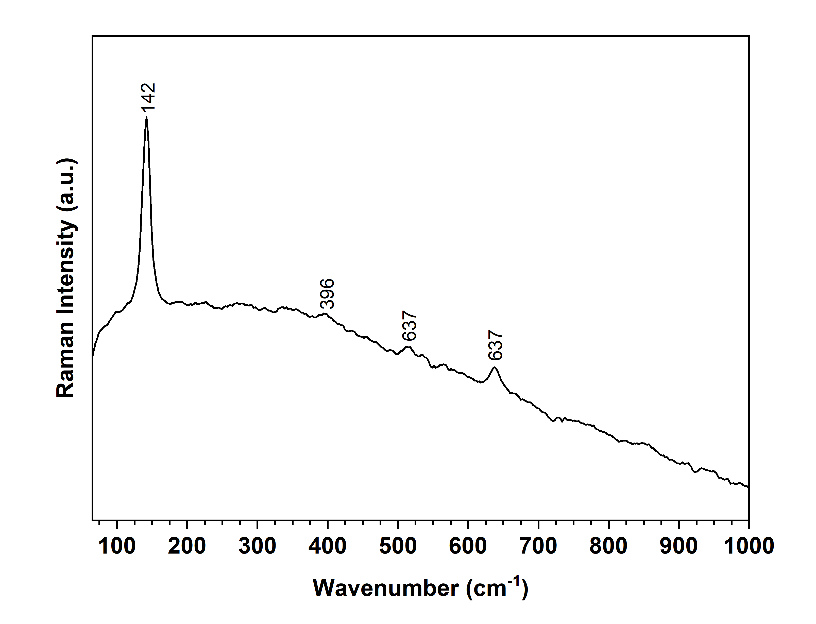
Figure S4. Raman in W1 of fragment V_006. Location of the spot analysis see Figure 4a.

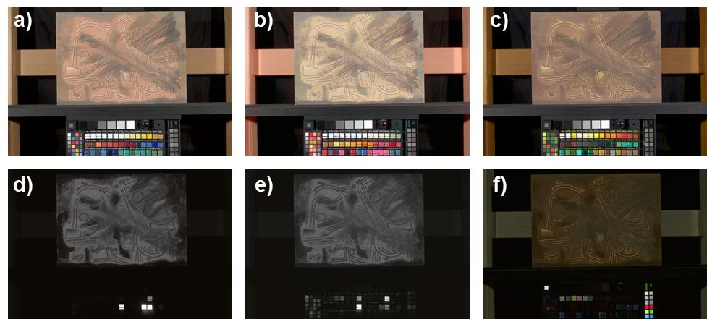
Figure S5. Multiband imaging set of fragment V_006. The pigment targets are placed in the bottom part of the image for comparison. a) VIS-R_vis, b) IRFC; c) UVFC, d) IR-L_vis, e) IR-L_uv, f) VIS-L_uv. Spectrally relevant for the discussion was observed for titanium dioxide (anatase) (n. 46) in (c), cadmium yellow (n. 22) and cadmium red (n. 23) in (d,e,f). In VIS-L_uv (f), zinc white (n. 57) is the unique white pigment presenting a yellow luminescence.

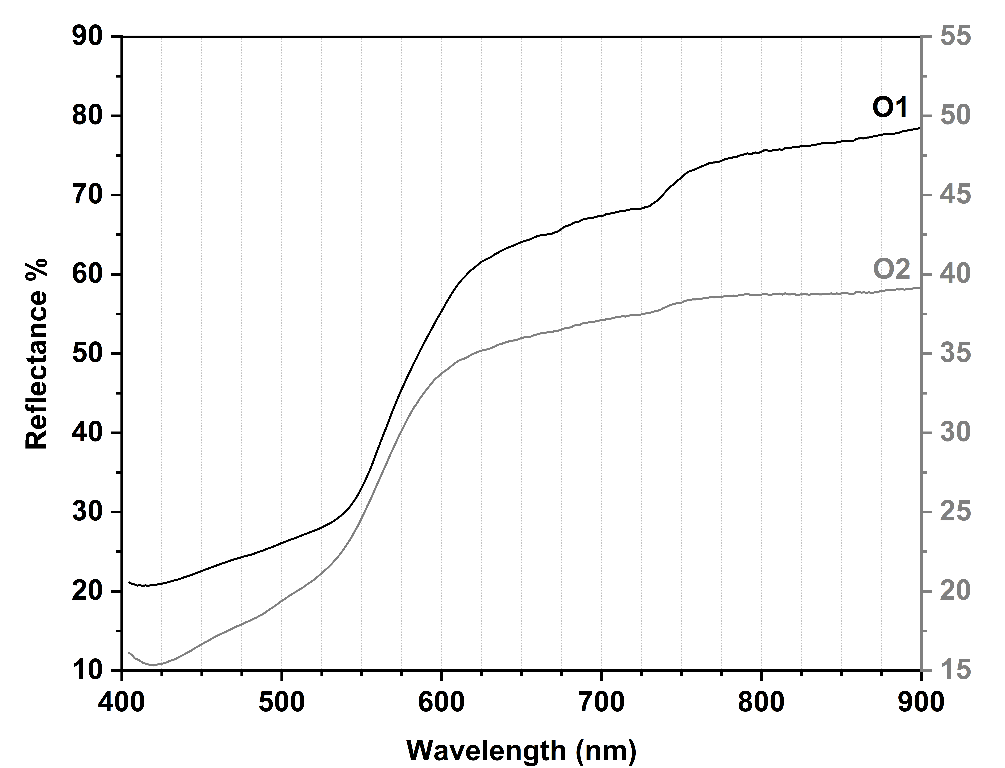
Figure S6. Reflectance spectra extracted from the image-cube acquired for fragment V_006 at the areas reported in Figure 4a.

Figure S7. VIS-R_vis details of the fragment V_013 displaying the cracking of the black paint and revealing underneath colors.

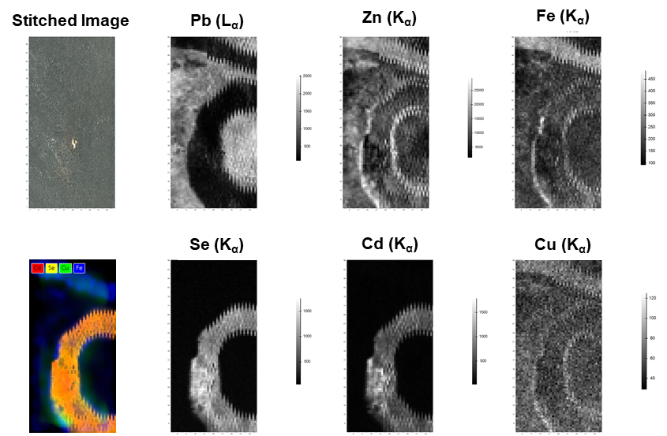
Figure S8. Results of the elemental distribution for map2 of V_013 Fragment (see Figure S11). From left to right: stitched image and distribution of selected elements considering one X-ray line. The scale of intensity per each elemental distribution is independent and considers the maximum and minimum counts collected for the X-ray line considered. Only elements relevant to the discussion are displayed. For the location of the mapping, see Figure 5a.
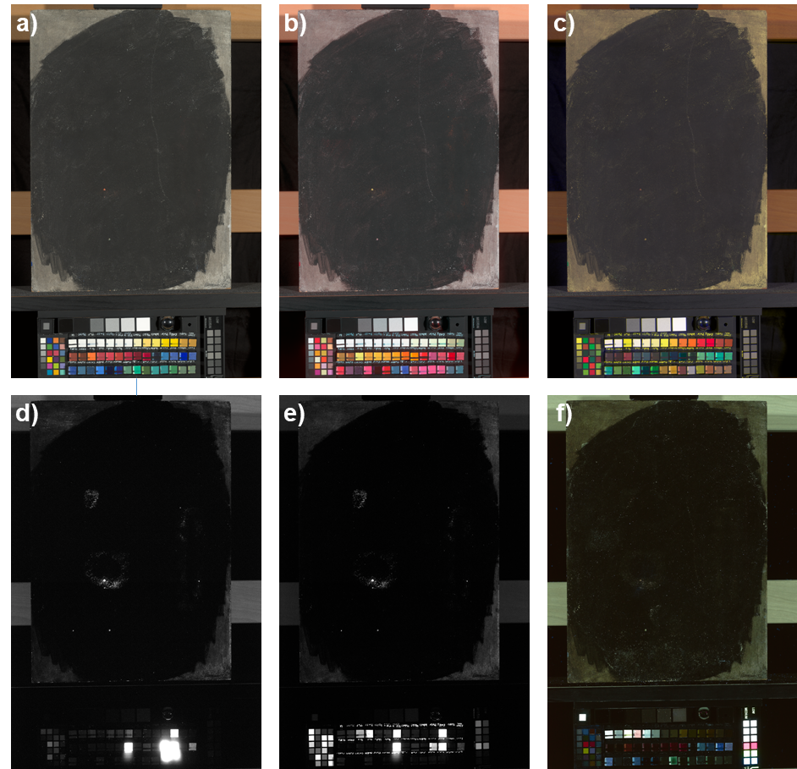
Figure S9. Multiband imaging set of fragment V_005. The pigment targets are placed in the bottom part of the image for comparison. a) VIS-R_vis, b) IRFC; c) UVFC, d) IR-L_vis, e) IR-L_uv, f) VIS-L_uv. Luminescence relevant for the discussion was observed for cadmium yellow (n. 22) and cadmium red (n. 23) in (d) and (e).

