Supplemental materials

Transcriptome-based identification and expression profiling of AP2/ERF members in Caragana intermedia and functional analysis of CiDREB3
Kun Liu^{1,2*}, Qi Yang^{2,*}, Tianrui Yang^{2,*}, Feiyun Yang^{2,3}, Ruigang Wang², Jingyu Cong^{2#}, Guojing Li^{2#}
¹ College of Agronomy, Inner Mongolia Agricultural University, Hohhot 010019, China
² Inner Mongolia Key Laboratory of Plant Stress Physiology and Molecular Biology, College of Life Sciences, Inner Mongolia Agricultural University, Hohhot, 010018, People’s Republic of China
³ College of Food Sciences and Engineering, Inner Mongolia Agricultural University, Hohhot, 010018, People’s Republic of China
* These authors contributed equally to this work.
# Corresponding Author:
Guojing Li and Jingyu Cong
29 East Erdos Street, Saihan District, Hohhot, Inner Mongolia, 010018, China
Email address: liguojing@imau.edu.cn and congjingyuwyh@163.com

Supplemental Figures
Supplementary Fig. S1 Phylogenetic evolution analysis of the AP2/ERF transcription factors in C. intermedia A1 to A6: DREB subfamily; B1 and B3: ERF subfamily; RAV: RAV subfamily

Supplementary Fig. S2 Phylogenetic analysis of DREB A1 group members in C. intermedia, M. truncatula and A. thaliana The black circle represents the group members of DREB A1 in C. intermedia

Supplementary Fig. S3 Phylogenetic analysis of DREB A2 and A3 group members in C. intermedia, M. truncatula and A. thaliana A2 and A3: DREB subfamily; The black circle represents the group members of DREB A2 in C. intermedia

Supplementary Fig. S4 Phylogenetic analysis of DREB A4 and A5 group members in C. intermedia, M. truncatula and A. thaliana a: DREB A4 subfamily; b: DREB A5 subfamily; The black circle represents the group members of DREB A4 and A5 in C. intermedia

Supplementary Fig. S5 Phylogenetic analysis of DREB A6 group members in C. intermedia, M. truncatula and A. thaliana The black circle represents the group members of DREB A6 in C. intermedia

Supplementary Fig. S6 Phylogenetic analysis of ERF B1, B2 and B4 group members in C. intermedia, M. truncatula and A. thaliana a: ERF B1 subfamily; b: ERF B2 and B4 subfamily; Black circle represents the group members of ERF B1 in C. intermedia

Supplementary Fig. S7 Phylogenetic analysis of ERF B3 group members in C. intermedia, M. truncatula and A. thaliana The black circle represents the group members of ERF B3 in C. intermedia

Supplementary Fig. S8 Phylogenetic analysis of ERF B5, B6 and RAV group members in C. intermedia, M. truncatula and A. thaliana a: ERF B5 subfamily; b: ERF B6 subfamily; c: RAV subfamily; Black circle represents the group members of RAV subfamily in C. intermedia

Supplementary Fig. S9. Homology modeling of the tertiary structure of the AP2/ERF transcription factors from C. intermedia
a: DREB A1 subfamily; b: DREB A2 subfamily; c: DREB A4 subfamily; d: DREB A5 subfamily; e: DREB A6 subfamily; f: ERF B1 subfamily; g: ERF B3 subfamily; h: RAV1 subfamily;

Supplementary Fig. S10 Analysis of the expression pattern of the genes encoding the AP2/ERF transcription factors in C. intermedia under various stress treatments. Cold treatment: 4°C; heat treatment: 42°C; salt treatment: 200 mM NaCl solution; mannitol treatment: 300 mM mannitol solution. The results of the qRT-PCR were subjected to LOG2 normalization, and the heat map was then plotted using Heml 1.0 software. The different colors indicate different gene expression levels. Specifically, red indicates a high gene expression level, green indicates a low gene expression level, and black indicates that the expression level is virtually zero.

Supplementary Fig. S11 Expression level of the T₃ homozygotes of CiDREB3 transgenic Arabidopsis
OE1~OE51 means transgenic line 1 to transgenic line 51. The result was calculated by 2^{-ΔCt} methods. The reference gene was AtEF1α. The experimental results were carried out in 2 biological repeats.

Supplemental Figures
Supplementary Fig. S1
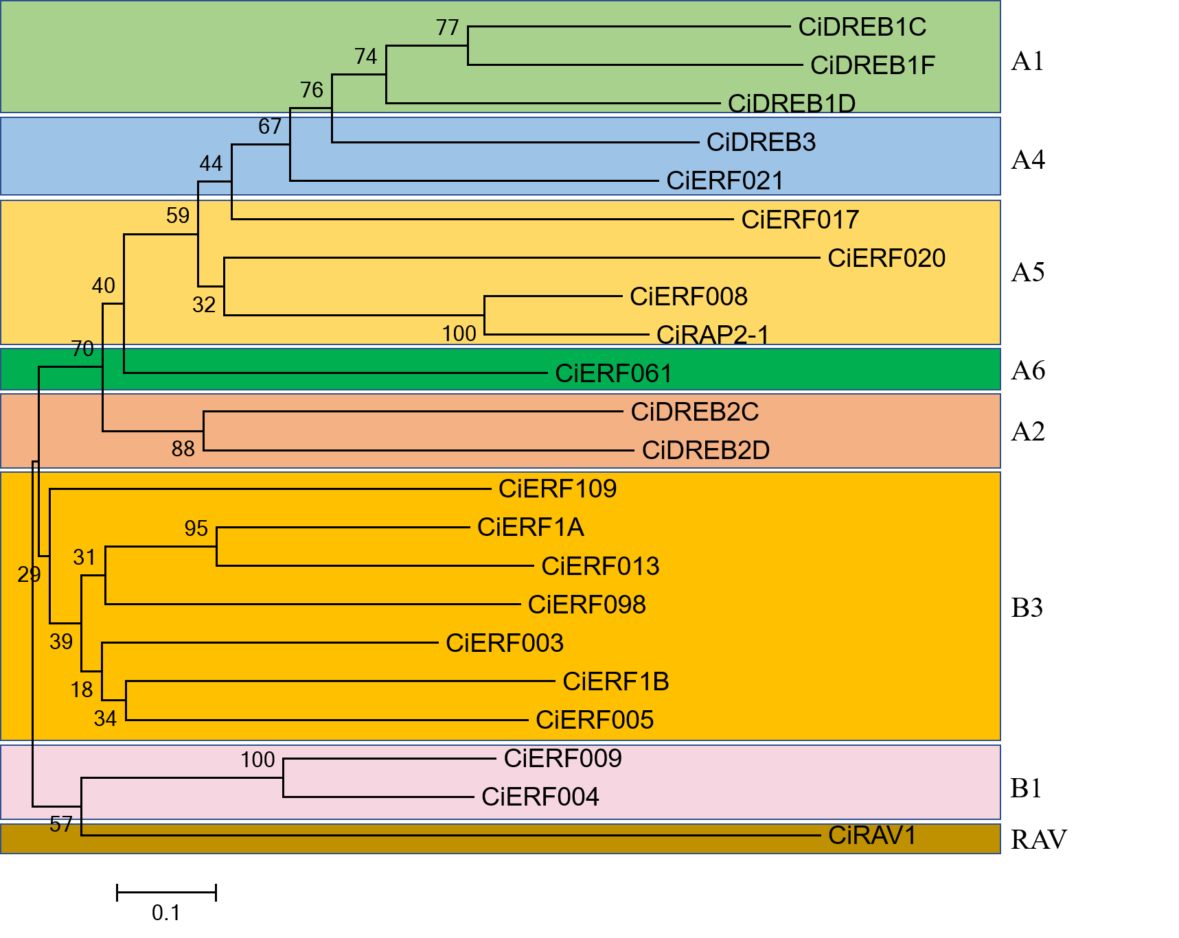

Supplementary Fig. S2
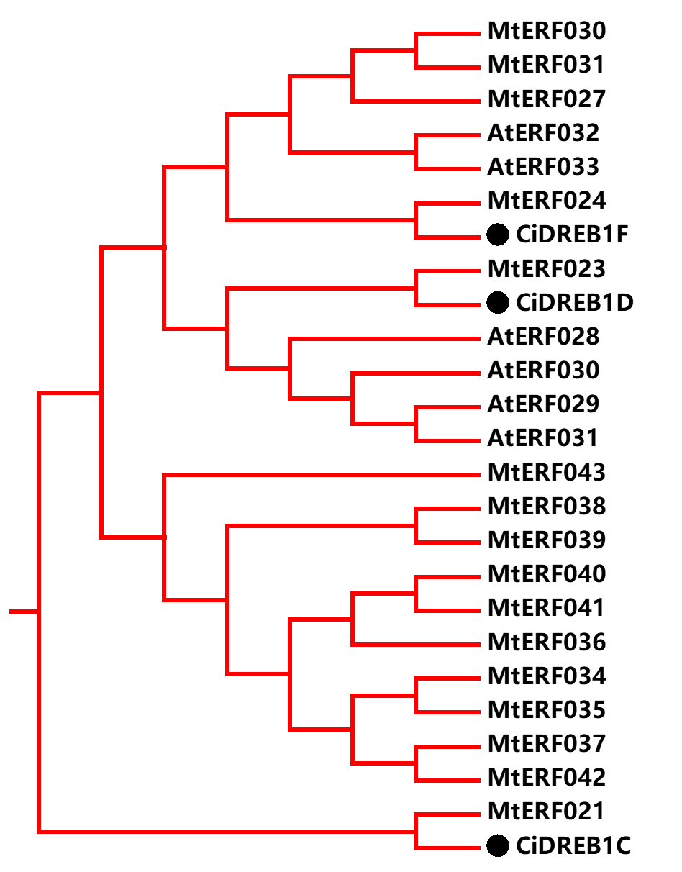

Supplementary Fig. S3
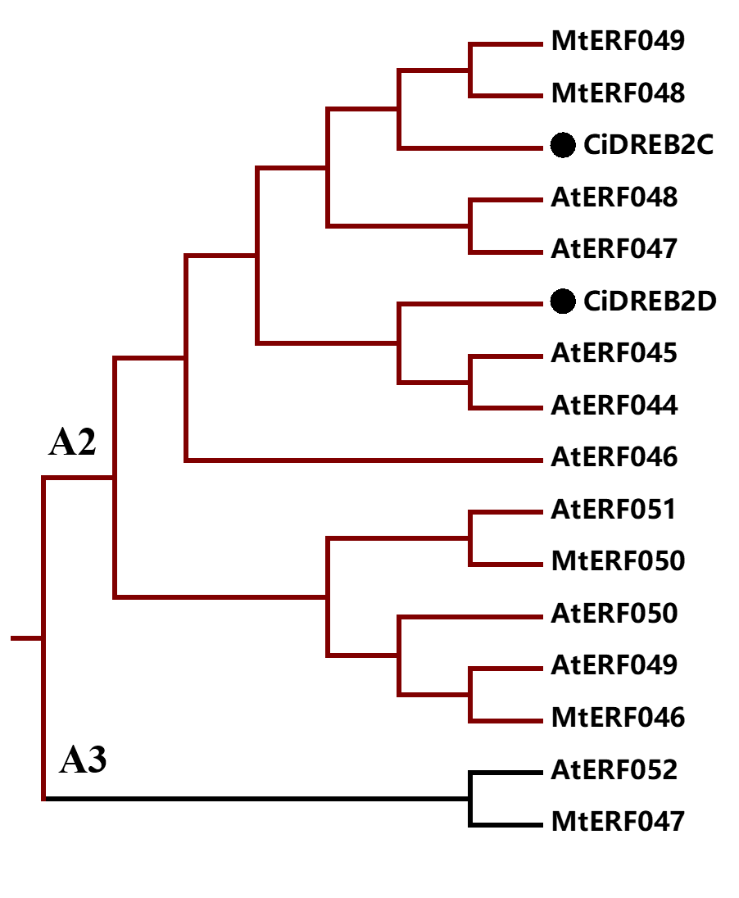

Supplementary Fig. S4
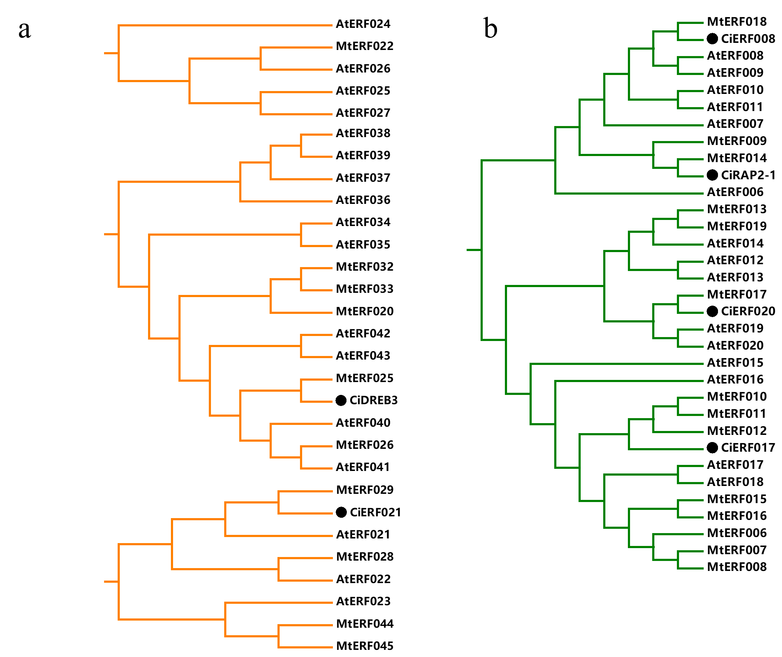

Supplementary Fig. S5
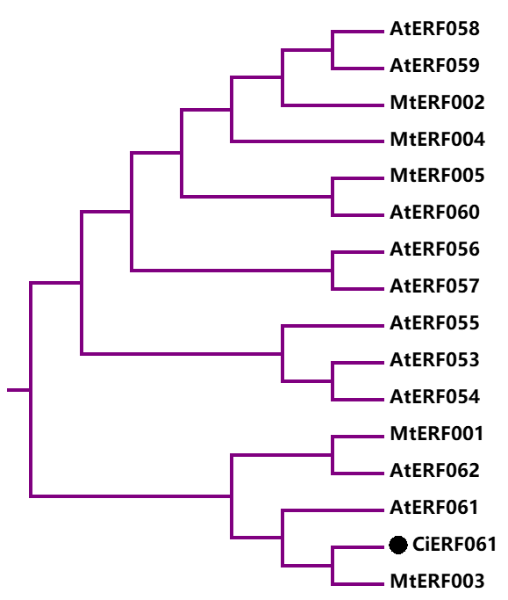

Supplementary Fig. S6
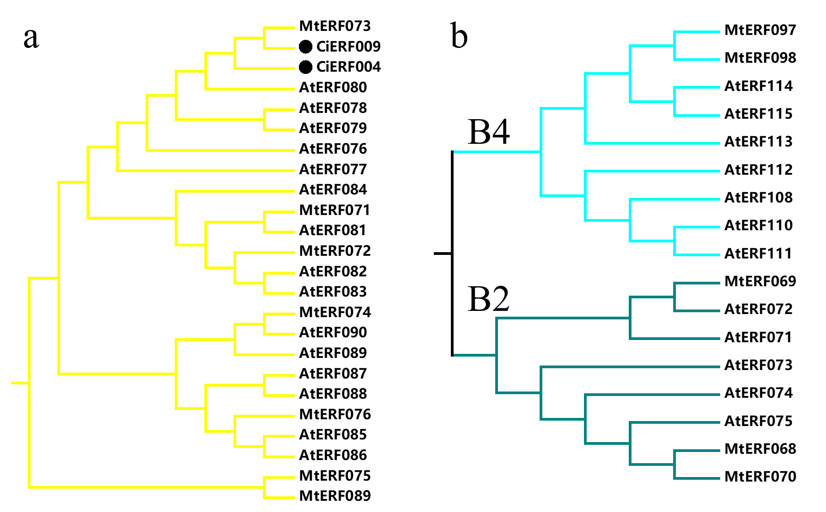

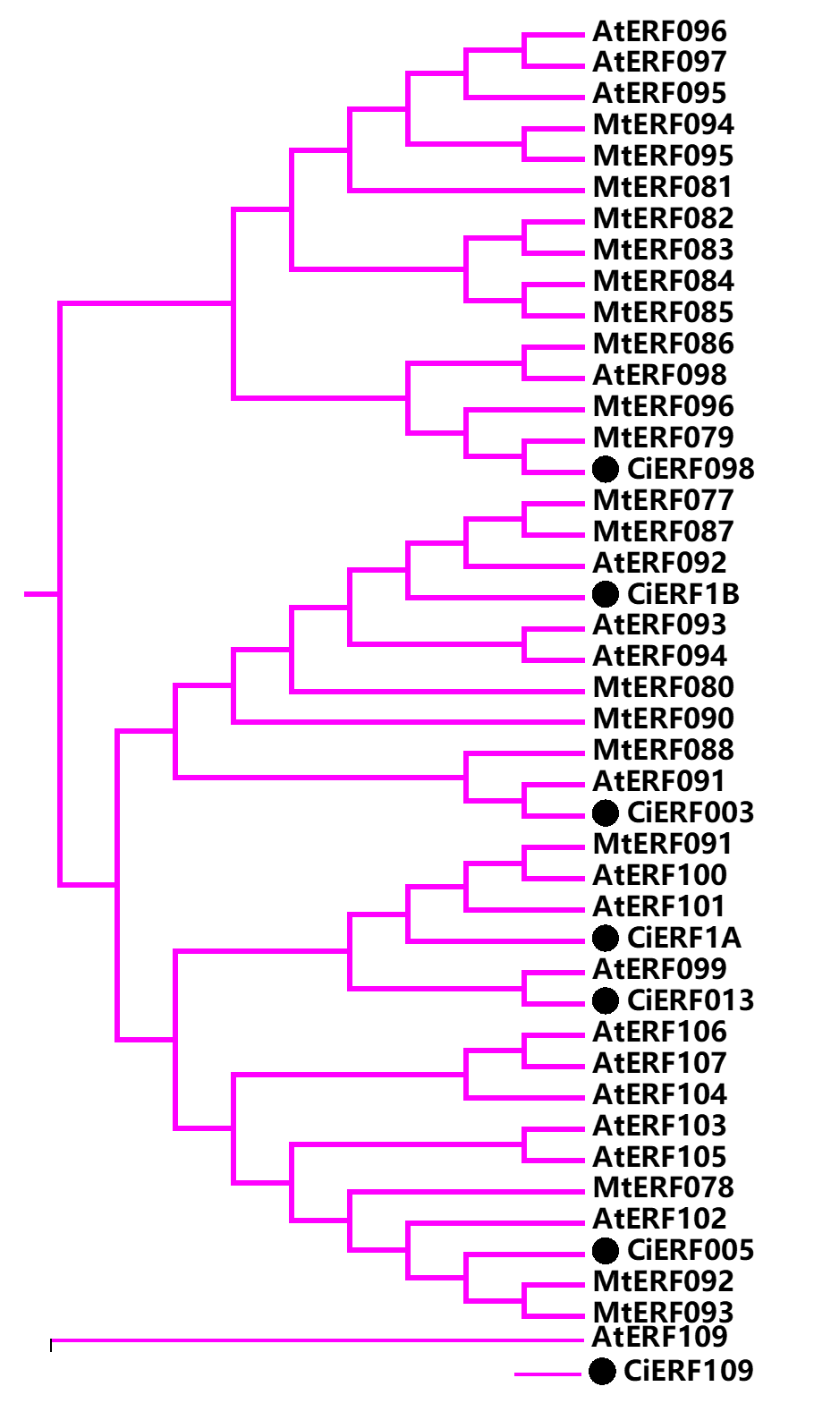
Supplementary Fig. S7

Supplementary Fig. S8
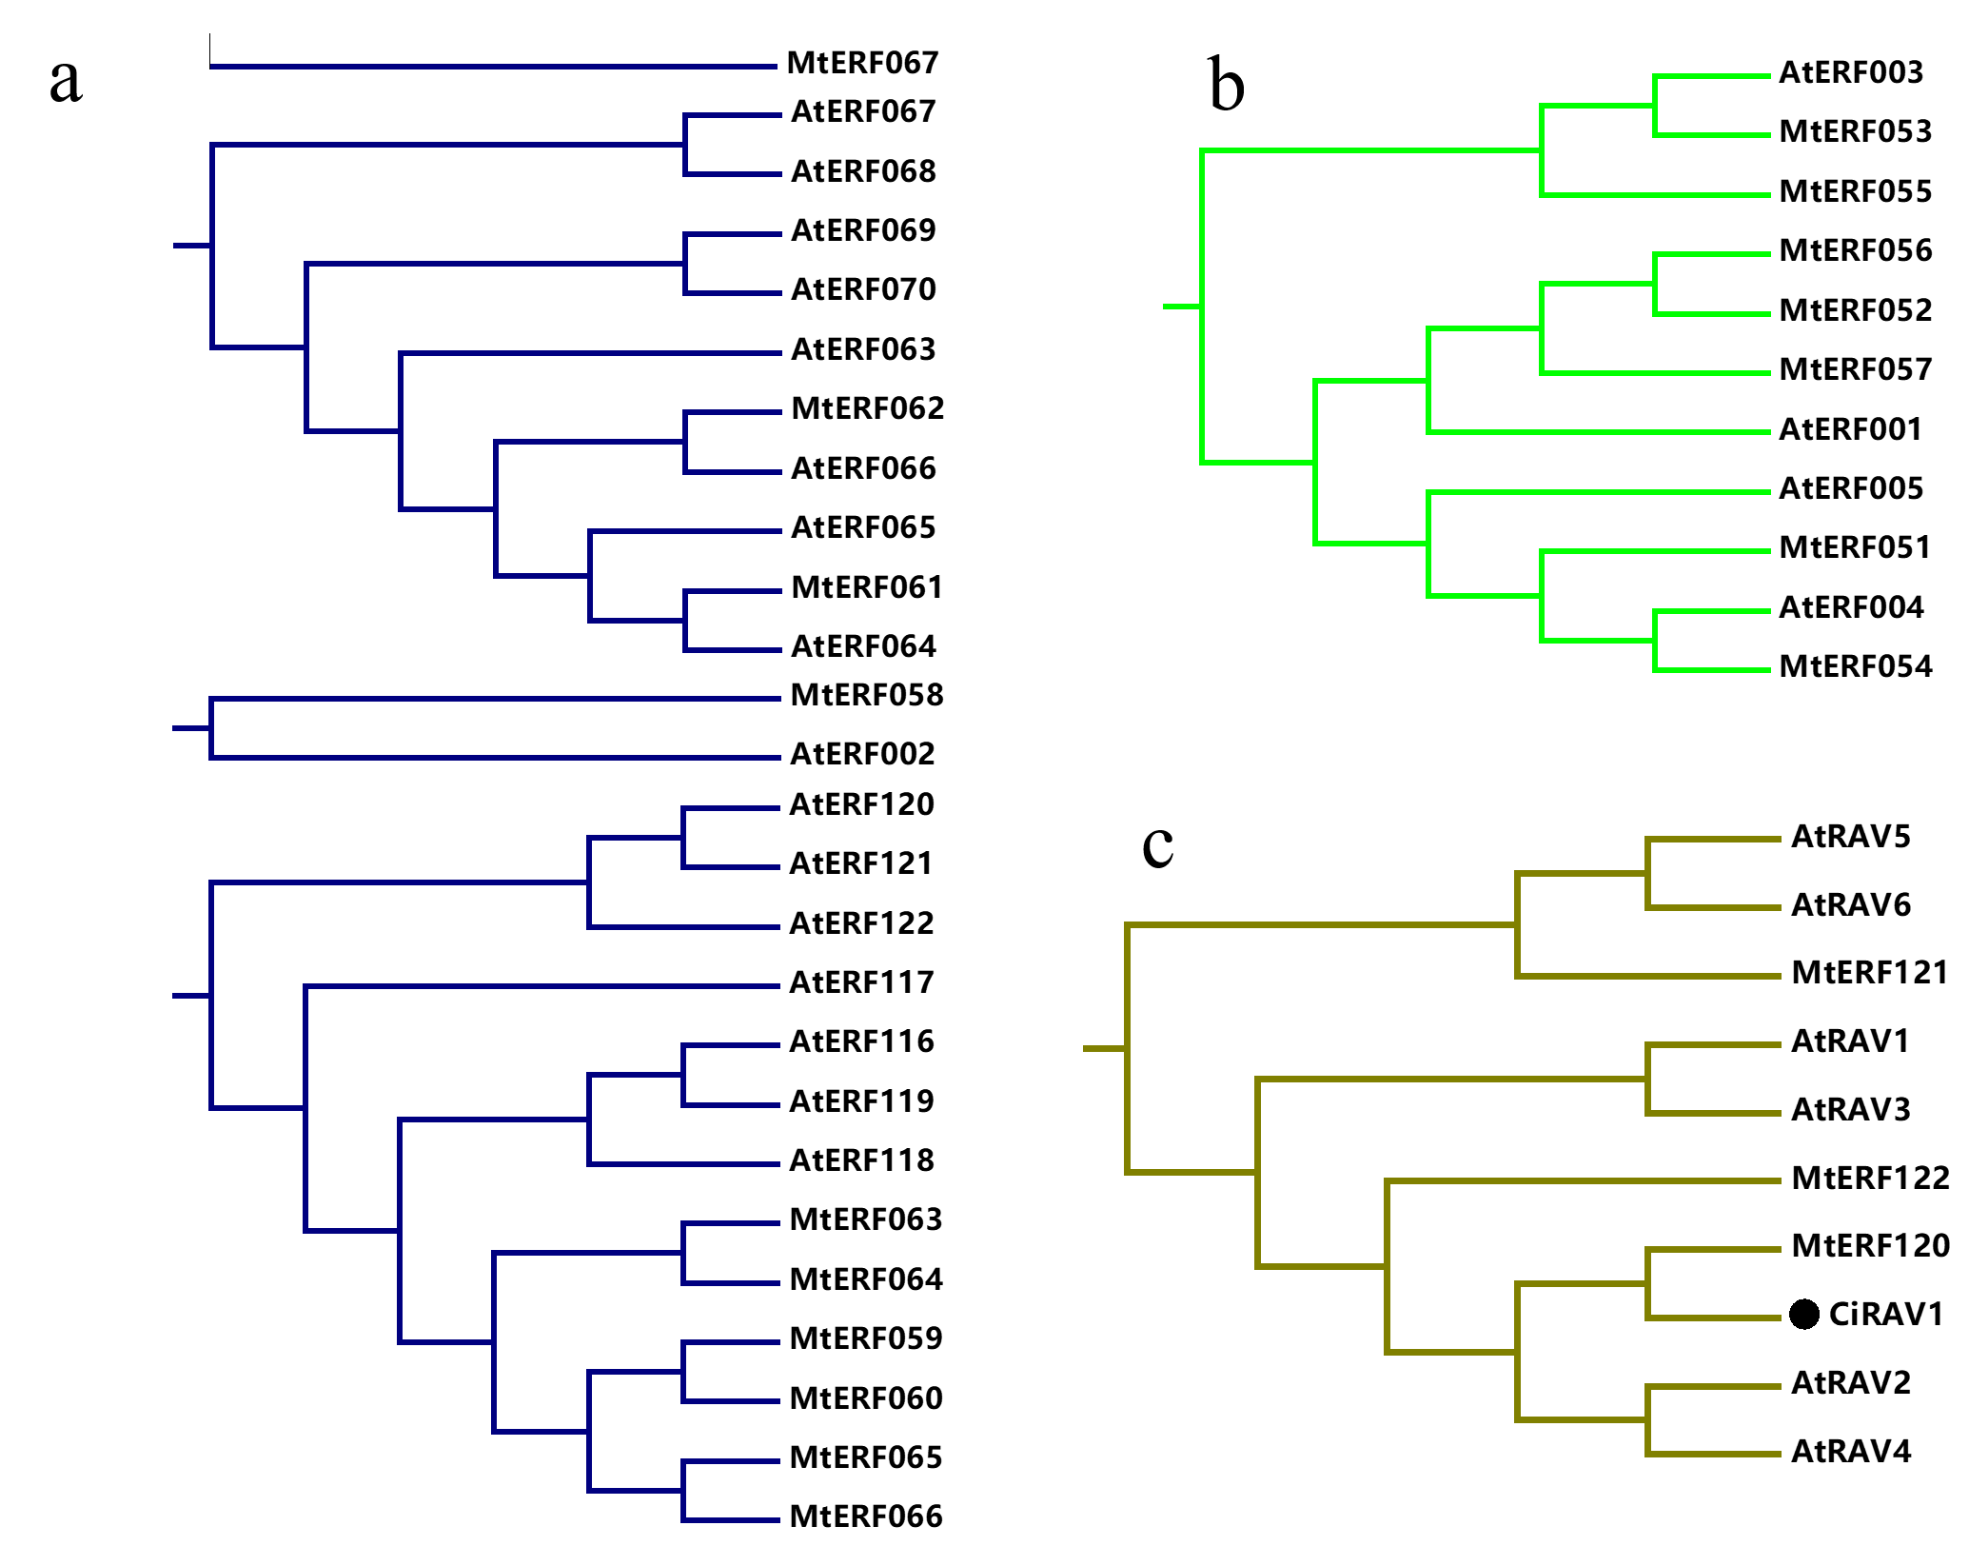

Supplementary Fig. S9.
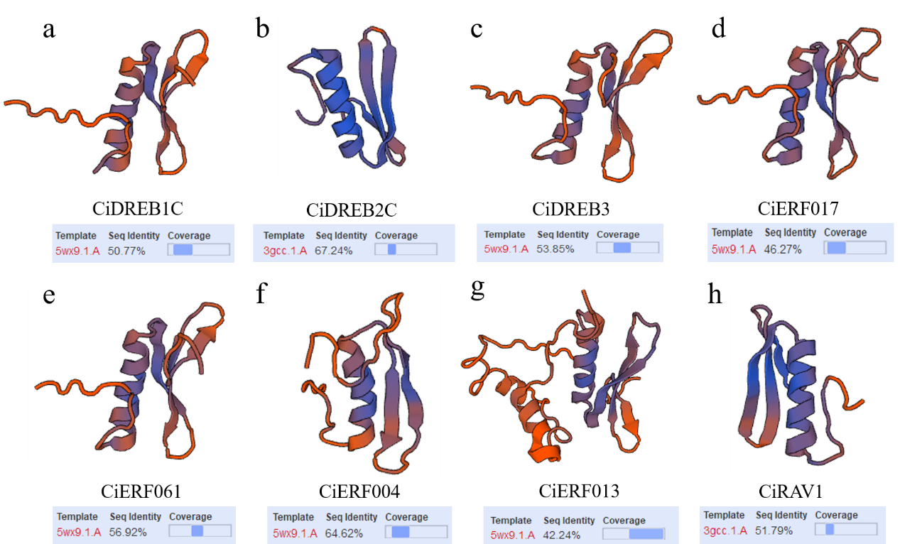

Supplementary Fig. S10
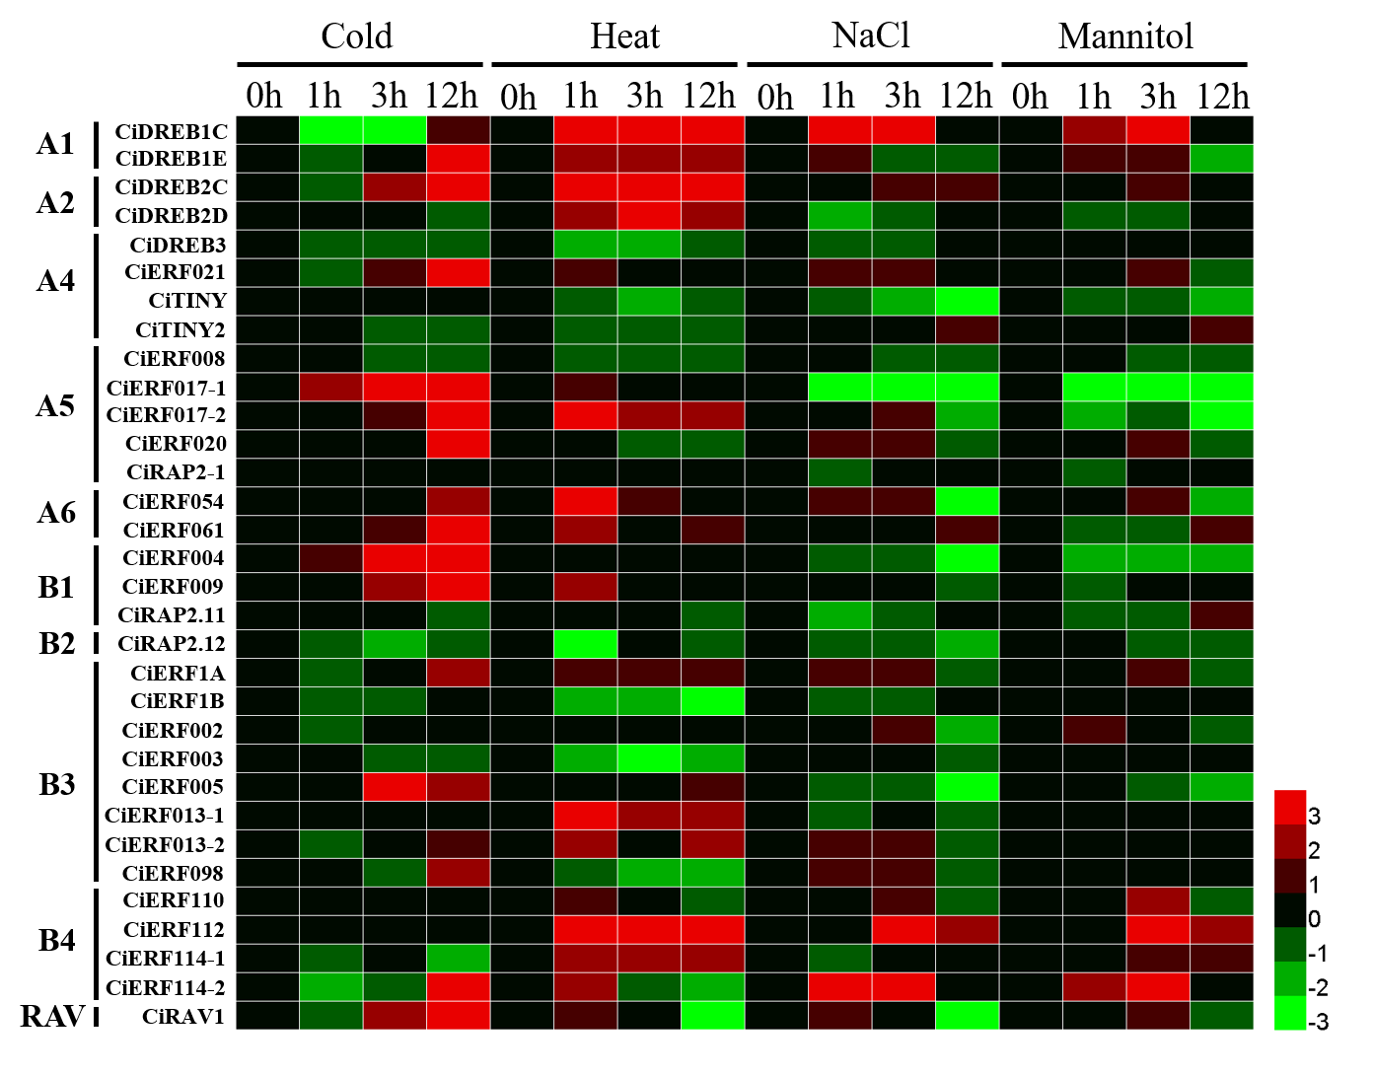

Supplementary Fig. S11

