SUPPLEMENTARY INFORMATION
EF-FACS circulating tumor cell detection complements ctDNA-based prognosis in stratification of non-small cell lung cancer patients
Maria Virginia Sanchez-Becerra^{1,2,3}, Marianne Oulhen^{1,2*}, Damien Drubay^{4,5}*, Jordi Remon³, Maud Ngo-Camus⁶, Claudio Nicotra⁶, Fabrice Malergue⁷, Jean Marc Busnel⁷, Nathalie Droin⁸, Agathe Aberlenc^{1,2}, Bastien Job⁹, Betty Leite⁸, Antoine Italiano⁶, David Planchard³, Benjamin Besse³, Françoise Farace^{1,2 $#}, Patrycja Pawlikowska^{1,2,$}
¹ Gustave Roussy, Université Paris-Saclay, “Rare Circulating Cells” Translational Platform, CNRS UMS3655 – INSERM US23 AMMICA, F-94805, VILLEJUIF France.² INSERM, U981 “Identification of Molecular Predictors and new Targets for Cancer Treatment”, F-94805, VILLEJUIF France.³ Gustave Roussy, Université Paris-Saclay, Department of Medicine, F-94805, VILLEJUIF France.⁴ Gustave Roussy, Office of Biostatistics and Epidemiology, Université Paris-Saclay, Villejuif, France.⁵ Inserm, Université Paris-Saclay, CESP U1018, Oncostat, Villejuif, France.⁶ Gustave Roussy, Drug Development Department (DITEP), VILLEJUIF France.⁷ Beckman Coulter, Life Sciences, Marseille, France.⁸ Gustave Roussy, Université Paris-Saclay, Genomic Platform, CNRS UMS3655 – INSERM US23 AMMICA, F-94805, VILLEJUIF France.⁹ Gustave Roussy, Université Paris-Saclay, Bioinformatics Platform, CNRS UMS3655 – INSERM US23 AMMICA, F-94805, Villejuif, France
*$These authors contributed equally to this work
# Corresponding author: Dr Françoise Farace, Gustave Roussy, Université Paris-Saclay, “Rare Circulating Cells” translational laboratory, CNRS UMS3655 – INSERM US23 AMMICA, F-94805, VILLEJUIF France Phone: (33)142115198.Email: francoise.farace@gustaveroussy.fr

- Supplementary Figures
- Supplementary Tables

- SUPPLEMENTARY FIGURES
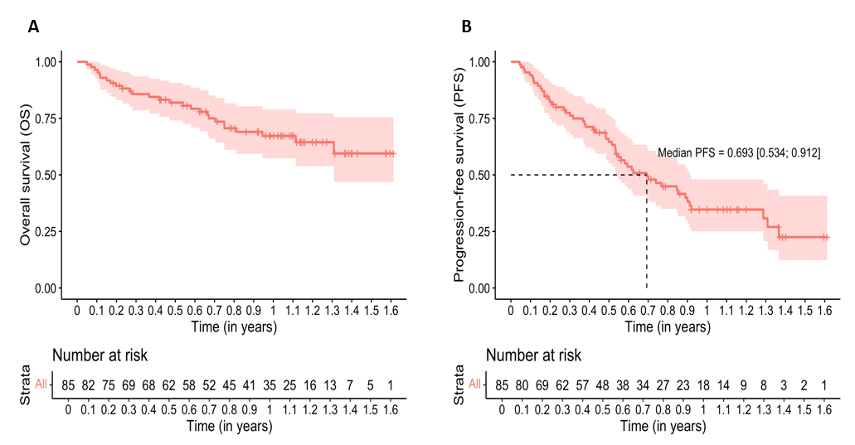
Supplementary Figure S1. Kaplan Meier curves for the whole population. A. Overall Survival;
B. Progression Free Survival.

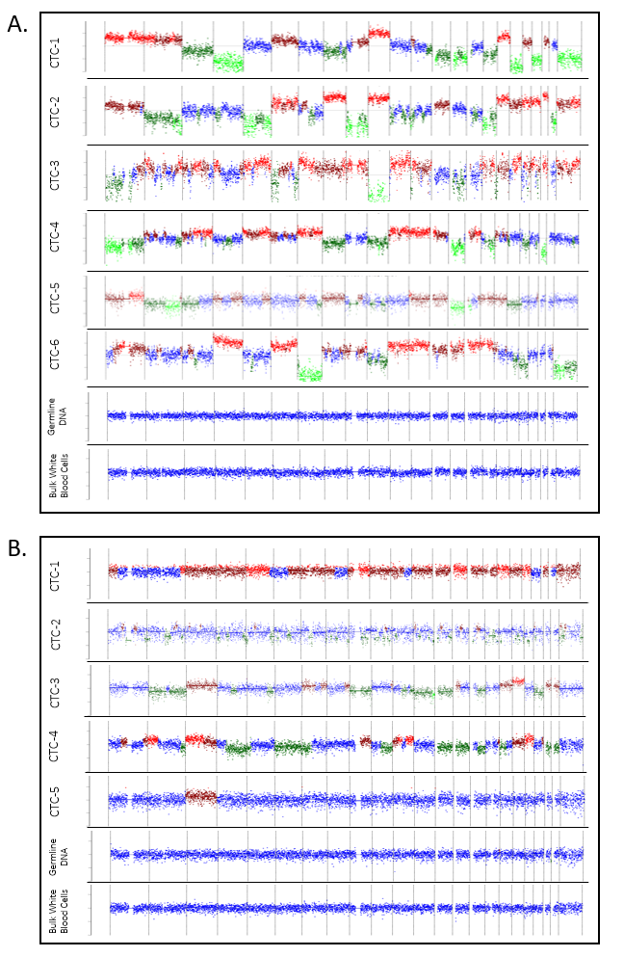
Supplementary Figure S2. Single-CTC, germline DNA and bulk of White Blood Cells Copy Number (CN) profile of two representative patients (A and B, respectively). Aberrant CN profiles permitted confirmation of malignancy of rare events detected by FACS. The profiles show the intra- and inter-tumor heterogeneity of CTCs.

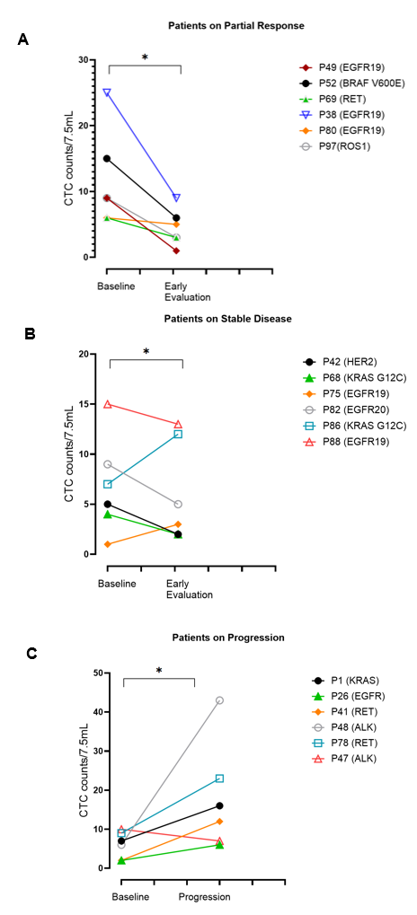
Figure S3. Role of EF-FACS CTC counts on on monitoring treatment response to target therapy. A. CTC count changes (baseline vs early timepoint) in patients under target therapy obtaining a Partial Response on first radiological evaluation B. CTC count changes (baseline vs early timepoint) in patients under target therapy obtaining a Stable Disease on first radiological evaluation. C. CTC count changes (baseline vs progression) in patients under target therapy. (Wilcoxon signed rank test p<0,05)

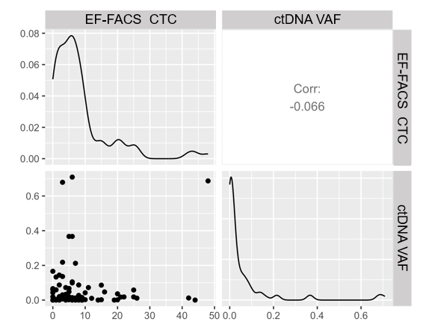
Supplementary Figure S4. Pearson correlation of CTC counts and ctDNA by continuous analysis showing independency of both variables.

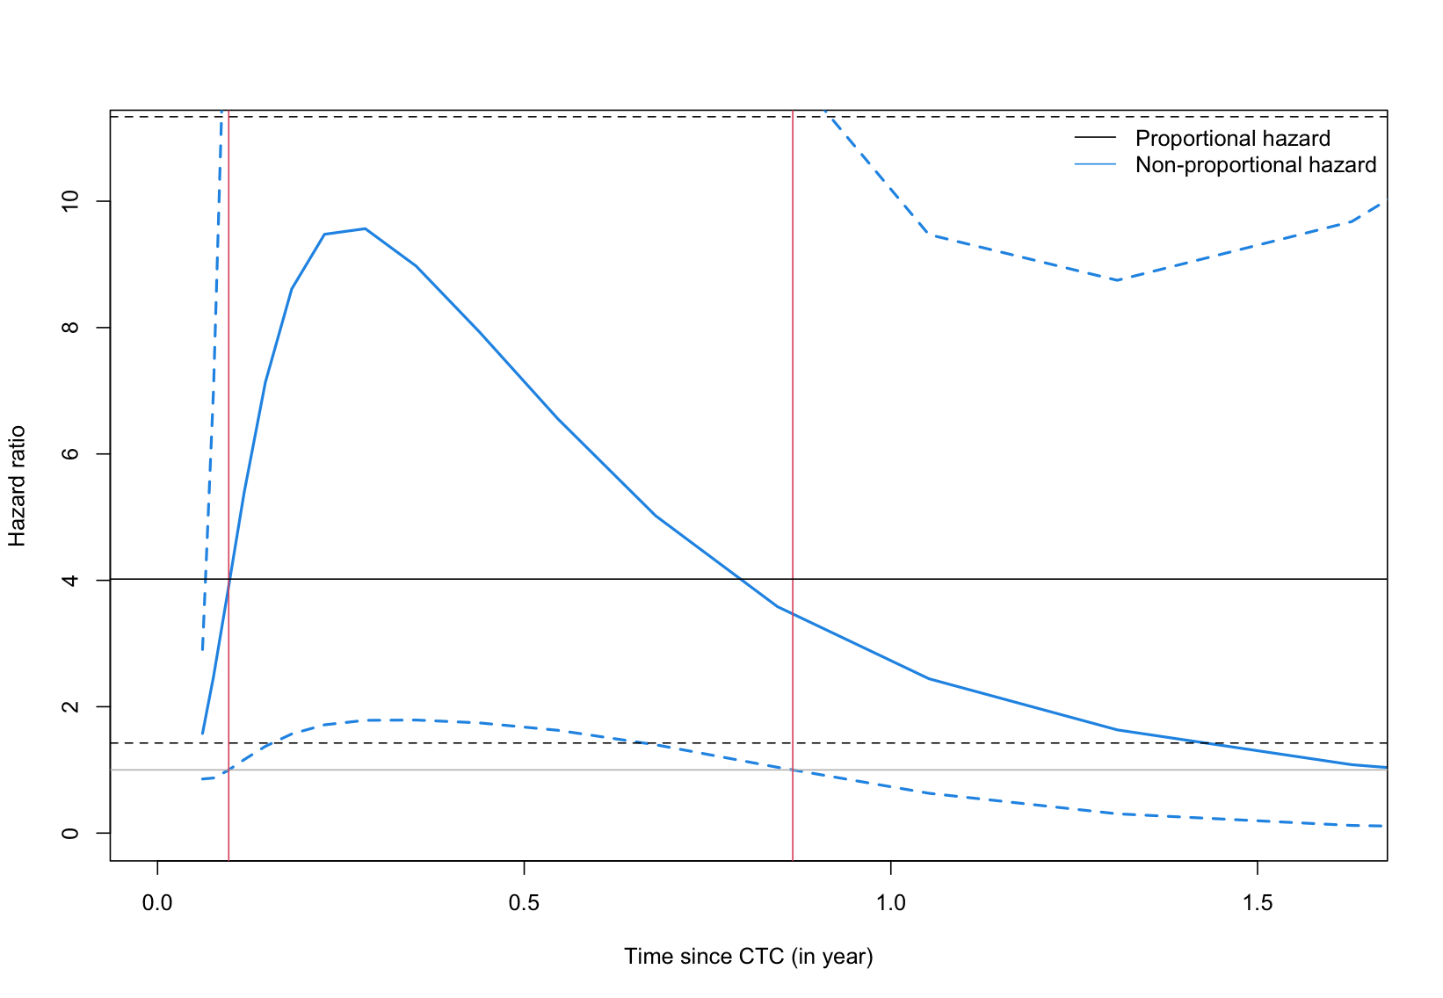
Supplementary Figure S5. Time-varying impact of the CTC counts on survival. Time-varying hazard ratio of the binarized CTC count using the cutoff of 5. The black line represents the hazard ratio under the proportional assumption and the blue solid line represents the time varying hazard ratio. The dotted lines represent their 95% confidence intervals. The red lines delimit the time windows during which there was an increased risk associated with the presence of CTC.

- SUPPLEMENTARY TABLES
Spiked Cells | No. of Repetition | Detection rate % | Median cell detected/7,5ml [range]
0 | 7 |  | 0,4 [0-2]
10 | 3 | 90 | 9 [8-10]
20 | 3 | 84 | 17 [16-19]
50 | 4 | 81 | 40 [36-44]
75 | 4 | 76,5 | 56 [39-73]
100 | 5 | 84,2 | 84 [68-97]
Supplementary Table S1. Linear Correlation Analysis of PC9 cells spiked in healthy donor blood samples undergoing an EF-FACS workflow. The table summarizes the quantities of spiked PC9 cells, the number of repetition of the experiment, detection rate (spiked vs FACS detected cells) and the median number of detected cells and the corresponding range.

 |  | Counts of CTC by CellSearch |  |  | Counts of CTC by EF-FACS
 |  | ≥1 | ≥2 | ≥5 | ≥5 | ≥10
CellSearch vs EF-FACS cohort  86 samples | N | 17 | 9 | 4 | 58 | 26
CellSearch vs EF-FACS cohort  86 samples | % | 19.8% | 10.5% | 4.6% | 67.4% | 30.2%
Target therapy population  40 samples | N | 10 | 5 | 2 | 28 | 12
Target therapy population  40 samples | % | 25% | 12.5% | 5% | 70% | 40%
Supplementary Table S2. Correlation of CTC counts (per 7.5 mL blood) by CellSearch vs EF-FACS. The table represents the number and percentage of samples yielding specific counts of CTCs detected by CellSearch and EF-FACS. Counts are represented for the whole CellSearch vs EF-FACS cohort, and for those patients undergoing target therapy at CTC collection (target therapy population).

