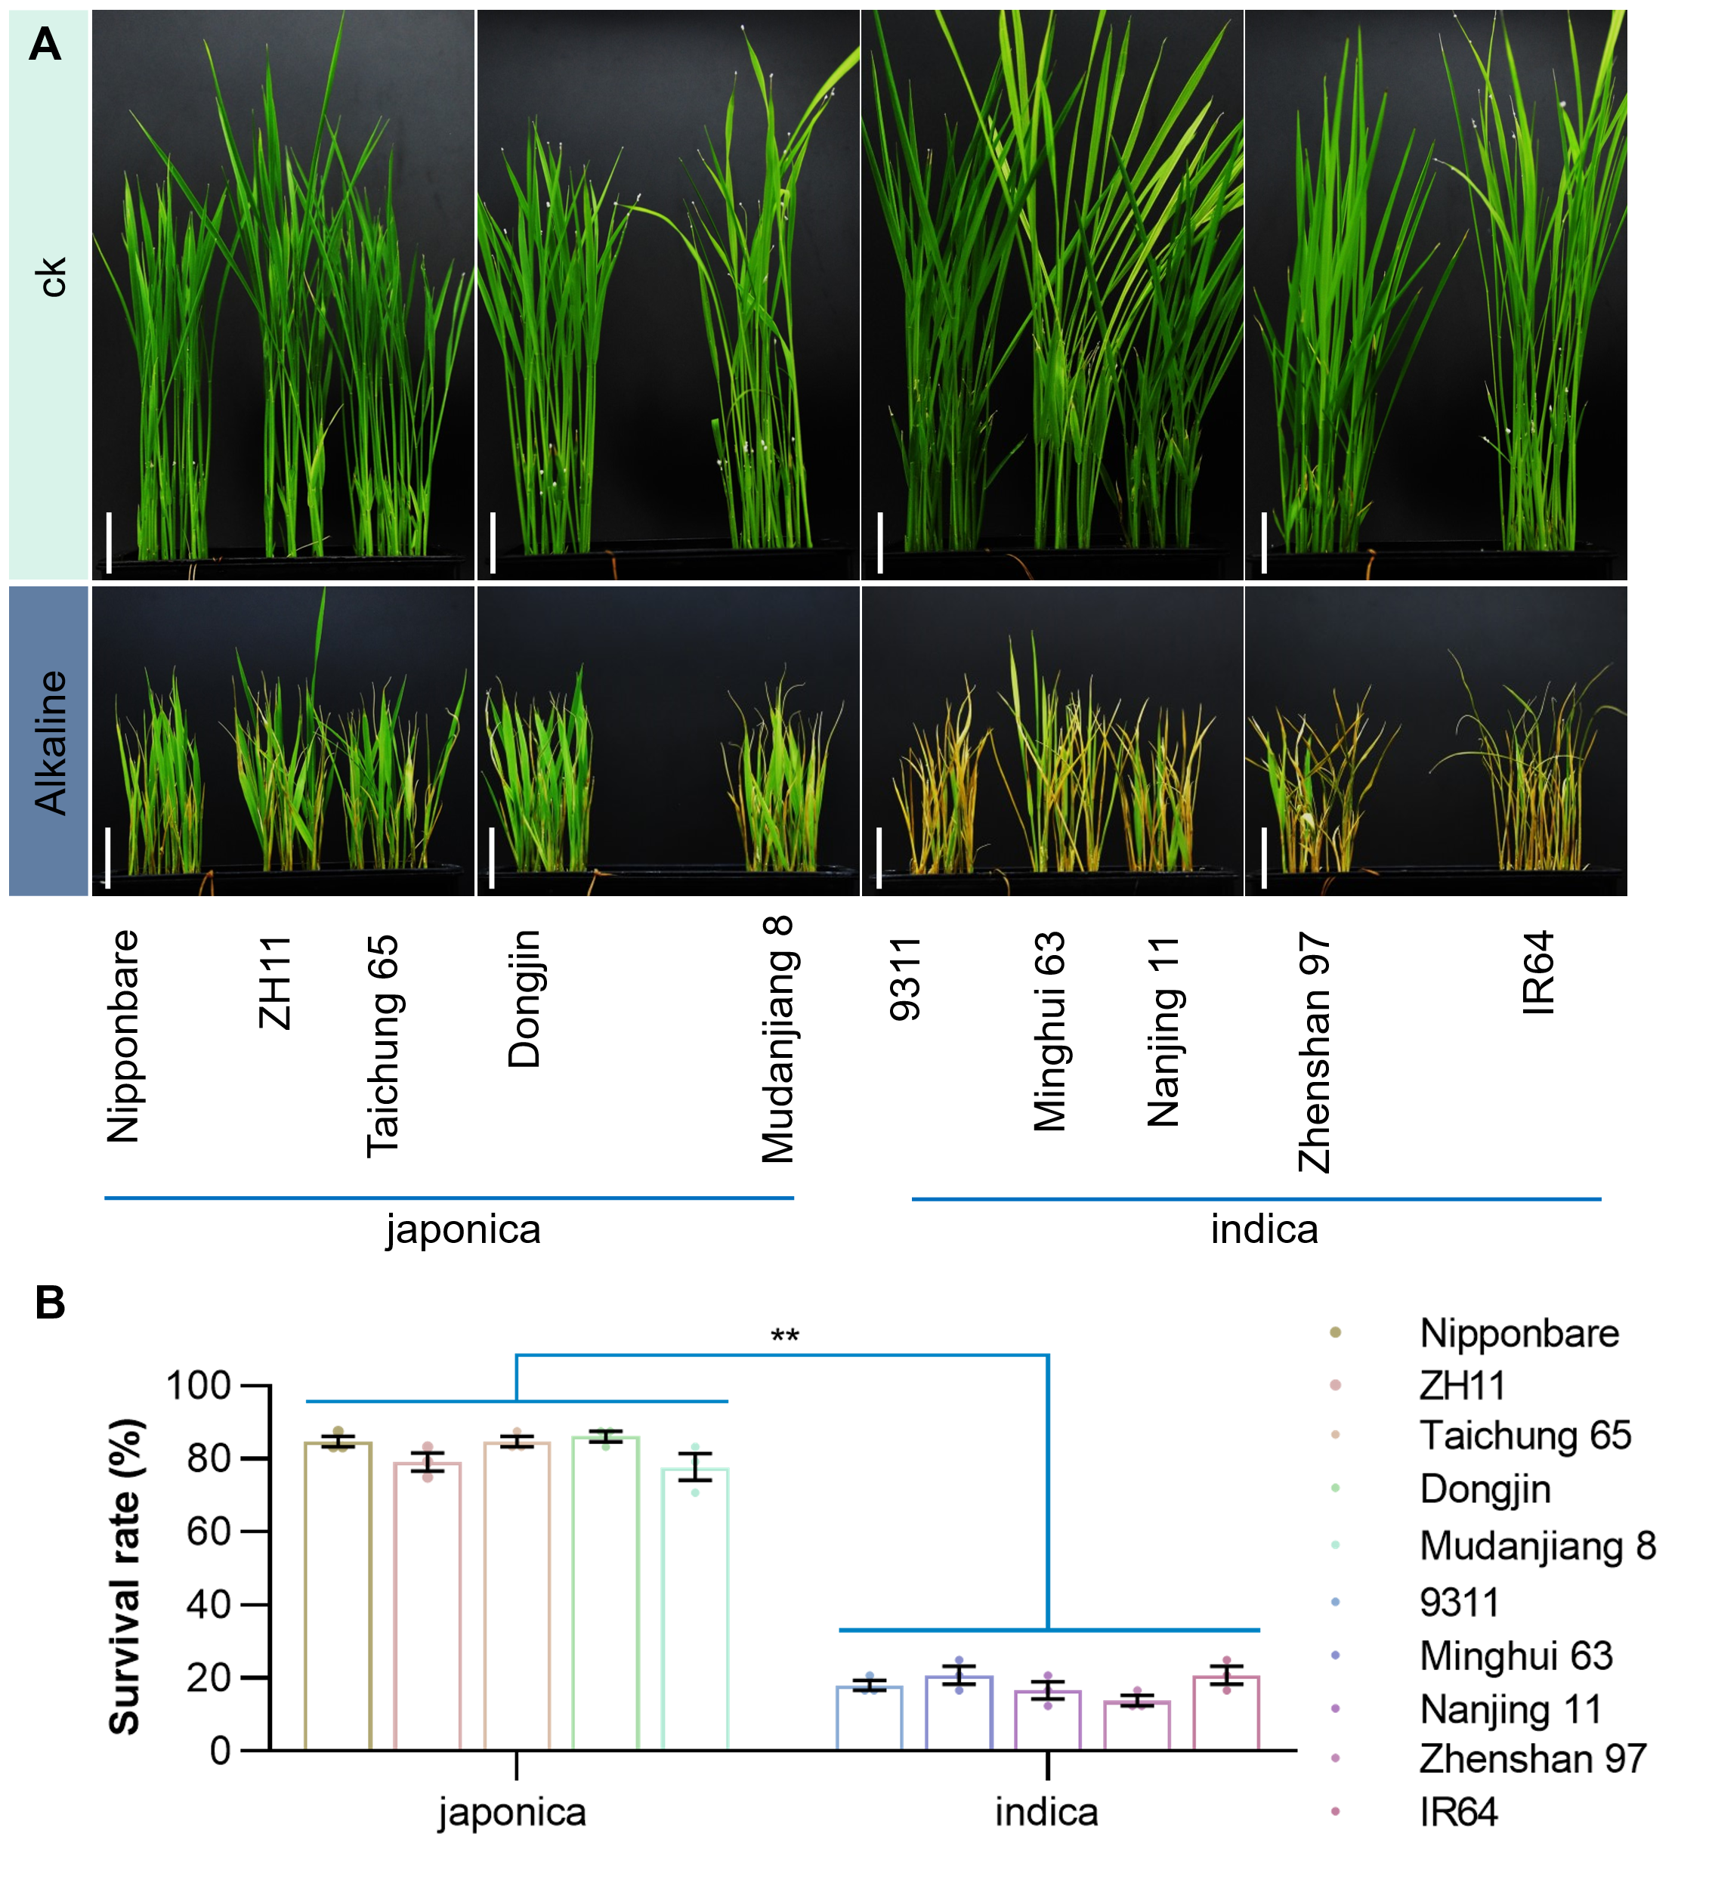
Extended Data Fig.1| Alkaline tolerance analysis of ten rice varieties.
(A) Representative phenotypes of different rice varieties before and after treatment and recovery at the seedling stage. Bars = 2 cm. (B) Survival rates of different rice varieties after alkali treatment and recovery at the seedling stage. n = 72 plants from three biological repeats.
Data represent mean ± SE. **P < 0.01 and *P < 0.05 analyzed by Student’s t-test.

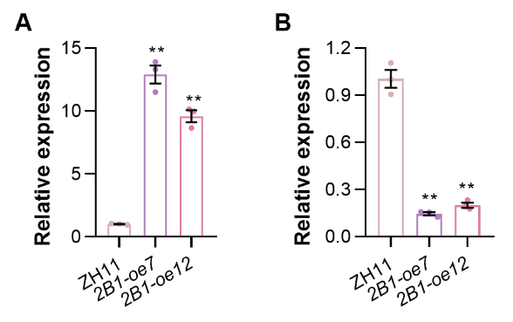
Extended Data Fig.2| OsALDH2B1 and GS3 expression analysis in 2B1-oe plants.
(A) OsALDH2B1 expression in 2B1-oe two weeks seedling shoots (2B1-oe). (B) GS3 expression in ~3 cm young panicles of 2B1-oe plants.
Data represent mean ± SE. n = 3. **P < 0.01 analyzed by Student’s t-test.

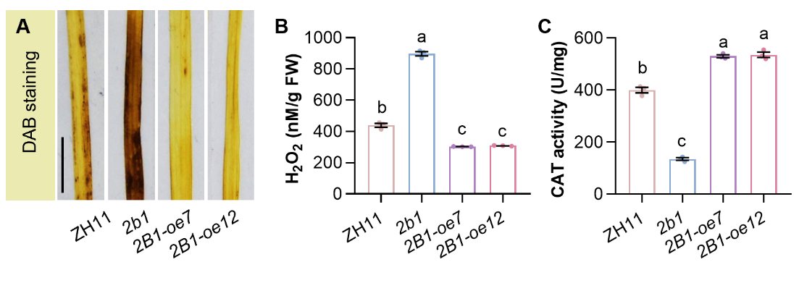
Extended Data Fig.3| OsALDH2B1 promotes H₂O₂ scavenging and catalase activity under alkaline stress.
(A-C) Visible detection of H₂O₂ by 3,3’-diaminobenzidine (DAB) staining (A), quantification of H₂O₂ content (B) and measurement of catalase activity (C) in leaves of ZH11, 2b1 and 2B1-oe at 6 h exposed to alkaline treatment. Bar, 1 cm.
Data represent mean ± SE. n = 3. Different letters above bars indicate differences by Multiple range test at P < 0.05.

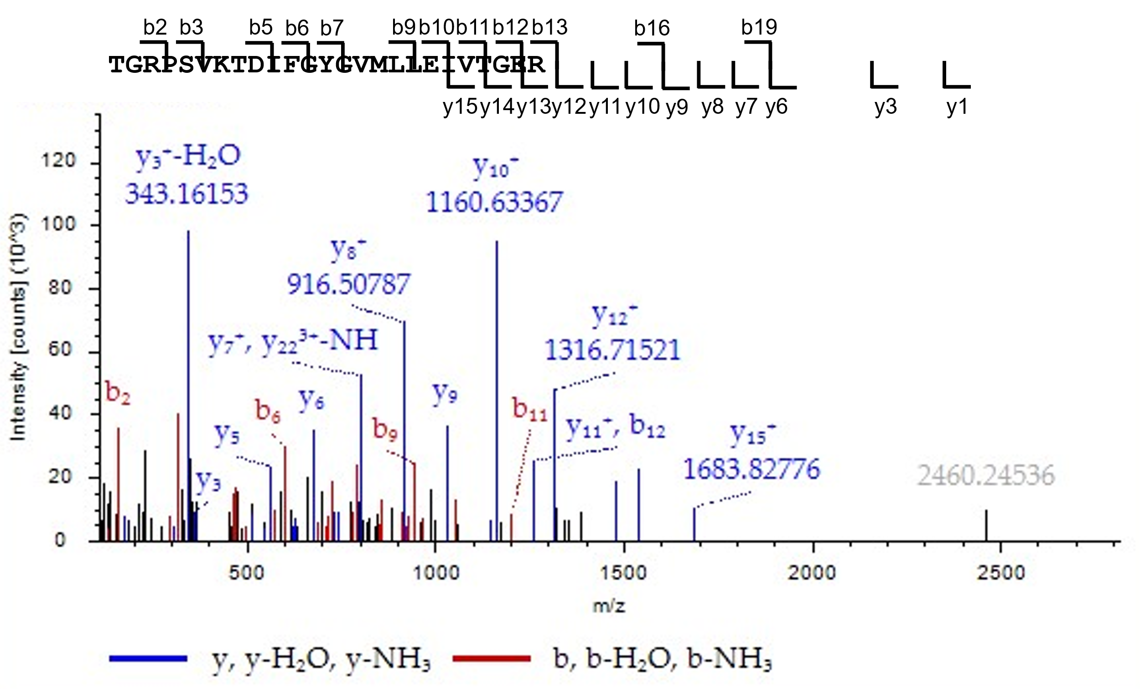
Extended Data Fig.4| Identification of SERL1 (LOC_Os11g39370) peptide by liquid chromatography-tandem mass spectrometry (LC-MS/MS) analysis.

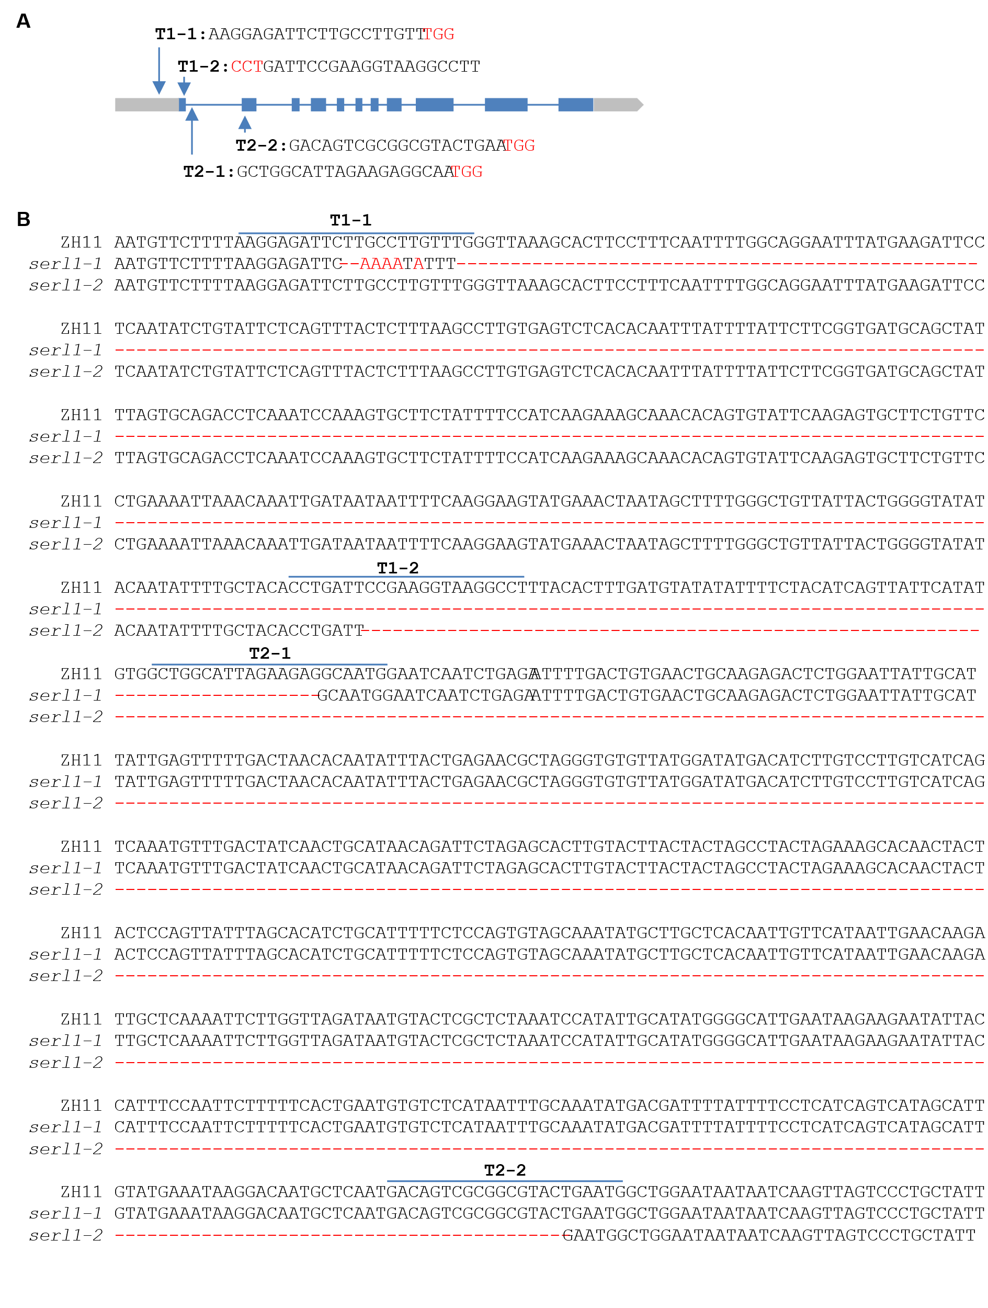
Extended Data Fig.5| The serl1 mutants genotype characterization.
(A) Target sites designed for genome editing of SERL1 by CRISPR/Cas9. The target site nucleotides are shown in capital letters, and the PAM site is indicated as red capital letters. (B) Sequence alignment of the target region showing large fragment deletion in two independent serl1 mutants.

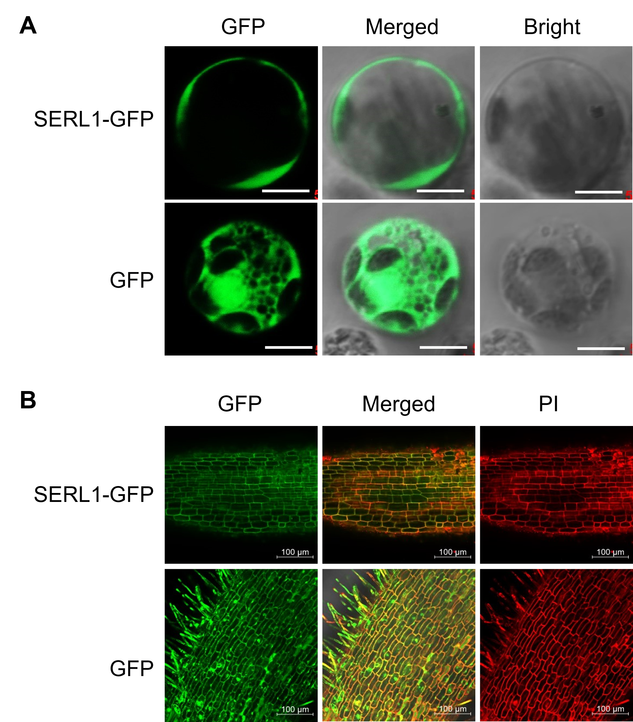
Extended Data Fig.6| Analysis of subcellular localization of SERL1 protein in rice.
(A) Analysis of subcellular localization of SERL1 protein by transient expression. The SERL1-green fluorescent protein (GFP) was expressed in rice protoplasts. Bars, 5 µm. (B) Analysis the subcellular localization of SERL1 protein in SERL1-C plants. The root tips of SERL1-C plants at three day after germination were used for analysis. The cell wall was stained with propidium iodide (PI) (Hu et al., 2017). Bars, 100 µm.

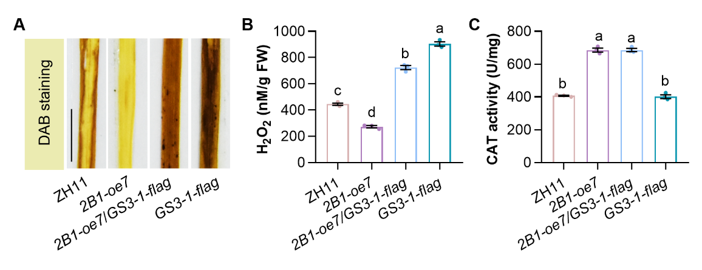
Extended Data Fig.7| OsALDH2B1 promoted H₂O₂ scavenging is partially dependent on GS3.
(A-C) Visible detection of H₂O₂ by DAB staining (A), quantification of H₂O₂ content (B) and measurement of catalase activity (C) in leaves of ZH11, 2B1-oe7, 2B1-oe/GS3-1-flag, and GS3-1-flag at 6 h exposed to alkaline treatment. Bar, 1 cm.
Data represent mean ± SE. n = 3. Different letters above bars indicate differences by Multiple range test at P < 0.05.

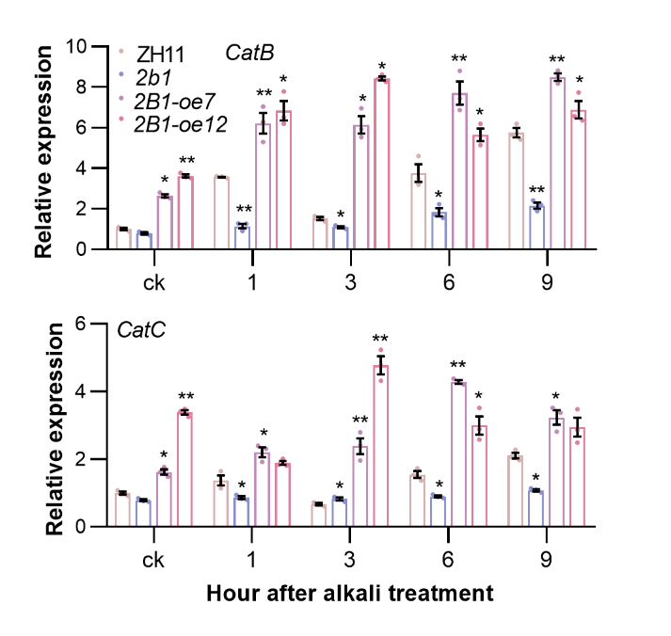
Extended Data Fig.8| CatB and CatC expressions in ZH11, 2b1 and 2B1-oe plants in response to alkaline treatment.
10-day-old WT seedlings were treated with alkaline for the indicated times.
Data represent mean ± SE. n = 3. **P < 0.01 and *P < 0.05 analyzed by Student’s t-test.

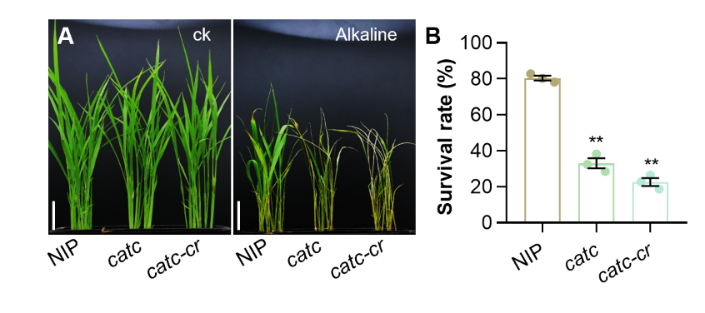
Extended Data Fig.9| CatC mutation increases alkaline sensitivity.
(A and B) Representative phenotypes (A) and survival rates after alkaline treatment (B) of ZH11 and catc seedlings. n = 48 from three biological repeats. Bars = 2 cm.
Data represent mean ± SE. **P < 0.01 analyzed by Student’s t-test.

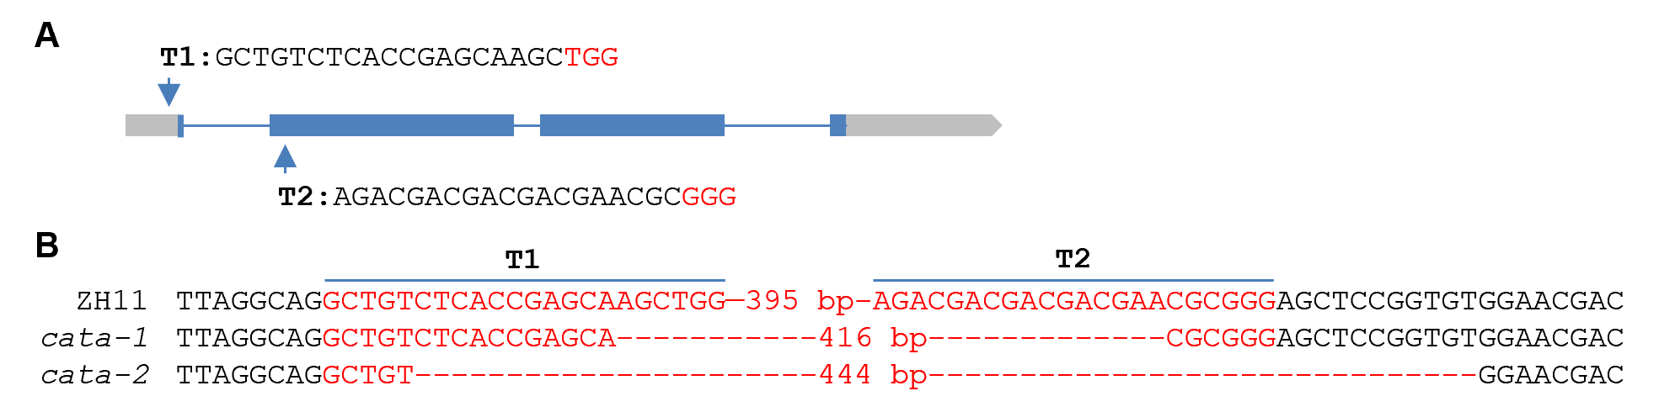
Extended Data Fig.10| The cata mutants genotype characterization.
(A) Target sites designed for genome editing of CatA by CRISPR/Cas9. The target site nucleotides are shown in capital letters, and the PAM site is indicated as red capital letters. (B) Sequence alignment of the target region showing large fragment deletion in two independent cata mutants.

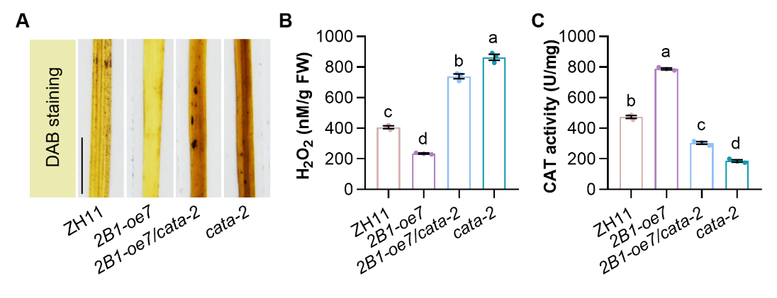
Extended Data Fig.11| CatA is involved in OsALDH2B1 promoted H₂O₂ scavenging and catalase activity.
(A-C) Visible detection of H₂O₂ by DAB staining (A), quantification of H₂O₂ content (B) and measurement of catalase activity (C) in leaves of ZH11, 2B1-oe7, 2B1-oe7/cata-2, and cata-2 at 6 h exposed to alkaline treatment. Bar, 1 cm.
Data represent mean ± SE. n = 3. Different letters above bars indicate differences by Multiple range test at P < 0.05.

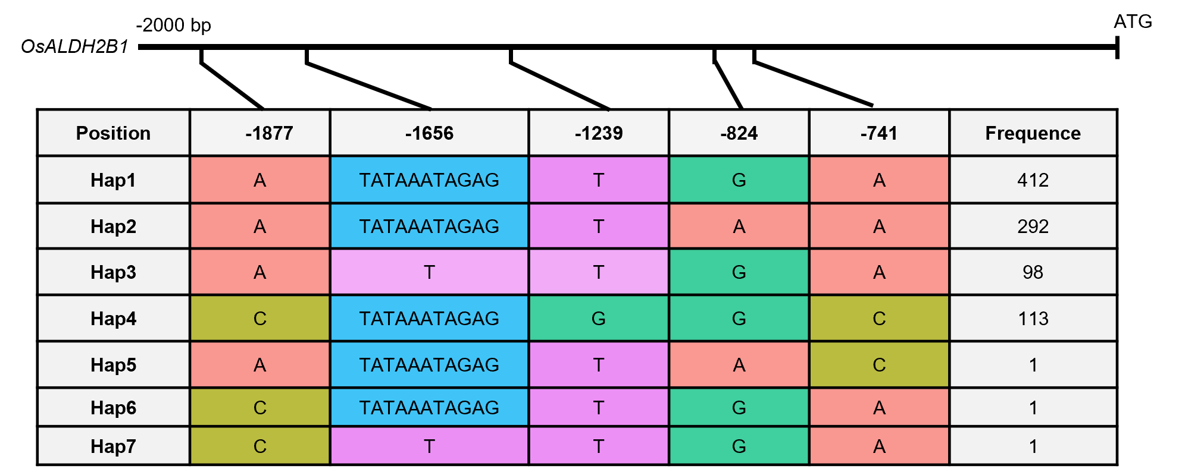
Extended Data Fig.12| Haplotype analysis of the OsALDH2B1 promoter regions from 918 cultivated rice accessions.

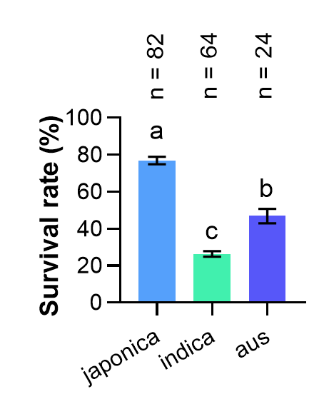
Extended Data Fig.13| Analyzing the alkaline tolerance of different rice subpopulations.
Data represent mean ± SE. Different letter above bars indicate differences by Multiple range test at P < 0.05.

