Photoelectronic Properties of End-bonded InAsSb Nanowire Array Detector under Weak Light

Xiaomei Yao^{1, 2, 3}, Xutao Zhang^{1, 5}, Tingting Kang¹, Zhiyong Song¹, Qiang Sun³, Dongdong Wei¹, Jin Zou^{3,4} and Pingping Chen^{1, 2*}.

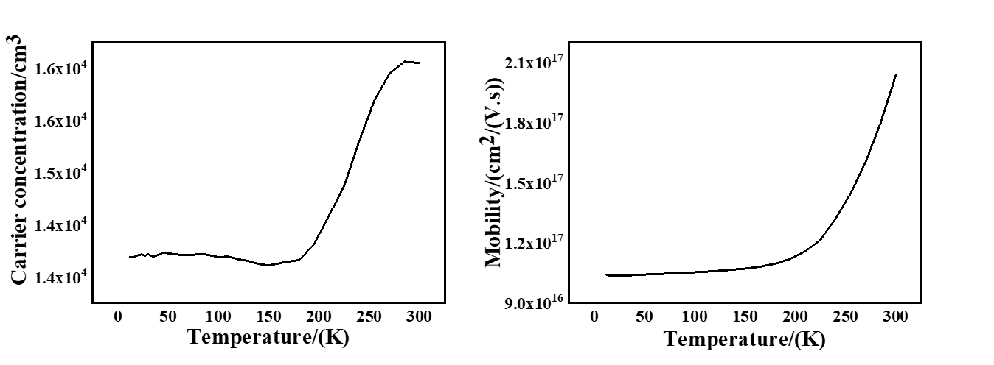 Figure S1: (a) The temperature dependent carrier concentration of the InAsSb epilayer. (b) The temperature dependent mobility of the InAsSb epilayer.
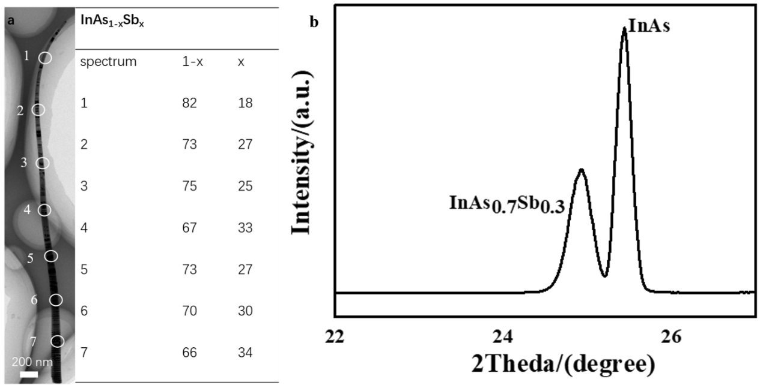
Figure S2: (a) The HRTEM image of the individual InAsSb nanowire and the value of the Sb content of the spot shown in (a). (b) XRD result of the InAsSb NW array with substrate.
Figure S3: The SEM image of the device.
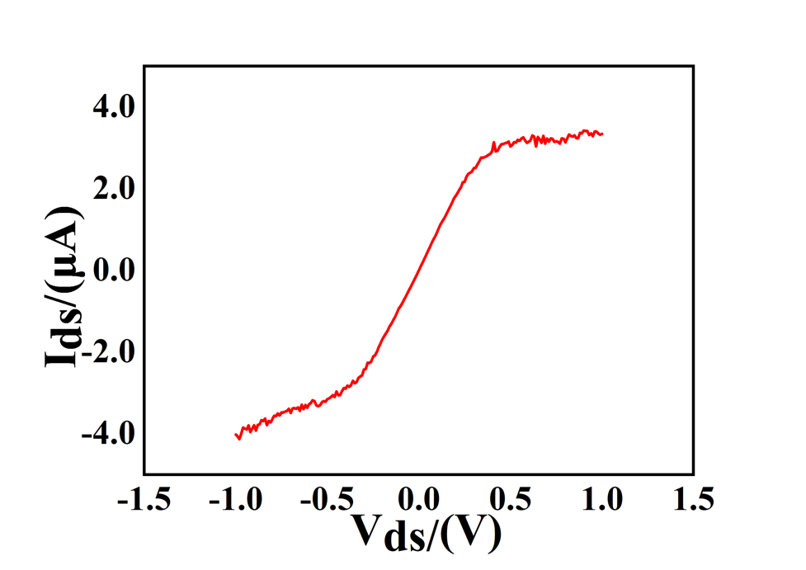
Figure S4: The output character of the individual NW device.
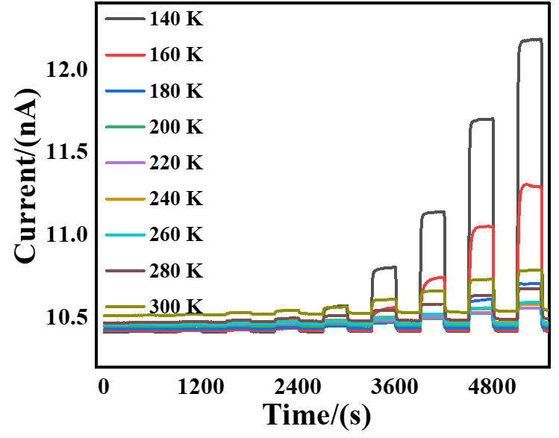
Figure S5: The photo response of the device in other temperatures. The inset shows the response time.
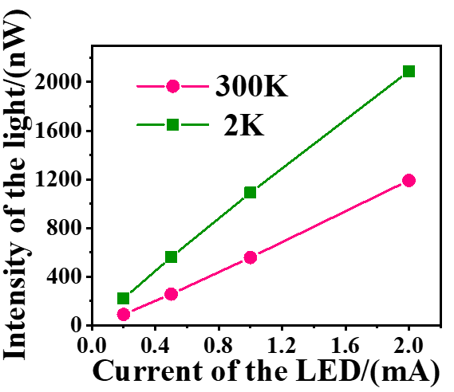
Figure S6: The relationship between the light intensity of the LED (620 nm) and the input current.

