Supplementary Figures
Supplementary Fig. 1| Heatmap of chromatin interactions in each chromosome of Ge (a), Gs (b), and GhP (c).

Supplementary Fig. 2| Genomic feature distribution in the three cotton genomes. Track a, gene density indicated by gene length / 1 Mb. Track b, Gypsy. Distribution of Gypsy TE density across chromosomes, Gypsy length / 1 Mb. Track c, Copia. Distribution of Copia density across chromosomes, Copia length / 1 Mb. Track d, DNA TEs. Distribution of DNA transposon density across chromosomes, DNA transposon length / 1 Mb.

Supplementary Fig. 3| Density distribution of Genes (a), Copia (b) and Gypsy (c) in three cotton genomes

Supplementary Fig. 4| GO enrichment analysis of genes in core gene families. * indicate p<0.05 (Fisher exact test).
Supplementary Fig. 5| Divergence between Gossypium genomes. Divergence times were estimated by Ks values for orthologous genes among Gossypium genomes. Ranges for divergence times are shown in the legend.

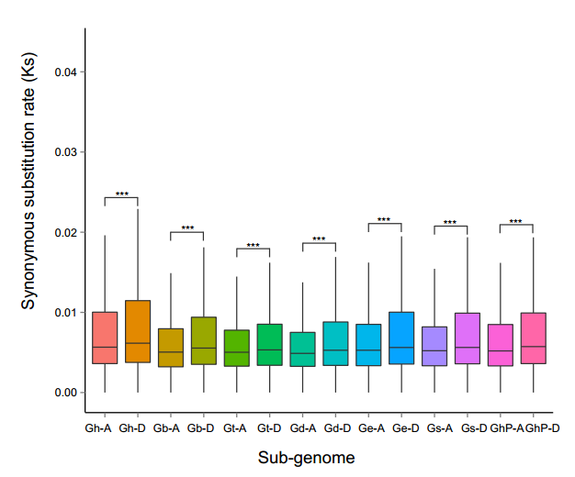
Supplementary Fig. 6| Divergence between Gm with other tetrploid cotton genomes in A/D subgenome. Divergence times were estimated by Ks values for orthologous genes. Differences between the A- and D- subgenomes were analyzed by Wilcoxon signed-rank test. *** indicates p-value < 0.001.
Supplementary Fig. 7| Characterization of genomic variations in Gossypium A (sub)genome and D (sub)genome. Genic synteny blocks are connected by gray lines. Translocation blocks and inversion blocks are connected by red and green lines, respectively.
Supplementary Fig. 8| SV number and length distribution of seven allotetraploid cotton genomes.
Supplementary Fig. 9| SVs and SV-related genes in seven cotton genomes relative to domesticated Gm. a. Venn diagram shown SVs in seven genomes. b. SV-related genes in seven genomes. d. SVs evolution in seven genomes.
Supplementary Fig. 10| SVs annotation in allotetraploid cotton, relative to domesticated Gm.
Supplementary Fig. 11| SVs density and number in 26 chromosomes.
Supplementary Fig. 12| Gene expression of Ghi_A10G09231.
Supplementary Fig. 13| SVs identified by Hi-C data. Gb, Ge, Gs and GhP Hi-C data mapped to TM-1 D01 (a.) and D04 (b.). The (a.) and (b.) dotted boxes indicate the inversions between D01 and D04, respectively.
Supplementary Fig. 14| NLR gene content of A subgenome and D subgenome in eight species/accessions. Pvalue: student′s t-test.
Supplementary Fig. 15| NLR distribution in GhP and Ge genome.
Supplementary Fig. 16| Cytological observation using probes specific for NLR clusters confirms the presence of NLR clusters in allotetraploid cotton by Oligo FISH. Prober 1-72 was design according R gene cluster in A04 of Ge. Prober 16-44, 19-44 and 49-54 were design according R gene cluster in A11 of Ge. White bars, 5 µm.

Supplementary Fig. 17| GO enrichment analysis of GhP specific genes.
Supplementary Fig. 18| KEGG enrichment analysis of GhP specific genes.
Supplementary Fig. 19| FPKM distribution of single copy gene (SCG; red) and positive selected gene (PSG; yellow) in different samples. a, FPKM of GhP samples. b, FPKM distribution of Gb samples.
Supplementary Fig. 20| Abiotic stress adaption of GhP. a, expression level of GhdadD. b, expression level of GhdadD were decreased in VIGS plants. c, salt and drought tolerance of GhdadD silenced plants were decreased. d. shown Ion leakage and relative leaf water content, respectively. ANOVA analyses were performed used standard t-test. LSD was used to put up multiple comparison.
Supplementary Fig. 21| AtD and DtA gene pairs distribution in eight genomes.

Supplementary Fig. 22| The distribution of HE region length in eight tetraploid cotton genomes.
Supplementary Fig. 23| HE clusters in eight tetraploid cotton genomes.
Supplementary Fig. 24| A typical HE, which contain NLR genes in Ghir_A01, were presented in eight allotetraploid cotton genomes. a. Top panel, comparison of Gh_At vs. D5 and Gh_At vs. A1 sequences show a typical HE in A01. Coverage of Gh genome by eight tetraploid Gossypium reads are shown at bottom. b, the phylogenetic relationship of a NLR gene in HE region.

