Supplementary: Shared genetic basis for brain structure, insulin resistance and inflammation in schizophrenia: a colocalization study.
Amalie C. M. Couch, Ph.D^{1*}; Benjamin I. Perry, MRCPsych, Ph.D²; Edward R. Palmer, MBBS, MRCPsych²; Jack Rogers, Ph.D²; Rachel Upthegrove, FRCPsych, Ph.D^{1,2,3,4*}

¹ Department of Psychiatry, University of Oxford, UK.
² Institute for Mental Health, School of Psychology, University of Birmingham, Birmingham, UK.
³ Birmingham Early Intervention Service, Birmingham and Solihull Mental Health Trust, UK.
⁴ Oxford Health NHS Foundation Trust, UK.

*Joint Corresponding authors:
Dr. Amalie Couch and Prof. Rachel Upthegrove,
Department of Psychiatry, University of Oxford,
Warneford Hospital, Oxford, OX3 7JX, United Kingdom

Tel: +44 (0) 1865 618200
Email: amalie.couch@psych.ox.ac.uk or rachel.upthegrove@psych.ox.ac.uk

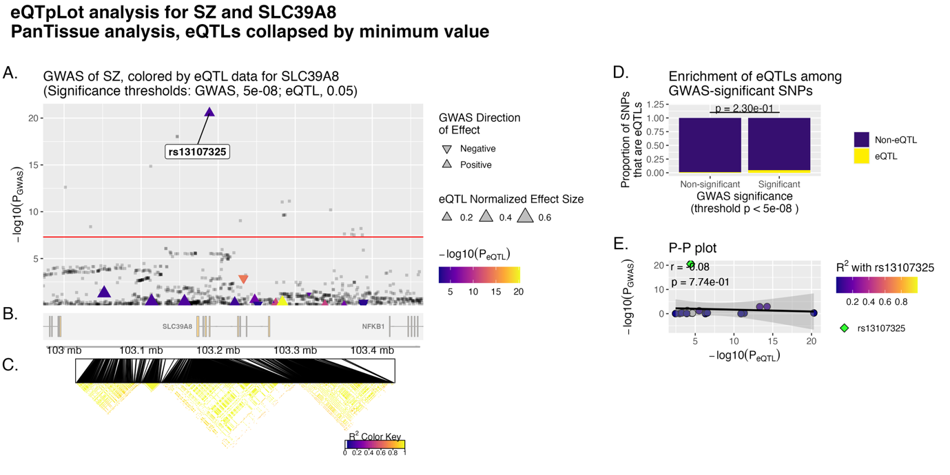
Supplementary Figure 1: Expression (e)QTL and GWAS colocalization analysis for schizophrenia (SZ) and SLC39A8 using the eQTpLot R package. eQTL plot generated using eQTpLot showing colocalization between SZ GWAS signals and expression quantitative trait loci (eQTLs) for SLC39A8, based on PanTissue GTEx data, with eQTLs collapsed by minimum p-value. (A) Manhattan plot of SZ GWAS association p-values (–log₁₀(P_{GWAS})), with points coloured by the strength of eQTL association for SLC39A8 (–log₁₀(P_{eQTL})) and shaped by GWAS direction of effect (upward triangle = positive; downward = negative) and eQTL effect size (triangle size). The genome-wide significant SNP rs13107325 is highlighted. (B) Genomic position of SLC39A8 and neighbouring genes in the region. (C) Linkage disequilibrium (LD) heatmap showing pairwise r² values across SNPs in the region; rs13107325 and LD values are color-coded as per the key. (D) Bar plot showing the proportion of SNPs that are eQTLs among genome-wide significant (p < 5×10⁻⁸) versus non-significant GWAS SNPs, with no significant enrichment observed (p = 0.23). (E) P–P plot showing the correlation between SZ GWAS p-values and SLC39A8 eQTL p-values (r = –0.08, p = 0.774), indicating minimal evidence for correlation between GWAS and eQTL signals.
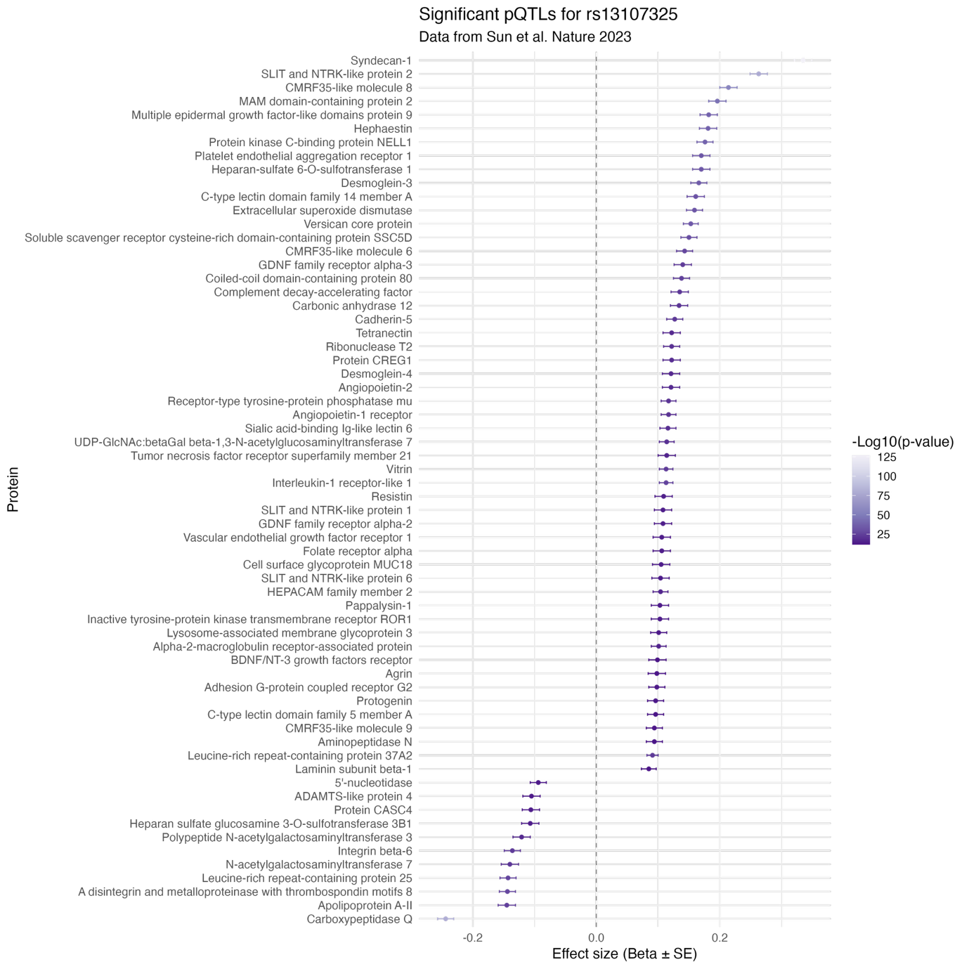
Supplementary Figure 2: Forest plot of protein quantitative trait loci (pQTL) associations with rs13107325 (P < 1.7x10⁻¹¹), with data derived from the UKB-PPP (29). This forest plot displays standardized effect sizes (β coefficients) and 95% confidence intervals for the association between the schizophrenia risk SNP rs13107325 and plasma levels of individual proteins, based on pQTL data. Proteins are ranked on the y-axis by effect size, with positive associations shown to the right and negative associations to the left of the zero line. Effect size magnitudes and statistical significance are visualized using purple circles, with circle shading indicating –log₁₀(P). The plot highlights proteins with diverse biological functions, including extracellular matrix components (e.g., Syndecan-1, Heparan sulphate 6-O-sulfotransferase), immune markers (e.g., Complement decay-accelerating factor, Interleukin-1 receptor-like 1), metabolic enzymes, and vascular/endothelial factors (e.g., Angiopoietin-like protein 2, VEGF receptor 1).

