Supplementary Information
Realization of ultrathin waveguides by elastic metagratings
Yabin Hu¹, Yunhao Zhang², Guangyuan Su², Meiying Zhao¹, Bing Li^{1,} *, Yongquan Liu^{2,} *, Zheng Li³
¹ School of Aeronautics, Northwestern Polytechnical University, Xi'an, Shaanxi, 710072, China
² State Key Laboratory for Strength and Vibration of Mechanical Structure, School of Aerospace Engineering, Xi'an Jiaotong University, Xi'an, 710049, China
³ Department of Mechanics and Engineering Science, Peking University, Beijing 100871, China
*Corresponding author E-mail address: bingli@nwpu.edu.cn; liuy2018@xjtu.edu.cn
Supplementary Information includes:
Supplementary Figure 1. Design details of the metagrating supercell.
Supplementary Figure 2. Out-of-plane deformation of cell Ⅱ at the representative frequencies.
Supplementary Figure 3. Experimental and numerical verifications of the omnidirectional isolation of the proposed metagrating at different frequencies.
Supplementary Figure 4. Omnidirectional isolation of arbitrary shaped isolators enclosed by the proposed metagratings.
Supplementary Figure 5. Guided-mode theory when a point source $S$ is placed at an arbitrary location.
Supplementary Figure 6. Schematic of experimental setup for measuring elastic-wave fields.
Supplementary Note 1. Design details of the metagrating supercell.
Supplementary Note 2. Disturbance induced by the twisting resonance of cell II.
Supplementary Note 3. Omnidirectional isolation under various frequencies.
Supplementary Note 4. Omnidirectional isolation in arbitrary shaped isolators.
Supplementary Note 5. General guided-mode theory in metagrating-based waveguide.

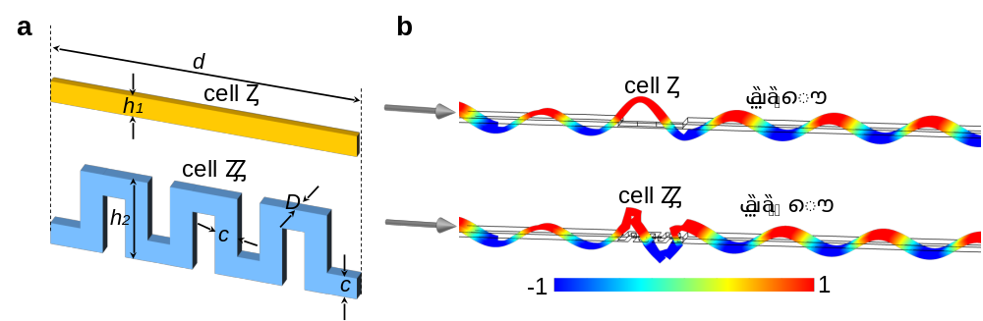
Supplementary Figure 1 | Design details of the metagrating supercell. (a) Schematic of the supercell consisting of unit cells $Ι$ and $ΙΙ$. (b) Simulated out-of-plane displacement fields for unit cells $Ι$ and $ΙΙ$ at 15 kHz, respectively. The transmitted fields between the two unit cells have a phase shift of $Δϕ=π$. A nearly total transmittance ($\left|t\right|≅1$) is obtained for both unit cells.

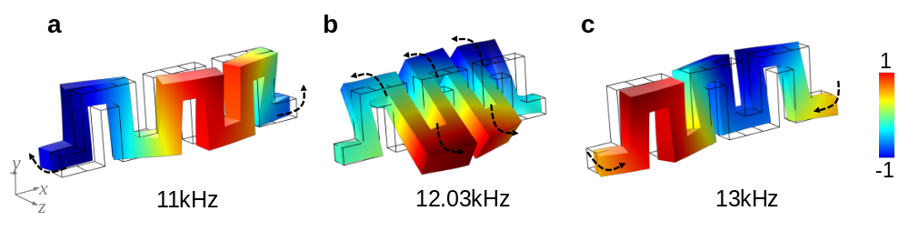
Supplementary Figure 2 | Out-of-plane deformation of cell Ⅱ at the representative frequencies. Simulated out-of-plane displacement fields at (a) 11 kHz, (b) 12.03 kHz (the disturbance frequency) and (c) 13 kHz. Obvious twisting resonance of cell II is captured at the disturbance frequency.

Supplementary Figure 3 | Experimental and numerical verifications of the omnidirectional isolation of the proposed metagrating at different frequencies. (a) Experimentally measured (EXP) and simulated (FEM) energy fields of a triangle-shaped omnidirectional isolator at 13 kHz when a point source is placed out of the enclosed region. (b) Same as a, but at 14 kHz. (c) (d) Same as a, b, respectively, but for a point source located in the enclosed region.

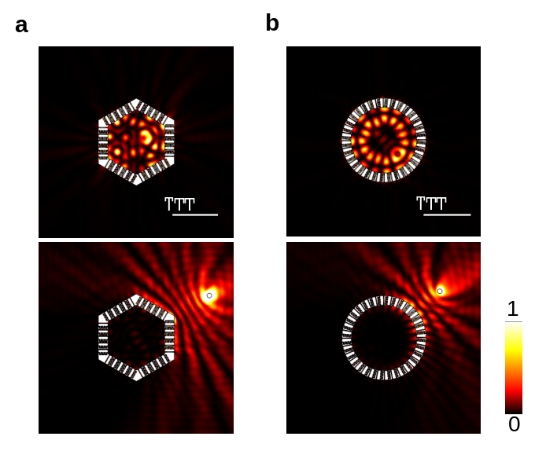
Supplementary Figure 4 | Omnidirectional isolation of arbitrary shaped isolators enclosed by the proposed metagratings. (a) Simulated energy fields of a hexagon-shaped omnidirectional isolator at 15 kHz when a point source is placed inside and outside the enclosed region, respectively. The side length of hexagon is 70 mm. (b) Same as a, but the enclosed region is designed as a circle-shape with an inner radius of $70 mm$.

Supplementary Figure 5 | Guided-mode theory when a point source $S$ is placed at an arbitrary location. (a) Schematic of omnidirectional wave reflection in a waveguide excited by a point source $S$ placed at an arbitrary location. (b) The variation $β$ as functions of the ratio $l/λ$ and the incident angle $θ_{i}$. The whole region is divided into five parts ($N=1$, $N=2$, $N=3$, $N=4$ and $N=5$), which represent different guided-mode orders. (c) Simulated displacement amplitude fields $|w|$ in the waveguides with $l/λ=0.2, 0.5, 1, 1.5, 2, 2.5$, respectively.

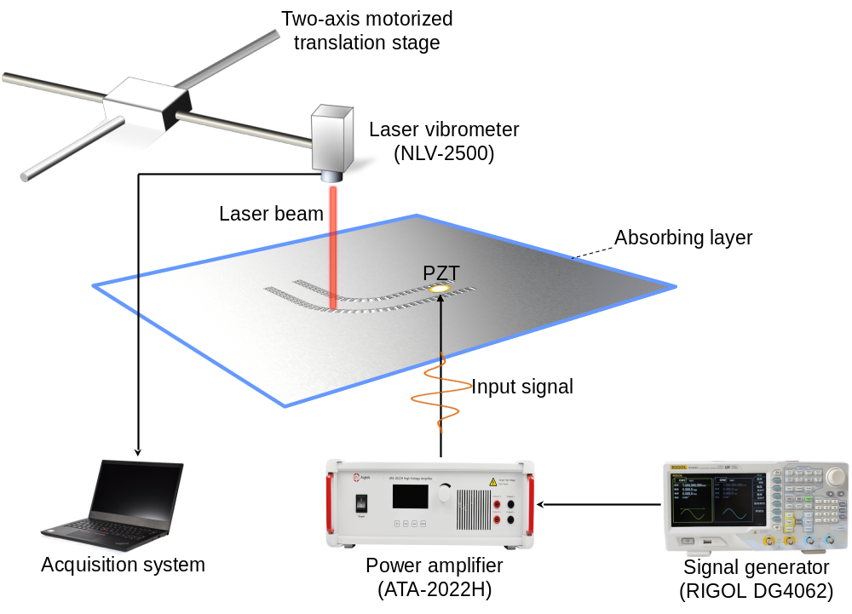
Supplementary Figure 6 | Schematic of experimental setup for measuring elastic-wave fields.

Supplementary Note 1. Design details of the metagrating supercell
The design details of the metagrating supercell are shown in Supplementary Fig. 1. As illustrated in Supplementary Fig. 1(a), the supercell consists of only two unit cells, cells $Ι$ and $ΙΙ$. Cell $Ι$ is a straight beam with height $h_{1}=1.5mm$. Cell $ΙΙ$ is a zigzag-type beam with the selected parameters of $h_{2}=5.7mm$, $c=1.5mm$. Cells $Ι$ and $ΙΙ$ have the same thickness $D=1.5mm$ and length $d=20.5mm$. Supplementary Fig. 1(b) shows the simulated out-of-plane displacement fields for unit cells $Ι$ and $ΙΙ$ at 15 kHz, respectively. It is clearly verified that the transmitted fields between the two unit cells have a phase shift of $Δϕ=π$, which agrees well with the supercell design criterion. Meanwhile, the transmittance keeps a nearly total transmission ($\left|t\right|≅1$) for both unit cells.

Supplementary Note 2. Disturbance induced by the twisting resonance of cell $ΙΙ$
It is indicated that the phase difference ${Δϕ=ϕ_{I}-ϕ}_{II}$ of the two unit cells has a stark perturbation around 12 kHz (see Fig. 2(c) in the main content). Correspondingly, there is an abrupt, ultra-narrow peak in the transmittance around this frequency (see Fig. 2(b) in the main content). To explain this abrupt disturbance, several out-of-plane deformations of unit cell $ΙΙ$ around this specific frequency are visualized in Supplementary Fig. 2. It is illustrated that a dramatic twisting deformation is induced at this disturbance frequency of 12.03 kHz, which is different from the bending deformation at the other adjacent frequencies. The twisting resonance of unit cell $ΙΙ$ contributes to the abrupt perturbation in $Δϕ$, which is far from the expected value $π$. Therefore, the transmittance has an abrupt increase around this disturbance point.

Supplementary Note 3. Omnidirectional isolation under various frequencies
To evaluate the robustness of omnidirectional isolation performance to frequency, we capture the experimentally measured and simulated energy fields of a triangle-shaped omnidirectional isolator at various frequencies. As shown in Supplementary Fig. 3, a robust nearly-total-trapping (or isolating) performance is realized at both 13 and 14 kHz, when a point source is placed inside (or outside) the isolator enclosed by the proposed metagratings. Experimental and simulated results congruously verify the robust omnidirectional isolation performance under various frequencies.

Supplementary Note 4. Omnidirectional isolation in arbitrary shaped isolators
Supplementary Figure 4 illustrates the omnidirectional isolation performance of the isolators with other exotic shapes. A hexagon region and a circle region, enclosed by the proposed metagratings, are performed. The hexagon region has a side length of $70 mm$ and the circle region has a radius of $70 mm$. As clearly shown in Supplementary Fig. 4, robust omnidirectional isolation performance is observed in both the two isolators with special shapes, no matter the point source is placed inside or outside the enclosed regions.

Supplementary Note 5. General guided-mode theory in metagrating-based waveguide
As illustrated in Supplementary Fig. 5(a), we consider a pair of wave beams generated from the point source $S$ and then propagate in the waveguide with incident angles $±θ_{i}$, respectively. The point source is placed at a general location inside the waveguide. To have a guided mode, point A before boundary reflection and point C after boundary reflection have the same phase with their projections B and D, respectively. Then, the round-trip phase acquired by the ray must be an integer multiple of 2π,
$$k(AC-BD)-2φ=2βπ$$ | (S1)
where $k$ is the wave number in the host plate, $φ$ is the phase shift of total boundary reflection by metagratings, $β$ is an integer (i.e., $β=0,1,2…$). According to the geometric relationship, we can derive $AC-BD=2lcosθ_{i}$. Eq. (S1) can be further written as
$$\frac{l}{λ}=\frac{βπ+φ}{2πcosθ_{i}}$$ | (S2)
Based on the above general equation, we can obtain the relation of guided-mode order $N=β+1$ with the wavelength $λ$ and waveguide width $l$.
In consideration of $θ_{i}∈[-\frac{π}{2},\frac{π}{2}]$, Eq. (S2) becomes $\frac{l}{λ}=\frac{βπ+φ}{2πcosθ_{i}}≥\frac{β}{2}+\frac{φ}{2π}$. Therefore, when the ratio of $l/λ$ is less than a certain value $\frac{φ}{2π}$, it won’t generate guided modes for all incident angles. The critical value of $l/λ$ is obtained by numerical simulations in Supplementary Fig. 5(c). From the amplitude fields of out-of-plane displacement, we can observe that elastic waves are trapped around the point source and prohibited from propagating along the waveguide when $l/λ=0.2$. Thus, the phase shift of total boundary reflection induced by metagtating is $φ=0.4π$.
Supplementary Figure 5(b) reports the variation of $β$ versus the ratio $l/λ$ and the incident angle $θ_{i}$ based on the general guided-mode theory for a point source $S$ located at a general location. It is presented that for the value $l/λ∈(0.2, 0.7]$, only the branch $β=0$ can satisfy the relation of Eq. (S2). Thus, only the guided-mode order $N=1$ exists. When the ratio is set as $l/λ∈(\text{0.7}\text{, }\text{1.2}]$, we can achieve $β=0$ and $β=1$ under the full-angle incidence. In this case, the guided-mode order is dominantly determined by the higher one, i.e., $N=2$. Following this theory, we can predict $N=3$ for $l/λ∈(1.2, 1.7]$, $N=4$ for $l/λ∈\left(1.7, 2.2\right]$ and $N=5$ for $l/λ∈\left(2.2, 2.7\right]$ under a point source incidence.
As verification, the simulated displacement amplitude fields $|w|$ in the waveguides with a series of $l/λ$ are shown in Supplementary Fig. 5(c). The point source is not placed in the middle of the waveguide. It is clearly illustrated that there are one, two, three, four, five rows of standing waves within waveguides corresponding to $l/λ=0.5, 1, 1.5, 2, 2.5$, respectively. The field patterns are very concordant with our analytical predictions. In a word, if the point source is placed at a general location (not in the middle of waveguide), both the odd and even modes can be generated and accurately predicted, which is a more general form of guided-mode theory for the metagrating-based ultrathin waveguide.

