Supplementary Figures
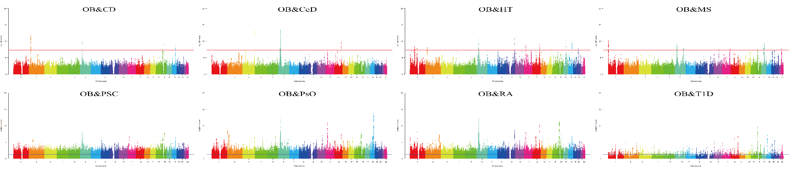
Figure S1. Manhattan plot of the PLACO results. Note: Red line represents the significance of 5×10⁻⁸. Abbreviations: OB, obesity; CD, crohn’s disease; CeD, celiac disease; HT, hypothyroidism; MS, multiple sclerosis; PSC, primary sclerosing cholangitis; PsO, psoriasis; RA, rheumatoid arthritis; T1D, type 1 diabetes.
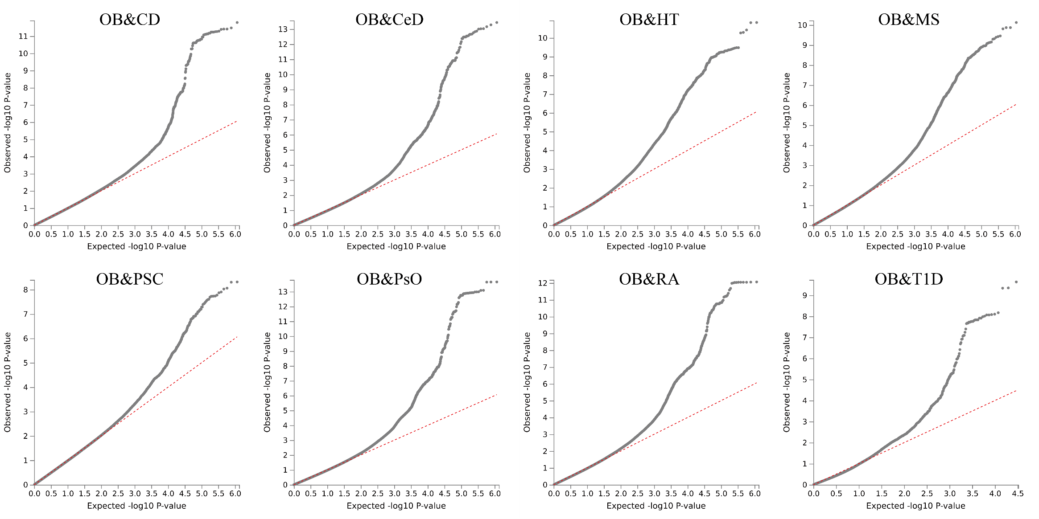
Figure S2. QQ plots for pleiotropic results performed by PLACO. Abbreviations: OB, obesity; CD, crohn’s disease; CeD, celiac disease; HT, hypothyroidism; MS, multiple sclerosis; PSC, primary sclerosing cholangitis; PsO, psoriasis; RA, rheumatoid arthritis; T1D, type 1 diabetes.

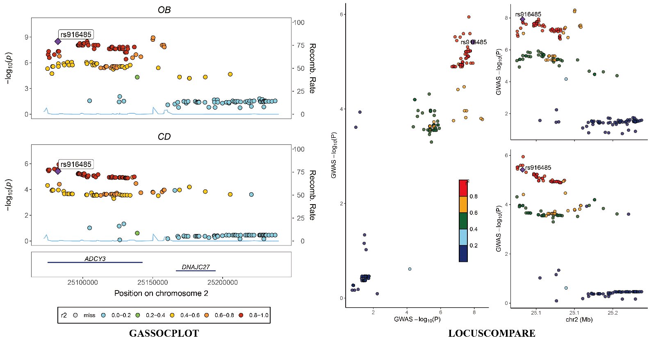
Figure S3. Regional plots of each colocalized locus (PP.H4 > 0.7) identified for corresponding trait pair (OB&CD) by using the PLACO. Note: PP.H4 was posterior probability of H4 calculated by coloc analysis; SNPs in LD that do not have any significant independent lead SNPs in the selected region are grayed out. For genes, mapped genes drawn by position mapping are in red; blue are unmapped protein-coding genes; dark gray are unmapped non-coding genes. Abbreviations: OB, obesity; CD, crohn’s disease; SNP, Single-nucleotide polymorphism; LD, Linkage disequilibrium

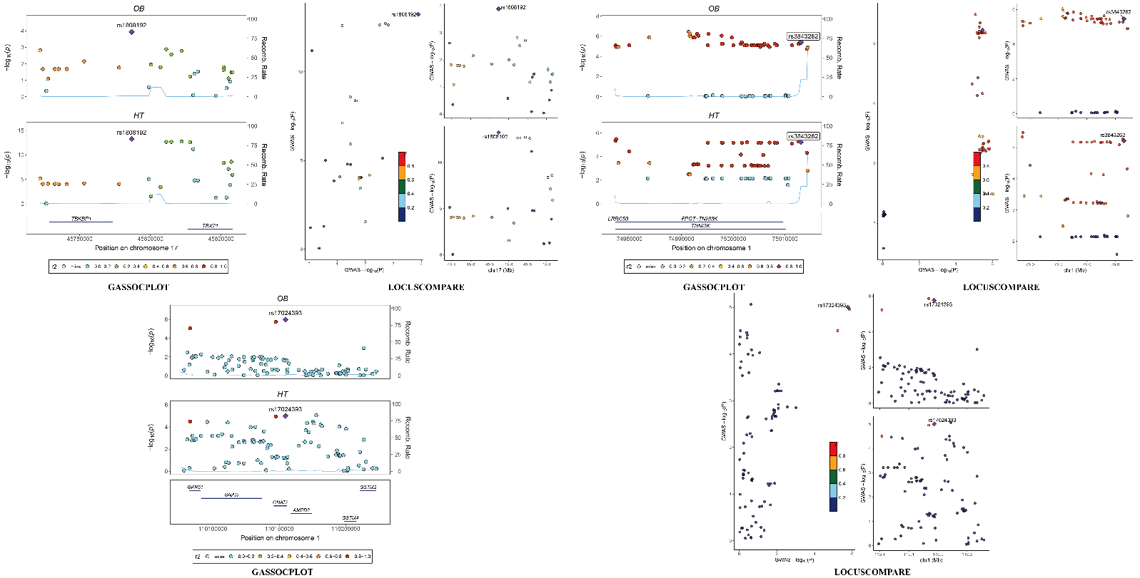
Figure S4. Regional plots of each colocalized locus (PP.H4 > 0.7) identified for corresponding trait pair (OB&HT) by using the PLACO. Note: PP.H4 was posterior probability of H4 calculated by coloc analysis; SNPs in LD that do not have any significant independent lead SNPs in the selected region are grayed out. For genes, mapped genes drawn by position mapping are in red; blue are unmapped protein-coding genes; dark gray are unmapped non-coding genes. Abbreviations: OB, obesity; HT, hypothyroidism; SNP, Single-nucleotide polymorphism; LD, Linkage disequilibrium

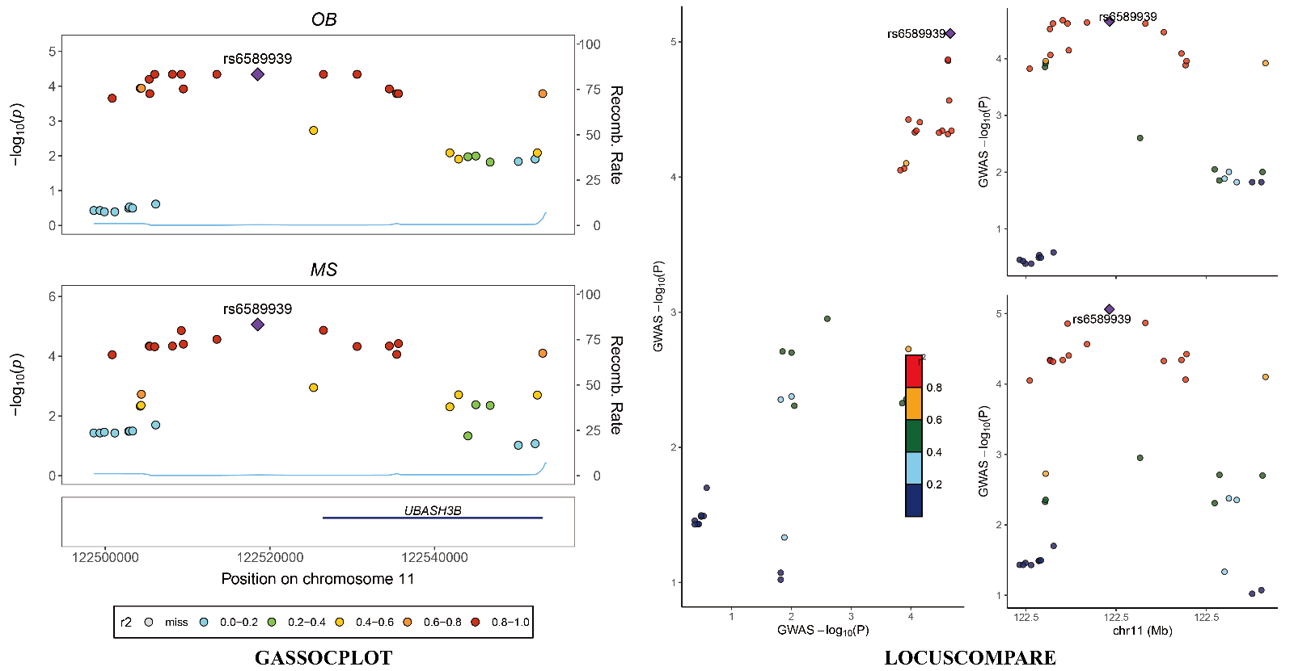
Figure S5. Regional plots of each colocalized locus (PP.H4 > 0.7) identified for corresponding trait pair (OB&MS) by using the PLACO. Note: PP.H4 was posterior probability of H4 calculated by coloc analysis; SNPs in LD that do not have any significant independent lead SNPs in the selected region are grayed out. For genes, mapped genes drawn by position mapping are in red; blue are unmapped protein-coding genes; dark gray are unmapped non-coding genes. Abbreviations: OB, obesity; MS, multiple sclerosis; SNP, Single-nucleotide polymorphism; LD, Linkage disequilibrium

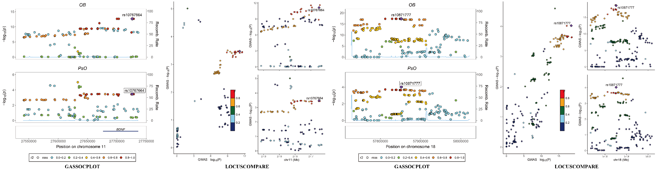
Figure S6. Regional plots of each colocalized locus (PP.H4 > 0.7) identified for corresponding trait pair (OB&PsO) by using the PLACO. Note: PP.H4 was posterior probability of H4 calculated by coloc analysis; SNPs in LD that do not have any significant independent lead SNPs in the selected region are grayed out. For genes, mapped genes drawn by position mapping are in red; blue are unmapped protein-coding genes; dark gray are unmapped non-coding genes. Abbreviations: OB, obesity; PsO, psoriasis; SNP, Single-nucleotide polymorphism; LD, Linkage disequilibrium

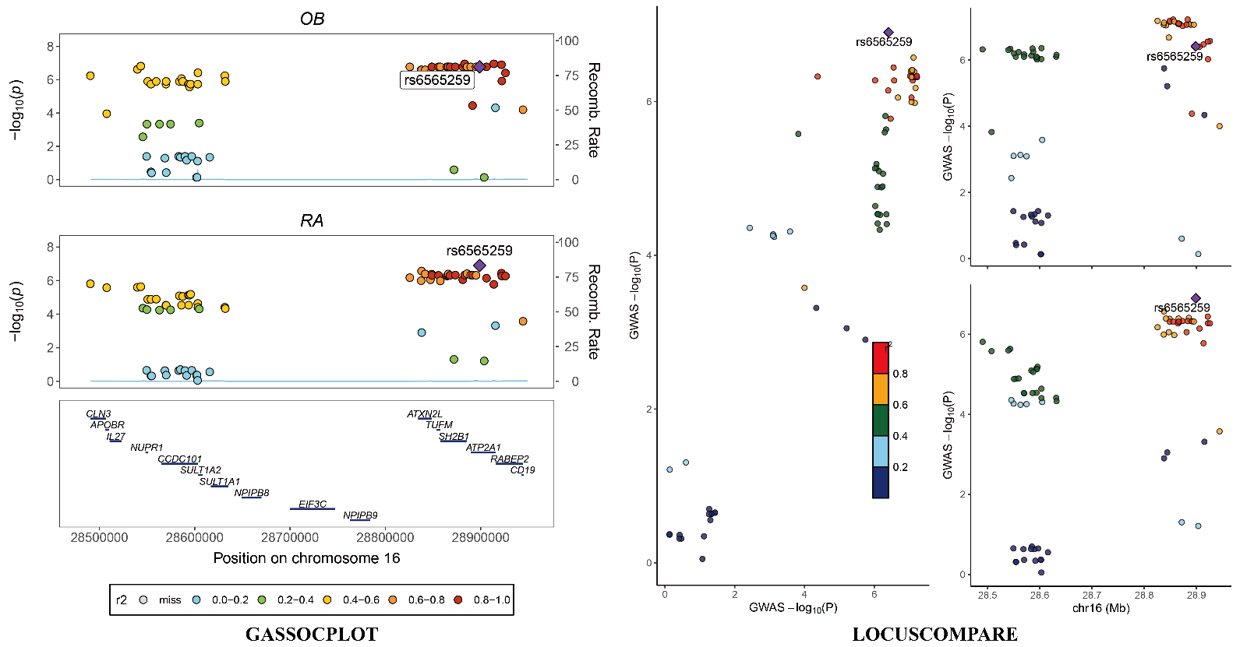
Figure S7. Regional plots of each colocalized locus (PP.H4 > 0.7) identified for corresponding trait pair (OB&RA) by using the PLACO. Note: PP.H4 was posterior probability of H4 calculated by coloc analysis; SNPs in LD that do not have any significant independent lead SNPs in the selected region are grayed out. For genes, mapped genes drawn by position mapping are in red; blue are unmapped protein-coding genes; dark gray are unmapped non-coding genes. Abbreviations: OB, obesity; RA, rheumatoid arthritis; SNP, Single-nucleotide polymorphism; LD, Linkage disequilibrium

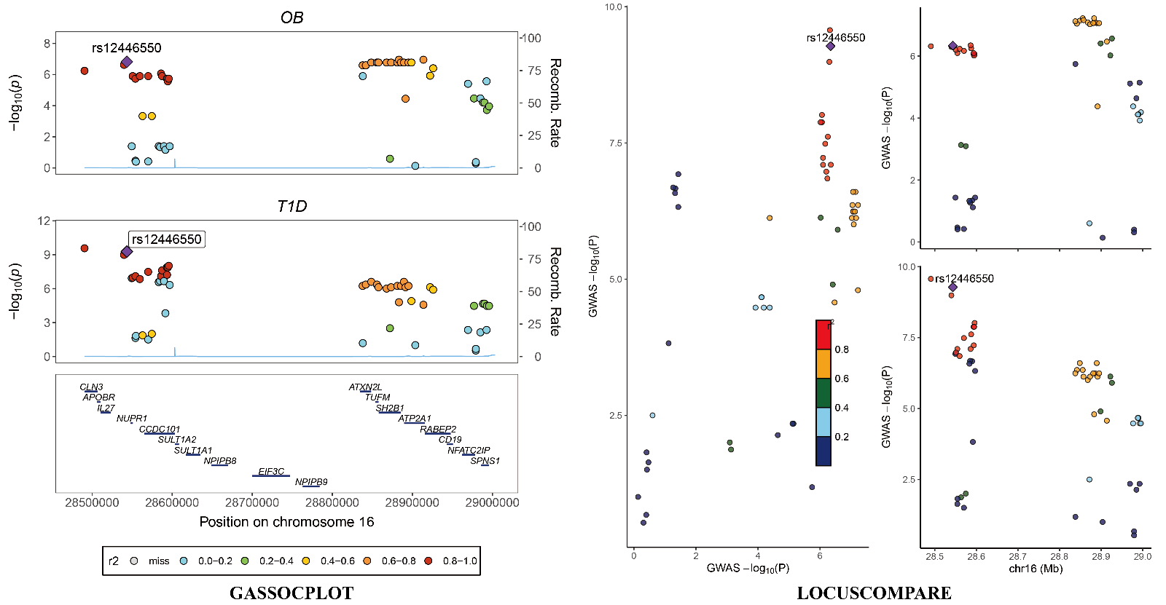
Figure S8. Regional plot of each colocalized locus (PP.H4 > 0.7) identified for corresponding trait pair (OB&T1D) by using the PLACO. Note: PP.H4 was posterior probability of H4 calculated by coloc analysis; SNPs in LD that do not have any significant independent lead SNPs in the selected region are grayed out. For genes, mapped genes drawn by position mapping are in red; blue are unmapped protein-coding genes; dark gray are unmapped non-coding genes. Abbreviations: OB, obesity; T1D, type 1 diabetes; SNP, Single-nucleotide polymorphism; LD, Linkage disequilibrium

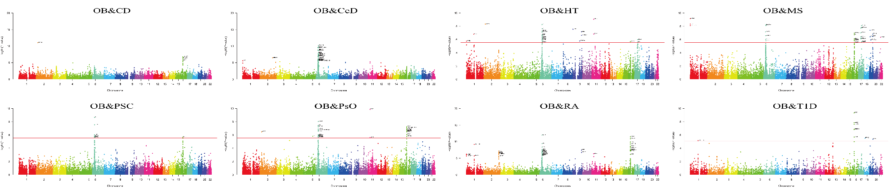
Figure S9. Manhattan plot of MAGMA gene analysis. Note: Red dot lines represent the Bonferroni significant threshold (P < 0.05/18,294) and the significant genes were labeled. Abbreviations: OB, obesity; CD, crohn’s disease; CeD, celiac disease; HT, hypothyroidism; MS, multiple sclerosis; PSC, primary sclerosing cholangitis; PsO, psoriasis; RA, rheumatoid arthritis; T1D, type 1 diabetes

