Supporting Information

Biomimetically-engineered FRP composites: integration of nanostructured resin matrix with hybrid fiber networks towards ultrahigh chemical stability and mechanical strengthening
Zuquan Jin ^{1,2,3*} · Hong Wang ^{1,2,3} · Bo Pang ^{1,2,3} · Shicai Li ^{1,2,3} · Mingfei Xu ^{1,2,3} ·
Ao Shen ^{1,2,3}
1. School of Civil Engineering, Qingdao University of Technology, Qingdao, 266520, China
2. Engineering Research Center of Concrete Technology under Marine Environment, Ministry of Education, Qingdao, 266520, China
3. International Cooperative Joint Laboratory for Low-Carbon Marine-concrete Technology, Ministry of Education, Qingdao 266033, China
Author Information
Corresponding Author
*Zuquan Jin. E-mail: jinzuquan@126.com

Note S1: Materials and experimental details.
Materials
Glass fiber: The glass fiber is 2400 tex untwisted roving, purchased from Taishan Glass Fiber Co., Ltd. The main elements and specific performance parameters are shown in Fig. S1 and Table S1. Carbon fiber: The specification of the carbon fiber is 12K, and its single - filament diameter is 6 μm. The specific performance parameters and main elements are shown in Fig. S2 and Table S2. The resin matrix is bisphenol A epoxy resin, with the grade of E51, and the performance indicators are shown in Table S3. PE is produced by Jiaxing United Chemical Co., Ltd. Its relative molecular mass is approximately 5000, and the epoxy value is 0.15 mol/100g. Methyltetrahydrophthalic anhydride is employed as the high-temperature curing agent to cross-link with the epoxy resin, forming a three-dimensional network upon curing. A small quantity of DMP30 may be added during the curing process to expedite the reaction rate.
Determination of the mixing amounts of carbon fibers and glass fibers
To enhance the pronounced hybrid effects and lower the cost of hybrid fibers in gradient distribution hybrid fiber composites, the ideal ratio of carbon fibers to glass fibers is established by considering the performance parameters of both fiber types and utilizing formula [1].
$$\frac{{\text{V}}_{\text{f}}}{{\text{V}}_{\text{G}}}\text{=1+}\frac{{\text{E}}_{\text{g}}}{{\text{E}}_{\text{c}}}\text{(}\frac{{\text{ε}}_{\text{gfu}}}{{\text{ε}}_{\text{cfu}}}\text{-1)}$$
Where: V_{f} = V_{c} + V_{G}, and it satisfies: V_{f} + V_{m} = 1;
V_{f} is the total volume fraction of fibers;
V_{m} represents the volume ratio of the resin matrix.
The analysis indicates a notable hybrid effect in FRP bars with carbon fiber content ≤ 15% and glass fiber content ≥ 85%. To replicate the gradient distribution pattern observed in bamboo, where carbon fibers encapsulate glass fibers in a "dense outside and sparse inside" arrangement, a composition of 15% carbon fibers and 85% glass fibers is recommended.
Preparation process of bars
FRP bars were fabricated using different blending methods and resin types, such as GFRP, H1FRP, H2FRP, H3FRP, and H4FRP (DE-FRP). The specific arrangement and types of fibers for each FRP bar variant are detailed in Table S4, while the fabrication process for DE-FRP bars is illustrated in Fig. S3. Following the blending of epoxy resin and curing agent, the mixture is fed into an impregnation device, where designated fibers are positioned on a yarn frame. These fibers are then guided through a preform mold, and the resulting preformed FRP bars undergo a sequence of treatments, including rib winding, high-temperature curing, and low-temperature cooling. Subsequently, the FRP bars are precisely cut to predefined lengths using a specialized cutting apparatus to yield various FRP bar categories.
Preparation of mechanical properties and durability samples
The energy-dispersive X-ray spectroscopy (EDS) analysis before and after modification of epoxy resin is shown in Fig. S4. The mechanical property specimens of epoxy resin and FRP bars are prepared as shown in Fig. S5. The epoxy resin is mainly subjected to contact angle tests, shear strength tests, and tensile strength tests before and after corrosion. The FRP bars are mainly subjected to tensile strength tests, shear strength tests, and compressive strength tests. It is worth noting that to facilitate the accurate characterization of the corrosion ion penetration depth by μ-XRF, it is necessary to ensure that the corrosion ions diffuse radially along the epoxy resin and FRP bars. Therefore, both ends of the specimens are sealed with silicone. In addition, the SWSC simulated pore solution and NaCl solution are prepared according to Table S5.
Note S2: Characterization and measurement
A field emission scanning electron microscope (SEM, TM4000Plus) equipped with an X-ray energy dispersive spectrometer (EDS) was used to examine the elemental distribution differences of EG and CNTs, as well as GFRP and DE-FRP before and after modification. The microstructure and elemental distribution of bamboo were also analyzed. Furthermore, SEM was used to observe the changes in the microstructure of the epoxy resin before and after modification and of GFRP and DE-FRP after corrosion. It is worth noting that since the surface of the FRP bar is wrapped with a layer of epoxy resin, if the FRP is directly observed by SEM, the morphology of the internal fibers of the FRP bar cannot be clearly observed. Therefore, the FRP bar needs to be polished. The changes in functional groups of the epoxy resin samples before and after modification were studied by Fourier transform infrared spectroscopy (FTIR, Thermo Fisher Scientific Nicolet iS20) to confirm the successful modification of the epoxy resin. During the test, the scanning range was 500 - 4000 cm⁻¹, the resolution was 4 cm⁻¹, and the incident angle was 45° ± 15°. Gel permeation chromatography (GPC, Agilent1260) was used to test the changes in the molecular weight of the epoxy resin matrix before and after modification. The chromatographic column was Plgel 5um MIXED-C, and the detector was a differential refractive index detector (RI). Approximately 10 mg of the cured epoxy resin flakes were taken, 2 mL of chromatographic-grade tetrahydrofuran was added, and the mixture was allowed to stand for 12 h for dissolution. After filtering with a 0.34 μm filter membrane, the sample was injected for testing at a flow rate of 1 mL/min, and the chromatographic time was 30 min. The contact angle of the sample surface was evaluated by a goniometer to assess its hydrophobic performance. During the test, a 7 μL drop of distilled water was dropped onto the sample surface. At least three different positions on the surface of each sample were selected for contact angle testing, and the average value was taken to obtain reproducible test values. A microhardness tester (HVST - 346) was used to compare the hardness changes of the epoxy resin before and after modification. The load for microhardness was set at 500 g, and the holding time was 10 s. Meanwhile, μ - XRF was used to characterize the penetration depth of corrosive ions in the epoxy resin. In addition, to verify the accuracy of μ - XRF, the hardness of the corroded epoxy resin was tested by microhardness, and the hardness change of the epoxy resin along the corrosion depth direction was observed (Fig. S6) to further verify the damage degree of corrosive ions to the epoxy resin and the enhancement effect of the modified epoxy resin.
The mechanical properties of FRP bars were analyzed. According to ACI 440.3R - 12, tensile tests were conducted on the corroded specimens to determine their tensile strength retention rate. The total length of the tensile specimens was 1020 mm, and both ends were encapsulated with hollow steel pipes filled with epoxy resin. The specimens were loaded at a speed of 2 mm/min until failure. The inter - laminar shear test of FRP bars was designed according to ASTM D4475 - 02. A testing machine was used for the short - beam shear test, and the loading speed was set at 1.5 mm/min. The size of the FRP bars used for the inter - laminar shear test was 80 mm [2]. The span - to - diameter ratio of the distance L between the lower support axes and the bar diameter d ranged from 3 ≤ L/d ≤ 6 to ensure that the failure mode of the FRP bars was fracture along the longitudinal shear plane. The acoustic emission technique was used to monitor the shear test process of FRP bar specimens. The acoustic emission equipment used for the inter - laminar shear test consisted of two RS - 2A broadband sensors (the detection surface was ceramic, and vaseline needed to be applied before detection to improve the acoustic coupling between the sensor and the sample), two 20/40/60 dB pre - amplifiers (the amplification value was set at 40 dB in the experiment), and an AE device. The sampling rate of the equipment was 3 MHz, and the sampling was triggered by setting the threshold. The signal threshold was set at 40 dB to filter out the background noise during the experiment .
Note S3: Mechanisms of resin yellowing and FRP bar deterioration
During the corrosion assessment of FRP bars, a comparison of the morphological changes between GFRP and DE-FRP revealed that immersion of GFRP bars in SWSC solution at 60°C for 120 days led to surface yellowing (Fig. S7). This discoloration is attributed to the degradation of molecules in the presence of the corrosive medium, resulting in the formation of phenol or the oxidation of phenol to p-benzoquinone and subsequently to o-benzoquinone. Phenol and p-benzoquinone are recognized chromophores capable of absorbing visible light at specific wavelengths, thereby imparting a yellow hue to the resin matrix [3,4]. In contrast, no discernible color alteration was observed on the surface of DE-FRP, underscoring the enhanced durability achieved through meticulous design considerations.
The corrosion progression of FRP bars in SWSC solution is illustrated in Fig. S8 and can be delineated into two primary stages. The first is the destruction of the resin in the FRP bar. Contact between the water and OH⁻ in the concrete with the resin causes swelling and degradation of the resin in the FRP bars, leading to the fracture of ester bonds in the resin and the formation of carboxylic acids and alcohols. This reduces the bond strength between the resin and the fibers, resulting in delamination between the resin and the fibers, thereby allowing more harmful substances to penetrate the interior of the FRP bar [5]. On the other hand, as the aqueous solution further infiltrates the outermost fibers, the main chain structures of glass fiber and basalt fiber react with hydroxide ions to form solid Si-OH gels and liquid SiO⁻. The liquid SiO⁻ also reacts with water molecules to form Si-OH gels. Since the density of these gels is significantly lower than that of the fibers, they accumulate at the fiber-resin interface, weakening the interfacial bonding performance [6].

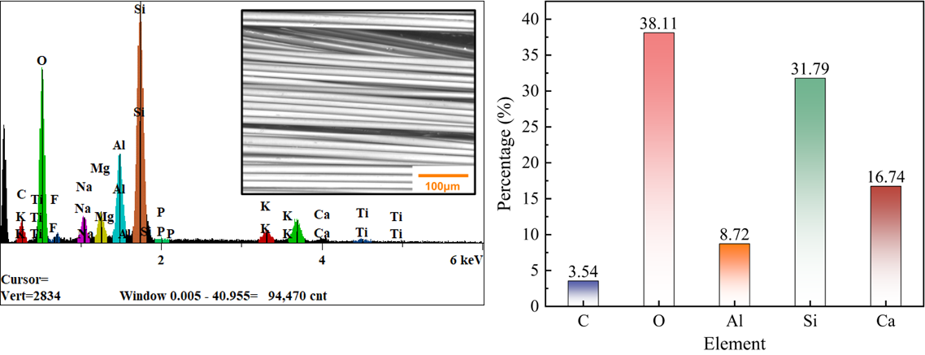

Fig. S1. Elemental distribution of glass fiber.
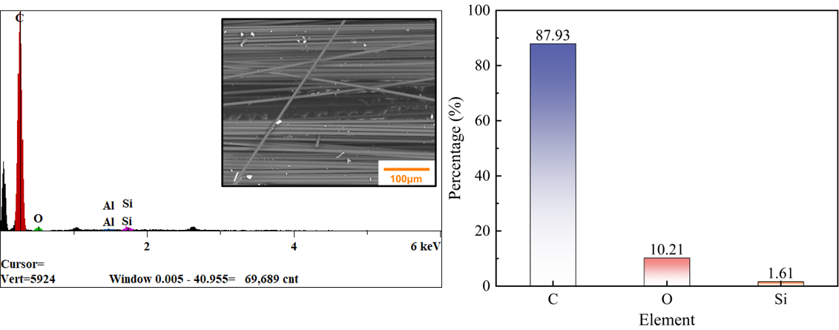
Fig. S2. Elemental distribution of carbon fiber.
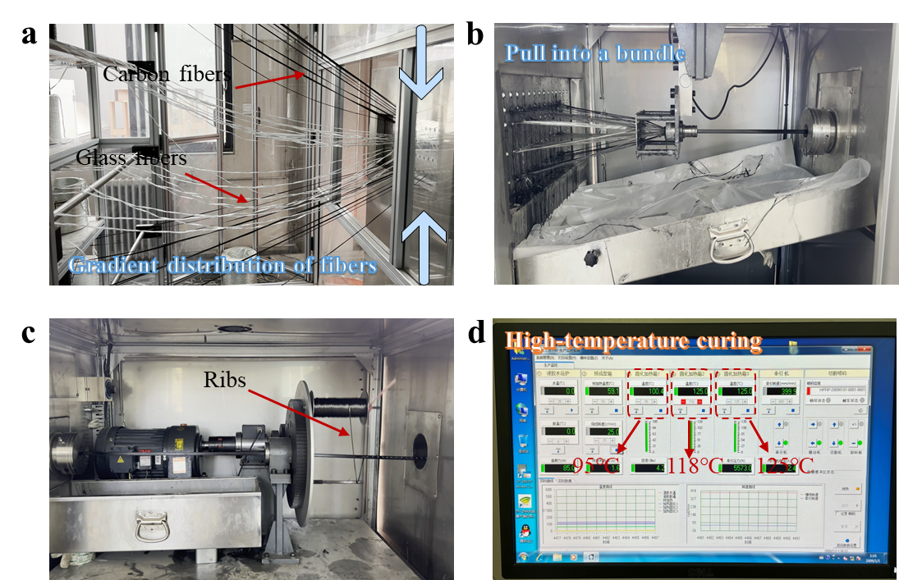
Fig. S3. Preparation process of FRP bars: (a) Fibers are arranged along the axis; (b) The squeegee blade scrapes off the excess resin; (c) Carbon fiber winding around the rib for forming; (d) Curing stage.
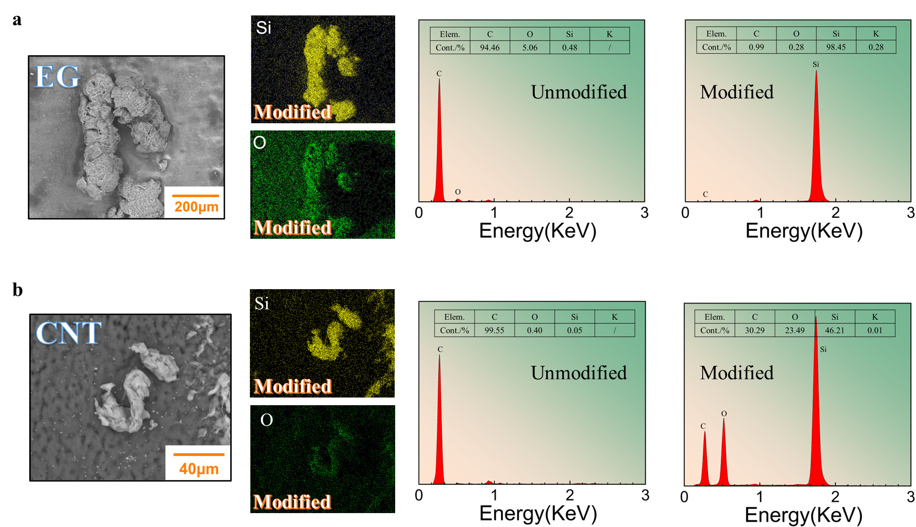
Fig. S4. EDS results for EG and CNTs.
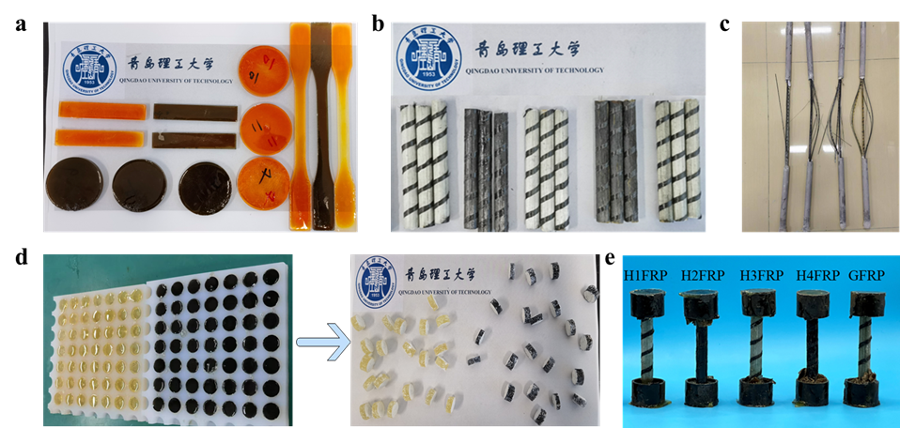
Fig. S5. Resin and FRP bar samples: (a) Samples for tensile strength, shear strength of epoxy resin; (b) Interlaminar shear strength samples of FRP bars; (c) Tensile strength samples of FRP bars; (d) Corrosion samples of epoxy resin; (e) Compressive strength samples of FRP bars.
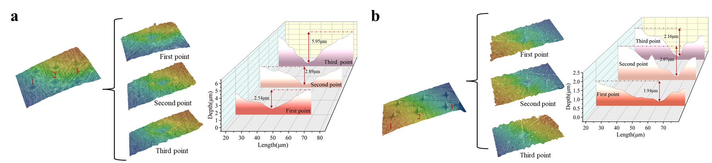
Fig. S6. Hardness variation along the corrosion depth direction.
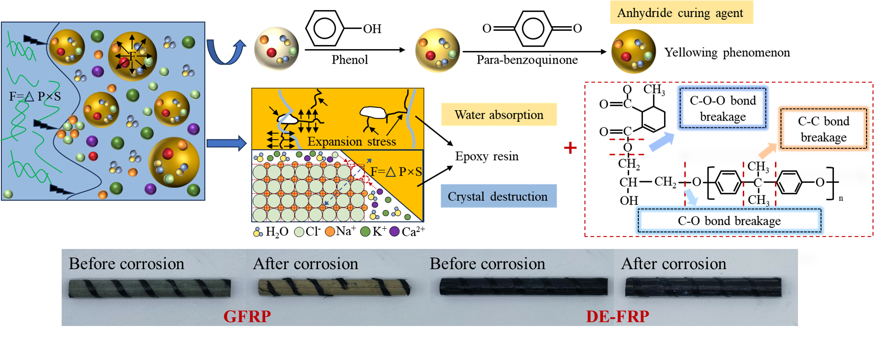
Fig. S7. Yellowing phenomenon and deterioration mechanism of epoxy resins.
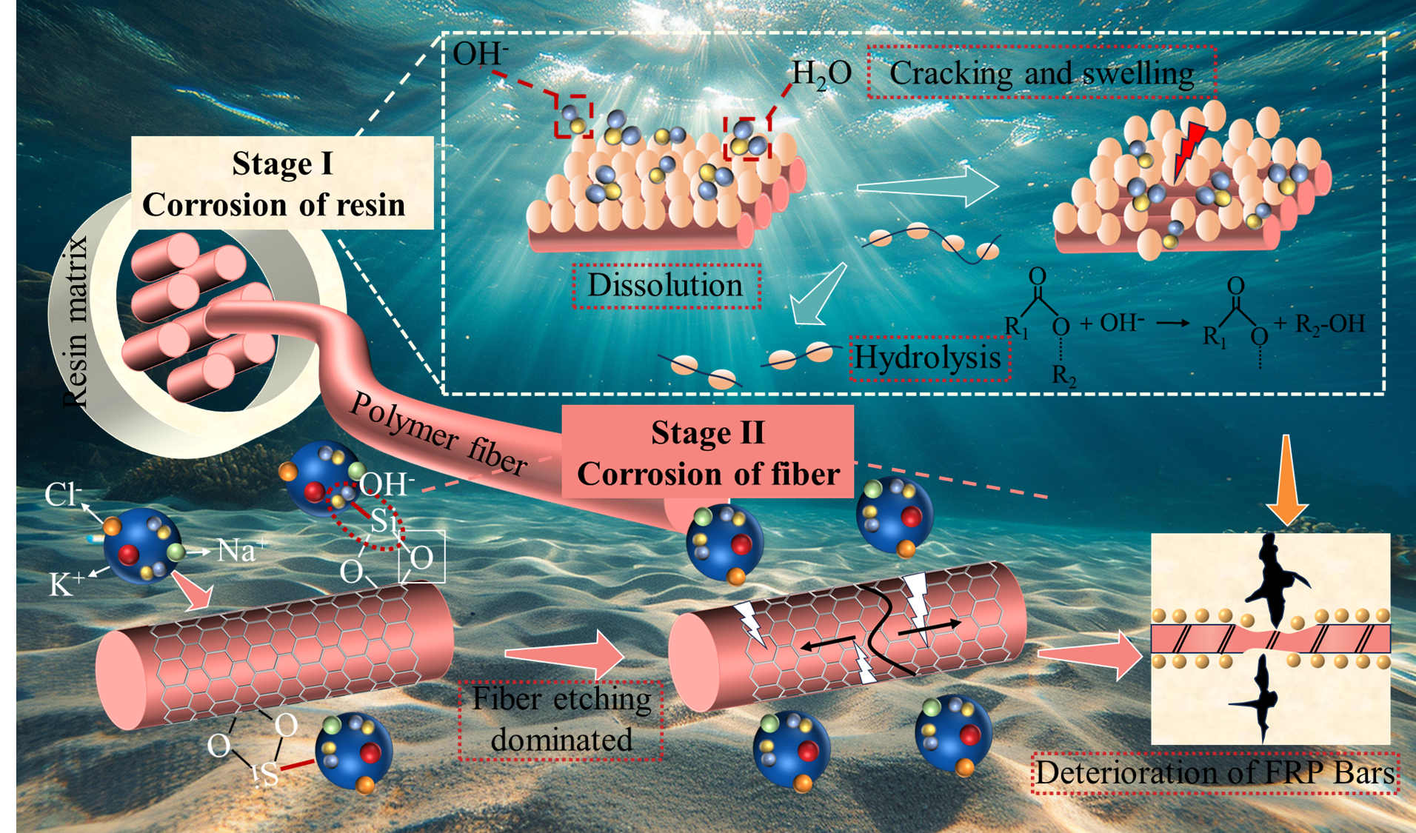
Fig. S8. The deterioration mechanism of FRP bars in SWSC.

Table S1. Glass fiber performance parameters.
Volume density  (g cm⁻³) | Fiber diameter  (μm) | Tensile strength  (MPa) | Elasticity modulus  (GPa) | Elongation  (%)
2.48 | 24 | 2025 | 81 | 2.5

Table S2. Carbon fiber performance parameters.
Volume density  (g cm⁻³) | Fiber diameter  (μm) | Tensile strength  (MPa) | Elasticity modulus  (GPa) | Elongation  (%)
1.80 | 6 | 4262 | 239 | 1.7

Table S3. Epoxy resin parameters.
Type | Color | Epoxy value  (mol/100g) | Volatility  (150℃/40min/%) | Viscosity  (25℃/mPa·s)
Bisphenol A epoxy resin | Transparent liquid | 0.48-0.55 | 0.50 | 11000-14000

Table S4. Arrangement modes and fiber types of various types of FRP bars.
Type | Volume fraction of glass fibers (%) | Volume fraction of carbon fibers (%) | Volume fraction of resin (%) | Resin type | Arrangement patterns of carbon fibers
GFRP | 65 | 0 | 35 | Normal resin | -
H1FRP | 53.3 | 9.75 | 35 | Normal resin | Core distribution
H2FRP | 53.3 | 9.75 | 35 | Normal resin | Outer edge design
H3FRP | 53.3 | 9.75 | 35 | Modified resin | Core distribution
H4FRP | 53.3 | 9.75 | 35 | Modified resin | Outer edge design

Table S5. Solution preparation (g/L).
Solution type | NaOH | KOH | Ca(OH)₂ | NaCl | PH
NaCl solution | - | - | - | 50 | 7.2
SWSC solution | 2.4 | 19.6 | 2 | 35 | 13.4

References
[1] Gao D, Zhu Z, Su C, Zhang T, Ji Y, Huang L (2024) Experimental study and
prediction on tensile behavior of steel fiber-reinforced-carbon/glass hybrid composite
bars in concrete environment. Constr Build Mater 414: 134988. https://doi.org/10.1016 /j.conbuildmat.2024.134988.
[2] Sarasinia F, Tirillòa J, Ferrantea L, Valente M, Valente T, Lampani L, Gaudenzi P, Cioffi S, Iannace S, Sorrentino L (2014) Drop-weight impact behaviour of woven hybrid basalt–carbon/epoxy composites. Compos B Eng 59: 204. https://doi.org/10.1016/j.compositesb.2013.12.006.
[3] Wu C, Meng B, Tam L, He L (2022) Yellowing mechanisms of epoxy and vinyl ester resins under thermal, UV and natural aging conditions and protection methods. Polym Test 114: 107708. https://doi.org/10.1016/j.polymertesting.2022.107708.
[4] Wang W, Gan J, Yuan Q,Chen J, Liu Z, Huang Y (2025) Flexible and transparent bamboo composites Enabled by a Dual-Resin blending strategy. Chem Eng J 509: 161256. https://doi.org/10.1016/j.cej.2025.161256.
[5] Feng G, Zhu D, Guo S, Rahman M, Jin Z, Shi C (2022) A review on mechanical
properties and deterioration mechanisms of FRP bars under severe environmental and
loading conditions. Cem Concr Compos 134: 104758. https://doi.org/10.1016/j.cemcon comp.2022.104758.
[6] Liu T, Liu X, Feng P (2020) A comprehensive review on mechanical properties of pultruded FRP composites subjected to long-term environmental effects. Compos B Eng 191: 107958. https://doi.org/10.1016/j.compositesb.2020.107958.

