Supplementary Information
See-through, flexible thin-film CMOS using a blend of tellurium and its oxide as a high-mobility p-type semiconductor

Himchan Oh¹, Sung Haeng Cho^{1*}, Jeho Na¹, Ji-Young Oh¹, Jae-Eun Pi², Sooji Nam¹, Kyunghee Choi¹, and Chi-Sun Hwang^{2*}

¹Flexible Electronics Research Section, Electronics & Telecommunications Research Institute (ETRI), Daejon 34129, Republic of Korea
²Reality Display Research Section, Electronics & Telecommunications Research Institute (ETRI), Daejon 34129, Republic of Korea

*Corresponding authors, E-mail addresses: helloshcho@etri.re.kr, and hwang-cs@etri.re.kr
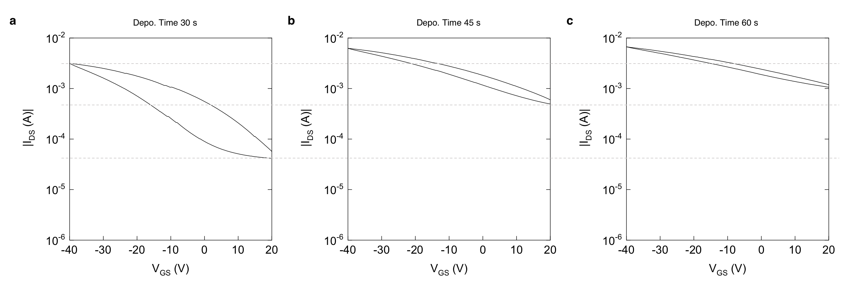
Supplementary Figure 1 | Transfer characteristics of pure tellurium thin-film transistors with different deposition times. a, 30 s (same as Fig. 1h in the main text). b, 45 s. c, 60 s.
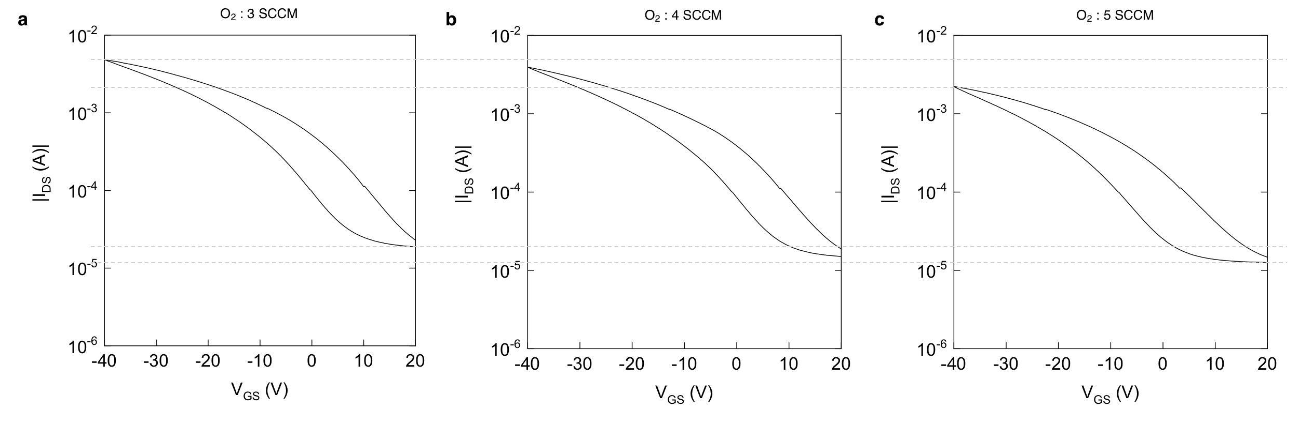
Supplementary Figure 2 | Transfer characteristics of reactively sputtered TeO_{x} thin-film transistors with different O₂ flow rate during depositions. a, 3 SCCM (same as Fig. 1i in the main text). b, 4 SCCM. c, 5 SCCM.
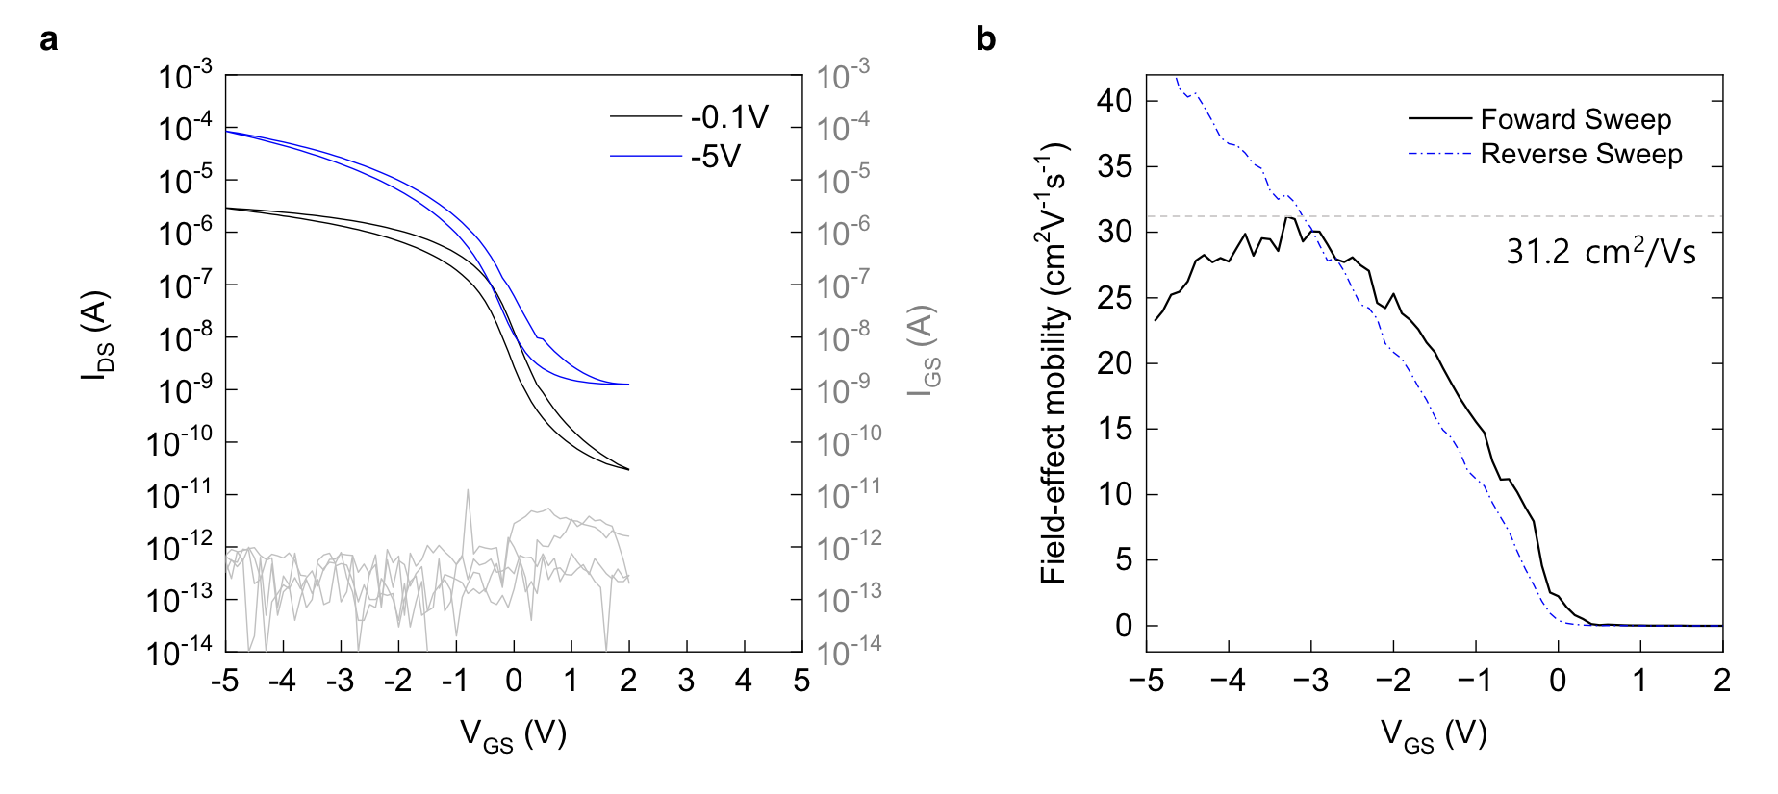
Supplementary Figure 3 | Device characteristics of the high-mobility Te/TeO₂ blended channel transistor (Te/TeO₂ power ratio : 42 W / 14 W). a, Transfer characteristic. b, Field-effect mobility curve.
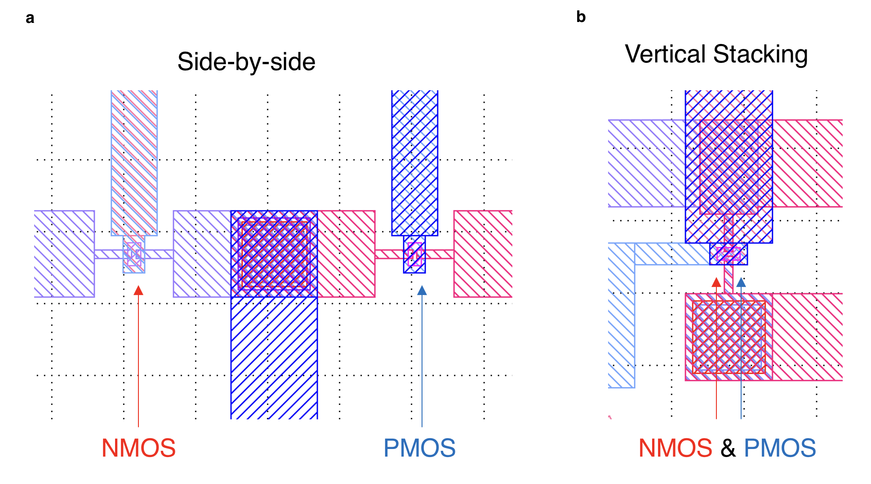
Supplementary Figure 4 | Layouts of CMOS inverters. a, Side-by-side configuration. b, Vertical integration with complete overlap of NMOS and PMOS.
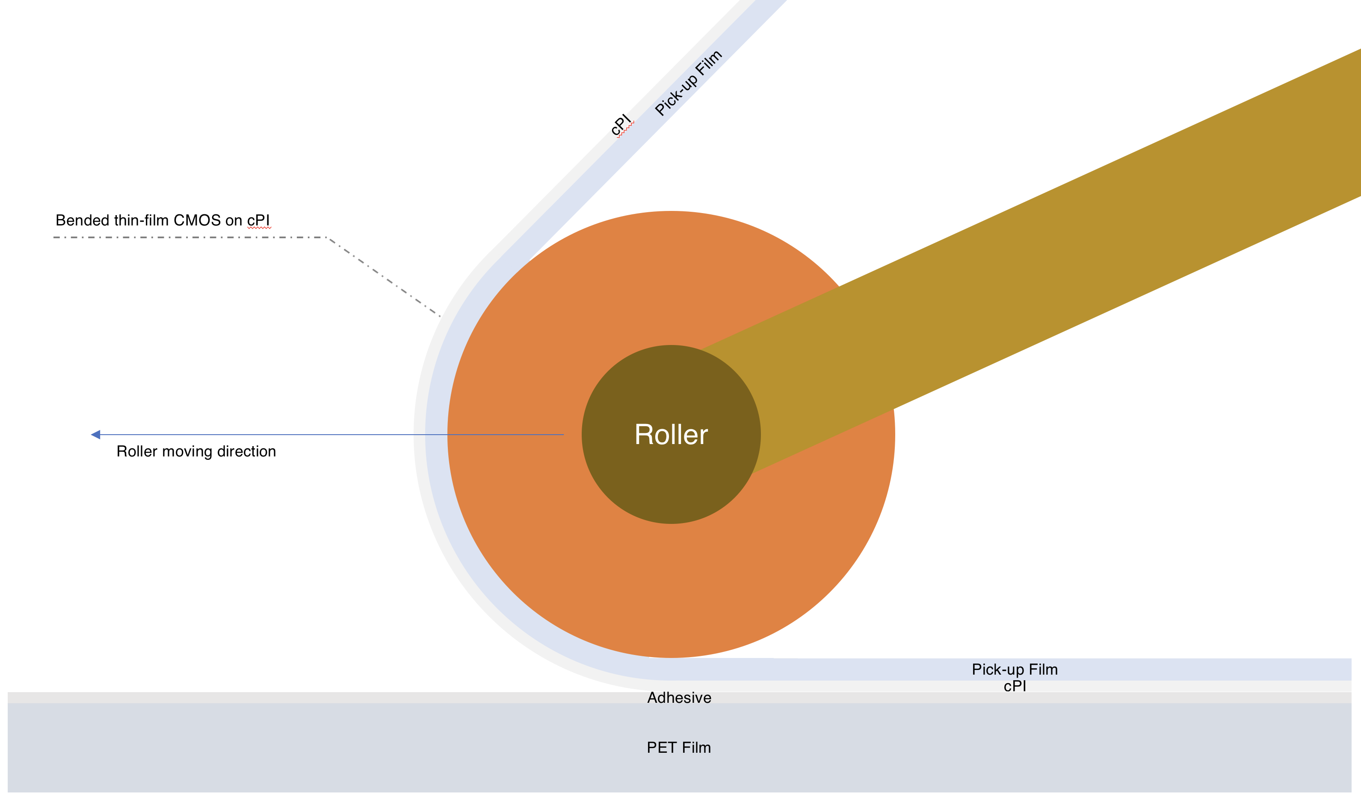 Supplementary Figure 5 | Roll pressing during the transfer process. Thin-film CMOS undergoes bending with a radius of curvature of 16mm.

