Supplementary Fig. 1 qPCR analysis of SmoA1, Gli1 and Gli2 in these genes overexpressing MEF cells.
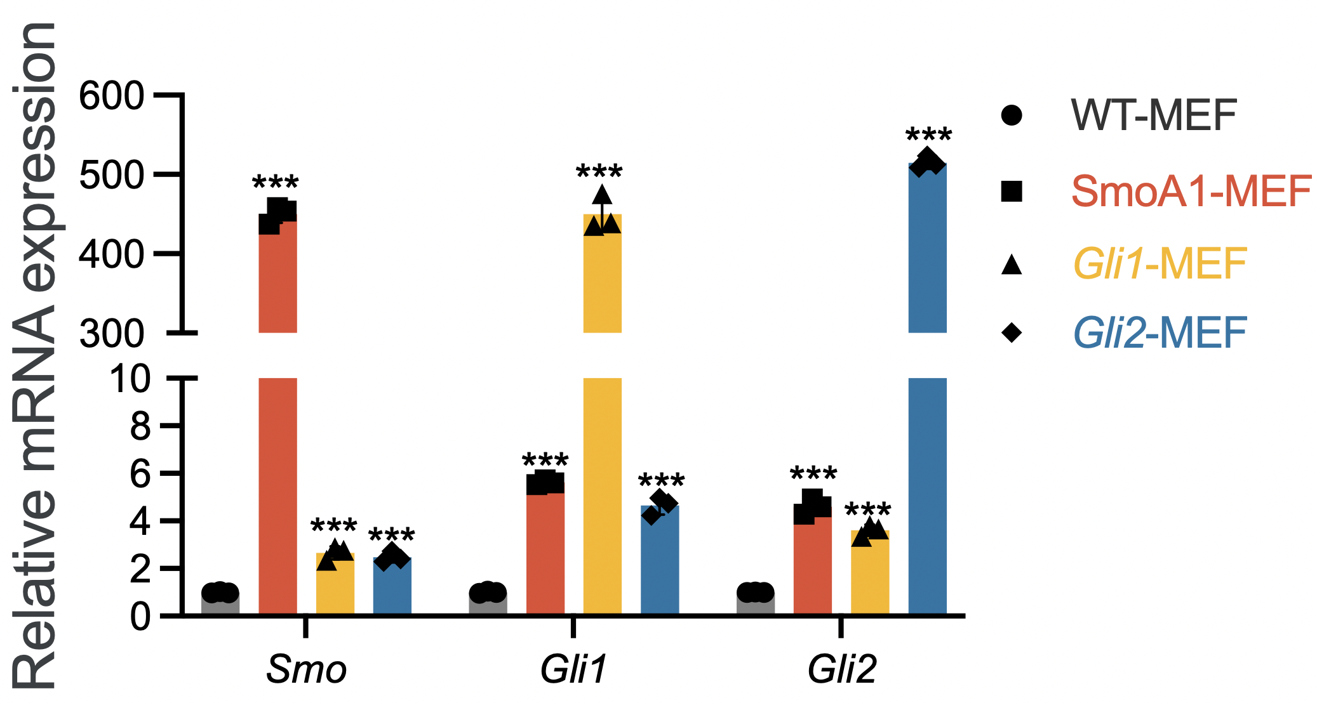
QPCR evaluation of the expression of Smo, Gli1, or Gli2 in SmoA1, Gli1, or Gli2 stably overexpressing MEF cells, WT-MEF cells served as control. ***P<0.001 vs. WT-MEF

Supplementary methods
The primers sequences (all for mouse specie) used in our qPCR experiments were as follows:
GAPDH (forward: CATCACTGCCACCCAGAAGACTG; reverse: ATGCCAGTGAGCTTCCCGTTCAG);
Gli1 (forward: CTCAAACTGCCCAGCTTAACCC); reverse: TGCGGCTGACTGTGTAAGCAGA);
Gli2 (forward: GCCCTGGAGAGTCACCCTT; reverse: TGCACAGACCGGAGGTAGT);
Ptch2 (forward: CTCCGCACCTCATATCCTAGC; reverse: TCCCAGGAAGAGCACTTTGC);
Sfrp1 (forward: CAATACCACGGAAGCCTCTAAGC; reverse: GCTTGCACAGAGATGTTCAATG);
Sirt1 (forward: GGAGCAGATTAGTAAGCGGCTTG; reverse: GTTACTGCCACAGGAACTAGAGG);
Sirt2 (forward: CGAAGGAGTGACACGCTACATG; reverse: GGTGGTACTTCTCCAGGTTTGC);
Sirt3 (forward: GCTACATGCACGGTCTGTCGAA; reverse: CAATGTCGGGTTTCACAACGCC);
Sirt4 (forward: GGCGACGTGTTCCTCACTG; reverse: ACAAAGTCAACCTTGTCTGGG);
Sirt5 (forward: ATCGCAAGGCTGGCACCAAGAA; reverse: CTAAAGCTGGGCAGATCGGACT);
Sirt6 (forward: CAGTACGTCAGAGACACGGTTG; reverse: GTCCAGAATGGTGTCTCTCAGC);
Sirt7 (forward: CTGGAGATTCCTGTCTACAACCG; reverse: AGTGACTTCCTACTGTGGCTGC)
SmoA1 (forward: GAGGCTACTTCCTCATCAGAGG; reverse: GCTGAAGGTGATGAGCACAAAGC).
Sequences for shRNAs are as following:
Scrambled shRNA: TTCTCCGAACGTGTCACGT;
ShSirt1#1: CCGGAGTGAGACCAGTAGCACTAATCTCGAGATTAGTGCTACTGGTCTCACTTTTTTG;
ShSirt1#2: CCGGAGTGAGACCAGTAGCACTAATCTCGAGATTAGTGCTACTGGTCTCACTTTTTTG.

