Supplementary Information
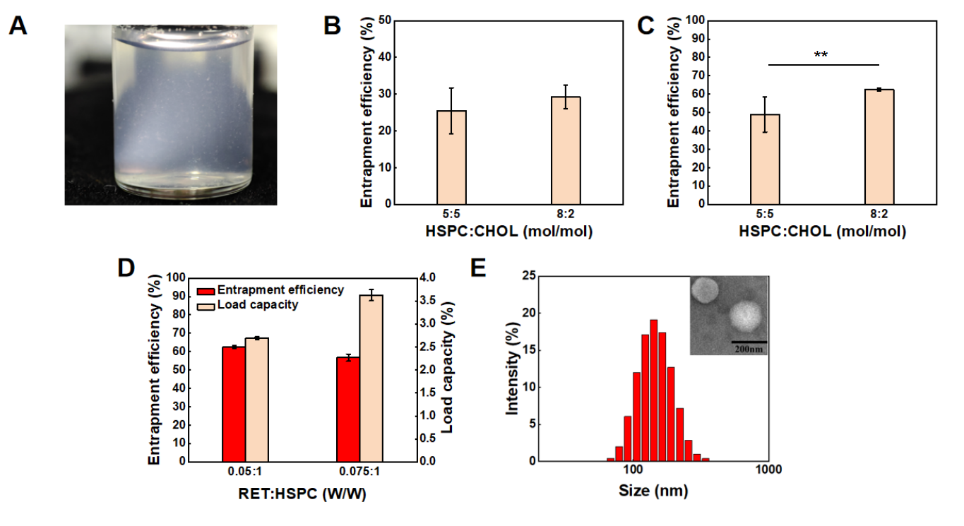
Fig. S1. Characterization of liposomes. (A) Appearance of blank liposomes with HSPC:Chol=7:3 after storage for one week. EE of (B) NA and (C) RET in RN-Lip with RET:HSPC=0.05:1(w/w). (D) EE of RET in RN-Lip with HSPC:CHOL=8:2. (E) Hydrodynamic size distribution of blank liposomes measured by DLS and morphology of RN-Lip observed by TEM.

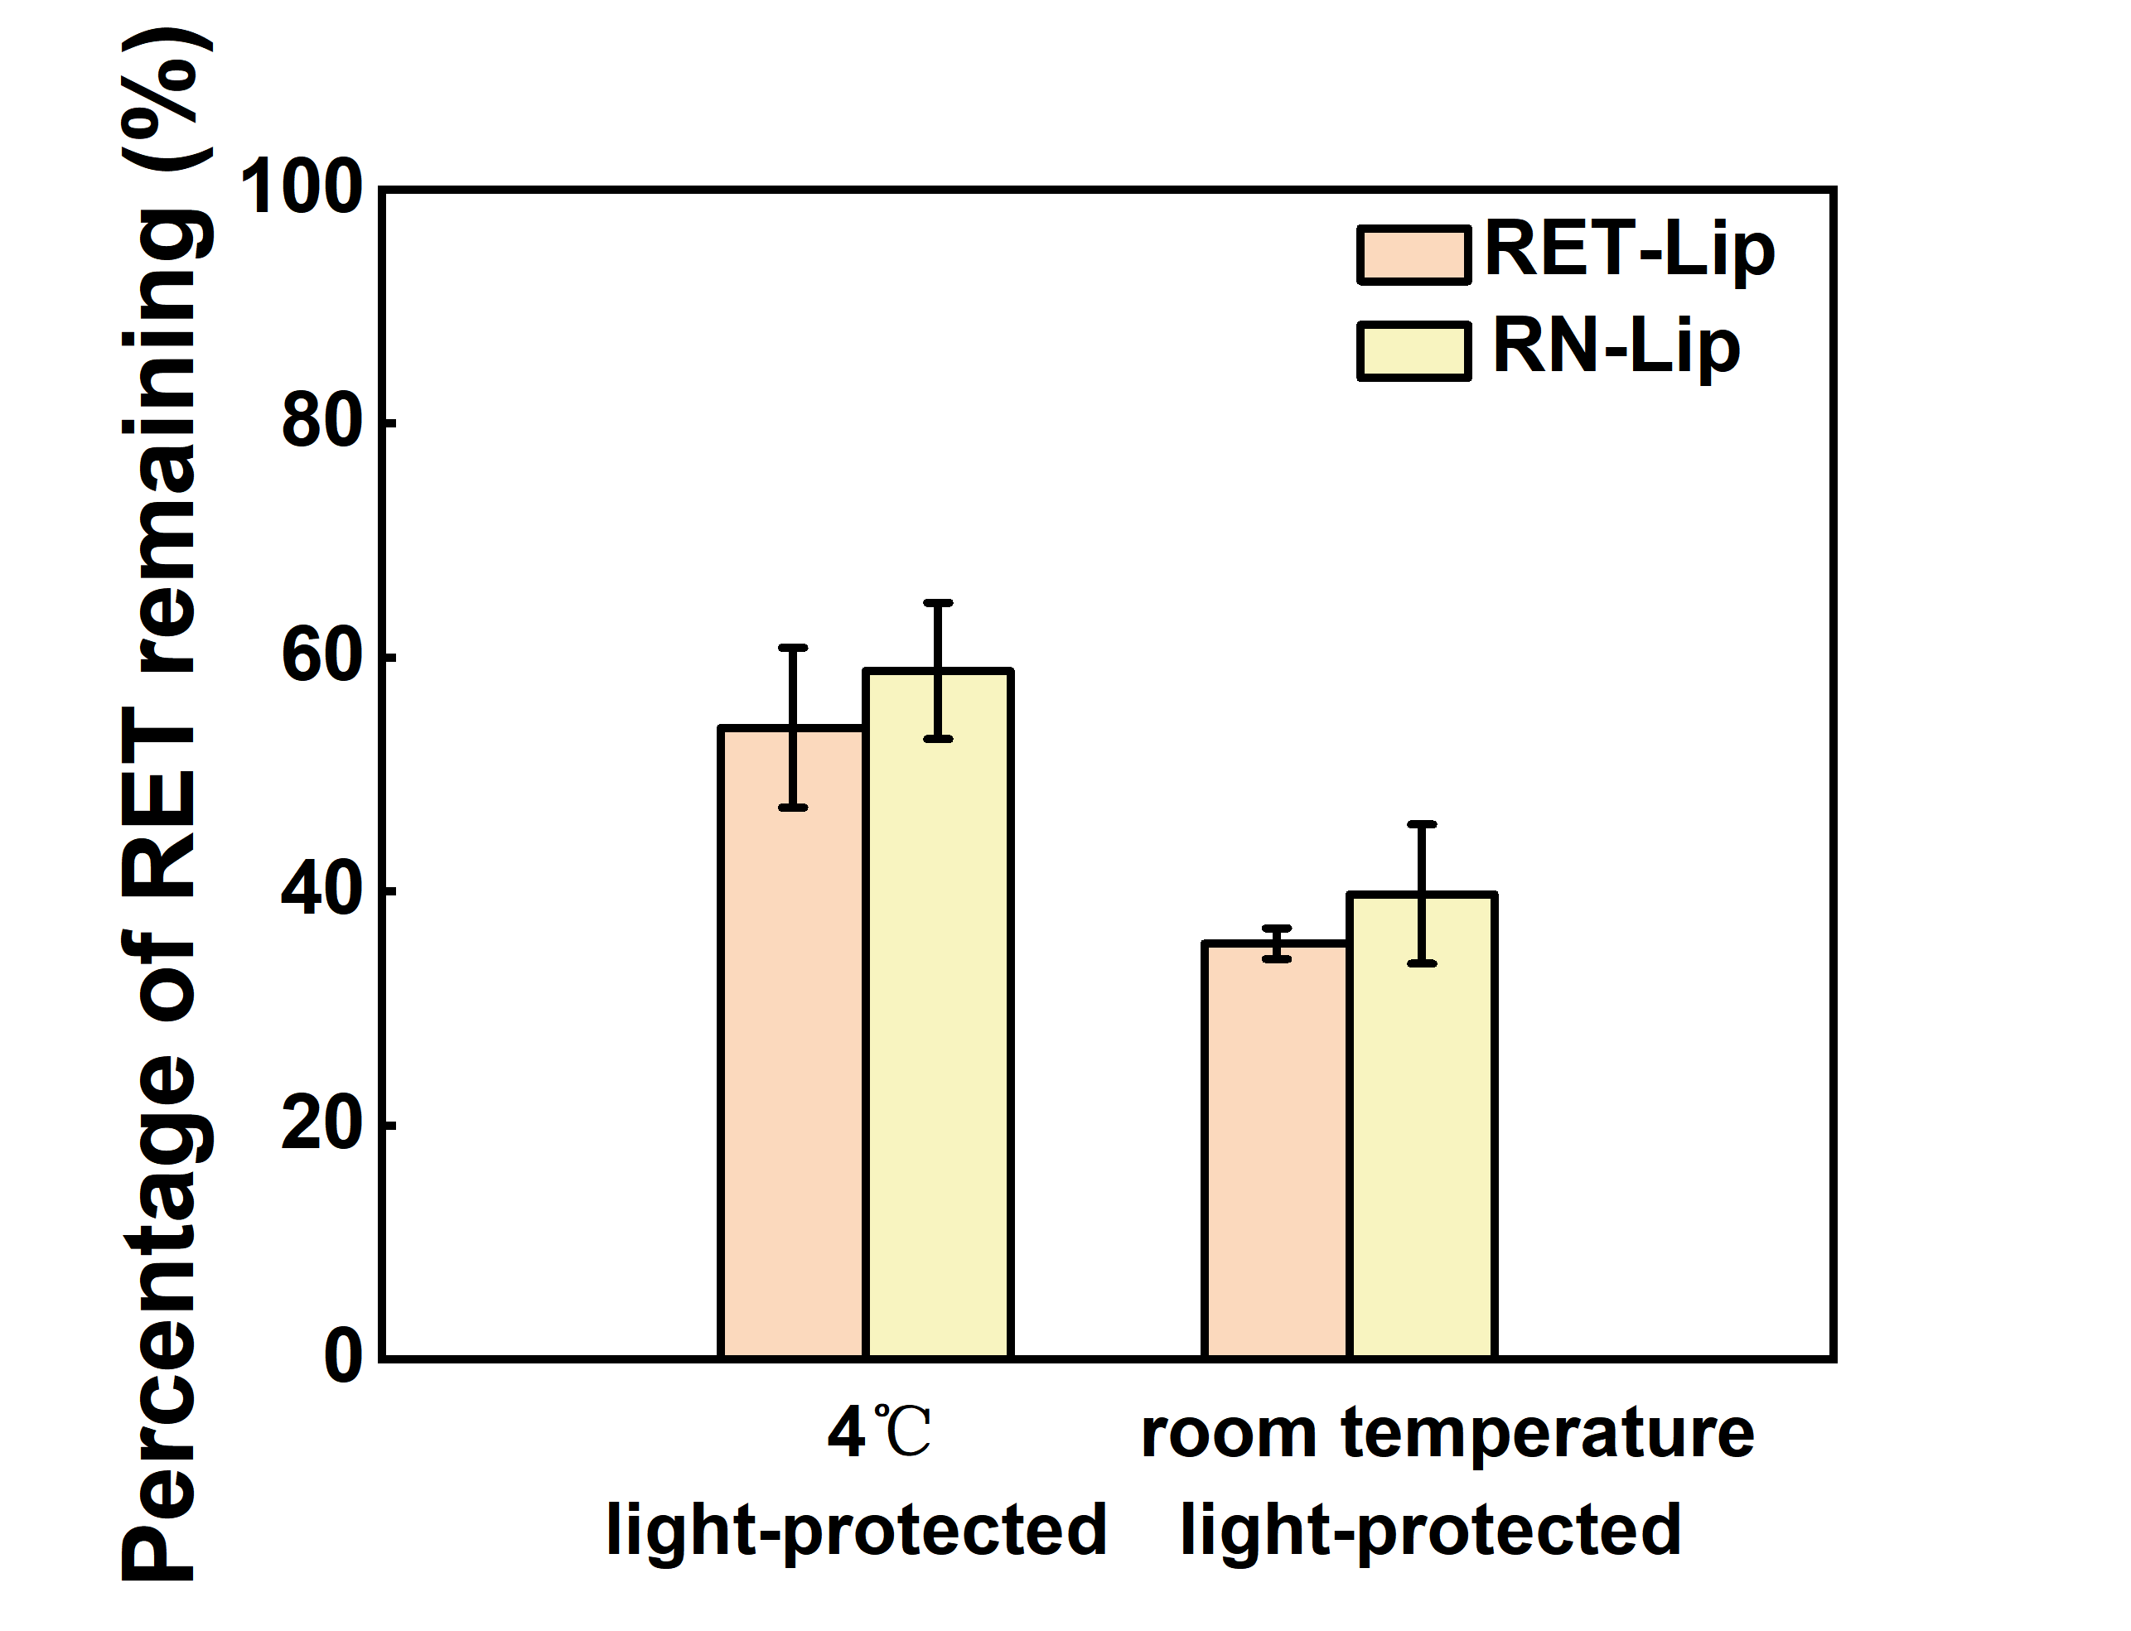
Fig. S2. The remaining amount of RET stored under 4℃, light-protected and room temperature, light-protected on the 30th day

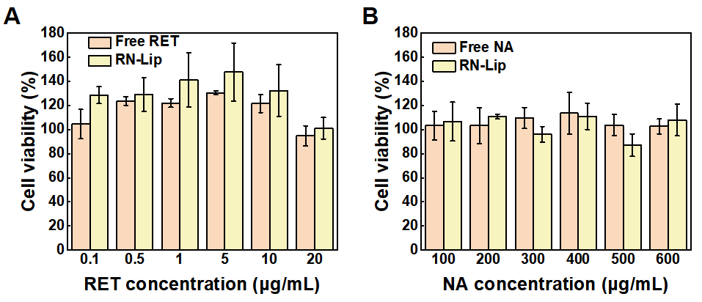
Fig. S3. In vitro cytotoxicity of HaCaT cells determined by MTT assay. Cells were treated with RN-Lip and (A) free RET or (B) free NA with equivalent RET or NA concentration. Data are presented as mean ± SD, n = 3.

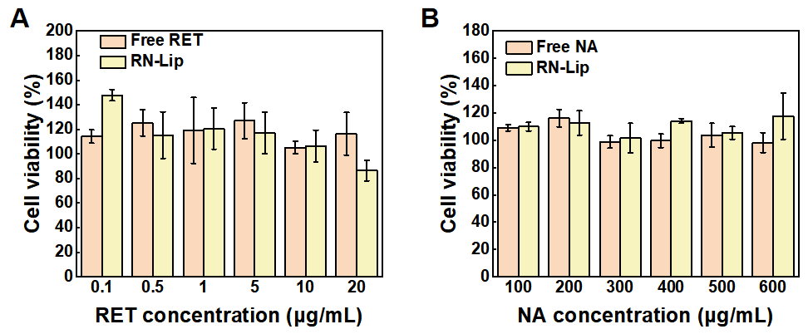
Fig. S4. In vitro cytotoxicity of B16F10 cells determined by MTT assay. Cells were treated with RN-Lip and (A) free RET or (B) free NA with equivalent RET or NA concentration. Data are presented as mean ± SD, n = 3.

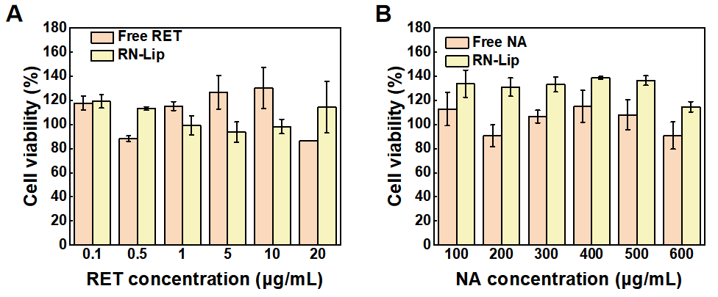
Fig. S5. In vitro cytotoxicity of BJ cells determined by MTT assay. Cells were treated with RN-Lip and (A) free RET or (B) free NA with equivalent RET or NA concentration. Data are presented as mean ± SD, n = 3.

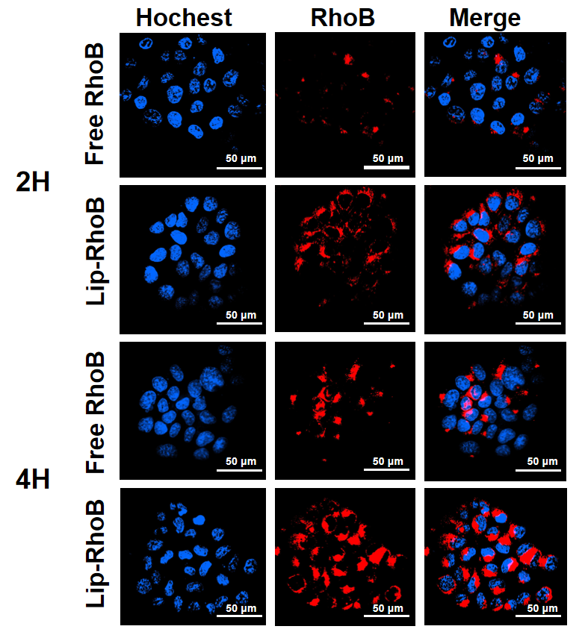
Fig. S6. Cellular uptake. Representative CLSM images of RhoB intracellular distribution in HaCaT cells treated with RhoB solution or Lip-RhoB.

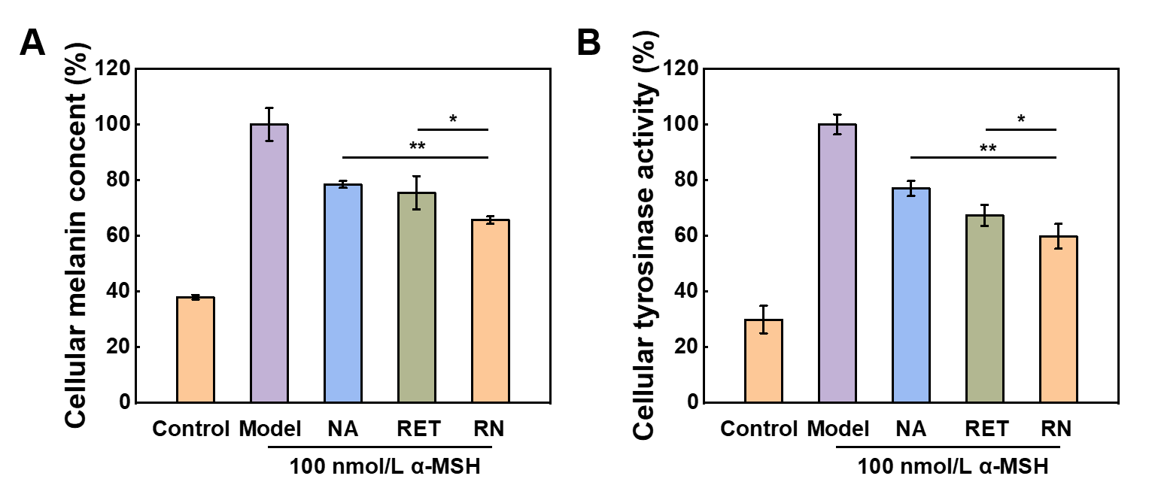

Fig. S7. (A) The content of melanin and (B) tyrosinase acidity in B16F10 cells after 24 treatment with free active ingredients solution. Except for the control group, B16F10 cells in all groups were treated with 100 nM α-MSH. Free NA and RN kept equivalent NA concentration (200 μg/mL), and free RET and RN kept equivalent RET concentration (10 μM). Data are presented as mean ± SD, n = 3. *p < 0.05, **p < 0.01.

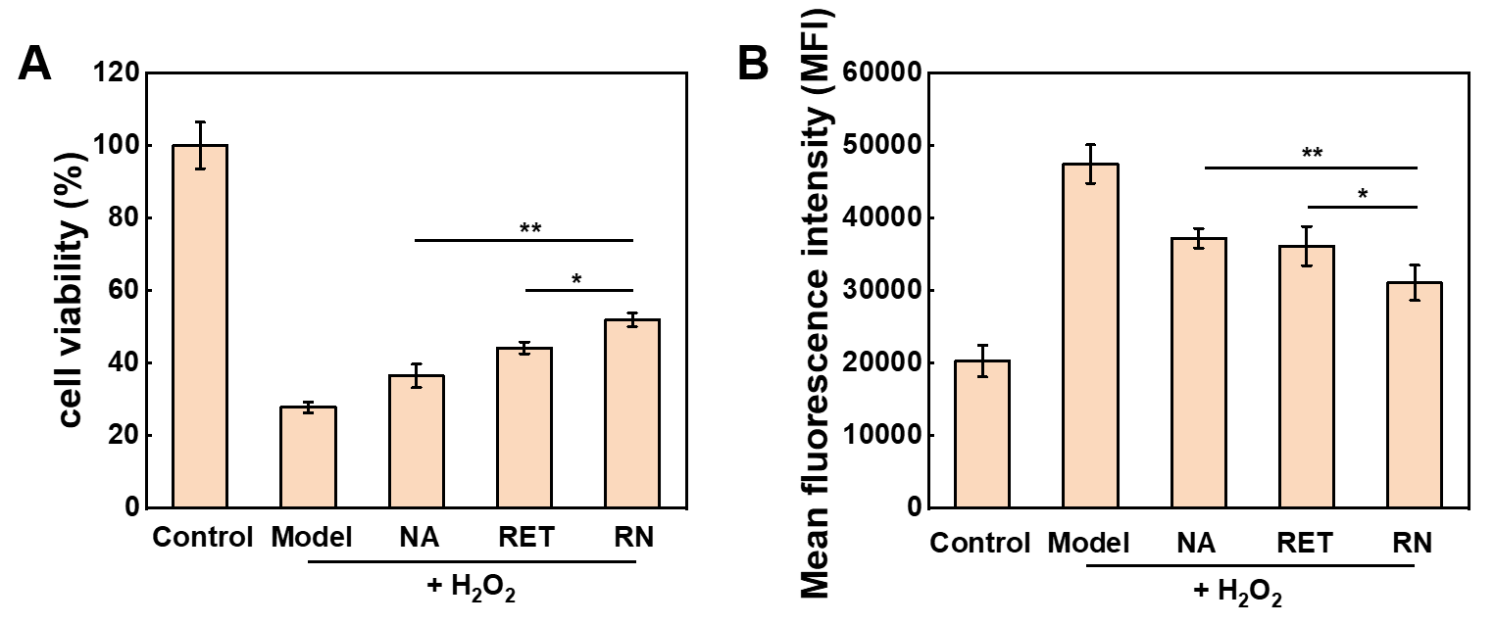
Fig. S8. Cellular antioxidation effect. (A) cell viability and (B) relative MFI showing intracellular ROS level of HaCaT cells treated with free active ingredients solution. Except the control group, cells in all the other groups were damaged by 800 µM H₂O₂. Free NA and RN kept equivalent NA concentration (200 μg/mL), and free RET and RN kept equivalent RET concentration (10 μM). Data are presented as mean ± SD, n = 3. *p < 0.05, **p < 0.01.

