Simulating interferon-γ assay testing patterns to detect bovine tuberculosis in Irish cattle herds

Contents
Supplementary tables 1
Supplementary figures 8
Supplementary methods 17

Supplementary tables
Supplementary table 1: Summary of diagnostic interferon-γ testing patterns in Ireland between start 2005 and end 2022. % all herds + means % herds with any type of bTB case detection positive (skin / interferon-γ / slaughterhouse).
Year | N cattle interferon-γ tested | % interferon-γ tested cattle + | N herds interferon-γ tested | % interferon-γ tested herds + | N all herds* | % all herds +
2005 | 3,866 | 11.7 | 96 | 82.3 | 121,375 | 6.0
2006 | 6,719 | 13.6 | 144 | 78.5 | 119,676 | 5.7
2007 | 12,491 | 13.6 | 284 | 87.3 | 117,761 | 6.4
2008 | 9,706 | 20.8 | 259 | 83.0 | 116,819 | 6.3
2009 | 4,638 | 22.2 | 103 | 82.5 | 115,833 | 5.4
2010 | 5,486 | 27.0 | 137 | 87.6 | 114,562 | 5.0
2011 | 3,668 | 24.9 | 98 | 83.7 | 114,785 | 4.5
2012 | 4,437 | 27.8 | 132 | 88.6 | 114,551 | 4.5
2013 | 4,706 | 25.2 | 130 | 83.8 | 114,335 | 4.1
2014 | 8,424 | 24.5 | 214 | 84.6 | 113,220 | 3.9
2015 | 22,049 | 15.1 | 454 | 80.8 | 113,612 | 3.6
2016 | 32,190 | 14.2 | 526 | 87.6 | 112,953 | 3.5
2017 | 33,881 | 12.9 | 606 | 84.0 | 112,373 | 3.7
2018 | 41,809 | 12.0 | 669 | 82.2 | 110,805 | 3.8
2019 | 41,444 | 8.1 | 695 | 75.1 | 109,486 | 4.0
2020 | 59,212 | 7.9 | 838 | 79.6 | 108,548 | 4.7
2021 | 55,533 | 9.0 | 853 | 80.8 | 108,044 | 4.7
2022 | 66,478 | 8.9 | 895 | 84.2 | 106,348 | 4.7

Supplementary table 2: Proportions of eligible skin tests followed by interferon-γ tests by county, in the study population of breakdowns ending between 2015 and 2020.
County | Eligible skin test not  followed by GIF test, N = 2,196¹ | Eligible skin test followed  by GIF test, N = 1,511¹
Carlow | 10 (67%) | 5 (33%)
Cavan | 91 (46%) | 107 (54%)
Clare | 128 (49%) | 132 (51%)
Cork | 344 (59%) | 235 (41%)
Donegal | 21 (48%) | 23 (52%)
Dublin | 7 (64%) | 4 (36%)
Galway | 186 (64%) | 105 (36%)
Kerry | 108 (50%) | 110 (50%)
Kildare | 17 (61%) | 11 (39%)
Kilkenny | 87 (73%) | 32 (27%)
Laois | 52 (51%) | 50 (49%)
Leitrim | 18 (42%) | 25 (58%)
Limerick | 79 (72%) | 31 (28%)
Longford | 7 (23%) | 24 (77%)
Louth | 23 (61%) | 15 (39%)
Mayo | 40 (47%) | 45 (53%)
Meath | 101 (63%) | 59 (37%)
Monaghan | 189 (69%) | 83 (31%)
Offaly | 87 (66%) | 44 (34%)
Roscommon | 36 (43%) | 48 (57%)
Sligo | 23 (29%) | 55 (71%)
Tipperary | 184 (68%) | 88 (32%)
Waterford | 28 (60%) | 19 (40%)
Westmeath | 173 (71%) | 72 (29%)
Wexford | 80 (68%) | 38 (32%)
Wicklow | 77 (60%) | 51 (40%)
¹n (%)

Supplementary table 3: Comparison of three final logistic regression models. AIC = Akaike’s information criterion. ECI = estimated calibration index. We selected the model with the lowest ECI.
Model | AIC | Corrected ECI | Corrected Somer’s D
Year end breakdown category + county + log herd size + herd type + log skin case count + count previous interferon-γ test in same breakdown | 3939 | 0.11 | 0.61
Year end breakdown category + county + herd size category + herd type + binned skin case count + count previous interferon-γ test in same breakdown | 3982 | 0.03 | 0.59
Year end breakdown numeric + county + log herd size + breeding herd + square root skin case count + count previous interferon-γ test in same breakdown | 4029 | 0.01 | 0.58

Supplementary table 4: Likelihood ratio test result for the final logistic regression model to explain the probability of an eligible skin test being followed by an interferon-γ test.
Dropped variable | Df | Deviance | AIC | LRT Chi | Pr  (>Chi) | AIC difference
None |  | 3,966.878 | 4,028.88 |  | NA | 0.00000
Year of breakdown end | 1 | 4,114.394 | 4,174.39 | 147.51624 | <0.0001 | 145.52
County | 25 | 4,111.460 | 4,123.46 | 144.58184 | <0.0001 | 94.58
Log herd size | 1 | 4,013.697 | 4,073.70 | 46.81902 | <0.0001 | 44.82
Breeding herd | 1 | 4,008.742 | 4,068.74 | 41.86405 | <0.0001 | 39.86
Square root skin case count | 1 | 4,505.959 | 4,565.96 | 539.08062 | <0.0001 | 537.08
Previous Interferon-γ test same breakdown | 1 | 4,035.726 | 4,095.73 | 68.84802 | <0.0001 | 66.84802

Supplementary table 5: Likelihood ratio test result for the final negative binomial regression model to explain the count of cattle interferon-γ tested in an interferon-γ test.
Dropped variable | Df | logLik | AIC | LRT Chi | Pr  (>Chi) | AIC difference
<none> |  | -7,025.7 | 14,099.47 |  | NA | 0.0
Year of breakdown end | 1 | -7,037.6 | 14,121.30 | 23.8 | <0.001 | 21.8
Regional Veterinary Office | 15 | -7,062.5 | 14,142.97 | 73.5 | <0.001 | 43.5
Log herd size | 1 | -7,263.1 | 14,572.24 | 474.8 | <0.001 | 472.8
Herd type | 4 | -7,031.5 | 14,103.07 | 11.6 | 0.021 | 3.6
Log count skin cases in eligible skin test | 1 | -7,039.5 | 14,125.09 | 27.6 | <0.001 | 25.6

Supplementary table 6: Summary statistics of potential explanatory variables for an eligible skin test being followed by an interferon-γ test. (Percentages for categories are by column).
Characteristic | FALSE, N = 2,196¹ | TRUE, N = 1,511¹
Count skin cases in eligible test | 4.0 (2.0, 6.0) | 7.0 (4.0, 11.0)
Cumulative count skin cases up  to end eligible test | 6 (4, 11) | 8 (5, 13)
Cumulative count skin or slaughterhouse  Cases up to end eligible test | 7 (5, 11) | 8 (6, 13)
Herd size | 132 (69, 208) | 110 (60, 184)
Count previous interferon-γ tests in same breakdown
0 | 1,720 (78%) | 1,407 (93%)
1 | 397 (18%) | 90 (6.0%)
2 | 63 (2.9%) | 14 (0.9%)
3 | 16 (0.7%) | 0 (0%)
Year breakdown end
2015 | 438 (20%) | 105 (6.9%)
2016 | 305 (14%) | 175 (12%)
2017 | 327 (15%) | 258 (17%)
2018 | 315 (14%) | 315 (21%)
2019 | 353 (16%) | 271 (18%)
2020 | 458 (21%) | 387 (26%)
Herd type
Beef breeding | 827 (38%) | 686 (45%)
Dairy | 821 (37%) | 529 (35%)
Fattener | 240 (11%) | 102 (6.8%)
Mixed | 262 (12%) | 161 (11%)
Store | 46 (2.1%) | 33 (2.2%)
¹Median (IQR); n (%)

Supplementary figures

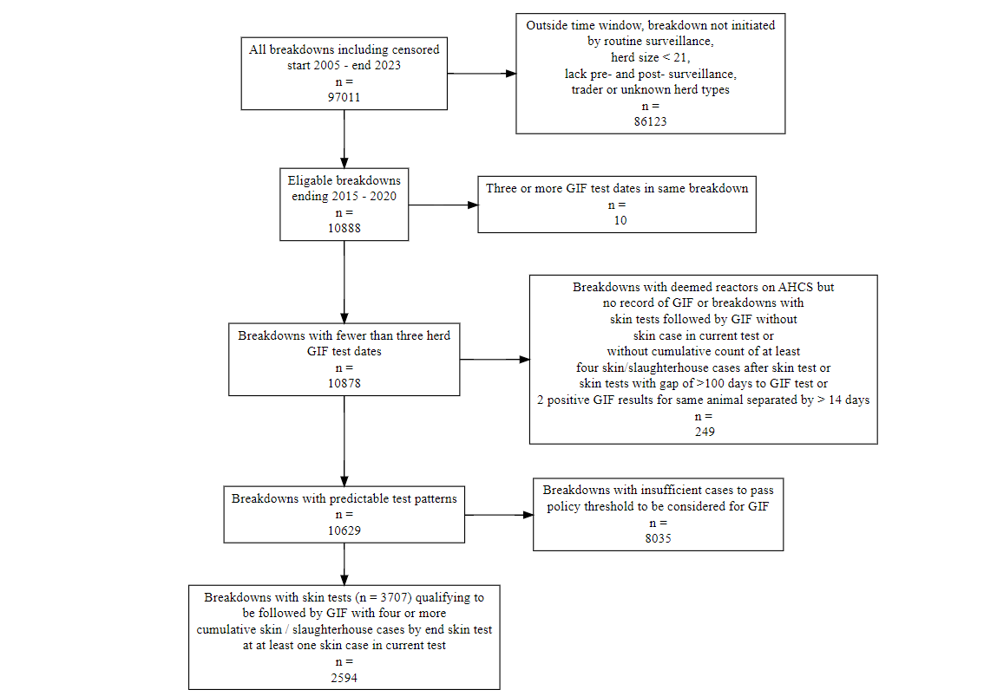
Supplementary Figure 1: Inclusion/exclusion criteria of potential breakdowns to include in our regression models.

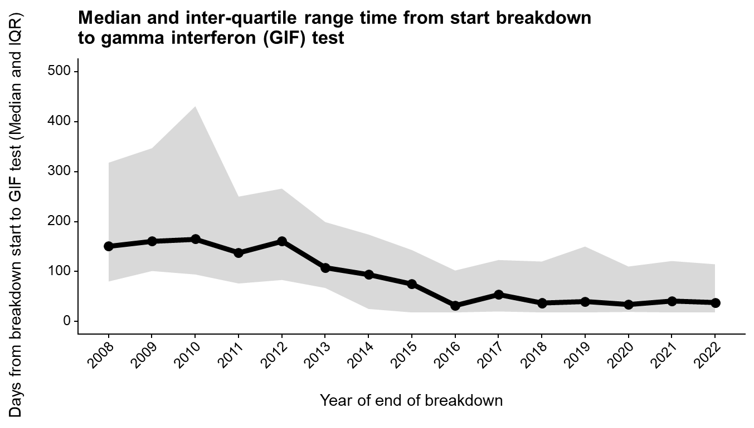
Supplementary Figure 2: Time in days from breakdown start date to interferon-γ test.
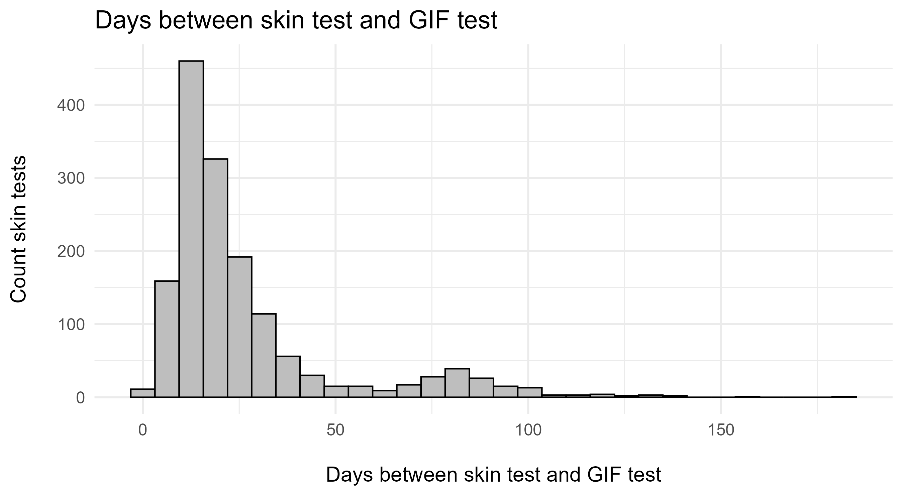
Supplementary Figure 3: Days between initiating skin test and interferon-γ test.

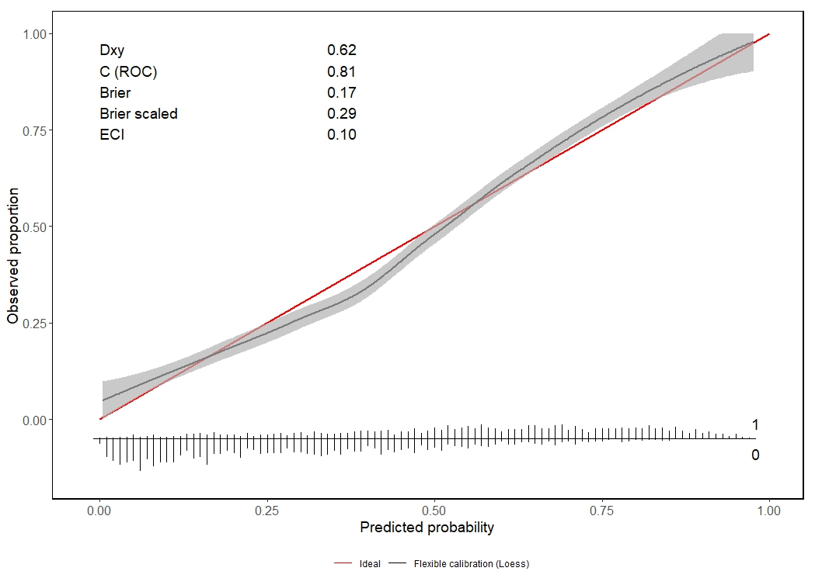
Supplementary Figure 4: The calibration curve from the logistic regression model with the lowest AIC. Observed compared to predicted probabilities in the full dataset are shown. This curve highlights an area of poor calibration.

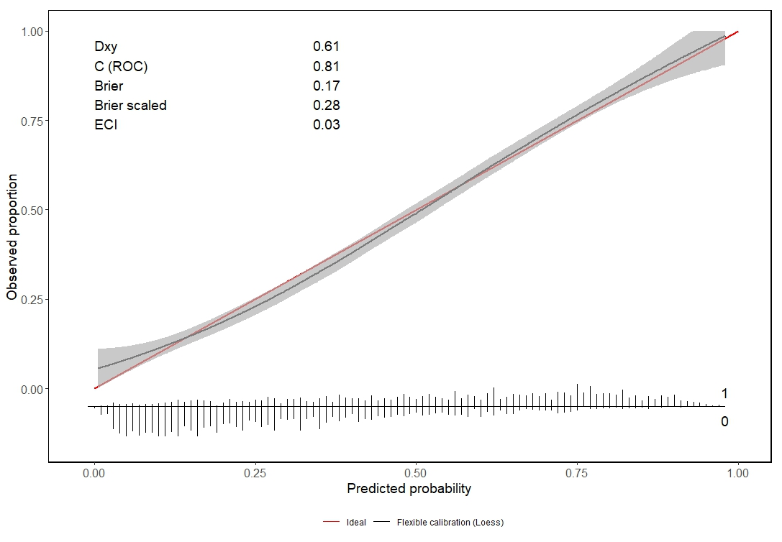
Supplementary Figure 5: The calibration curve from the logistic regression model with the lowest combined AIC and estimated calibration index. Observed compared to predicted probabilities in the full dataset are shown.

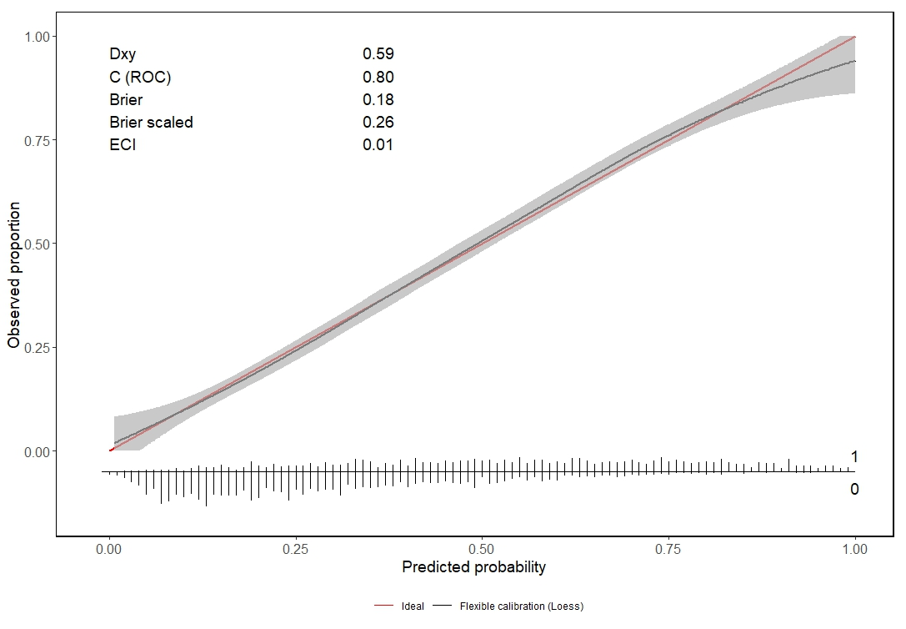
Supplementary Figure 6: The calibration curve from the selected logistic regression model with the lowest estimated calibration index. Observed compared to predicted probabilities in the full dataset are shown.

.

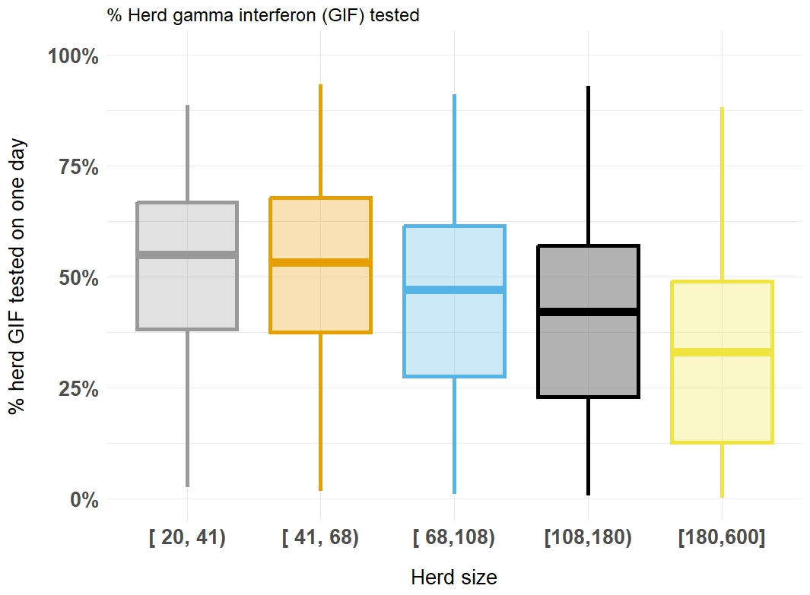
Supplementary Figure 7: The proportion of the herd selected for interferon-γ testing in a single herd-level interferon-γ testing event, stratified by herd size.

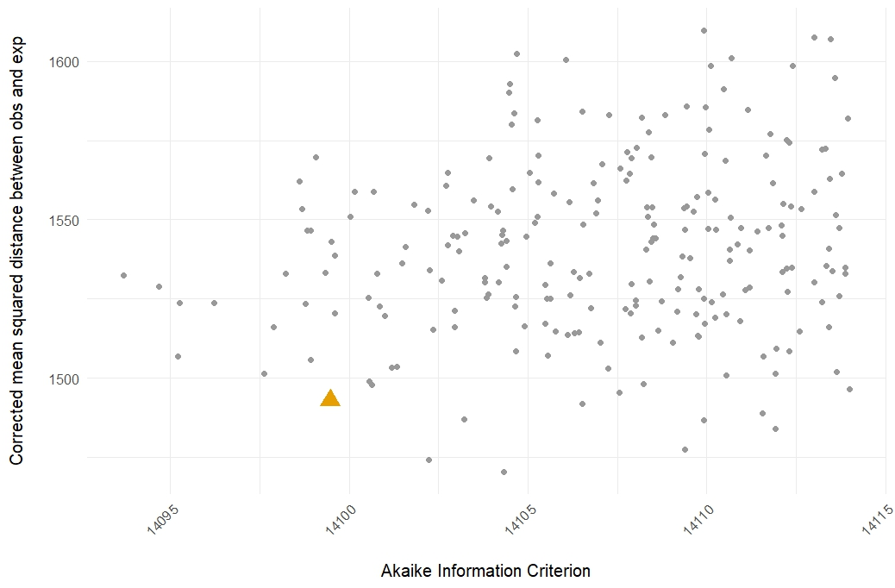
Supplementary Figure 8: Akaike Information Criterion and corrected mean squared distance between observed and expected data in multivariable models to explain the count of cattle interferon-γ tested. The yellow triangle indicates the selected model.

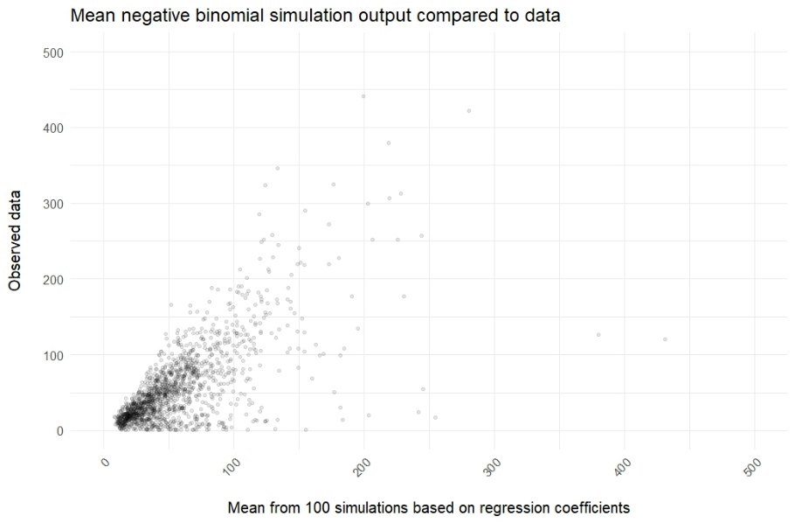
Supplementary Figure 9: Observed compared to predicted counts of cattle interferon-γ tested on a single date, based on simulations based on our final truncated negative binomial model.

Supplementary methods
Interferon-γ testing policy and implementation
The interferon-γ test has been used in Ireland since 1994 (More and Good, 2006). Unlike the skin test, its specificity, reported to be approximately 91 per cent in the Irish context (Gormley et al., 2013), is considered too low to be used as a population level screening test, given the apparent animal level prevalence of bTB in Ireland ranged from 1.62 to 3.25 cattle positive per thousand skin tests conducted between 2000 and 2023. However, the use of interferon-γ in parallel with the skin test, in herds with relatively higher counts of skin cases already detected, allows for the detection of additional infected cattle (Clegg et al., 2019, 2017; Gormley et al., 2006).
Control policy for bTB allows interferon-γ testing to be used in three different contexts in Ireland. (1) Diagnostic interferon-γ testing for the detection of additional infected animals in herds where high levels of M. bovis transmission are suspected (Clegg et al., 2019, 2017; Good and Duignan, 2016); (2) inconclusive interferon-γ testing to add evidence on the true infection status of cattle with inconclusive results in the skin test (Ryan et al., 2023) and (3) quality control interferon-γ testing to monitor the integrity of skin testing (Clegg et al., 2017; Good and Duignan, 2016). This current study is based only on diagnostic interferon-γ testing.
In 2015, policy was enhanced in relation to strategic application of the diagnostic interferon-γ test in restricted herds (S.I. No. 58 of 2015, 2015). Additional laboratory locations enabled testing of blood samples from herds from all regions within eight hours (More et al., 2018). Publication of the updated 2016 version of Veterinary Handbook for Herd Management in the bTB eradication programme (Good and Duignan, 2016) clarified implementation goals for veterinarians managing bTB outbreaks. These were:
- Sampling for interferon-γ should be undertaken in herds with bTB breakdowns in which four or more positive animals have already been disclosed.
- Sampling should be undertaken ten or more days after tuberculin injection in the preceding skin test.
- Veterinarians should select cattle for interferon-γ testing from particular groups or those associated with particular land fragments with regard to grazing/housing with the reactor animals during the relevant period prior to detection/removal. Where it was not possible to categorise particular epidemiological groups e.g. in smaller herds, all animals aged over one year should be tested.
These policy updates were increasingly implemented between 2015 and 2020 but there were discrepancies in implementation. Local veterinary discretion and logistical capacity influenced the rate of adaption. In December 2019, the threshold for implementing interferon-γ testing was updated to five or more TB positive animals in herds of size up to and including 100 cattle; five per cent or more of the herd is TB positive, for herds of size of greater than100 cattle; any herd with ten or more TB positive animals, regardless of herd size; disclosure of further skin reactors, and/or factory lesions at a third, and/or any subsequent reactor retest.
Animals older than six months could be preferentially selected for testing, and if there were skin or PM cases in younger cohorts, these could also be tested. All guidelines allowed the veterinarian to select how many cattle to sample, based on cohorts in the herd which they believed to be most at risk of exposure to M. bovis in the outbreak.

