Supplementary Information
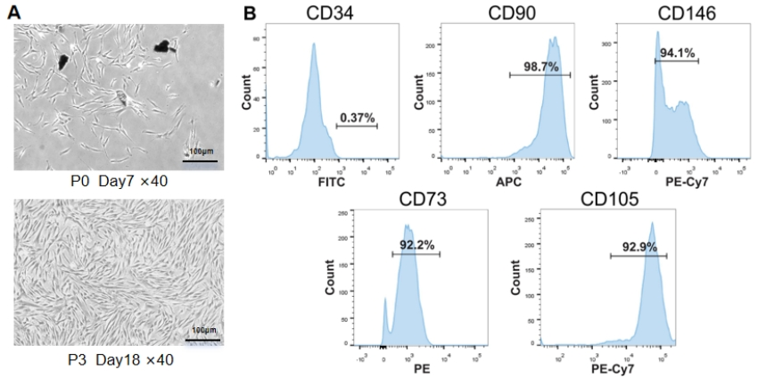
Figure S1. Characterization of DPSCs.
- DPSCs cultured in vitro display a spindle-shaped morphology after 7 and 18 days, Scale bar: 100 μm. (B) Flow cytometric analysis reveals positive expression of CD73, CD90, CD105, and CD146, and negative expression of CD34.

Figure S2. Cellular internalization analysis of engineered EVs in BMSCs and DPSCs.
(A, C) Representative fluorescence microscopy images showing uptake of PKH67-labeled EVs (green), Rd-B2-EVs, and Apt-B2-EVs, with Cy5-labeled Apt02 (red) in BMSCs (A) and DPSCs (C). (B, D) Quantitative analysis of internalized fluorescence intensity for corresponding groups in BMSCs (B) and DPSCs (D). Data presented as mean±SD (n=3; one-way ANOVA, ns, not significant). Scale bars: 100 µm.

Table S1. Aptamer sequences and design parameters
Aptamer Name | Base Sequence (5′-3′)
Apt02 | GCTGATAGGATGGGTTGTAGGTCTAGGGGGGGGCC
Apt-Rd | GGTTAGGCGTGGGGGGCTGAGGGTGTGAGTACGAT

Table S2. Primer sequences and parameters for target gene amplification
Primer Name | Sequence (5’-3’) | Target Gene | Length (nt) | GC Content (%)
VEGF-F | TGTGAATGCAGACCAAAGAAAGA | VEGF | 23 | 56.5
VEGF-R | TTCGTTTAACTCAAGCTGCCTCG | VEGF | 23 | 56.5
FGF2-F | GCTGTACTGCAAAAACGGGG | FGF2 | 20 | 60.0
FGF2-R | TCCGTGACCGGTAAGTATTG | FGF2 | 20 | 45.0
ANG1-F | CAGTGCCACAGAGTGGAAGA | ANG1 | 20 | 55.0
ANG1-R | GCTGGTAGGTGTTGCTGATG | ANG1 | 20 | 50.0
EphrinB2-F | GCTGGAGAAAGTGCTGGAAG | EphrinB2 | 20 | 55.0
EphrinB2-R | CAGGTAGGTGTTGCTGATGG | EphrinB2 | 21 | 52.4
GAPDH-F | GGAGCGAGATCCCTCCAAAAT | GAPDH | 21 | 61.9
GAPDH-R | GGCTGTTGTCATACTTCTCATGG | GAPDH | 24 | 58.3

Table S3. Antibodies used for Western Blot analysis
Target Protein | Antibody (Host) | Supplier | Catalog # | Dilution
ERK1/2 | Rabbit Polyclonal | Proteintech | 11257-1-AP | 1:5000
AKT | Rabbit Polyclonal | Proteintech | 10176-2-AP | 1:1000
EphB4 | Rabbit Polyclonal | Proteintech | 20883-1-AP | 1:3000
EphrinB2 | Rabbit Polyclonal | Proteintech | 26533-1-AP | 1:2000
GAPDH | Mouse Monoclonal | Proteintech | 60004-1-Ig | 1:100000
β-actin | Mouse Monoclonal | Proteintech | 66009-1-Ig | 1:10000
CD63 | Mouse Monoclonal | Proteintech | 67605-1-Ig | 1:10000
CD81 | Rabbit Polyclonal | Proteintech | 27855-1-AP | 1:2000
CD9 | Rabbit Polyclonal | Proteintech | 20597-1-AP | 1:5000
P-ERK1/2 | Rabbit Monoclonal | Proteintech | 80031-1-RR | 1:5000
P-AKT | Mouse Monoclonal | Proteintech | 66444-1-Ig | 1:5000
P-EphB4 | Rabbit Polyclonal | Thermofisher | PA5-64792 | 1:1000
P-EphrinB2 | Rabbit Polyclonal | HZbscience | HZ-13085R | 1:500
FGF2 | Rabbit Monoclonal | Abcam | ab208687 | 1:2000
ANG1 | Rabbit Monoclonal | Abcam | ab183702 | 1:2000
VEGF | Rabbit Monoclonal | Abcam | ab32152 | 1:1000

