Supplementary Material

Andean Fish inventories, an eDNA metabarcoding approach
Martín Holguín Osorio1,2*, Iván Darío Soto Calderón1, Luz Fernanda Jiménez Segura2, Tatiana Arias ³.
* Correspondence: Martin Holguin Osorio: martin.holguin.o@gmail.com

Additional Data

1.1. Primer design for local fish
The COX1 primer pair (FishF2) was tested in the laboratory through PCR amplification followed by gel electrophoresis, using an annealing temperature of 56 °C and a MgCl2 concentration of 2.5 mM. Genomic extracts were obtained from one representative species for each of 16 fish families: Astroblepus chapmani (Astroblepidae), Astroblepus grixalvii (Astroblepidae), Brycon henni (Bryconidae), Hoplosternum magdalenae (Callichthyidae), Astyanax fasciatus (Characidae), Geophagus steindachneri (Cichlidae), Cetopsorhamdia nasus (Heptapteridae), Pimelodella chagresi (Heptapteridae), Lasiancistrus caucanus (Loricariidae), Chaetostoma thomsoni (Loricariidae), Parodon magdalenensis (Parodontidae), Saccodon dariensis (Parodontidae), Ichthyoelephas longirostris (Prochilodontidae), Prochilodus magdalenae (Prochilodontidae), Trichomycterus chapmani (Trichomycteridae), and Trichomycterus caliensis (Trichomycteridae). Amplification was successful for nine of the 16 genomic DNA extracts, corresponding to the following families: (1) Astroblepidae, (5) Characidae, (8) Heptapteridae, (10) Loricariidae, (12) Parodontidae, (13) Prochilodontidae, (14) Prochilodontidae, (15) Trichomycteridae, and (16) Trichomycteridae (Supplementary Figure 2).
To identify primer anchoring regions in the 12S region, the optimal primer sets were predicted using ecoPrimers v0.5 (Riaz et al., 2011), a program that designs efficient barcode markers and primers based on reference sequence records and specified parameters. The program was configured to amplify segments between 150–300 bp, considering only sequences from the taxonomic group identified by teleostei's TAXID (representing approximately 96% of the world's fish species) (Wiley, 2010) and allowing a maximum of three errors per oligonucleotide. Potential primer pairs were evaluated to select the best set, based on two criteria: (1) the highest Bc index (proportion of taxa in the dataset adequately amplified) and Bs index (proportion of taxa correctly identified), and (2) compatibility with the region amplified by the Valentini et al. (2016) primers (45–96 bp), enabling the recovery of comparable meta-barcodes.

To visualize the primer anchoring regions, all primers designed in silico with ecoPrimers were aligned with the Valentini primers and the complete mitochondrial genome Brycon henni (Landínez-García et al., 2016) using Geneious Prime 2019 v.2.3. The selected primer pair was named 300enV in reference to Valentini's work targets the 12S mitochondrial region. Laboratory validation was conducted using Brycon henni genomic DNA and PCR with varying MgCl2 concentrations (1.5, 2, 2.5 mM) and annealing temperatures (50, 53.3, 56.6, and 60 °C). Amplification was successful across all conditions except at 60 °C with 1.5 mM MgCl₂. Optimal PCR conditions were identified as 55.1 °C annealing temperature and 1.8 mM MgCl₂ concentration (Supplementary Figure 3).

1.2. Proposed protocol for a non-invasive method to monitor fish richness
Based on the experience gained during the pilot tests (first two experimental stages), simulations, and the final test (third experimental stage), two reference databases were developed—one for COX1 and another for 12S. Additionally, two data analysis pipelines were created in QIIME2, which are publicly available at: https://github.com/ictioTintin/Mebarcoding_en_peces_con_Qiime2. The following protocol outlines the fieldwork procedures for eDNA sampling:

a. Preparation of Sampling Equipment
The day before sampling, all equipment was sterilized with a 1% hypochlorite solution to prevent cross-contamination from surface contact during the process. A gas mask was worn to ensure safety during sterilization (Supplementary Figure 5).

b. Sampling in Lentic Systems (Still Water)
- Decontamination: The bilge hose was purged with 1% hypochlorite by pumping water through it into a bucket to remove any non-sampling eDNA (Supplementary Figure 6).
- Water Collection: The pump was submerged to a depth of 1 m, and water was allowed to flow briefly to flush out residual hypochlorite. Then, a 15 L bucket was filled.
- Sample Collection: After covering and shaking the bucket, a 100 mL sample was collected, followed by a 2 L sample.
- Physicochemical Measurements: Parameters such as pH, conductivity, temperature, and dissolved oxygen were recorded using an HQ40D portable multiparameter probe.
- Storage: Samples were stored in a cooler with frozen gel packs (-20 °C) until they were transported to the camp for filtration (Supplementary Figure 7).

c. Sampling in Lotic Systems (Flowing Water)
- Decontamination: Contaminant vectors were removed from all equipment before sampling.
- Water Collection: Three 5 L samples were taken—one from each shore and one from the center of the water flow. These were mixed to form a 15 L composite sample.
- Sample Collection: From the composite sample, a 100 mL sample and a 2 L sample were collected.
- Physicochemical Measurements: pH, conductivity, temperature, and dissolved oxygen were measured using the HQ40D multiparameter probe.
- Storage: Samples were refrigerated with frozen gel packs at -20 °C until filtration at the camp (Supplementary Figure 8).
d. Work Area Preparation and Filtration
- Setup and Sterilization: The filtration area and equipment were sterilized. Two filtration systems were used:
  - System 1: For 100 mL samples, disposable cups under vacuum pressure (15–18 inHg).
  - System 2: For 2 L samples, reusable cups sterilized a day prior, under vacuum pressure (15–20 inHg).
- Filtration Process:
  - Dilutions were processed sequentially.
  - System 1 had a maximum cup capacity of 20 mL, while System 2 could hold 300 mL.
  - To reduce filtering time for 2 L samples, three filtration columns and filters were used simultaneously.
- Timing and Drying:
  - The start and end times of filtration were recorded.
  - After filtration, filters were kept under vacuum for an additional 10 minutes to dry.
- Filter Preservation:
  - Filters were carefully folded using tweezers and scalpel handles and placed in 15 mL Falcon tubes filled one-third with silica gel.
  - Tubes were labeled with the monitoring station code and stored in a cooler with gel packs to maintain a temperature of 4 °C during transport to the ichthyology lab, where they were stored at -20 °C (Supplementary Figure 10).
This protocol ensures reliable and contamination-free eDNA sampling, facilitating accurate assessment of fish species richness in aquatic environments.

d. eDNA extraction from environmental samples in the first sampling to define extraction kit
The eDNA from the two subsamples for each site collected during the first sampling campaign was extracted using either the PowerSoil DNA Isolation Kit (ref. 12888, MO BIO, USA) or the Water RNA/DNA Purification Kit (ref. 26480, Norgen, Canada). Extractions were performed following the manufacturer’s protocol instructions, eluting the eDNA in 40 µl of elution buffer. Based on the greater number of detected ASVs in downstream analyses, the Norgen kit was selected for all remaining eDNA extractions.
This result was excluded from the main results of the paper due to two reasons: (1) Primers that were not fish specific were used in the first sampling to have a glance at the metazoan information that could be rescued, and no comparisons were made for the results of the FishF2 and 300enV primers. (2) Calibration of the detection method was done for the FishF2 and 300enV primers, but not for Leray, which was the set that was used to compare the two detection methods. Therefore, there is no clear criterion to say that one or the other method is better for the detection of freshwater fish.

Supplementary Figures and Tables
Supplementary Table 1. Monitoring stations included in the analysis and the total number of species recorded through traditional monitoring methods from 2005 to 2020.
Sites* | Station code | Name | Total number of species detected by fishing | Season sampled/ Year | Vacuum pump pressure | Depth | Altitude (m.s.) | Latitude | Longitude | Lentic or lotic
Em | E3-4 | Dam foot | 10 | Both seasons / 2019 and 2020 | 18–29 mmHg | 0m | 685 | -75.13897 | 6.93201 | Lentic
Ec | E3-1 | Reservoir tail | 27 | Both seasons / 2019 and 2020 | 18–29 mmHg | 0m | 684 | -75.17876 | 6.86849 | Lentic
Qsa | Q3-4 | Santa Ana creek | 10 | Both seasons / 2019 and 2020 | 18–29 mmHg | 0m | 754 | -75.1606843 | 6.9250882 | Lotic
Qb | Q3-10 | Boquerón creek | 21 | Both seasons / 2019 and 2020 | 18–29 mmHg | 0m | 368 | -75.0587655 | 7.0210394 | Lotic
RG | R2 | Guadalupe River | 23 | Both seasons / 2019 and 2020 | 2 mmHg and 18–29 mmHg | 0m | 708 | -75.18983 | 6.83858 | Lotic
RPd | R1b | Porce River - Canal After Porce II Discharge | 2 | Both seasons / 2019 and 2020 | 18–29 mmHg | 0m | 687 | -75.17881 | 6.8408 | Lotic
RP3 | R6 | Porce River After Porce III Discharge | 16 | Rainy season / 2019 | 2 mmHg | 0m | 338 | -75.05783 | 7.03206 | Lotic
Ecen | E3-2 | Reservoir center | 14 | Dry season / 2019 | 2 mmHg | 0m and 5m | 700 | -75.17677 | 6.8915 | Lentic
* And embalmed; Q broken; R River; DATUM coordinates: WGS 84

Supplementary Table 2. Sampling sites at each sampling stage.
Primers | Sampling 1 | Sampling 2 | Sampling 3 | Sampling 4 | Sampling 5
Cox1 Metazoa / Leray | Sites 1
Cox1 Cauca-Mag Fish / FishF2 |  | Sites 2 | 3 Sites | 3 Sites | 3 Sites
12S Fish / 300enV |  |  | 3 Sites | 3 Sites | 3 Sites
Sites 1 (6 samples in total): Ecen (bottom). Powersoil, Ecen (bottom)1KM, Ecen (surface). Powersoil, Ecen (surface)KM, RG. Powersoil, RG.KM; Sites 2 (1 sample in total): RP3; 3 sites (6 samples total): RPd, RG, Qb, Qsa, Em, Ec

Supplementary Table 3. Estimated Bs (proportion of taxa of the example dataset that are properly identified) indices for each pair of primers.
Couple of primers | Bs Index
Link | Species, 0.4546253957
FishF2 | Species, 0.891809023
300enV | Species, 0.844780753

Supplementary Table 4. General information of the environmental samples in the positive control.
Sample | Loci | Number of forward sequences | Number of sequences in reverse direction | Number of sequences after denoising
mixture | COX1 | 345798 | 345798 | 185362
mixture | 12S | 28883 | 28883 | 3433
D1 | COX1 | 377593 | 377593 | 197683
D1 | 12S | 18121 | 18121 | 8228
D2 | COX1 | 14792 | 14792 | 6790
D2 | 12S | 24676 | 24676 | 11200
D3 | COX1 | 288097 | 288097 | 169341
D3 | 12S | 24776 | 24776 | 13421
D4 | COX1 | 104673 | 104673 | 58782
D4 | 12S | 26044 | 26044 | 14883
D5 | COX1 | 47041 | 47041 | 40616
D5 | 12S | 240246 | 240246 | 210027
D6 | COX1
D6 | 12S | 54019 | 54019 | 25138
D7 | COX1
D7 | 12S | 41246 | 41246 | 36035
D8 | COX1 | 54581 | 54581 | 44821
D8 | 12S | 56859 | 56859 | 47817
D9 | COX1
D9 | 12S | 143667 | 143667 | 127012
D10 | COX1
D10 | 12S

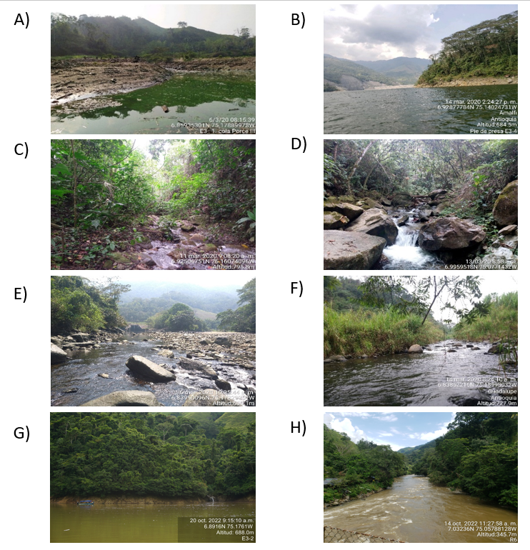
Supplementary Figure 1. Photographs of the eight monitoring stations: A) reservoir tail, B) dam foot, C) Santa Ana creek D), Boquerón creek, E) Porce river - canal after Porce II discharge, F) Guadalupe river, G) Reservoir center, and H) Porce river after Porce III discharge.

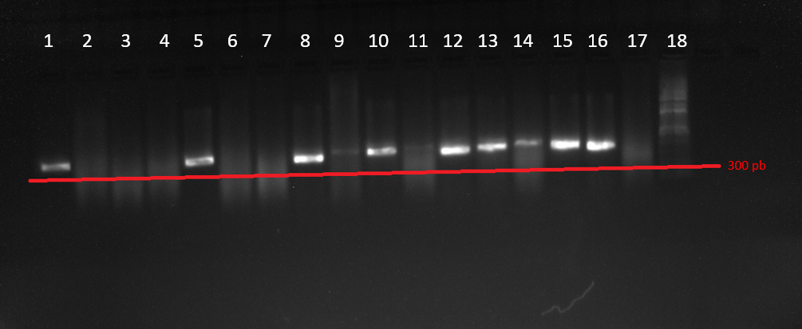
Supplementary Figure 2. Amplification of COX1 with the FishF2 primers in (1) Astroblepidae, (2) Astroblepidae, (3) Bryconidae, (4) Callichthyidae, (5) Characidae, (6) Cichlidae, (7) Heptapteridae, (8) Heptapteridae, (9) Loricariidae, (10) Loricariidae, (11) Parodontidae, (12) Parodontidae, (13) Prochilodontidae, (14) Prochilodontidae, (15) Trichomycteridae and (16) Trichomycteridae. (17) negative control with elution buffer, and (18) molecular weightstandard.

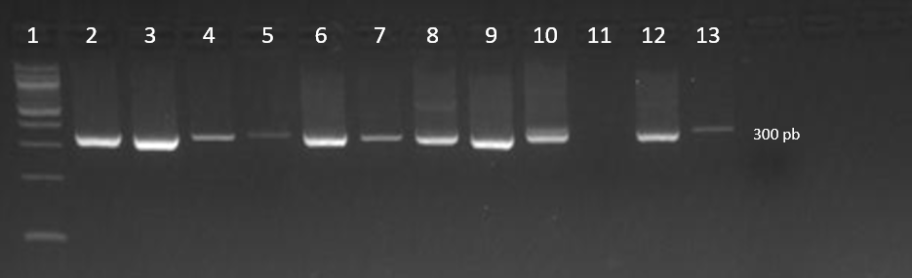
Supplementary Figure 3. Amplification of 12S with the 300env primers : (1) Molecular weight standard, (2) 1.5 mm MgCl2 and 50 °C, (3) 2 MgCl2 and 50 °C, (4) 2.5 MgCl2 and 50 °C, (5) 1.5 mm MgCl2 and 53.3 °C, (6) 2 MgCl2 and 53.3 °C, (7) 2.5 MgCl2 and 53.3 °C, (8) 1.5 mm MgCl2 and 56.6 °C, (9) 2 MgCl2 and 56.6 °C, (10) 2.5 MgCl2 and 56.6 °C, (11) 1.5 mm MgCl2 and 60 °C, (12) 2 MgCl2 and 60 °C, (13) 2.5 MgCl2 and 60 °C.

Supplementary Figure 4. Flowchart illustrating the three possible strategies for creating a metabarcoding database (adapted from Taberlet et al., 2018). The strategy used to create the local COX1 database is highlighted in purple, the strategy for creating the local 12S database is shown in blue, and the approach for cases where complete genomic data are available is marked in green.

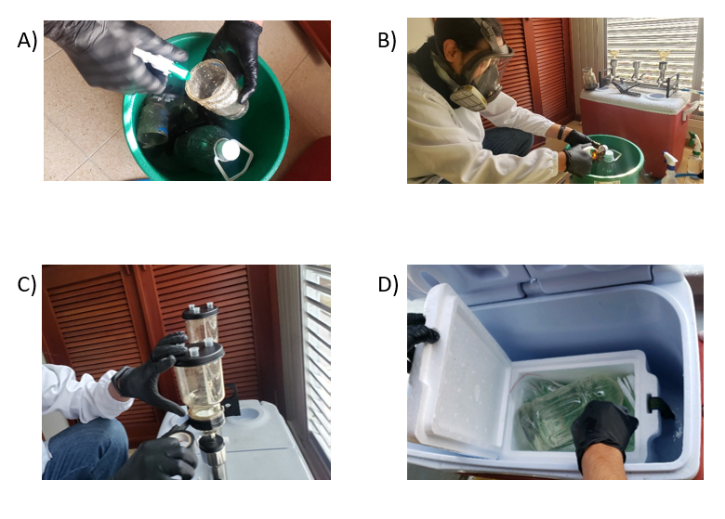
Supplementary Figure 5. (A) and (B) Sterilization of equipment (elimination of possible contaminations), (C) and (D) Preparation of equipment for filtration

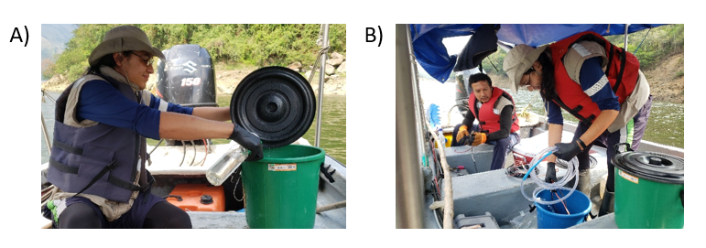
Supplementary Figure 6. Preparation of equipment at the environmental sampling site for lentic systems.
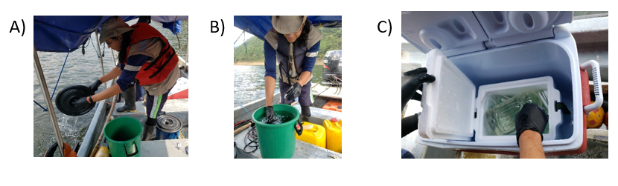
Supplementary Figure 7. A and B: Collection and C: storage of environmental samples in lentic systems.
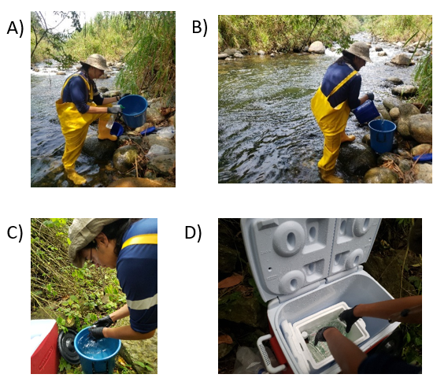
Supplementary Figure 8. A: Preparation, B and C: collection and D: storage of environmental samples.
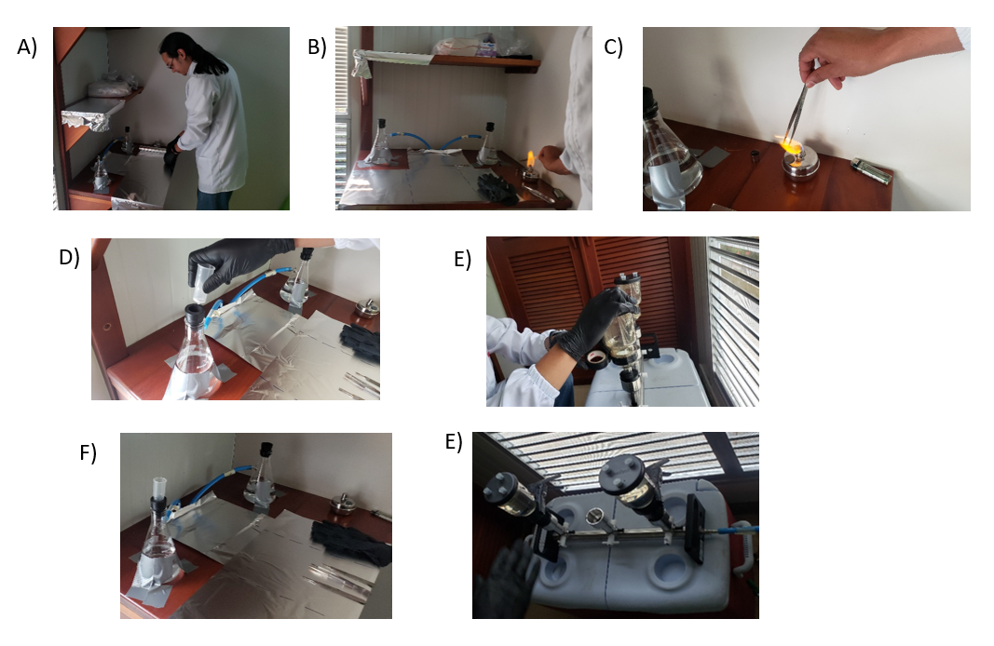
Supplementary Figure 9. A: Preparation. B and C: Sterilization of the work area and equipment with which the filters will be handled, D: location of disposable cups in 100ml filtration system, E: sealing of vacuum leaks in the filtration system, F: water filtration in 100ml system and E: water filtration in 2L vacuum system.

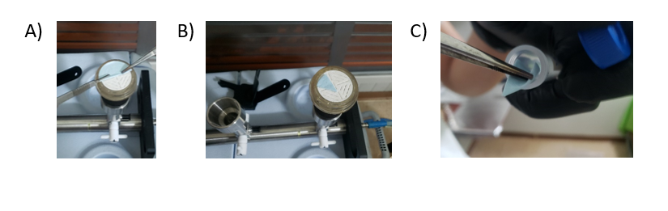
Supplementary Figure 10. A, B and C: Filter bending and storage.

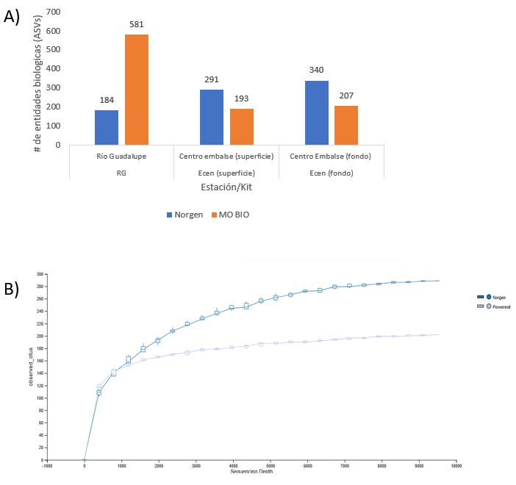
Supplementary Figure 11. The number of detected biological entities or ASVs (y-axis) by kit and sampling station (x-axis) during the first stage. B: Rarefaction curves representing the entire eDNA signal (all organisms). Data in this stage were unfiltered, focusing on determining which kit captured the highest number of ASVs (biological entities). Results compare the performance of the two kits used in the first stage.

REFERENCES
Landínez-García, R. M., Alzate, J. F., & Márquez, E. J. (2016). Complete mitogenome of the neotropical fish brycon henni, eigenmann 1913 (Characiformes, bryconidae). Mitochondrial DNA Part A: DNA Mapping, Sequencing, and Analysis, 27(3), 2259–2260. https://doi.org/10.3109/19401736.2014.984170
Riaz, T., Shehzad, W., Viari, A., Pompanon, F., Taberlet, P., & Coissac, E. (2011). EcoPrimers: Inference of new DNA barcode markers from whole genome sequence analysis. Nucleic Acids Research. https://doi.org/10.1093/nar/gkr732
Valentini, A., Taberlet, P., Miaud, C., Civade, R., Herder, J., Thomsen, P. F., Bellemain, E., Besnard, A., Coissac, E., Boyer, F., Gaboriaud, C., Jean, P., Poulet, N., Roset, N., Copp, G. H., Geniez, P., Pont, D., Argillier, C., Baudoin, J. M., … Dejean, T. (2016). Next-generation monitoring of aquatic biodiversity using environmental DNA metabarcoding. Molecular Ecology. https://doi.org/10.1111/mec.13428
Wiley, E. O. and G. D. J. (2010). A teleost classification based on monophyletic groups. https://www.researchgate.net/publication/259298619_A_teleost_classification_based_on_monophyletic_groups

