Supplementary:

Identification of lncRNA and their related genes:
XIST is a long noncoding RNA that plays a central role in the formation of the inactive X chromosome (Xi) in female mammals due to equalize gene expression with males. a matrix protein hnRNPU/SP120/SAF-A is required for the accumulation of XIST RNA on the Xi (lncRNA7). Also, Zhang et al. (2021) showed that the XIST gene was introduced as a hub lncRNA in MS disease (lncRNA8). Multiple sclerosis (MS) is a autoimmune disease with a dramatic sex bias, affecting 7 times more women than men (2). Activation of Toll-like receptor 7 (TLR7) by self-RNA is a central pathogenic process leading to aberrant production of type I interferon (IFN) in autoimmune disease. XIST lncRNA stimulated IFN-α production by plasmacytoid DCs in a TLR7-dependent manner (3). Mounting evidence demonstrates that TLR7 escapes X chromosome inactivation (XCI), leading to enhanced expression of TLR7 in women compared with men (3,4). Accordingly, increasing hnRNPU and TLR7 genes expression in women can cause a stronger immune response to viral diseases such as corona (6). Of course, it should be noted that women are more susceptible to autoimmune diseases than men due to the presence of more stimuli to initiate an immune response (2). In addition, the presence of the TSIX gene in the B cell line with avg_log2FC of 8.51 in Covid19 and 7.72 in MS can confirm the effect of gender on the intensity of the immune response in women. TSIX gene together with XIST and binding to hnRNPU gene can help to inactivate the X chromosome in women (9). The increase in the expression of this gene in people with corona and MS can confirm its role in regulating the intensity of the immune response, especially in women. Of course, in order to more accurately confirm these results, more biological studies and experiments are needed.
Increased lncMIF-AS1 expression (avg_log2FC 10.23) following miR-212-5 inhibition leads to increased NDUFA4 expression in T cell. The upregulated expression of NDUFA4 then greatly promoted the proliferation and decreased the apoptosis of cells through activation of the oxidative phosphorylation pathway (lncRNA21). NF-κB signaling is a key regulator in maintaining the function of macrophages (7). M1 macrophages are main contributors of pro-inflammatory factors, while M2 macrophages are endowed with anti-infammatory and immunosuppressive characteristics (8). MDSCs are considered as immunosuppressive cells and high infiltration of MDSCs is related to poor prognosis in cancer. For example, MDSC function is activated by TNFR/TNFR2 signaling through an NF-κB-dependent manner (9). NF-κB and immune cells supports that these NF-κB associated lncRNAs may serve important roles in regulating immune response (lncRNA10). In addition, immune checkpoints are responsible for the activation of T cell function. High expression of immune checkpoints such as PD-1 and PD-L1 can suppress T cell activation (10). Therefore, lncRNAs such as AC020916.1 (avg_log2FC 1.72 and 0.52 in covid19 in B cell and monocyte, respectively) and AC245128.3 (avg_log2FC 1.65 in covid19 in monocyte) can affect the immune system (lncRNA10). GABPB1-AS1 (avg_log2FC 0.82 in B cell and 0.69 in NK cell in covid19) regulates the SP1/Wnt/β-catenin signaling pathway and with downregulated GABPB1 which leading to the downregulation of the gene encoding Peroxiredoxin-5 (PRDX5) peroxidase and the eventual suppression of the cellular antioxidant capacity and cell proliferation is enhanced (lncRNA3). lncPSMA3-AS1 (avg_log2FC 0.57 in B cell in MS) increases the expression of TLR10, EZH2 and LYL1 genes, which regulates B cell differentiation & immune response (lncRNA1). AC016831.7 (avg_log2FC 0.82 in B cell and 0.69 in NK cell in covid19) cause positive regulator of type I interferon pathway by promoting the phosphorylation of STAT1 and STAT2 and enhances the immune response (lncRNA11,12). Also, LINC01215 (avg_log2FC 0.68 in covid19 in B cell) binds to the promoter region of RUNX3 and recruits DNMT1, DNMT3A and DNMT3B proteins to inhibit the transcription of RUNX3, further upregulating the expressions of MMP-2, MMP-9 and Vimentin and downregulating the expression of E-cadherin, therefore promoting proliferation, migration and inhibit apoptosis and its involved in immune response with positive regulate T cell receptor signaling pathway (lncRNA13,14). lncSLC16A1-AS1 (avg_log2FC 1.68 in covid19 in B cell) by affecting SLC16A1/ MCT1 by E2F1 promotes cell viability, proliferation, cell migration and inhibits apoptosis & ferroptosis (lncRNA2,4). MALAT1 (avg_log2FC 0.12 in B cell and 0.74 in T cell in MS) Induces Tolerogenic Dendritic Cells and Regulatory T Cells via miR155/Dendritic Cell-Specific Intercellular Adhesion Molecule-3 Grabbing Nonintegrin (DC-SIGN) /IL10 Axis and Regulate immune response (lncRNA1,29). lncRNA LINC00402 (avg_log2FC 3.83 in covid19 in NK cell) enhanced the activity of ERK1 and ERK2, increased FOS nuclear accumulation, and augmented expression of interleukin-2 and Egr-1 after T cell receptor engagement and Promote Immune response (lncRNA24). lncITGB2-AS1 (avg_log2FC 1.22 in covid19 in NK cell) can promote cell survival, migration & invasion and inhibit apoptosis by binding to HMGA1 and activated integrin-related FAK signaling (lncRNA25.26). lncMIR181A1HG (avg_log2FC 0.86 in covid19 in NK cell) with epigenetic regulator of early stages of mesenchymal lineage by binding to SOX5 and DLX gene can stimulate cell cycle, cell migration and inhibition of apoptosis (lncRNA25.14). lncRNA AC005264.1 (avg_log2FC 1.73 in covid19 in Monocyte) by inhibiting P53 can promote cell survival, migration & invasion and inhibit apoptosis (lncRNA25.16). By binding to SVC2 gene and increasing its expression, AC113404.1 (avg_log2FC 8.67 in covid19 in NK cell) can strengthen the cell cycle, cell survival, cell migration and inhibition of apoptosis (lncRNA27). lncTRG-AS1 (avg_log2FC 1.82 in covid19 and 2.24 in MS in NK cell) suppresses the expression of miR-877-5p while miR-877-5p suppresses SUZ12 expression. Therefore, increasing the expression of SUZ12 can strengthen the proliferation and immune response and inhibit apoptosis (lncRNA27). Also, AC012615.1 (avg_log2FC 0.8 in covid19 in NK cell) can increase cell proliferation and inhibit apoptosis by affecting KRAS (lncRNA23). lncTHAP9-AS1 (avg_log2FC 0.97 in covid19 in T cell) can regulate cell proliferation and migration by binding to SOX4, VEGFA and YAP (lncRNA18,19,20). lncEPHA1-AS1 (avg_log2FC 0.87 in covid19 in T cell) by binding to EphA1 receptor and lncTHUMPD3-AS1 (avg_log2FC 0.76 in covid19 in B cell) by binding to CXCL17 and BCAT1 can promote cell proliferation, migration & inhibit apoptosis (lncRNA17,5,6). The decrease in the expression of LINC0068 (avg_log2FC -2.53 in MS in NK cell) can leading to the downregulation of the PPP2R3B, which ultimately leads to the enhancement of cell growth and the concomitant increase of the immune response (lncRNA28).
Based on the mentioned points, by increasing the expression of non-protein-coding genes in the blood, the corona virus can increase cell proliferation and subsequently increase its population in the host's body. Also, by increasing the expression of these genes, they can help the migration of immune cells from the blood to other tissues such as the brain.
Table9. LncRNA List in cell type
Ref, | Function | Protein Target | Cell Line | avg_log2FC |  | Rank |  | lncRNA
 |  |  |  | MS | nCoV | MS | nCoV | lncRNA
7, 8 | X-Inactivation &  The difference in immune response between men and women due to the difference in TLR gene expression | HNRNPU | B | 12.98 | 9.65 | 7 | 2 | XIST
7, 8 |  | HNRNPU | T | - | 11.06 | - | 1 | XIST
7, 8 |  | HNRNPU | M | 12.98 | 12.79 | 2 | 1 | XIST
7, 8 |  | HNRNPU | NK | 11.20 | 11.28 | 29 | 1 | XIST
5, 6 | Promote cell proliferation, migration & Inhibit Apoptosis | CXCL17  BCAT1 | B | - | 0.76 | - | 41 | THUMPD3-AS1
10 | Positive regulating inflammation and immune response | NF-Κb pathway | B | - | 1.72 | - | 56 | AC020916.1
10 | Positive regulating inflammation and immune response | NF-Κb pathway | M | - | 0.52 | - | 34 | AC020916.1
11, 12 | positive regulator of type I interferon pathway | STAT1  STAT2 | B | - | 0.82 | - | 57 | AC016831.7  (LINC00513)
11, 12 | positive regulator of type I interferon pathway | STAT1  STAT2 | NK | - | 0.69 | - | 65 | AC016831.7  (LINC00513)
13. 14 | promoting proliferation.  And immune response | RUNX3 | B |  | 0.68 | - | 95 | LINC01215
3 | suppression of the cellular antioxidant capacity and | GABPB1 | B | 0.24 | - | 19 | - | GABPB1-AS1
3 | suppression of the cellular antioxidant capacity and | GABPB1 | T | 1.34 | - | 84 | - | GABPB1-AS1
2, 4 | Promote cell viability, proliferation, cell migration and Inhibit apoptosis & ferroptosis | SLC16A1/ MCT1 | B | 1.68 | - | 33 | - | SLC16A1-AS1
1 | Regulate B cell differentiation & Immune response | TLR10  EZH2  LYL1 | B | 0.57 | - | 43 | - | PSMA3-AS1
9 | Bind to XIST & Help to X chromosome inactivation & Regulate Immune response | HNRNPU |  | 7,72 | 8.51 | 44 | 110 | TSIX
1, 29 | Regulate immune response | DC-SIGN  IL10 | B | 0.12 | - | 76 | - | MALAT1
1, 29 | Regulate immune response | DC-SIGN  IL10 | T | 0.74 | - | 14 | - | MALAT1
- | - | - | T | - | 1.53 | - | 2 | FP671120.3
- | - | - | T | - | 4.71 | - | 4 | AC105052.3
- | - | - | T | - | 1.71 | - | 19 | AC021028.1
- | - | - | T | 9.87 | - | 31 | - | AC005480.1
- | - | - | T | - | 0.95 | - | 30 | POLR2J3.1
- | - | - | T | - | 2.85 | - | 79 | AL121983.2
17 | Promote apoptosis & involved in AD | EphA1 receptor | T | - | 0.87 | - | 21 | EPHA1-AS1
18, 19, 20 | Regulate Cell proliferation and migration | SOX4  VEGFA  YAP | T | - | 0.97 | - | 31 | THAP9-AS1
21 | Promote proliferation and inhibit apoptosis | NDUFA4 | T | 10.23 | - | 99 | - | MIF-AS1
23 | Promote proliferation and inhibit apoptosis | KRAS | NK | - | 0.8 | - | 18 | AC012615.1
22 | Regulate Proliferation & Immune response | SUZ12 | NK | 2.24 | 1.82 | 79 | 20 | TRG-AS1
24 | Promote Immune response | ERK1, 2 | NK | - | 3.83 | - | 50 | LINC00402
25, 26 | Promote cell survival, migration & invasion and inhibit apoptosis | HMGA1 | NK | - | 1.22 | - | 57 | ITGB2-AS1
27 | Promote cell proliferation | SVC2 | NK | 8.68 | - | 21 | - | AC113404.1
28 | negative regulator of a gene with potential role in spermatogenesis | PPP2R3B | NK | -2.53 | - | 93 | - | LINC00685
- | - | - | M | - | 1.83 | - | 97 | AC025171.3
- | - | - | M | -1.20 | - | 38 | - | LINC00877
14 | epigenetic regulator of early stages of mesenchymal lineage | SOX5  DLX | M | - | 0.86 | - | 32 | MIR181A1HG
10 | Positive regulating inflammation and immune response | NF-Κb | M | - | 1.65 | - | 64 | AC245128.3
16 | Promote cell survival, migration & invasion and inhibit apoptosis | P53 | M | - | 1.73 | - | 80 | AC005264.1

Pathway Analysis:
The results of pathway analysis with G profiler software in B cell show that, the selected genes are involved in biologically important pathways such as Interferon gamma signaling, immune response, Programmed Cell Death, SARS-CoV Infections, TNF alpha signaling pathway, MAPK signaling pathway and regulation of IFN signaling, and these pathways have the highest score among the existing pathways (Fig 1). Also, these results have been confirmed in PPI networks (fig 5). For example, XIST (HNRNPU), can activate the MAPK pathway through DDX3 and increase the production of pro-inflammatory genes (S4-7). Also, the HLA-DRB5 gene intensified the immune response with production of pro-inflammatory genes by activation of the JAK-STAT pathway (S7). According to the studies, the production of inflammatory factors in the blood has increased (S9).
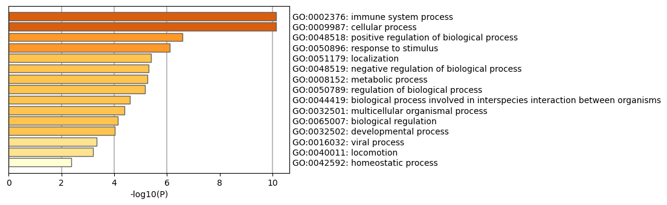
Fig 1. The top-level Gene Ontology biological processes can be viewed here in B Cell

Our studies show that the selected genes in T cell line can involve in biological pathways such as immune response, regulation of reactive oxygen species metabolic process, SARS CoV 2 signaling, cell motility, positive regulation of apoptotic process, TGF-beta receptor signaling in EMT (epithelial to mesenchymal transition), TNF alpha signaling pathway and Cytokine Signaling in Immune system (fig 2). Also, these results have been confirmed in PPI networks (fig 6). For example, MRPL23 and POLR2J3 can be induced TGF-beta Receptor signaling and NF-KB pathway in order to produce pro-inflammatory genes. Also, our findings show that, MYL12A and MYL6B can help EMT and the migration of T cells from the blood to other tissues, especially the brain (S10). The increase in the expression of these genes can indicate the increase in the migration rate of immune cells during Covid19 and MS.
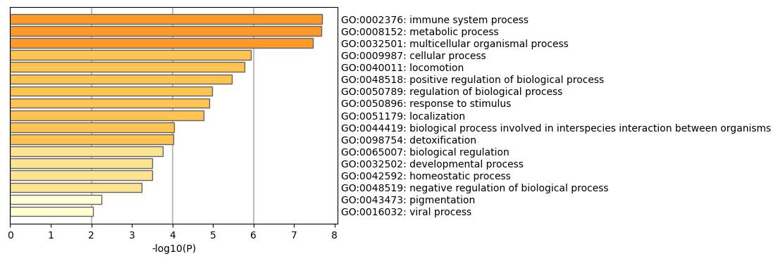
Fig 2. The top-level Gene Ontology biological processes can be viewed here in T Cell

G Profiler result in NK cell line show that, those genes involve in immune response, Interferon Signaling, Epstein-Barr virus infection, SARS CoV2 signaling, cellular response to cytokine stimulus and etc. this pathway have a high score than other pathways (Fig 3). These results have been confirmed in PPI networks (fig 7). For example, XIST (HNRNPU) can induced expression of TLR genes and increases the production of pro-inflammatory genes to call other immune cells. And other genes such as SUZ12 (TRG-AS1), H3-4 and RAD9A can regulate cell cycle and apoptosis by MAPK signaling.
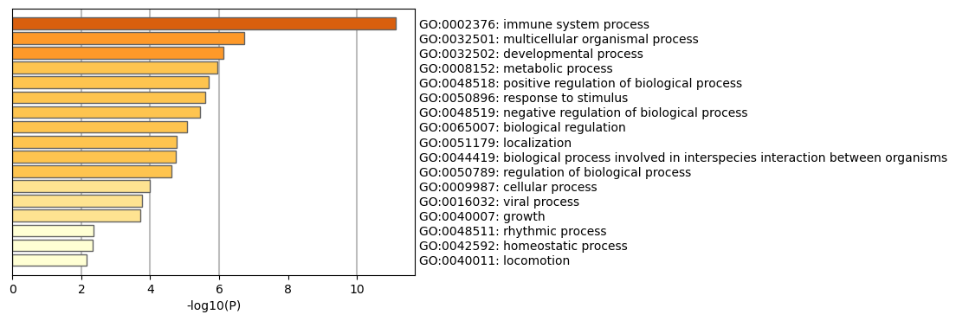
Fig 3. The top-level Gene Ontology biological processes can be viewed here in NK Cell

In finally, G Profiler in monocyte cell line can show that our genes involved in positive regulation of immune response response, Cytokine Signaling in Immune system. inflammatory response to antigenic stimulus, regulation of protein kinase activity and positive regulation of cell migration with high score (Fig 4). These results have been confirmed in PPI networks (fig 8). For example, In addition to the XIST gene, other genes such as CCR1, CCR2 and B2M (markers of macrophages) can induce the immune response through the MAPK pathway. Also, IL10, CD44, MMP9 and PTEN genes can cause the recruit and accumulation of other immune cells in the blood and other target tissues through Cytokine Signaling.
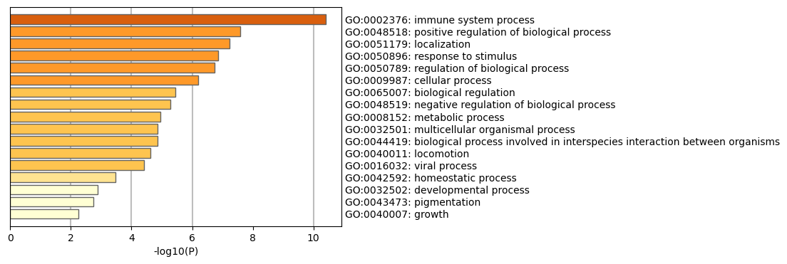
Fig 4. The top-level Gene Ontology biological processes can be viewed here in Monocytel

PPI Network analysis:
In this section, we will analysed the relationships between the proteins encoded by the selected genes in Covid-19 &MS disease. As mentioned in the text above, for each cell type, we have a total of 200 genes, of course, some of them are lncRNA and cannot code a protein, but we know that these genes play a very important role in stimulating immune response and and control the cell cycle. Accordingly, we replaced lncRNA with protein coding genes under their influence and entered them into our PPI network. In order to draw the PPI network, 200 genes consisting of 100 genes related to corona disease and 100 genes related to MS disease in each cell line were given to the STRING tool. The networks were drawn without entering the neighborhood and based on the accuracy of 0.7.
PPI network in B cell (Fig 5) shows that 88 proteins are present in this network. The shared genes of Covid19 and MS, such as XIST (HNRNPU) and HLA-DRB5, are seen at both ends of this network, which can initiate different cellular pathways to activate the immune response. As you can see in the figure below, HNRNPU gene can contribute to immune response activity through several pathways (S1). In the first pathway, with the help of POLR2A and UBX1 genes, it connects to transcription genes and transcription factors and can increase the expression of pro-inflammatory genes by activating them (S2-4). On the other hand, this gene can help to activate the MAPK pathway through DDX3 and increase the production of pro-inflammatory genes (S4-7). On the other hand, the HLA-DRB5 gene intensified the immune response by activating MHC-II and MHC-I (S8) and also contributed to the production of pro-inflammatory genes by directly affecting the activation of the JAK-STAT pathway (S7). According to the studies, the production of inflammatory factors in the blood has increased (S9).
Among the 200 analyzed genes in T cell, only 72 genes were able to form a PPI network (Fig 6). MRPL23 and POLR2J3 can be connected to the genes effective in cell proliferation such as SOX2, MYC and etc. and also the genes of the NF-KB pathway in order to produce pro-inflammatory genes and positively affect their activity. Since the increase in the expression of these genes in T cells has been reported in our findings, it is expected that the expression of pro-inflammatory genes will also increase. Also, our findings show that two genes, MYL12A and MYL6B, are present in the T cell, which can help the migration of T cells from the blood to other tissues, especially the brain (S10). The increase in the expression of these genes can indicate the increase in the migration rate of immune cells during Covid19 and MS.
In the NK cell, there are important protein coding genes that can lead to the production of pro-inflammatory genes through the MAPK pathway (Fig 7). Among these genes, necessary transcription and translation factors are seen, which are important for the expression of pro-inflammatory genes. Among these genes, there are lncRNAs that can increase the cell proliferation, cell migration, and most importantly, the immune response. Among these genes, we can mention XIST, which by increasing its expression in blood cells, the expression of TLR7 gene, which is one of the main receptors for the virus to enter blood cells, which increases the production of pro-inflammatory genes to call other immune cells. As you can see in the figure, among the 200 studied genes, about 70 genes created different PPI networks. For example, the network created by SUZ12 (TRG-AS1), SMARCA5, H3-4 and RAD9A are considered as the most important and key genes regulating cell cycle and apoptosis. TRG-AS1 (suz12), SMARCA5 genes have increased expression in people with corona and can influence the expression of H3-4, RAD9A genes; Because these two genes directly affect the compaction of chromatin and therefore can control the cell cycle. In the other part, a network including IFI6, OASL, MRPL23, IFI44L, IFITM3, IFI44 genes which are expressed in corona disease and IFI16 and IFNAR1 genes which are expressed in MS disease, these genes are formed as transcription and translation factors to make genes. pro-inflammatory are necessary and can be connected to the previous network that controlled the cell cycle with the help of gene mediators. Another network consisting of SLC7A5, SLC1A5, KRAS (AC012615.1), PLCE1, AREG, MAPK3, MAPK1 and DAPK1 is observed, which participate in MAPK signaling and KRAS signaling, which are among the most important pathways that produce pro-inflammatory factors. Also, in the meantime, another network consisting of HNRNPU, NCL, SNRPE, ZRSR3, LSM5 and CRNKL3 is observed, which control the cell cycle and apoptosis. and other network members, each of which in turn affects the immune response.
As you can see in the figure, from the set of 200 genes in the monocyte cell line, 92 genes have formed several ppi networks (Fig 8), among which the largest network includes the most important genes controlling cell proliferation such as TP53, controlling chromatin and immune response such as HNRNPU (XIST). Inflammatory pathway receptors such as CCR1 and CCR2, which are essential for the initiation of the immune response, important markers of macrophages such as B2M, which indicate the initiation of the immune response, genes that stimulate the immune response, such as IL10 and CD44, MMP9 and PTEN, as well as important genes for calling other cells. Safety is observed. Also, the network of HLA genes can be seen, which play a very important role in creating and intensifying the immune response. Also, in addition to the cases described, another network including genes that protect the nervous system such as COX7A1 in COVID19 and NDUFB8, NDUFS6, NDUFA11 and UQCRHL in MS disease is observed, whose expression is increased in blood cells, which can be a prognosis for the onset of nerve damage.
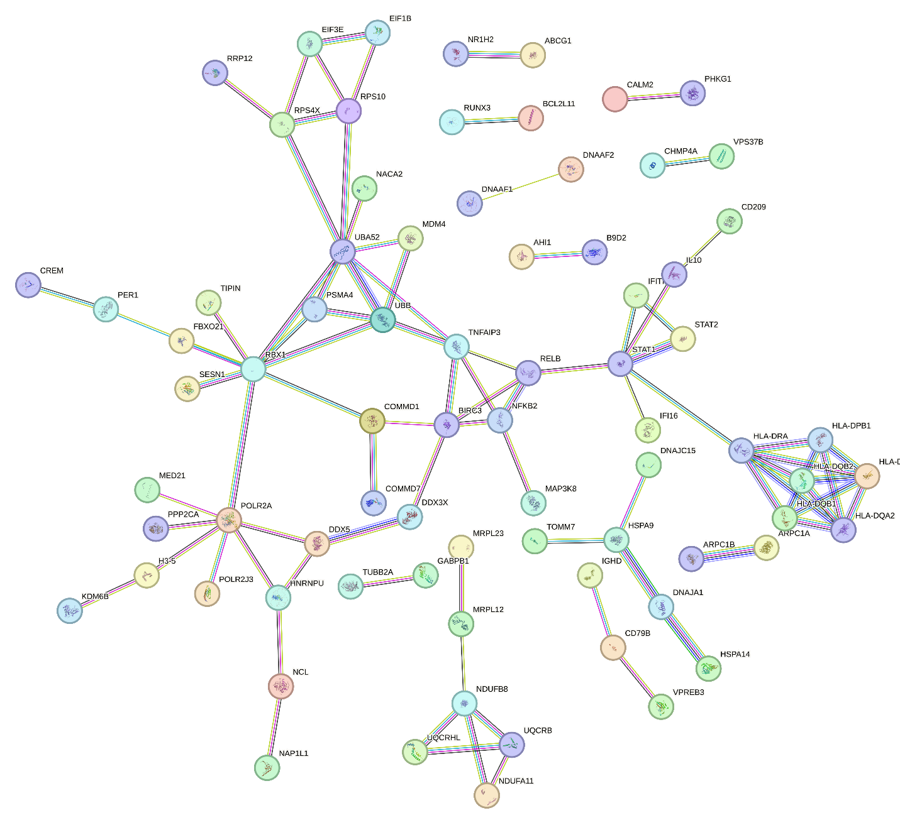
Fig 5. PPI in B Cell

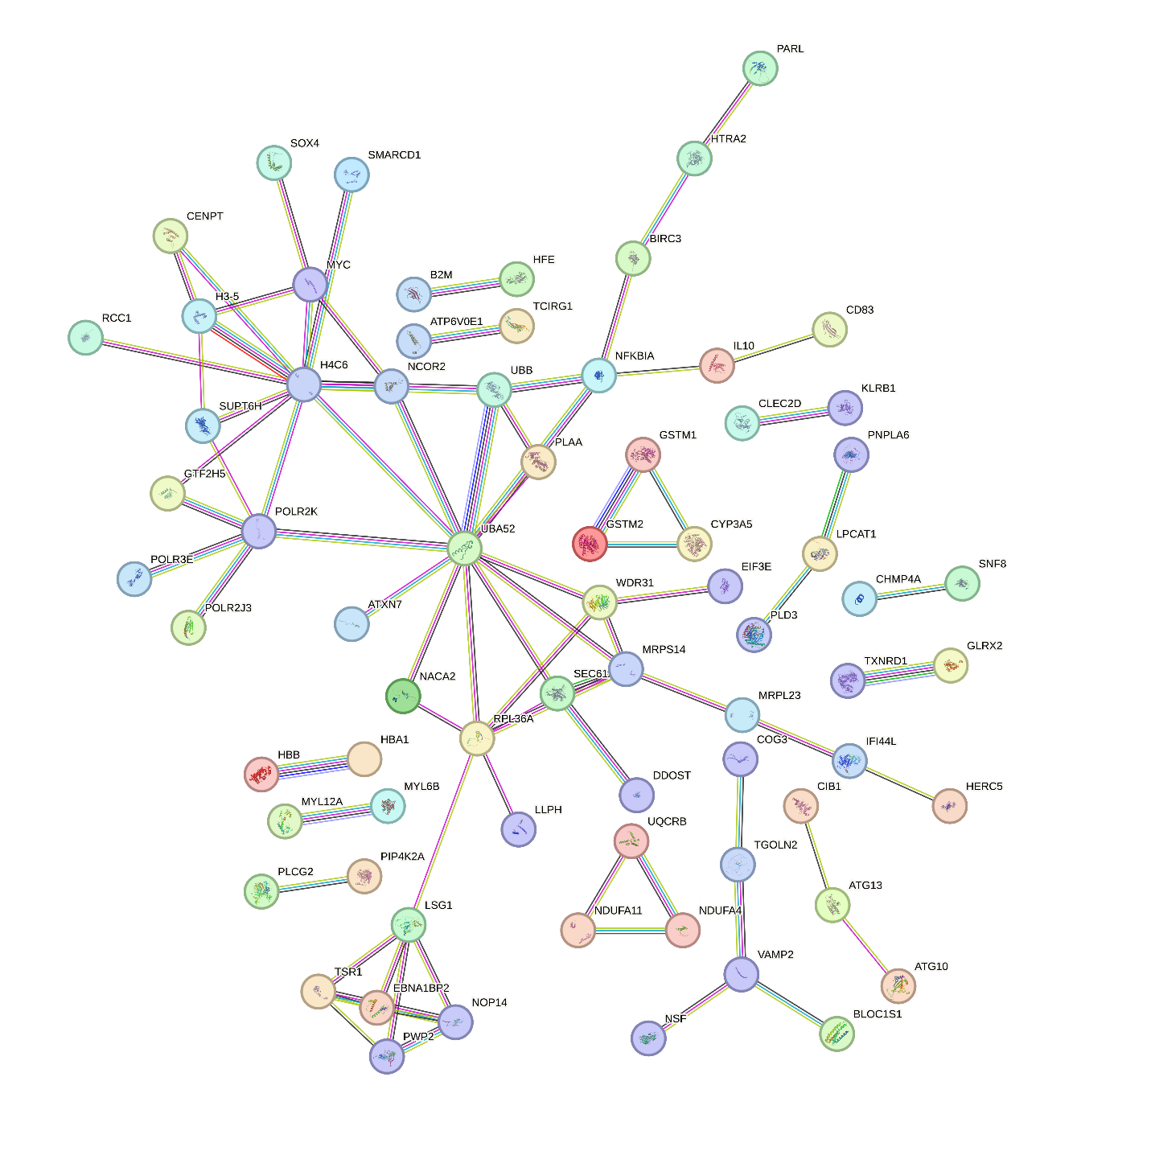
Fig 6. PPI in T Cell

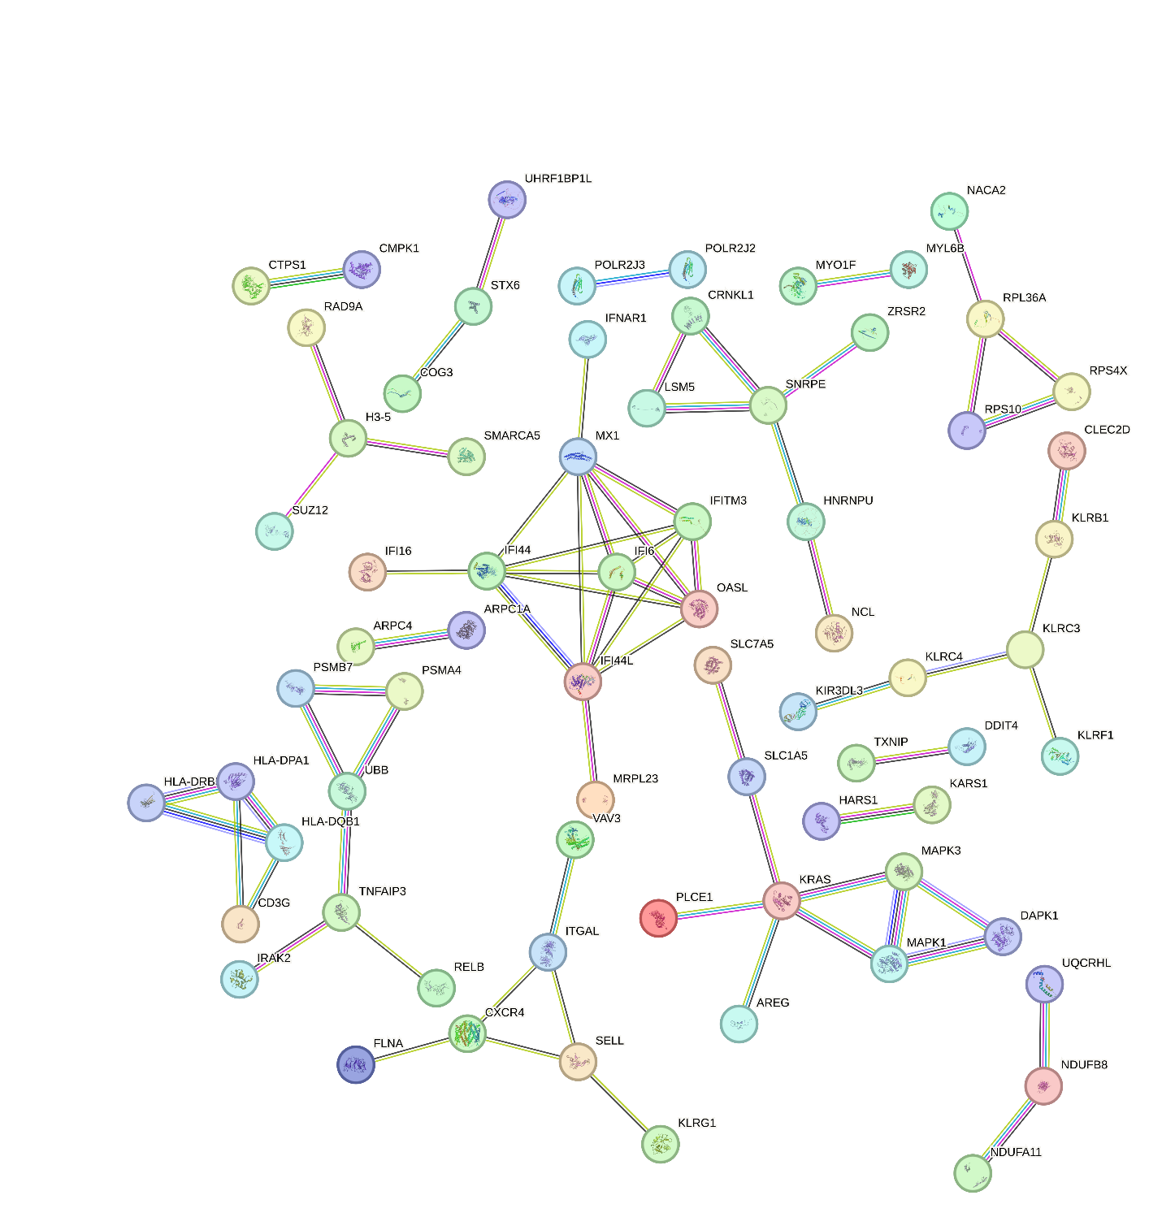
Fig 7. PPI in NK Cell Cell

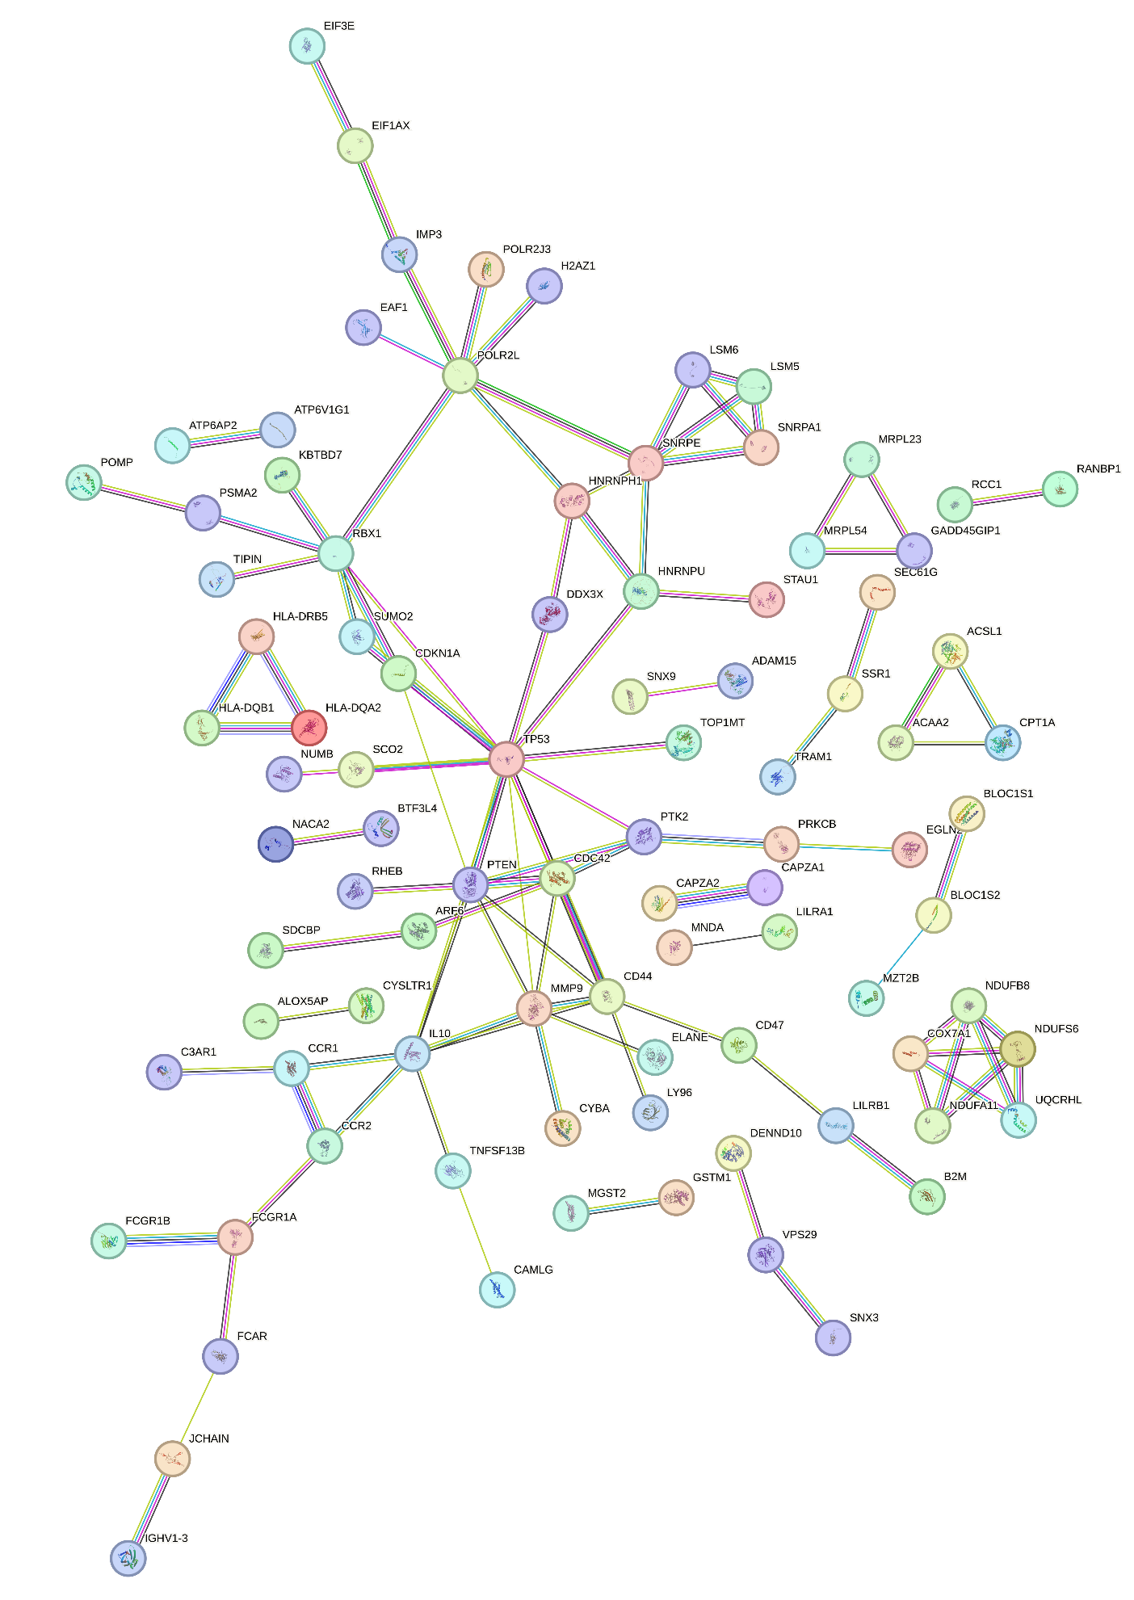
Fig 8. PPI in Monocyte

Biomarker Detection:
=
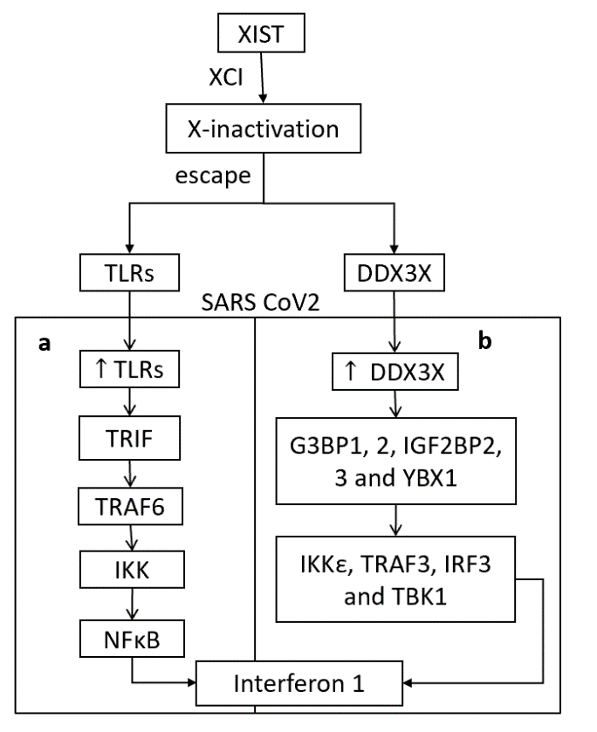
FIG 9. Production of interferon due to the activation of XIST and DDX3X genes during the entry of SARS-CoV-2 virus. a) by binding the TRIF to endosomal TLR3, 7-9 and phosphorylating the TRAF6 gene, the IKK pathway and finally NFκB are activated. Activation of NFκB through this pathway leads to the expression of Interferon 1 and its secretion outside the cell. b) DDX3X, which is an RNA helicase, participates in antiviral signaling pathways. This gene is recruited to the viral replication sites and interacts with the scaffold proteins of stress granules, such as G3BP1, G3BP2, IGF2BP2, IGF2BP3 and YBX1. Then, DDX3X participates in antiviral signaling pathways by regulating the activity of TBK1, IKKε, TRAF3 and IRF3. Finally, it leads to the production of type I interferon and can strongly regulate the immune response.

