Supporting information
Fast Photo-carrier Multiplication by Engineered Potential Trap in MoS₂/Ge Double Junction Phototransistor
Youngseo Park¹, Han Beom Jeong², Hu Young Jeong³, Sangwan Sim⁴, Geonwook Yoo⁵, and Junseok Heo^{1,6,*}
¹Department of Electrical and Computer Engineering, Ajou University, Suwon 16499, South Korea.
²Department of Materials Science and Engineering, Korea Advanced Institute of Science and Technology (KAIST), Daejeon 34141, South Korea.
³Graduate School of Semiconductor Materials and Devices Engineering, Ulsan National Institute of Science and Technology (UNIST), Ulsan 44919, South Korea.
⁴Division of Electrical Engineering, Hanyang University, Ansan 15588, South Korea
⁵School of Electronic Engineering, Soongsil University, Seoul 06938, South Korea
⁶Department of Intelligence Semiconductor Engineering, Ajou University, Suwon 16499, South Korea
*Corresponding author: jsheo@ajou.ac.kr (J.H.)

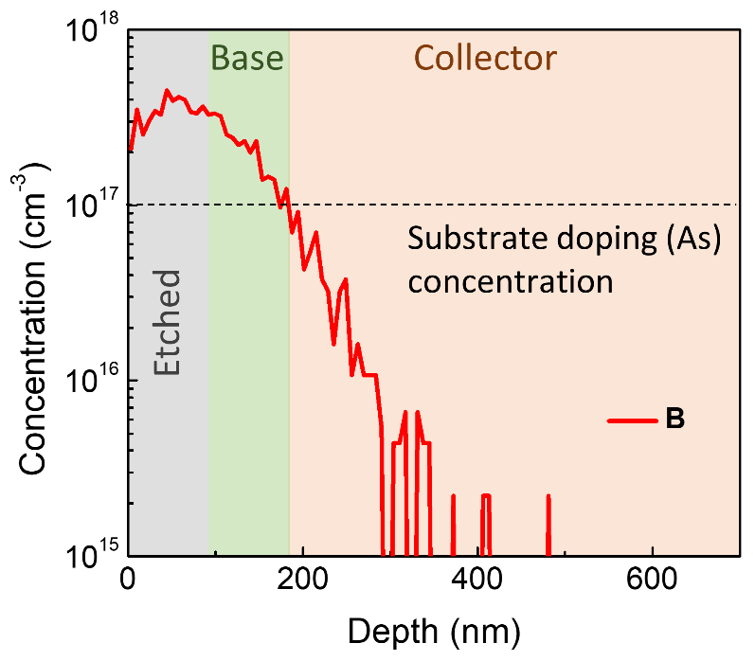
Figure S1. SIMS profile of Ge substrate implanted with 1×10¹³ cm^{–2} B at 60 keV with tilt angles of 7 °.

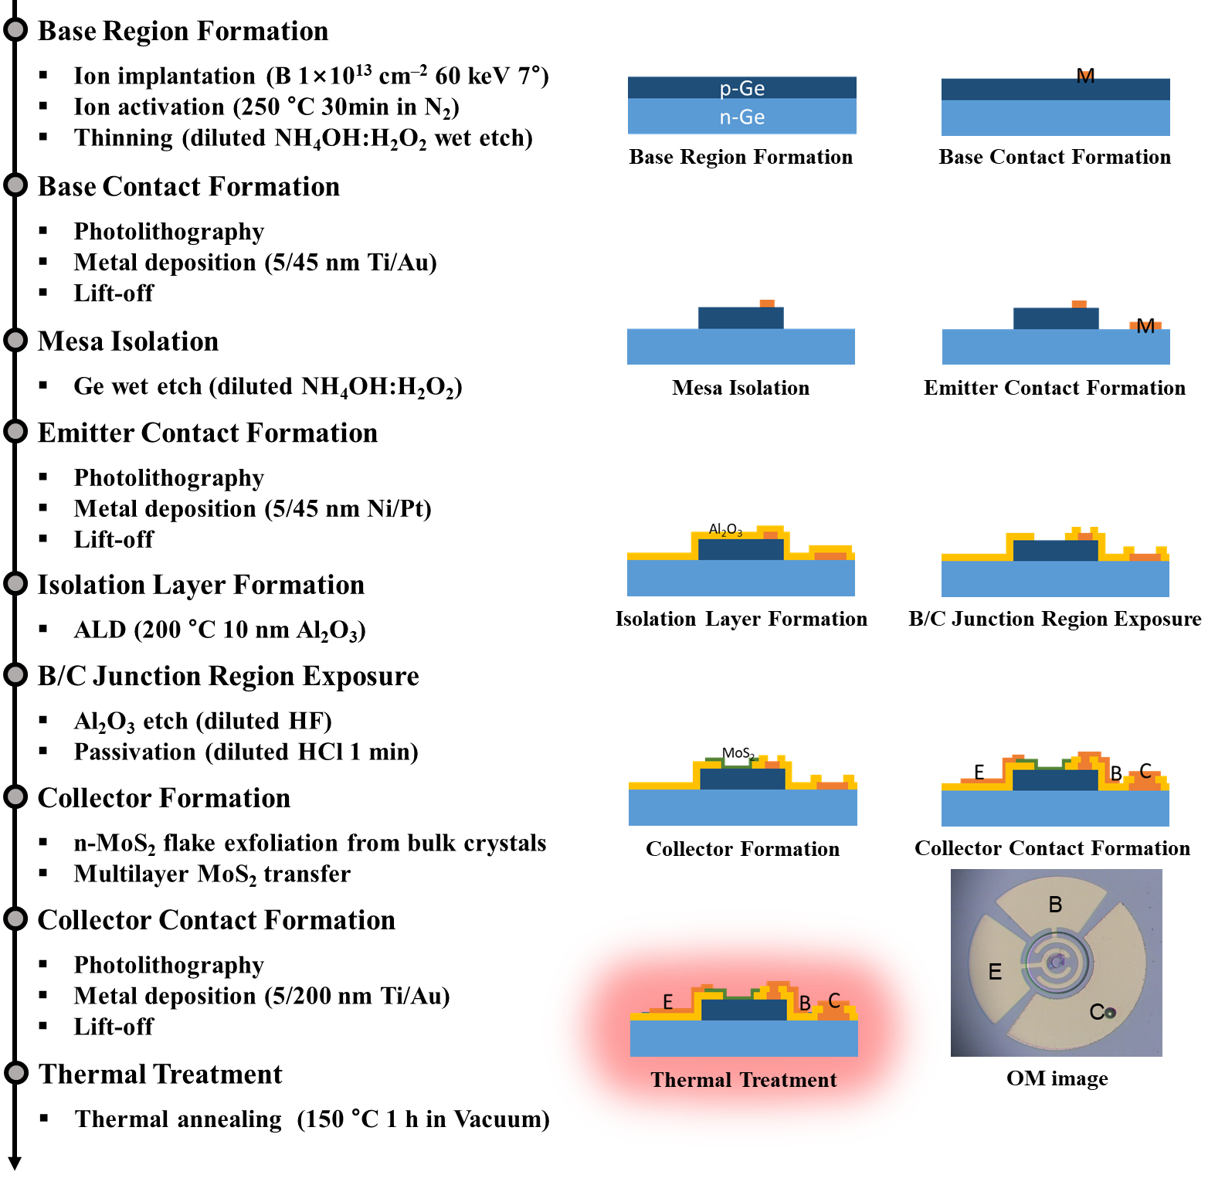
Figure S2. Fabrication process of Ge/MoS₂ double junction phototransistor.
Fabrication process
The fabrication process of Ge/MoS₂ double junction phototransistor is shown in Figure S2. A n-type Ge substrate (1×10¹⁷ cm^{–2}) was implanted with 1×10¹³ cm^{–2} B at 60 keV with tilt angles of 7 ° and then activated at 250 °C for 30 min. Thickness of implanted Ge substrate was controlled with wet etching in solution of NH₄OH:H₂O₂:H₂O (1:1:20) up to ~100 nm. Ti/Au (5/45 nm) contacts were fabricated for p-Ge using mask aligner and electron-beam evaporator. A mesa structure was formed using photolithography followed by wet etching in solution of NH₄OH:H₂O₂:H₂O in the ratio of 1:1:20. 5/45 nm Ni/Pt were deposited as n-Ge electrode using electron-beam evaporation and a standard lift-off technique. In order isolate a metal contact of MoS₂, 10 nm Al₂O₃ was deposited at 200 °C using atomic layer deposition (ALD). The isolation layer (Al₂O₃) was etched until p-Ge surface was completely exposed to control a junction area of MoS₂ and p-Ge. At this time, to form a sloped sidewall at the isolation layer,¹ diluted hydrofluoric acid (HF:H₂O = 1:100) was used and a circular shape was shown with a diameter of 20 μm. To lead to oxide-free Ge surface, the exposed Ge was passivated by 50% diluted HCl for 1 min.² Multilayer MoS₂ flakes mechanically exfoliated from n-type MoS₂ crystals (~1×10¹⁷ – ~1×10¹⁸ cm^{–3}) (2Dsemiconductors, USA) and then transferred onto the exposed Ge surface. The MoS₂ electrode was patterned on top of MoS₂ on the isolation layer using conventional lift-off technique and then 5/200 nm Ti/Au were deposited by e-beam evaporation. The fabricated device was annealed at 150 °C for 1 hour using a rapid thermal process (RTP) to remove any absorbed organic residues and form a reliable junction between the Ge and MoS₂ interface.³
The smile image was fabricated on a quartz substrate. 300 nm Al was deposited and patterned using electron-beam evaporation and the conventional lift-off technique, respectively.

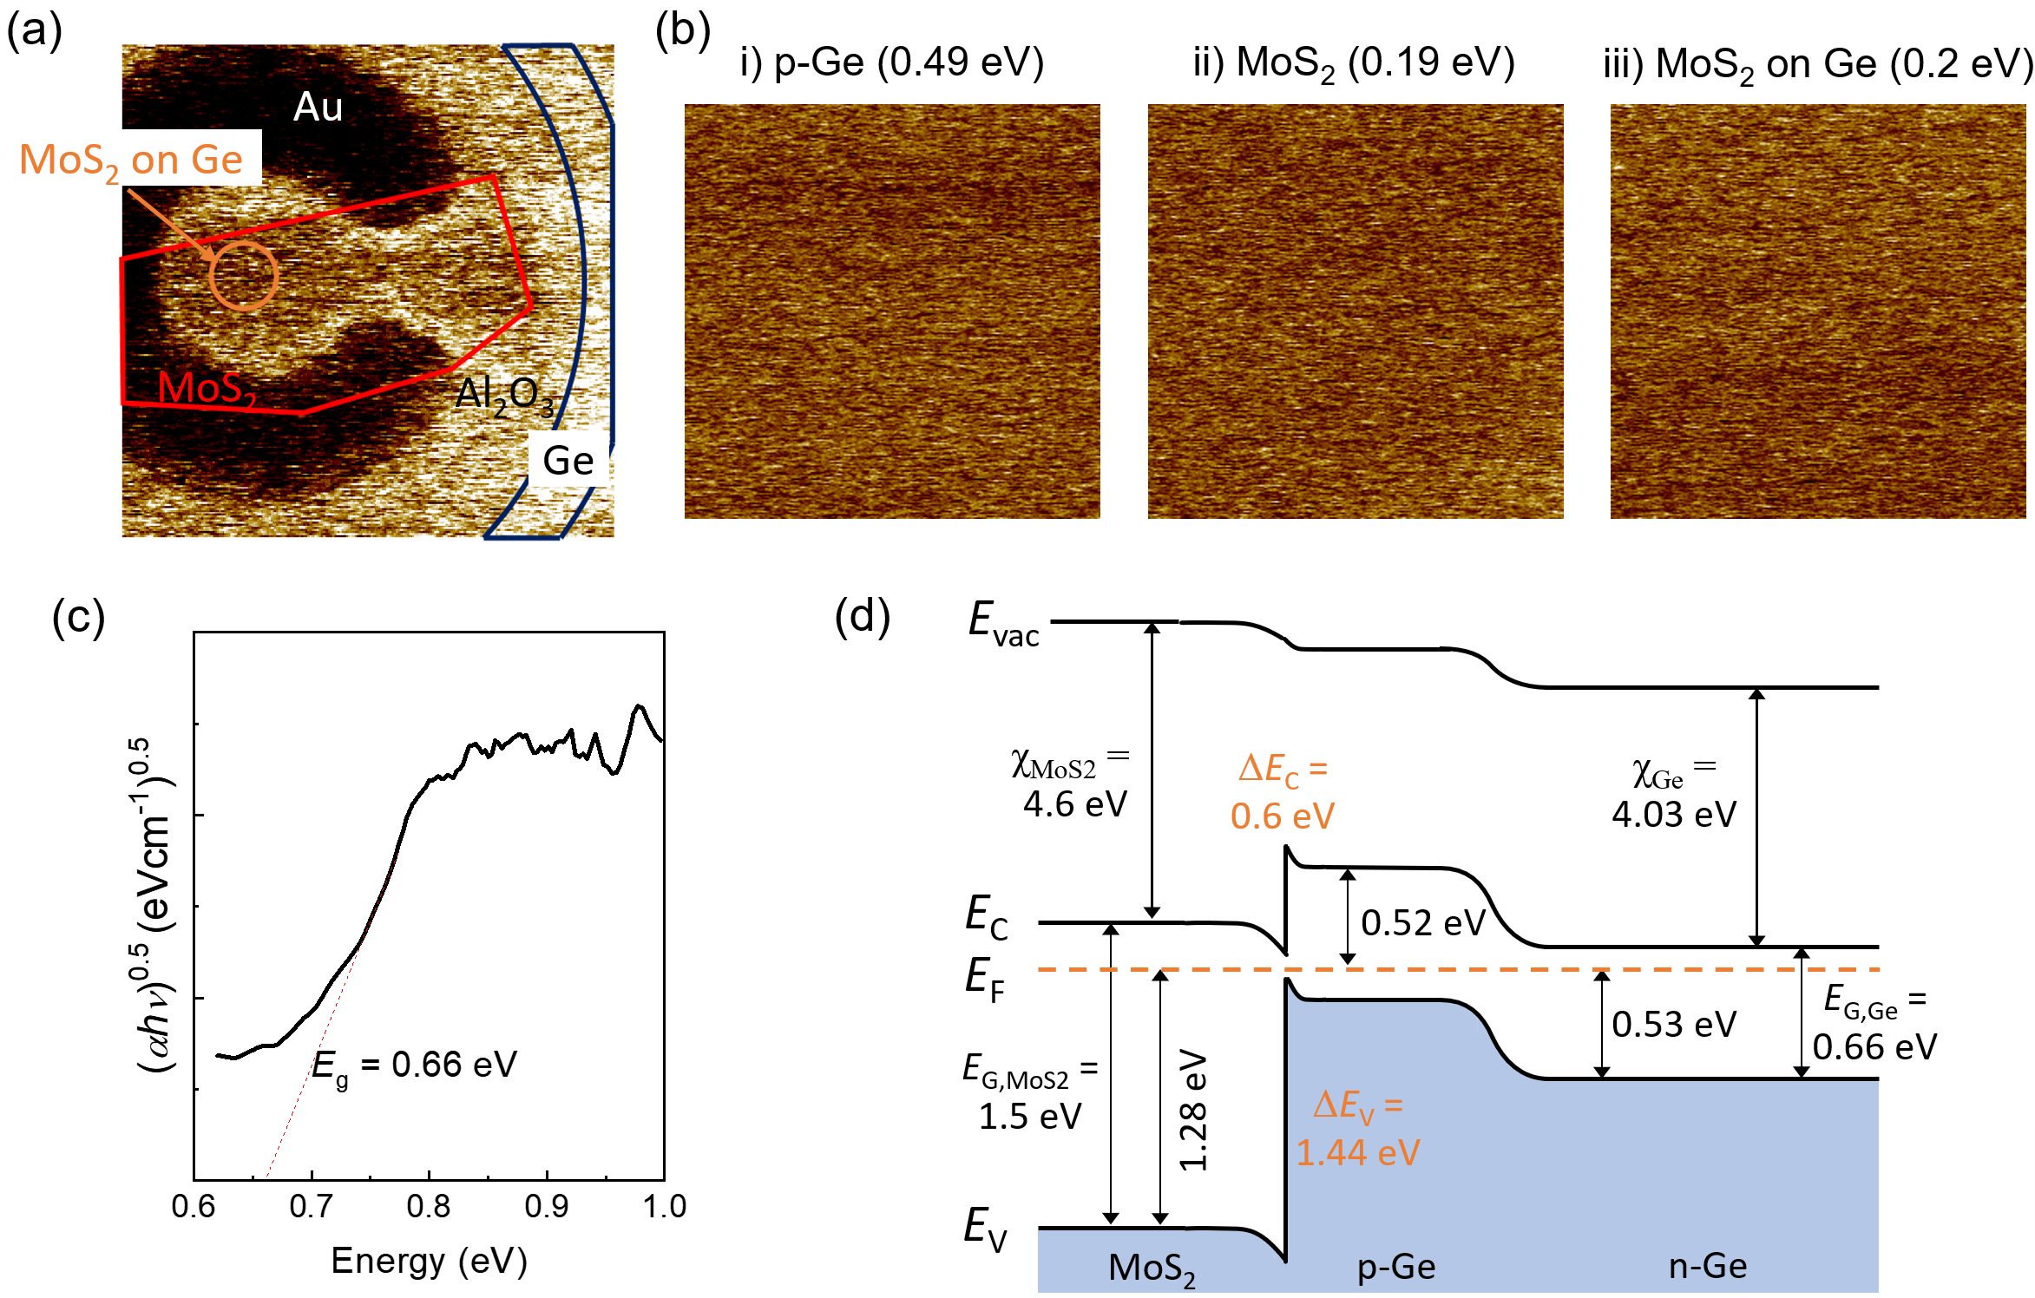
Figure S3. Energy band diagram (a) KPFM image of Ge/MoS₂ heterojunction. Red, navy, and orange solid lines mark the position of MoS₂, exposed Ge, Ge/MoS₂ junction, respectively. (b) Surface potential maps corresponding with i) p-Ge, ii) MoS₂, and iii) p-Ge/MoS₂. (c) Tauc plot for the determination of the indirect band gap using (αhν)^{0.5}. (d) Energy band diagram of Ge/MoS₂ double junction phototransistor.
Energy band diagram of Ge/MoS₂ vdWs heterojunction
To plot energy band diagram of Ge/MoS₂ vdWs heterojunction, KPFM measurement and Tauc plot method were performed. To measure work functions of p-Ge and MoS₂, p-Ge/MoS₂ heterojunction was fabricated for KPFM measurement. The fabrication process for KPFM measurement is analogous to the process for Ge/MoS₂ vdWs phototransistor. However, to simultaneously measure the surface potential of MoS₂, p-Ge, MoS₂/p-Ge heterojunction, p-Ge was exposed without contact metal. At this time, a MoS₂ flake of 6 to 7 nm was used. Surface potential difference was measured by KPFM mapping using AFM, as shown in Figure S3a. Red, navy, and orange solid lines show MoS₂, p-Ge, p-Ge/MoS₂ junction, respectively. Figure S3b shows surface potential maps with mean values of p-Ge, MoS₂, and p-Ge/MoS₂. The work functions of MoS₂ and p-Ge were 4.82 and 4.55 eV, respectively, calculated as Φ_{s} = Φ_{tip} − ΔV_{CPD}, where Φ_{s} is the work function of the sample, Φ_{tip} is the work function of the tip, and ΔV_{CPD} is the potential difference between sample and tip, which is measured by KPFM. Here, Φ_{tip} was found to be ~ 5.02 eV. To determine band gap of Ge, absorption coefficient of Ge was measured onto exposed p-Ge using microspectrophotometer (20/30 PV Microspectrophotometer-Apollo Raman Microspectrometer, CRAIC). Figure S3c shows Tauc plot for the determination of the indirect band gap using (αhν)^{0.5}. Where α is absorption coefficient, h is Planck’s constant, and ν is the photon frequency. Indirect band gap of Ge was found to be ~ 0.66 eV. Based on extracted data, energy band diagram of Ge/MoS₂ double junction phototransistor was expected, as shown in Figure S3d and S3e.
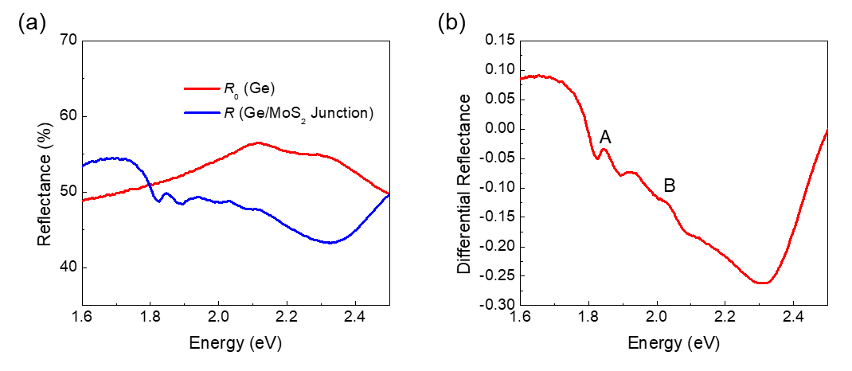
Figure S4. Reflectance spectra (a) Reflectance spectra of Ge and the Ge/MoS₂ heterojunction. The reflectance spectra were characterized by UV-Vis micro-spectrophotometer. (b) Differential reflectance spectra revealing exciton peaks of MoS₂. The differential reflectance is defined as (R ˗ R₀)/R, where R is reflectance of Ge/MoS₂ and R₀ is reflectance of Ge. The A- and B- exciton of MoS₂ were observed at ~1.84 and 2.03 eV, respectively.⁴

Figure S5. Comparison of electrical performance for hot electron transistors (HETs) and heterojunction bipolar transistors (HBTs) based on 2D materials.^{5–12}

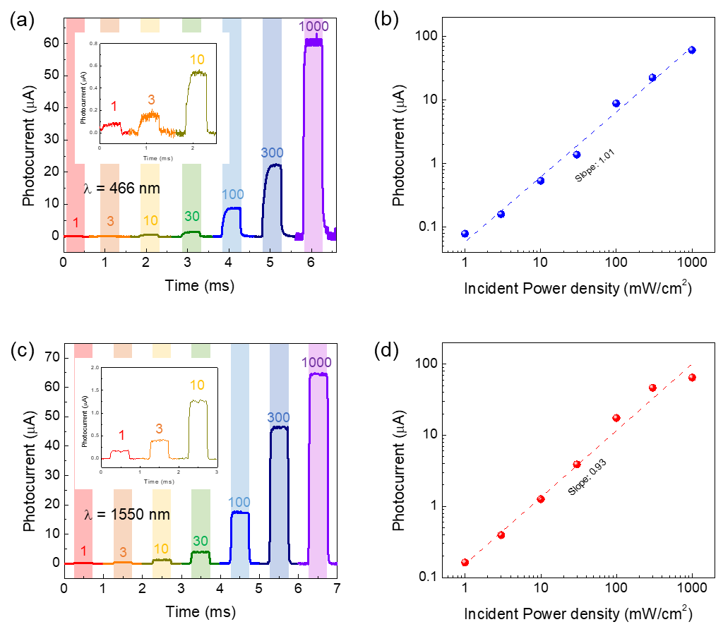
Figure S6. Power dependent photoresponse characteristics of Ge/MoS₂ double junction phototransistor. (a) Temporal photoresponse with different power density of 1, 3, 10, 30, 100, 300 and 1000 mW/cm² under 466 and (c) 1550 nm illumination. (b) Photocurrent under 466 and (d) 1550 nm illumination as a function of the incident power density.

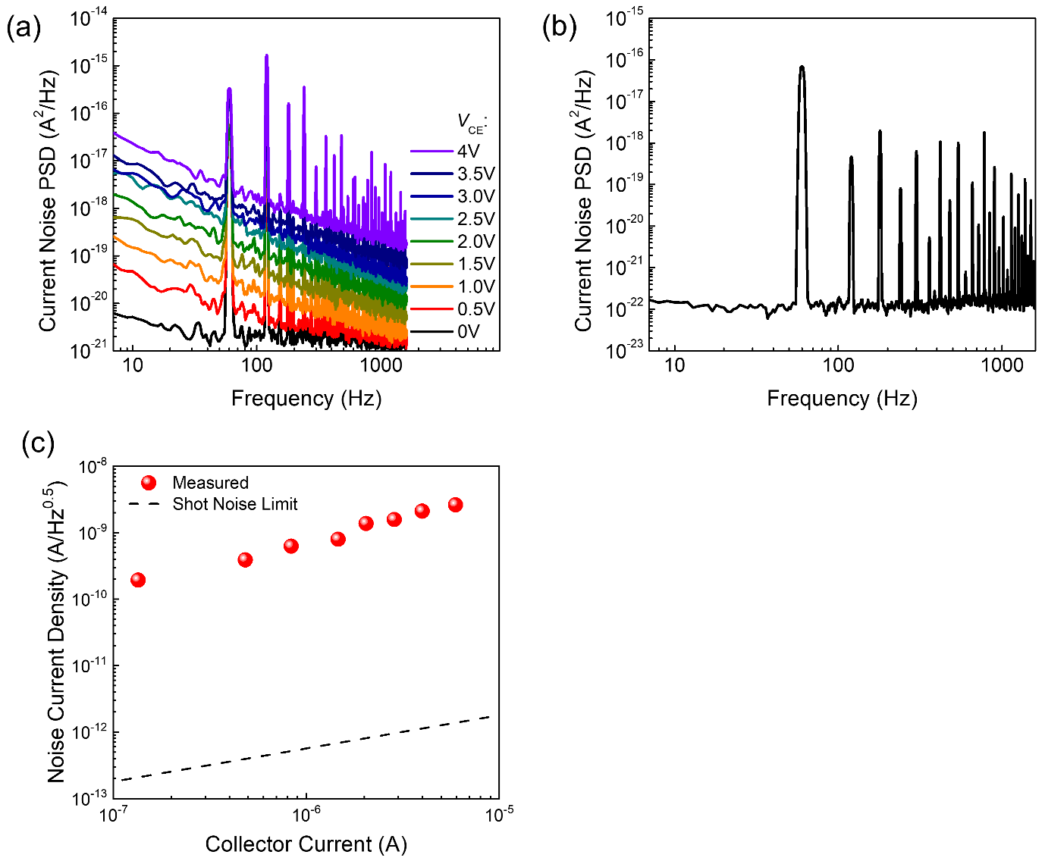
Figure S7. Current noise of phototransistor. (a) Current noise power spectral density (PSD) for several V_{CE} from 0 to 4 V. (b) Current noise PSD of measurement instrument. Input power noise are observed at intervals of 60 Hz. (c) Noise current density with respect to the collector current.

Figure S8. Spectral responsivity and external quantum efficiency (EQE) of Ge/MoS₂ double junction phototransistor.

REFERENCES
(1) Song, D. Y.; Chu, D.; Lee, S. K.; Pak, S. W.; Kim, E. K. High Photoresponsivity from Multilayer MoS2/Si Heterojunction Diodes Formed by Vertically Stacking. J. Appl. Phys. 2017, 122 (12). https://doi.org/10.1063/1.4994740.
(2) Okumura, H.; Akane, T.; Matsumoto, S. Carbon Contamination Free Ge(100) Surface Cleaning for MBE. Appl. Surf. Sci. 1998, 125 (1), 125–128. https://doi.org/10.1016/S0169-4332(97)00587-4.
(3) Park, Y.; Lee, S.; Park, H. J.; Baac, H. W.; Yoo, G.; Heo, J. Hybrid Metal-Halide Perovskite-MoS2 Phototransistor. J. Nanosci. Nanotechnol. 2016, 16 (11), 11722–11726. https://doi.org/10.1166/jnn.2016.13581.
(4) Niu, Y.; Gonzalez-Abad, S.; Frisenda, R.; Marauhn, P.; Drüppel, M.; Gant, P.; Schmidt, R.; Taghavi, N. S.; Barcons, D.; Molina-Mendoza, A. J.; de Vasconcellos, S. M.; Bratschitsch, R.; De Lara, D. P.; Rohlfing, M.; Castellanos-Gomez, A. Thickness-Dependent Differential Reflectance Spectra of Monolayer and Few-Layer MoS2, MoSe2, WS2 and WSe2. Nanomaterials 2018, 8 (9). https://doi.org/10.3390/nano8090725.
(5) Yan, X.; Zhang, D. W.; Liu, C.; Bao, W.; Wang, S.; Ding, S.; Zheng, G.; Zhou, P. High Performance Amplifier Element Realization via MoS2/GaTe Heterostructures. Adv. Sci. 2018, 5 (4), 1–7. https://doi.org/10.1002/advs.201700830.
(6) Lee, G.; Pearton, S. J.; Ren, F.; Kim, J. 2D Material-Based Vertical Double Heterojunction Bipolar Transistors with High Current Amplification. Adv. Electron. Mater. 2019, 5 (3), 1–7. https://doi.org/10.1002/aelm.201800745.
(7) Lin, C. Y.; Zhu, X.; Tsai, S. H.; Tsai, S. P.; Lei, S.; Shi, Y.; Li, L. J.; Huang, S. J.; Wu, W. F.; Yeh, W. K.; Su, Y. K.; Wang, K. L.; Lan, Y. W. Atomic-Monolayer Two-Dimensional Lateral Quasi-Heterojunction Bipolar Transistors with Resonant Tunneling Phenomenon. ACS Nano 2017, 11 (11), 11015–11023. https://doi.org/10.1021/acsnano.7b05012.
(8) Torres, C. M.; Lan, Y. W.; Zeng, C.; Chen, J. H.; Kou, X.; Navabi, A.; Tang, J.; Montazeri, M.; Adleman, J. R.; Lerner, M. B.; Zhong, Y. L.; Li, L. J.; Chen, C. D.; Wang, K. L. High-Current Gain Two-Dimensional MoS2-Base Hot-Electron Transistors. Nano Lett. 2015, 15 (12), 7905–7912. https://doi.org/10.1021/acs.nanolett.5b03768.
(9) Vaziri, S.; Lupina, G.; Henkel, C.; Smith, A. D.; Östling, M.; Dabrowski, J.; Lippert, G.; Mehr, W.; Lemme, M. C. A Graphene-Based Hot Electron Transistor. Nano Lett. 2013, 13 (4), 1435–1439. https://doi.org/10.1021/nl304305x.
(10) Zeng, C.; Song, E. B.; Wang, M.; Lee, S.; Torres, C. M.; Tang, J.; Weiller, B. H.; Wang, K. L. Vertical Graphene-Base Hot-Electron Transistor. 2013.
(11) Vaziri, S.; Belete, M.; Dentoni Litta, E.; Smith, A. D.; Lupina, G.; Lemme, M. C.; Östling, M. Bilayer Insulator Tunnel Barriers for Graphene-Based Vertical Hot-Electron Transistors. Nanoscale 2015, 7 (30), 13096–13104. https://doi.org/10.1039/c5nr03002a.
(12) Zubair, A.; Nourbakhsh, A.; Hong, J. Y.; Qi, M.; Song, Y.; Jena, D.; Kong, J.; Dresselhaus, M.; Palacios, T. Hot Electron Transistor with van Der Waals Base-Collector Heterojunction and High-Performance GaN Emitter. Nano Lett. 2017, 17 (5), 3089–3096. https://doi.org/10.1021/acs.nanolett.7b00451.

