Supplementary Information
Why Do Methane Emissions Occur? Towards a Predictive Framework for Risk-Targeted Mitigation in Oil and Gas Operations
Abdulmuiz A. Adekomi^{a,b,c},Shuting (Lydia) Yang^{b,c}, Shannon Stokes^{b,c}, and Arvind P. Ravikumar^{a,b,c,*}
ªHildebrand Department of Petroleum and Geosystems Engineering, The University of Texas at Austin, Austin, Texas 78712, United States.
^{b}Center for Energy and Environmental Systems Analysis (CEESA), The University of Texas at Austin, Austin, Texas 78712, United States
^{c}Energy Emissions Modeling and Data Lab, The University of Texas at Austin, Austin, Texas 78712, United States
*Corresponding author: arvind.ravikumar@austin.utexas.edu
Supplementary Note S1. Cause Analysis Data Classification Framework
This section outlines the methodology used to classify operator-submitted causal attributions for methane emission events into standardized causal categories. The goal was to enable consistent and actionable causal analysis across the basin-wide dataset.
Supplementary Note S1.1. Initial Operator-Submitted Causal Attributions
Following aerial measurement campaigns conducted in 2024, five participating operators submitted causal attributions for 1,669 emission events. Each operator applied varying emission rate thresholds to emissions detected via aerial surveys, from inclusive of all detected sources to focusing only on those exceeding 25 kg/h, reflecting variations in internal policies, resource availability, and operational priorities. Operators conducted preliminary investigations using site-level knowledge, maintenance logs, and diagnostic records. These attributions were then reviewed by the research team for consistency, with follow-up clarification requested as needed. The raw dataset included 61 unique cause descriptions, reflecting significant heterogeneity in terms of terminology and specificity across operators. Fig. S1 shows the distribution of emission events across these unharmonized operator-provided descriptions of the events.

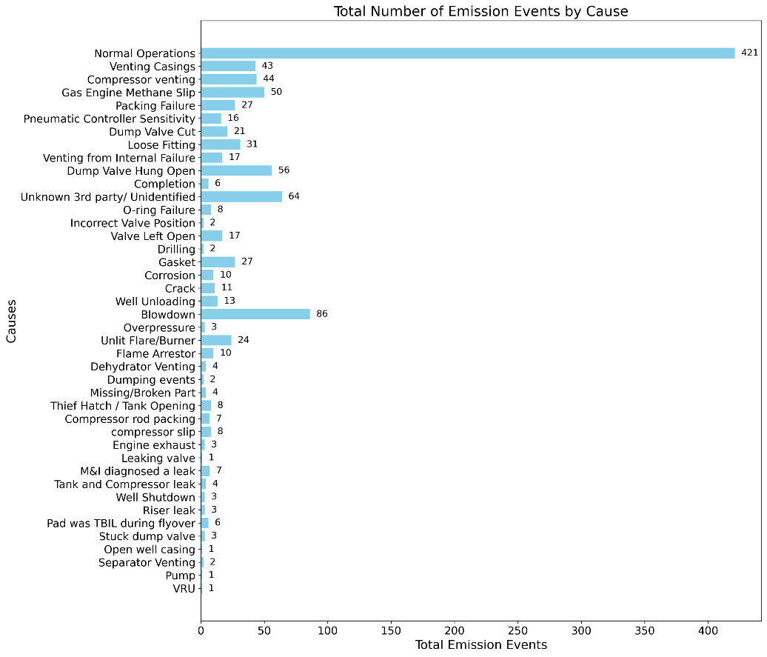
Supplementary Fig 1. Distribution of operator-reported emission events across unharmonized cause descriptions. The plot shows the distribution of 1,669 methane emission events reported by operators, categorized into 61 varieties of causes, showing the spread and categorization across different emission sources. This classification provides insight into the range of emission causes before harmonization, highlighting the potential areas for further standardization and analysis.

Supplementary Note S1.2. Harmonization of Cause Descriptions and Initial Categorization
To enable structured causal analysis, the 61 operator-provided descriptions were systematically grouped into 11 harmonized causal categories. This process involved consolidating similar cause types (e.g., “dump valve stuck open,” “valve left open,” and “valve hung open” were grouped under “Incorrect Valve Position”). The consolidated causal categories were reviewed with all participating operators to ensure consistency, identify and correct errors, and solicit buy-in for the future categorization of emission events. These 11 categories encompass nine causal categories alongside "Normal Operations" and "Unknown 3rd Party/Unidentified" sources. The nine causal categories identified were: abnormal tank emissions, mechanical failures, incorrect valve position, unlit/malfunctioning flare, maintenance venting, blowdown, well unloading, drilling/completions, and heater malfunction. To address the potential for misattribution between process-driven events and component-level failures, particularly in interconnected systems, an attribution hierarchy was established. For instance, an emission detected at a storage tank that occurred concurrently with a documented 'well unloading' operation was categorized as 'well unloading' based on the operator's determination of the primary causal driver. Conversely, an emission from a tank with no concurrent planned operations was investigated for equipment-related issues and categorized as 'abnormal tank emissions' (e.g., due to a malfunctioning controller or leaking thief hatch). While this protocol aimed to minimize misattribution, we acknowledge that distinguishing between these types presents uncertainty, as discussed in the main text (Section 2.4). Therefore, operator reporting consistency and research team review were critical in mitigating uncertainty. Supplementary Fig. 2 shows the distribution of all 1,669 events across the 11 harmonized categories. The full mapping of operator descriptions to harmonized categories is provided in Table 1 (main text). Supplementary Fig. 3 shows the distribution of total emission rate attributable to events across the 11 harmonized causal categories.

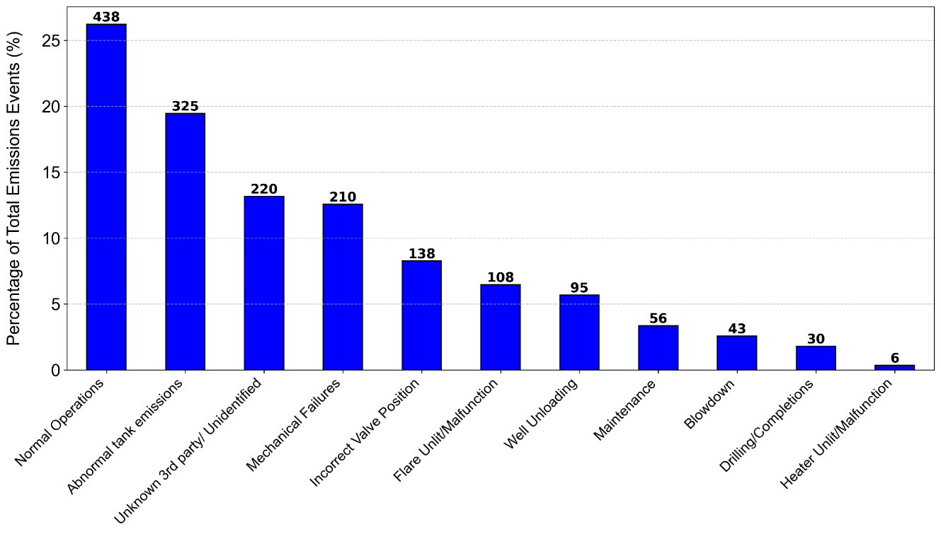
Supplementary Fig. 2: Distribution of 1,669 methane emission events across 11 harmonized causal categories. These categories include nine distinct operational causal mechanisms, along with "Normal Operations" and "Unknown 3rd Party/Unidentified" sources. The number of emission events in each category is annotated above each corresponding bar, providing a clear overview of the frequency distribution across the categorized causes.

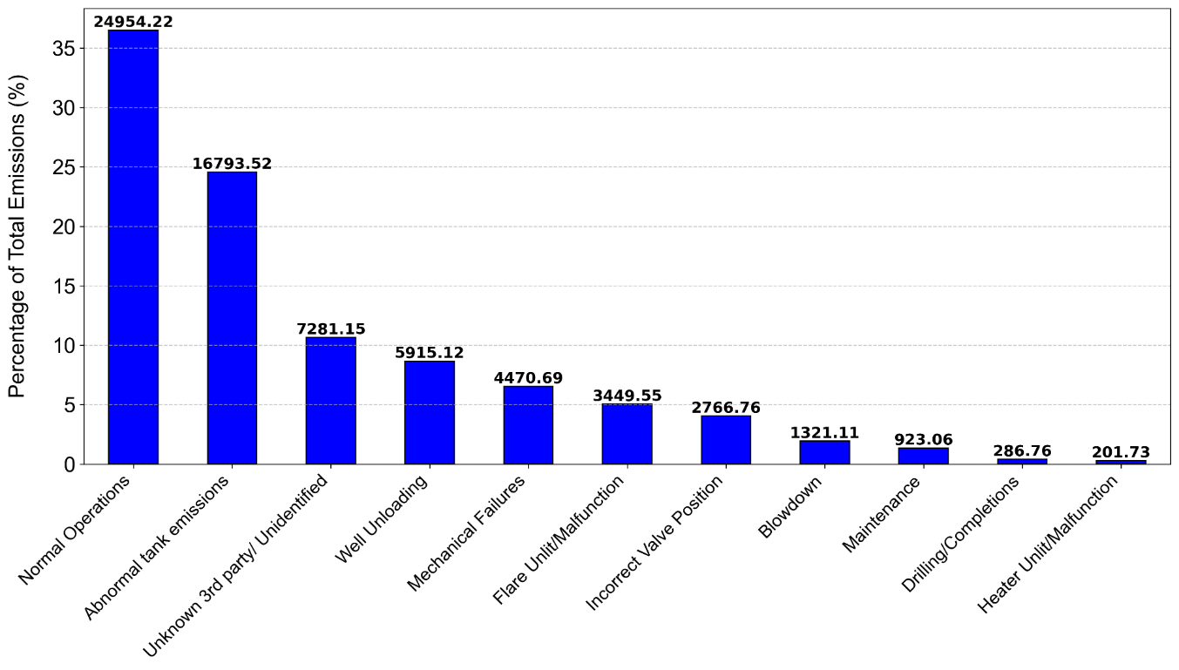
Supplementary Fig. 3: Distribution of total measured methane emissions rate across the 11 harmonized causal categories. These categories include nine distinct causal categories, "Normal Operations," and "Unknown 3rd Party/Unidentified" sources. The total methane emission rates attributed to each category are annotated above the corresponding bars, providing insights into the relative contribution of each causal category to the overall emission mass profile.

Supplementary Note S1.3. Causal Categories Exclusions
To focus the causal analysis on actionable emission events, two categories were excluded: normal operations, representing 26.2% of the events, which are the expected, routine emissions from standard equipment functions operating as designed (e.g., compressor rod packing vents), and unknown/third party, representing 13% of emission events, including emissions where a conclusive cause could not be identified on a participating operator's asset, or emissions clearly originating from the infrastructure of non-participating third-party companies. After these exclusions, 1,011 emission events remained for a detailed causal analysis. Supplementary Fig. 4 shows the distribution of these events across the nine harmonized causal categories.

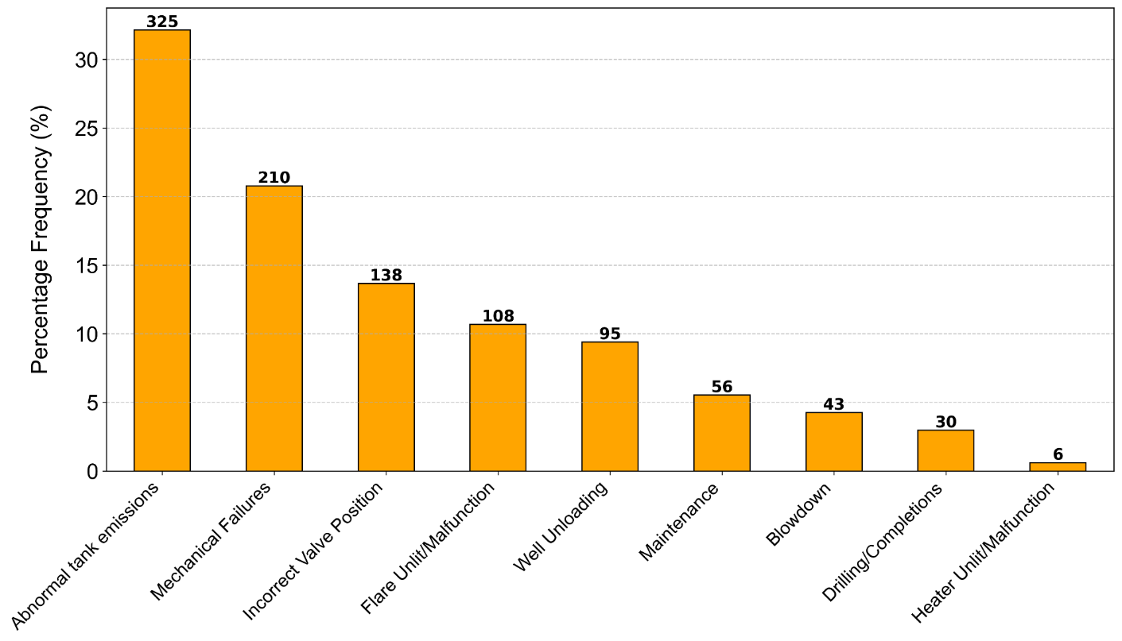
Supplementary Fig. 4: Distribution of 1,011 actionable methane emission events across nine harmonized causal categories, after excluding “Normal Operations” and “Unknown/Third Party.” The Y-axis shows the percentage frequency relative to 1,011 events.

This classification process, from raw operator inputs (Supplementary Fig. 1) to harmonized categories (Supplementary Fig. 2), to a refined analyzed dataset (Supplementary Fig. 4), provides a consistent foundation for causal analysis across the Appalachian Basin for this study.

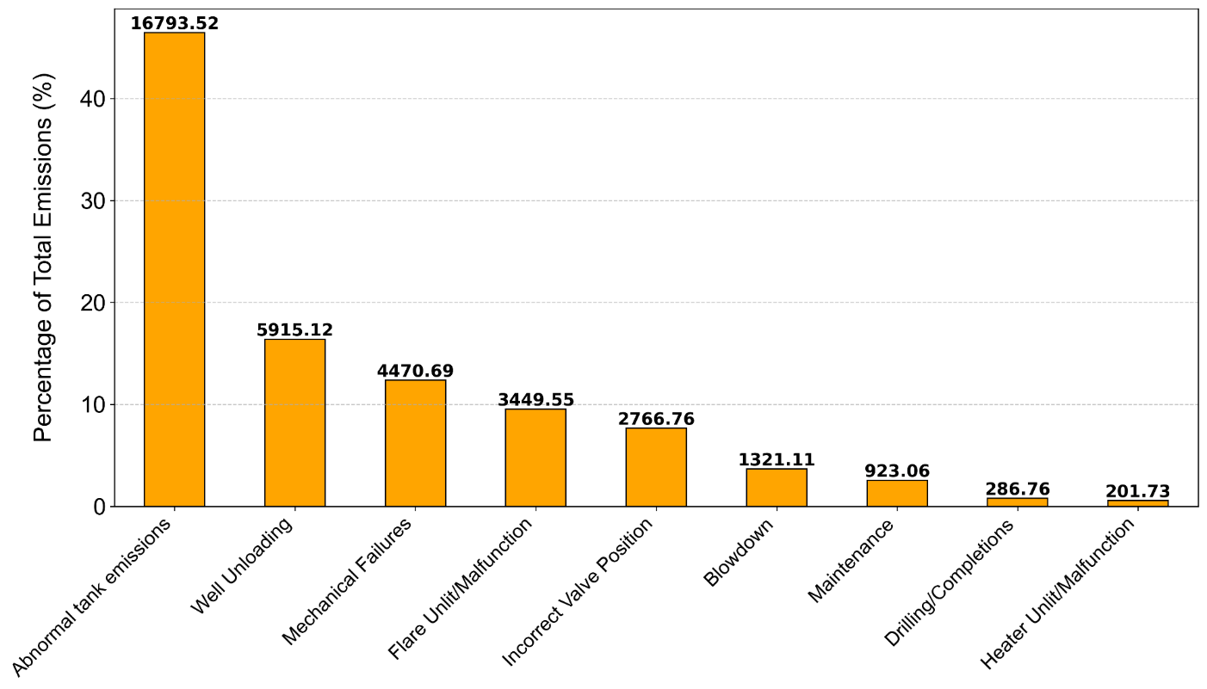
Supplementary Fig. 5: Basin-wide assessment of methane emission causal categories, excluding normal operations and unidentified sources. The total emission rates (kg/h) are annotated on the bars, revealing significant disparities across the causal categories.

Supplementary Fig. 5 shows the cumulative methane emissions associated with each causal category across the full dataset. This unnormalized view further substantiates the findings from the main text (Section 3.1), reinforcing the disproportionately high emissions linked to emission causes such as abnormal tank emissions. Overall, it is important to note that the findings and specific distribution of causal categories are characteristic of the Appalachian Basin during the study period and would be expected to differ in other basins due to variations in geological characteristics, infrastructure, and operational practices. The specific timing of the survey rounds are presented in Supplementary Table 1.

Supplementary Table 1. Survey round details for the 2024 Appalachian Methane Initiative, including start and end dates, along with survey duration in days for each round.
Survey Round | Survey Start Date | Survey End Date | Duration (Days)
1 | 4/8/2024 | 5/8/2024 | 30
2 | 6/20/2024 | 7/13/2024 | 23
3 | 8/6/2024 | 8/20/2024 | 14
4 | 10/2/2024 | 12/17/2024 | 76

Supplementary Note S2. Failure Mode and Effects Analysis (FMEA)
This section provides detailed input data, normalized scores, and Risk Priority Numbers (RPNs) for the FMEA analysis conducted on the 1,011 identified emission events. The methodology for computing Severity (S), Occurrence (O), Detection (D), and the RPN are described in the main text (Section 2.3.1).
Supplementary Note S2.1. FMEA Scoring Data and Results
Supplementary Table 2 presents the comprehensive data used for the FMEA, detailing for each of the nine failure modes the raw average emission rate (kg/h) for Severity, the normalized Severity score (S), the total event frequency for Occurrence, the normalized Occurrence score (O), the average duration for Detection, the normalized Detection score (D), and the final RPN score. The min–max normalization was based on the following parameter ranges: for Severity, derived from average emission rate, the α_{min} was 10.24 kg/h for drilling/completions, and α_{max} was 70.44 kg/h for well unloading. For occurrence, based on event frequency, α_{min} was 6 for heater unlit/malfunction, and α_{max} was 325 events for tank emissions.
Detection scoring was based on emission event duration, under the assumption that longer-lasting emissions are more likely to coincide with aerial surveys. The Detection Difficulty (D) score was designed to assess the risk that a failure mode might be underrepresented by intermittent, snapshot-based aerial surveys. It reflects the likelihood of an emission event being captured during a survey, with shorter-duration events receiving higher scores due to their lower probability of coinciding with a measurement overflight. While this score does not directly correlate with cumulative emissions, it highlights failure modes that are more likely to evade detection unless alternative detection methods, such as continuous monitoring are implemented. It prioritizes strategic mitigation planning by identifying emissions that could be systematically underestimated, rather than focusing on repair response time. Very short-duration events, such as blowdowns, are less likely to coincide with a survey and were therefore considered more difficult to detect. An inverse relationship was applied: shorter durations received higher Detection scores (D = 10), indicating lower detectability, whereas longer durations received lower scores (D = 1), indicating higher detectability. In most cases, the average event duration was used for scoring, as obtained from operator-reported causal analysis data. Where duration data was significantly skewed, the median value was used as a more representative measure of central tendency. For detection, based on event duration, α_{min} was 1 hour for blowdown and α_{max} (longest duration, mapping to D=1) was 24 days for drilling/completions.

Supplementary Table 2. Detailed input data, normalized scores for Severity (S), Occurrence (O), and Detection (D), and resulting Risk Priority Numbers (RPN) for each of the nine harmonized emission failure modes. Severity scores are based on average emission rates, Occurrence scores on event frequencies, and Detection scores on event durations (inversely scaled). All scores ranged from 1 to 10.
Class | Average Emission rate(kg/h) | Severity (S) | Frequency | Occurrence (O) | Average Duration | Detection (D) | RPN = SxOxD
Drilling and Completions | 10.24 | 1.00 | 30 | 1.68 | 24 days | 1.00 | 2
Mechanical Failures | 22.13 | 2.78 | 210 | 6.76 | 14 days | 4.76 | 90
Incorrect Valve Positions | 21.79 | 2.73 | 138 | 4.72 | 8 days | 7.01 | 90
Abnormal Tank emissions | 52.64 | 7.34 | 325 | 10.00 | 9 days | 6.63 | 487
Blowdown | 31.45 | 4.17 | 43 | 2.04 | 1 hour | 10.00 | 85
Maintenance | 16.76 | 1.97 | 55 | 2.38 | 1 day | 9.64 | 45
Well Unloading | 70.44 | 10.00 | 96 | 3.54 | 2.3hrs | 9.98 | 353
Flare Unlit/Malfunction | 32.24 | 4.29 | 108 | 3.88 | 4 days | 8.51 | 142
Heater Unlit/Malfunction | 33.62 | 4.50 | 6 | 1.00 | 2 days | 9.26 | 42

Given that the RPN is calculated as the product of severity (S), occurrence (O), and detection (D), and each component is scored on a scale from 1 to 10, the theoretical RPN range spans from 1 for least critical to 1000 for the most critical. In this study, the observed RPN values ranged from 2 to 487, reflecting the relative composite impact of each failure mode within the study context. It is important to note that our FMEA's Detection score was developed from the perspective of identifying risk within an intermittent, survey-based monitoring framework. An alternative formulation designed specifically for other goals, such as guiding operational repair prioritization, may adopt a different metric, such as a cumulative emissions score, to directly reflect long-duration, high-impact sources.

Supplementary Note S3. Fault Tree Analysis (FTA)
This section provides the detailed structure and input data for the FTA used to quantitatively assess the annual probability of methane emission events from key causal categories. Supplementary Fig. 6 shows the FTA logic diagram illustrating the hierarchical structure used to model failure pathways for the major causal categories analyzed. This structure served as the basis for calculating the overall and individual annual probabilities of methane emissions from these categories, as reported in the (main text) Section 3.4 and Supplementary Table 2. The fault tree logic enables the identification of critical contributing events and their combinations, supporting risk prioritization.

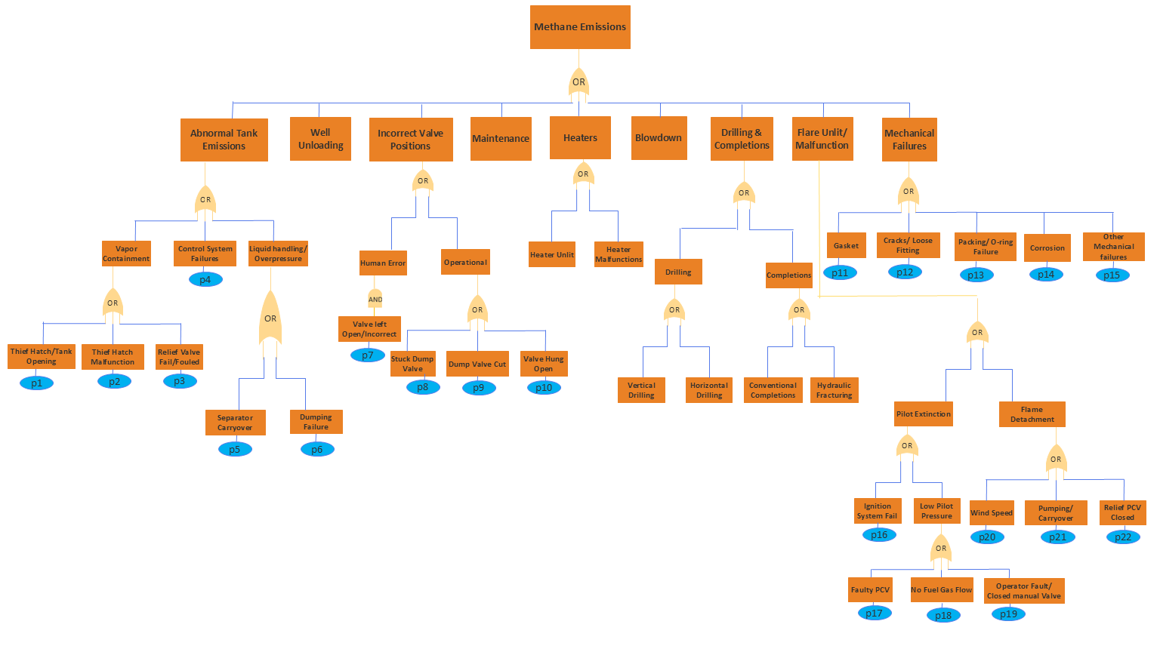
Supplementary Fig. 6. The fault tree diagram illustrating the logical pathways from basic operational and equipment failures to the top event 'Methane Emissions (per year)'. The probabilities (p) for basic events represent annual probabilities. Logical relationships are defined by OR and AND gates, whereas intermediate events correspond to failure modes.

Supplementary Table 3. Descriptions of the basic events and their assigned annual failure probabilities used in the FTA. Probabilities were derived from the study dataset, supplemented by literature estimates and external reliability standards, where applicable. The probabilities marked with ** were normalized using causal analysis data.
Base Event | Event Name | Prob. (per year) | Source/Justification
p1 | Hatch malfunction | 0.000018 | ¹*
p2 | Relief valve fouled/fail | 0.004 | ²
p3 | Thief‐hatch /tank opening | 0.01 | ¹
p4 | Control system failure | 0.0085 | ³
p5 | Separator carryover | 0.004 | ⁴
p6 | Dumping valve failure | 0.0001 | ⁵
p7 | Stuck dump valve | 0.0001 | ⁵
p8 | Dump valve hung open | 0.0001 | ⁵
p9 | Dump valve cut | 0.000005 | ⁵
p10 | Human valve open | 0.02 | ⁶
p11 | Gasket failure | 0.00315 | ³*
p12 | Cracks/ loose fitting | 0.005175 | ³*
p13 | Packing / O-ring failure | 0.00255 | ³*
p14 | Corrosion | 0.005 | ³
p15 | Other internal failure | 0.009 | ³*
p16 | Ignition system fails | 0.000152 | ⁷
p17 | Faulty PCV | 0.00000029 | ⁷
p18 | No fuel gas flow | 0.000152 | ⁷
p19 | Operator fault/closed manual valve | 0.0000285 | ⁷
p20 | Wind speed/environmental | 0.000057 | ⁷
p21 | Pumping/carryover | 0.000228 | ⁷
p22 | Relief PCV closed | 0.001 | ⁷

To assess the validity of the model, the FTA-derived annual probabilities were compared with empirically derived event frequencies. The empirical frequency is calculated as
$$Empirical Annual Event Frequency= \frac{Total Observed Events for a Category}{Total Population of Associated Components Surveyed}$$
This validation was performed for two distinct cases to test the model's robustness and highlight the importance of data sources. This discrepancy for flares highlights the critical need for measurement-informed, basin-specific data over generic failure rates. A similar quantitative validation with empirical data was not performed for other causal categories, such as mechanical failures, owing to the lack of a comprehensive component-level inventory across the surveyed facilities, which prevented the calculation of a comparable empirical event frequency. However, the strong alignment for the well-inventoried tank category provides confidence in the overall FTA approach.

Supplementary Note S4. Emission Rate Contribution by Causal Category for Small vs. Large Emitters
This section provides supplementary data to (main text) Section 3.2b, which compares the emission drivers of small (<100 kg/h) versus large (≥100 kg/h) methane emitters. While the Fig. 4 (main text) focuses on the frequency of emission causes and their Escalation Ratios (ER) between these two emitter classes, Supplementary Fig. 7 illustrates the percentage contribution of each category to the total mass of emissions within each emitter class (small vs. large). This provides an understanding of not only the frequency of each causal category but also its relative impact on the total emissions volume for that category.
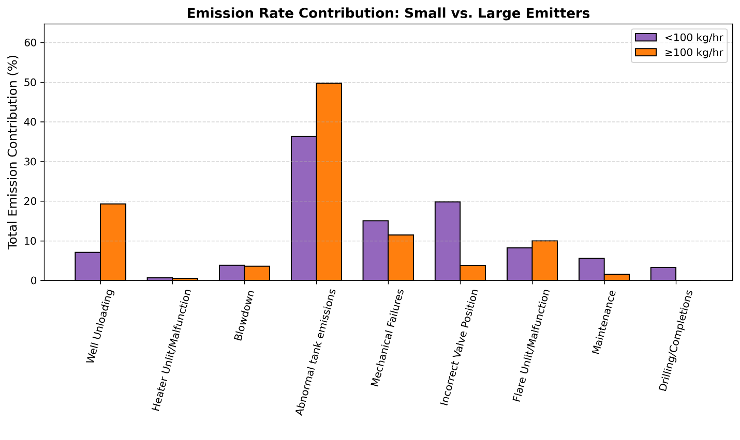
Supplementary Fig. 7. Comparison of the percentage contribution to the total emission mass by causal category for small (<100 kg/h, purple bars) and large (≥100 kg/h, orange bars) emitter events. Each bar represents the proportion of the total emission mass attributable to a specific causal category within each emitter class. This figure complements Main Text Fig. 3, which presents the frequency distribution and Escalation Ratios.

To complement the frequency-based analysis in the main text, Supplementary Fig. 7 compares the proportional contributions of different causal categories to total methane emissions, separated by emitter size class. This highlights how certain emission cause dominate by their contribution to overall emissions volume. For example, tank emissions contribute sigsnificantly to the emissions mass in both small emitter events, 36%, and large emitter events by 50%, highlighting their overall high impact regardless of the individual event magnitude class. Well unloading events may be less frequent among small emitters as shown in Fig. 3 (main text), Supplementary Fig. 7 indicates their substantial contribution to the emissions mass when they do occur in the large emitter class. Conversely, mechanical failures and incorrect valve positioning were more prominent contributors to the emission mass of small emitters than to that of large emitters, which is consistent with their lower ER frequency.

References

1. Cadwallader, L. C. Selected Component Failure Rate Values From Fusion Safety Assessments Taks. Ida. Natl. Eng. Environ. Lab. INEEL/EXT-98-00892, (1998).
2. U.S. Environmental Protection Agency. Test and Repair Pressure Safety Valves. Partn. Rep. Oppor. Fact Sheet No 602 Reducing Methane Emiss. (2011).
3. Li, X., Liu, W., Zhou, N. & Yuan, X. Probability Analysis of Hazardous Chemicals Storage Tank Leakage Accident Based on Neural Network and Fuzzy Dynamic Fault Tree. Appl. Sci. 15, 3504 (2025).
4. Center for Chemical Process Safety. Qualitative and Quantitative Prediction of Human Error in Risk Assessment. (Wiley, 2004). doi:10.1002/9780470925096.
5. Health and Safety Executive. (n.d.). Failure Rate and Event Data for use within Land Use Planning Risk Assessments. UK Health Saf. Exec. (2001).
6. Bridges, W. G., & Thomas, H. W. Accounting for Human Error Probability in SIL Verification Calculations. 8th Glob. Congr. Process Saf. Houst. TX (2012).
7. Kabir, S., Taleb-Berrouane, M. & Papadopoulos, Y. Dynamic reliability assessment of flare systems by combining fault tree analysis and Bayesian networks. Energy Sources Part Recovery Util. Environ. Eff. 45, 4305–4322 (2023).

