Appendix
Supplementary Table 1. List of analyzed microsatellite loci. Loci 1, 4, 7, 9, 10, 12, 14, 19, 20, 22, 28, 29, and 30 were originally published by Shaw et al. (2008) and locus 56 in Stenøien et al. (2011). In addition, loci 68 and 93 were provided through personal communication by T. Stenøien. The Locus column refers to the original locus identifiers used in those publications. The 5′–3′ forward primer and 5′–3′ reverse primer sequences used for PCR amplification are listed. The motif indicates the repeated microsatellite tandem motif. The forward flank (bp) and reverse flank (bp) correspond to the lengths of the non-repetitive sequences flanking the motif on each side.
Locus | 5'–3' forward primer | 5'–3' reverse primer | Motif | Forward flank (bp) | Reverse flank (bp)
1 | AACCACAAGTGAGCATTACC | ACCTCTCCTCTCTGATTTCTG | CA- | 124 | 112
4 | TTGTGAGGAAGTGGTGTTG | TCAGCAAGAGATTTGTGACC | CA- | 140 | 23
7 | TCCAATGACGGTAGGAAAC | TCCAAGTGTCTTACAATGTCTG | GA- | 30 | 128
9 | GCATTTGATTACGAACAAGAG | CGGATGAGCAGAAACAAC | CT- | 54 | 98
10 | GGGTTAGGGGATGATCCTG | CTTCAGCCACGAATCCATT | GA- | 164 | 34
12 | TGGAATGAATTGGAGCAAC | TTGGTATGTATGCGAAGAAAG | AC- | 86 | 23
14 | TCCCCCACTCCTCTACTTG | CTTGGATTCCTTTGCTTCTG | AG- | 68 | 109
19 | GCAAACCCTAAAACACAGTG | ATCGGCGTATCTTGATGTC | AAG- | 170 | 72
20 | ACCCAACGGACTCTACGG | AACGCTGAAACAGACCTCG | TTC- | 119 | 145
22 | TCCCCAACACAAACCTTC | GCTTTGAAGAAAGTTCCAGTG | GAT- | 32 | 34
28 | CCGAAAAGGGAACAAACAAA | TCCTTCTCCTCTGCGTGTTT | AC | 231 | 269
29 | CTCATCAGCCCAGTCAGTCA | ACCCACGCATCAAAAGAAAC | AAG- | 134 | 41
30 | ACCACCCTCCTCTCAATCCT | AGTGTTTGCCAGTGCCTCTT | GAT- | 88 | 29
56 | CGCCTGTTTGTGCTCTTCC | CGAGTTGCGGAAACGTGAG | AAG | 191 | 237
68 | TACCCACTTCCCACTTGGC | CAGCTTGCTGTGACTTCTGG | 3 bp
93 | GGGCCGCTGAAATTGTTGG | GGCCTTTTCTTCAACCGACC | 3 bp

Supplementary Table 2. Sphagnum fuscum multilocus genotypes of the Pyrenean, Canadian, and Norwegian populations The MLG codes correspond to the identified multilocus genotypes in each region. The pyrenean population codes follow the nomenclature in Table 2. Note that loci 4, 10, and 28 were excluded due to missing data in the Norwegian and Canadian samples; consequently, we lost resolution for Pyrenean samples, FMP* coincides with PDH2, and EST1* coincides with EST3. The Norwegian and Canadian population codes are based on Kyrkjeeide et al. (2023). The region column indicates the geographic origin of each MLG (PYR: Pyrenees; CAN: Canada; NOR: Norway). Columns labeled locus7, locus9, locus20, locus22, locus30, locus56, and locus68 show the allele sizes (in base pairs) at each microsatellite locus.

MLG | REGIONS | locus7 | locus9 | locus20 | locus22 | locus30 | locus 56 | locus68
CAU | PYR | 189 | 182 | 294 | 103 | 130 | 206 | 227
CDV | PYR | 189 | 184 | 294 | 103 | 130 | 206 | 231
EPL | PYR | 193 | 184 | 291 | 97 | 130 | 206 | 227
EST 1 | PYR | 189 | 184 | 294 | 103 | 127 | 206 | 227
EST 2 | PYR | 189 | 184 | 288 | 103 | 130 | 206 | 227
FER | PYR | 189 | 184 | 291 | 103 | 130 | 206 | 227
FMP* | PYR | 193 | 184 | 291 | 103 | 130 | 206 | 227
PDH 1 | PYR | 189 | 186 | 291 | 103 | 127 | 206 | 227
219 | CAN | 189 | 182 | 294 | 103 | 127 | 209 | 225
210 | CAN | 189 | 186 | 288 | 103 | 130 | 212 | 225
212 | CAN | 189 | 182 | 288 | 109 | 127 | 209 | 225
ss60 | CAN | 189 | 186 | 291 | 103 | 127 | 212 | 225
209 | NOR | 193 | 182 | 288 | 97 | 130 | 212 | 225
211 | NOR | 193 | 186 | 291 | 103 | 130 | 212 | 227
ss58 | NOR | 189 | 186 | 291 | 106 | 130 | 215 | 225

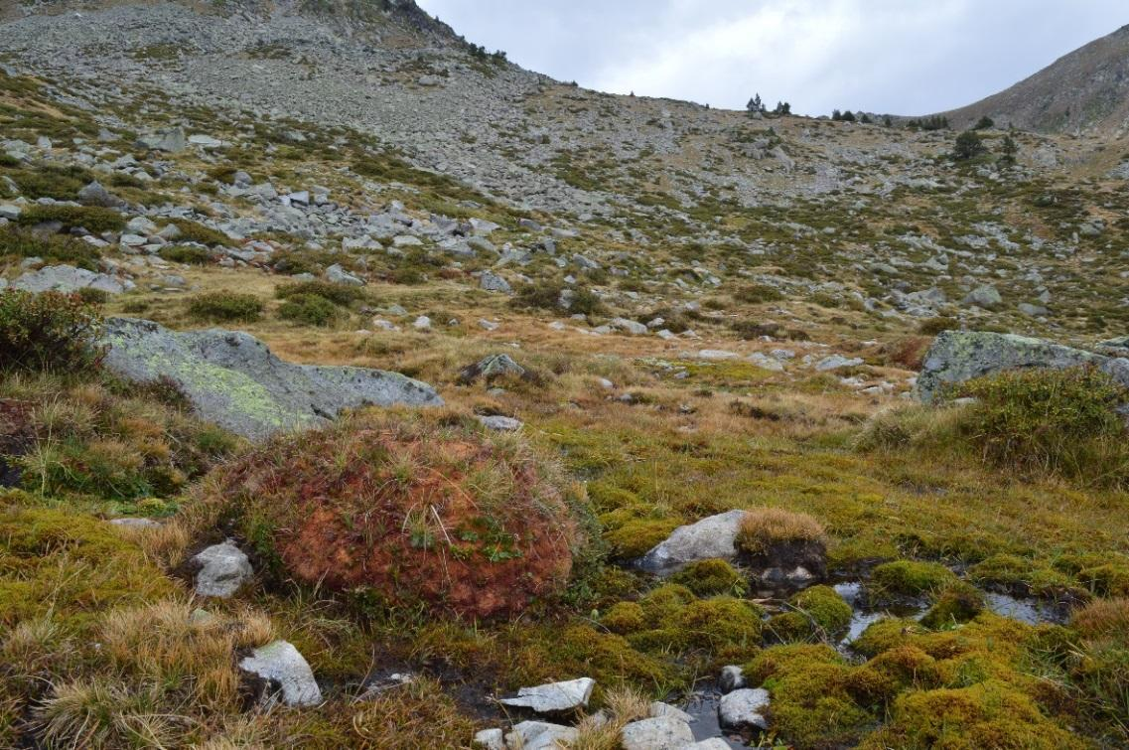
Supplementary Figure 1. Sphagnum fuscum hummock at Estibèra (EST). A distinctively elevated, dome-shaped cushion is visible in the lower left quadrant, displaying the characteristic brownish coloration typical of S. fuscum. Author: Nil Escolà Lamora.

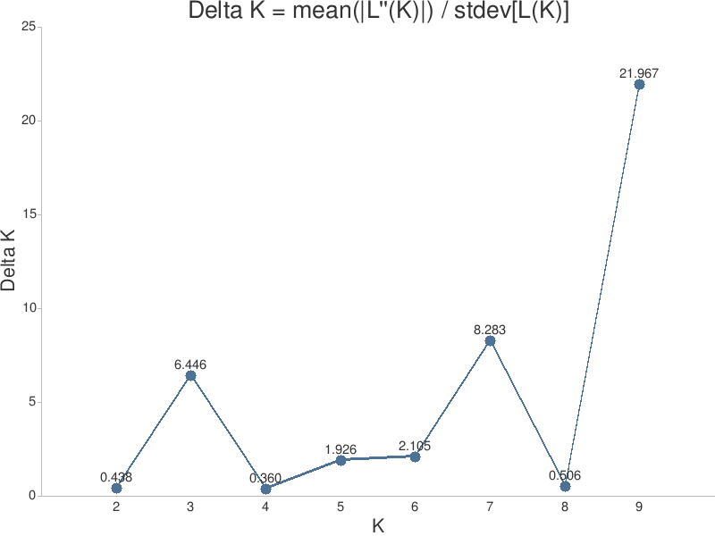
Supplementary Figure 2. Evanno’s ∆K values from K = 2 to K = 9. The highest peak at K = 9 indicates the most likely number of genetic clusters in the dataset. Smaller, suboptimal peaks at K = 3 and K = 7.

