Supplementary Material

1. Methodology
1.1 X-ray diffraction (XRD).
X-ray diffraction (XRD) analyses of the potassium mineral samples were performed using a LabX XRD-6000 diffractometer (Shimadzu, Japan) operated with Cu Kα radiation (λ = 1.54056 Å), voltage of 30 kV, and current of 30 mA. The diffractograms were recorded for 2θ from 4° to 90°, using a scanning speed of 1° min⁻¹.

1.2. Energy Dispersive X-Ray Analysis (EDX)
Semi-quantitative atomic compositions were evaluated by energy-dispersive X-ray (EDX) spectroscopy using a JEOL microscope (JSM-6510) operated at an acceleration voltage of 15 kV with a distance of 10 mm and a secondary electron detector.
2. Table and figure
Table S1. Chemical analysis (by X-ray fluorescence), surface area, and particle size for KR_{feldspar} and KR_{polyhalite}.
Oxide species | KR_{feldspar}  (wt.%) | KR_{polyhalite}  (wt.%)
K₂O | 8.35 | 12.00
Na₂O | 7.44 | 1.74
MgO | 0.35 | 6.79
Al₂O₃ | 20.4 | <0.1
SiO₂ | 55.1 | 0.36
P₂O₅ | 0.06 | 0.02
CaO | 1.7 | 16.2
TiO₂ | 0.6 | <0.01
MnO | 0.25 | <0.01
Fe₂O₃ | 3.88 | 0.01
SO₃ | <0.01 | 47.5
Others | 1.86 | 15.27
Total | 100 | 100
C | 0.62 | 0.86
N | 0.62 | 0.66
H | 0.19 | 1.43
Particle size | 561.60 nm | 385.10 nm
Surface area | 2.75 m² g⁻¹ | 0.38 m² g⁻¹

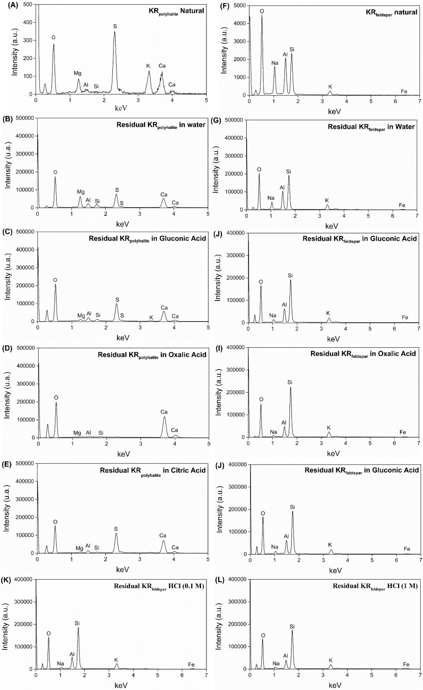

Fig. S1. Energy dispersive X-ray analysis (EDX) of residual: A) KR_{polyhalite} natural, B) KR_{polyhalite} in water, C) KR_{polyhalite} in gluconic acid, D) KR_{polyhalite} in oxalic acid, E) KR_{polyhalite} in citric acid, F) KR_{feldspar} natural, G) KR_{feldspar} in water, H) KR_{feldspar} in gluconic acid, I) KR_{feldspar} in oxalic acid, J) KR_{feldspar} in citric acid, K) KR_{feldspar} in HCl (0.1 M) and KR_{feldspar} in HCl (1 M).

