Table 1. Basic properties of the soil studied.
Index properties | As-received | Passing 2 mm
Standard compaction test  Maximum dry density: g/cm³ | 1920
Optimum water content (%) | 11
Cement content by mass (%) | 8
Grains size distribution
Gravel content: % | --
Sand content: % | 95 | 88
Silt content: % | 5 | 12
Specific gravity (soil + cement) |  | 2.82
Grain characteristics
$$C_{c}$$ | 1.5 | 2.3
$$C_{u}$$ | 2.4 | 9.0
Soil classification based on USCS.  (ASTM, 2011) | Poorly graded sand with silt  (SP – SM) | Well-graded sand with silt  (SW – SM)

Table 2. Test setup and locations of cracks characterization.
Sample ID | Observable cracks after cycle 3
OH-100 | 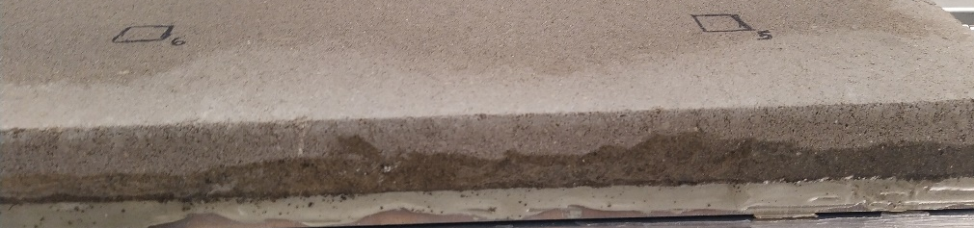
SH-80 | 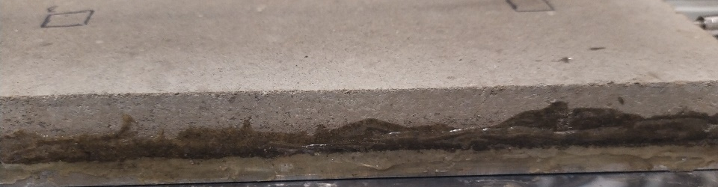
SH-60 | 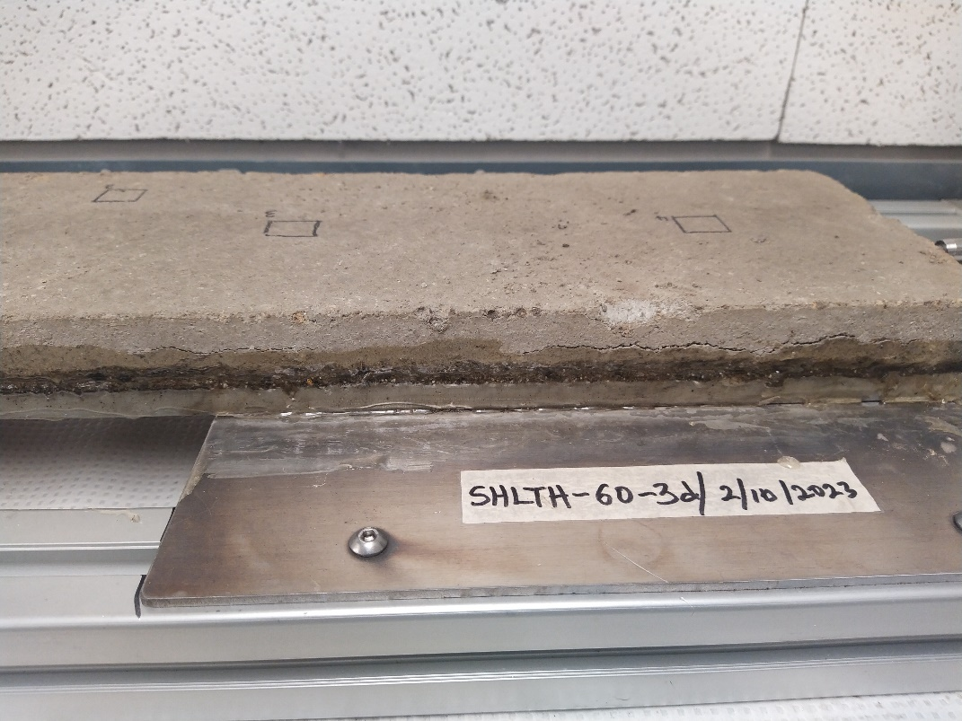  Direction of crack travel  A large crack that appears to split the sample into an upper and lower portions

Table 3. Physical observation of samples after three wetting-drying cycles.
152.4 mm

Sample ID | Images of Samples
Samples in setup condition | 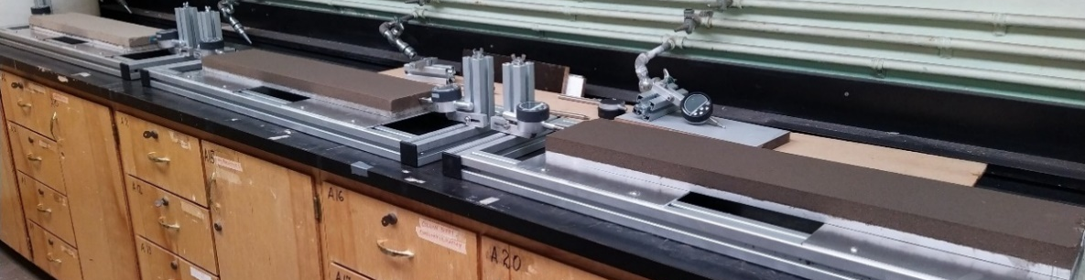  SH-80  OH-100  SH-60
OH-100 | 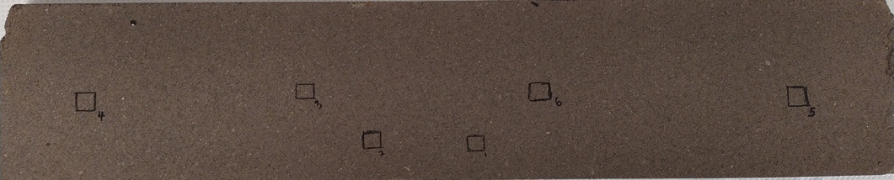
SH-80 | 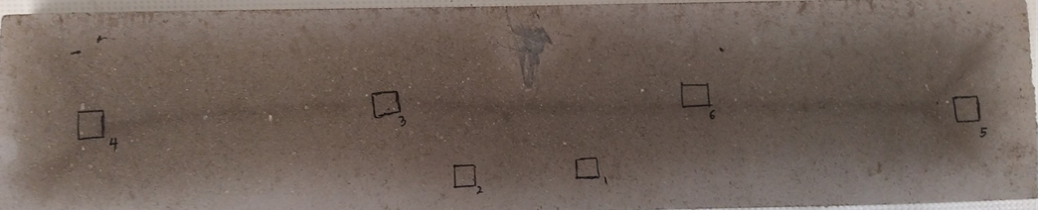
SH-60 | 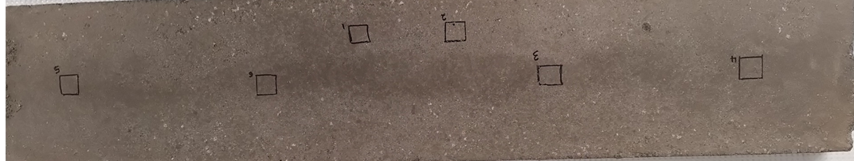  762 mm
NB: White arrows indicate a hypothesized development, concentration, and direction of travel of tensile stresses.

Table 4. Samples of images used for cracks characterization.
Sample ID | Original Image | Cycle -1 | Cycle - 2 | Cycle - 3
Sample ID | Original Image | Isolated Cracks and Pores (Scale: 500µm)
OH-100-Loc 1 | 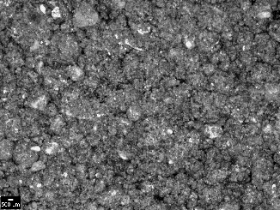 | 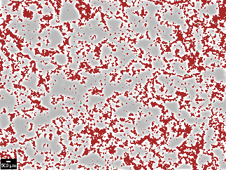 | 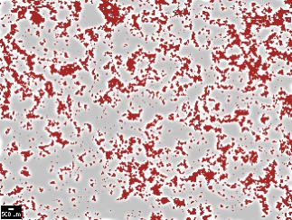 | 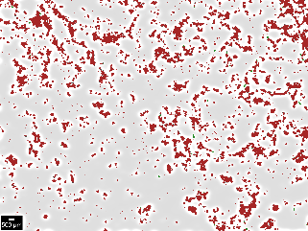
OH-100-Loc 3 | 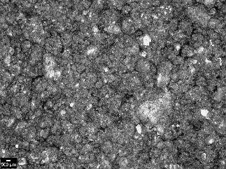 | 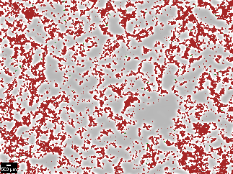 | 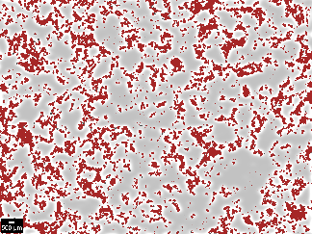 | 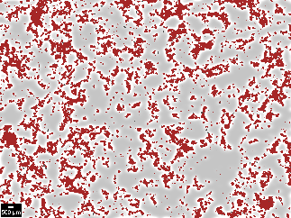
SH-80-Loc 1 | 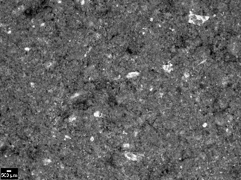 | 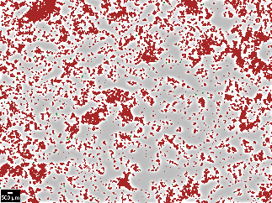 | 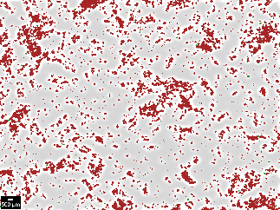 | 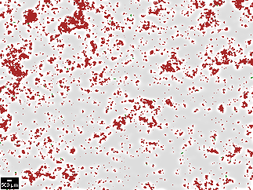
SH-80-Loc 3 | 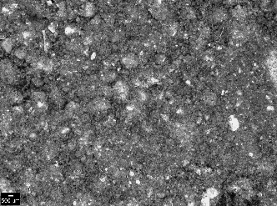 | 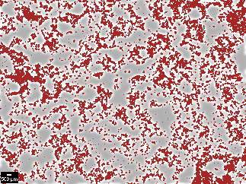 | 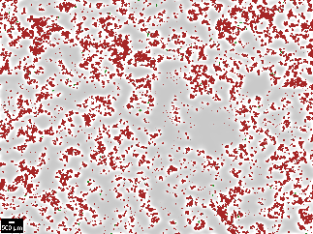 | 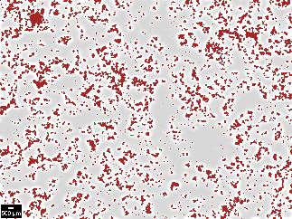
SH-60-Loc 1 | 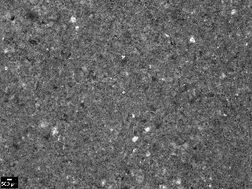 | 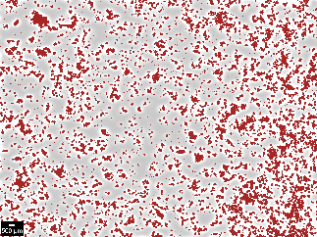 | 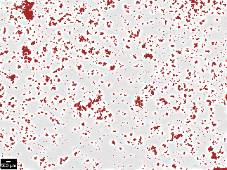 | 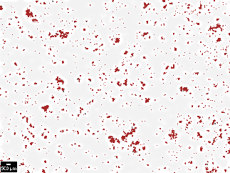
SH-60-Loc 3 | 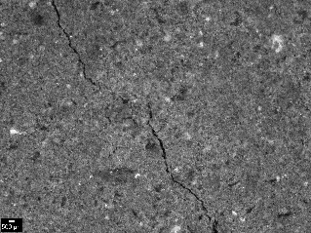 | 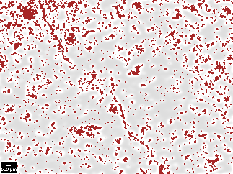 | 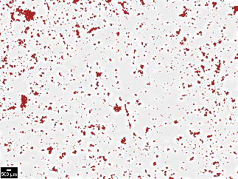 | 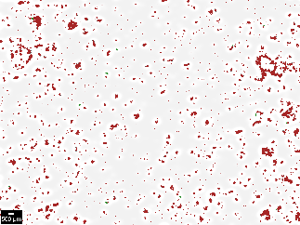

Table 5. Pore area fraction and size variation with cycles for different treatment.
Pore Area Fraction (%)
Test ID | OH-100 |  |  |  |  |  | SH-80 |  |  |  |  |  | SH-60
Location | 1 | 2 | 3 | 4 | 5 | 6 | 1 | 2 | 3 | 4 | 5 | 6 | 1 | 2 | 3 | 4 | 5 | 6
Cycle 1 | 33 | 33 | 35 | 34 | 30 | 34 | 32 | 30 | 39 | 38 | 32 | 11 | 37 | 30 | 26 | 42 | 37 | 38
Cycle 2 | 33 | 25 | 27 | 31 | 27 | 34 | 26 | 25 | 25 | 35 | 35 | 6 | 22 | 26 | 22 | 26 | 38 | 29
Cycle 3 | 24 | 27 | 22 | 19 | 28 | 21 | 21 | 18 | 25 | 25 | 18 | 23 | 12 | 21 | 12 | 19 | 17 | 24
Mean | 30 | 28 | 27 | 27 | 28 | 29 | 26 | 24 | 29 | 32 | 27 | 11 | 22 | 26 | 19 | 28 | 29 | 30
± SD | 5 | 4 | 6 | 8 | 2 | 7 | 5 | 6 | 8 | 7 | 9 | 9 | 13 | 5 | 7 | 12 | 12 | 7
Pore Size Variation (μm)
Cycle 1 | 421 | 354 | 376 | 366 | 347 | 208 | 374 | 369 | 375 | 430 | 326 | 185 | 323 | 311 | 297 | 342 | 320 | 319
Cycle 2 | 353 | 319 | 333 | 341 | 319 | 347 | 293 | 292 | 280 | 341 | 335 | 176 | 262 | 282 | 270 | 290 | 327 | 303
Cycle 3 | 311 | 341 | 326 | 306 | 345 | 328 | 275 | 279 | 308 | 302 | 269 | 306 | 241 | 265 | 243 | 265 | 251 | 280
Mean | 359 | 338 | 344 | 337 | 337 | 287 | 312 | 311 | 318 | 354 | 309 | 215 | 273 | 285 | 269 | 297 | 297 | 300
± SD | 56 | 18 | 27 | 30 | 16 | 75 | 53 | 49 | 49 | 66 | 36 | 72 | 43 | 23 | 27 | 40 | 42 | 19

Table 6. Heatmap of mean and standard deviation values.
Pore Area Fraction (%)
Parameter | Mean |  |  | SD
Test ID | OH-100 | SH-80 | SH-60 | OH-100 | SH-80 | SH-60
Cycle 1 | 33 | 28 | 35 | 2 | 10 | 6
Cycle 2 | 29 | 22 | 27 | 4 | 11 | 6
Cycle 3 | 23 | 21 | 17 | 3 | 3 | 5
Pore Size Variation (μm)
Cycle 1 | 338 | 332 | 318 | 72 | 84 | 15
Cycle 2 | 335 | 280 | 288 | 14 | 59 | 23
Cycle 3 | 326 | 289 | 257 | 16 | 17 | 15

