Figure S1. Percentage of pore fraction at six locations for three wetting-drying cycles: (a). cycle 1; (b). cycle 2; (c). cycle 3.
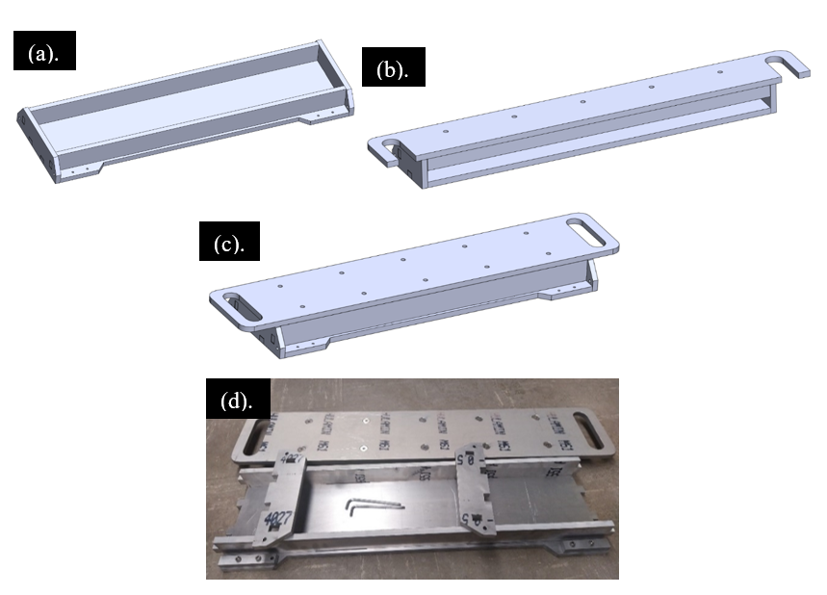
Figure S2. Compaction mold for restrained shrinkage samples: (a) mold with top cover; (b) longitudinal section through the mold; (c) 3-D of the mold; (d) the actual compaction mold.

Figure S3. Rate of drying shrinkage for OH and SH samples: (a) cycle 1; (b) cycle 2; (c) cycle 3

Figure S4. Measured effective total cohesion for OH and SH treatment.

