Figure supplementary

Figure S1
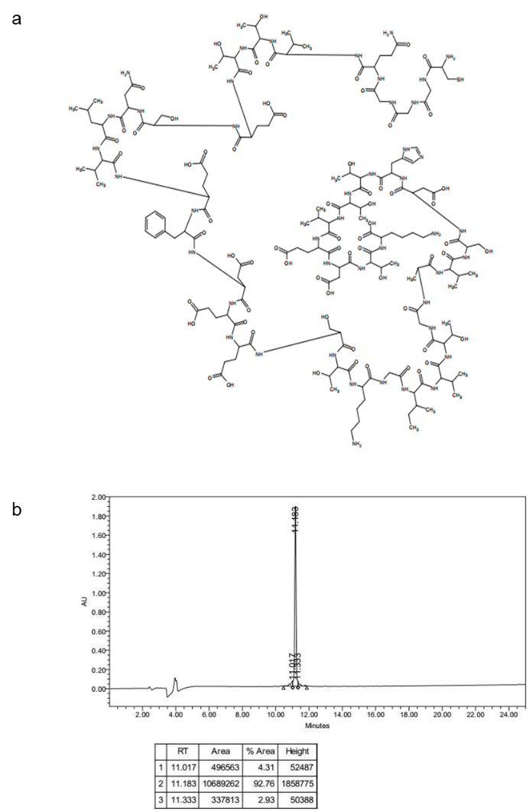
- molecular formula of FnBPA5; (b) molecular formula of IR-CF3; (c) FnBPA5 purity measured by HPLC.

Figure S2
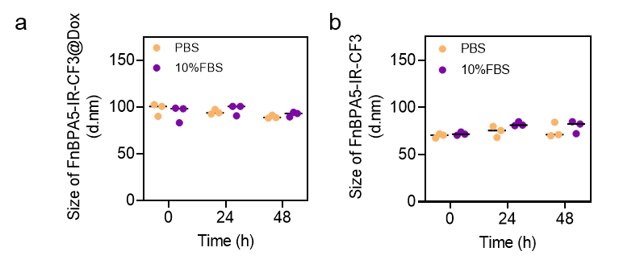
Particle size changes of FnBPA5-IR-CF3@Dox (a) and FnBPA5-IR-CF3 (b) in PBS and PBS containing 10% FBS at different time point.

Figure S3
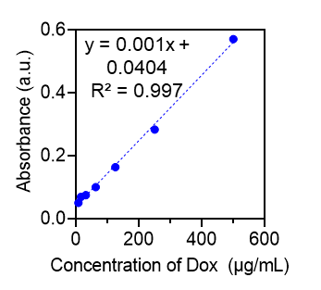
Standard Curve of Dox.

Figure S4
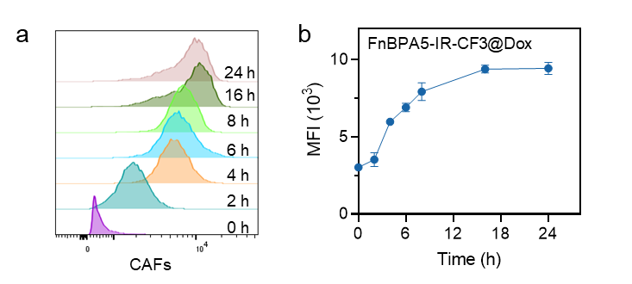
- Flow cytometry of FnBPA5-IR-CF3@Dox uptake by CAFs at different time points; (b) quantitative analysis curve of Dox-related MFI, n=3.

Figure S5
Cytotoxicity of FnBPA5-IR-CF3 on CAFs at different concentrations.

Figure S6
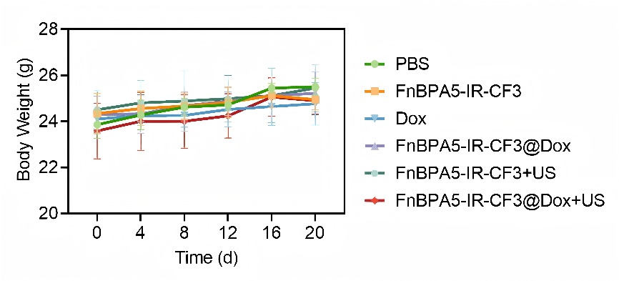
The time-dependent weight change curves of mice in different treatment groups during the treatment period, n=5.

Figure S7
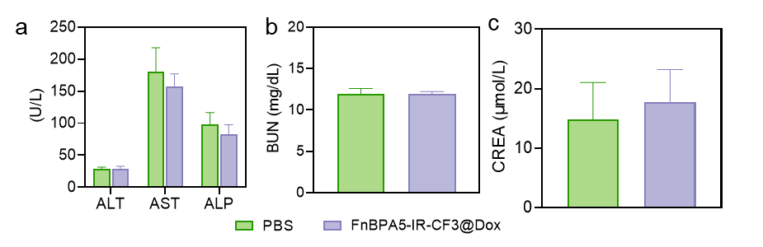
Serum levels of ALT, AST, ALP, CREA, and BUN in mice at the end of treatment. n=5.

Figure S8
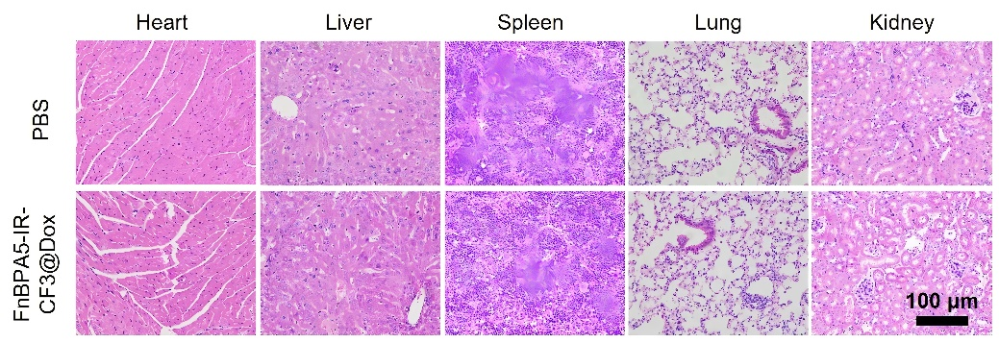
H&E staining of major organs in mice

