SUPPLEMENTARY MATERIALS

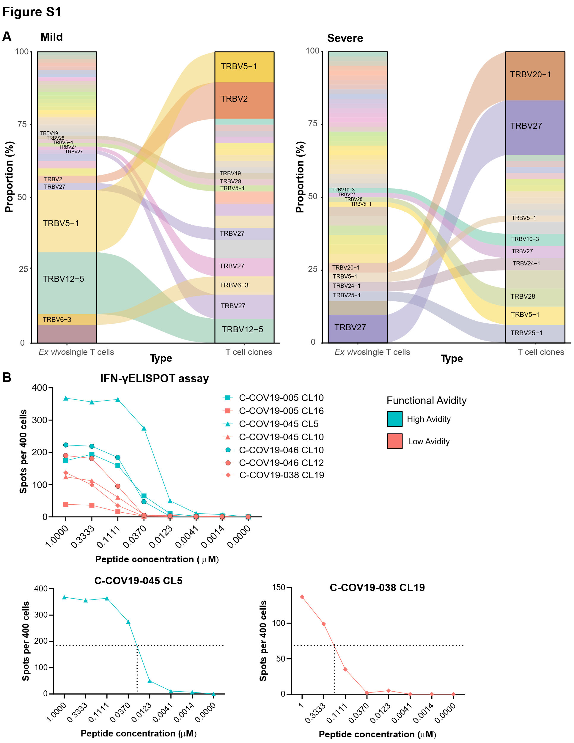

Figure S1. TCR clonotypes for single cells and T cell clones and EC50 derivation. (A) Flow diagrams to show T cell clonotypes (defined as TRBV gene usage and CDR3β sequence) between SmartSeq2 sequenced ex vivo single cells (ex vivo single T cells column) and bulk TCR sequenced T cell clones grown in vitro culture (T cell clones column). Panel on the left shows grouped TCRs from patients with mild disease, panel on the right for patients with severe disease. (B) Upper panel: IFN-γ ELISPOT assay for representative high and low functional avidity clones for each patient in blue and red respectively (C-COV19-038 only has low functional avidity clone shown). Lower panels: high functional avidity clone from C-COV19-45 and low functional avidity clone from C-COV-038 with example of EC50 derivation.

Figure S2. FACS gating strategy and peptide titration. (A) Gating strategy for flow cytometric analyses. (B) Nucleoprotein peptide titration at varying concentrations for ICS for MIP1β and CD107a. Representative flow cytometry plots shown (from single T cell clone).

Figure S3. T cell response six months post infection to NP Vaccinia virus. Representative ICS flow cytometry plots showing MIP1β and CD107a protein expression after incubation with NP-expressing Vaccinia virus in three patient-derived bulk T cell lines from six months convalescent PBMC samples.

Table S1. Genes used for gene module scoring in single cell expression analysis.

Cytotoxicity | Inhibitory receptors
GZMA | KLRC1
GZMB | PDCD1
GZMH | CD200R1
GZMK | LAG3
PRF1 | HAVCR2
GNLY | CD160
NKG7 | CTLA4
 | BTLA
 | TIGIT

Table S2. αβ VJ gene usage and CDR3 sequences for ex vivo single cell TCR sequencing.

Table S3. αβ VJ gene usage and CDR3 sequences from bulk TCR sequencing of T cell clones.

Table S4. EC50 values from selected T cell clones.

Table S5. COvid-19 Multi-omics Blood ATlas (COMBAT) Consortium.

