Supplementary Information

Hydrogen plasma reduction for direct upcycling of battery waste into high-performance alloys
I-Jun Ro^{a,†}, Chang-Gi Lee^{a,†}, Won-Hyoung Leeª, Ubaid Manzoor^{b}, Jinyeon Hwang^{c}, Jae-Pyoung Ahn^{d}, Baptiste Gault^{b,e,*}, Dierk Raabe^{b,*}, Se-Ho Kim^{a,b,*}
[a] Department of Materials Science & Engineering, Korea University, Anam-ro 145, Seoul 02841, Republic of Korea
[b] Max Planck Institute for Sustainable Materials (formerly Max-Planck-Institut für Eisenforschung GmbH), Max-Planck-Straße 1, 40237 Düsseldorf, Germany
[c] R&D Center, Remplir Inc., Chorok-ro 680-61, Hwaseong 18628, Republic of Korea
[d] Advanced Analysis Center, Korea Institute of Science Technology, Hwarang-ro 14-gil 5, Seoul 02792, Republic of Korea
[e] Department of Materials, Imperial College London, Kensington, London SW7 2BP, United Kingdom
†These authors contributed equally.
*Corresponding authors: b.gault@mpi-susmat.de, d.raabe@mpi-susmat.de, sehonetkr@korea.ac.kr

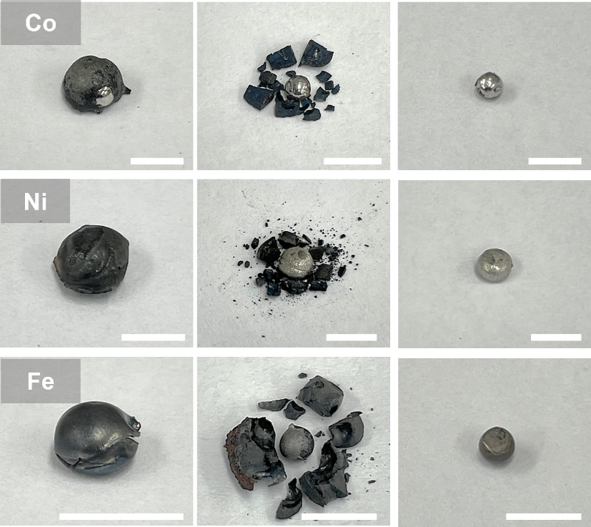
Figure S1. The metal extraction sequence from the final products of hydrogen plasma reduced LiCoO₂ (LCO), Li(Ni_{0.8}Co_{0.1}Mn_{0.1})O₂ (NCM811), and LiFePO₄ (LFP) pellets. Scale bars: 5 mm

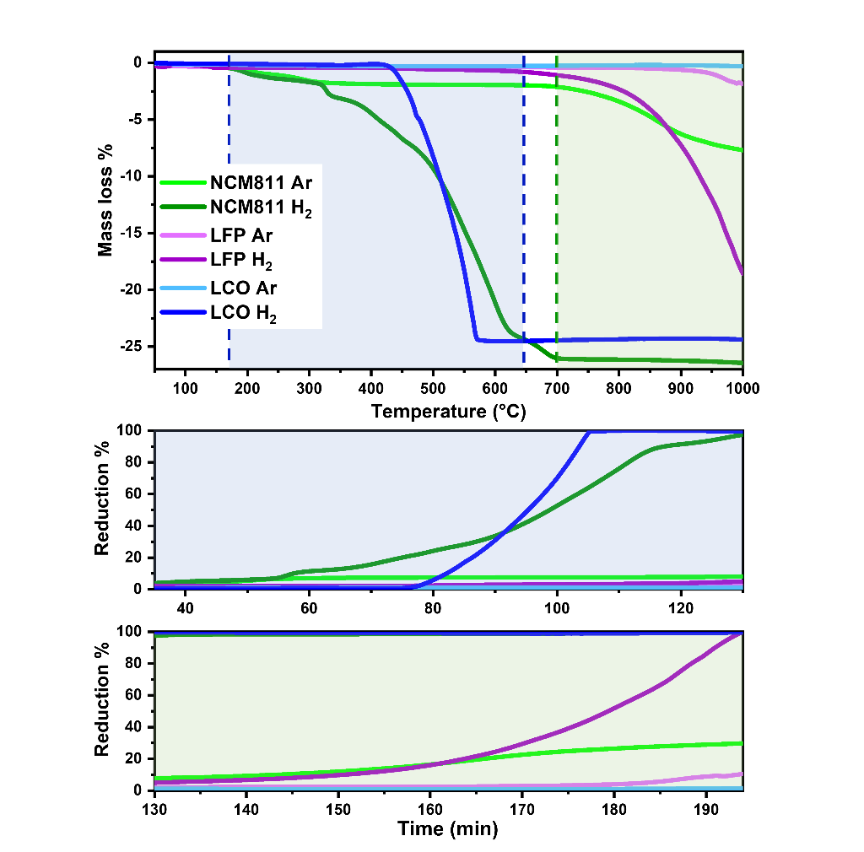
Figure S2. Mass loss%-temperature plot for LCO, NCM811, and LFP pellets under both Ar and Ar-5 vol.%H₂ conditions, and corresponding reduction%-time plot.
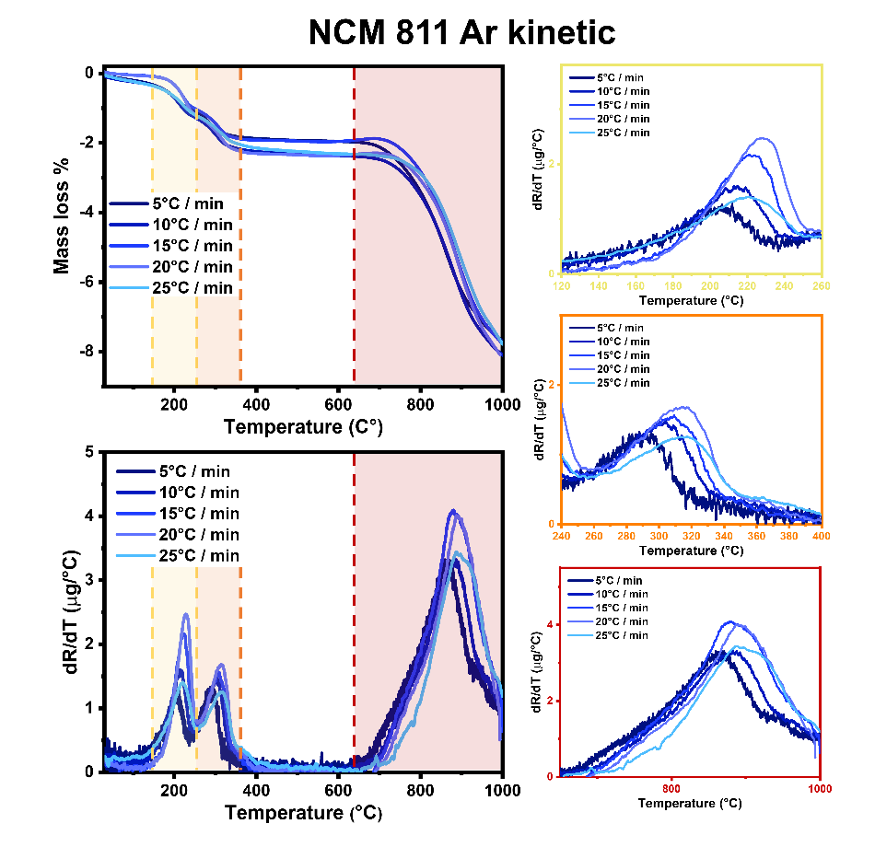
Figure S3. Mass loss% versus temperature and dR/dT versus temperature plots of NCM811 sample under Ar atmosphere.

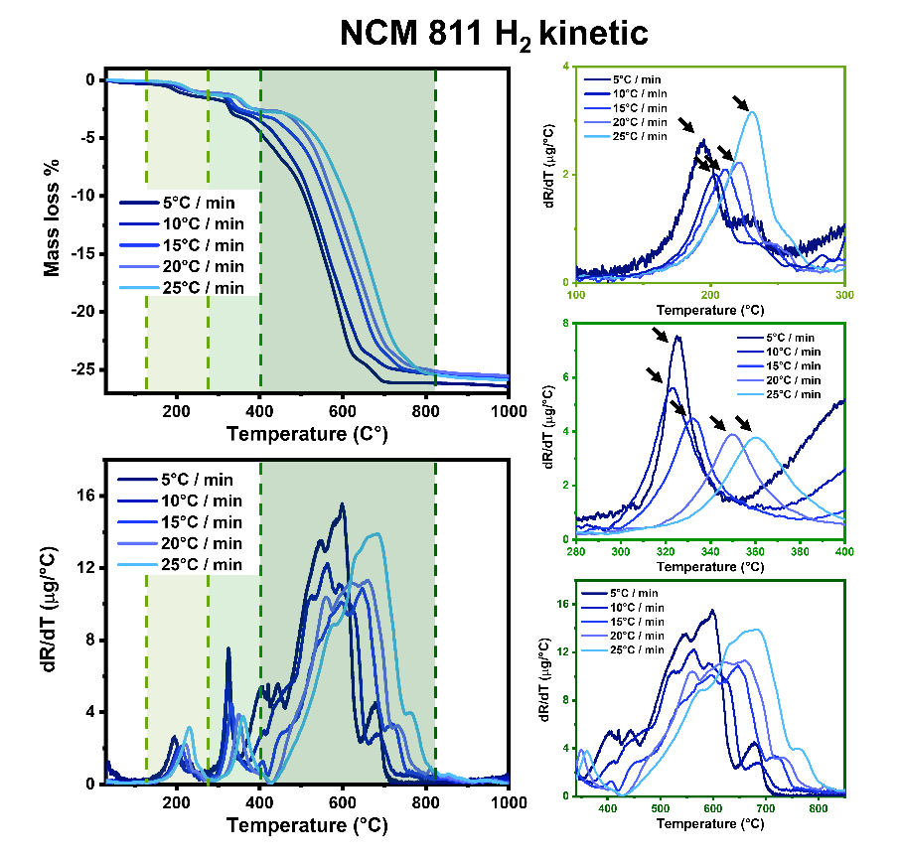
Figure S4. Mass loss% versus temperature and dR/dT versus temperature plots of NCM811 sample under Ar-5 vol.% H₂ atmosphere.

Thermogravimetric analysis of NCM811 pellets was performed under Ar and Ar-5 vol.% H₂ atmosphere, respectively, with ramping rates varying from 5 to 25°C/min (5, 10, 15, 20, and 25°C/min) during heating from 30°C to 1000°C. Three distinctive DTG peaks were observed under both conditions. By plotting ln(β/T²) vs. temperature (where β is heating rates) from the peaks, the activation energies can be derived from the slope values. Under a hydrogen atmosphere, the activation energies of the 1st, 2nd, and 3rd peaks are 1.8, 1.8, and 6.2 times lower than under an Ar atmosphere, respectively.

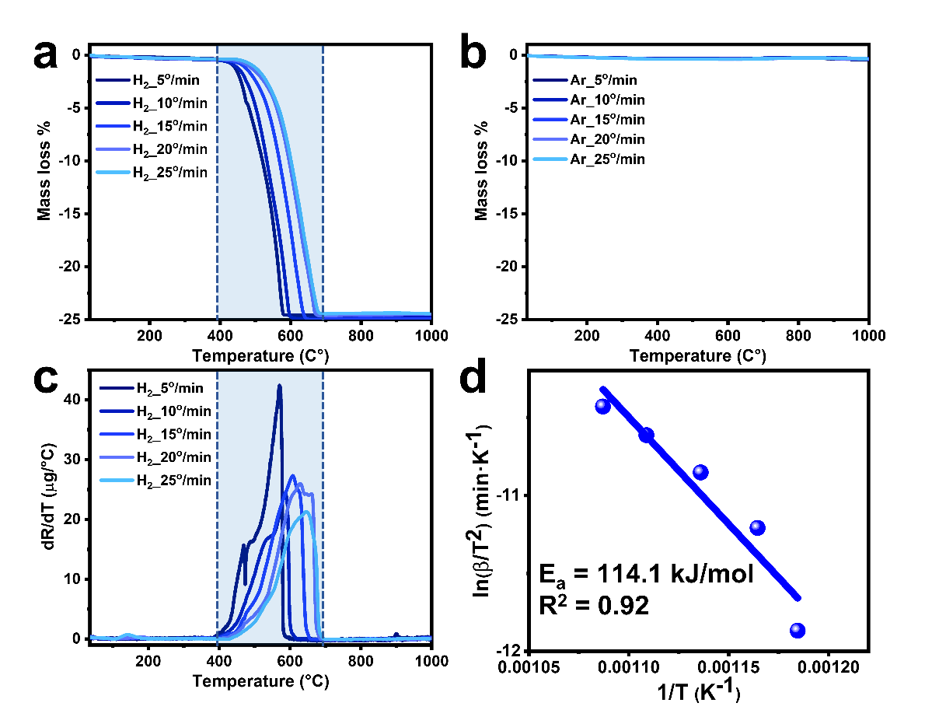
Figure S5. Thermogravimetric analysis results of LCO. Mass loss% vs. temperature profile under (a) hydrogen atmosphere (Ar-5 vol.% H₂) and (b) Ar atmosphere with various ramping rates. (c) dR/dT vs temperature plots of LCO and (d) Kissinger–Akahira–Sunose (KAS) plot for LCO under Ar-5 vol.% H₂ atmosphere.

Thermogravimetric analysis of LCO pellets was conducted under both Ar and Ar-5 vol.% H₂ atmosphere, respectively, with heating rates of 5, 10, 15, 20, and 25 °C/min during heating from 30°C to 1000°C. Under a hydrogen atmosphere, the reduction of LCO began around 400°C and was completed around 700°C. During the reduction process, about 25% of the weight was reduced under a hydrogen-containing atmosphere, while there was almost no change occurred under an inert atmosphere. In Figure S5d, the activation energy for the reduction of LCO is 114.1 kJ/mol from the KAS model. According to Li et al. [1] and Zhi-kang et al. [2], the activation energy for the carbothermic reduction of LCO from KAS model was 389.61 kJ/mol and 280.68 kJ/mol, respectively. Compared to these values, the use of a 5 vol.% hydrogen gas mixture lowers the activation energy to roughly one-third of that required for carbothermic reaction.

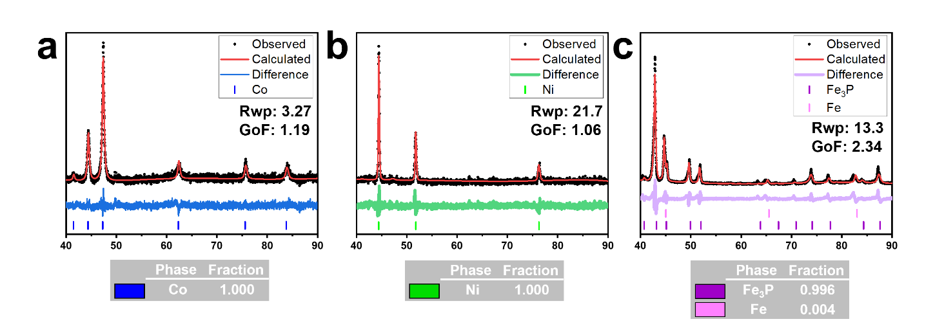
Figure S6. X-ray diffraction (XRD) patterns with Rietveld refinement results of reduced metals obtained from (a) LCO, (b) NCM811, and (c) LFP pellets after hydrogen plasma reduction (HPR) process in Figure 2f.

Quantitative analysis for the metallic phases obtained from cathode materials was performed via Rietveld refinement using Profex software (version 5.3.0) [3]. The Co metal derived from LCO is entirely composed of Co [4], while the metallic phase synthesised from NCM811 primarily consists of Ni [5] with a face-centered cubic (FCC) structure. According to the result of the scanning electron microscopy energy dispersive X-ray spectroscopy (SEM-EDS) shown in Figure S7, this FCC phase metal is composed of approximately 95 at.% of Ni and 5 at.% of Co. Lastly, from Rietveld refinement iterations, the metallic phase obtained from LFP, is composed of 99.6% Fe₃P [6] and 0.4% Fe [7].
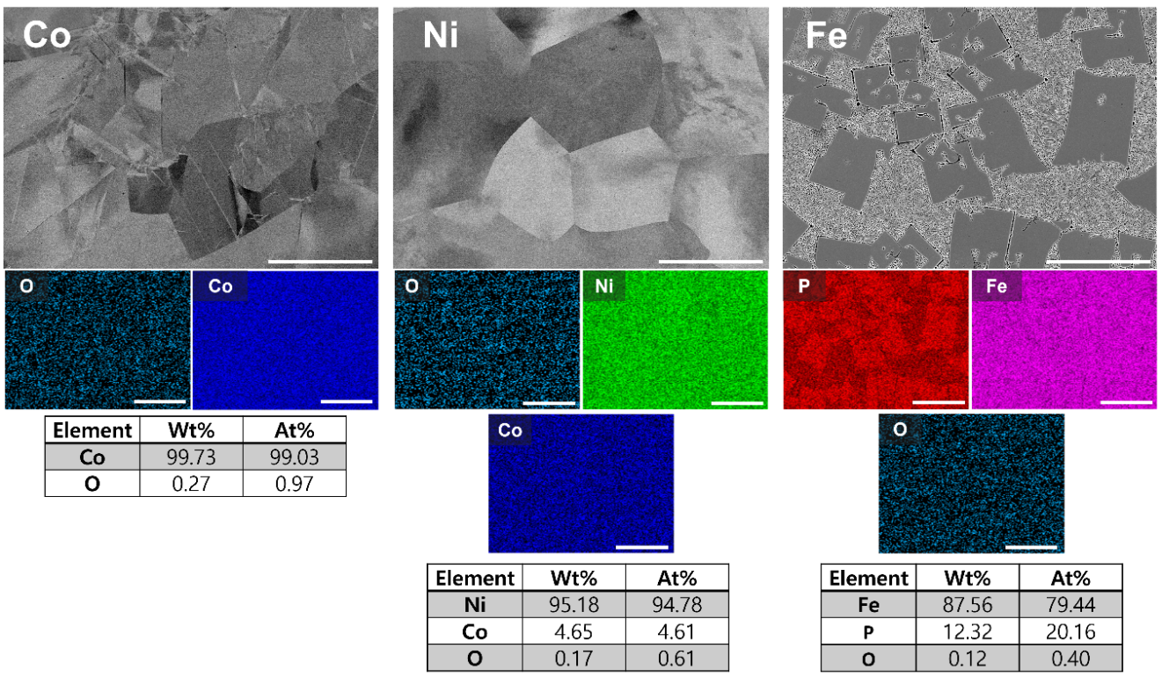
Figure S7. SEM-EDS results of hydrogen plasma reduced metals from (a) LCO, (b) NCM811, and (c) LFP in Figure 2g. Scale bars: 50 μm.
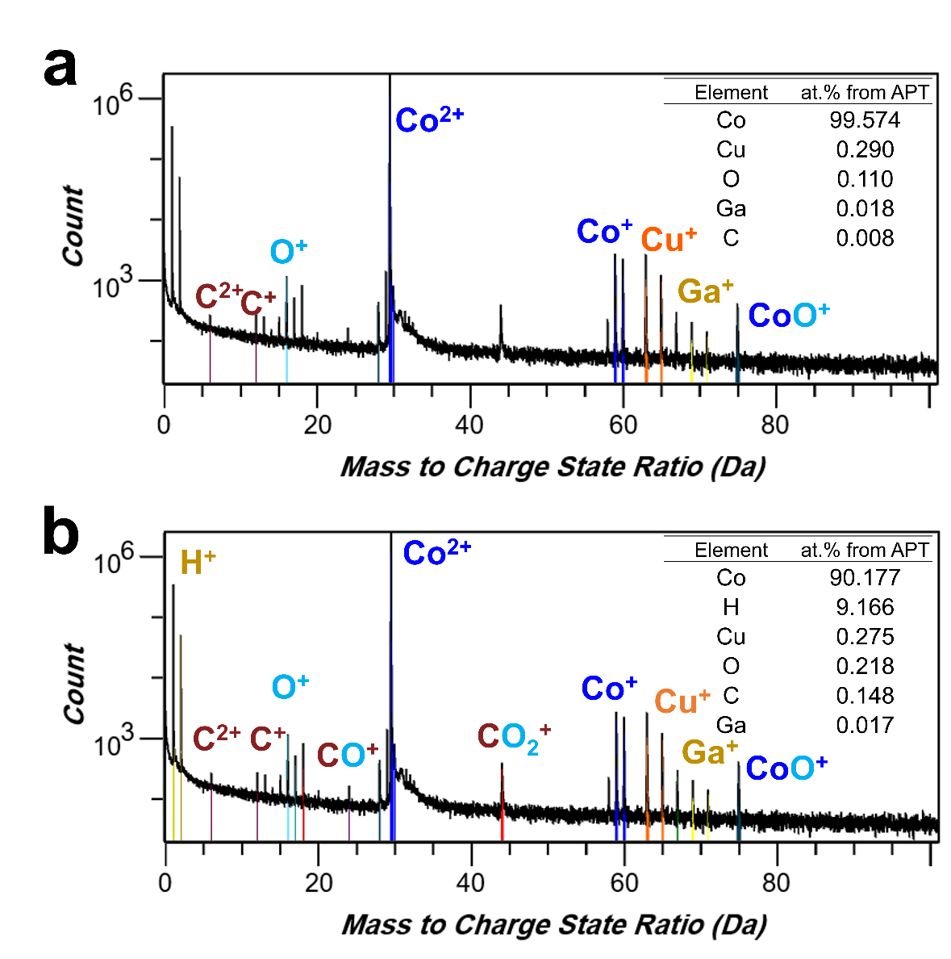
Figure S8. (a) APT mass spectrum assigned Co, O, and C peaks, corresponding chemical composition (at.%) of Co metal reduced from LCO in Figure 2h. Without gas molecules existing inside the local electrode atom probe (LEAP) analysis chamber, only 0.110 at.% of O and 0.115 at.% of C were detected. (b) APT mass spectrum ranging and chemical composition (at.%) of Co form LCO including H⁺, H²⁺, Cu⁺, Cu²⁺, Ga⁺, CO⁺, and CO₂⁺ ions in the ranging.

Two versions of the atom probe tomography (APT) mass spectrum for Co, Ni, and Fe₃P results, as shown in Figure 2h, are presented in Figures S8, S9, and S10, respectively. In Figures S8a, S9a, and S10a, the peaks are labeled with the corresponding cathode metal, along with C and O. Ga and Cu are also labelled, where Ga is an impurity element added during the focused ion beam (FIB) process for APT specimen preparation and can be effectively reduced by a prolonged fine milling process. Cu, which is introduced from the hearth of an arc-melting furnace during the HPR process[8], can be reduced by minimising the plasma-exposed area or by using a lower plasma ignition current. Furthermore, according to the literature [9], the actual O and C content of the specimen can be more accurately measured by assigning individual C and O ions, as well as metal oxide and Metal carbide compounds. H_{x}, H_{x}O_{x}, C_{x}, O_{x}, and CO_{x} molecular ions can originate from residual gases inside the ultra-high vacuum (10⁻¹⁰-10⁻¹¹ Torr) LEAP analysis chamber, potentially increasing the concentration of H, C, and O in the APT specimens. Therefore, the APT data for Co, Ni, and Fe₃P shown in Figure 2h, along with the corresponding discussion in the manuscript, are based on the results of the mass spectrum shown in Figures S8a, S9a, and S10a.

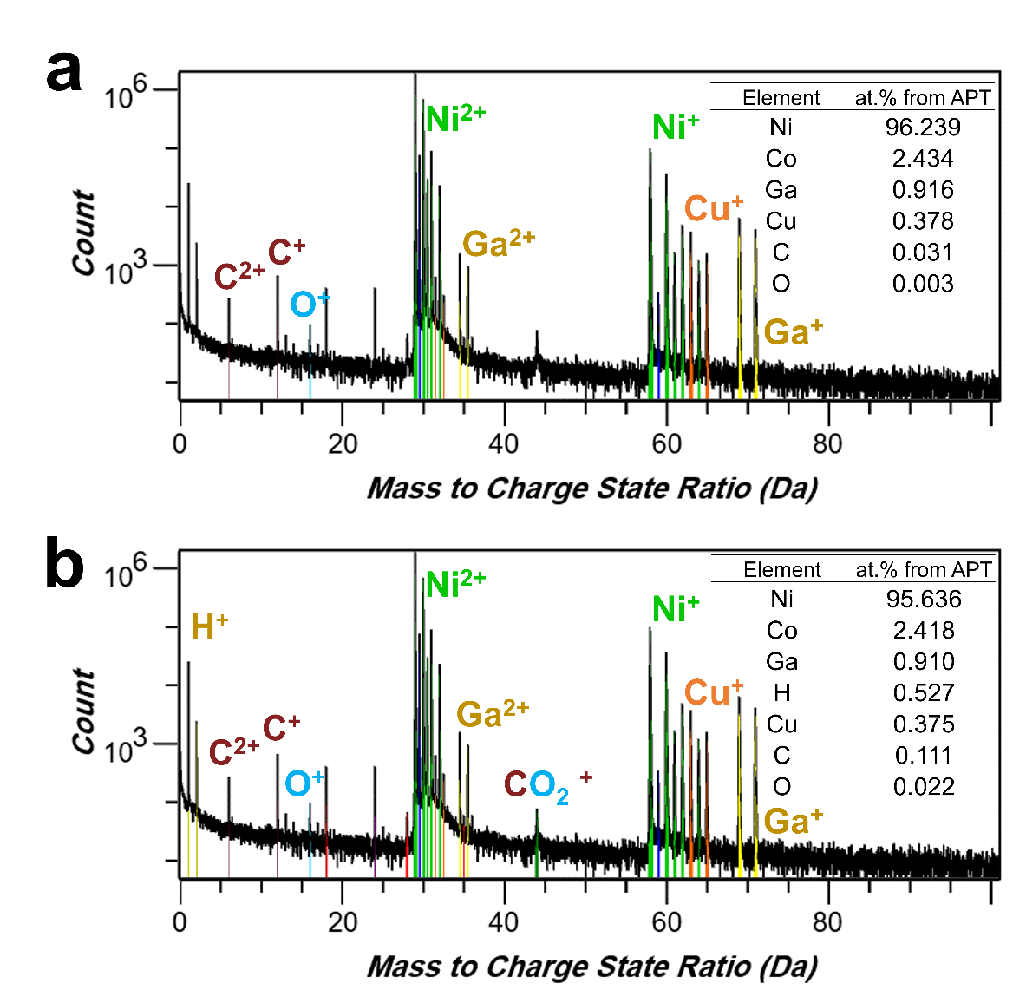
Figure S9. (a) APT mass spectrum ranging result and chemical composition (at.%) of Ni from NCM811 in figure 2h. Without impurities and other gas molecules existing inside the LEAP analysis chamber, only 0.099 at.% of C and 0.003 at.% of O were detected. (b) APT mass spectrum ranging and chemical composition (at.%) of Ni from NCM811 including H⁺, H²⁺, Cu⁺, Ga⁺, Ga²⁺, CO⁺, and CO₂⁺ ions in the ranging.

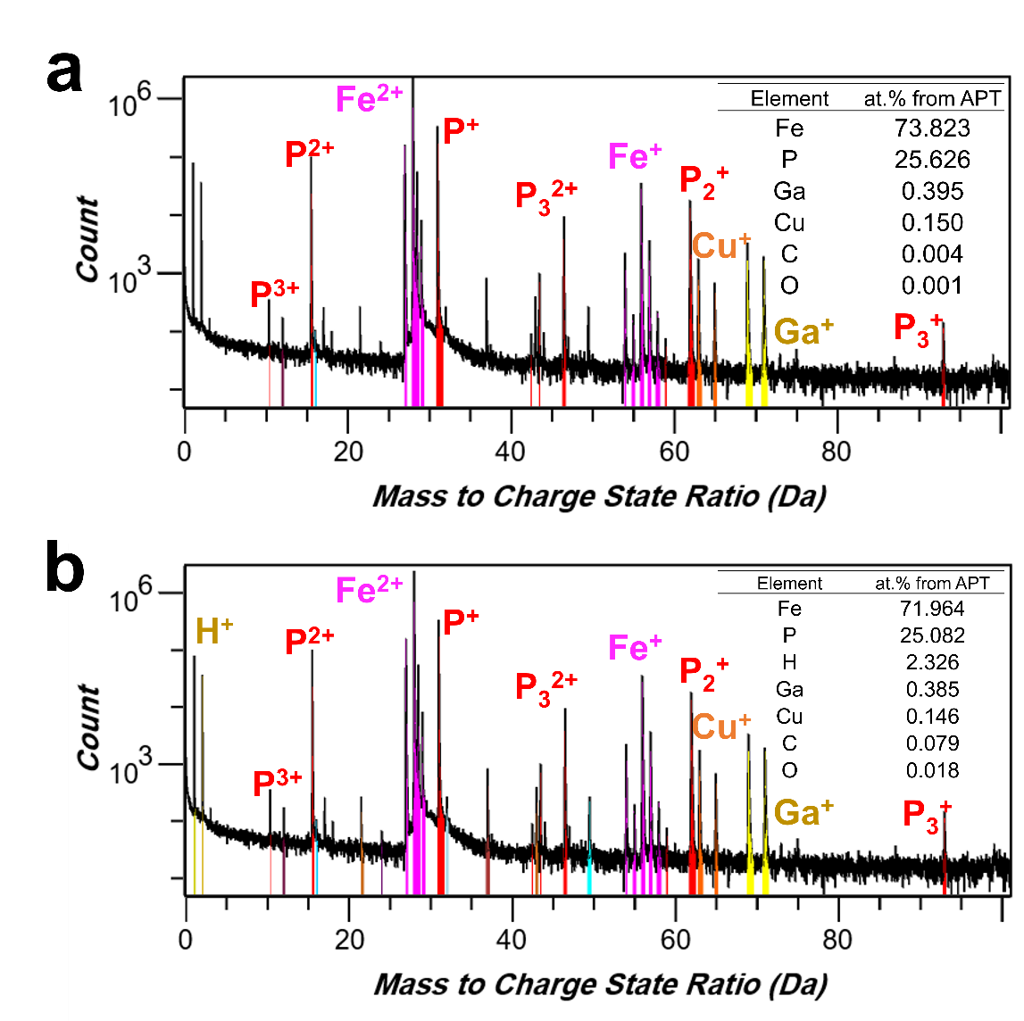
Figure S10. (a) APT mass spectrum ranging result and chemical composition (at.%) of Fe₃P from LFP in figure 2h. Without impurities and other gas molecules existing inside the LEAP analysis chamber, only 0.015 at.% of O and 0.005 at.% of C were detected. (b) APT mass spectrum ranging and chemical composition (at.%) of Fe₃P from LFP including H⁺, H²⁺, Cu⁺, Ga⁺, Ga²⁺, CO₂⁺, PC⁺, and P₂C⁺ ions in the ranging.

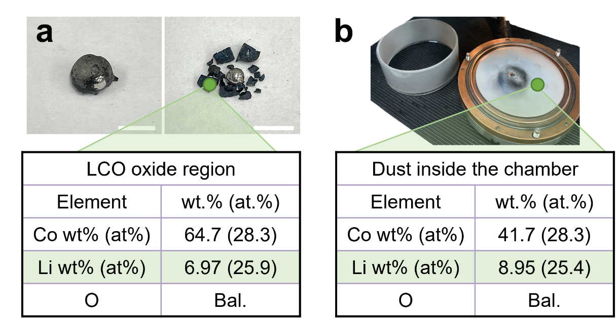
Figure S11. Inductively Coupled Plasma Optical Emission spectroscopy (ICP-OES) results of the oxide shell and dust formed after the HPR process of LCO pellets in Figure S1. Scale bars: 5 mm.

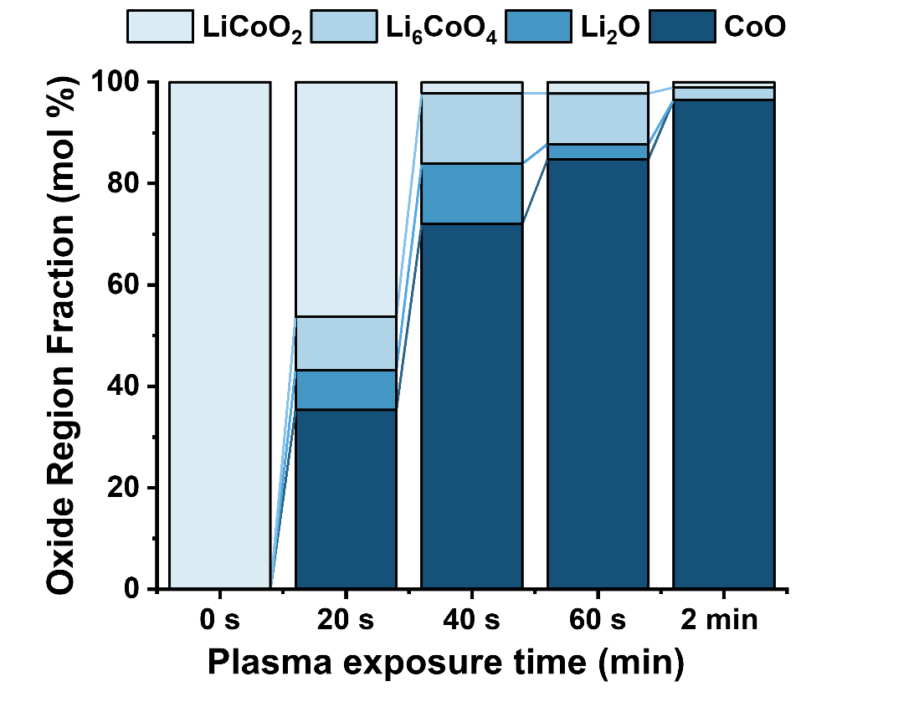
Figure S12. Phase fraction in oxide region in Figure S11 with variation of hydrogen plasma exposure time (0 s, 20 s, 40 s, 60 s, and 2 min).

The phase change of the oxide region by the hydrogen plasma reduction process is analyzed with XRD. The Li₆CoO₄ and Li₂O phases increase from 0 to 40 seconds and then continue to decrease after 40 seconds. Furthermore, the LiCoO₂ phase decreases and the CoO phase increases as the hydrogen plasma exposure time increases.
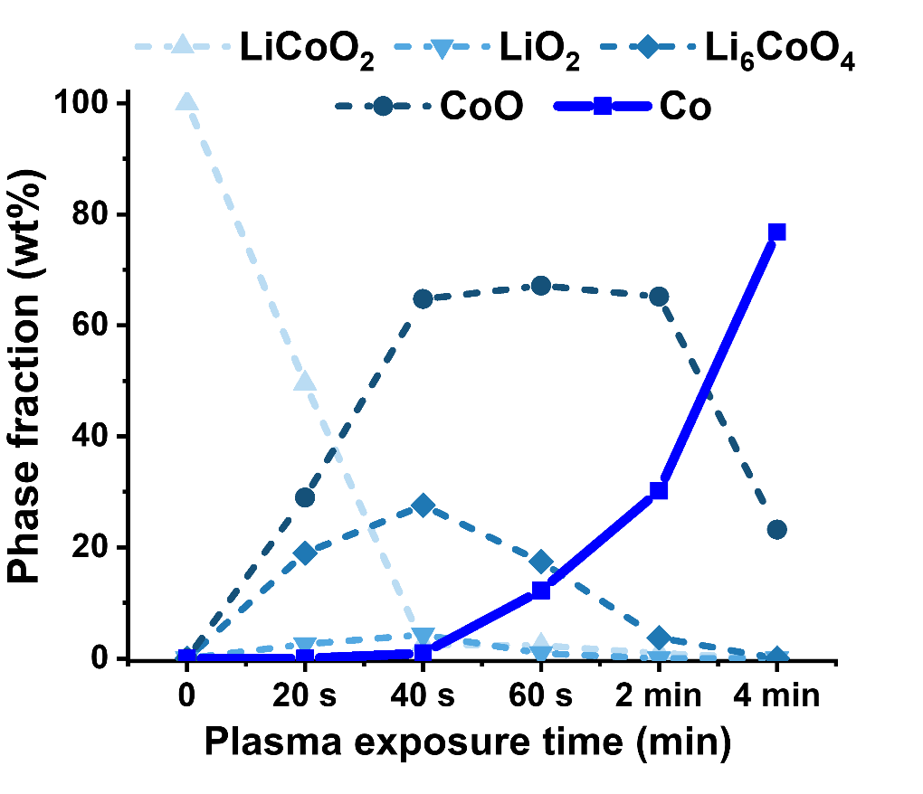
Figure S13. Phase fraction of LCO pellet with variation of hydrogen plasma exposure time (0 s, 20 s, 40 s, 60 s, 2 min, and 4 min).

The phase fraction of the whole product, including the oxide and recovered Co regions, is shown above as the hydrogen plasma exposure time increases. In the case of the four minutes hydrogen plasma exposure time, the amount of the oxide region was too small to be analyzed with XRD. Therefore, based on the trend shown in Figure S13, it is assumed that the entire oxide layer consists of the CoO phase.

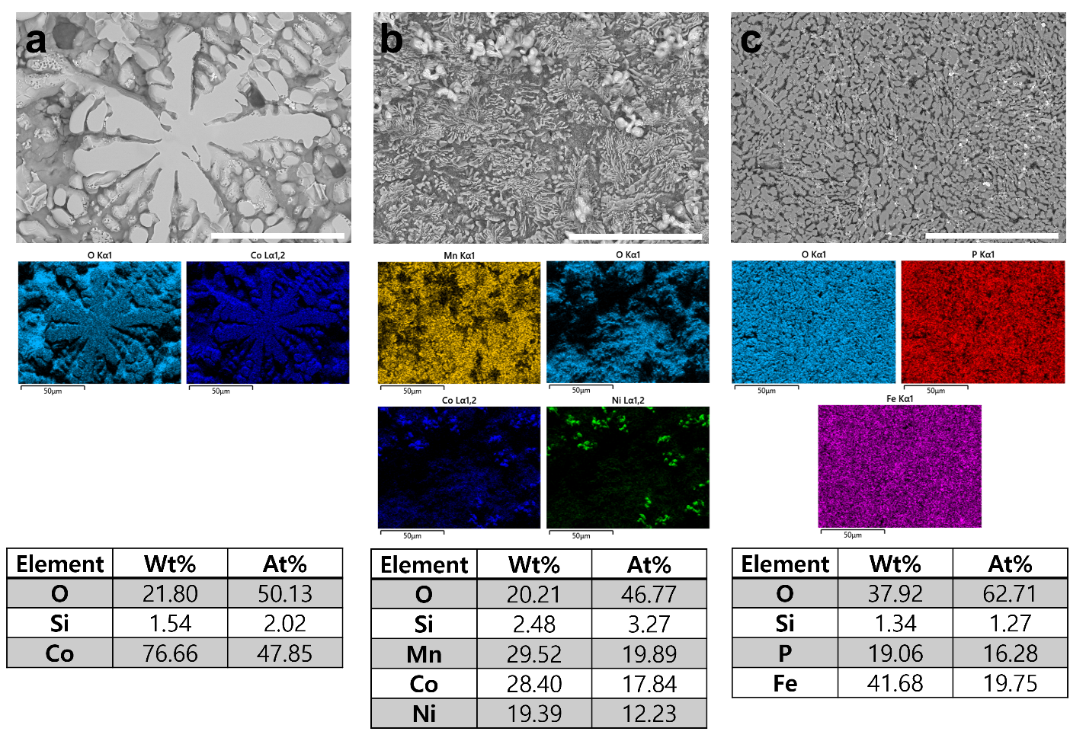
Figure S14. SEM-EDS results of oxide shell regions formed after hydrogen plasma reduction of (a) LCO, (b) NCM811, (c) LFP. Scale bars: 50 μm.

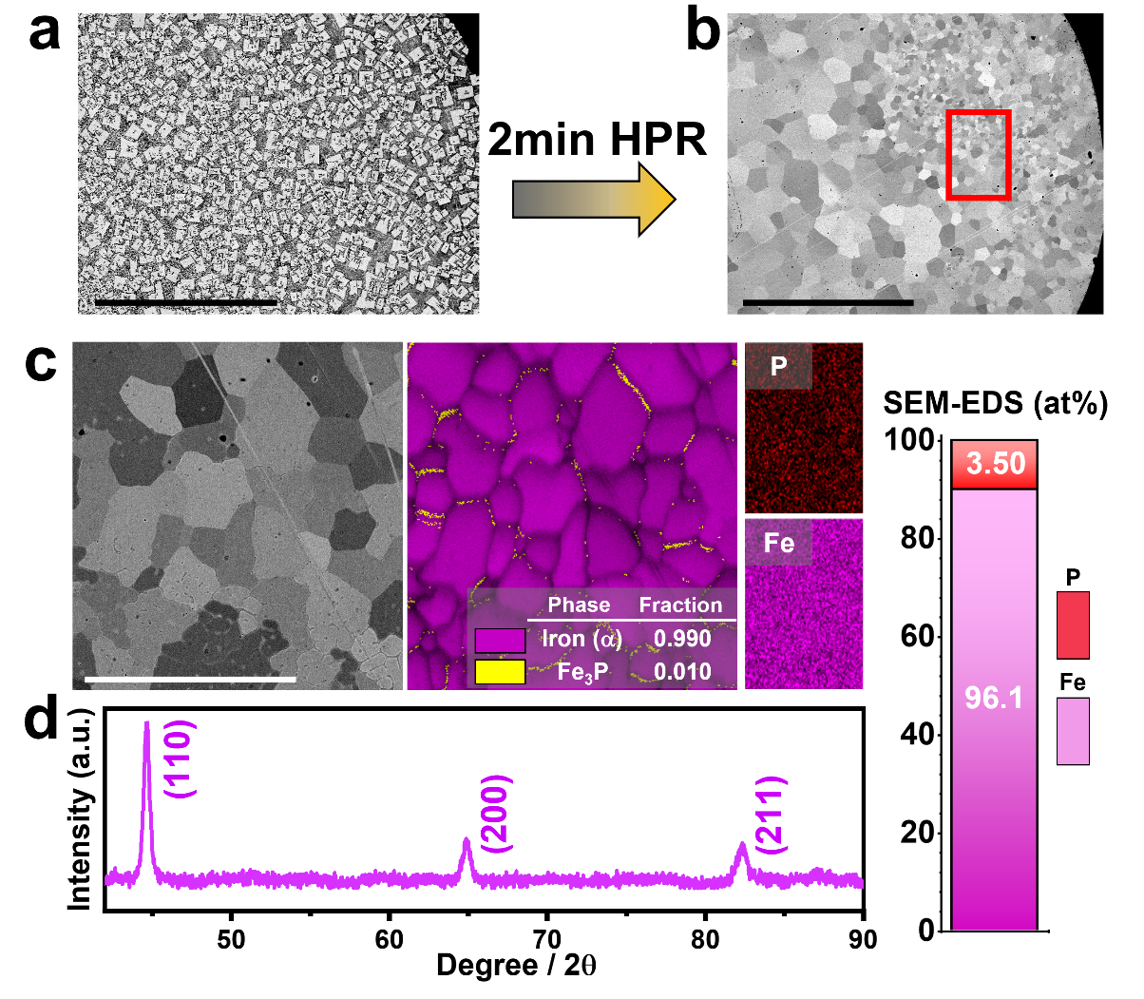
Figure S15. (a) BSE-SEM image of Fe₃P from LFP in Figure 2c. (b) BSE-SEM image of iron after applying hydrogen plasma for 2 min on Fe₃P in (a). (c) SEM-EBSD and -EDS results and (d) XRD result of synthesised iron in (b). Scale bars: 500 μm (a and b); 50 μm (c).

After two minutes of HPR process on Fe₃P synthesised from LFP pellets, an iron phase was formed throughout the specimen while the Fe₃P phase was eliminated. According to the scanning electron microscopy electron backscatter diffraction (SEM-EBSD) and -EDS results, only 1% of the Fe₃P phase and 3.5 at.% of phosphorus remained inside the sample, meaning almost pure iron was formed. The XRD result also shows that the final product is pure iron.
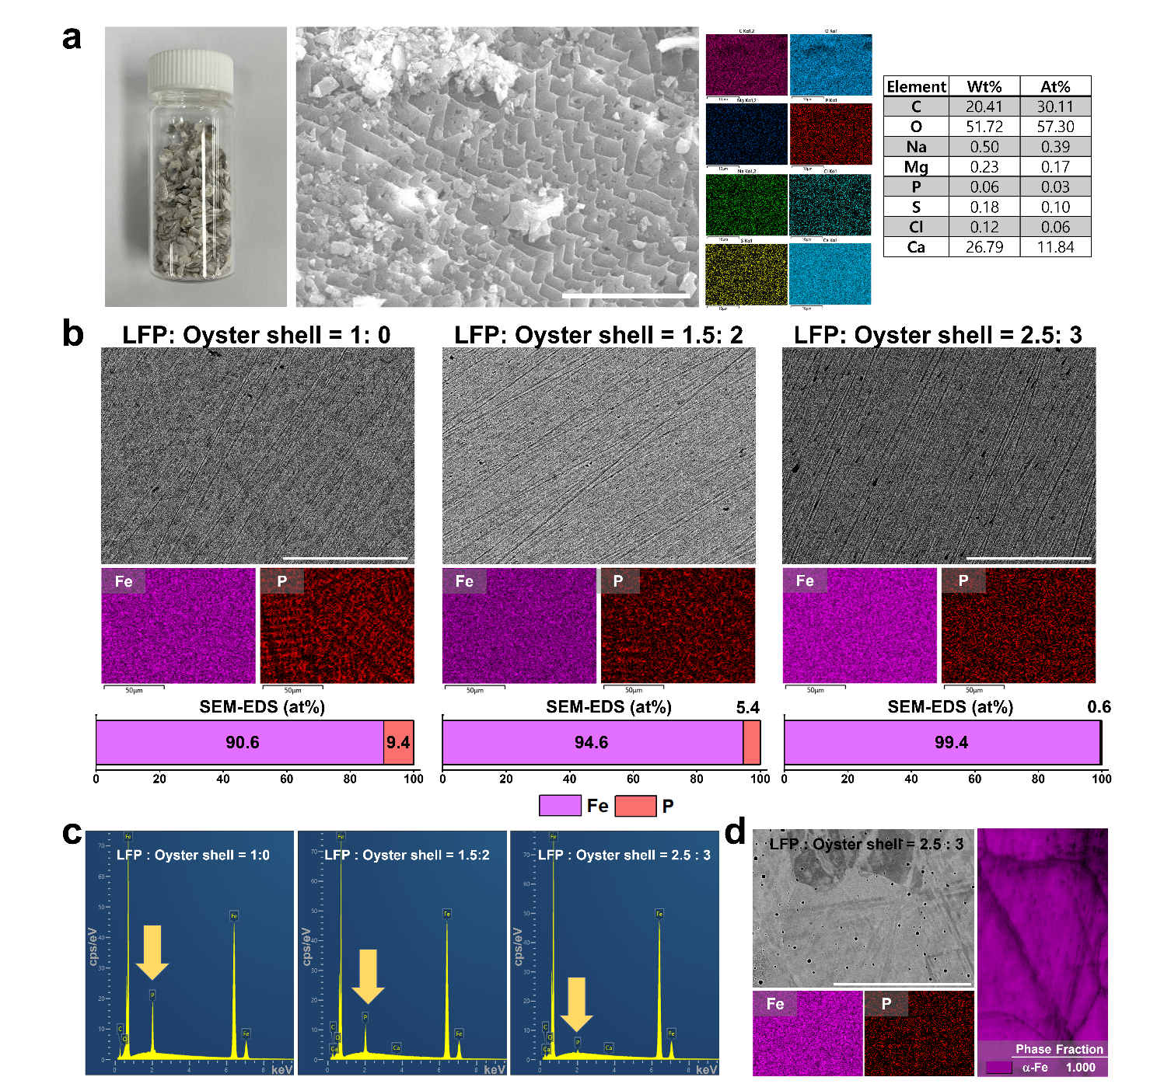
Figure S16. (a) The photograph of the oyster shell used for dephosphorisation and the SEM-EDS result. (b) SEM-EDS results of the hydrogen plasma reduced pellet composed of LFP and oyster shell with different mixing ratios and (c) EDS spectrum of reduced products in (b). (d) The SEM-EDS and EBSD results of hydrogen plasma reduced pellet composed of LFP and oyster shell mixed at the ratio of 2.5:3. Scale bars: 10 μm (a); 50 μm (b-d).

The oyster shell was ground into < 212 μm size particles and homogeneously mixed with LFP powders. The mixture was pelletised, and hydrogen plasma reduced (the detailed information of this process is presented in materials and methods section of the manuscript). The amount of P in the product is decreasing as the amount of oyster shell increases.

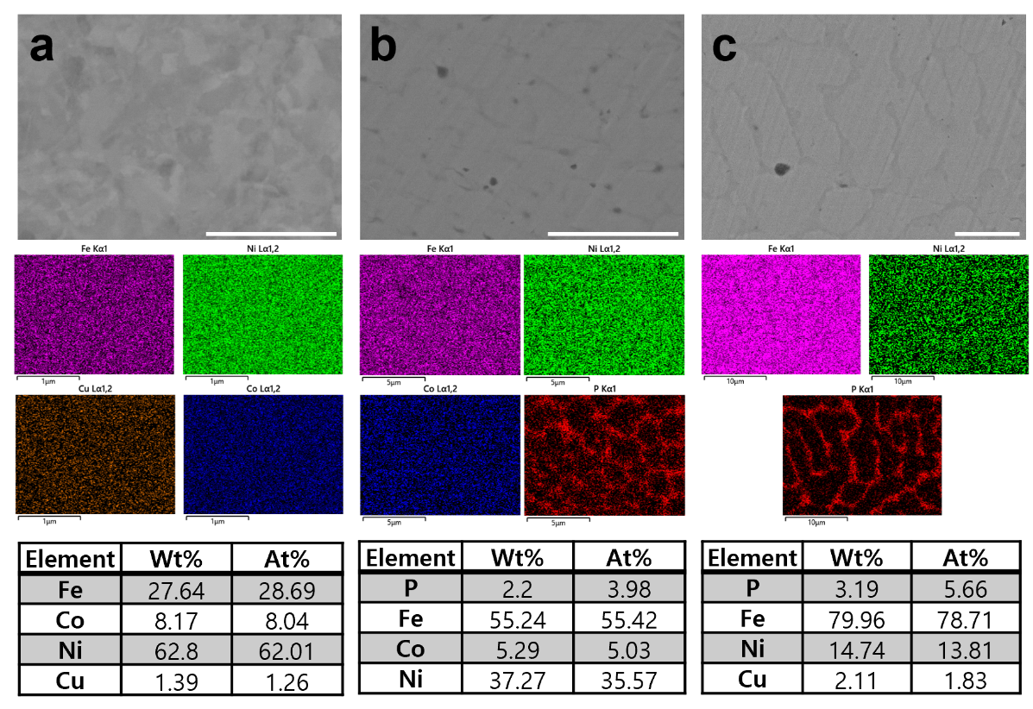
Figure S17. SEM–EDS results of the hydrogen plasma reduced pellets composed of LFP and NCM811. Mixing ratio of LFP:NCM811 = 2.53:1 for (a), LFP:NCM811 = 2.5:1 for (b), LFP:NCM811 = 10:1 for (c). Scale bars: 1 μm (a); 5 μm (b and c).

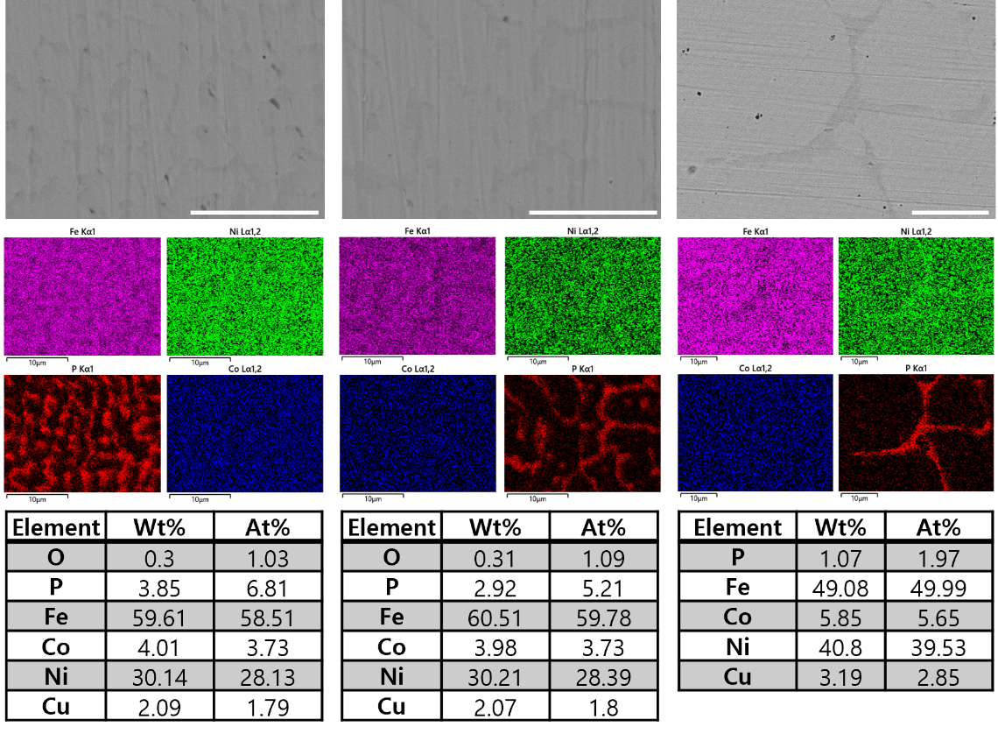
Figure S18. SEM–EDS results of the three hydrogen plasma reduced pellets composed of LFP and NCM811. Mixing ratio of LFP:NCM811 = 3:1. Scale bars: 10 μm.

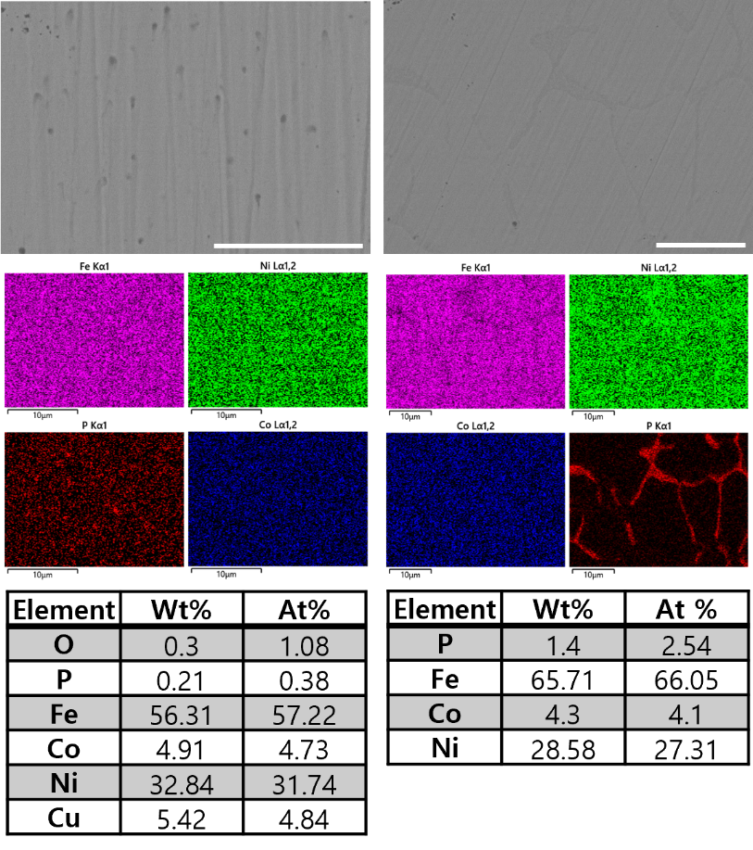
Figure S19. SEM–EDS results of the two hydrogen plasma reduced pellets composed of LFP and NCM811. Mixing ratio of LFP:NCM811 = 4:1. Scale bars: 10 μm.

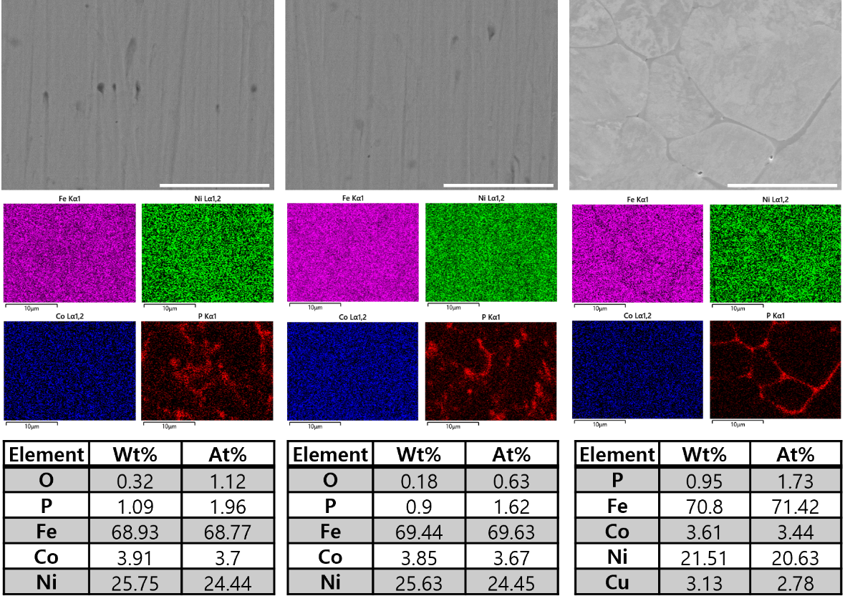
Figure S20. SEM–EDS results of the three hydrogen plasma reduced pellets composed of LFP and NCM811. Mixing ratio of LFP:NCM811 = 5:1. Scale bars: 10 μm.

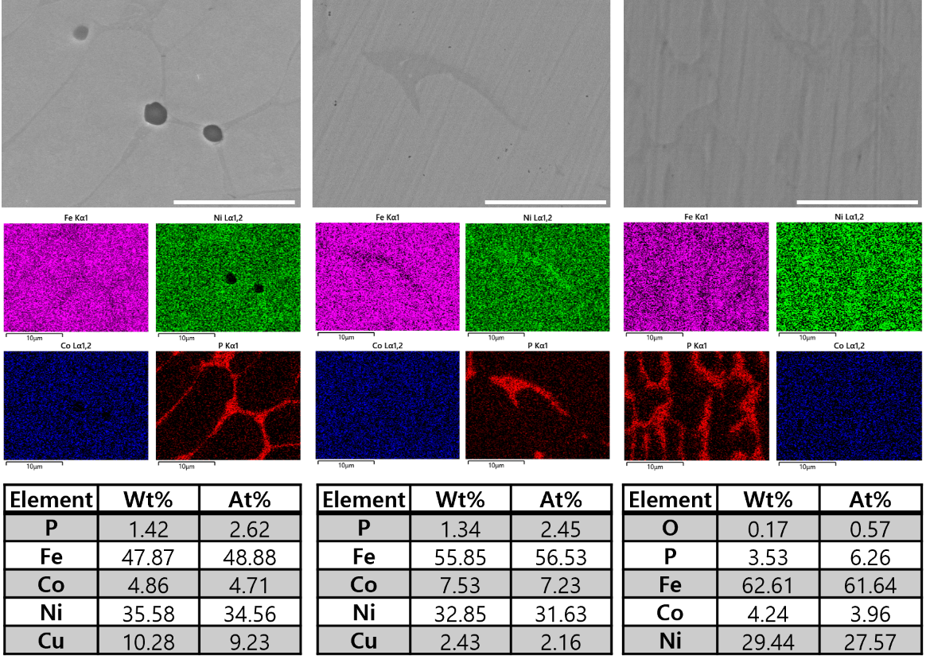
Figure S21. SEM–EDS results of the three hydrogen plasma reduced pellets composed of LFP and NCM811. Mixing ratio of LFP:NCM811 = 5:1. Scale bars: 10 μm.

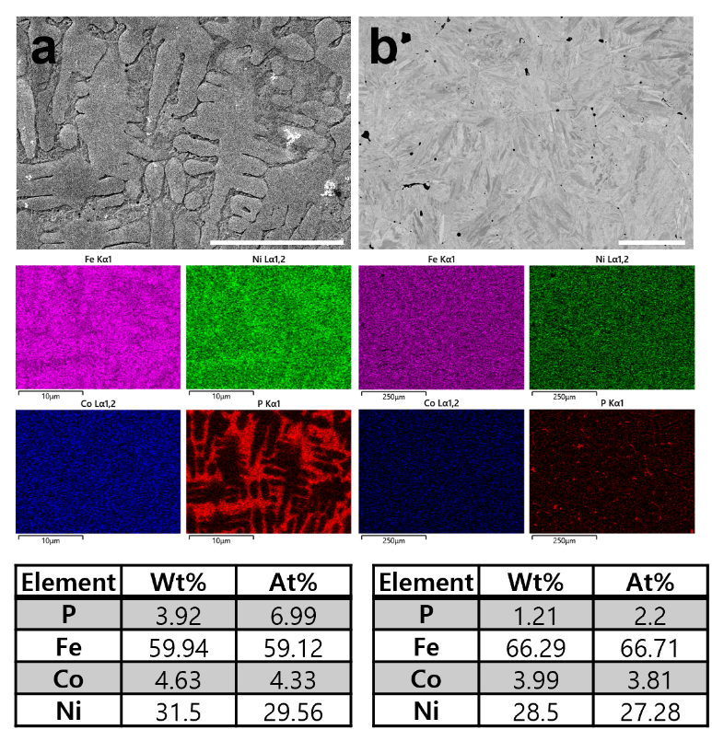
Figure S22. SEM–EDS results after re-melting the hydrogen plasma–reduced LFP and NCM811 mixed pellets (5:1 ratio): (a) under an Ar atmosphere and (b) under ambient air for 60 s using an arc-melting furnace. Scale bars: 10 μm (a) and 100 μm (b).

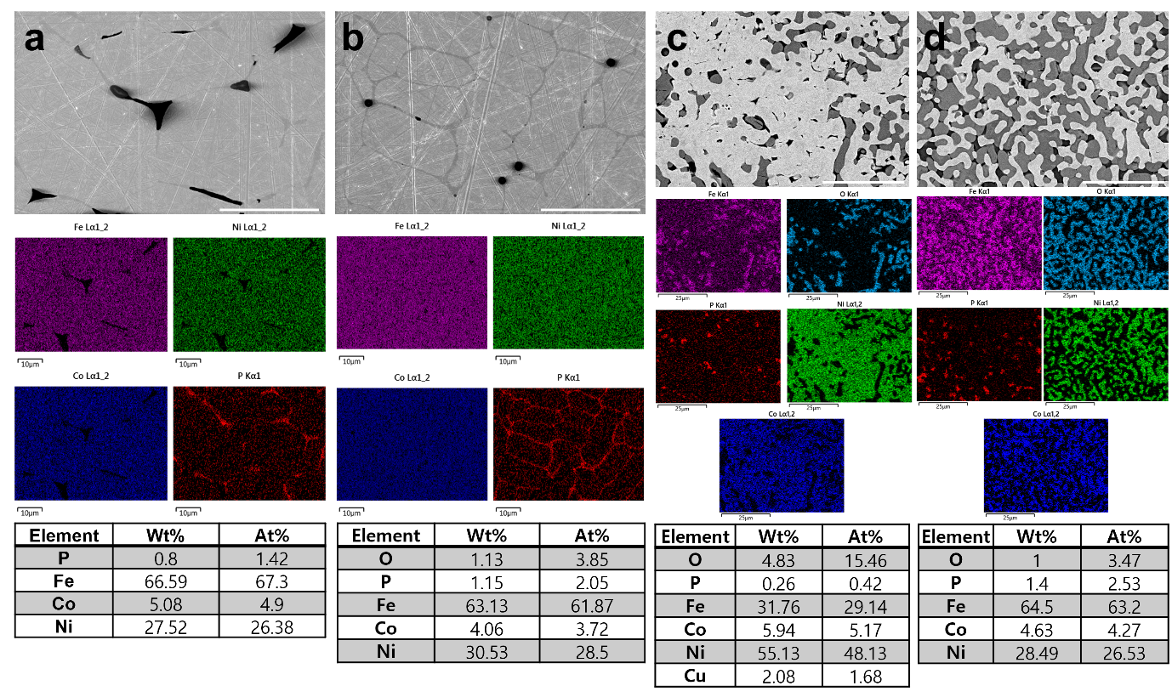
Figure S23. SEM-EDS results after heat treat of the hydrogen plasma reduced LFP and NCM811 mixed pellets (4: 1 ratio) (a) at 900 ºC for 1 hr, (b) at 1000 ºC for 1 hr and 1050 ºC for 1 hr, (c) at 1000 ºC for 30 min, followed by 1050 ºC for 30 min, and (d) at 1050 ºC for 30 min under air atmosphere. Scale bars: 20 μm (a-d).

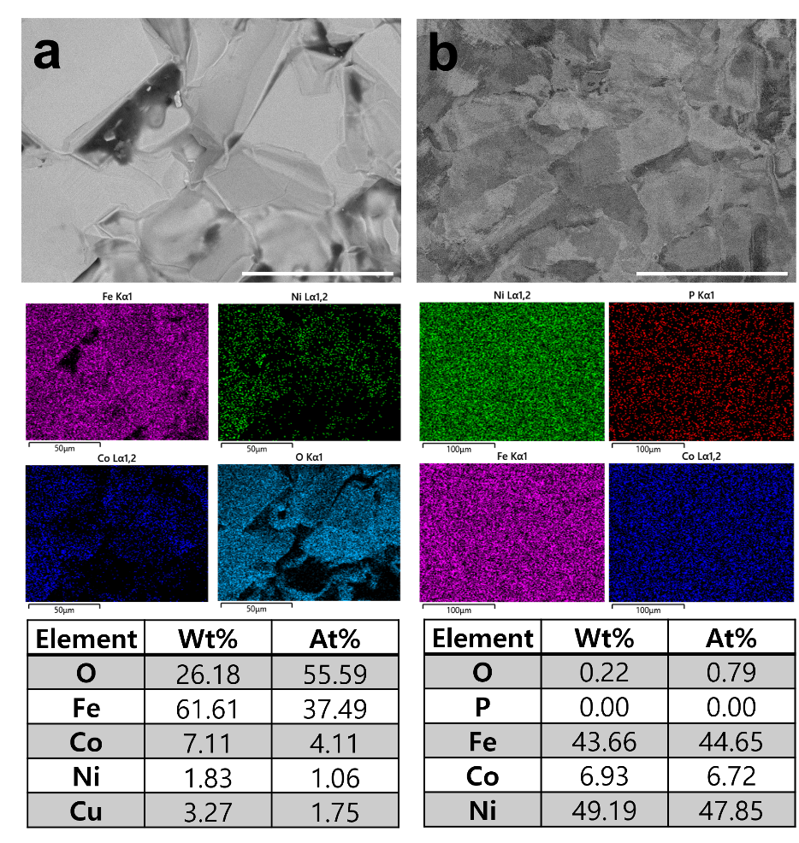
Figure S24. (a) SEM-EDS results after heat treatment of the reduced LFP and NCM811 mixed pellets (4: 1 ratio) at 1100 ºC for 24 hr. (b) SEM-EDS results of the alloy after heat treatment of oxide particles in (a). Scale bars: 50 μm (a and b).

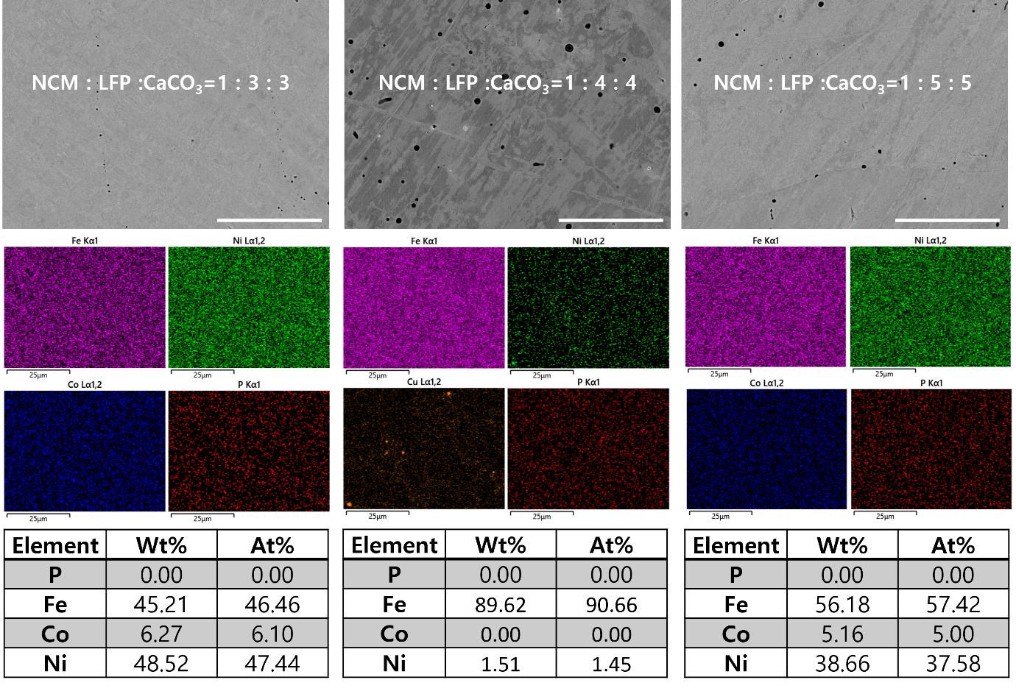
Figure S25. SEM-EDS results of dephosphorised Fe-Ni-Co alloy from hydrogen plasma reduced the LFP, NCM811, and CaCO₃ mixed pellets. Mixing ratios are given in each figure. Scale bars: 20 μm.

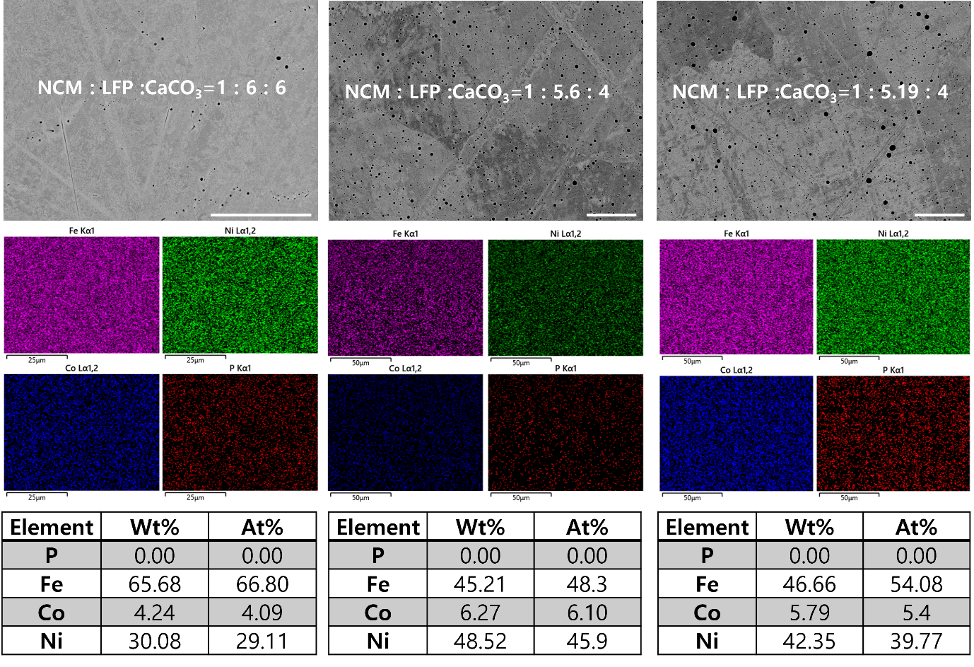
Figure S26. SEM-EDS results of dephosphorised Fe-Ni-Co alloy from hydrogen plasma reduced the LFP, NCM811, and CaCO₃ mixed pellets. Mixing ratios are given in each figure. Scale bars: 20 μm.

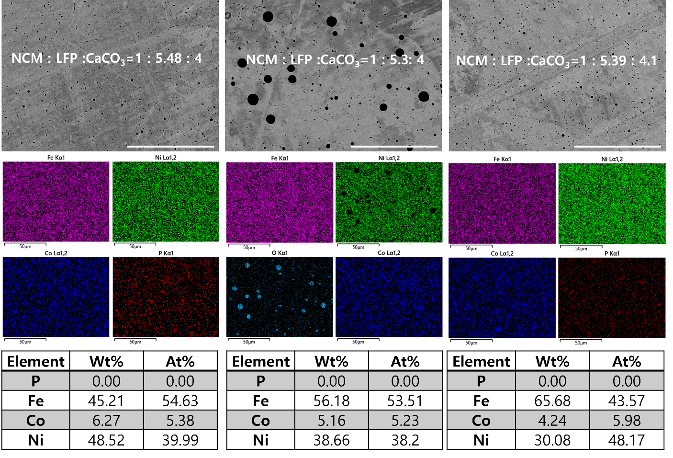
Figure S27. SEM-EDS results of dephosphorised Fe-Ni-Co alloy from hydrogen plasma reduced the LFP, NCM811, and CaCO₃ mixed pellets. Mixing ratios are given in each figure. Scale bars: 50 μm.

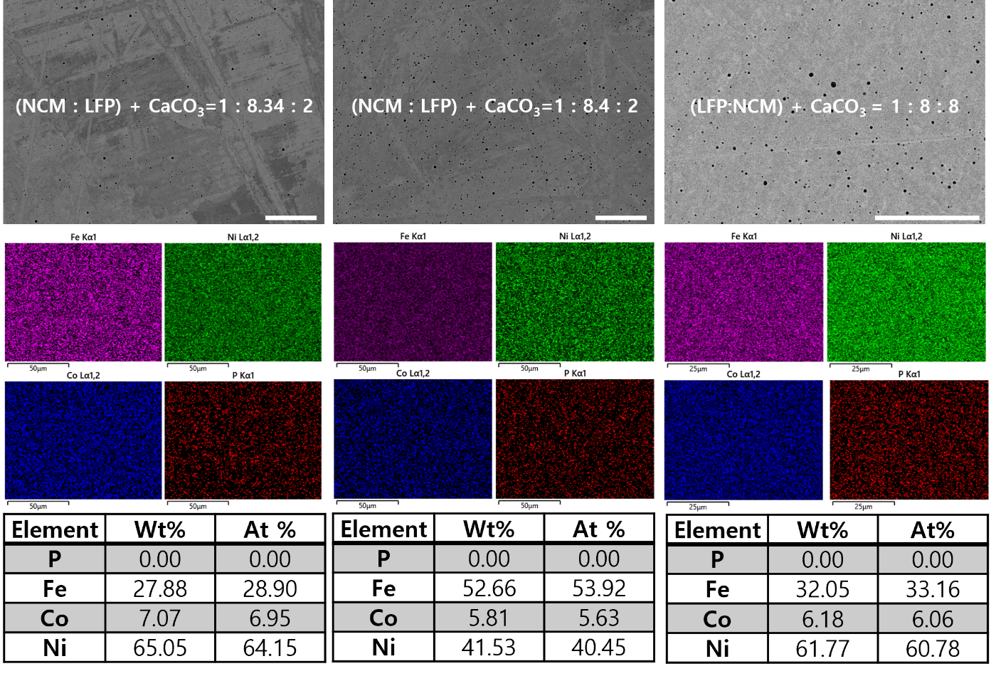
Figure S28. SEM-EDS results of dephosphorised Fe-Ni-Co alloy from hydrogen plasma reduced the LFP, NCM811, and CaCO₃ mixed pellets. Mixing ratios are given in each figure. Scale bars: 50 μm.

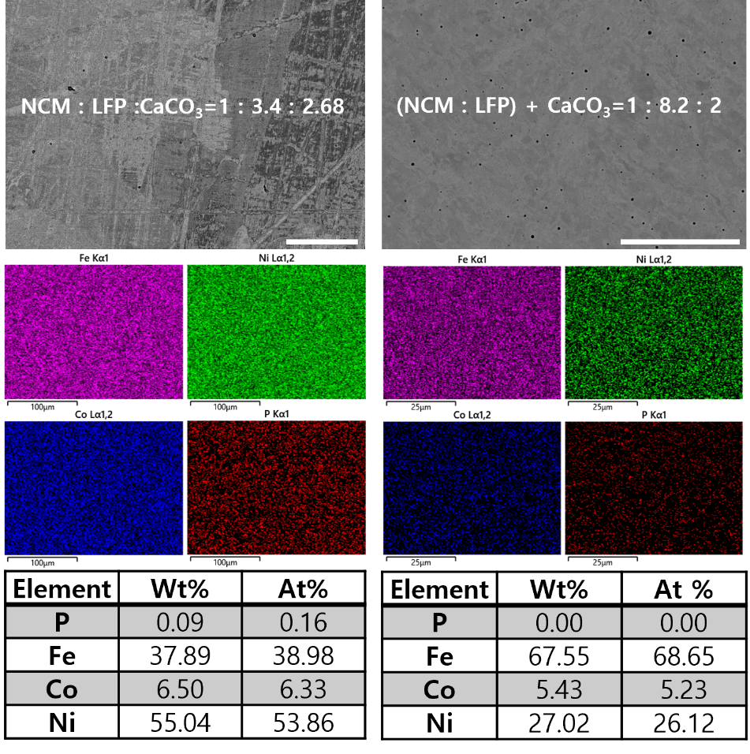
Figure S29. SEM-EDS results of dephosphorised Fe-Ni-Co alloy from hydrogen plasma reduced the LFP, NCM811, and CaCO₃ mixed pellets. Mixing ratios are given in each figure. Scale bars: 50 μm.

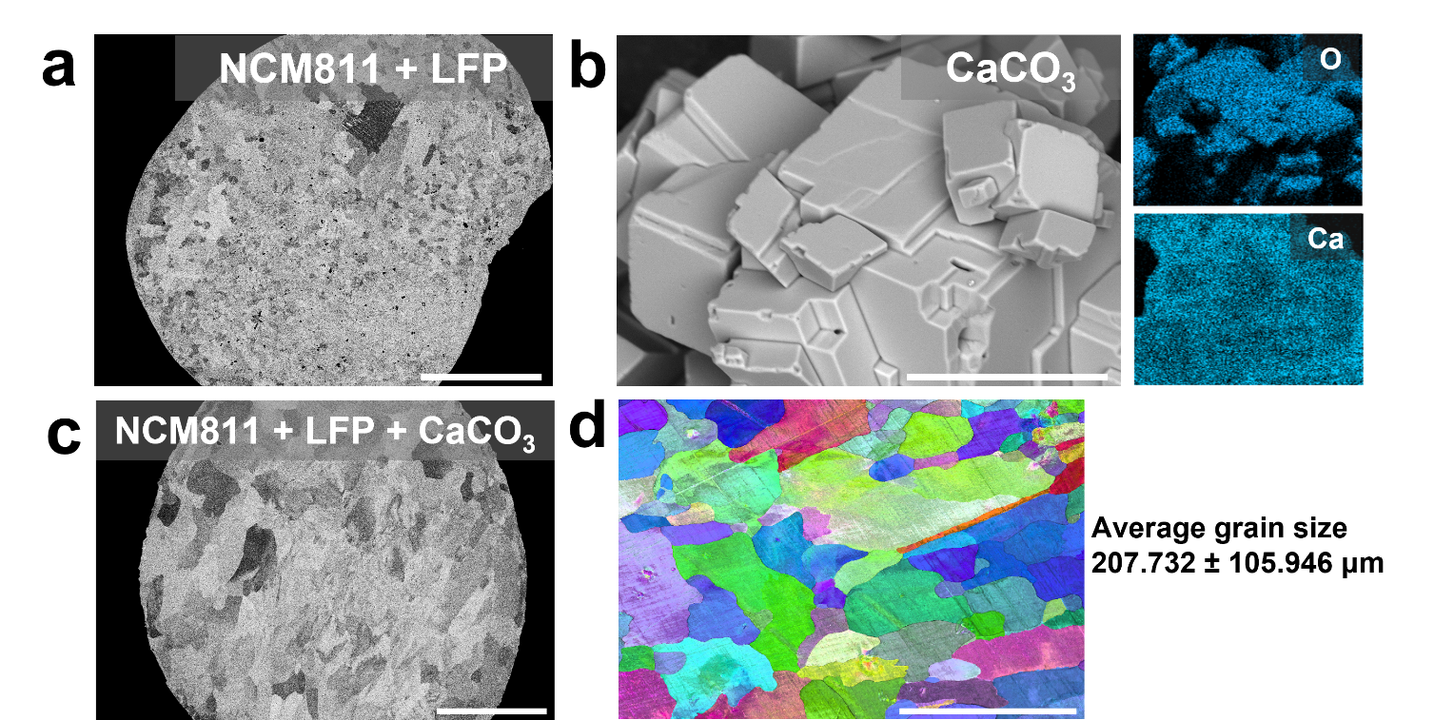
Figure S30. (a) Low magnification SEM image of hydrogen plasma reduced alloy from NCM811 and LFP mixed pellet. (b) SEM image and EDS maps of CaCO₃ powder, and (c) Low magnification SEM image of HPR super invar alloy from NCM811, LFP, and CaCO₃ mixed pellet. (d) SEM-EBSD result of super invar alloy in (f), with calculated average grain size by using the OIM program. Scale bars: 500 μm (a, c, and d); 10 μm (b).

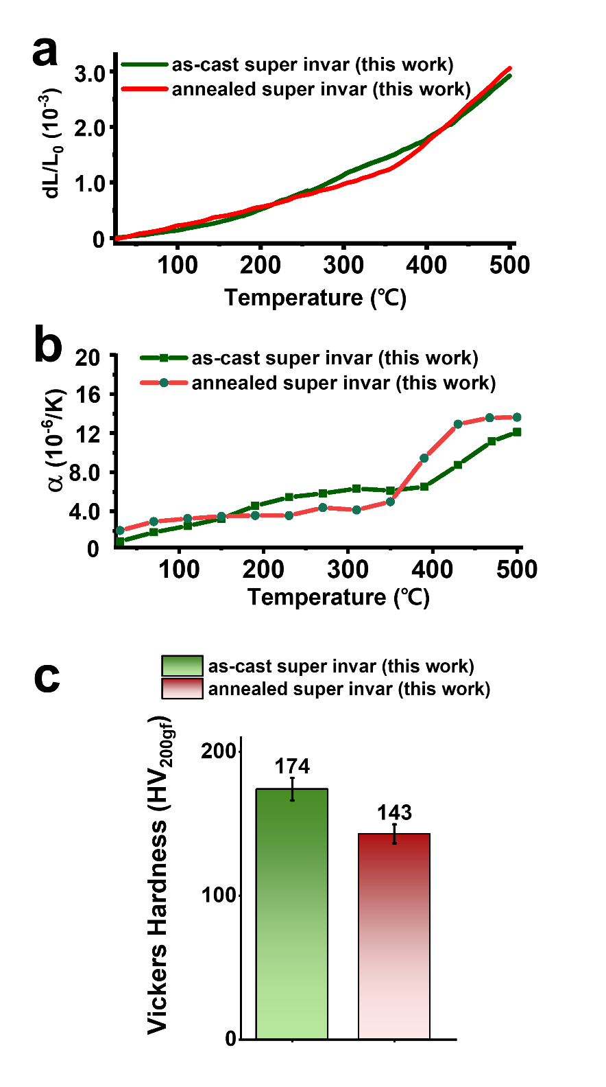
Figure S31. (a) Thermal expansion test result and (b) thermal expansion coefficient of as-cast and annealed super invar alloys synthesised from NCM811, LFP, and CaCO₃. (c) Measured Vickers hardness (200 gf) of as-cast and annealed super invar alloy in Figure 3.

The annealing process was conducted under vacuum conditions at 1200°C for 5 hours. Thermal expansion measurements for both alloys were performed under identical conditions (see materials and methods section).

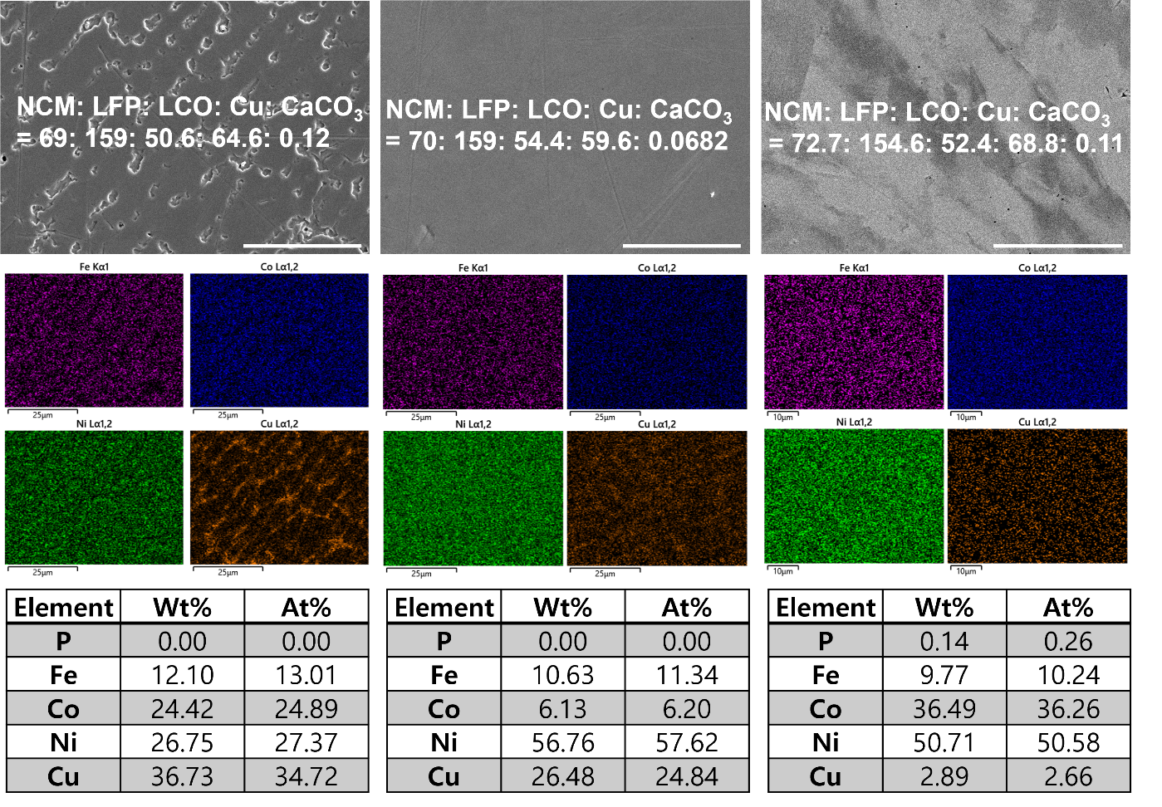
Figure S32. SEM–EDS results after hydrogen plasma reduction of a pellet composed of LFP, NCM811, LCO, and CaCO₃, along with Cu pellets for HEA alloy design. Mixing ratios are given in each figure. Scale bars: 20 μm.

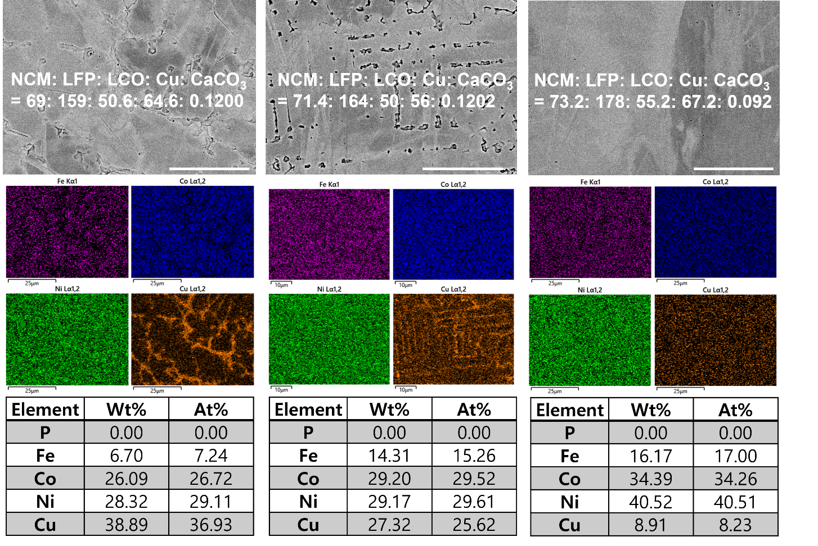
Figure S33. SEM–EDS results after hydrogen plasma reduction of a pellet composed of LFP, NCM811, LCO, and CaCO₃, along with Cu pellets for HEA alloy design. Mixing ratios are given in each figure. Scale bars: 20 μm.

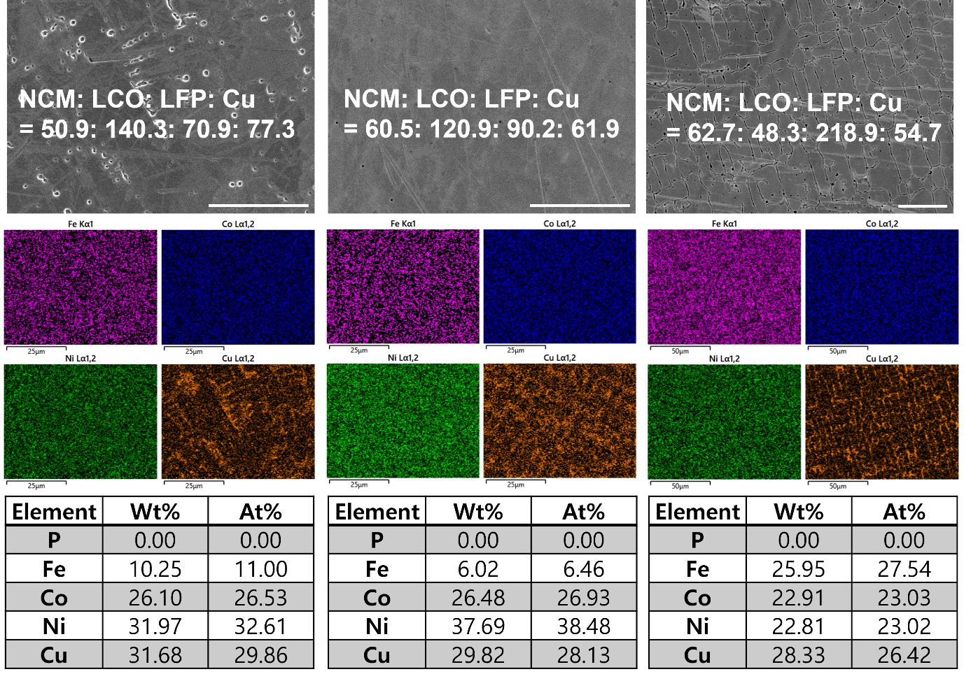
Figure S34. SEM–EDS results after hydrogen plasma reduction of a pellet composed of LFP, NCM811, LCO, and CaCO₃, along with Cu pellets for HEA alloy design. Mixing ratios are given in each figure. Scale bars: 20 μm.

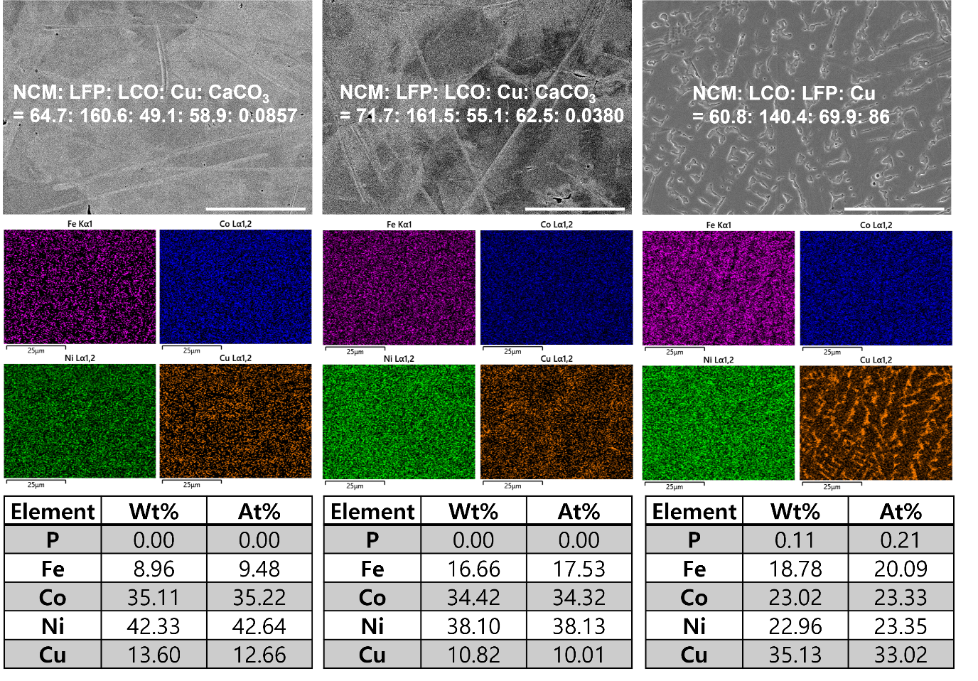
Figure S35. SEM–EDS results after hydrogen plasma reduction of a pellet composed of LFP, NCM811, LCO, and CaCO₃, along with Cu pellets for HEA alloy design. Mixing ratios are given in each figure. Scale bars: 20 μm.

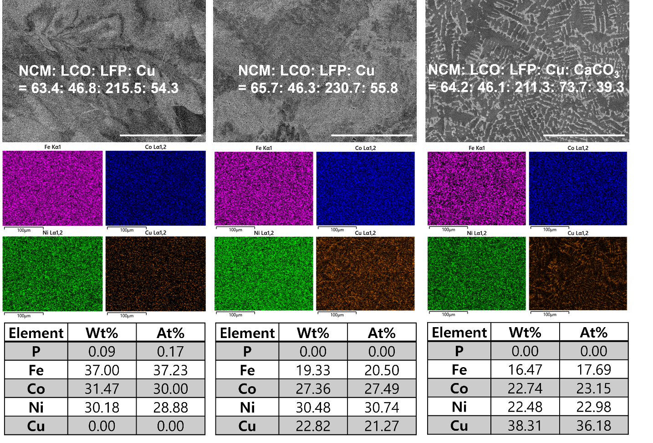
Figure S36. SEM–EDS results after hydrogen plasma reduction of a pellet composed of LFP, NCM811, LCO, and CaCO₃, along with Cu pellets for HEA alloy design. Mixing ratios are given in each figure. Scale bars: 100 μm.

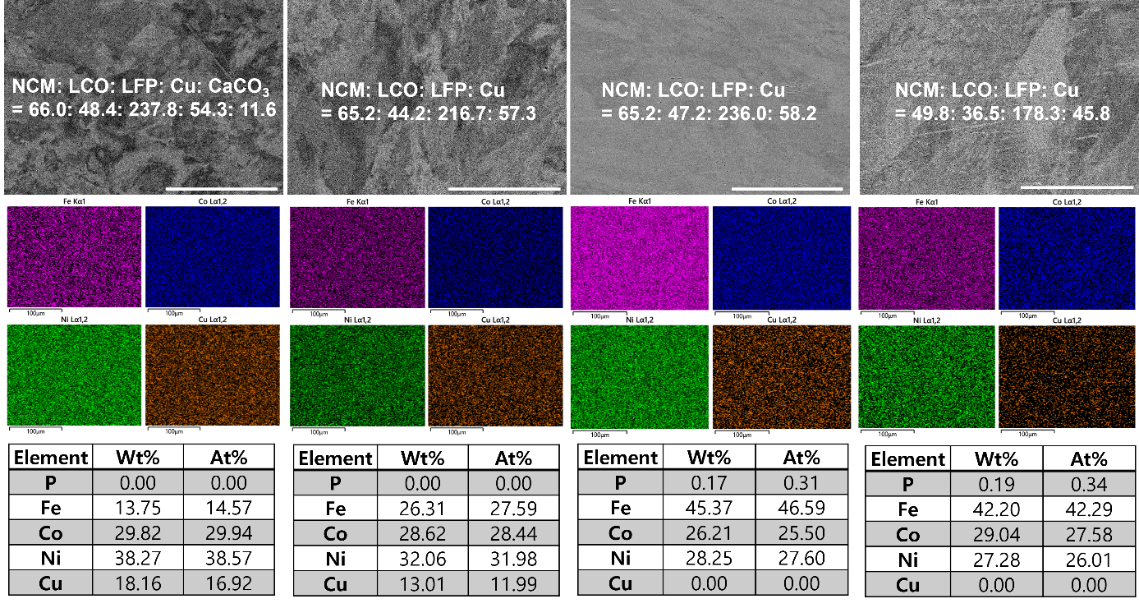
Figure S37. SEM–EDS results after hydrogen plasma reduction of a pellet composed of LFP, NCM811, LCO, and CaCO₃, along with Cu pellets for HEA alloy design. Mixing ratios are given in each figure. Scale bars: 100 μm.

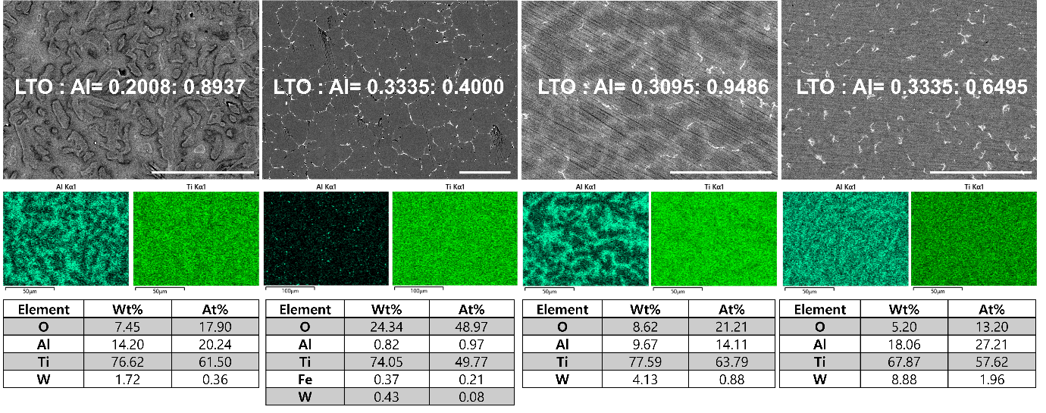
Figure S38. SEM-EDS results of hydrogen plasma reduced LTO and Al pellets for TiAl alloy design. Mixing ratios are given in each figure. Scale bars: 50 μm.

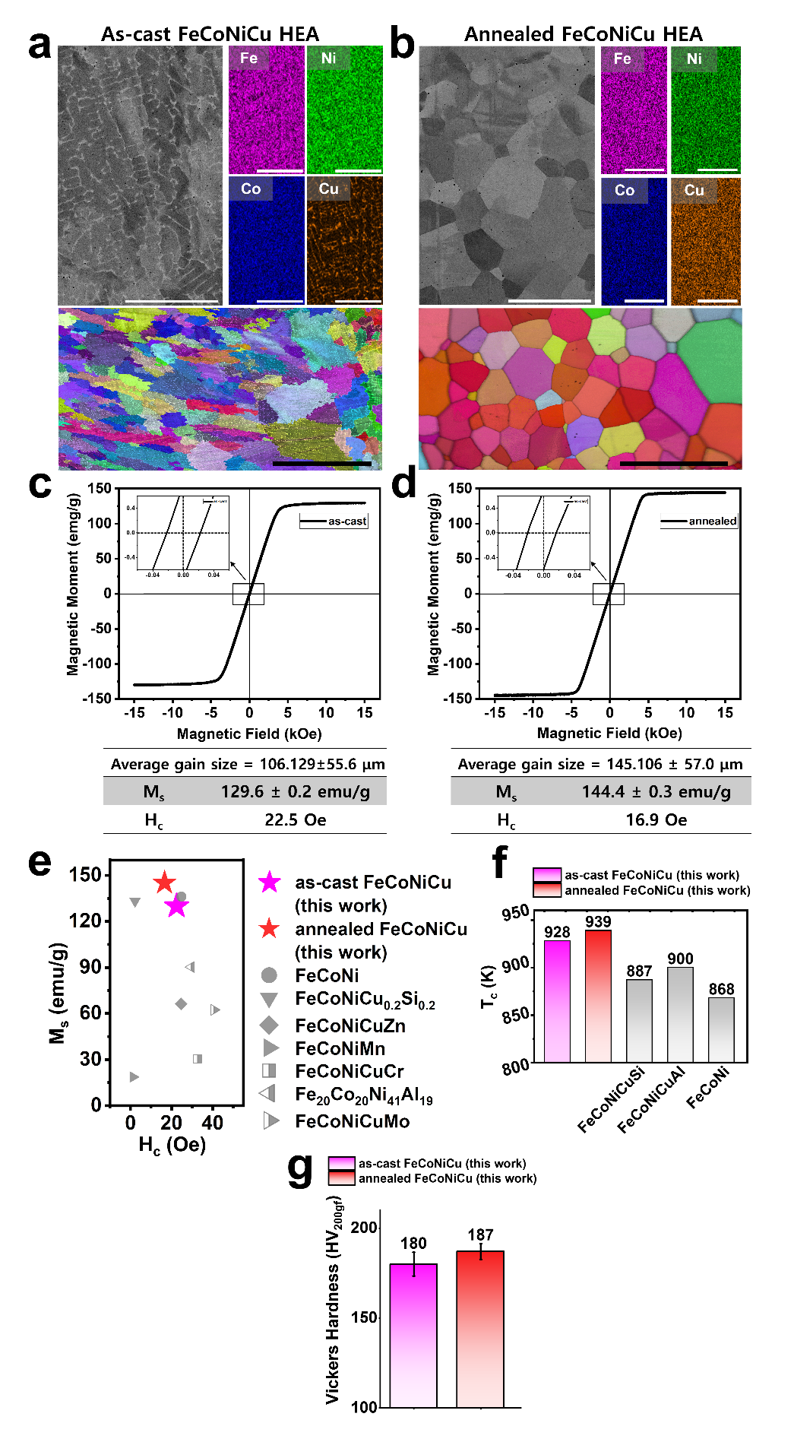
Figure S39. SEM-EDS and EBSD results of (a) as-cast and (b) annealed FeCoNiCu high-entropy alloy in Figure 4a. Magnetisation curve of (c) as-cast and (d) annealed FeCoNiCu high-entropy alloy in Figure 4a. (e) M_{s} vs. H_{c} plot and (f) Curie temperature comparison of various magnetic HEAs [9, 10]. (g) Measured Vickers hardness (200 gf) of as-cast and annealed FeCoNiCu alloy in Figure 3. Scale bars: 50 μm (white scale bar in a); 400 μm (black scale bar in a); 200 μm (white scale bar in b); 400 μm (white scale bar in b).
The annealing process was conducted under vacuum conditions at 1200°C for 5 hours. Comparing Figure S39a and b, the crystal structure of both before and after the annealing is FCC structure. Cu distribution was segregated in the as-cast specimen, while Cu after annealing was homogenously distributed.

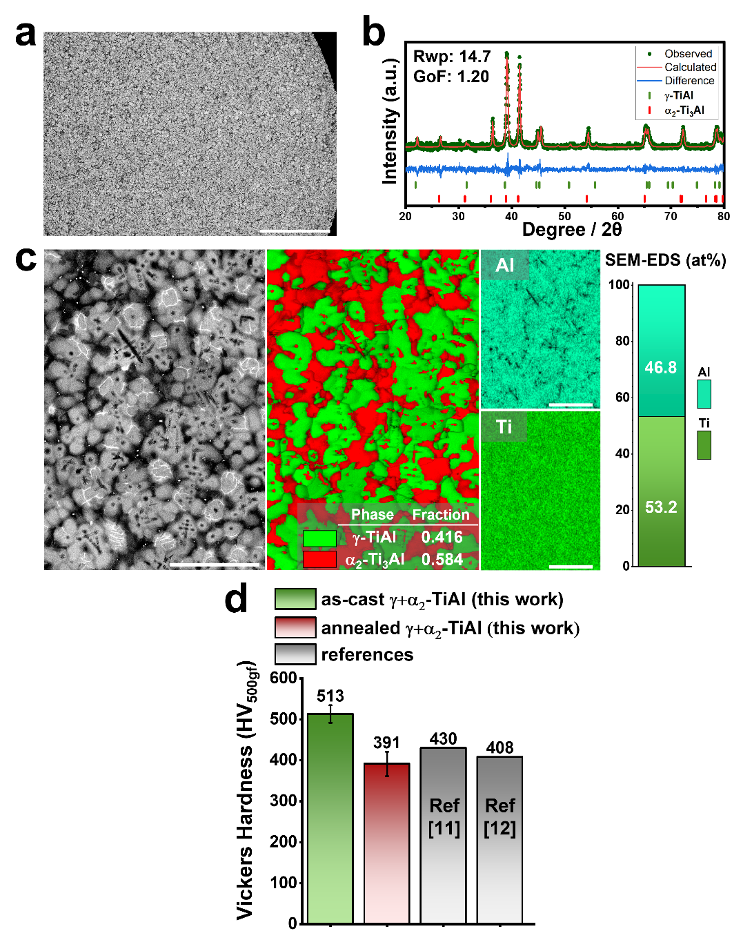
Figure S40. (a) The low magnification SEM image of hydrogen plasma reduced α₂-Ti₃Al and γ-TiAl binary TiAl alloy from LTO and Al mixed pellets. (b) The XRD result of TiAl alloy in (a) and (c) SEM-EBSD and EDS results of hydrogen plasma reduced α₂-Ti₃Al and γ-TiAl binary TiAl alloy from LTO and Al mixed pellets. (d) Vickers hardness of as-cast and annealed TiAl alloy in (a) with references [11, 12]. Scale bars: 500 μm (a); 50 μm (c).

Figure S40 shows the XRD, SEM-EDS, and -EBSD results for the synthesised α₂-Ti₃Al / γ-TiAl binary phase alloy produced from LTO and Al pellets by hydrogen plasma reduction. From XRD analysis, the alloy is fully composed of α₂-Ti₃Al [14] and γ-TiAl [15] phases, with the calculated phase fractions of 0.322 and 0.678 from Rietveld refinement, respectively. This corresponds to the SEM-EBSD analysis, although the phase fraction is slightly different. The SEM-EDS result shows that the alloy is composed of 46.8 at.% of Al and 53.2 at.% of Ti. This α₂-Ti₃Al / γ-TiAl binary TiAl alloy is used in aerospace materials due to its high specific strength, excellent creep resistance with high corrosion resistance properties, high ductility, and high fracture toughness than the γ-TiAl alloys [16, 17]. The annealing was conducted under vacuum conditions at 1200°C for 24 hours. By relieving the thermal stress in as-cast sample, the hardness value is comparable to the conventional TiAl alloys for aerospace crafts after annealing.

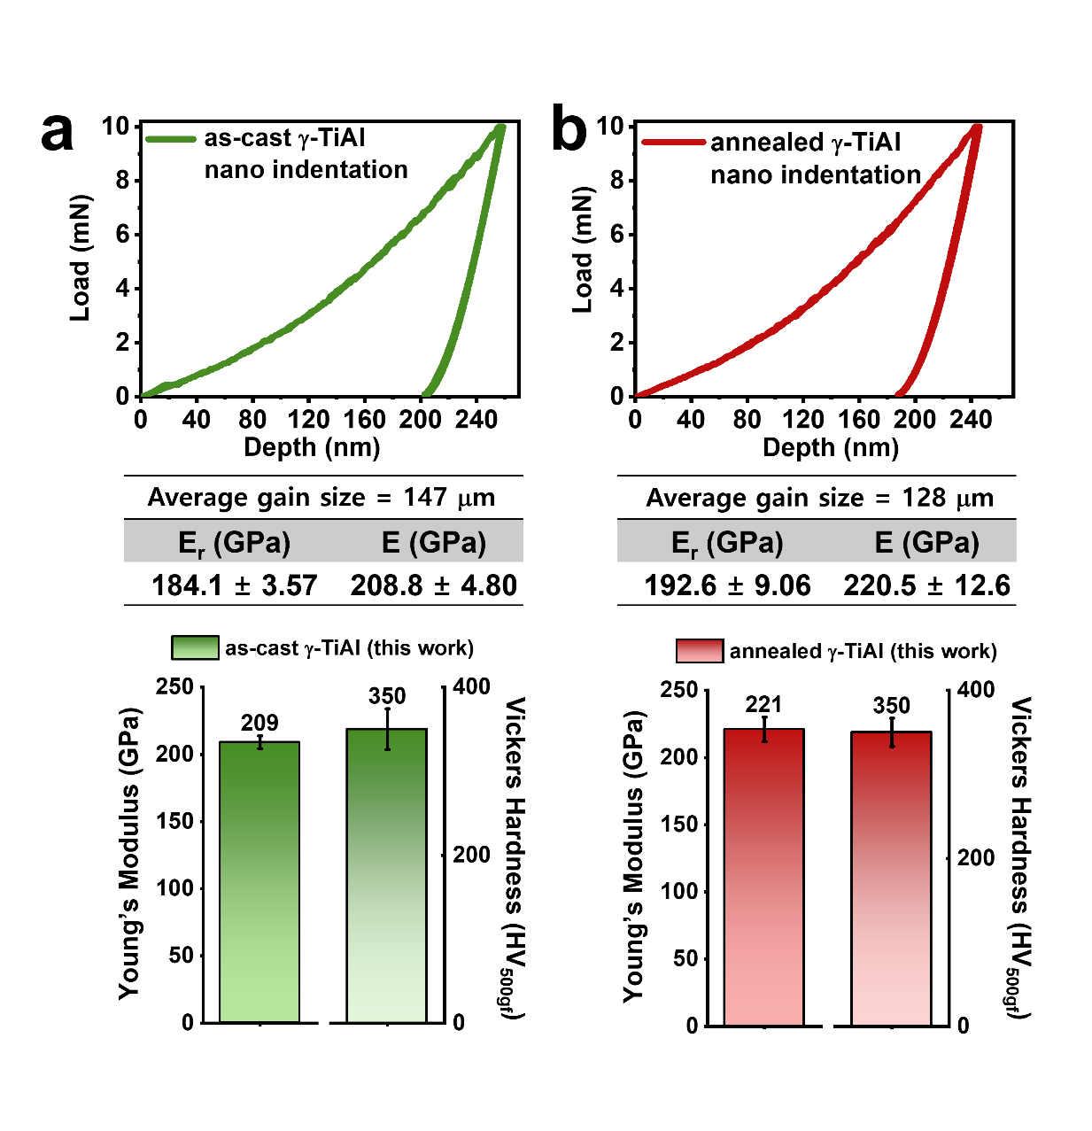
Figure S41. Results of nano-indentation and Vickers hardness test of (a) as-cast and (b) annealed γ-TiAl in Figure 4f.

The annealing process was conducted under vacuum conditions at 1200°C for 5 hours. After annealing, the Young’s modulus slightly increased, while the Vickers hardness remained the same.

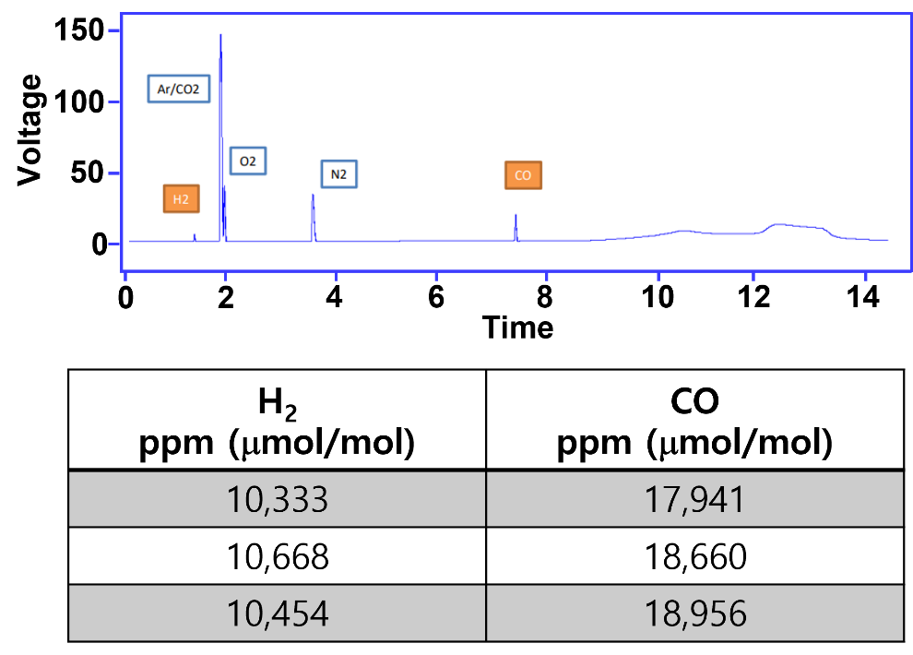
Figure S42. Gas chromatography results of the generated gas during the HPR process of NCM811 pellets.

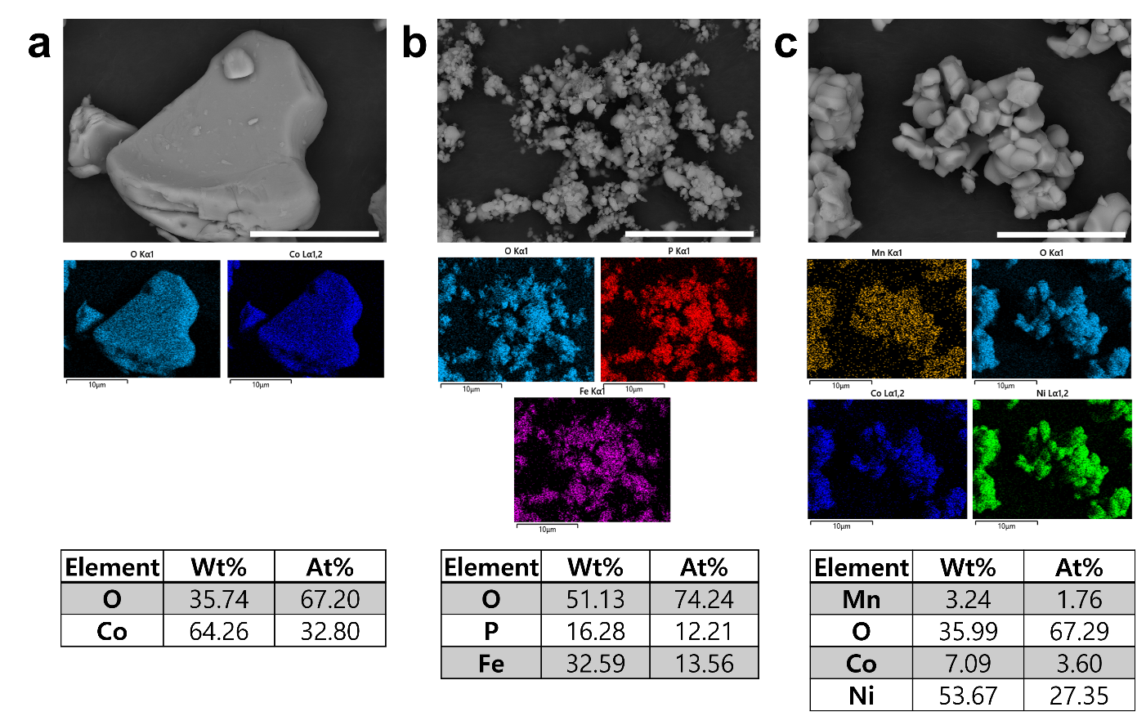
Figure S43. SEM-EDS results of pristine (a) LCO, (b) LFP, and (c) spent cathode power of NCM811. Scale bars: 10 μm.

Yield calculation and process efficiency
The yield efficiency of the HPR was quantitatively evaluated using 1 g pellet samples for each of tested cathode materials (LCO, NCM811, and LFP). The yield was calculated based on the recovered metal weight after 1 min HPR treatment compared to the initial theoretical amount of transition metal in the original cathode powders.

$$Yield \left(\%\right) for NCM811 and LCO=\frac{mass of metal recovered after HPR }{\left(1g-oxide mass after HPR\right)×theoretical fraction of Ni,Co in cathode}×100\%$$

$$Yield \left(\%\right) for LFP=\frac{mass of metal recovered after HPR ×fraction of Fe in Fe3P}{\left(1g-oxide mass after HPR\right)×theoretical fraction of Fe in LFP}×100\%$$

Table S1. Calculated metal recovery of cathodes from 1-min HPR process.
Material | Input Pellet Mass (g) | Metal Mass after 1min HPR (g) | Oxide Mass after 1min HPR (g)
LCO | 1.000 | 0.1088 | 0.6705
NCM811 | 1.000 | 0.1350 | 0.3242
LFP | 1.000 | 0.1640 | 0.5260

Table S2. Detailed information on the pouch cells used for both the electrochemical tests presented in Figure S44 and the collection of spent NCM811 materials.
NCM811 Pouch cell
Anode |  | Cathode
Current collector | Cu | Current collector | Al
Active material | Graphite | Active material | NCM811  (LiNi_{0.8} Co_{0.1}Mn_{0.1}O₂)
Conducting agent | Super P carbon | Conducting agent | Super P carbon
Binder | PAA (polyacrylic acid) / SBR  (styrene-butadiene rubber) | Binder | PVDF  (Polyvinylidene fluoride)
Loading density | 1.0 mg cm⁻² | Loading density | 3.5 mg cm⁻²
Active material content | 95% | Active material content | 95%
Electrolyte |  | Separator
LiPF₆/Carbonate-based liquid electrolyte |  | Polyethylene/polypropylene composite

Figure S44. (a) The dimensions of the electrode and the NCM811 pouch cell (Table S1), (b) the galvanostatic charge–discharge voltage profile within the voltage window of 2.8–4.2 V, and (c) the corresponding cycling performance of the NCM811 pouch cell prior to dismantling. After 428 cycles, the cell testing was stopped at discharged (lithiated) state.
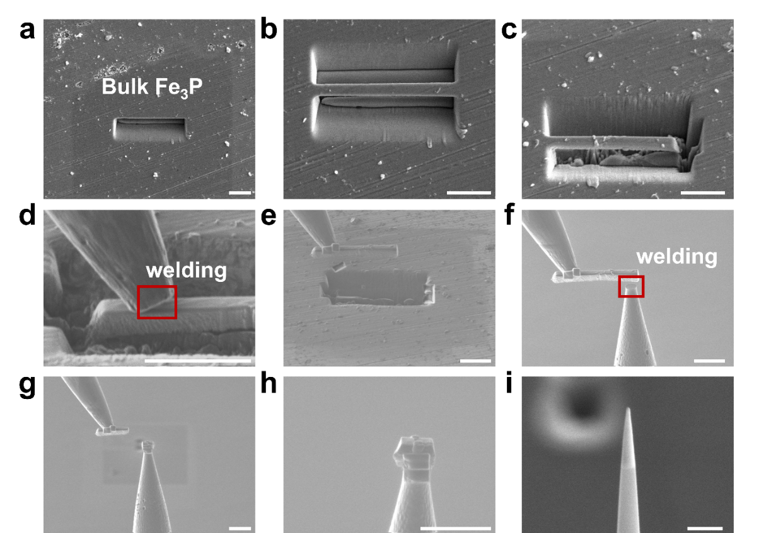
Figure S45. Preparing the APT sample for Fe₃P shown in Figure 2h. The APT specimen fabrication methods for Co and Ni in Figure 2h were identical. Scale bars: 5 μm (a-h) and 1 μm (i).

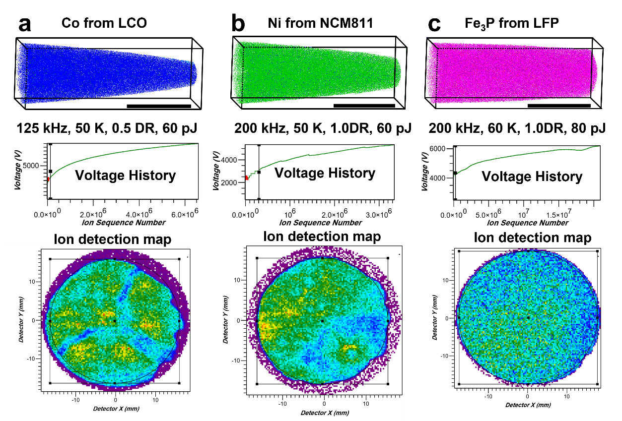
Figure S46. APT measurement conditions, voltage history graph, and ion detection map of (a) Co, (b) Ni, and (c) Fe₃P in Figure 2h are shown.
References
[1] J. Li et al., “Pyrolysis kinetics and reaction mechanism of the electrode materials during the spent LiCoO2 batteries recovery process,” Journal of Hazardous Materials, vol. 398, p. 122955, Nov. 2020, doi: 10.1016/j.jhazmat.2020.122955.
[2] B. A. Nuraeni, K. Avarmaa, L. H. Prentice, W. J. Rankin, and M. A. Rhamdhani, “Recovery of Cobalt and Lithium by Carbothermic Reduction of LiCoO2 Cathode Material: A Kinetic Study,” Metall Mater Trans B, vol. 54, no. 2, pp. 602–620, Apr. 2023, doi: 10.1007/s11663-022-02712-1.
[3] N. Doebelin and R. Kleeberg, “Profex : a graphical user interface for the Rietveld refinement program BGMN,” J Appl Crystallogr, vol. 48, no. 5, pp. 1573–1580, Oct. 2015, doi: 10.1107/S1600576715014685.
[4] L. Marick, “Variation of Resistance and Structure of Cobalt with Temperature and a Discussion of Its Photoelectric Emission,” Phys. Rev., vol. 49, no. 11, pp. 831–837, Jun. 1936, doi: 10.1103/PhysRev.49.831.
[5] I.-K. Suh, H. Ohta, and Y. Waseda, “High-temperature thermal expansion of six metallic elements measured by dilatation method and X-ray diffraction,” J Mater Sci, vol. 23, no. 2, pp. 757–760, Feb. 1988, doi: 10.1007/BF01174717.
[6] S. Rundqvist, “Some investigations of the ternary system Fe-P-B. Some features of the systems Cr-P-B, Mn-P-B, Co-P-B and Ni-P-B,” Acta Chem. Scand., vol. 16, pp. 1–9, 1962.
[7] J. Zhang and F. Guyot, “Thermal equation of iron and Fe0.91Si0.09 Sample: P = 3.9 GPa, T = 773 K”.
[8] I. R. Souza Filho et al., “Sustainable steel through hydrogen plasma reduction of iron ore: Process, kinetics, microstructure, chemistry,” Acta Materialia, vol. 213, p. 116971, Jul. 2021, doi: 10.1016/j.actamat.2021.116971.
[9] J. D. Poplawsky, R. Pillai, Q.-Q. Ren, A. J. Breen, B. Gault, and M. P. Brady, “Measuring oxygen solubility in Ni grains and boundaries after oxidation using atom probe tomography,” Scripta Materialia, vol. 210, p. 114411, Mar. 2022, doi: 10.1016/j.scriptamat.2021.114411.
[10] H. Xu, X. Wang, J. Liu, and F. Kong, “Novel Co75Al8.4Si8.3Ti8.3 medium entropy alloy for both high magnetization and Curie temperature,” Scripta Materialia, vol. 243, p. 115989, Apr. 2024, doi: 10.1016/j.scriptamat.2024.115989.
[11] P. Kumari, A. K. Gupta, R. K. Mishra, M. S. Ahmad, and R. R. Shahi, “A Comprehensive Review: Recent Progress on Magnetic High Entropy Alloys and Oxides,” Journal of Magnetism and Magnetic Materials, vol. 554, p. 169142, Jul. 2022, doi: 10.1016/j.jmmm.2022.169142.
[12] W. Xu, K. Huang, S. Wu, Y. Zong, and D. Shan, “Influence of Mo content on microstructure and mechanical properties of β-containing TiAl alloy,” Transactions of Nonferrous Metals Society of China, vol. 27, no. 4, pp. 820–828, Apr. 2017, doi: 10.1016/S1003-6326(17)60094-3.
[13] S.-W. Kim, J. K. Hong, Y.-S. Na, J.-T. Yeom, and S. E. Kim, “Development of TiAl alloys with excellent mechanical properties and oxidation resistance,” Materials & Design (1980-2015), vol. 54, pp. 814–819, Feb. 2014, doi: 10.1016/j.matdes.2013.08.083.
[14] M. Berthet, B. Legrand, J. Martinez, and I. Parrot, “A General Approach to the Aza-Diketomorpholine Scaffold,” Org. Lett., vol. 19, no. 3, pp. 492–495, Feb. 2017, doi: 10.1021/acs.orglett.6b03656.
[15] K.-D. Liss et al., “Hydrostatic Compression Behavior and High-Pressure Stabilized β-Phase in γ-Based Titanium Aluminide Intermetallics,” Metals, vol. 6, no. 7, p. 165, Jul. 2016, doi: 10.3390/met6070165.
[16] Y.-O. Jung, M.-S. Kim, J. Park, G. Yang, D. W. Lee, and S.-W. Kim, “Achieving fine fully lamellar microstructure of casting TiAl alloy by simple heat treatment,” Materials Characterization, vol. 200, p. 112881, Jun. 2023, doi: 10.1016/j.matchar.2023.112881.
[17] O. Genc and R. Unal, “Development of gamma titanium aluminide (γ-TiAl) alloys: A review,” Journal of Alloys and Compounds, vol. 929, p. 167262, Dec. 2022, doi: 10.1016/j.jallcom.2022.167262.

