Table S1 The distribution status and first detection of oriental fruit fly (Orifly) and Mediterranean fruit fly (Medfly) around the world.
Number | Countries or Regions | Oriental fruit fly |  |  |  | Mediterranean fruit fly
Number | Countries or Regions | Stage | The first detection |  |  | Stage | The first detection
Africa
1 | Algeria | / | / |  | Present |  | 1859
2 | -Algiers | / | / |  | Present |  | 1859
3 | Republic of Angola | Present | 2008 |  | Present |  | 1965
4 | Benin | Present | 2004 |  | Present |  | 1994
5 | Botswana | Present | 2014 |  | Present |  | 2008
6 | Burkina faso | Present | 2005 |  | Present |  | 1950
7 | Burundi | Present | 2011 |  | Present |  | 1934
8 | Cameroon | Present | 2004 |  | Present |  | 1982
9 | Cape Verde | Present | 2014 |  | Present |  | 1982
10 | Central African Republic | Present | 2008 |  | / |  | /
11 | Chad | Present | 2008 |  | / |  | /
12 | Comoros | Present | 2005 |  | Present |  | 2000
13 | Congo | Present | 2008 |  | Present |  | 1908
14 | The Democratic Republic of the Congo | Present | 2006 |  | Present |  | 1927
15 | -Bas Congo | / | / |  | Present |  | 2007
16 | -Kivu Nord | / | / |  | Present |  | 1937
17 | -Equateur | / | / |  | Present |  | 1927
18 | -Orientale | / | / |  | Present |  | 1934
19 | The Republic of Côte d'Ivoire | / | / |  | Present |  | 1983
20 | Egypt | / | / |  | Present |  | 1904
21 | -New Valley Governorate | / | / |  | Present |  | 1936
22 | -Giza | / | / |  | Present |  | 1927
23 | -Cairo | / | / |  | Present |  | 1927
24 | Equatorial Guinea | Present | 2006 |  | / |  | /
25 | Eritrea | / | / |  | Present |  | 1946
26 | Ethiopia | Present | 2005 |  | Present |  | 1975
27 | -Gamo Gofa | / | / |  | Present |  | 2010
28 | -Wolayita | / | / |  | Present |  | 2010
29 | -Sidama | / | / |  | Present |  | 2010
30 | -Harari | / | / |  | Present |  | 2011
31 | Gabon | Present | 2006 |  | Present |  | 1982
32 | Gambia | Present | 2008 |  | / |  | /
33 | Ghana | Present | 2005 |  | Present |  | 1920
34 | Guinea | Present | 2006 |  | Present |  | 1994
35 | Guinea-Bissau | Present | 2008 |  | / |  | /
36 | Ivory Coast | Present | 2005 |  | / |  | /
37 | Kenya | Present | 2003 |  | Present |  | 1923
38 | Lesotho | / | / |  | Absent |  | 1948
39 | Liberia | Present | 2008 |  | Present |  | 1966
40 | Libya | / | / |  | Present |  | 1939
41 | -Tripoli | / | / |  | Present |  | 1939
42 | Madagascar | Present | 2014 |  | Present |  | 1958
43 | Malawi | / | / |  | Present |  | 2010
44 | Mali | Present | 2005 |  | Present |  | 1950
45 | Mauritania | Present | 2008 |  | / |  | /
46 | Mauritius | Eradicated | 1996 |  | Present |  | 1942
47 | Mayotte | Present | 2007 |  | / |  | /
48 | Morocco | / | / |  | Present |  | 1908
49 | Mozambique | Present | 2008 |  | Present |  | 1903
50 | Namibia | Present | 2014 |  | Present |  | 2000
51 | Niger | Present | 2008 |  | Present |  | 2001
52 | Nigeria | Present | 2005 |  | Present |  | 1936
53 | Reunion | / | / |  | Present |  | 1939
54 | Rwanda | Present | 2009 |  | / |  | /
55 | Saint Helena | / | / |  | Present |  | 1957
56 | Sao Tome and Principe | / | / |  | Present |  | 1969
57 | Senegal | Present | 2004 |  | Present |  | 1980
58 | Seychelles | / | / |  | Present |  | 1908
59 | Sierra Leone | Present | 2008 |  | Present |  | 1982
60 | South Africa | Present | 2007 |  | Present |  | 1895
61 | -Western Cape | / | / |  | Present |  | 1895
62 | -Free State | / | / |  | Present |  | 1906
63 | -Kwazulu Natal | / | / |  | Present |  | 1906
64 | -Mpumalanga | / | / |  | Present |  | 1920
65 | -Eastern Cape | / | / |  | Present |  | 1897
66 | -Gauteng | / | / |  | Present |  | 1906
67 | -North West | / | / |  | Present |  | 1919
68 | -Northern Province | / | / |  | Present |  | 1926
69 | -Canary Islands | / | / |  | Present |  | 1934
70 | Sudan | Present | 2004 |  | Present |  | 1955
71 | -Sennar | / | / |  | Present |  | 2009
72 | -Al Jazirah | / | / |  | Present |  | 2009
73 | Swaziland | Present | 2013 |  | Present |  | 1991
74 | Tanzania | Present | 2003 |  | Present |  | 1926
75 | Togo | Present | 2004 |  | Present |  | 1982
76 | Tunis | / | / |  | Present |  | 1855
77 | Uganda | Present | 2004 |  | Present |  | 1950
78 | Zambia | Present | 2008 |  | Present |  | 1952
79 | Zimbabwe | Present | 2014 |  | Present |  | 1911
Asia
80 | Bangladesh | Present | 1913 |  | / |  | /
81 | Bhutan | Present | 2007 |  | / |  | /
82 | Brunei Darussalam | Present | 1994 |  | / |  | /
83 | Cambodia | Present | 1969 |  | / |  | /
84 | China | Present | 1912 |  | / |  | /
85 | -Anhui | Present | 2008 |  | / |  | /
86 | -Chongqing | Present | 2009 |  | / |  | /
87 | -Fujian | Present | 1960 |  | / |  | /
88 | -Guangdong | Present | 1982 |  | / |  | /
89 | -Guangxi | Present | 1956 |  | / |  | /
90 | -Guizhou | Present | 2005 |  | / |  | /
91 | -Hainan | Present | 1934 |  | / |  | /
92 | -Hong Kong | Present | 1994 |  | / |  | /
93 | -Hubei | Present | 2006 |  | / |  | /
94 | -Hunan | Present | 2005 |  | / |  | /
95 | -Jiangsu | Present | 2003 |  | / |  | /
96 | -Jiangxi | Present | 2008 |  | / |  | /
97 | -Macao | Present | 1996 |  | / |  | /
98 | -Shanghai | Present | 2001 |  | / |  | /
99 | -Sichuan | Present | 1960 |  | / |  | /
100 | -Tibet | Present | 2013 |  | / |  | /
101 | -Taiwan | Present | 1911 |  | / |  | /
102 | -Yunnan | Present | 1956 |  | / |  | /
103 | -Zhejiang | Present | 2007 |  | / |  | /
104 | Christmas Island (Indian Ocean) | Present | 1993 |  | / |  | /
105 | Gaza Strip | / | / |  | Present |  | 2002
106 | India | Present | 1909 |  | / |  | /
107 | -Andhra Pradesh | Present | 2006 |  | / |  | /
108 | -Assam | Present | 2013 |  | / |  | /
109 | -Bihar | Present | 2013 |  | / |  | /
110 | -Delhi | Present | 2013 |  | / |  | /
111 | -Goa | Present | 2009 |  | / |  | /
112 | -Gujarat | Present | 2013 |  | / |  | /
113 | -Himachal Pradesh | Present | 2013 |  | / |  | /
114 | -Indian Punjab | Present | 2013 |  | / |  | /
115 | -Jammu and Kashmir | Present | 2013 |  | / |  | /
116 | -Karnataka | Present | 1994 |  | / |  | /
117 | -Kerala | Present | 2008 |  | / |  | /
118 | -Madhya Pradesh | Present | 2003 |  | / |  | /
119 | -Maharashtra | Present | 2013 |  | / |  | /
120 | -Manipur | Present | 2014 |  | / |  | /
121 | -Odisha | Present | 2013 |  | / |  | /
122 | -Rajasthan | Present | 1994 |  | / |  | /
123 | -Sikkim | Present | 1913 |  | / |  | /
124 | -Tamil Nadu | Present | 1994 |  | / |  | /
125 | -Uttar Pradesh | Present | 1994 |  | / |  | /
126 | -Uttarakhand | Present | 2013 |  | / |  | /
127 | -West Bengal | Present | 1994 |  | / |  | /
128 | Indonesia | Present | 1909 |  | / |  | /
129 | -Irian Jaya | Present | 1992 |  | / |  | /
130 | -Java | Present | 1909 |  | / |  | /
131 | -Kalimantan | Present | 1994 |  | / |  | /
132 | -Nusa Tenggara | Present | 2014 |  | / |  | /
133 | -Sulawesi | Present | 1994 |  | / |  | /
134 | -Sumatra | Present | 1913 |  | / |  | /
135 | Iran | / | / |  | Present |  | 1958
136 | -Fars | / | / |  | Present |  | 1977
137 | -Mazandaran | / | / |  | Present |  | 1977
138 | Iraq | / | / |  | Present |  | 1947
139 | Israel | / | / |  | Present |  | 1900
140 | Japan | Eradicated | 1933 |  | / |  | /
141 | -Okinawa | Eradicated | 1933 |  | / |  | /
142 | -Ryukyu Archipelago | Eradicated | 1987 |  | / |  | /
143 | Jordan | / | / |  | Present |  | 1996
144 | Laos | Present | 1969 |  | / |  | /
145 | Lebanon | / | / |  | Present |  | 1964
146 | Malaysia | Present | 1983 |  | / |  | /
147 | -Peninsular Malaysia | Present | 1994 |  | / |  | /
148 | -Sabah | Present | 1994 |  | / |  | /
149 | Myanmar | Present | 1913 |  | / |  | /
150 | Nepal | Present | 1994 |  | / |  | /
151 | Pakistan | Present | 1939 |  | / |  | /
152 | Philippines | Present | 1956 |  | / |  | /
156 | Syria | / | / |  | Present |  | 2001
157 | Thailand | Present | 1969 |  | / |  | /
158 | Turkey | / | / |  | Present |  | 1900
159 | -Burdur | / | / |  | Present |  | 2000
160 | United Arab Emirates | Present | 2006 |  | / |  | /
161 | Northern Mariana Islands | Present | 1935 |  | / |  | /
162 | Vietnam | Present | 1969 |  | / |  | /
163 | Yemen | / | / |  | Present |  | 1986
Europe
164 | Albania | / | / |  | Present |  | 1966
165 | Belgium | / | / |  | Absent |  | 2013
166 | Bosnia-Hercegovina | / | / |  | Present |  | 2007
167 | Bulgaria | / | / |  | Present |  | 2002
168 | Croatia | / | / |  | Present |  | 2000
169 | Cyprus | / | / |  | Present |  | 1914
170 | France | / | / |  | Present |  | 1900
171 | -Corsica | / | / |  | Present |  | 2006
172 | -Alpes-Cote d'Azur | / | / |  | Absent |  | 2010
173 | -Auvergne-Rhone-Alpes | / | / |  | Absent |  | 2007
174 | -Centre-Val de Loire | / | / |  | Absent |  | 2013
175 | -Ile-de-France | / | / |  | Absent |  | 2010
176 | -Hauts-de-France | / | / |  | Absent |  | 2010
177 | -Nouvelle-Aquitaine | / | / |  | Absent |  | 2010
178 | -Bourgogne-Franche-Comte | / | / |  | Absent |  | 2010
179 | Germany | / | / |  | Absent |  | 1979
180 | Greece | / | / |  | Present |  | 1915
181 | -Crete | / | / |  | Present |  | 1995
182 | -Chios Island | / | / |  | Present |  | 1993
183 | -Attica | / | / |  | Present |  | 1965
184 | -North Aegean | / | / |  | Present |  | 1991
185 | -Thessaly | / | / |  | Present |  | 1991
186 | -Kriti | / | / |  | Present |  | 1992
187 | Hungary | / | / |  | Absent |  | 1991
188 | Italy | Present | 2018 |  | Present |  | 1870
189 | -Apulia | / | / |  | Present |  | 2010
190 | -Campania | / | / |  | Present |  | 1985
191 | -Central Italy | / | / |  | Present |  | 2006
192 | -Lazio | / | / |  | Present |  | 2006
193 | -Sicily | / | / |  | Present |  | 1882
194 | -Tuscany | / | / |  | Absent |  | 2018
195 | -Emilia-Romagna | / | / |  | Absent |  | 2001
196 | -Sardegna | / | / |  | Present |  | 1979
197 | Luxembourg | / | / |  | Absent |  | 1992
198 | Malta | / | / |  | Present |  | 1893
199 | Montenegro | / | / |  | Present |  | 2000
200 | Netherlands | / | / |  | Absent |  | 1966
201 | Portugal | / | / |  | Present |  | 1929
202 | -Regiao Autonoma dos Acores | / | / |  | Present |  | 1929
203 | -Regiao Autonoma da Madeira | / | / |  | Present |  | 1929
204 | -Aveiro | / | / |  | Present |  | 2016
205 | -Faro | / | / |  | Present |  | 2008
206 | Romania | / | / |  | Present |  | 2013
207 | Russian Federation | / | / |  | Present |  | 1994
208 | -Krasnodar Krai | / | / |  | Present |  | 1994
209 | -Rostov oblast | / | / |  | Present |  | 2014
210 | Serbia | / | / |  | Present |  | 1992
211 | Slovenia | / | / |  | Present |  | 1995
212 | Spain | / | / |  | Present |  | 1842
213 | -Provincia de Santa Cruz de Tenerife | / | / |  | Present |  | 2006
214 | -Girona | / | / |  | Present |  | 2005
215 | -Islas Baleares | / | / |  | Present |  | 1932
216 | -Valencia | / | / |  | Present |  | 2003
217 | -Catalonia | / | / |  | Present |  | 1991
218 | -Castilla-La Mancha | / | / |  | Absent |  | 2017
219 | Switzerland | / | / |  | Present |  | 1945
220 | UK | / | / |  | Absent |  | 1869
221 | Ukraine | / | / |  | Eradicated |  | 1937
North America
222 | Bermuda | / | / |  | Eradicated |  | 1990
223 | Mexico | / | / |  | Eradicated |  | 1977
224 | -Chiapas | / | / |  | Eradicated |  | 1977
225 | -Campeche State | / | / |  | Eradicated |  | 2005
226 | -Baja California | / | / |  | Eradicated |  | 2004
227 | USA | Present | 1945 |  | Present |  | 1910
228 | -Hawaii | Present | 1945 |  | Present |  | 1910
229 | -California | Eradicated | 1988 |  | Eradicated |  | 1975
230 | -Florida | Eradicated | 1969 |  | Eradicated |  | 1929
231 | -Texas | / | / |  | Eradicated |  | 1966
232 | Belize | / | / |  | Eradicated |  | 1989
233 | Costa Rica | / | / |  | Present |  | 1955
234 | Dominican Republic | / | / |  | Eradicated |  | 2015
235 | El Salvador | / | / |  | Present |  | 1975
236 | Guatemala | / | / |  | Present |  | 1975
237 | Honduras | / | / |  | Present |  | 1975
238 | Nicaragua | / | / |  | Present |  | 1960
239 | Panama | / | / |  | Present |  | 1963
240 | -Puerto Rico | / | / |  | Eradicated |  | 2015
South America
241 | Argentina | / | / |  | Present |  | 1934
242 | -Mendoza | / | / |  | Present |  | 1992
243 | -Buenos Aires | / | / |  | Present |  | 1999
244 | -Entre Rios | / | / |  | Present |  | 1993
245 | -Jujuy | / | / |  | Present |  | 1989
246 | -La Rioja | / | / |  | Present |  | 1998
247 | -Tucuman | / | / |  | Present |  | 1991
248 | -Rio Negro | / | / |  | Eradicated |  | 2000
249 | -Neuquen | / | / |  | Present |  | 2000
250 | Bolivia | / | / |  | Present |  | 1972
251 | Brazil | / | / |  | Present |  | 1901
252 | -Sao Paulo | / | / |  | Present |  | 1997
253 | -Mato Grosso do Sul | / | / |  | Present |  | 1993
254 | -Rio de Janeiro | / | / |  | Present |  | 1996
255 | -Bahia | / | / |  | Present |  | 1982
256 | -Ceara | / | / |  | Present |  | 2004
257 | -Para | / | / |  | Present |  | 1997
258 | -Rondônia | / | / |  | Present |  | 1996
259 | -Estado de Tocantins | / | / |  | Present |  | 2007
260 | -Estado do Rio Grande do Norte | / | / |  | Present |  | 1993
261 | -Estado de Alagoas | / | / |  | Present |  | 2006
262 | -Amapa | / | / |  | Present |  | 2010
263 | -Distrito Federal | / | / |  | Present |  | 1991
264 | -Espirito Santo | / | / |  | Present |  | 1993
265 | -Goias | / | / |  | Present |  | 1994
266 | -Maranhao | / | / |  | Present |  | 2010
267 | -Estado de Santa Catarina | / | / |  | Present |  | 2009
268 | -Mato Grosso | / | / |  | Present |  | 2010
269 | -Minas Gerais | / | / |  | Present |  | 1996
270 | -Estado de Pernambuco | / | / |  | Present |  | 2004
271 | -Piaui | / | / |  | Present |  | 2010
272 | -Estado do Rio Grande do Sul | / | / |  | Present |  | 1998
273 | Chile | Absent | 2014 |  | Present |  | 1963
274 | Colombia | / | / |  | Present |  | 1980
275 | Ecuador | / | / |  | Present |  | 1980
276 | Paraguay | / | / |  | Present |  | 1993
277 | Peru | / | / |  | Present |  | 1977
278 | Uruguay | / | / |  | Present |  | 1967
279 | Venezuela | / | / |  | Present |  | 1960
Oceania
280 | Australia | Eradicated | 1995 |  | Present |  | 1896
281 | -South Australia | / | / |  | Absent |  | 2001
282 | -New South Wales | / | / |  | Absent |  | 1898
283 | -Australian Northern Territory | Eradicated | 1997 |  | / |  | /
284 | -Western Australia | / | / |  | Present |  | 1896
285 | -Queensland | Eradicated | 1995 |  | Absent |  | 1909
286 | -Victoria | / | / |  | Absent |  | 1909
287 | Cook Islands | Eradicated | 2013 |  | / |  | /
288 | French Polynesia（France） | Present | 1996 |  | / |  | /
289 | Guam | Eradicated | 1947 |  | / |  | /
290 | Nauru | Eradicated | 1993 |  | / |  | /
291 | New Zealand | Absent | 2014 |  | Eradicated |  | 1996
292 | Palau | Present | 1996 |  | / |  | /
293 | Papua New Guinea | Present | 1992 |  | / |  | /

Table S2 the bioclimatic variables in typical Maxent prediction
Variables | Name
bio1 | Annual Mean Temperature
bio2 | Mean Diurnal Range
bio3 | Isothermality
bio4 | Temperature Seasonality
bio5 | Max Temperature of Warmest Month
bio6 | Min Temperature of Coldest Month
bio7 | Temperature Annual Range
bio8 | Mean Temperature of Wettest Quarter
bio9 | Mean Temperature of Driest Quarter
bio10 | Mean Temperature of Warmest Quarter
bio11 | Mean Temperature of Coldest Quarter
bio12 | Annual Precipitation
bio13 | Precipitation of Wettest Month
bio14 | Precipitation of Driest Month
bio15 | Precipitation Seasonality
bio16 | Precipitation of Wettest Quarter
bio17 | Precipitation of Driest Quarter
bio18 | Precipitation of Warmest Quarter
bio19 | Precipitation of Coldest Quarter

Table S3 The regularized training gain (contribution fraction) of bioclimatic variables and invasion expansion on the predicted potential geographical distribution from the Maxent SDMs (by comparing regularized training gain of the model with only a focal variable or without the focal variable).
Environmental variables | Orifly 2020 |  | Orilfy 2050 |  | Medfly 2020 |  | Medfly 2050
Environmental variables | With only variable | Without variable | With only variable | Without variable | With only variable | Without variable | With only variable | Without variable
Temperature seasonality | 0.91 | 1.18 | 0.95 | 1.23 | 0.64 | 1.13 | 0.74 | 1.19
Mean temperature of warmest quarter | 0.62 | 1.23 | 0.74 | 1.25 | 0.57 | 0.99 | 0.51 | 0.95
Mean temperature of coldest quarter | 0.21 | 1.21 | 0.18 | 1.19 | - | - | - | -
Precipitation of wettest quarter | 0.91 | 1.13 | 0.98 | 1.19 | 0.34 | 1.19 | 0.32 | 1.21
Precipitation of driest quarter | 0.07 | 1.21 | 0.05 | 1.18 | 0.04 | 1.14 | 0.07 | 1.19
Distance to already infected area (invasion expansion) | 0.72 | 1.24 | 0.77 | 1.26 | 0.74 | 1.07 | 0.79 | 1.12

Table S4 The potential geographical distribution area (×10⁴ km²) for oriental fruit fly under current and future climate (AF, Africa, AS, Asia, EU, Europe, NA, North America, OA, Oceania, SA, South America).
RCP | Risk | Continent |  |  |  |  |  | Total
RCP | Risk | AF | AS | EU | NA | OA | SA | Total
Current-2020 | Low | 412 | 189 | 58 | 119 | 160 | 468 | 1407
Current-2020 | Medium | 730 | 318 | 26 | 85 | 156 | 791 | 2106
Current-2020 | High | 666 | 594 | 2 | 82 | 35 | 227 | 1606
Current-2020 | Total | 1808 | 1101 | 86 | 286 | 351 | 1486 | 5118
RCP2.6-2050 | Low | 412 | 189 | 58 | 119 | 160 | 468 | 1407
RCP2.6-2050 | Medium | 781 | 426 | 23 | 154 | 164 | 429 | 1976
RCP2.6-2050 | High | 989 | 574 | 9 | 149 | 121 | 898 | 2741
RCP2.6-2050 | Total | 2080 | 1165 | 123 | 503 | 458 | 1532 | 5861
RCP4.5-2050 | Low | 284 | 163 | 105 | 185 | 164 | 220 | 1119
RCP4.5-2050 | Medium | 709 | 360 | 28 | 156 | 123 | 354 | 1730
RCP4.5-2050 | High | 1052 | 635 | 9 | 142 | 134 | 957 | 2928
RCP4.5-2050 | Total | 2045 | 1157 | 141 | 483 | 421 | 1530 | 5777
RCP6.0-2050 | Low | 328 | 179 | 129 | 205 | 175 | 225 | 1241
RCP6.0-2050 | Medium | 758 | 371 | 35 | 122 | 103 | 610 | 2000
RCP6.0-2050 | High | 1018 | 607 | 7 | 144 | 175 | 701 | 2651
RCP6.0-2050 | Total | 2104 | 1157 | 171 | 471 | 453 | 1536 | 5891
RCP8.5-2050 | Low | 281 | 167 | 130 | 203 | 139 | 205 | 1125
RCP8.5-2050 | Medium | 737 | 401 | 28 | 143 | 100 | 398 | 1806
RCP8.5-2050 | High | 1045 | 601 | 8 | 129 | 156 | 928 | 2867
RCP8.5-2050 | Total | 2063 | 1170 | 166 | 475 | 395 | 1531 | 5799

Table S5 The potential geographical distribution area (×10⁴km²) for Mediterranean fruit fly under current and future climate (AF, Africa, AS, Asia, EU, Europe, NA, North America, OA, Oceania, SA, South America).
RCP | Risk | Continent |  |  |  |  |  | Total
RCP | Risk | AF | AS | EU | NA | OA | SA | Total
Current-2020 | Low | 718 | 518 | 200 | 237 | 447 | 445 | 2565
Current-2020 | Medium | 964 | 321 | 176 | 186 | 215 | 601 | 2462
Current-2020 | High | 808 | 55 | 43 | 133 | 110 | 481 | 1629
Current-2020 | Total | 2490 | 894 | 418 | 556 | 771 | 1527 | 6656
RCP2.6  -2050 | Low | 803 | 613 | 157 | 389 | 240 | 670 | 2873
RCP2.6  -2050 | Medium | 959 | 275 | 161 | 257 | 116 | 451 | 2219
RCP2.6  -2050 | High | 433 | 86 | 127 | 168 | 103 | 274 | 1190
RCP2.6  -2050 | Total | 2195 | 974 | 445 | 814 | 459 | 1395 | 6282
RCP4.5  -2050 | Low | 753 | 449 | 194 | 371 | 221 | 614 | 2603
RCP4.5  -2050 | Medium | 767 | 237 | 151 | 255 | 124 | 446 | 1981
RCP4.5  -2050 | High | 437 | 80 | 123 | 136 | 78 | 225 | 1078
RCP4.5  -2050 | Total | 1957 | 765 | 469 | 762 | 424 | 1285 | 5663
RCP6.0  -2050 | Low | 884 | 577 | 125 | 349 | 225 | 676 | 2835
RCP6.0  -2050 | Medium | 801 | 273 | 158 | 236 | 112 | 536 | 2116
RCP6.0  -2050 | High | 460 | 79 | 123 | 143 | 85 | 208 | 1099
RCP6.0  -2050 | Total | 2144 | 929 | 407 | 728 | 422 | 1420 | 6050
RCP8.5-2050 | Low | 872 | 478 | 233 | 377 | 252 | 683 | 2894
RCP8.5-2050 | Medium | 723 | 217 | 164 | 302 | 134 | 377 | 1918
RCP8.5-2050 | High | 349 | 66 | 88 | 153 | 81 | 209 | 947
RCP8.5-2050 | Total | 1944 | 761 | 486 | 832 | 467 | 1269 | 5758

Table S6 The change of potential geographical distribution area for oriental fruit fly in 2050 and 2070 (compared with current climate) (10⁴ km²) (AF, Africa, AS, Asia, EU, Europe, NA, North America, OA, Oceania, SA, South America).
RCP | Change of PGD | Continent |  |  |  |  |  | Total
RCP | Change of PGD | AF | AS | EU | NA | OA | SA | Total
RCP2.6-2050 | Expansion | 289 | 131 | 58 | 221 | 120 | 58 | 878
RCP2.6-2050 | Contraction | 17 | 68 | 20 | 4 | 13 | 12 | 135
RCP2.6-2050 | Unchanged | 1791 | 1034 | 65 | 282 | 338 | 1473 | 4983
RCP4.5-2050 | Expansion | 255 | 126 | 90 | 209 | 88 | 67 | 835
RCP4.5-2050 | Contraction | 19 | 70 | 35 | 12 | 18 | 22 | 176
RCP4.5-2050 | Unchanged | 1790 | 1031 | 51 | 274 | 333 | 1463 | 4942
RCP6.0-2050 | Expansion | 320 | 127 | 104 | 193 | 115 | 61 | 920
RCP6.0-2050 | Contraction | 24 | 71 | 19 | 8 | 13 | 11 | 147
RCP6.0-2050 | Unchanged | 1785 | 1030 | 66 | 278 | 338 | 1474 | 4971
RCP8.5-2050 | Expansion | 276 | 145 | 109 | 203 | 62 | 57 | 851
RCP8.5-2050 | Contraction | 22 | 77 | 29 | 14 | 18 | 11 | 170
RCP8.5-2050 | Unchanged | 1787 | 1025 | 57 | 272 | 333 | 1475 | 4948

Table S7 The change of potential geographical distribution area for Mediterranean fruit fly in 2050 and 2070 (compared with current climate) (10⁴ km²) (AF, Africa, AS, Asia, EU, Europe, NA, North America, OA, Oceania, SA, South America).
RCP | Change of PGD | Continent |  |  |  |  |  | Total
RCP | Change of PGD | AF | AS | EU | NA | OA | SA | Total
RCP2.6-2050 | Expansion | 92 | 356 | 64 | 348 | 14 | 95 | 970
RCP2.6-2050 | Contraction | 388 | 277 | 37 | 90 | 326 | 227 | 1344
RCP2.6-2050 | Unchanged | 2103 | 618 | 381 | 466 | 445 | 1300 | 5312
RCP4.5-2050 | Expansion | 26 | 222 | 90 | 359 | 14 | 88 | 799
RCP4.5-2050 | Contraction | 559 | 351 | 39 | 152 | 361 | 330 | 1792
RCP4.5-2050 | Unchanged | 1931 | 543 | 379 | 404 | 410 | 1197 | 4864
RCP6.0-2050 | Expansion | 80 | 300 | 55 | 299 | 12 | 95 | 841
RCP6.0-2050 | Contraction | 426 | 266 | 66 | 127 | 360 | 202 | 1447
RCP6.0-2050 | Unchanged | 2064 | 629 | 352 | 429 | 411 | 1325 | 5209
RCP8.5-2050 | Expansion | 60 | 230 | 110 | 409 | 13 | 88 | 910
RCP8.5-2050 | Contraction | 606 | 364 | 42 | 133 | 317 | 345 | 1807
RCP8.5-2050 | Unchanged | 1884 | 531 | 376 | 423 | 454 | 1181 | 4848

Table S8 The comparison of suitable degree between oriental fruit fly and Mediterranean fruit fly in overlap area of potential geographical distribution under current and future climate (AF, Africa, AS, Asia, EU, Europe, NA, North America, OA, Oceania, SA, South America).
RCP | Risk | Continent |  |  |  |  |  | Total
RCP | Risk | AF | AS | EU | NA | OA | SA | Total
Current-2020 | Orifly dominance | 470 | 474 | 6 | 50 | 132 | 294 | 1426
Current-2020 | No dominance | 767 | 150 | 27 | 130 | 116 | 623 | 1812
Current-2020 | Medfly dominance | 558 | 32 | 51 | 67 | 89 | 430 | 1228
RCP2.6-2050 | Orifly dominance | 897 | 409 | 10 | 135 | 136 | 739 | 2326
RCP2.6-2050 | No dominance | 743 | 119 | 20 | 148 | 83 | 346 | 1459
RCP2.6-2050 | Medfly dominance | 276 | 44 | 84 | 150 | 75 | 155 | 784
RCP4.5-2050 | Orifly dominance | 852 | 365 | 10 | 140 | 149 | 704 | 2219
RCP4.5-2050 | No dominance | 615 | 113 | 32 | 149 | 76 | 278 | 1264
RCP4.5-2050 | Medfly dominance | 260 | 40 | 88 | 124 | 66 | 151 | 728
RCP6.0-2050 | Orifly dominance | 916 | 446 | 14 | 132 | 156 | 779 | 2443
RCP6.0-2050 | No dominance | 666 | 129 | 43 | 119 | 66 | 359 | 1382
RCP6.0-2050 | Medfly dominance | 303 | 34 | 101 | 133 | 65 | 139 | 776
RCP8.5-2050 | Orifly dominance | 972 | 331 | 9 | 118 | 152 | 679 | 2261
RCP8.5-2050 | No dominance | 599 | 108 | 59 | 130 | 72 | 289 | 1257
RCP8.5-2050 | Medfly dominance | 181 | 31 | 83 | 144 | 74 | 142 | 655

Supplement figures.
Figure S1. The invasion progression of the Oriental fruit fly: (a) 1900-1930, (b) 1930-1960, (c) 1960-1990, (d) 1990-2000, (e) 2000-2010, and (f) 2010-2020. (● Newly invaded area, ● Previously distributed area).
Figure S2. The invasion progression of Mediterranean fruit fly: (a) before 1900，(b) 1900-1930, (c) 1930-1960, (d) 1960-1990, (e) 1990-2010, and (f) 2010-2020. (● Newly invaded area, ● Previously distributed area).
Figure S3. Model performance and Jackknife estimates of the main bioclimatic variables: (a) model sensitivity and (b) environmental variables for Orifly; (c) model sensitivity and (d) environmental variables for Medfly.
Figure S4. The potential geographical distribution of Orifly and Medfly in 2050 under different climate scenarios (a) RCP 2.6 for Orifly; (b) RCP 4.5 for Orifly; (c) RCP 6.0 for Orifly; (d) RCP 2.6 for Medfly; (e) RCP 4.5 for Medfly; (f) RCP 6.0 for Medfly.
Figure S5. The rate of change for potential geographical distribution between Oriental fruit fly and Mediterranean fruit fly in 2050 under different climate scenario; (a) RCP 2.6 for Orifly; (b) RCP 4.5 for Orifly; (c) RCP 6.0 for Orifly; (d) RCP 2.6 for Medfly; (e) RCP 4.5 for Medfly; (f) RCP 6.0 for Medfly.
Figure S6. The changes of potential geographical distribution in different climate scenarios for both species. ((a) changes of PGDs, (b) connectivity).
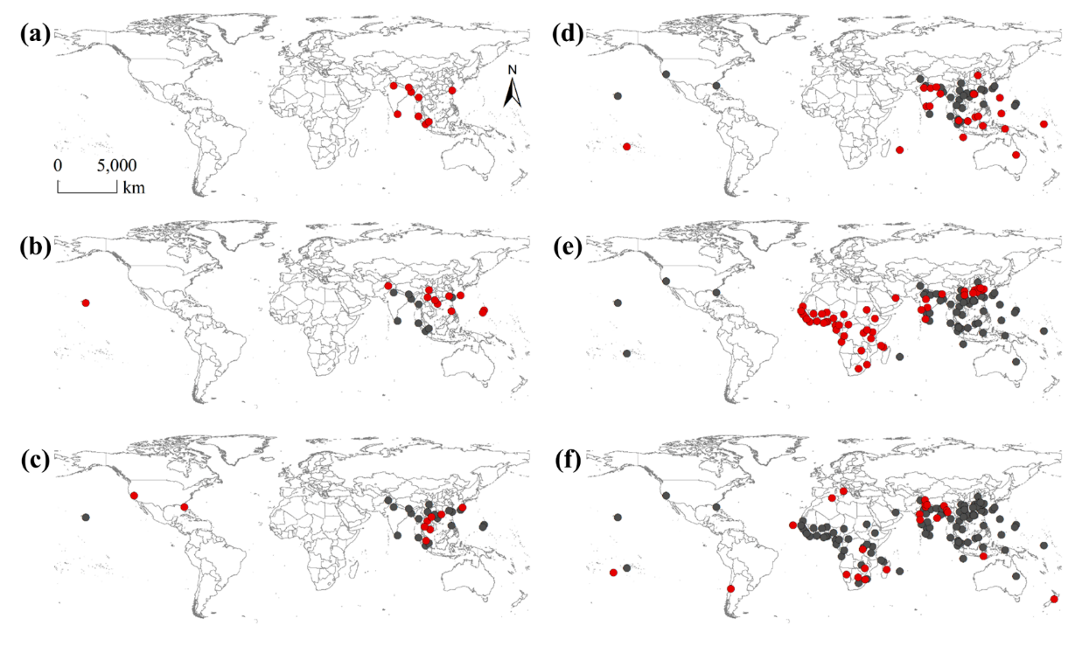
Figure S1

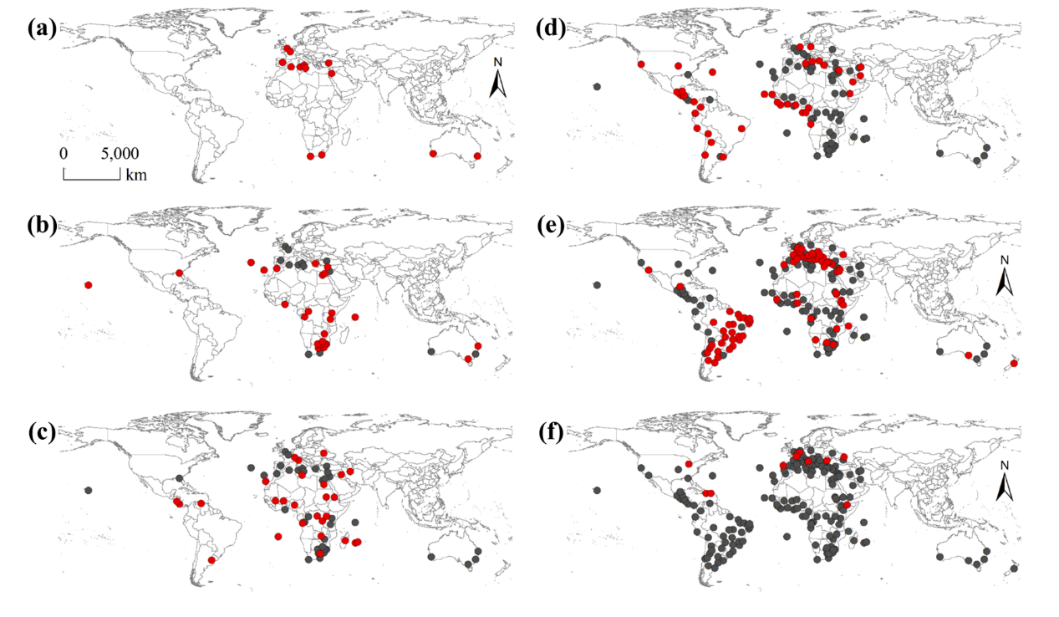
Figure S2

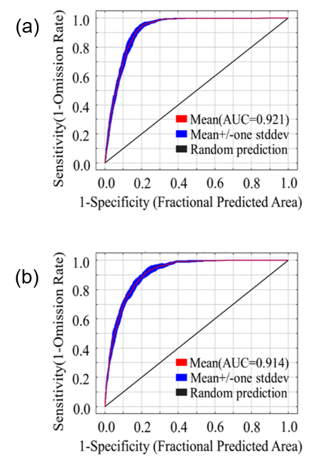
Figure S3

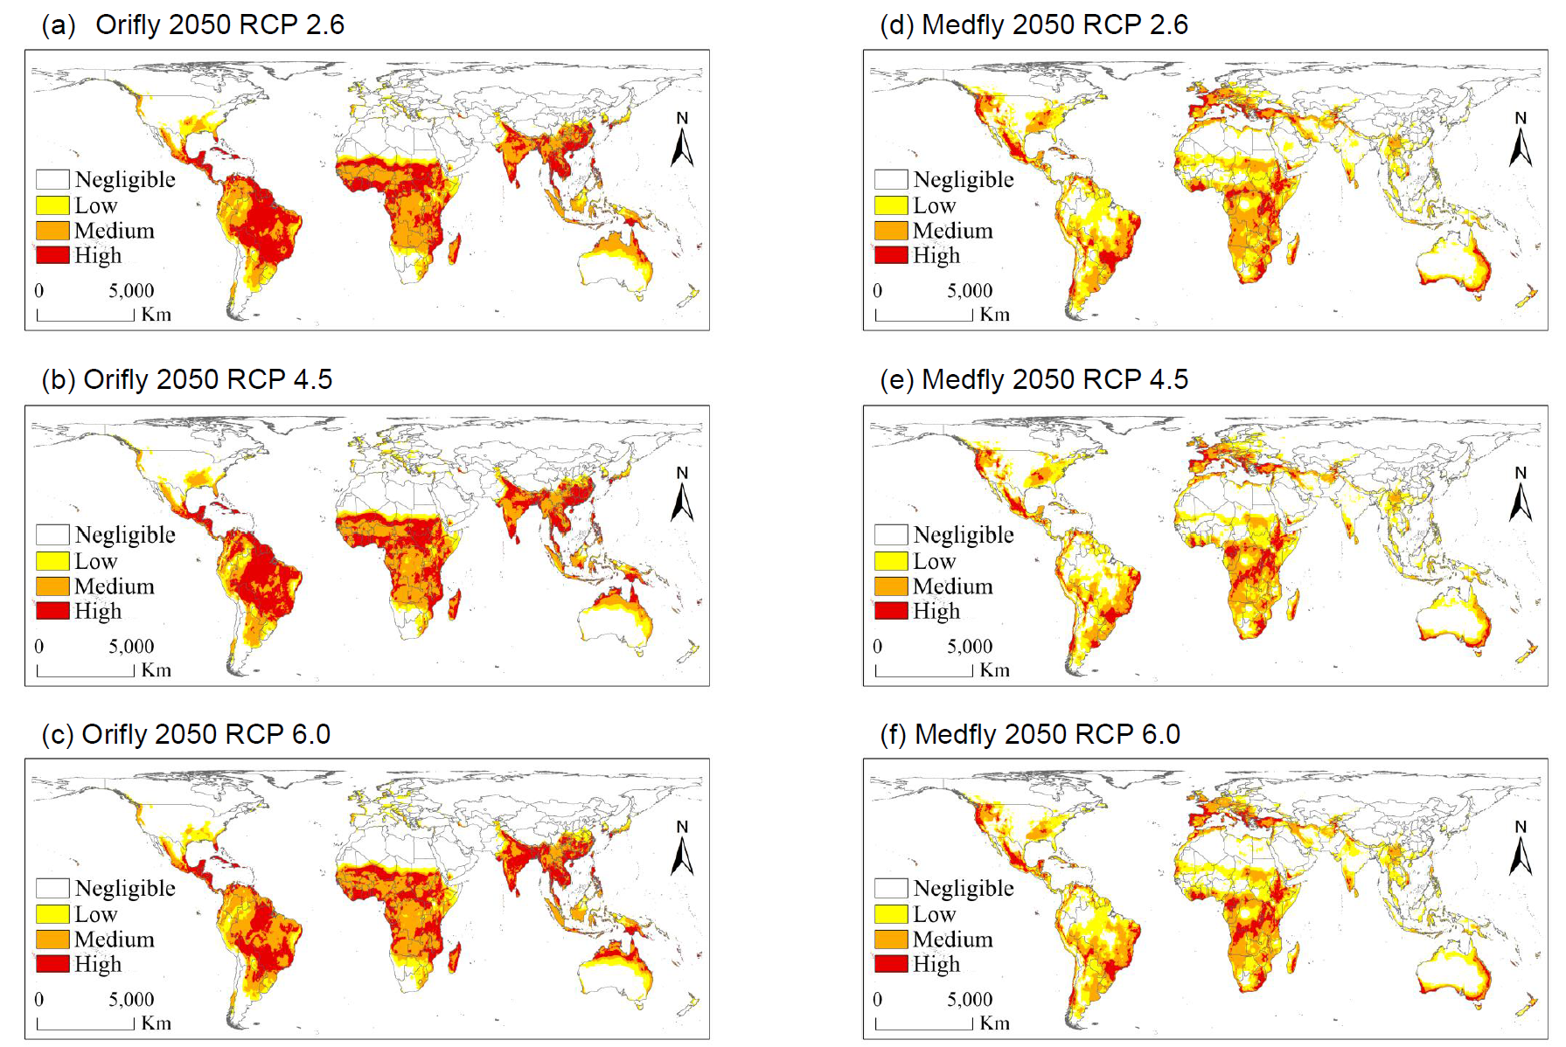
Figure S4

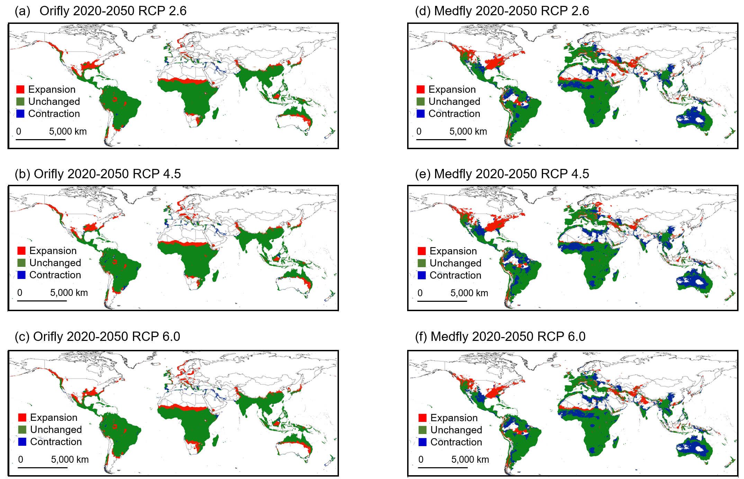
Figure S5

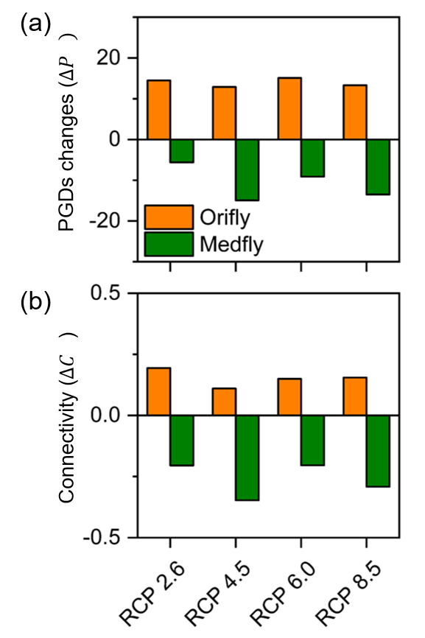
Figure S6

