SUPPLEMENTARY DIGITAL CONTENT

SUPPLEMENTARY METHODS
Antidepressants were defined into 5 categories: selective serotonin reuptake inhibitors (SSRIs), serotonin/norepinephrine reuptake inhibitors (SNRIs), serotonin modulators (SMODs), tricyclic antidepressants (TCAs), and atypical antidepressants. The most common drugs for each category were selected for inclusion. Drugs in the SSRIs category were sertraline, fluvoxamine, fluoxetine, paroxetine, citalopram, and escitalopram. Drugs in the SNRIs category include venlafaxine, desvenlafaxine, duloxetine, milnacipran, levomilnacipran. Drugs in the SMODs category included nefazodone, trazodone, vilazodone, and vortioxetine. Drugs in the TCA category were amitriptyline, clomipramine, doxepin, imipramine, trimipramine, desipramine, nortriptyline, protriptyline, maprotiline, and amoxapine. Drugs in the atypical antidepressant category included bupropion, mirtazapine, agomelatine.

Table S1. Drug Utilization
Drug Name | N
FLUOXETINE | 39
PAROXETINE | 23
SERTRALINE | 82
CITALOPRAM | 77
ESCITALOPRAM | 181
FLUVOXAMINE | 1
VENLAFAXINE | 41
DESVENLAFAXINE | 4
DULOXETINE | 48
MILNACIPRAN | 0
LEVOMILNACIPRAN | 0
AMITRIPTYLINE | 38
CLOMIPRAMINE | 1
DOXEPIN | 6
IMIPRAMINE | 0
TRIMIPRAMINE | 0
DESIPRAMINE | 0
NORTRIPTYLINE | 5
PROTRIPTYLINE | 0
MAPROTILINE | 0
AMOXAPINE | 0
BUPROPION | 31
MIRTAZAPINE | 42
AGOMELATINE | 0
REBOXETINE | 0
PHENELZINE | 0
TRANYLCYPROMINE | 0
ISOCARBOXAZID | 0
SELEGILINE | 1
MOCLOBEMIDE | 0
RASAGILINE | 3
NEFAZODONE | 0
TRAZODONE | 314
VILAZODONE | 4
VORTIOXETINE | 0

Table S2. Cox regression models for survival with various antidepressants

Selective Serotonin Reuptake Inhibitors |  |  |  | Imputed
Characteristic | HR | 95% CI | p-value | HR | 95% CI | p-value
SSRI use | 1.25 | 1.02, 1.54 | 0.035 | 1.35 | 1.16, 1.57 | <0.001
Age
< 45 | — | — |  | — | —
45-54 | 1.37 | 0.97, 1.93 | 0.07 | 1.4 | 1.12, 1.75 | 0.004
55-64 | 2.07 | 1.50, 2.85 | <0.001 | 1.81 | 1.47, 2.22 | <0.001
65-74 | 3.97 | 2.76, 5.69 | <0.001 | 2.92 | 2.33, 3.66 | <0.001
≥75 | 4.44 | 2.93, 6.72 | <0.001 | 3.57 | 2.77, 4.61 | <0.001
Comorbid Depression or Anxiety | 0.94 | 0.77, 1.13 | 0.5 | 0.83 | 0.72, 0.96 | 0.01
Insurance type
Private | — | — |  | — | —
Public | 0.68 | 0.54, 0.86 | <0.001 | 0.82 | 0.72, 0.95 | 0.006
Self-Pay/Indigent | 0.67 | 0.37, 1.23 | 0.2 | 1.31 | 0.95, 1.81 | 0.1
Race
White | — | — |  | — | —
Black | 0.86 | 0.64, 1.15 | 0.3 | 1 | 0.83, 1.21 | >0.9
Other | 1.01 | 0.65, 1.57 | >0.9 | 0.82 | 0.61, 1.10 | 0.2
High Neighborhood Disadvantage
FALSE | — | — |  | — | —
TRUE | 1.38 | 1.15, 1.65 | <0.001 | 1.25 | 1.10, 1.41 | <0.001
MGMT Status
Methylated | — | — |  | — | —
Unmethylated | 0.52 | 0.43, 0.62 | <0.001 | 0.53 | 0.47, 0.60 | <0.001
IDH status
IDH-Mut | — | — |  | — | —
IDH-WT | 0.61 | 0.42, 0.87 | 0.006 | 0.65 | 0.51, 0.84 | <0.001
Chemotherapy
No | — | — |  | — | —
Yes | 0.78 | 0.56, 1.08 | 0.13 | 0.77 | 0.60, 0.99 | 0.04
Radiotherapy
No | — | — |  | — | —
Yes | 0.27 | 0.19, 0.39 | <0.001 | 0.51 | 0.39, 0.67 | <0.001
Extent of Resection
Biopsy | — | — |  | — | —
Gross Total Resection | 0.58 | 0.46, 0.72 | <0.001 | 0.64 | 0.56, 0.74 | <0.001
Partial Resection | 0.73 | 0.58, 0.91 | 0.006 | 0.74 | 0.63, 0.87 | <0.001
RUCA
Metropolitan | — | — |  | — | —
Micropolitan | 0.84 | 0.66, 1.07 | 0.2 | 0.9 | 0.76, 1.06 | 0.2
Rural | 1.41 | 0.87, 2.28 | 0.2 | 1.4 | 1.02, 1.92 | 0.037
Small Town | 0.91 | 0.67, 1.24 | 0.6 | 1.18 | 0.96, 1.45 | 0.12
Abbreviations: CI = Confidence Interval, HR = Hazard Ratio

Serotonin/Norepinephrine Reuptake Inhibitors
Characteristic | HR | 95% CI | p-value | HR | 95% CI | p-value
SNRI use | 1.25 | 0.89, 1.75 | 0.2 | 1.35 | 1.05, 1.74 | 0.02
Age
< 45 | — | — |  | — | —
45-54 | 1.37 | 0.97, 1.92 | 0.071 | 1.4 | 1.12, 1.75 | 0.003
55-64 | 2.06 | 1.50, 2.84 | <0.001 | 1.83 | 1.49, 2.25 | <0.001
65-74 | 4.01 | 2.80, 5.76 | <0.001 | 2.99 | 2.39, 3.74 | <0.001
≥75 | 4.39 | 2.90, 6.65 | <0.001 | 3.56 | 2.76, 4.60 | <0.001
Comorbid Depression or Anxiety | 0.99 | 0.83, 1.19 | >0.9 | 0.9 | 0.79, 1.03 | 0.12
Insurance type
Private | — | — |  | — | —
Public | 0.67 | 0.53, 0.84 | <0.001 | 0.82 | 0.71, 0.95 | 0.006
Self-Pay/Indigent | 0.66 | 0.36, 1.20 | 0.2 | 1.31 | 0.95, 1.81 | 0.1
Race
White | — | — |  | — | —
Black | 0.83 | 0.62, 1.11 | 0.2 | 0.97 | 0.80, 1.17 | 0.7
Other | 1 | 0.64, 1.55 | >0.9 | 0.79 | 0.59, 1.07 | 0.13
High Neighborhood Disadvantage
FALSE | — | — |  | — | —
TRUE | 1.36 | 1.14, 1.63 | <0.001 | 1.23 | 1.08, 1.39 | 0.002
MGMT Status
Methylated | — | — |  | — | —
Unmethylated | 0.52 | 0.43, 0.62 | <0.001 | 0.52 | 0.46, 0.59 | <0.001
IDH status
IDH-Mut | — | — |  | — | —
IDH-WT | 0.61 | 0.43, 0.87 | 0.006 | 0.65 | 0.51, 0.84 | <0.001
Chemotherapy
No | — | — |  | — | —
Yes | 0.8 | 0.58, 1.11 | 0.2 | 0.78 | 0.61, 1.01 | 0.057
Radiotherapy
No | — | — |  | — | —
Yes | 0.26 | 0.19, 0.37 | <0.001 | 0.49 | 0.37, 0.64 | <0.001
Extent of Resection
Biopsy | — | — |  | — | —
Gross Total Resection | 0.58 | 0.47, 0.72 | <0.001 | 0.65 | 0.57, 0.75 | <0.001
Partial Resection | 0.72 | 0.58, 0.91 | 0.006 | 0.74 | 0.63, 0.87 | <0.001
RUCA
Metropolitan | — | — |  | — | —
Micropolitan | 0.85 | 0.67, 1.08 | 0.2 | 0.9 | 0.76, 1.06 | 0.2
Rural | 1.43 | 0.88, 2.31 | 0.15 | 1.44 | 1.05, 1.97 | 0.025
Small Town | 0.92 | 0.67, 1.25 | 0.6 | 1.19 | 0.97, 1.47 | 0.094
Abbreviations: CI = Confidence Interval, HR = Hazard Ratio

Serotonin Modulator use
Characteristic | HR | 95% CI | p-value | HR | 95% CI | p-value
Serotonin Modulator use | 1.63 | 1.42, 1.88 | <0.001 | 1.63 | 1.42, 1.88 | <0.001
Age
< 45 | — | — |  | — | —
45-54 | 1.36 | 1.09, 1.70 | 0.008 | 1.36 | 1.09, 1.70 | 0.008
55-64 | 1.76 | 1.43, 2.17 | <0.001 | 1.76 | 1.43, 2.17 | <0.001
65-74 | 2.98 | 2.38, 3.73 | <0.001 | 2.98 | 2.38, 3.73 | <0.001
≥75 | 3.56 | 2.76, 4.60 | <0.001 | 3.56 | 2.76, 4.60 | <0.001
Comorbid Depression or Anxiety | 0.87 | 0.76, 0.99 | 0.03 | 0.87 | 0.76, 0.99 | 0.03
Insurance type
Private | — | — |  | — | —
Public | 0.8 | 0.70, 0.93 | 0.002 | 0.8 | 0.70, 0.93 | 0.002
Self-Pay/Indigent | 1.23 | 0.89, 1.71 | 0.2 | 1.23 | 0.89, 1.71 | 0.2
Race
White | — | — |  | — | —
Black | 0.96 | 0.80, 1.16 | 0.7 | 0.96 | 0.80, 1.16 | 0.7
Other | 0.8 | 0.59, 1.08 | 0.2 | 0.8 | 0.59, 1.08 | 0.2
High Neighborhood Disadvantage
FALSE | — | — |  | — | —
TRUE | 1.24 | 1.09, 1.40 | 0.001 | 1.24 | 1.09, 1.40 | 0.001
MGMT Status
Methylated | — | — |  | — | —
Unmethylated | 0.53 | 0.47, 0.60 | <0.001 | 0.53 | 0.47, 0.60 | <0.001
IDH status
IDH-Mut | — | — |  | — | —
IDH-WT | 0.7 | 0.54, 0.89 | 0.005 | 0.7 | 0.54, 0.89 | 0.005
Chemotherapy
No | — | — |  | — | —
Yes | 0.8 | 0.62, 1.02 | 0.069 | 0.8 | 0.62, 1.02 | 0.069
Radiotherapy
No | — | — |  | — | —
Yes | 0.47 | 0.37, 0.62 | <0.001 | 0.47 | 0.37, 0.62 | <0.001
Extent of Resection
Biopsy | — | — |  | — | —
Gross Total Resection | 0.65 | 0.57, 0.75 | <0.001 | 0.65 | 0.57, 0.75 | <0.001
Partial Resection | 0.72 | 0.61, 0.84 | <0.001 | 0.72 | 0.61, 0.84 | <0.001
RUCA
Metropolitan | — | — |  | — | —
Micropolitan | 0.9 | 0.76, 1.06 | 0.2 | 0.9 | 0.76, 1.06 | 0.2
Rural | 1.43 | 1.04, 1.96 | 0.026 | 1.43 | 1.04, 1.96 | 0.026
Small Town | 1.22 | 0.99, 1.50 | 0.062 | 1.22 | 0.99, 1.50 | 0.062
Abbreviations: CI = Confidence Interval, HR = Hazard Ratio

Tricyclics
Characteristic | HR | 95% CI | p-value | HR | 95% CI | p-value
Tricyclic Use | 1.84 | 1.21, 2.80 | 0.005 | 1.43 | 1.04, 1.97 | 0.027
Age
< 45 | — | — |  | — | —
45-54 | 1.34 | 0.96, 1.88 | 0.09 | 1.4 | 1.12, 1.75 | 0.004
55-64 | 2.09 | 1.52, 2.87 | <0.001 | 1.85 | 1.51, 2.28 | <0.001
65-74 | 4.02 | 2.80, 5.76 | <0.001 | 2.99 | 2.39, 3.74 | <0.001
≥75 | 4.27 | 2.83, 6.45 | <0.001 | 3.55 | 2.75, 4.58 | <0.001
Comorbid Depression or Anxiety | 1.01 | 0.85, 1.20 | >0.9 | 0.93 | 0.81, 1.05 | 0.2
Insurance type
Private | — | — |  | — | —
Public | 0.69 | 0.55, 0.86 | 0.001 | 0.83 | 0.72, 0.95 | 0.008
Self-Pay/Indigent | 0.68 | 0.37, 1.23 | 0.2 | 1.3 | 0.94, 1.79 | 0.12
Race
White | — | — |  | — | —
Black | 0.78 | 0.58, 1.05 | 0.1 | 0.96 | 0.80, 1.16 | 0.7
Other | 1.01 | 0.65, 1.56 | >0.9 | 0.8 | 0.59, 1.07 | 0.13
High Neighborhood Disadvantage
FALSE | — | — |  | — | —
TRUE | 1.34 | 1.12, 1.61 | 0.002 | 1.23 | 1.08, 1.39 | 0.001
MGMT Status
Methylated | — | — |  | — | —
Unmethylated | 0.52 | 0.43, 0.62 | <0.001 | 0.52 | 0.46, 0.59 | <0.001
IDH status
IDH-Mut | — | — |  | — | —
IDH-WT | 0.59 | 0.42, 0.85 | 0.004 | 0.65 | 0.51, 0.84 | <0.001
Chemotherapy
No | — | — |  | — | —
Yes | 0.78 | 0.56, 1.09 | 0.14 | 0.78 | 0.61, 1.01 | 0.056
Radiotherapy
No | — | — |  | — | —
Yes | 0.28 | 0.20, 0.39 | <0.001 | 0.5 | 0.38, 0.65 | <0.001
Extent of Resection
Biopsy | — | — |  | — | —
Gross Total Resection | 0.58 | 0.47, 0.72 | <0.001 | 0.64 | 0.56, 0.74 | <0.001
Partial Resection | 0.73 | 0.58, 0.92 | 0.007 | 0.74 | 0.63, 0.87 | <0.001
RUCA
Metropolitan | — | — |  | — | —
Micropolitan | 0.85 | 0.67, 1.08 | 0.2 | 0.89 | 0.76, 1.06 | 0.2
Rural | 1.43 | 0.88, 2.32 | 0.14 | 1.42 | 1.04, 1.95 | 0.029
Small Town | 0.92 | 0.68, 1.26 | 0.6 | 1.19 | 0.97, 1.46 | 0.1
Abbreviations: CI = Confidence Interval, HR = Hazard Ratio

Monoamine Oxidase Inhibitors
Characteristic | HR | 95% CI | p-value | HR | 95% CI | p-value
MAOI use | 0.87 | 0.22, 3.48 | 0.8 | 0.87 | 0.22, 3.48 | 0.8
Age
< 45 | — | — |  | — | —
45-54 | 1.4 | 1.12, 1.75 | 0.003 | 1.4 | 1.12, 1.75 | 0.003
55-64 | 1.83 | 1.49, 2.26 | <0.001 | 1.83 | 1.49, 2.26 | <0.001
65-74 | 2.98 | 2.38, 3.73 | <0.001 | 2.98 | 2.38, 3.73 | <0.001
≥75 | 3.52 | 2.72, 4.54 | <0.001 | 3.52 | 2.72, 4.54 | <0.001
Comorbid Depression or Anxiety | 0.93 | 0.82, 1.06 | 0.3 | 0.93 | 0.82, 1.06 | 0.3
Insurance type
Private | — | — |  | — | —
Public | 0.83 | 0.72, 0.95 | 0.008 | 0.83 | 0.72, 0.95 | 0.008
Self-Pay/Indigent | 1.31 | 0.95, 1.80 | 0.11 | 1.31 | 0.95, 1.80 | 0.11
Race
White | — | — |  | — | —
Black | 0.96 | 0.80, 1.16 | 0.7 | 0.96 | 0.80, 1.16 | 0.7
Other | 0.79 | 0.59, 1.06 | 0.12 | 0.79 | 0.59, 1.06 | 0.12
High Neighborhood Disadvantage
FALSE | — | — |  | — | —
TRUE | 1.23 | 1.08, 1.40 | 0.001 | 1.23 | 1.08, 1.40 | 0.001
MGMT Status
Methylated | — | — |  | — | —
Unmethylated | 0.52 | 0.46, 0.59 | <0.001 | 0.52 | 0.46, 0.59 | <0.001
IDH status
IDH-Mut | — | — |  | — | —
IDH-WT | 0.65 | 0.51, 0.84 | <0.001 | 0.65 | 0.51, 0.84 | <0.001
Chemotherapy
No | — | — |  | — | —
Yes | 0.78 | 0.61, 1.01 | 0.056 | 0.78 | 0.61, 1.01 | 0.056
Radiotherapy
No | — | — |  | — | —
Yes | 0.49 | 0.37, 0.64 | <0.001 | 0.49 | 0.37, 0.64 | <0.001
Extent of Resection
Biopsy | — | — |  | — | —
Gross Total Resection | 0.65 | 0.56, 0.74 | <0.001 | 0.65 | 0.56, 0.74 | <0.001
Partial Resection | 0.74 | 0.63, 0.87 | <0.001 | 0.74 | 0.63, 0.87 | <0.001
RUCA
Metropolitan | — | — |  | — | —
Micropolitan | 0.89 | 0.75, 1.05 | 0.2 | 0.89 | 0.75, 1.05 | 0.2
Rural | 1.41 | 1.03, 1.93 | 0.034 | 1.41 | 1.03, 1.93 | 0.034
Small Town | 1.19 | 0.97, 1.46 | 0.1 | 1.19 | 0.97, 1.46 | 0.1
Abbreviations: CI = Confidence Interval, HR = Hazard Ratio

Atypical Antidepressants
Characteristic | HR | 95% CI | p-value | HR | 95% CI | p-value
Atypical Antidepressant Use | 1.33 | 0.93, 1.90 | 0.11 | 1.52 | 1.15, 2.02 | 0.004
Age
< 45 | — | — |  | — | —
45-54 | 1.36 | 0.97, 1.91 | 0.075 | 1.38 | 1.10, 1.73 | 0.005
55-64 | 2.07 | 1.50, 2.84 | <0.001 | 1.82 | 1.48, 2.24 | <0.001
65-74 | 3.95 | 2.75, 5.66 | <0.001 | 2.96 | 2.36, 3.70 | <0.001
≥75 | 4.22 | 2.79, 6.39 | <0.001 | 3.46 | 2.68, 4.47 | <0.001
Comorbid Depression or Anxiety | 0.99 | 0.83, 1.18 | >0.9 | 0.91 | 0.79, 1.03 | 0.13
Insurance type
Private | — | — |  | — | —
Public | 0.67 | 0.54, 0.85 | <0.001 | 0.82 | 0.71, 0.94 | 0.005
Self-Pay/Indigent | 0.64 | 0.35, 1.17 | 0.2 | 1.26 | 0.91, 1.75 | 0.2
Race
White | — | — |  | — | —
Black | 0.81 | 0.61, 1.09 | 0.2 | 0.96 | 0.80, 1.16 | 0.7
Other | 1.01 | 0.65, 1.56 | >0.9 | 0.8 | 0.59, 1.08 | 0.15
High Neighborhood Disadvantage
FALSE | — | — |  | — | —
TRUE | 1.36 | 1.13, 1.63 | <0.001 | 1.22 | 1.07, 1.38 | 0.002
MGMT Status
Methylated | — | — |  | — | —
Unmethylated | 0.52 | 0.43, 0.62 | <0.001 | 0.52 | 0.46, 0.59 | <0.001
IDH status
IDH-Mut | — | — |  | — | —
IDH-WT | 0.61 | 0.42, 0.86 | 0.006 | 0.65 | 0.51, 0.84 | <0.001
Chemotherapy
No | — | — |  | — | —
Yes | 0.8 | 0.57, 1.11 | 0.2 | 0.78 | 0.60, 1.00 | 0.048
Radiotherapy
No | — | — |  | — | —
Yes | 0.26 | 0.18, 0.37 | <0.001 | 0.49 | 0.37, 0.64 | <0.001
Extent of Resection
Biopsy | — | — |  | — | —
Gross Total Resection | 0.57 | 0.46, 0.71 | <0.001 | 0.64 | 0.56, 0.74 | <0.001
Partial Resection | 0.72 | 0.57, 0.91 | 0.005 | 0.74 | 0.63, 0.87 | <0.001
RUCA
Metropolitan | — | — |  | — | —
Micropolitan | 0.85 | 0.67, 1.09 | 0.2 | 0.9 | 0.76, 1.06 | 0.2
Rural | 1.45 | 0.89, 2.35 | 0.13 | 1.45 | 1.05, 1.99 | 0.022
Small Town | 0.93 | 0.68, 1.27 | 0.7 | 1.21 | 0.99, 1.50 | 0.068
Abbreviations: CI = Confidence Interval, HR = Hazard Ratio

Any antidepressant USE
Characteristic | HR | 95% CI | p-value | HR | 95% CI | p-value
Any antidepressant use | 1.57 | 1.38, 1.78 | <0.001 | 1.57 | 1.38, 1.78 | <0.001
Age
< 45 | — | — |  | — | —
45-54 | 1.34 | 1.07, 1.68 | 0.01 | 1.34 | 1.07, 1.68 | 0.01
55-64 | 1.74 | 1.41, 2.14 | <0.001 | 1.74 | 1.41, 2.14 | <0.001
65-74 | 2.81 | 2.24, 3.51 | <0.001 | 2.81 | 2.24, 3.51 | <0.001
≥75 | 3.49 | 2.71, 4.51 | <0.001 | 3.49 | 2.71, 4.51 | <0.001
Comorbid Depression or Anxiety | 0.77 | 0.67, 0.88 | <0.001 | 0.77 | 0.67, 0.88 | <0.001
Insurance type
Private | — | — |  | — | —
Public | 0.81 | 0.70, 0.93 | 0.003 | 0.81 | 0.70, 0.93 | 0.003
Self-Pay/Indigent | 1.23 | 0.89, 1.70 | 0.2 | 1.23 | 0.89, 1.70 | 0.2
Race
White | — | — |  | — | —
Black | 1 | 0.83, 1.20 | >0.9 | 1 | 0.83, 1.20 | >0.9
Other | 0.84 | 0.62, 1.14 | 0.3 | 0.84 | 0.62, 1.14 | 0.3
High Neighborhood Disadvantage
FALSE | — | — |  | — | —
TRUE | 1.23 | 1.08, 1.40 | 0.001 | 1.23 | 1.08, 1.40 | 0.001
MGMT Status
Methylated | — | — |  | — | —
Unmethylated | 0.55 | 0.48, 0.62 | <0.001 | 0.55 | 0.48, 0.62 | <0.001
IDH status
IDH-Mut | — | — |  | — | —
IDH-WT | 0.66 | 0.51, 0.84 | 0.001 | 0.66 | 0.51, 0.84 | 0.001
Chemotherapy
No | — | — |  | — | —
Yes | 0.77 | 0.60, 0.99 | 0.038 | 0.77 | 0.60, 0.99 | 0.038
Radiotherapy
No | — | — |  | — | —
Yes | 0.51 | 0.39, 0.67 | <0.001 | 0.51 | 0.39, 0.67 | <0.001
Extent of Resection
Biopsy | — | — |  | — | —
Gross Total Resection | 0.63 | 0.55, 0.73 | <0.001 | 0.63 | 0.55, 0.73 | <0.001
Partial Resection | 0.72 | 0.61, 0.84 | <0.001 | 0.72 | 0.61, 0.84 | <0.001
RUCA
Metropolitan | — | — |  | — | —
Micropolitan | 0.92 | 0.77, 1.08 | 0.3 | 0.92 | 0.77, 1.08 | 0.3
Rural | 1.46 | 1.06, 2.00 | 0.019 | 1.46 | 1.06, 2.00 | 0.019
Small Town | 1.22 | 0.99, 1.50 | 0.061 | 1.22 | 0.99, 1.50 | 0.061
Abbreviations: CI = Confidence Interval, HR = Hazard Ratio

Table S3. Cox Regression analysis for antidepressant use in depression/anxiety only
Depression Only
Characteristic | HR | 95% CI | p-value
Antidepressant Use
No | — | —
Yes | 2.46 | 1.85, 3.26 | <0.001
Age
< 45 | — | —
45-54 | 1.82 | 1.22, 2.71 | 0.003
55-64 | 2.01 | 1.40, 2.89 | <0.001
65-74 | 2.69 | 1.80, 4.02 | <0.001
≥75 | 4.57 | 2.70, 7.76 | <0.001
Insurance Type
Private | — | —
Public | 0.82 | 0.62, 1.09 | 0.2
Self-Pay/Indigent | 2.35 | 1.15, 4.82 | 0.02
Race
White | — | —
Black | 1.11 | 0.79, 1.58 | 0.5
Other | 0.59 | 0.22, 1.60 | 0.3
High Neighborhood Disadvantage
No | — | —
Yes | 1.51 | 1.17, 1.94 | 0.001
MGMT Status
Unmethylated | — | —
Methylated | 0.52 | 0.41, 0.67 | <0.001
IDH Status
Wildtype | — | —
Mutant | 0.58 | 0.37, 0.89 | 0.013
Chemotherapy
No | — | —
Yes | 0.62 | 0.39, 0.99 | 0.047
Radiotherapy
No | — | —
Yes | 0.18 | 0.11, 0.31 | <0.001
Extent of Resection
Biopsy | — | —
Gross Total Resection | 0.75 | 0.58, 0.98 | 0.036
Partial Resection | 1.11 | 0.82, 1.50 | 0.5
RUCA
Metropolitan | — | —
Micropolitan | 0.91 | 0.64, 1.29 | 0.6
Rural | 0.91 | 0.52, 1.59 | 0.7
Small Town | 1.27 | 0.89, 1.80 | 0.2
Abbreviations: CI = Confidence Interval, HR = Hazard Ratio

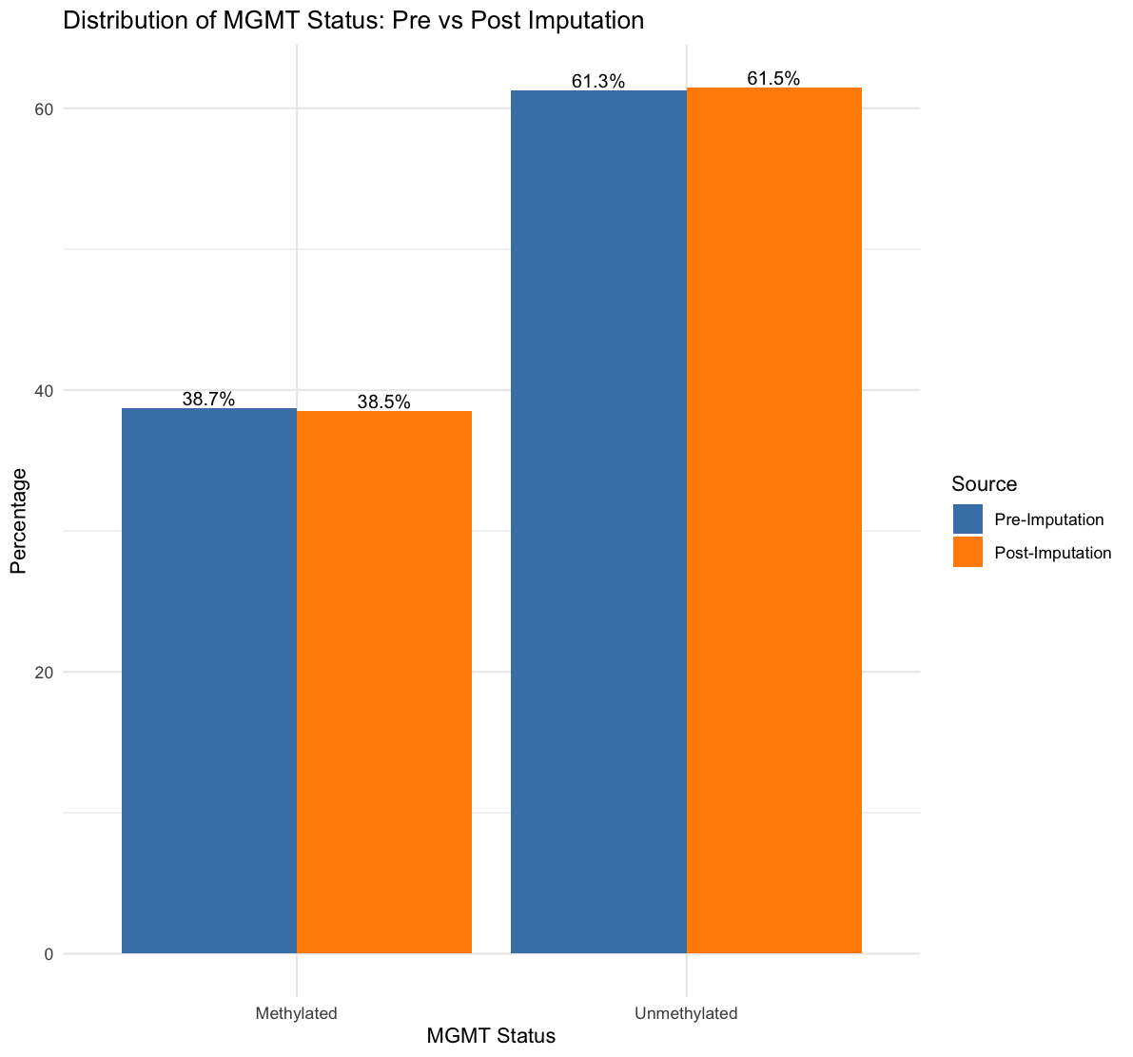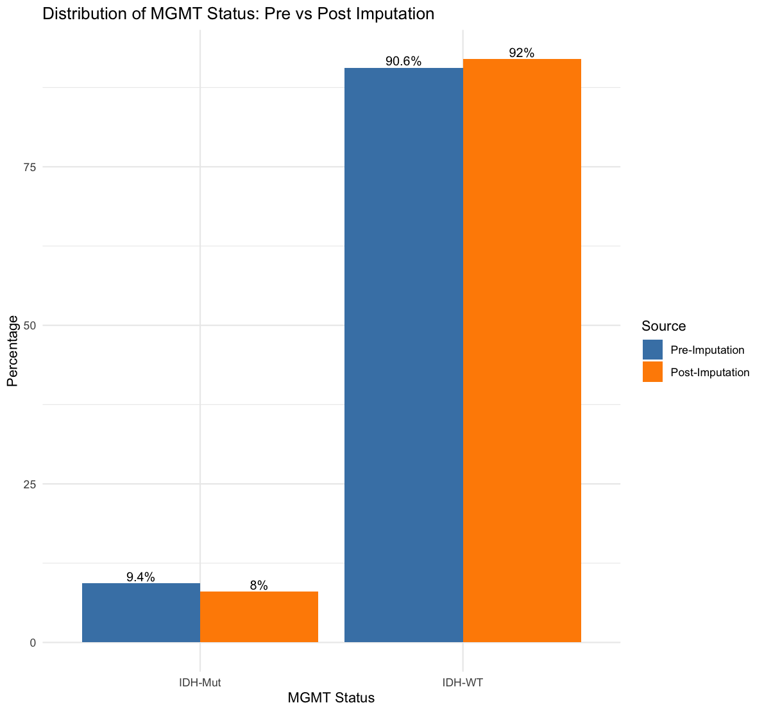

Figure S1. MGMT methylation and IDH status pre and post imputation

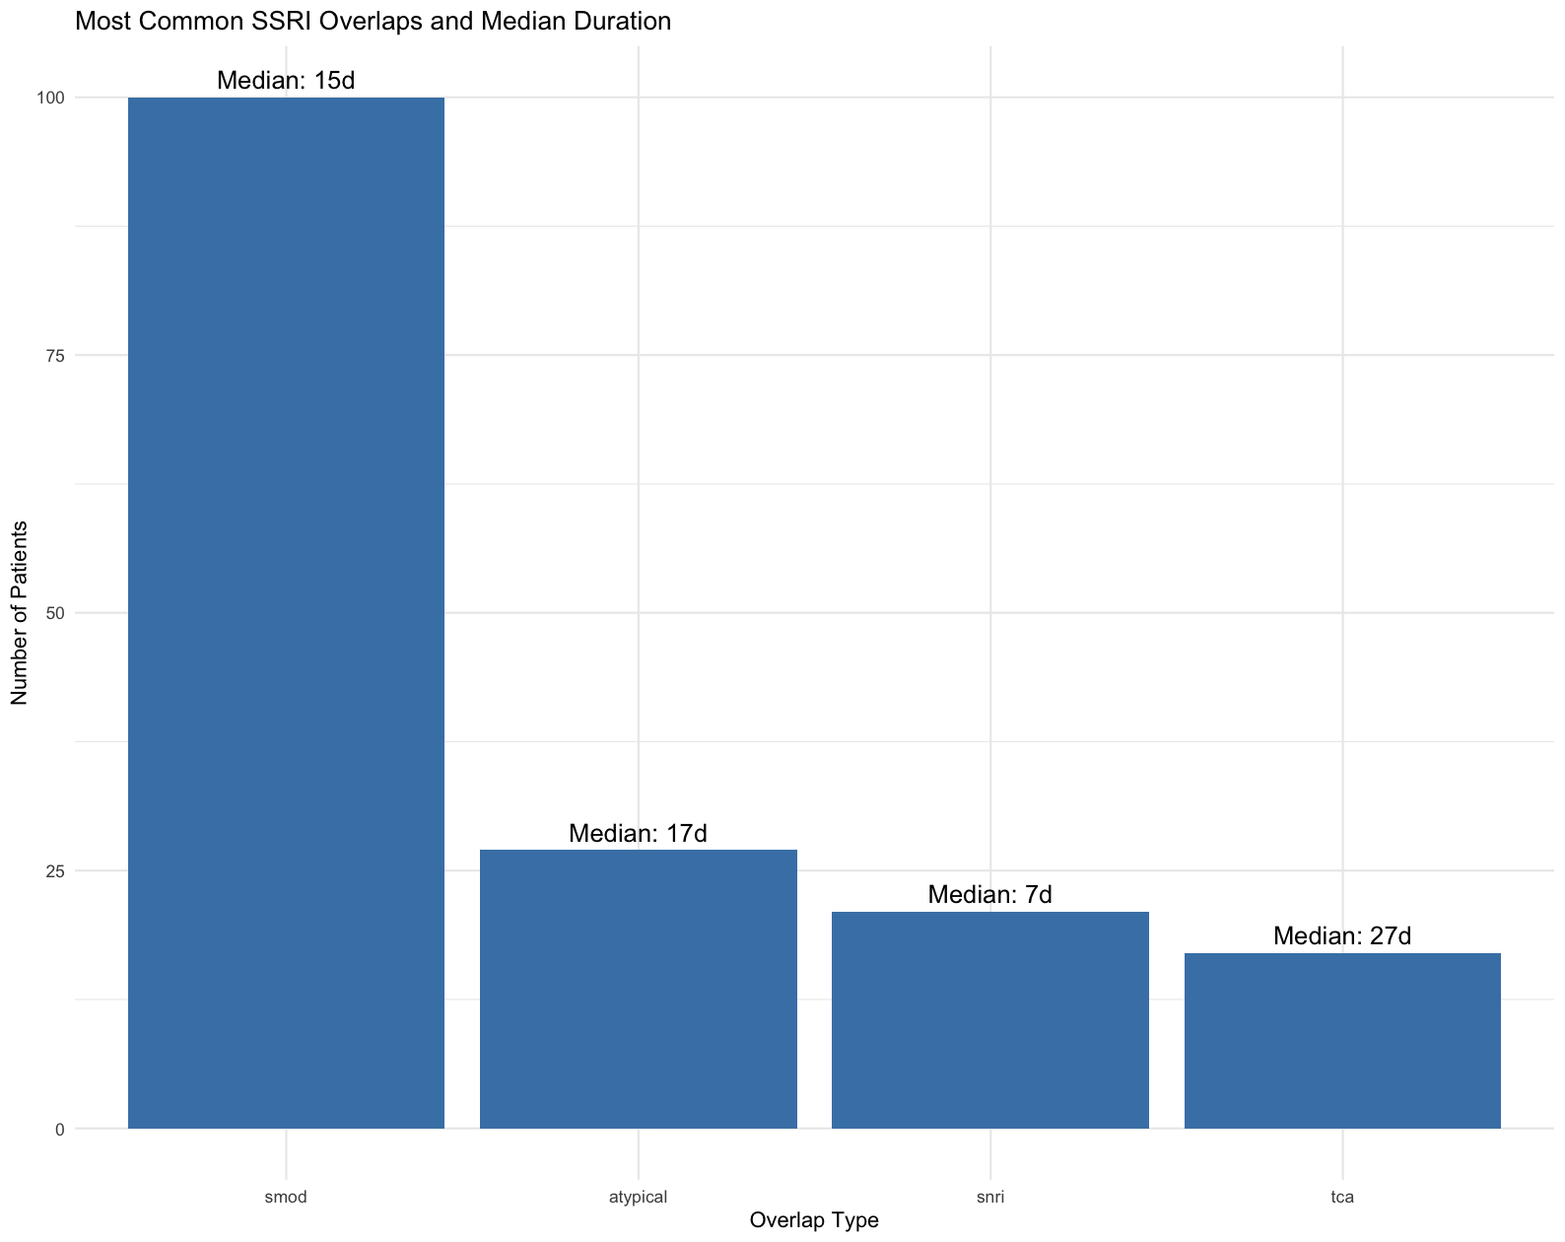

Figure S2. Most common forms of polytherapy

