Supporting Information for “Ratoon rice allows millions of smallholders to meet production and environmental goals” by Yuan et al.

CONTENTS

- Rice production in the study region 2

- Nitrogen surplus estimation 2

- Greenhouse gas emissions estimation 3

- Site selection 5

- Yield potential simulation 5

- Historical harvested area and yield trends 6

Supplementary Figures S1-8 8-15
Supplementary Tables S1-22 16-38
Additional References associated with Supplementary Information 39

1. Rice production in the study region
In our analysis, we focused on fourteen provincial-level administrative regions (referred to as provinces) where ratoon rice system (RR) is commercially cultivated by farmers (Extended Data Fig. 1). RR coexists with both single-season rice (SR) and double-season rice (DR) systems in the provinces of Anhui, Fujian, Guangxi, Hubei, Hunan, Jiangxi, Yunnan, and Zhejiang. RR is grown alongside SR in Guizhou, Henan, Jiangsu, Sichuan, and Chongqing provinces, and alongside DR in Guangdong province (Extended Data Fig. 1, Supplementary Fig. S1). Collectively, these fourteen provinces account for over 70% and 97% of the national harvested areas for SR and DR, averaging 19.9 million hectares and 9.9 million hectares, respectively, between 2020 and 2022¹. Detailed information on harvested rice area, total rice production, and their contributions to the national totals for each province is provided in Supplementary Table S1. In this study, we employed a two-step approach to identify major rice-producing regions and dominant rice systems in each province. First, we identified the major rice-producing regions in each province. Then, within these regions, we determined the dominant rice cropping systems. This process resulted in a total of 183 region-system combinations, including 103 for SR, 40 for DR, and 40 for RR (Extended Data Fig. 1). Additionally, crop calendars illustrating the temporal distribution of rice farming in each system and province are shown in Supplementary Figs. S2 and S3, highlighting the temporal patterns of rice farming. The rice cropping systems across these provinces vary considerably in crop management practices and yields, with specific information on agronomic inputs and rice productivity detailed in Supplementary Tables S4-6.

2. Nitrogen surplus estimation
Nitrogen (N) surplus, which is the difference between external N inputs (such as synthetic N fertilizer, manure, and biological N fixation) and N removal through harvested grain and straw, were assessed for each rice season. These included SR, the early and late seasons of DR, and the main and ratoon seasons of RR. N inputs were calculated for each rice growing season in each province. Synthetic N fertilizer inputs were obtained directly from our farm surveys. Manure N inputs were estimated based on the amount and type of manure applied in paddy fields, assuming an average N concentration of 0.6% for animal manure and 0.3% for plant compost². Biological N fixation was assumed to contribute 25 kg N per hectare for lowland rice³. N inputs from atmospheric deposition and irrigation water were not included, as they are typically offset by N losses from leaching and denitrification⁴.

Grain N removal was calculated based on average grain yield and grain N concentration (Supplementary Table S11). N removal through straw was estimated by considering the fraction of straw left as mulch, incorporated into the soil, burned in the field, or removed from the field, associated N loss factors from straw under these management practices, and typical N concentration in rice straw (Supplementary Table S12). Straw biomass was estimated using a harvest index of 0.5, representing the ratio of grain yield to total above-ground biomass⁵.

The yield-scaled N surplus was calculated by dividing the N surplus by grain yield, expressed as kilograms of N per Mg of rice grain (Fig. 2). This metric standardizes N surplus across different rice systems and regions, providing insight into nitrogen use efficiency. A threshold N balance of 75 kg N ha⁻¹ was used to estimate potential N loss (Fig. 3), as losses tend to increase substantially when N balance exceeds this level, according to previous studies^{6,7}.

3. Greenhouse gas emissions estimation
In our analysis, we estimated CO₂, methane (CH₄), and nitrous oxide (N₂O) emissions separately for each rice growing season (including SR, the early and late seasons of DR, and the main and ratoon seasons of RR) across all 183 region-system combinations. Emissions from agricultural inputs were calculated by multiplying the quantity of each input by its corresponding emission factor, and then summing the values for all inputs used within each rice season (Extended Data Fig. 1, Supplementary Tables S4-6 and S8). For emissions from fossil fuel consumption in field operations, estimates were based on the type and number of operations performed and their specific fuel requirements (Supplementary Table S9).

CH₄ emissions from rice paddy fields were calculated using the Intergovernmental Panel on Climate Change (IPCC) tier-2 methodology^{8,9}:
$${CH}_{4} emission (kg {CH}_{4} {ha}^{-1})=GD×{EF}_{C}×{SF}_{W}×{SF}_{P}×{SF}_{O}$$
where:
GD is the crop growth duration for each rice season, calculated based on the dates of crop establishment and harvest.
EF_{C} is a baseline emission factor for continuously flooded fields without organic amendments.
SF_{W} and SF_{P} are scaling factors accounting for differences in water regime during the cultivation period and the pre-season, respectively.
SF_{O} is a scaling factor for the type and amount of organic amendment applied, calculated as:
$${SF}_{O}={\left(1+\sum_{i}{{ROA}_{i}×{CFOA}_{i}}\right)}^{0.59}$$
where:
ROA_{i} is the application rate of organic amendment i.
CFOA_{i} is the conversion factor for organic amendment i.

Total N₂O emissions were calculated as the sum of direct and indirect N₂O emissions. Direct soil N₂O emissions for a given rice season were calculated based on the magnitude of the N surplus, as per van Groenigen et al.¹⁰:
$$N_{2}O emissions \left(kg N_{2}O-N {ha}^{-1}\right)=1.435+0.081×e^{0.0443×N surplus}$$
where N surplus defined as the difference between N inputs and crop N uptake.

Indirect N₂O emissions were estimated using the IPCC methodology, assuming that indirect N₂O emissions represent 20% of direct N₂O emissions^{8,9}.

All emissions were converted to CO₂-equivalent (CO₂-eq) values using the 100-year global warming potentials of CH₄ and N₂O, which are 25 and 298 times the intensity of CO₂ on a mass basis¹¹, respectively. For each rice growing season, we calculated the GWP by summing the CO₂, CH4, and N₂O emissions, all expressed as CO₂-eq (Supplementary Fig. S5). For systems with two rice-growing seasons per year, emissions from DR and RR were calculated as the sum of emissions from the early and late seasons, and the main and ratoon seasons, respectively. Yield-scaled GWP (kg CO₂-eq Mg⁻¹ of rice grain) was calculated as the quotient between GWP and rice grain yield (Fig. 2).

4. Site selection
Following the established protocols from the Global Yield Gap Atlas (www.yieldgap.org), we employed the Spatial Production Allocation Model (SPAM 2020; www.mapspam.info) to identify the major rice-producing regions in China (Extended Data Fig. 1). We selected reference weather station (RWS) buffers and climate zones (CZ) based on previous studies¹². RWS buffers represented geographic areas surrounding weather stations that capture local climatic conditions affecting rice growth, while CZs were broader regions defined by similar climate patterns, essential for understanding environmental influences on rice cultivation¹³. In total, we identified 50 RWS buffers across the country, including 38 buffers within the 14 selected provinces (32 for SR, 21 for DR, and 26 for RR) and 12 in the remaining provinces (12 for SR). Some RWS buffers overlapped across systems, indicating regions where multiple rice cropping systems coexist (Extended Data Fig. 1). Accordingly, we selected 22 CZs in total, comprising 14 within the 14 selected provinces (12 for SR, 8 for DR, and 13 for RR) and 8 in the remaining provinces (8 for SR), with similar overlaps observed in these areas. The rice harvested areas located within the selected RWS buffers and CZs in the 14 provinces represented 61% and 92% of the total rice area in those provinces, respectively, and 49% and 74% of the national total. Altogether, the selected RWS buffers and CZs from all provinces accounted for 63% and 91% of the national rice harvested area, respectively. This extensive coverage highlights the representativeness of our selected regions, ensuring that the findings are applicable to a substantial portion of China’s rice production landscape (Extended Data Fig. 1).

5. Yield potential simulation
Rice yield potential was estimated to determine the attainable yield (defined as 80% of yield potential) for each rice-growing season across 183 region-system combinations¹⁴. For DR and RR systems, which involve more than one rice season, the average yield potential was calculated by averaging the yield potential across all rice seasons based on the harvested rice area. Yield potential was simulated using the ORYZA v3 model for SR and DR, and the ORYZA_R model for RR^{15,16}. Simulations were based on actual crop management practices, measured daily weather data, soil properties, and genetic coefficients of representative rice varieties¹⁷. Crop management data were collected through farm surveys and consultations with local agronomists and extension agents (Supplementary Table S2). This included information on dominant rice systems, their proportion of total harvested area in each region, crop establishment methods (transplanting or direct-seeding), sowing and/or transplanting dates, planting density, seedling age for transplanted rice, dominant rice variety names and maturities for SR, DR (early and late seasons), and RR (main and ratoon seasons). Data on cutting heights for the ratoon season of RR were collected. Long-term (2003 to 2022) measured daily weather data, including solar radiation, minimum and maximum temperatures, precipitation, vapor pressure deficit, and wind speed, were collected for all 50 identified RWS (Extended Data Fig. 1). The weather data were subjected to rigorous quality control measures to fill in missing data and correct erroneous values using linear interpolation^{18,19}. In simulations of irrigated rice yield potential, soil properties were not explicitly specified, as yield potential for irrigated rice assumes no limitations from water or nutrient availability^{12,20}. Thus, default soil properties for paddy rice in China were used.

Widely cultivated rice varieties in each region, identified through surveys and literature, were used in the simulations. Both inbred and hybrid rice varieties were considered, reflecting their respective proportions in each region. Hybrid rice typically has a 10-15% higher yield than inbred rice and accounts for more than half of the harvested rice area in China²¹⁻²³. For example, in Hubei Province, simulations for SR included Huanghuazhan (inbred) and Yangliangyou6 (hybrid); for DR, Zhongjiazao17 (inbred) and Liangyou287 (hybrid) were used for the early season, and Xiangzaoxian45 (inbred) and Tianyouhuazhan (hybrid) for the late season. For RR, Huahuazhan (inbred) and Fengliangyouxiang1 (hybrid) were used (Supplementary Table S13). In regions where both variety types are grown, yield potential was calculated as a weighted average based on the harvested area proportions of inbred and hybrid rice²⁴ (Supplementary Fig. S7). Likewise, yield potential was also simulated for the rest of the provinces by following the same approach. For example, while Kongyu131 was used in earlier studies for Northeast China²⁵, our simulations used Longeng31, a newer variety with higher yield potential that has replaced Kongyu131 in recent years²⁴ (Supplementary Fig. S7).

6. Historical harvested area trends
Over the past 30 years, the total harvested rice area in China has experienced a slight decline¹. During this period, the area of SR increased from 13 million hectares to 19 million hectares, while the area under DR decreased largely from 17 million hectares to 10 million hectares¹. Meanwhile, rice yield has increased substantially, although the rates of increase varied across rice systems and provinces¹. To assess historical trends in harvested areas and yields of SR and DR over the past three decades, we applied three parsimonious regression models, including linear regression, piecewise regression with one breakpoint, and piecewise regression with two breakpoints, across both the 14 studied provinces and the remaining provinces (Supplementary Tables S14-16 and S18-20). These models were used to assess the historical trends in areas for SR and for both early and late seasons of DR at the provincial level²⁶. Model selection was based on several criteria, including the Akaike Information Criterion (AIC), Bayesian Information Criterion (BIC), Root Mean Square Error (RMSE), coefficient of determination (R²), and confidence intervals²⁷, ensuring the most suitable model was chosen for each dataset. In cases where the p-value for the trend in the most recent phase exceeded 0.05, indicating a lack of statistical significance, the rate of area or yield change was set to zero. For RR, yield trends of both main and ratoon seasons were assumed to be equal to SR in provinces where both SR and RR are planted. In Guangdong province where there is no SR, the yield trends for both main and ratoon seasons of RR were assumed to be the same with early and late seasons of DR, respectively. In all cases, if the extrapolated yield for 2040 exceeded the attainable yield (defined as 80% of the yield potential), the yield was capped at the attainable yield.

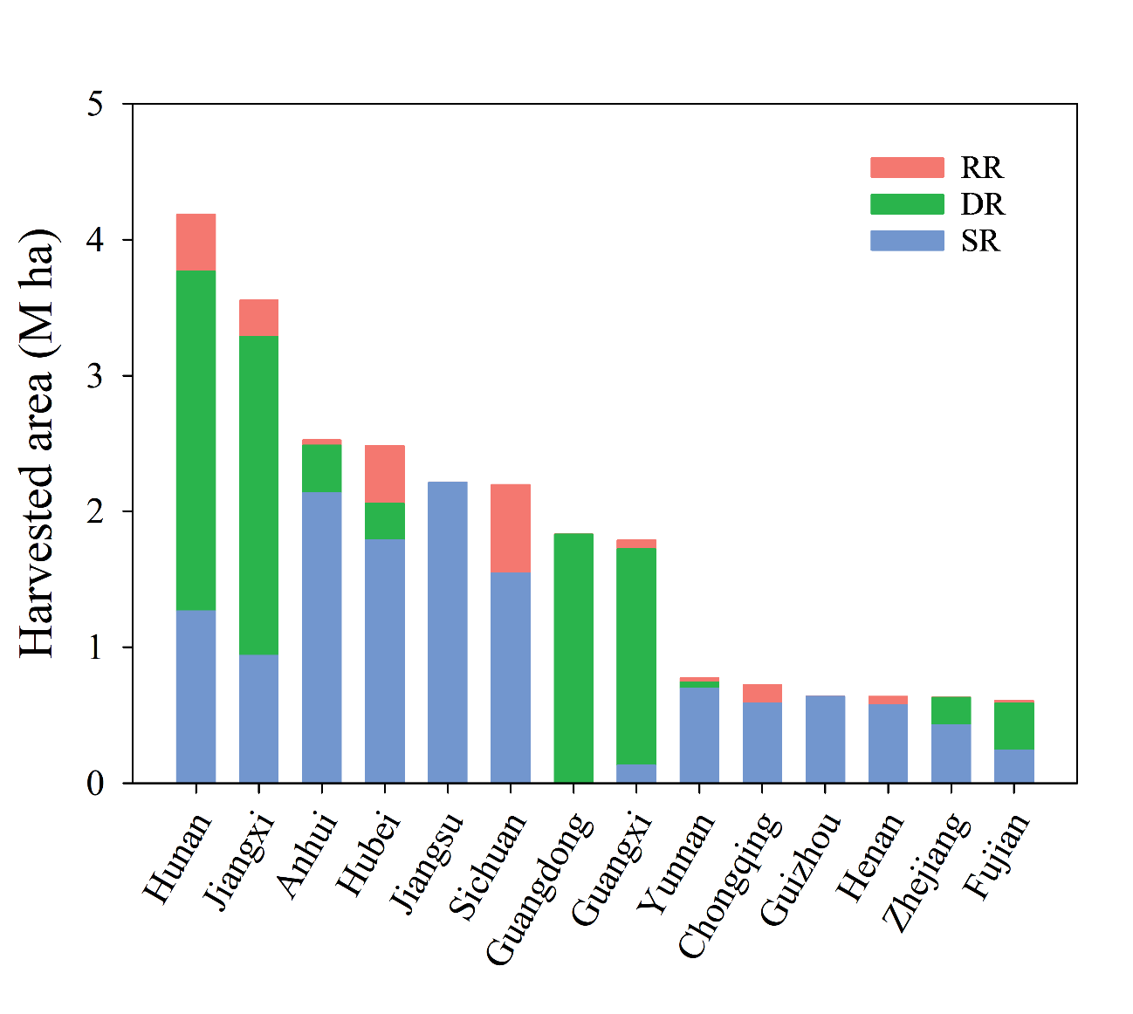
Supplementary Fig. S1. Average annual rice harvested area during the 2020-2022 period of single-season (SR), double-season (DR), and ratoon rice systems (RR) for each of the fourteen provinces, and sort from highest to lowest based on total area. The areas for DR and RR systems were calculated by aggregating the early and late season rice areas and summing the main and ratoon season areas, respectively, for each year. The location of each province is provided in Extended Data Fig. 1.

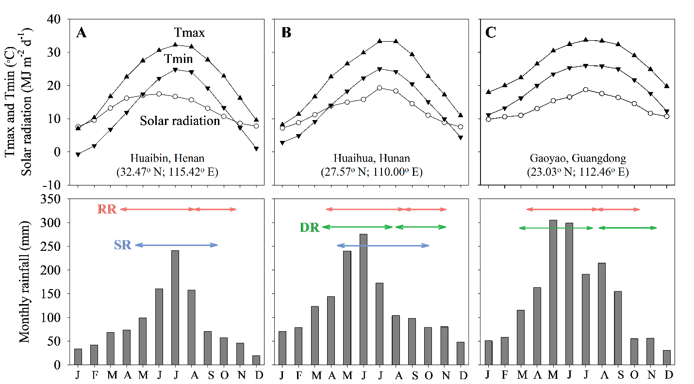
Supplementary Fig. S2. Monthly means of solar radiation, maximum (Tmax) and minimum (Tmin) temperatures, and total precipitation (2003-2022). Three sites were selected to illustrate weather patterns from north to south for (A) subtropical region in the north-south transitional zone of China where SR and RR are typically grown (Huaibin, Henan), (B) subtropical region in central China where single-season rice (SR), DR, and RR are typically grown (Huaihua, Hunan), and (C) tropical region in south China where double-season rice (DR) and ratoon rice (RR) are typically grown (Gaoyao, Guangdong). Arrows indicate the approximate duration of the rice season(s) at each site. Please refer to the location of Henan, Hunan, and Guangdong provinces in Extended Data Fig. 1.

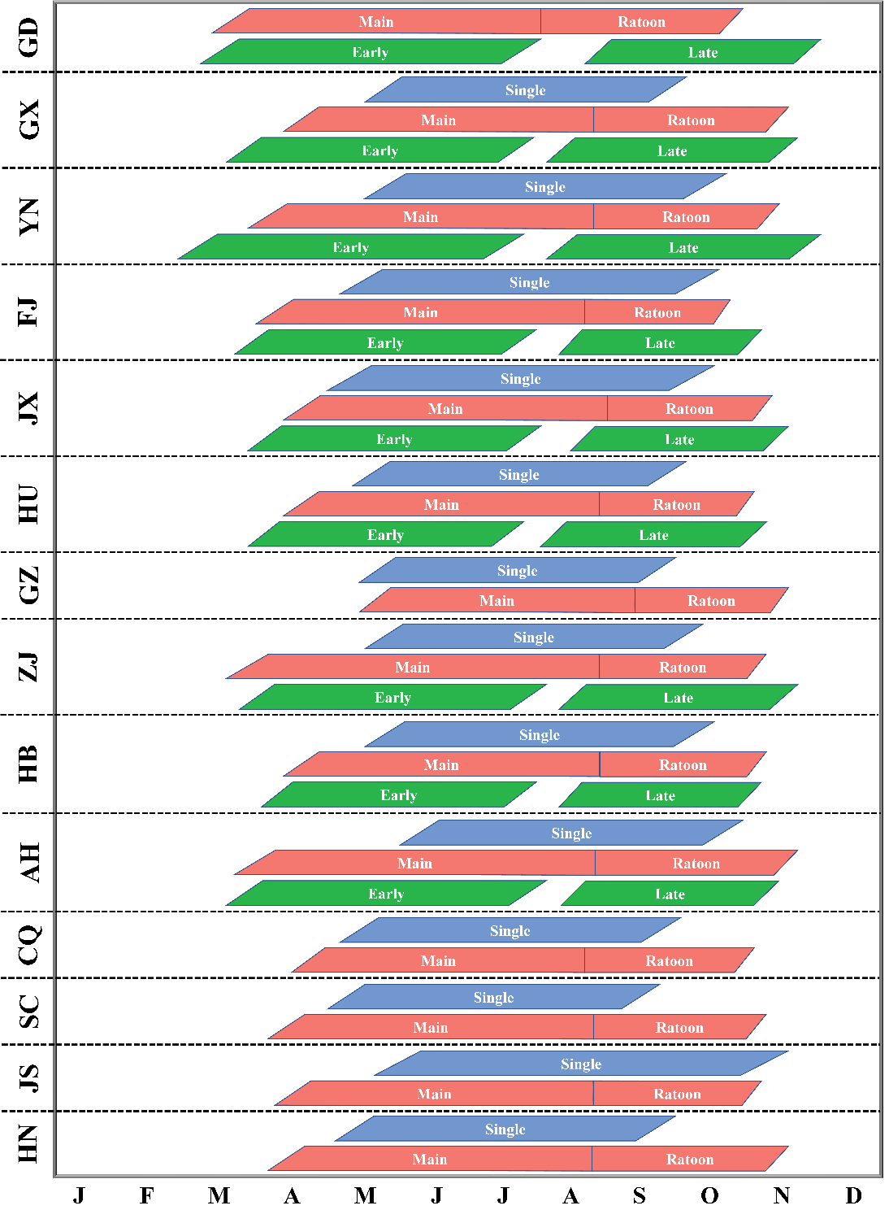
Supplementary Fig. S3. Crop calendars for single-season (blue), double-season (green), and ratoon rice (red) systems in selected provinces. Provinces were sorted according to latitude, from tropical (top) to non-tropical regions (bottom). Each box represents a rice season, from establishment to harvest maturity. GD: Guangdong; GX: Guangxi; YN: Yunnan; FJ: Fujian; JX: Jiangxi; HU: Hunan; GZ: Guizhou; ZJ: Zhejiang; HB: Hubei; AH: Anhui; CQ: Chongqing; SC: Sichuan; JS: Jiangsu; HN: Henan. The location of each province is provided in Extended Data Fig. 1.

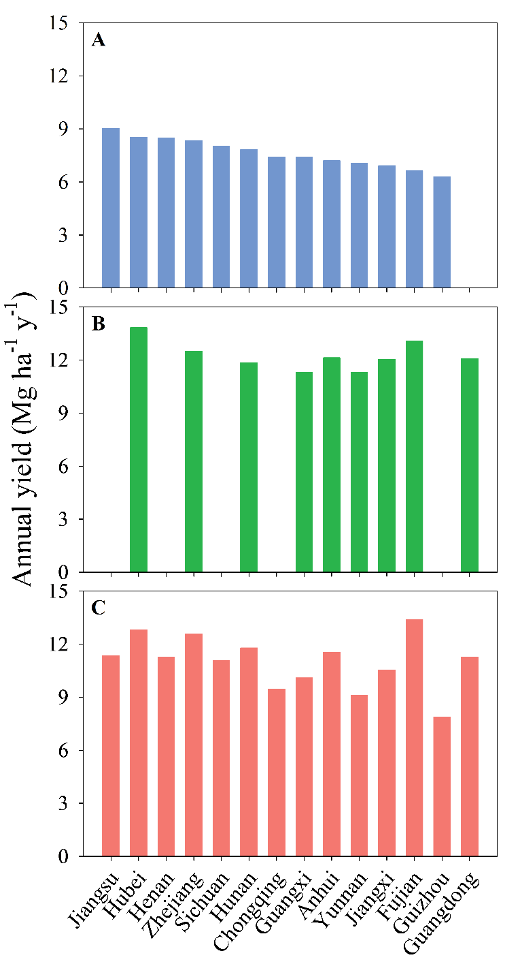
Supplementary Fig. S4. Comparison of average annual rice yield during the 2020-2022 period of single-season (A), double-season (B), and ratoon rice systems (C) for each of the fourteen provinces, and sort from highest to lowest based on yield of single-season rice. The annual yields for double-season and ratoon rice systems were calculated by area-weighted aggregation of the early and late season rice yields, and of the main and ratoon season yields, respectively, for each year. The absence of bars indicates no single-season rice planting in Guangdong (A) and no double-season rice planting in Jiangsu, Henan, Sichuan, Chongqing, and Guizhou (B). The location of each province is provided in Extended Data Fig. 1.

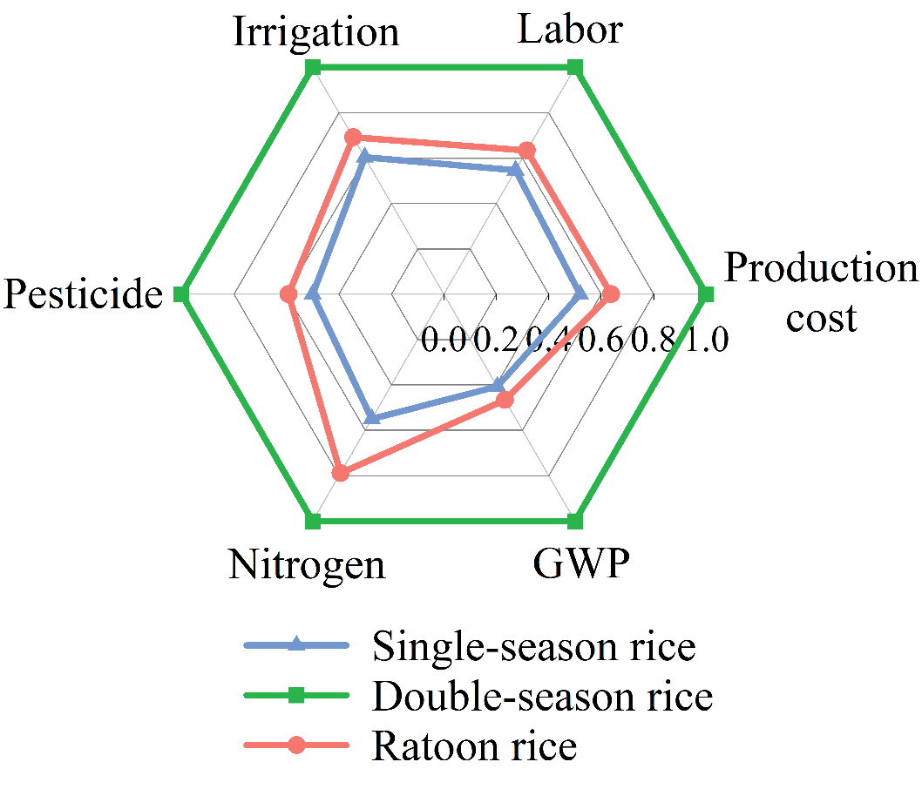
Supplementary Fig. S5. Comparison of annual production cost, labor input, irrigation amount, pesticide usage, total nitrogen input, and global warming potential (GWP) on an area basis across single-season rice (SR), double-season rice (DR), and ratoon rice (RR) systems. For each metric, data were normalized relative to the maximum value across the three rice systems. Data on the absolute values of these metrics for each system are presented in Supplementary Table S7.

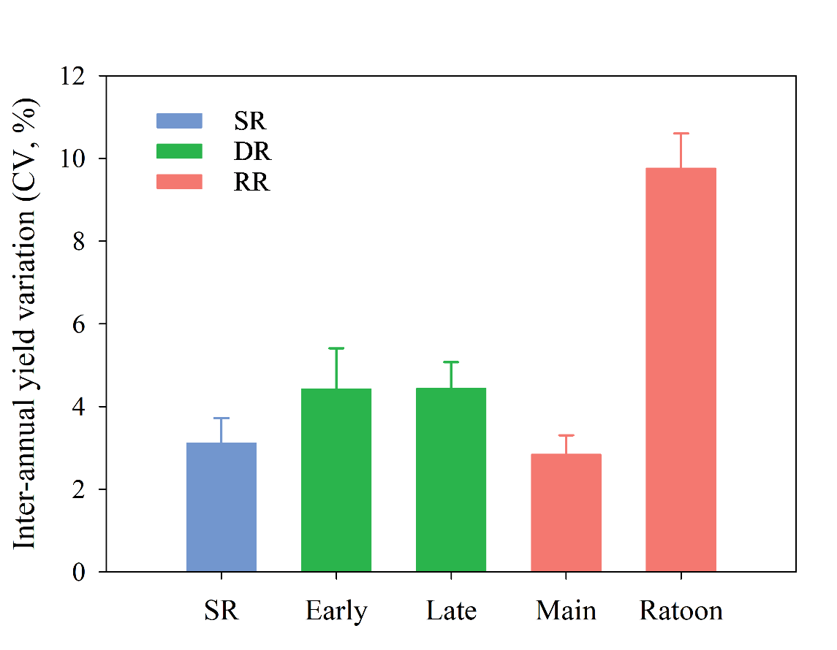
Supplementary Fig. S6. Inter-annual yield variation (expressed as coefficient variation [CV], %) for single-season rice (SR), early and late seasons of double-season rice (DR), and main and ratoon seasons of ratoon rice (RR). Error bars represent the standard deviation from the mean (n=13 for SE, n=9 for DR, and n=14 for RR).

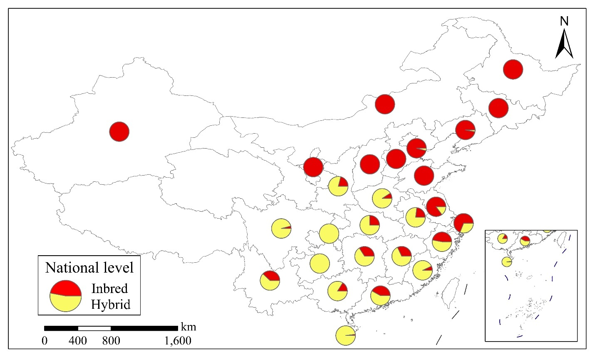
Supplementary Fig. S7. Share of the harvested area of inbred (red portions of pie charts) and hybrid (yellow portions of pie charts) rice varieties to total harvested rice area in each province. The base map was applied without endorsement using data from the National Platform for Common Geospatial Information Services (https://www.tianditu.gov.cn/).

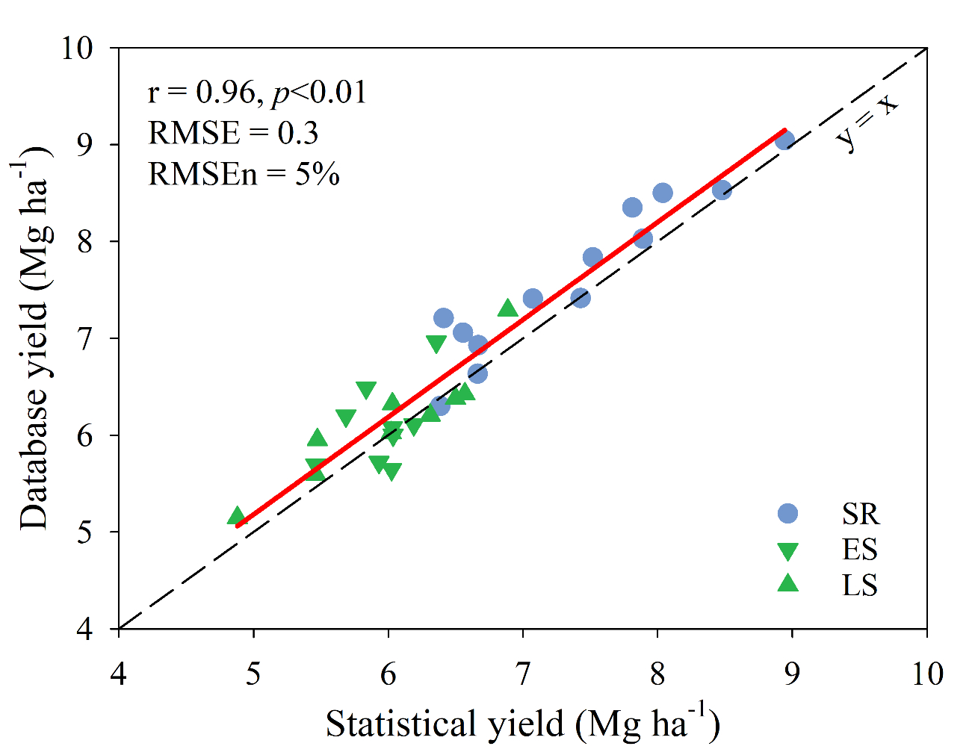
Supplementary Fig. S8. Provincial average yield based on our database actual yields versus average rice yield reported in the National Bureau of Statistics of China for single-season rice (SR) and early (ES) and late season (LS) of double-season rice for each of the 14 provinces included in the analysis. Dashed diagonal line indicates y = x. The Pearson correlation coefficient (r) and associated p-value, root mean square error (RMSE), and normalized RMSE percentage (RMSEn) of the fitted linear regression models (solid lines) are shown.

Supplementary Table S1. Annual rice harvested area (and percentage of national total) and rice production (and percentage of national total) across fourteen provinces during the 2020-2022 period. Provinces were sorted in a descending order of rice harvested area. Source: National Bureau of Statistics of China¹.
Province | Rice harvested area (kha) | % national rice area | Rice production (Mt) | % national rice production
Hunan | 3978 | 13 | 27 | 13
Jiangxi | 3421 | 11 | 21 | 10
Anhui | 2507 | 8 | 16 | 7
Hubei | 2272 | 8 | 19 | 9
Jiangsu | 2214 | 7 | 20 | 9
Sichuan | 1872 | 6 | 15 | 7
Guangdong | 1833 | 6 | 11 | 5
Guangxi | 1758 | 6 | 10 | 5
Yunnan | 761 | 3 | 5 | 2
Chongqing | 658 | 2 | 5 | 2
Guizhou | 641 | 2 | 4 | 2
Zhejiang | 633 | 2 | 5 | 2
Henan | 609 | 2 | 5 | 2
Fujian | 600 | 2 | 4 | 2
Total |  | 80 |  | 78
Thousand hectares (kha), million metric tons (Mt).

Supplementary Table S2. Questionnaire used in our study to collect yield and management data.
No. | Variable | Data
1 | Region
2 | Cropping system
 | DOMINANT PRACTICES | Source of management data:
 |  | 1st season§ | 2nd season
3 | Crop establishment method
4 | Sowing and transplanting date
5 | Harvest method
6 | Harvest date
7 | Tillage method
8 | Rice variety type
9 | Management of rice nursery
10 | Field size (ha per field)
11 | Is this operation mechanized? (yes/no)
 | Tillage
 | Puddling
 | Sowing or transplanting
 | Fertilizing
 | Spraying
 | Weeding
 | Harvesting
 | Grain drying
12 | Labor requirements (hour-person per season ha⁻¹)
13 | Straw management
14 | Stubble height of main season (cm)
15 | Seeding rate (kg ha⁻¹)
16 | Total N rate (kg ha⁻¹)
17 | Total P rate (kg ha⁻¹)
18 | Total K rate (kg ha⁻¹)
19 | Other nutrients (kg ha⁻¹), if any
20 | Manure source & rate (kg ha⁻¹) -cow, goat, poultry, compost
21 | Lime (kg ha⁻¹)
22 | Total irrigation amount (indicate m³ ha⁻¹ or mm depth per ha)
23 | Source and type of irrigation
24 | Source of energy for pumping
25 | Names of the most commonly used insecticides
26 | Names of the most commonly used fungicides
27 | Names of the most commonly used herbicides
28 | Total active ingredient of insecticides (kg ha⁻¹) & No. of spraying times [X]
29 | Total active ingredient of fungicides (kg ha⁻¹) & No. of spraying times [X]
30 | Total active ingredient of herbicides (kg ha⁻¹) & No. of spraying times [X]
31 | Other chemicals? (e.g., rodenticide, molluscicide, nematicide, growth regulators/hormones) -Indicate product (or active ingredient) and rate
32 | RICE YIELD | Source of yield data:
 |  | 1st season§ | 2nd season
 | Paddy yield at 14% MC (kg ha⁻¹) -year: XXX
 | Paddy yield at 14% MC (kg ha⁻¹) -year: XXX
 | Paddy yield at 14% MC (kg ha⁻¹) -year: XXX
§ The first season refers to the early season of double-season rice and main season of ratoon rice, and the second season refers to the late season of double-season rice and ratoon season of ratoon rice. In the case of single-season rice system, there is only one season.

Supplementary Table S3. Sources of data on crop management practices, applied inputs, and actual yield for single-season, double-season, and ratoon rice systems in each of the fourteen selected provinces.
Province | Crop management practices | Actual yield
Anhui | Farm survey | Farm survey, statistical data
Chongqing | Farm survey | Farm survey, statistical data
Fujian | Farm survey | Farm survey
Guangdong | Farm survey, statistical data | Farm survey, project survey
Guangxi | Farm survey, DARA survey, statistical data | Farm survey, statistical data
Guizhou | ATEC survey, statistical data | Farm survey, statistical data
Henan | Farm survey, statistical data | Farm survey
Hubei | Farm survey | Farm survey, statistical data, yield measurement in-situ
Hunan | Farm survey, CARS survey, statistical data | Farm survey, CARS survey, statistical data, yield measurement in-situ
Jiangsu | Farm survey, DARA survey, statistical data | Farm survey, statistical data
Jiangxi | Farm survey, statistical data | Farm survey, statistical data
Sichuan | Farm survey, statistical data | Project survey, statistical data, yield measurement in-situ
Yunnan | Farm survey | Farm survey
Zhejiang | Farm survey, statistical data | Farm survey, statistical data
DARA: Department of Agriculture and Rural Affairs in each province; ATEC: Agricultural Technology Extension Center in each province; CARS: China Agriculture Research System.

Supplementary Table S4. Fertilizer inputs include nitrogen (N), phosphorus (P), and potassium (K) in single-season rice (SR), early (ES) and late (LS) seasons of double-season rice (DR), and main (MS) and ratoon (RS) seasons of ratoon rice (RR) in each of the fourteen selected provinces.
Province | N application rate (kg ha⁻¹) |  |  |  |  |  |  | P application rate (kg ha⁻¹) |  |  |  |  |  |  | K application rate (kg ha⁻¹)
 | SR | DR |  |  | RR |  |  | SR | DR |  |  | RR |  |  | SR | DR |  |  | RR
 |  | ES | LS |  | MS | RS |  |  | ES | LS |  | MS | RS |  |  | ES | LS |  | MS | RS
Anhui | 209 | 165 | 180 |  | 218 | 135 |  | 107 | 75 | 90 |  | 120 | 64 |  | 129 | 75 | 90 |  | 135 | 64
Chongqing | 161 | ^{n.a.} | ^{n.a.} |  | 118 | 60 |  | 55 | ^{n.a.} | ^{n.a.} |  | 64 | 0 |  | 51 | ^{n.a.} | ^{n.a.} |  | 57 | 0
Fujian | 165 | 103 | 139 |  | 210 | 45 |  | 83 | 36 | 52 |  | 105 | 0 |  | 135 | 76 | 132 |  | 210 | 0
Guangdong | ^{n.a.} | 189 | 172 |  | 195 | 138 |  | ^{n.a.} | 77 | 77 |  | 90 | 0 |  | ^{n.a.} | 122 | 122 |  | 104 | 45
Guangxi | 196 | 171 | 164 |  | 244 | 68 |  | 65 | 70 | 68 |  | 83 | 0 |  | 135 | 125 | 123 |  | 180 | 34
Guizhou | 183 | ^{n.a.} | ^{n.a.} |  | 135 | 45 |  | 103 | ^{n.a.} | ^{n.a.} |  | 68 | 0 |  | 103 | ^{n.a.} | ^{n.a.} |  | 135 | 0
Henan | 168 | ^{n.a.} | ^{n.a.} |  | 105 | 69 |  | 94 | ^{n.a.} | ^{n.a.} |  | 75 | 0 |  | 94 | ^{n.a.} | ^{n.a.} |  | 90 | 0
Hubei | 186 | 128 | 166 |  | 199 | 83 |  | 114 | 53 | 64 |  | 83 | 0 |  | 126 | 75 | 98 |  | 128 | 23
Hunan | 163 | 160 | 165 |  | 201 | 102 |  | 75 | 85 | 87 |  | 93 | 10 |  | 112 | 98 | 115 |  | 154 | 55
Jiangsu | 200 | ^{n.a.} | ^{n.a.} |  | 195 | 135 |  | 98 | ^{n.a.} | ^{n.a.} |  | 113 | 0 |  | 122 | ^{n.a.} | ^{n.a.} |  | 225 | 150
Jiangxi | 195 | 166 | 159 |  | 109 | 49 |  | 85 | 80 | 83 |  | 105 | 0 |  | 110 | 108 | 138 |  | 139 | 0
Sichuan | 156 | ^{n.a.} | ^{n.a.} |  | 181 | 60 |  | 75 | ^{n.a.} | ^{n.a.} |  | 71 | 0 |  | 135 | ^{n.a.} | ^{n.a.} |  | 83 | 0
Yunnan | 189 | 199 | 191 |  | 203 | 72 |  | 70 | 98 | 98 |  | 77 | 0 |  | 60 | 94 | 94 |  | 95 | 0
Zhejiang | 181 | 155 | 168 |  | 248 | 123 |  | 66 | 58 | 58 |  | 105 | 10 |  | 104 | 73 | 85 |  | 180 | 45
^{n.a.}: data were not surveyed due to lack of planting of the specific rice system.

Supplementary Table S5. Seeding rate, irrigation water amount, and pesticides usage (in active ingredient) in single-season rice (SR), early (ES) and late (LS) seasons of double-season rice (DR), and main (MS) and ratoon (RS) seasons of ratoon rice (RR) in each of the fourteen selected provinces.
Province | Seeding rate (kg ha⁻¹) |  |  |  |  |  |  | Irrigation water (mm) |  |  |  |  |  |  | Pesticides usage (kg ha⁻¹)
 | SR | DR |  |  | RR |  |  | SR | DR |  |  | RR |  |  | SR | DR |  |  | RR
 |  | ES | LS |  | MS | RS |  |  | ES | LS |  | MS | RS |  |  | ES | LS |  | MS | RS
Anhui | 49 | 53 | 38 |  | 30 | 0 |  | 524 | 225 | 225 |  | 262 | 116 |  | 2.5 | 3.2 | 2.7 |  | 2.4 | 0.4
Chongqing | 20 | ^{n.a.} | ^{n.a.} |  | 23 | 0 |  | 277 | ^{n.a.} | ^{n.a.} |  | 389 | 46 |  | 1.4 | ^{n.a.} | ^{n.a.} |  | 1.4 | 0.0
Fujian | 38 | 26 | 17 |  | 29 | 0 |  | 300 | 400 | 433 |  | 450 | 300 |  | 2.5 | 2.6 | 2.4 |  | 2.6 | 0.5
Guangdong | ^{n.a.} | 40 | 36 |  | 38 | 0 |  | ^{n.a.} | 490 | 490 |  | 710 | 400 |  | ^{n.a.} | 1.6 | 1.6 |  | 1.6 | 0.0
Guangxi | 24 | 27 | 27 |  | 28 | 0 |  | 485 | 404 | 423 |  | 600 | 275 |  | 3.3 | 2.5 | 2.6 |  | 2.7 | 1.5
Guizhou | 15 | ^{n.a.} | ^{n.a.} |  | 26 | 0 |  | 500 | ^{n.a.} | ^{n.a.} |  | 600 | 50 |  | 1.9 | ^{n.a.} | ^{n.a.} |  | 2.0 | 0.0
Henan | 65 | ^{n.a.} | ^{n.a.} |  | 23 | 0 |  | 532 | ^{n.a.} | ^{n.a.} |  | 539 | 120 |  | 2.0 | ^{n.a.} | ^{n.a.} |  | 2.0 | 0.0
Hubei | 37 | 71 | 34 |  | 25 | 0 |  | 448 | 201 | 116 |  | 525 | 185 |  | 1.8 | 1.7 | 1.8 |  | 1.6 | 0.7
Hunan | 38 | 72 | 47 |  | 35 | 0 |  | 392 | 277 | 286 |  | 371 | 167 |  | 2.6 | 2.3 | 2.4 |  | 2.7 | 1.0
Jiangsu | 71 | ^{n.a.} | ^{n.a.} |  | 30 | 0 |  | 476 | ^{n.a.} | ^{n.a.} |  | 560 | 150 |  | 2.5 | ^{n.a.} | ^{n.a.} |  | 1.8 | 0.8
Jiangxi | 25 | 45 | 38 |  | 58 | 0 |  | 407 | 395 | 518 |  | 520 | 110 |  | 1.8 | 1.7 | 2.0 |  | 2.1 | 0.2
Sichuan | 26 | ^{n.a.} | ^{n.a.} |  | 16 | 0 |  | 540 | ^{n.a.} | ^{n.a.} |  | 305 | 75 |  | 1.5 | ^{n.a.} | ^{n.a.} |  | 2.0 | 0.0
Yunnan | 44 | 34 | 34 |  | 32 | 0 |  | 562 | 587 | 150 |  | 510 | 15 |  | 1.9 | 2.0 | 2.0 |  | 2.3 | 0.2
Zhejiang | 48 | 70 | 27 |  | 21 | 0 |  | 592 | 483 | 483 |  | 407 | 253 |  | 2.6 | 2.1 | 2.8 |  | 2.4 | 0.7
^{n.a.}: data were not surveyed due to lack of planting of the specific rice system.

Supplementary Table S6. Labor inputs, crop growth duration, and grain yield in single-season rice (SR), early (ES) and late (LS) seasons of double-season rice (DR), and main (MS) and ratoon (RS) seasons of ratoon rice (RR) in each of the fourteen selected provinces.
Province | Labor input (h ha⁻¹) |  |  |  |  |  |  | Growth duration (d) |  |  |  |  |  |  | Yield (Mg ha⁻¹)
 | SR | DR |  |  | RR |  |  | SR | DR |  |  | RR |  |  | SR | DR |  |  | RR
 |  | ES | LS |  | MS | RS |  |  | ES | LS |  | MS | RS |  |  | ES | LS |  | MS | RS
Anhui | 70 | 75 | 60 |  | 56 | 53 |  | 133 | 98 | 109 |  | 137 | 82 |  | 7.2 | 6.2 | 6.0 |  | 8.3 | 3.3
Chongqing | 146 | ^{n.a.} | ^{n.a.} |  | 170 | 39 |  | 126 | ^{n.a.} | ^{n.a.} |  | 114 | 76 |  | 7.4 | ^{n.a.} | ^{n.a.} |  | 7.2 | 2.3
Fujian | 180 | 195 | 210 |  | 270 | 30 |  | 127 | 104 | 100 |  | 112 | 74 |  | 6.6 | 7.0 | 6.4 |  | 8.5 | 4.9
Guangdong | ^{n.a.} | 56 | 60 |  | 60 | 30 |  | ^{n.a.} | 111 | 109 |  | 108 | 90 |  | ^{n.a.} | 6.1 | 6.0 |  | 7.6 | 3.8
Guangxi | 243 | 185 | 186 |  | 218 | 34 |  | 124 | 103 | 105 |  | 108 | 76 |  | 7.4 | 5.7 | 5.6 |  | 7.9 | 2.2
Guizhou | 230 | ^{n.a.} | ^{n.a.} |  | 210 | 30 |  | 121 | ^{n.a.} | ^{n.a.} |  | 98 | 61 |  | 6.3 | ^{n.a.} | ^{n.a.} |  | 6.1 | 1.8
Henan | 71 | ^{n.a.} | ^{n.a.} |  | 23 | 30 |  | 116 | ^{n.a.} | ^{n.a.} |  | 112 | 85 |  | 8.5 | ^{n.a.} | ^{n.a.} |  | 8.2 | 3.1
Hubei | 149 | 34 | 34 |  | 65 | 30 |  | 139 | 102 | 94 |  | 111 | 67 |  | 8.5 | 6.5 | 7.3 |  | 8.7 | 4.1
Hunan | 104 | 94 | 85 |  | 113 | 33 |  | 125 | 99 | 97 |  | 124 | 64 |  | 7.8 | 5.6 | 6.2 |  | 8.2 | 3.6
Jiangsu | 100 | ^{n.a.} | ^{n.a.} |  | 120 | 30 |  | 144 | ^{n.a.} | ^{n.a.} |  | 117 | 67 |  | 9.0 | ^{n.a.} | ^{n.a.} |  | 7.7 | 3.6
Jiangxi | 90 | 111 | 132 |  | 68 | 30 |  | 133 | 106 | 101 |  | 126 | 73 |  | 6.9 | 5.7 | 6.3 |  | 7.3 | 3.2
Sichuan | 120 | ^{n.a.} | ^{n.a.} |  | 124 | 34 |  | 121 | ^{n.a.} | ^{n.a.} |  | 122 | 63 |  | 8.0 | ^{n.a.} | ^{n.a.} |  | 8.2 | 2.9
Yunnan | 229 | 98 | 98 |  | 83 | 30 |  | 137 | 113 | 130 |  | 139 | 70 |  | 7.1 | 6.0 | 5.1 |  | 7.2 | 1.9
Zhejiang | 52 | 60 | 55 |  | 64 | 28 |  | 157 | 110 | 109 |  | 143 | 80 |  | 8.3 | 6.1 | 6.4 |  | 8.2 | 4.4
^{n.a.}: data were not surveyed due to lack of planting of the specific rice system.

Supplementary Table S7. Agricultural inputs, labor input, production cost, yield, and economic and environmental outcomes on area and/or yield-scaled basis of single-season (SR), double-season (DR), and ratoon rice (RR).
Metric | Unit | SR | DR | RR
Area basis
Net profit | US$ ha⁻¹ | 1021.6 | 712.2 | 1930.0
Yield | Mg ha⁻¹ | 7.9 | 12.0 | 11.4
Yield variation | % | 2.9 | 3.8 | 4.3
PFP_{N} | kg kg⁻¹ | 42.6 | 36.2 | 45.5
ROI |  | 0.52 | 0.19 | 0.80
Eco-efficiency | US$ kg⁻¹ | 0.12 | 0.03 | 0.20
Area basis
Production cost | US$ ha⁻¹ | 1965.5 | 3787.1 | 2414.1
Labor | Man-hour ha⁻¹ | 119.0 | 217.9 | 137.9
Irrigation | mm | 474.3 | 785.9 | 543.6
Pesticide | kg ha⁻¹ | 2.12 | 4.23 | 2.51
Nitrogen | kg ha⁻¹ | 209.6 | 381.1 | 300.5
GWP | Mg ha⁻¹ | 8.3 | 20.5 | 9.6
Yield-scaled basis
Production cost | US$ Mg⁻¹ | 249.7 | 315.9 | 211.8
Labor | Man-hour Mg⁻¹ | 15.1 | 18.2 | 12.1
Irrigation | m³ Mg⁻¹ | 60.2 | 65.6 | 47.7
Pesticide | kg Mg⁻¹ | 0.27 | 0.35 | 0.22
Nitrogen surplus | kg Mg⁻¹ | 12.4 | 18.3 | 10.0
GWP | Mg Mg⁻¹ | 1.06 | 1.71 | 0.84
PFP_{N}: partial factor productivity from applied N; ROI: return on investment; GWP: global warming potential.

Supplementary Table S8. Emission factors used for estimating greenhouse gases emissions from manufacturing, packaging, and transportation of agricultural inputs used in rice production.
Inputs | Unit | Emission factor (CO₂-eq kg unit⁻¹) | References
Machinery | MJ | 0.071 | Dyer and Desjardins²⁸; Khoshnevisan et al.²⁹
Diesel | l | 2.76 | Khoshnevisan et al.²⁹; Pishgar-Komleh et al.³⁰
Electricity | kWh | 0.78 | Casey and Holden³¹; Mondani et al.³²
Nitrogen (N) | kg | 4.77 | Lal³³; Pathak and Wassman³⁴
Phosphorus (P₂O5) | kg | 0.73 | Lal³³; Pathak and Wassman³⁴
Potassium (K₂O) | kg | 0.55 | Lal³³; Pathak and Wassman³⁴
Manure | kg | 0.13 | Li and Kotelko³⁵; Mondani et al.³²
Pesticides | kg a.i. § | 18.7 | Lal³³; Yang et al.³⁶
Seed | kg | 0.78 | Guo et al.³⁷
§ a.i., active ingredient.

Supplementary Table S9. Fuel consumption and operation time of machine in different field operations in rice production.
Field operation | Fuel consumption (l ha⁻¹) | Operation time (h ha⁻¹)
Land preparation (full tillage) | 38 | 7.5
Land preparation (minimum tillage) | 23 | 4.0
Plowing | 15 | 3.75
Transplanting | 15 | 3.75
Spraying | 1.5 | 2.25
Harvesting | 10 | 1.5
Data from Sims et al.³⁸; Wang et al.³⁹; Pang et al.⁴⁰; NKU⁴¹; NBSC⁴².

Supplementary Table S10. Unit prices of the various operations and inputs involved in rice production.
Items | Unit | Price (US$ unit⁻¹)
Operations
Tillage (full) | Time | 277
Tillage (minimum) | Time | 162
Plowing | Time | 115
Transplanting | Time | 115
Harvesting | Time | 277
Inputs
Seed (japonica) | kg | 1.5
Seed (inbred indica) | kg | 1.2
Seed (hybrid indica) | kg | 6.2
Seed (indica-japonica hybrid) | kg | 8.5
Urea | kg | 0.3
Superphosphate | kg | 0.1
Muriate of potash | kg | 0.7
Manure | Mg | 6.2
Irrigation water | kt | 3.8
Electricity | kWh | 0.1
Pesticides | kg | 89
Herbicides | kg | 34
Fungicides | kg | 123
Labor | hour | 3.1
Data from NDRC⁴³; NAESC⁴⁴; and farm survey.

Supplementary Table S11. Nitrogen concentration (%) of rice grain and straw for single-season rice, early and late seasons of double-season rice, and main and ratoon season of ratoon rice.
Rice system | Season | Grain | Straw
Single-season rice |  | 1.20 | 0.65
Double-season rice | Early | 1.21 | 0.75
 | Late | 1.17 | 0.72
Ratoon rice | Main | 1.36 | 1.44
 | Ratoon | 1.14 | 0.66
Data from Xu et al.⁴⁵; Zheng⁴⁶.

Supplementary Table S12. The assumed fraction of the total amount of straw remaining in the field (%) and the assumed fraction of nitrogen lost from crop residues by burning or leaching (%) under different straw managements.
Straw management | Straw remaining, % | Nitrogen lost, %
Straw mulch | 90 | 20
Straw is incorporated | 90 | 10
Burn in the field | 90 | 90
Removed out of field | 10 | 10
Data from Dobermann et al.⁴.

Supplementary Table S13. Rice varieties used in yield potential simulation for single-season rice, early and late seasons of double-season rice, and ratoon rice systems in each region.
Province | Single-season | Double-season rice |  |  | Ratoon rice
 | rice | Early |  | Late
Anhui | Huanghuazhan, Yangliangyou6 | Liangyou287, Zhongjiazao17 |  | Tianyouhuazhan, Xiangzaoxian45 | Huanghuazhan, Fengliangyouxiang1
Chongqing | Yuxiang203 | Teyou582 |  | Teyou582 | Yuxiang203
Fujian | Huanghuazhan, Yangliangyou6 | ^{n.a.} |  | ^{n.a.} | Huazheyou261
Guangdong | ^{n.a.} | Huanghuazhan, Teyou582 |  | Huanghuazhan, Teyou582 | Huanghuazhan
Guangxi | Huanghuazhan, Yliangyou1 | Huanghuazhan, Teyou582 |  | Huanghuazhan, Teyou582 | Huanghuazhan
Guizhou | Huazheyou261 | ^{n.a.} |  | ^{n.a.} | Yuxiang203
Heilongjiang | Longgeng31 | ^{n.a.} |  | ^{n.a.} | ^{n.a.}
Henan | Huanghuazhan, Yangliangyou6 | ^{n.a.} |  | ^{n.a.} | Liangyou6326
Hubei | Huanghuazhan, Yangliangyou6 | Liangyou287, Zhongjiazao17 |  | Tianyouhuazhan, Xiangzaoxian45 | Huanghuazhan, Liangyou6326, Yongyou4949
Hunan | Huanghuazhan, Yliangyou1 | Liangyou287, Zhongjiazao17 |  | Tianyouhuazhan, Xiangzaoxian45 | Huanghuazhan, Yongyou4949
Jiangsu | Wuyungeng9, Yongyou2640 | ^{n.a.} |  | ^{n.a.} | Fengliangyouxiang1
Jiangxi | Huanghuazhan, Yliangyou1 | Liangyou287, Zhongjiazao17 |  | Tianyouhuazhan, Xiangzaoxian45 | Yongyou4949
Jilin | Longgeng31 | ^{n.a.} |  | ^{n.a.} | ^{n.a.}
Liaoning | Liaogeng9 | ^{n.a.} |  | ^{n.a.} | ^{n.a.}
Shandong | Wuyungeng9, Yangliangyou6 | ^{n.a.} |  | ^{n.a.} | ^{n.a.}
Sichuan | Yuxiang203 | ^{n.a.} |  | ^{n.a.} | Yuxiang203
Yunnan | Yungeng9, Huazheyou261 | ^{n.a.} |  | ^{n.a.} | Yuxiang203
Zhejiang | Huanghuazhan, Yongyou2640 | Teyou582, Zhongjiazao17 |  | Teyou582, Xiangzaoxian45 | Yongyou4949
Inbred rice varieties: Huanghuazhan, Longgeng31, Wuyungeng9, Liaogeng9, Yungeng9, Zhongjiazao17, and Xiangzaoxian45.
Ordinary hybrid rice varieties: Yangliangyou6, Yuxiang203, Yliangyou1, Huazheyou261, Liangyou287, Teyou582, Tianyouhuazhan, Fengliangyouxiang1, and Liangyou6326.
Indica-japonica hybrid rice varieties: Yongyou2640 and Yongyou4949.
Information on these varieties can be found in China Rice Data Center (https://www.ricedata.cn/).
^{n.a.}: no reference weather station was selected due to lack of or limited harvested rice for the specific rice system.

Supplementary Table S14. Coefficient of determination (R²), breakpoint indicating the year when a change in the slope occurred and 95% confidence interval (CI), slopes, 95% CI, and 95% CI of each segment of regression models fitted to the relationship between rice harvested area and years for single-season rice system in selected provinces during the past 30 years (1993-2022).
Province | R² | Year and 95% CI of breakpoint | Slope, 95% CI, and stand error of each segment
Anhui | 0.96 | 1993 [1990, 1996] | 0 (56); 40 [37, 44] (2) *
Chongqing | 0.93 | 2009 [2007, 2011] | -13 [-15, -10] (1) *; 0 (1)
Fujian | 0.85 | 2003 [2001, 2004]; 2009 [2006, 2011] | 10 [6, 13] (2) *; 0 (6); -3 [-6, 1] (2) *
Guangxi | 0.48 | 1994 [1991, 1996] | -7 [-13, 0] (3) *; 0 (0)
Guizhou | 0.78 | 2017 [2015, 2019] | -1 [-2, -1] (0) *; -15 [-22, -7] (4) *
Henan | 0.93 | 2002 [2000, 2004]; 2008 [2007, 2010] | 0 (2); 22 [14, 30] (4) *; 0 (1)
Hubei | 0.99 | 2008 [2006, 2009]; 2018 [2017, 2019] | 20 [16, 24] (2) *; 73 [64, 83] (5) *; 0 (13)
Hunan | 0.98 | 1999 [1998, 2001]; 2005 [2004, 2007] | 8 [-7, 22] (7) *; 93 [62, 125] (15) *; 21 [15, 28] (3) *
Jiangsu | 0.47 | 2003 [2001, 2005]; 2007 [2003, 2011] | -28 [-42, -14] (7) *; 0 (29); 0 (6)
Jiangxi | 0.97 | 2009 [2006, 2011] | 15 [11, 19] (2) *; 43 [36, 50] (3) *
Sichuan | 0.98 | 2006 [2001, 2011]; 2015 [2013, 2017] | -13 [-17, -9] (2) *; -20 [-26, -14] (3) *; 0 (3)
Yunnan | 0.88 | 1998 [1997, 1999]; 2001 [2000, 2002] | -19 [-29, -8] (5) *; 0 (15); -15 [-17, -12] (1) *
Zhejiang | 0.95 | 2005 [2004, 2006]; 2014 [2012, 2017] | 40 [35, 45] (2) *; -29 [-37, -20] (4) *; 0 (6)
Values in square brackets and brackets represent 95% CI and stand error, respectively.
Asterisks indicate significance at * p<0.05.

Supplementary Table S15. Coefficient of determination (R²), breakpoint indicating the year when a change in the slope occurred and 95% confidence interval (CI), slopes, 95% CI, and 95% CI of each segment of regression models fitted to the relationship between rice harvested area and years for early and late seasons of double-season rice system in selected provinces during the past 30 years (1993-2022).
Season | Province | R² | Year and 95% CI of breakpoint | Slope, 95% CI, and stand error of each segment
Early | Anhui | 0.98 | 2003 [2001, 2005]; 2011 [2009, 2013] | -20 [-23, -18] (1) *; 0 (3); -13 [-15, -10] (1) *
 | Fujian | 0.99 | 1999 [1998, 2000]; 2003 [2002, 2003] | -10 [-14, -5] (2) *; -60 [-76, -45] (8) *; -11 [-12, -9] (1) *
 | Guangdong | 0.97 | 2008 [2005, 2010] | -31 [-35, -27] (2) *; -6 [-11, -1] (2) *
 | Guangxi | 0.95 | 2002 [1999, 2005] | 0 (3); -19 [-21, -16] (1) *
 | Hubei | 0.98 | 1997 [1996, 1998]; 2000 [1999, 2002] | 0 (7); 0 (16); -12 [-14, -9] (1) *
 | Hunan | 0.87 | 2004 [2002, 2006]; 2014 [2012, 2016] | -44 [-54, -33] (5) *; 22 [7, 37] (7) *; -50 [-74, -26] (12) *
 | Jiangxi | 0.74 | 2003 [2001, 2004]; 2008 [2007, 2010] | -28 [-38, -19] (5) *; 59 [29, 90] (15)*; -20 [-29, -12] (4) *
 | Yunnan | 0.77 | 2002 [1998, 2006] | 0 (0); -1 [-2, -1] (0)*
 | Zhejiang | 0.96 | 2005 [2004, 2007] | -69 [-77, -61] (4) *; 0 (4)
Late | Anhui | 0.86 | 1995 [1993, 1997]; 1999 [1997, 2002] | 0 (15); 0 (28); -7 [-12, -3] (2) *
 | Fujian | 0.96 | 1999 [1998, 2000]; 2001 [2000, 2002] | -9 [-16, -2] (3) *; 0 (19); -4 [-6, -2] (1) *
 | Guangdong | 0.96 | 1998 [1994, 2002]; 2006 [2004, 2009] | 0 (6); -42 [-57, -27] (7) *; -3 [-8, 2] (3) *
 | Guangxi | 0.97 | 2002 [1999, 2005] | -5 [-9, -1] (2) *; -17 [-19, -15] (1) *
 | Hubei | 0.98 | 1997 [1995, 1999]; 2001 [2000, 2003] | -16 [-27, -5] (5) *; 0 (16); -15 [-18, -13] (1) *
 | Hunan | 0.92 | 2006 [2004, 2008]; 2014 [2012, 2016] | -43 [-51, -36] (4) *; 23 [-1, 47] (12) *; -48 [-72, -23] (12) *
 | Jiangxi | 0.69 | 2003 [2000, 2006]; 2011 [2009, 2013] | -13 [-21, -5] (4) *; 30 [11, 48] (9) *; -31 [-42, -19] (6) *
 | Yunnan | 0.55 | 1993 [1991, 1995]; 2004 [1999, 2008] | 0 (8); -4 [-6, -1] (1) *; 0 (0)
 | Zhejiang | 1.00 | 2012 [2010, 2013] | -36 [-44, -29] (4) *; 0 (13); -5 [-8, -3] (1) *
Values in square brackets and brackets represent 95% CI and stand error, respectively.
Asterisks indicate significance at * p<0.05.

Supplementary Table S16. Coefficient of determination (R²), breakpoint indicating the year when a change in the slope occurred and 95% confidence interval (CI), slopes, 95% CI, and 95% CI of each segment of regression models fitted to the relationship between rice harvested area and years for early (ES) and late (LS) seasons of double-season rice system in Hainan and single-season rice system in the rest provinces during the past 30 years (1993-2022).
Province | R² | Year and 95% CI of breakpoint | Slope, 95% CI, and stand error of each segment
Beijing | 0.98 | 2005 [2003, 2006] | -2 [-3, -2] (0) *; 0 [0, 0] (0) *
Gansu | 0.85 | 1998 [1996, 2000] | 0 [0, 0] (0) *; 0 [0, 0] (0) *
Hebei | 0.92 | 1999 [1997, 2001]; 2003 [2001, 2005] | 0 (1); 0 (7); 0 [-1, 0] (0) *
Heilongjiang | 0.99 | 2005 [2004, 2007]; 2013 [2012, 2014] | 73 [57, 90] (8) *; 270 [223, 317] (23) *; -31 [-70, 8] (19) *
Inner Mongolia | 0.61 | 1998 [1991, 2005]; 2013 [2009, 2017] | 0 (2); 0 (1); 8 [3, 13] (2) *
Jilin | 0.93 | 2019 [2014, 2023] | 16 [14, 18] (1) *; 0 (18)
Liaoning | 0.68 | 1995 [1993, 1998]; 2008 [2005, 2010] | 0 (8); 14 [8, 20] (3) *; -11 [-15, -6] (2) *
Ningxia | 0.74 | 2018 [2017, 2019] | 1 [1, 1] (0) *; -11 [-16, -7] (2) *
Shandong | 0.74 | 2001 [2000, 2002]; 2003 [2000, 2006] | 6 [4, 9] (1) *; 0 (18); -1 [-2, 0] (0) *
Shanghai | 0.99 | 1999 [1998, 1999]; 2003 [2002, 2003] | -3 [-5, -2] (1) *; 0 (2); 0 [-1, 0] (0) *
Shannxi | 0.91 | 2015 [2010, 2021] | -2 [-3, -2] (0) *; 0 (1)
Shanxi | 0.97 | 2007 [2005, 2009]; 2016 [2014, 2019] | 0 [-1, 0] (0) *; 0 [0, 0] (0) *; 0 (0)
Tianjin | 0.85 | 1999 [1998, 2000]; 2002 [2001, 2003] | 0 (1); 0 (3); 2 [2, 3] (0) *
Tibet | 0.81 | 2006 [2002, 2010]; 2016 [2015, 2017] | 0 (0); 0 (1); -9 [-11, -6] (1) *
Xinjiang | 0.35 | 2002 [1996, 2008] | 0 (0); 0 [0, 0] (0) *
Hainan (ES) | 0.90 | 2008 [2005, 2011]; 2013 [2009, 2016] | -3 [-4, -3] (0) *; 2 [-3, 8] (3) *; -4 [-6, -2] (1) *
Hainan (LS) | 0.96 | 1996 [1994, 1998] | 0 (2); -4 [-5, -4] (0) *
Values in square brackets and brackets represent 95% CI and stand error, respectively.
Asterisks indicate significance at * p<0.05.

Supplementary Table S17. Current (2020-2022) and future (2040) population, per-capita rice demand (in kg paddy rice), and total annual national rice demand (in Mt paddy rice) for China.
Item | Scenario | Value
Population (million) † | Baseline (2020-2022) | 1457
 | Year 2040 | 1350
Per-capita demand (kg) ‡ | Baseline (2020-2022) | 151
 | Year 2040-IMPACT | 150
 | Year 2040-RECC | 154
 | Year 2040-MAgPIE | 151
 | Year 2040-AIM/CGE | 148
Total demand (Mt) ⸸ | Baseline (2020-2022) | 220
 | Year 2040-IMPACT | 202
 | Year 2040-RECC | 207
 | Year 2040-MAgPIE | 204
 | Year 2040-AIM/CGE | 199
† The current (2020-2022) and future (2040) population are sourced from the UN Population Dynamics⁴⁷ and the medium fertility variant of the UN population projections⁴⁸, respectively.
‡ The current per-capita rice demand was calculated by dividing the total domestic rice consumption, as reported by the FAO⁴⁹ and USDA⁵⁰, by the current population⁴⁷. Future per-capita rice demand was estimated using the current per-capita rice demand as a baseline, adjusted for the projected relative changes as forecasted by the IMPACT model under the SSP2 scenario⁵¹, RECC⁵², MAgPIE-China⁵³, and AIM/CGE⁵⁴. For detailed methodologies, see the Methods section. Both current and future per-capita rice demands are expressed in terms of paddy rice, converting the originally reported milled rice from the USDA database and the three models using a rice milling rate of 0.67 for China⁵⁰.
⸸ The current national total rice demand was estimated based on the average annual figures for national rice production, imports, exports, and stock changes during the period 2020-2022. The future national total rice demand by 2040 was calculated as the product of the projected future population and the estimated future per-capita rice demand for 2040, as derived from each respective projection.

Supplementary Table S18. Coefficient of determination (R²), breakpoint indicating the year when a change in the slope occurred and 95% confidence interval (CI), slopes, 95% CI, and 95% CI of each segment of regression models fitted to the relationship between rice yield and years for single-season rice system in selected provinces during the past 30 years (1993-2022).
Province | R² | Year and 95% CI of breakpoint | Slope, 95% CI, and stand error of each segment
Anhui | 0.02 |  | 0 (8)
Chongqing | 0.38 | 2010 [1995, 2025] | 0 (35); 15 [-58, 89] (35) *
Fujian | 0.95 | 1995 [1987, 2003] | 80 [3, 157] (38) *; 46 [41, 52] (3) *
Guangxi | 0.91 | 1994 [1992, 1997] | 268 [88, 448] (88) *; 73 [60, 87] (7) *
Guizhou | 0.05 |  | 0 (12)
Henan | 0.63 |  | 80 [58, 103] (11) *
Hubei | 0.28 | 1995 [1991, 1998] | 0 (87); 0 (6)
Hunan | 0.59 |  | 32 [22, 42] (5) *
Jiangsu | 0.73 | 1996 [1992, 2000] | 187 [39, 335] (72) *; 30 [15, 46] (7) *
Jiangxi | 0.64 | 1992 [1991, 1993] | 0 (211); 0 (6)
Sichuan | 0.52 |  | 33 [22, 45] (6) *
Yunnan | 0.73 | 1996 [1991, 2001] | 122 [22, 222] (49) *; 31 [17, 45] (7) *
Zhejiang | 0.89 | 1995 [1993, 1997] | 0 (53); 41 [30, 53] (5) *
Values in square brackets and brackets represent 95% CI and stand error, respectively.
Asterisks indicate significance at * p<0.05.

Supplementary Table S19. Coefficient of determination (R²), breakpoint indicating the year when a change in the slope occurred and 95% confidence interval (CI), slopes, 95% CI, and 95% CI of each segment of regression models fitted to the relationship between rice yield and years for early and late seasons of double-season rice system in selected provinces during the past 30 years (1993-2022).
Season | Province | R² | Year and 95% CI of breakpoint | Slope, 95% CI, and stand error of each segment
Early | Anhui | 0.62 | 1999 [1989, 2009] | 0 (49); 68 [39, 97] (14) *
 | Fujian | 0.94 | 2000 [1994, 2006] | 24 [-6, 54] (15) *; 62 [54, 71] (4) *
 | Guangdong | 0.09 |  | 0 (6)
 | Guangxi | 0.41 | 2008 [2004, 2012]; 2013 [2008, 2018] | 0 (13); 0 (69); 0 (37)
 | Hubei | 0.05 |  | 0 (6)
 | Hunan | 0.71 | 1992 [1989, 1994] | 0 (258); 30 [22, 37] (4) *
 | Jiangxi | 0.82 | 1993 [1991, 1995]; 2014 [2011, 2018] | 0 (104); 0 (8); -43 [-116, 30] (36) *
 | Yunnan | 0.60 | 1995 [1992, 1998]; 2019 [2016, 2021] | 0 (89); -63 [-87, -39] (12) *; 0 (166)
 | Zhejiang | 0.76 | 1998 [1995, 2001] | 0 (26); 48 [36, 60] (6) *
Late | Anhui | 0.45 | 1995 [1992, 1998]; 2007 [2002, 2012] | 0 (77); 0 (20); 38 [11, 65] (13) *
 | Fujian | 0.98 | 2002 [2000, 2005]; 2008 [2004, 2012] | 23 [7, 38] (7) *; 106 [56, 156] (24) *; 64 [50, 77] (7) *
 | Guangdong | 0.32 |  | 19 [9, 30] (5) *
 | Guangxi | 0.81 |  | 40 [33, 47] (3) *
 | Hubei | 0.87 | 1997 [1995, 1998]; 2005 [2003, 2008] | 148 [80, 216] (33) *; 0 (23); 77 [60, 95] (9) *
 | Hunan | 0.38 | 1992 [1990, 1993] | 0 (258); 0 (4)
 | Jiangxi | 0.86 | 2005 [2003, 2007]; 2009 [2007, 2012] | 0 (10); 0 (55); 0 (13)
 | Yunnan | 0.72 | 1998 [1996, 1999]; 2006 [2003, 2009] | -195 [-297, -94] (50) *; 191 [89, 292] (50) *; 0 (16)
 | Zhejiang | 0.39 |  | 18 [10, 26] (4) *
Values in square brackets and brackets represent 95% CI and stand error, respectively.
Asterisks indicate significance at * p<0.05.

Supplementary Table S20. Coefficient of determination (R²), breakpoint indicating the year when a change in the slope occurred and 95% confidence interval (CI), slopes, 95% CI, and 95% CI of each segment of regression models fitted to the relationship between rice yield and years for early (ES) and late (LS) seasons of double-season rice system in Hainan and single-season rice system in the rest provinces during the past 30 years (1993-2022).
Province | R² | Year and 95% CI of breakpoint | Slope, 95% CI, and stand error of each segment
Beijing | 0.45 | 2006 [2002, 2011]; 2015 [2012, 2018] | -55 [-96, -13] (20) *; 89 [-19, 197] (53) *; 0 (77)
Gansu | 0.72 | 1994 [1991, 1997]; 2001 [1996, 2006] | 0 (200); 0 (151); -113 [-157, -70] (21) *
Hebei | 0.01 |  | 0 (12)
Heilongjiang | 0.94 | 1995 [1991, 1998]; 2007 [2003, 2011] | 0 (74); 114 [74, 154] (20) *; 20 [-6, 46] (13) *
Inner Mongolia | 0.89 | 2006 [2003, 2008]; 2014 [2012, 2017] | 220 [172, 268] (24) *; 0 (56); 0 (67)
Jilin | 0.39 | 2003 [1998, 2008]; 2008 [2004, 2012] | 0 (50); 0 (240); 0 (50)
Liaoning | 0.57 | 2011 [2006, 2015]; 2016 [2012, 2020] | 0 (18); 229 [-20, 478] (121) *; 0 (121)
Ningxia | 0.55 | 1992 [1991, 1993]; 1997 [1994, 2000] | 0 (296); 0 (187); -26 [-48, -3] (11) *
Shandong | 0.54 |  | 60 [40, 80] (10) *
Shanghai | 0.81 | 1997 [1990, 2004]; 2016 [2013, 2019] | 0 (31); 40 [22, 59] (9) *; 0 (38)
Shannxi | 0.67 | 1994 [1991, 1997] | 0 (225); 81 [58, 104] (11) *
Shanxi | 0.68 | 2009 [2007, 2011]; 2013 [2011, 2015] | -165 [-232, -99] (32) *; 861 [99, 1623] (371) *; 0 (107)
Tianjin | 0.34 |  | 68 [33, 103] (17) *
Tibet | 0.64 | 2005 [1999, 2010] | 133 [70, 197] (31) *; 0 (24)
Xinjiang | 0.78 | 2007 [1999, 2015] | 170 [104, 237] (33) *; 59 [-14, 132] (36) *
Hainan (ES) | 0.97 | 2005 [1999, 2011] | 56 [43, 70] (7) *; 87 [75, 99] (6) *
Hainan (LS) | 0.7 | 2011 [2006, 2016] | 0 (10); 96 [47, 144] (24) *
Values in square brackets and brackets represent 95% CI and stand error, respectively.
Asterisks indicate significance at * p<0.05.

Supplementary Table S21. Cross-validation of yield potential (Mg ha⁻¹) estimated in our study with yield reported in well-managed rice fields that were free from nutrient limitations and biotic and abiotic stresses for single-season rice, early and late seasons of double-season rice, and main and ratoon seasons of ratoon rice in the studied provinces for which data are available.
Province | Single-season rice |  |  | Double-season rice |  |  |  |  |  | Ratoon rice |  |  |  | Sources
 |  |  |  | Early season |  | Late season |  |  |  | Main season |  | Ratoon season
 | S † | P§ |  | S† | P§ | S† |  | P§ |  | S† | P§ | S† | P§
Anhui | 11.5 | 11.1 |  | 10.0 | 9.1-9.5 | 9.9 | 9.3-9.5 |  |  | 11.3 | 11.7 | 7.6 | 6.9 | Wang et al.⁵⁵; Zhu et al.⁵⁶; Ke et al.⁵⁷; Xi et al.⁵⁸; Tao and Han⁵⁹
Chongqing | 10.3 | 10.6 |  | ^{nil} |  | ^{nil} |  |  |  | 11.1 | 12.0 | 5.4 | 5.6 | Liu et al.⁶⁰; Xu⁶¹
Fujian | 12.5 | 12.0-12.9 |  | 10.4 | 9.0 | 11.2 | 11.5 |  |  | 11.5 | 12.7 | 7.4 | 7.5 | Zheng⁶²; Ma⁶³; Chen et al.⁶⁴
Guangdong | ^{nil} |  |  | 8.9 | 9.3 | 9.1 | 8.7 |  |  | 9.5 | 10.3 | 6.1 | 6.3 | Huang et al.⁶⁵; Hu et al.⁶⁶
Guangxi | 11.9 | 11.6 |  | 8.6 | 8.8 | 9.3 | 10.3 |  |  | 9.6 | 9.7 | 5.4 | 6.1 | Li et al.⁶⁷; Dai et al.⁶⁸; Huang et al.⁶⁹
Guizhou | 10.3 | 10.8 |  | ^{nil} |  | ^{nil} |  |  |  | 10.4 | 9.5 | 4.9 | 3.8 | Zhang et al.⁷⁰; Liu and Zheng⁷¹
Henan | 11.4 | 12.1-12.5 |  | ^{nil} |  | ^{nil} |  |  |  | 11.3 | 10.7 | 8.1 | 6.2 | Wang et al.⁷²; Zhang et al.⁷³
Hubei | 11.4 | 11.5 |  | 9.5 | 8.5-9.8 | 9.2 | 9.3 |  |  | 10.4 | 10.1-10.2 | 7.0 | 6.8-7.7 | Chong et al.⁷⁴; Wang et al.⁷⁵; Chen et al.⁷⁶; Zheng et al.⁷⁷
Hunan | 11.0 | 10.6-12.2 |  | 9.4 | 8.9 | 9.1 | 9.3-9.7 |  |  | 10.7 | 10.6-11.5 | 7.2 | 6.6-7.5 | He et al.⁷⁸; Qin et al.⁷⁹; Tang et al.⁸⁰
Jiangsu | 11.8 | 11.5-11.8 |  | ^{nil} |  | ^{nil} |  |  |  | 10.1 | 8.3 | 7.4 | 4.3 | Chen et al.⁸¹; Fan et al.⁸²
Jiangxi | 10.9 | 10.3 |  | 8.6 | 9.2 | 9.1 | 9.5 |  |  | 10.8 | 10.6 | 7.9 | 6.9 | Luo et al.⁸³; Lin et al.⁸⁴; Xu et al.⁸⁵
Sichuan | 10.7 | 10.9-11.2 |  | ^{nil} |  | ^{nil} |  |  |  | 10.9 | 10.7 | 5.6 | 5.4 | Wang et al.⁸⁶; Xu et al.⁸⁷
Yunnan | 11.9 | 12.0-12.5 |  | ^{nil} |  | ^{nil} |  |  |  | 12.1 | 12.7 | 5.8 | 4.7 | Wu⁸⁸; Li et al.⁸⁹
Zhejiang | 10.8 | 10.5 |  | 9.5 | 8.3 | 9.7 | 9.3-10.7 |  |  | 11.4 | 11.0 | 8.0 | 7.5 | Shang et al.⁹⁰; Hu et al.⁹¹; Li et al.⁹²; Tang et al.⁹³
† Values indicate the average simulated yield potential for each system at provincial level.
§ Data on yield were from well-managed rice fields that were free from nutrient limitations and biotic and abiotic stresses.
^{nil}: no planting of this rice system.

Supplementary Table S22. Cross-validation of average farmer yield (Mg ha⁻¹) estimated in our database with those reported in previous publications for main and ratoon seasons of ratoon rice system in the studied provinces for which data are available.
Province | Main season |  |  | Ratoon season |  | Sources
 | Database† | Publications§ |  | Database† | Publications§
Anhui | 7.9-8.6 | 8.2-9.0 |  | 3.1-3.3 | 3.1-3.7 | Xi et al.⁹⁴; Xu⁹⁵
Chongqing | 6.4-7.9 | 6.3-9.9 |  | 2.1-2.6 | 1.8-2.3 | Zhang et al.⁹⁶; Xiao et al.⁹⁷
Fujian | 8.5 | 9.0 |  | 4.9 | 4.5 | Zou et al.⁹⁸; Chen et al.⁹⁹
Guangdong | 7.5-7.7 | 6.8-7.5 |  | 3.5-4.1 | 3.4-5.1 | Hu et al.¹⁰⁰
Guangxi | 7.4-8.3 | 7.5 |  | 2.1-2.4 | 1.5-3.0 | MARA¹⁰¹; DARAGZAR¹⁰²
Guizhou | 6.1 | 6.9 |  | 1.8 | 1.5-3.1 | DARAG¹⁰³; CGG¹⁰⁴
Henan | 8.2 | 6.9-8.6 |  | 3.1 | 3.0 | Zhang et al.¹⁰⁵; Wang et al.¹⁰⁶
Hubei | 8.3-9.2 | 7.2-9.3 |  | 3.7-4.5 | 3.3-4.5 | Luo¹⁰⁷; Yu et al.¹⁰⁸
Hunan | 7.1-9.0 | 7.5-9.6 |  | 2.2-5.1 | 2.3-6 | Chen et al.¹⁰⁹; Wang et al.¹¹⁰
Jiangsu | 7.7 | 7.0 |  | 3.6 | 3-3.8 | Di and Lu¹¹¹; JPFSRA¹¹²
Jiangxi | 7.1-7.6 | 7.2-8.2 |  | 2.8-3.7 | 2.2-4.5 | Xiong et al.¹¹³; CCSB¹¹⁴
Sichuan | 7.9-8.6 | 8.4 |  | 2.8-3.0 | 2.1-3.8 | Xu et al.¹¹⁵; Jiang et al.¹¹⁶
Yunnan | 7.2-7.3 | 6.6-7.5 |  | 1.6-2.2 | 1.5-3.0 | Li et al.¹¹⁷; MARA¹¹⁸; DPRG¹¹⁹
Zhejiang | 7.4-9.0 | 7.5-9.5 |  | 4.2-4.6 | 2.3-4.5 | Tang et al.¹²⁰; QGZ¹²¹
† Values indicate the range of averages provided for each region-system combination in each province.
§ Data on yield were from previous studies based on on-farm surveys and local statistics.

Additional references associated with Supplementary Information
- National Bureau of Statistics of China. https://www.stats.gov.cn/ (accessed May 25, 2024).
- Shen, Q. R. Organic-based fertilizers in China (China Agriculture Press, Beijing, 2021).
- Ludemann, C. I. et al. A global FAOSTAT reference database of cropland nutrient budgets and nutrient use efficiency (1961–2020): nitrogen, phosphorus and potassium. Earth Syst. Sci. Data 16, 525–541 (2024).
- Dobermann, A., Witt, C. & Dawe, D. Increasing productivity of intensive rice systems through site-specific nutrient management (Science Publishers Inc. and International Rice Research Institute, Enfield NH, USA and Los Baños, Philippines, 2004).
- Jiang, Y. et al. Limited potential of harvest index improvement to reduce methane emissions from rice paddies. Glob. Chang. Biol. 25, 686–698 (2019).
- McLellan, E. L. et al. The nitrogen balancing act: tracking the environmental performance of food production. Bioscience 68, 194–203 (2018).
- Zhao, X. et al. Assessment of drainage nitrogen losses on a yield-scaled basis. Field Crops Res. 199, 156–166 (2016).
- Intergovernmental Panel on Climate Change. 2006 IPCC guidelines for national greenhouse gas inventories (Institute for Global Environmental Strategies, Hayama, Kanagawa, Japan, 2006).
- Intergovernmental Panel on Climate Change. IPCC 2019 Refinement to the 2006 IPCC guidelines for national greenhouse gas inventories (Switzerland, 2019).
- van Groenigen, J. W. et al. Towards an agronomic assessment of N₂O emissions: a case study for arable crops. Eur. J. Soil Sci. 61, 903–913 (2010).
- Intergovernmental Panel on Climate Change. Climate Change 2021: The Physical Science Basis. Contribution of Working Group I to the Sixth Assessment Report of the Intergovernmental Panel on Climate Change (Cambridge University Press, 2021).
- Yuan, S. et al. Southeast Asia must narrow down the yield gap to continue to be a major rice bowl. Nat. Food 3, 217–226 (2022).
- van Bussel, L. G. et al. From field to atlas: upscaling of location-specific yield gap estimates. Field Crops Res. 177, 98–108 (2015).
- Yuan, S. et al. Sustainable intensification for a larger global rice bowl. Nat. Commun. 12, 7163 (2021).
- Li, T. et al. From ORYZA2000 to ORYZA (v3): An improved simulation model for rice in drought and nitrogen-deficient environments. Agric. For. Meteorol. 237, 246–256 (2017).
- Ling, X. et al. Modelling rice growth and grain yield in rice ratooning production system. Field Crops Res. 241, 107574 (2019).
- Van Wart, J. et al. Estimating crop yield potential at regional to national scales. Field Crops Res. 143, 34–43 (2013).
- Van Wart, J. et al. Creating long-term weather data from thin air for crop simulation modeling. Agric. For. Meteorol. 209, 49–58 (2015).
- 19Grassini, P. et al. How good is good enough? Data requirements for reliable crop yield simulations and yield-gap analysis. Field Crops Res. 177, 49–63 (2015).
- Evans, L. T. & Fischer, R. A. Yield potential: its definition, measurement, and significance. Crop Sci. 39, 1544–1551 (1999).
- Li, J., Luo, X. & Zhou, K. Research and development of hybrid rice in China. Plant Breed. 143, 96–104 (2024).
- Huang, M. The decreasing area of hybrid rice production in China: Causes and potential effects on Chinese rice self-sufficiency. Food Sec. 14, 267–272 (2022).
- Zheng, W. et al. Research and development strategies for hybrid japonica rice. Rice 13, 1–22 (2020).
- National Agro-Tech Extension and Service Center of China. National statistics on the adoptions of major varieties in China’s crop sector (National Agro-Tech Extension Service Center, 2021-2023).
- Deng, N. et al. Closing yield gaps for rice self-sufficiency in China. Nat. Commun. 10, 1725 (2019).
- Grassini, P., Eskridge, K. M. & Cassman, K. G. Distinguishing between yield advances and yield plateaus in historical crop production trends. Nat. Commun. 4, 2918 (2013).
- Ali, M. et al. Cotton yield prediction with Markov Chain Monte Carlo-based simulation model integrated with genetic programing algorithm: A new hybrid copula-driven approach. Agric. Forest Meteorol. 263, 428–448 (2018).
- Dyer, J. A. & Desjardins, R. L. Carbon dioxide emissions associated with the manufacturing of tractors and farm machinery in Canada. Biosyst. Eng. 93, 107–118 (2006).
- Khoshnevisan, B., Rafiee, S., Omid, M., Yousefi, M. & Movahedi, M. Modeling of energy consumption and GHG (greenhouse gas) emissions in wheat production in Esfahan province of Iran using artificial neural networks. Energy 52, 333–338 (2013).
- Pishgar-Komleh, S. H., Omid, M. & Heidari, M. D. On the study of energy use and GHG (greenhouse gas) emissions in greenhouse cucumber production in Yazd province. Energy 59, 63–71 (2013).
- Casey, J. W. & Holden, N. M. Analysis of greenhouse gas emissions from the average Irish milk production system. Agric. Syst. 86, 97–114 (2005).
- Mondani, F., Aleagha, S., Khoramivafa, M. & Ghobadi, R. Evaluation of greenhouse gases emission based on energy consumption in wheat agroecosystems. Energy Rep. 3, 37–45 (2017).
- Lal, R. Carbon emission from farm operations. Environ. Int. 30, 981–990 (2004).
- Pathak, H. & Wassmann, R. Introducing greenhouse gas mitigation as a development objective in rice-based agriculture: I. Generation of technical coefficients. Agric. Syst. 94, 807–825 (2007).
- Li, X. M. & Kotelko, M. An integrated manure utilization system (IMUS): its social and environmental benefits. The 3rd international methane and nitrous oxide mitigation conference, Lecture No.: AG056 (Beijing, China, 2003).
- Yang, X., Gao, W., Zhang, M., Chen, Y. & Sui, P. Reducing agricultural carbon footprint through diversified crop rotation systems in the North China Plain. J. Clean. Prod. 76, 131–139 (2014).
- Guo, J., Song, Z., Zhu, Y., Wei, W., Li, S. & Yu, Y. The characteristics of yield-scaled methane emission from paddy field in recent 35-year in China: A meta-analysis. J. Clean. Prod. 161, 1044–1050 (2017).
- Sims, R., Flammini, A., Puri, M. & Bracco, S. Opportunities for agri-food chains to become energy-smart (UN Food and Agricultural Organization, Rome and GIZ, 2015).
- Wang, Y., Xu, L. & Cao, L. Agricultural mechanization and agricultural green development under the “dual carbon” goal. J. Huazhong Agric. Univ. (Soc. Sci. Ed.) 13, 56–69 (2023).
- Pang, K. et al. Spatiotemporal distribution of activity and its emissions for agricultural equipment in China. Acta Sci. Circumst. 41, 4268–4279 (2021).
- Nankai University. Analysis of agricultural machinery energy consumption and activity status in typical regions of China and policy recommendations. May 1, 2014. https://www.efchina.org/Reports-zh/report-ctp-20140501-zh (accessed December 10, 2024).
- National Bureau of Statistics of China. China Energy Statistical Yearbook (China Statistics Press, Beijing, 2023).
- National Development and Reform Commission. https://www.ndrc.gov.cn/ (accessed May 25, 2024).
- National Agro-Tech Extension and Service Center. Compilation of Cost and Benefit Data of National Agricultural Products (China Agriculture Press, Beijing, 2021-2023).
- Xu, X. et al. Estimating nutrient uptake requirements for rice in China. Field Crops Res. 180, 37–45 (2015).
- Zheng, C. Heavy soil drying and skip-row planting of main crop for increasing the grain yield and quality of ratoon crop in mechanized rice ratooning system (Huazhong Agricultural University, Wuhan, 2022).
- United Nations. Population Dynamics. https://population.un.org/wup/DataQuery (accessed May 25, 2024).
- United Nations, Department of Economic and Social Affairs, Population Division. World Population Prospects 2024. 2024. https://population.un.org/wpp/ (accessed April 5, 2025)
- Food and Agriculture Organization of the United Nations, Crops and livestock products. https://www.fao.org/faostat/en/#data/QCL (accessed May 25, 2024).
- US Department of Agriculture. Foreign Agricultural Service. https://apps.fas.usda.gov/psdonline/app/index.html#/app/advQuery (accessed May 20, 2024).
- Robinson, S. et al. The International Model for Policy Analysis of Agricultural Commodities and Trade (IMPACT): Model Description for Version 3, IFPRI Discussion Paper 1483 (International Food Policy Research Institute, 2015).
- Koizumi, T., Gay, S. H. & Furuhashi, G. Reviewing Indica and Japonica rice market developments (OECD Publishing, Paris, France, 2021).
- Wang, X. et al. Bundled measures for China’s food system transformation reveal social and environmental co-benefits. Nat. Food 6, 72–84 (2025).
- Hasegawa, T., Fujimori, S., Takahashi, K. & Masui, T. Scenarios for the risk of hunger in the twenty-first century using Shared Socioeconomic Pathways. Environ. Res. Lett. 10, 014010 (2015).
- Wang, S. & Xu, C. Planting performance and intensive cultivation techniques of Weiliangyou8612 in the middle and lower reaches of the Yangtze River. Anhui Agric. Sci. Bull. 30, 16–18 (2024).
- Zhu T. et al. Super-high yield characteristics of mechanically transplanting double-cropping early rice in the northern margin area of Yangtze River. Sci. Agric. Sin. 54, 1553–1564 (2021).
- Ke, J. et al. Suitable varieties and high-yielding population characteristics of late season rice in the northern margin area of double-cropping rice along the Yangtze River. Acta Agron. Sin. 48, 1005–1016 (2022).
- Xi, M. et al. Progress and challenges of rice ratooning technology in Anhui Province, China. Crop Environ. 2, 81–86 (2023).
- Tao, Y. & Han, Y. Research on Screening Ratoon Rice Varieties by Machine Transplanting in Wanzhi District of Wuhu City. China Seed Ind. 5, 107–112 (2024).
- Liu, J. et al. Effects of four post-rapeseed sowing dates on hybrid indica rice yield and quality. South China Agr. 17, 114–120 (2023).
- Xu, F. Significant achievements of the high-yield and high-efficiency technology integration and extension project for hybrid mid-season rice-ratoon rice in Sichuan-Chongqing region. Plant Doctor 29, 47–49 (2016).
- Zeng, H. Performance and cultivation techniques analysis of rice variety “Nei6you7075” in Wuping County. South China Agr. 15, 33–34 (2021).
- Ma G. Research progress on super-high yield cultivation of double-season rice in the southern three-maturing rice area. J. Agric. Sci. Technol. 3, 16–21 (2000).
- Chen, H. et al. Progress and challenges of rice ratooning technology in Fujian Province, China. Crop Environ. 2, 121–125 (2023).
- Huang N. et al. Light energy use efficiency and cluster analysis of main cultivars of double-season rice in South China. Chinese J. Eco-Agr. 27, 1714–1724 (2019).
- Hu, X. et al. Progress and challenges of rice ratooning technology in Guangdong Province, China. Crop Environ. 2, 17–23 (2023).
- Li, Y. et al. Demonstration performance and high-yield cultivation techniques of “Yliangyou2” in a 100-acre contiguous area of Tianyang County. Modern Agric. Sci. Technol. 10, 50–51 (2016).
- Dai, G. et al. Breeding and application of a new two-line super rice variety Guiliangyou 2 for early/late-cropping dual-usage. J. South. Agr. 46, 560–563 (2015).
- Huang, R., Tang, C., Shen, W., Liao, C., Wei, F. & Yang, G. Super-high yield cultivation techniques for ratoon rice using Zhongzheyou10. China Rice 25, 114–115 (2019)
- Zhang, W. et al. A new two-line hybrid rice variety “Longliangyou0078” of multi-panicle type: breeding and application. Chinese Agric. Sci. Bull. 38, 1–5 (2022).
- Liu, X. & Zheng, X. Analysis of climatic conditions for developing ratoon rice in Guizhou Province. Guizhou Agric. Sci. 1, 41–44 (1993).
- Wang, W., Wang, K. & Yin, F. Key cultivation techniques for super rice “Yliangyou 2”. China Agric. Technol. Ext. 29, 16 (2013).
- Zhang, Q. et al. Progress and challenges of rice ratooning technology in the south of Henan Province, China. Crop Environ. 2, 75–80 (2023).
- Chong, H. et al. Dense planting with reduced nitrogen input improves grain yield, protein quality, and resource use efficiency in hybrid rice. J. Plant Growth Regul. 42, 960–972 (2023).
- Wang, D. et al. Integrated crop management practices for maximizing grain yield of double-season rice crop. Sci. Rep. 7, 38982 (2017).
- Chen, J. et al. Study on double mechanical transplanting cultivation mode of double cropping rice in southeastern Hubei province. Hubei Agric. Sci. 59, 20–23 (2020).
- Zheng, C. et al. Effects of skip-row planting on grain yield and quality of mechanized ratoon rice. Field Crops Res. 285, 108584 (2022).
- He, J. et al. The effects of reducing nitrogen fertilizer application on the yield and quality of super rice Weiliangyou 8612. Crops 5, 73–79 (2024).
- Qin, J., et al. Integrated nutrient, water and other agronomic options to enhance rice grain yield and N use efficiency in double-season rice crop. Field Crops Res. 148, 15–23 (2013).
- Tang, Q. & Qing, X. The progress and development strategies for ratoon rice production in Hunan province. Hybrid Rice 38, 1–9 (2022).
- Chen, L. et al. Reducing environmental risk by improving crop management practices at high crop yield levels. Field Crops Res. 265, 108123 (2021).
- Fan, D., Li, R., Ma, J., Zhang, G. & Xu, H. Greenhouse gas intensity from different cultivars of ratoon rice fields in Taihu Lake region, China. J. Agro-Environ. Sci. 41, 2082–2090 (2022).
- Luo, L. et al. Quanyouhang1573, a new three-line medium indica hybrid rice combination with high yield. Hybrid Rice 37, 75–77 (2022).
- Lin, H., Pan, X., Shi, Q., Peng, C., Wu, J. & Lei, X. The effect of row plant spacing configuration on the yield of super high yielding early and late rice. Chinese J. Rice Sci. 25, 79–85 (2011).
- Xu, R. et al. Current status and development strategies of ratoon rice production in Jiangxi Province. China Agric. Technol. Ext. 39, 21–23 (2023).
- Wang, D. et al. Geographic variation in the yield formation of single-season high yielding hybrid rice in southern China. J. Integr. Agr. 20, 438–449 (2021).
- Xu, F. et al. Yield formation characteristics of high-yielding varieties in hybrid mid-season rice-ratoon rice systems in southern Sichuan. J. Nucl. Agric. Sci. 36, 1849–1859 (2022).
- Wu, C. Experimental study on the new rice variety Taiyou1750 in the mid-season rice planting area of the Upper Yangtze River. Agric. Dev. Equip. 7, 176–178 (2024).
- Li, G., Liu, Y., Yuan, J., Xia, Q., Long, R. & Yang, C. Study on high yield cultivation technique of ratoon rice in the low latitude plateau. J. Yunnan Agric. Univ. 30, 560–565 (2015).
- Shang, Z., Zhu, Z. & Yao, Y. Zhongzheyouhuaxiangzhan-a new high-quality and high-yield hybrid rice combination. J. Zhejiang Agric. Sci. 64, 1715–1718 (2023).
- Hu, J., Yu, W., Chen, X. & Liu, S. Characterization of yield and dry matter production of early indica rice in Taizhou, Zhejiang, China. China Rice 27, 98–102 (2021).
- Li, Y. et al. Performance and high-yielding cultural techniques of high-quality indica-japonica hybrid rice combination Yongyou1540 planted as double-cropping late rice in Quzhou. Hybrid Rice 37, 125–128 (2022).
- Tang, Z. et al. Current status and development strategies of ratoon rice production in Zhejiang Province. China Rice 30, 78–81+86 (2024).
- Xi, M. et al. Progress and challenges of rice ratooning technology in Anhui Province, China. Crop Environ. 2, 81–86 (2023).
- Xu, X. Studies on mechanized cultivation technology for rice harvested twice a year (Anhui Agricultural University, Hefei, 2016).
- Zhang, W. et al. Progress and challenges of rice ratooning technology in Chongqing Municipality, China. Crop Environ. 2, 137–146 (2023).
- Xiao, R. et al. Screening for ratooning rice of direct seeding medium rice varieties suitable in Chongqing area and their high-yield abilities. J. South. Agric. 52, 104–114 (2021).
- Zou, J. et al. The underlying mechanism of variety-water-nitrogen-stubble damage interactions on yield formation in ratoon rice with low stubble height under mechanized harvesting. J. Integr. Agric. 23, 806–823 (2024).
- Chen, H. et al. Progress and challenges of rice ratooning technology in Fujian Province, China. Crop Environ. 2, 121–125 (2023).
- Hu, X. et al. Progress and challenges of rice ratooning technology in Guangdong Province, China. Crop Environ. 2, 17–23 (2023).
- Ministry of Agriculture and Rural Affairs. Rice ratooning is emerging. November 13, 2014. http://www.moa.gov.cn/xw/qg/201411/t20141113_4147202.htm (accessed August 12, 2024).
- Department of Agriculture and Rural Affairs of Guangxi Zhuang Autonomous Region. Training of ratoon rice production technology in Guangxi. November 4, 2015. http://www.xinhuanet.com/politics/2015-11/04/c_128393703.htm (accessed August 12, 2024).
- Department of Agriculture and Rural Affairs of Guizhou. Ratoon rice in Congjiang achieves high yield. October 31, 2017. https://nynct.guizhou.gov.cn/xwzx/zwdt/201710/t20171031_24910310.html (accessed August 12, 2024).
- Congjiang Government in Guizhou. Ratoon rice in Congjiang of Guizhou. September 8, 2023. https://www.congjiang.gov.cn/xwzx/bmdt/202309/t20230908_82339744.html (accessed August 12, 2024).
- Zhang, Q. et al. Progress and challenges of rice ratooning technology in the south of Henan Province, China. Crop Environ. 2, 75–80 (2023).
- Wang, H. et al. Differences in grain yield and quality in main and ratoon rice in Southern Henan Province. Chin. J. Rice Sci. 34, 425–434 (2020).
- Luo, K. The development status and strategy of ratooning rice industry in Hubei Province. Hubei Agric. Sci. 55, 3001–3002 (2016).
- Yu, X. et al. Comparisons between main and ratoon crops in resource use efficiencies, environmental impacts, and economic profits of rice ratooning system in central China. Sci. Total Environ. 799, 149246 (2021).
- Chen, Y., Zheng, H., Wang, W. & Tang, Q. Early harvesting and increasing stubble-cutting height enhance ratoon rice yield. Exp. Agric. 59, e20 (2023).
- Wang, W. et al. Progress and challenges of rice ratooning technology in Hunan Province, China. Crop Environ. 2, 101–110 (2023).
- Di, T. & Lu, W. A preliminary study on the rice ratooning technology of indica hybrid rice in Liyang City. Shanghai Agric. Sci. Tech. 1, 46-47 (2020).
- Jiangsu Provincial Food and Strategic Reserves Administration. Guidelines on ratoon rice production in Jiangsu. August 12, 2021. https://lsj.jiangsu.gov.cn/art/2021/8/12/art_81745_9973387.html (accessed August 15, 2024).
- Xiong, L. et al. Progress and challenges of rice ratooning technology in Jiangxi Province, China. Crop Environ. 2, 87–91 (2023).
- Chongyi County Statistics Bureau. Investigation and analysis of ratoon rice planting in Chongyi County. October 19, 2022. http://www.chongyi.gov.cn/cyxxxgk/cy9490/202210/71056915c66a462ea21227b32a52498f.shtml (accessed August 15, 2024).
- Xu, F. et al. Progress in research of yield formation of ratooning rice and its high-yielding key regulation technologies. Sci. Agric. Sin. 48, 1702–1717 (2015).
- Jiang, P. et al. Progress and challenges of rice ratooning technology in Sichuan Province, China. Crop Environ. 2, 111–120 (2023).
- Li, K. P. et al. High-yielding cultural techniques for hybrid rice grown as ratoon rice in the hot and humid areas of Jinggu, Yunnan. Hybrid Rice 29, 44–46 (2014).
- Ministry of Agriculture and Rural Affairs. A good harvest of ratoon rice in Yingjiang, Yunnan. November 15, 2023. http://www.moa.gov.cn/xw/qg/202311/t20231115_6440585.htm (accessed August 15, 2024).
- Dehong Prefecture People’s Government. Ratoon rice in Dehong of Yunnan. November 9, 2023. https://m.dehong.gov.cn/index.php?a=show&catid=23&id=77978 (accessed August 15, 2024).
- Tang, Z. et al. Production status and development countermeasures of ratoon rice in Zhejiang Province. China Rice 30, 78 (2024).
- Qingyuan government in Zhejiang. Ratoon rice in Qingyuan of Zhejiang. April 16, 2024. https://www.zjqy.gov.cn/art/2024/4/16/art_1229356029_58963155.html (accessed August 16, 2024).

