Extended Data Figures

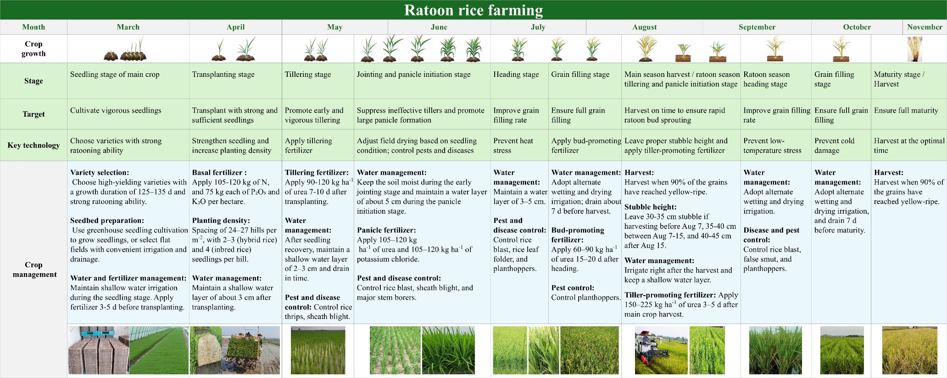
Extended Data Fig. 1. Crop calendar, growth stages, and key management practices in main and ratoon seasons of ratoon rice in central China. Figure shows the seasonal timeline, crop development stages, and major management practices for both main and ratoon season crops in a representative ratoon rice farming system in central China. It presents the specific crop management objectives and core technologies applied at each stage to achieve high yield and efficiency in ratoon rice production. Data are provided as Source Data.

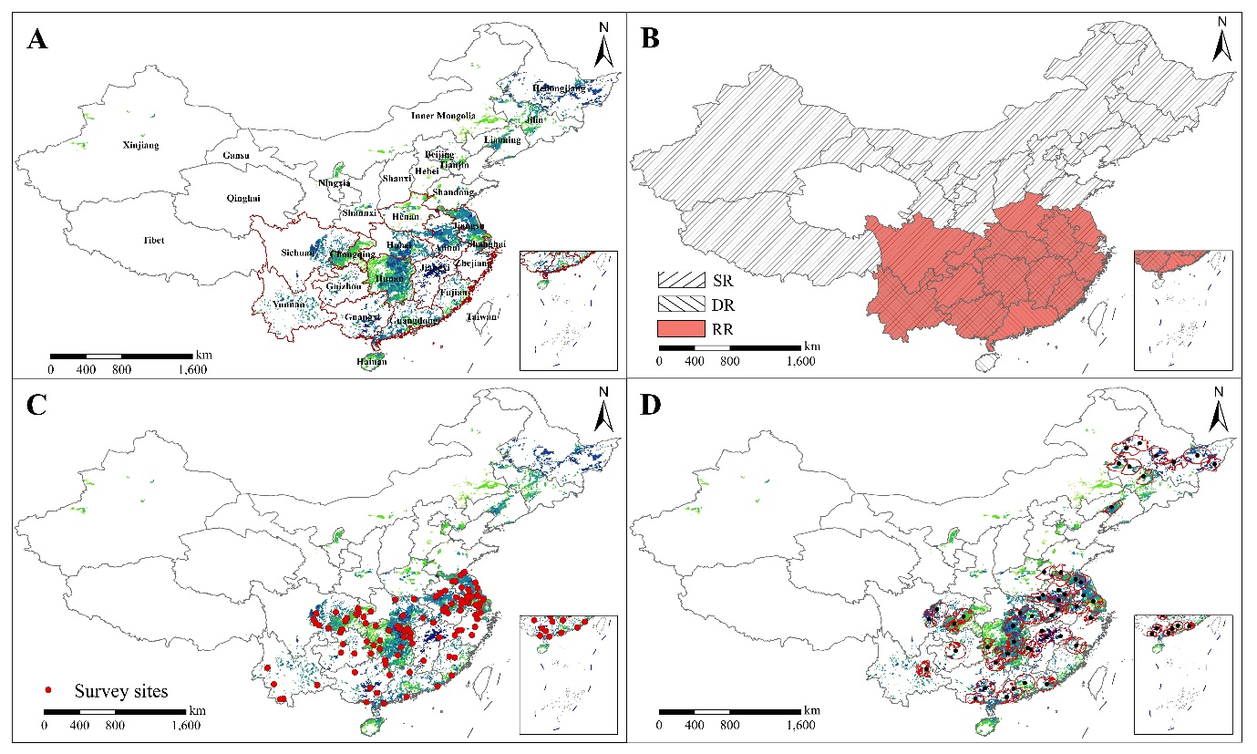
Extended Data Fig. 2. The locations of the fourteen selected provinces, distributions of different rice systems, survey sites, and selected buffer zones. Figure shows maps for (A) the location of fourteen studied provinces (red polygons), (B) distribution of single-season rice (left slash), double-season rice (right slash), and ratoon rice (red) systems in each province, (C) the location of survey sites (red circles), and (D) reference weather stations (black circles) and selected buffers (red polygons) for single-season rice, double-season rice, and ratoon rice systems. The darker the green, the larger the rice area (SPAM 2020; www.mapspam.info) in panels A, C, and D. The base map was applied without endorsement using data from the National Platform for Common Geospatial Information Services (https://www.tianditu.gov.cn/). Data are provided as Source Data.

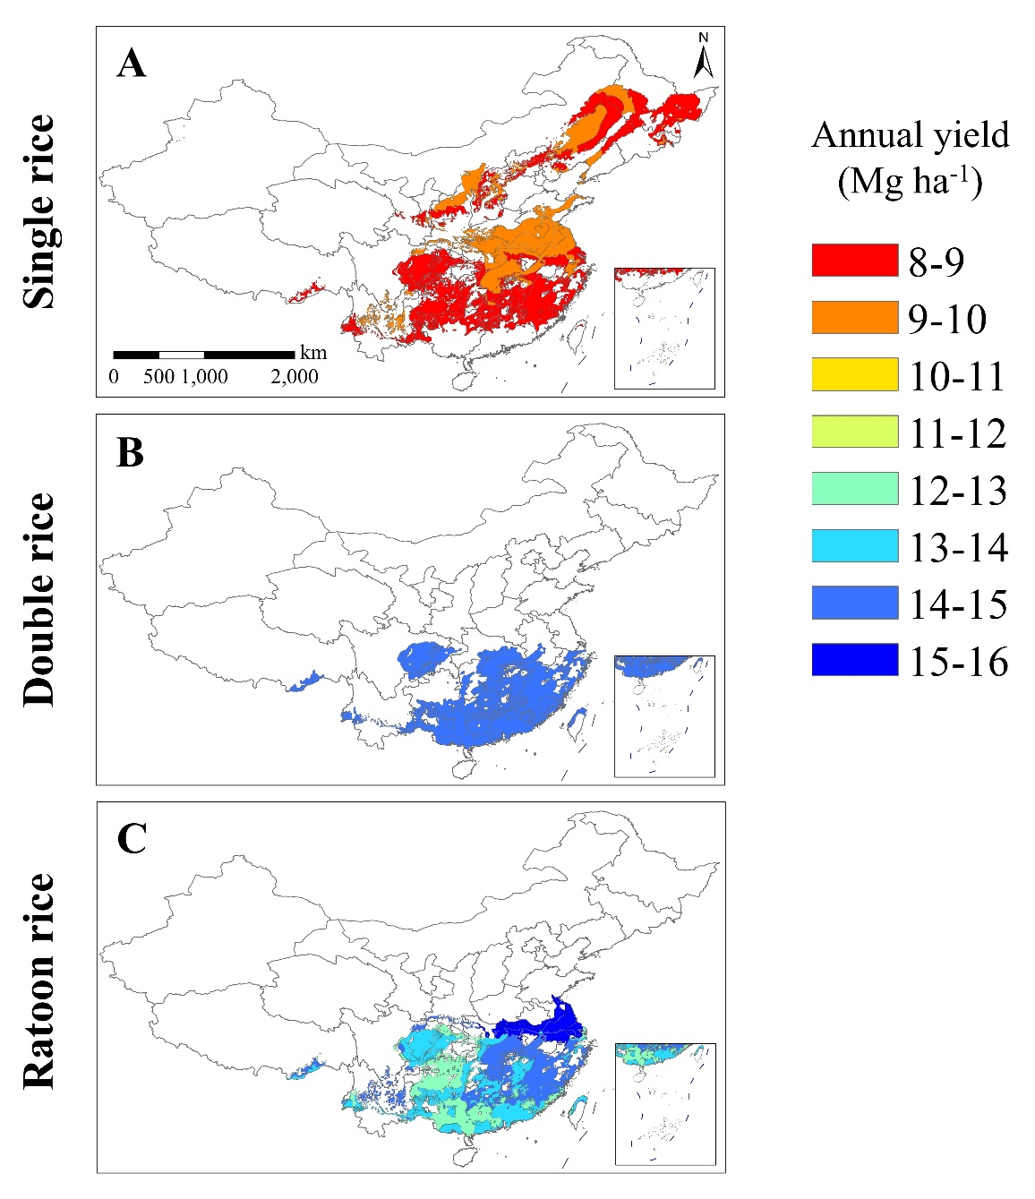
Extended Data Fig. 3. Annual attainable yield for single-season rice, double-season rice, and ratoon rice systems in China at the climate zone level. Panels show annual attainable yield for (A) single-season rice, (B) double-season rice, and (C) ratoon rice systems. The base map was applied without endorsement using data from the National Platform for Common Geospatial Information Services (https://www.tianditu.gov.cn/). Data are provided as Source Data.

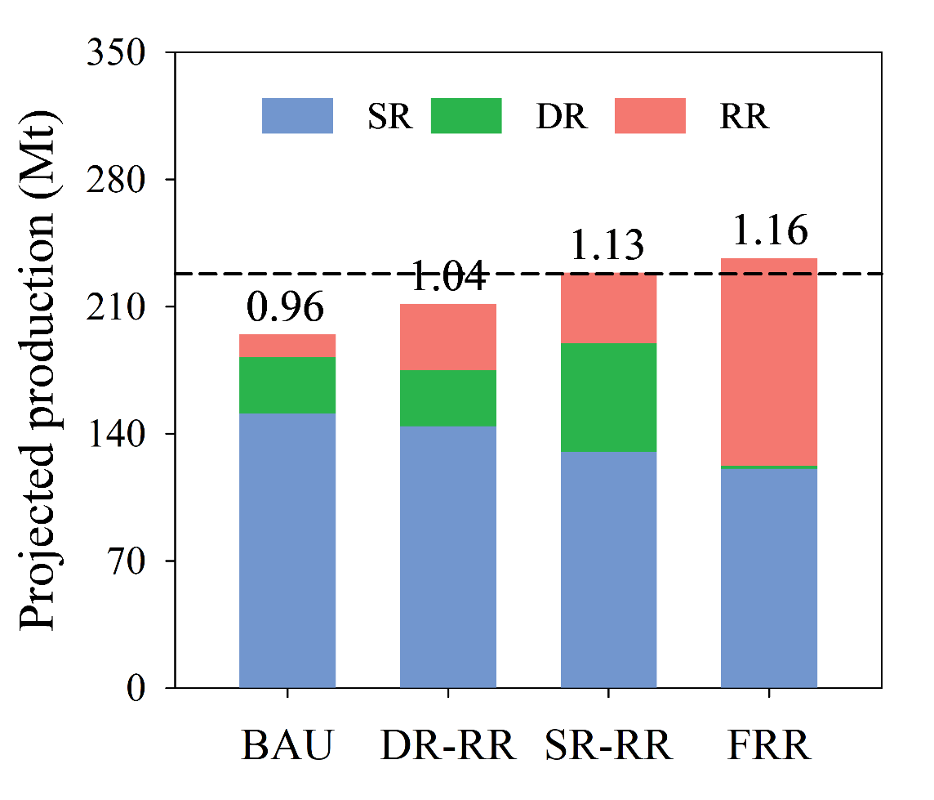
Extended Data Fig. 4. Projected national total rice production under different scenarios based on yield extrapolation by 2040. Projected national rice production for single-season (SR), double-season (DR), and ratoon rice (RR) systems under different scenarios, including continuation of historical trends without changes in RR area (BAU), reallocation of future DR area loss to RR (DR-RR), maintenance of DR area and some transition of SR to RR (SR-RR), and complete replacement of SR and DR with RR where biophysically feasible and without substituting other food crops (FRR). Extrapolated rice yield by 2040 was estimated based on the observed patterns for each rice system in each province over the past 30 years (see Methods). Baseline values around the year 2020-2022 are shown (horizontal dashed lines). Also shown is the rice self-sufficiency (production-to-demand ratio) in 2040. Data are provided as Source Data.

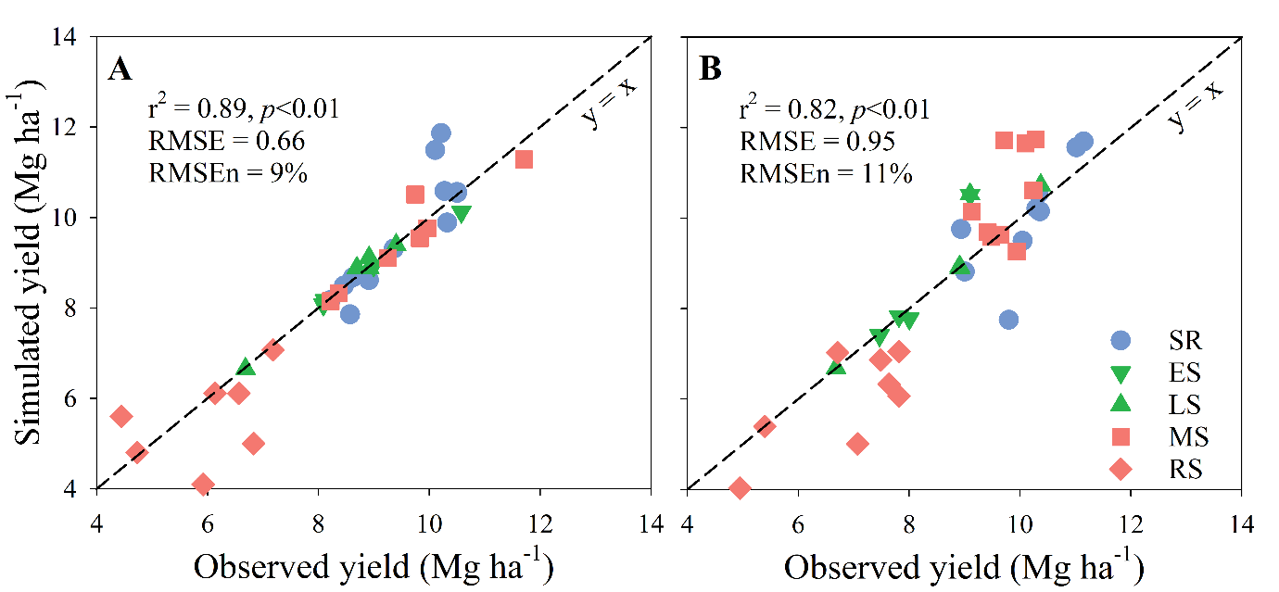
Extended Data Fig. 5. Rice model calibration and validation. Comparison of simulated versus observed grain yield by using ORYZA model for single-season rice (SR) and early (ES) and late season (LS) of double-season rice and ORYZA_R model for main (MS) and ratoon season (RS) of ratoon rice for calibration (A) and validation (B) datasets. Dashed diagonal line indicates y = x. Data are provided as Source Data.

