Changes in the Excitability of Primary Hippocampal Neurons Following Exposure to 3.0 GHz Radiofrequency Electromagnetic Fields
Ibtissam Echchgadda^{1*}, Jody C. Cantu², Gleb P. Tolstykh², Joseph W. Butterworth², Jason A. Payne¹, Bennett L. Ibey¹
¹Air Force Research Laboratory, 711th Human Performance Wing, Airman Systems Directorate, Bioeffects Division, Radio Frequency Bioeffects Branch, 4141 Petroleum Road, JBSA Fort Sam Houston, TX 78234, USA
²General Dynamics Information Technology, 4141 Petroleum Road, JBSA Fort Sam Houston, TX 78234, USA
*Corresponding author, email ibtissam.echchagadda.1@us.af.mil

Supplementary Information
Supplementary Figure 1. GTEM enclosed RF-EMF exposure system. (a) The system consisted of a GTEM enclosed in an insulated, Styrofoam™ chamber. (b) The GTEM was retrofitted with an environmental controller that maintained the inner GTEM chamber at biological conditions (37 ºC, 5% CO₂, 95% RH). (c) Schematic of exposure setup: GTEM is enclosed in an insulation chamber and connected to a digital RF signal generator.

Supplementary Figure 2. Patch-clamp electrophysiology of PHNs. Representative images of patched PHNs are shown in unexposed (a) and RF-EMF exposed (b). (c) Current injection protocol used for PHNs. Examples of current-clamp recordings are shown in unexposed (d) and exposed (e). Note that smaller current injection required to elicit AP in RF-EMF exposed neuron.

Supplementary Figure 3. Cell viability profiles from unexposed and RF-EMFs exposed PHNs. Percent cell viability assessed at 24 h following mock (unexposed) or RF-EMFs exposure. RF-EMFs was compared to unexposed that was set at 100%. Data are expressed as percent of the mean value ± SD, n=7.
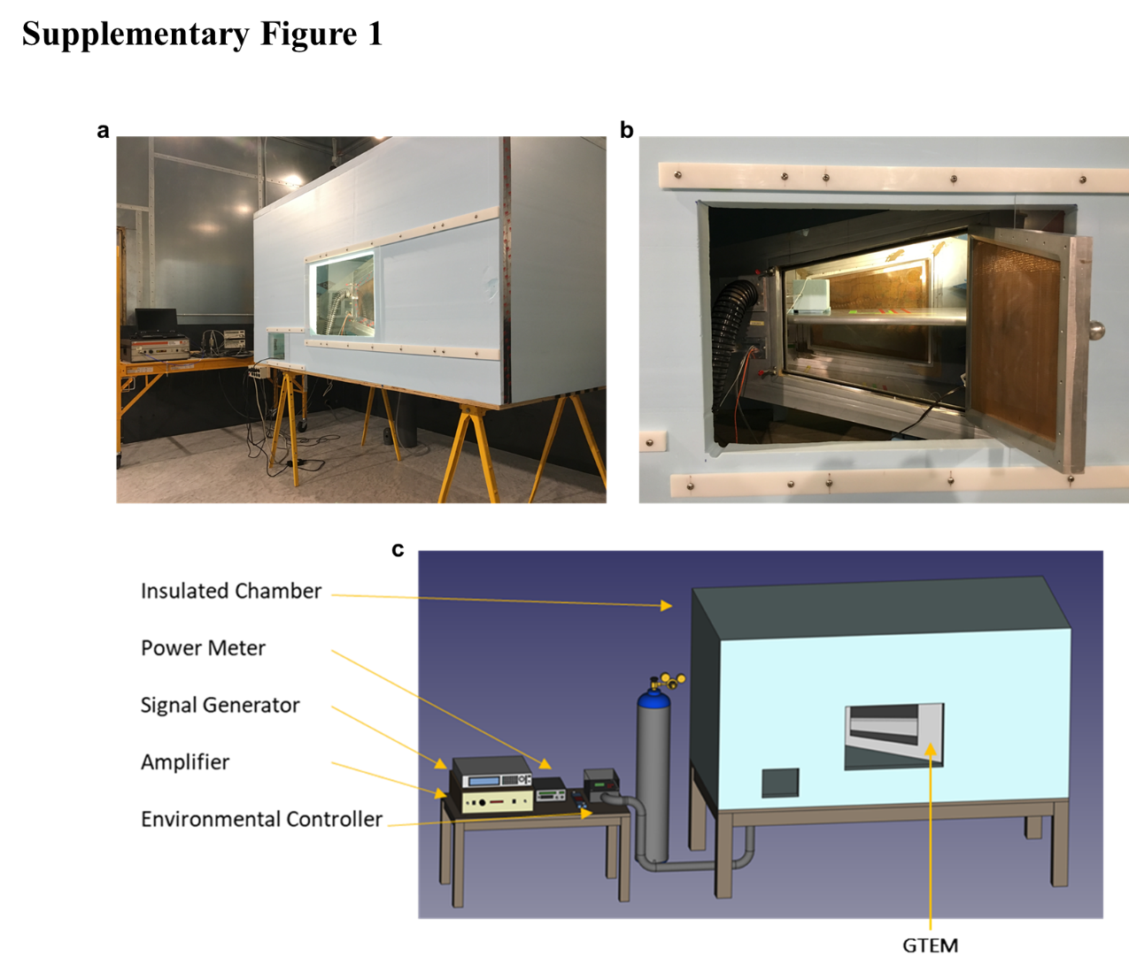
GTEM enclosed RF-EMF exposure system. (a) The system consisted of a GTEM enclosed in an insulated, Styrofoam™ chamber. (b) The GTEM was retrofitted with an environmental controller that maintained the inner GTEM chamber at biological conditions (37 ºC, 5% CO₂, 95% RH). (c) Schematic of exposure setup: GTEM is enclosed in an insulation chamber and connected to a digital RF signal generator.

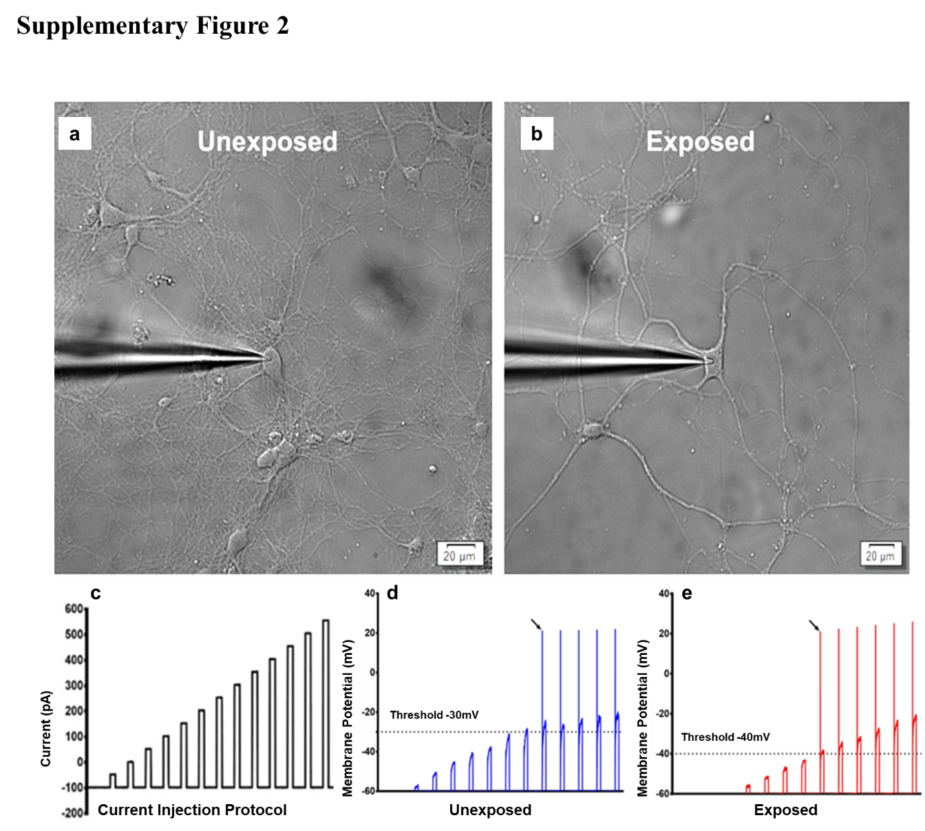
Patch-clamp electrophysiology of PHNs. Representative images of patched PHNs are shown in unexposed (a) and RF-EMF exposed (b). (c) Current injection protocol used for PHNs. Examples of current-clamp recordings are shown in unexposed (d) and exposed (e). Note that smaller current injection required to elicit AP in RF-EMF exposed neuron.

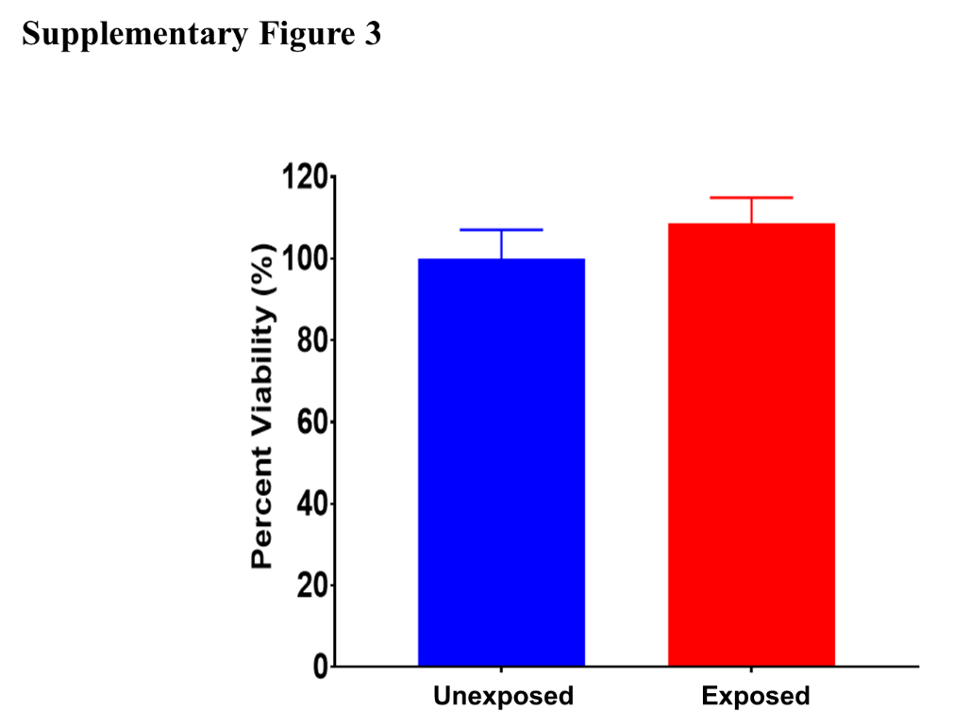
Cell viability profiles from unexposed and RF-EMFs exposed PHNs. Percent cell viability assessed at 24 h following mock (unexposed) or RF-EMFs exposure. RF-EMFs was compared to unexposed that was set at 100%. Data are expressed as percent of the mean value ± SD, n=7.

