EXTENDED DATA FILES

Extended Data Fig. 1 Phase analysis of CoCrNi. a, Phase fraction as a function of temperature for CoCrNi, obtained using Thermo-CalcTM with the TCHEA5 database. b, Experimental thermal profile used for the in situ dilatometry with synchrotron X-ray diffraction (D-SXRD) experiment. The points marked in b indicate selected XRD patterns, acquired during the process, which are shown in c.

Extended Data Fig. 2 Depiction of the Baseline Shift. a, Second heating cycle of the quenched CoCrNi sample, highlighting the baseline shift in specific heat (C_{p}). After the reaction, the baseline transitions from the initial Cpg₁ to a higher Cpg₂, indicating a permanent structural change. b, Schematic representation of different thermal signal morphologies: a baseline shift (red), a simple reaction peak (cyan), and a reaction peak superimposed on a BLS (purple), as typically detected by calorimetry or related techniques.

Extended Data Fig. 3: Cooling curves from thermal analyses in the CoCrNi alloy. a, C_{p} curves during the cooling cycles of the aged (100 h at 748 K) and quenched (water cooled from 1473 K) samples, all performed at a cooling rate of 40 K/min. b, TEC curves of the aged sample in the D-SXRD experiment. c, Volume-temperature curves of the aged sample during the first heating and the first and second cooling cycles (D-SXRD). No reaction peak is observed in any of the above figures.

Extended Data Fig. 4 Dilatometry analysis of pure Ni after aging at 748 K for 100 h. a, TEC curves. Aside from the magnetic transition near 640 K (Curie temperature), no distinct reactions, such as peaks or baseline shifts, are observed. b, Volume as a function of temperature, showing virtually identical behavior between both cycles, in contrast to the distinct evolution seen for CoCrNi (Fig. 2d). The similarity between the first and second heating cycles (a,b) indicates that the behavior observed in CoCrNi is not associated with vacancy-related effects.

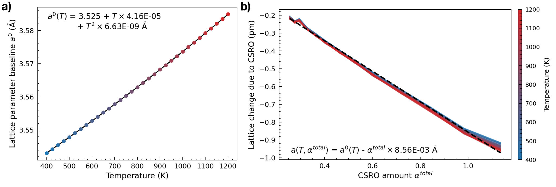
Extended Data Fig. 5 Lattice parameter model fitting. a Lattice parameter of random solid solution (RSS) CoCrNi as a function of temperature, fitted with a quadratic model $a^{RSS}(T)=a_{0 }+AT+BT^{2}$. b SRO-induced lattice contraction $Δa=a^{RSS}(T)-a^{SRO}(T,α^{total})$ as a function of $α^{total}$ at various temperatures. The near-universal linear relationship supports the separability of thermal and SRO effects in the lattice model.

Extended Data Fig. 6. Supplementary data analyses from the in situ dilatometry with synchrotron X-ray diffraction experiment, combined with atomistic simulations. a, Estimated lattice parameter profiles with three different transition temperatures. Lattice parameter curves obtained using the lattice model (Equation 4, Methods section on the manuscript) by enforcing three different CSRO profiles. All three curves assume a fixed CSRO state up to T_{kr}, transitioning to equilibrium CSRO above this temperature. The T_{kr} are selected as the identified T_{kr} from the aged, reheated, and quenched state from Fig. 2d, respectively. b, XRD data dispersion as a function of temperature (Debye-Waller effect), indicated by the standard deviation in the lattice parameter values from the D-SXRD experiment of the aged CoCrNi sample. c, Estimated CSRO content from dilatometry measurements of experimental states shown in Fig. 2d, compared against the equilibrium CSRO profile. The volumetric data in Fig. 2d (manuscript) is converted to lattice parameter data by estimating the total number of unit cells in the sample calculated from the highest temperature datapoint of the quenched state. Similar procedure as Fig. 3d (manuscript) is applied to estimate CSRO profiles. d, The relative contribution of CSRO evolution to the total TEC as a function of temperature for all three experimental states.

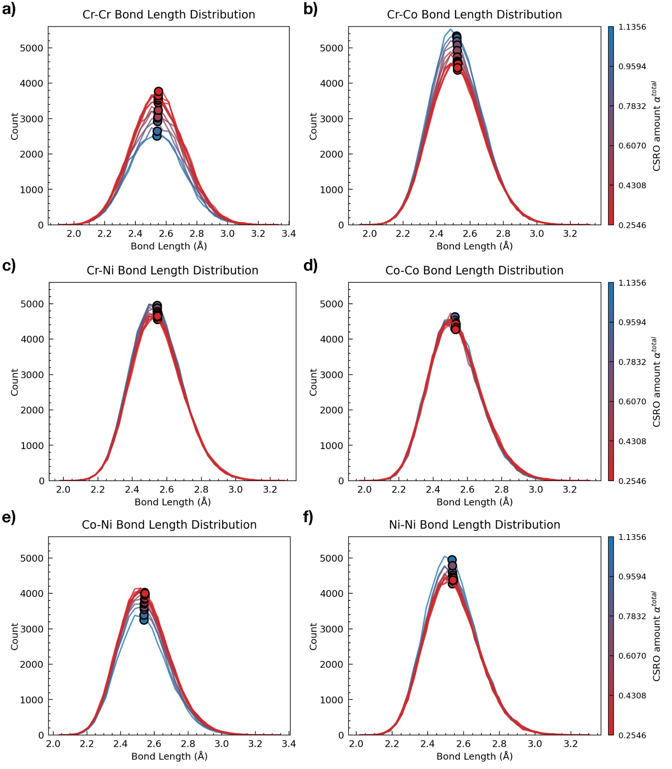

Extended Data Fig. 7 Distribution of nearest-neighbor bond lengths with varying SRO for all six atomic pairs in CoCrNi at varying levels of SRO. Configurations were sampled from MC simulations across fictitious temperatures from 400 to 1600 K. The color bar indicates the total amount of short-range order via $α^{total}=Σ_{ij} \left|α_{ij}\right|.$
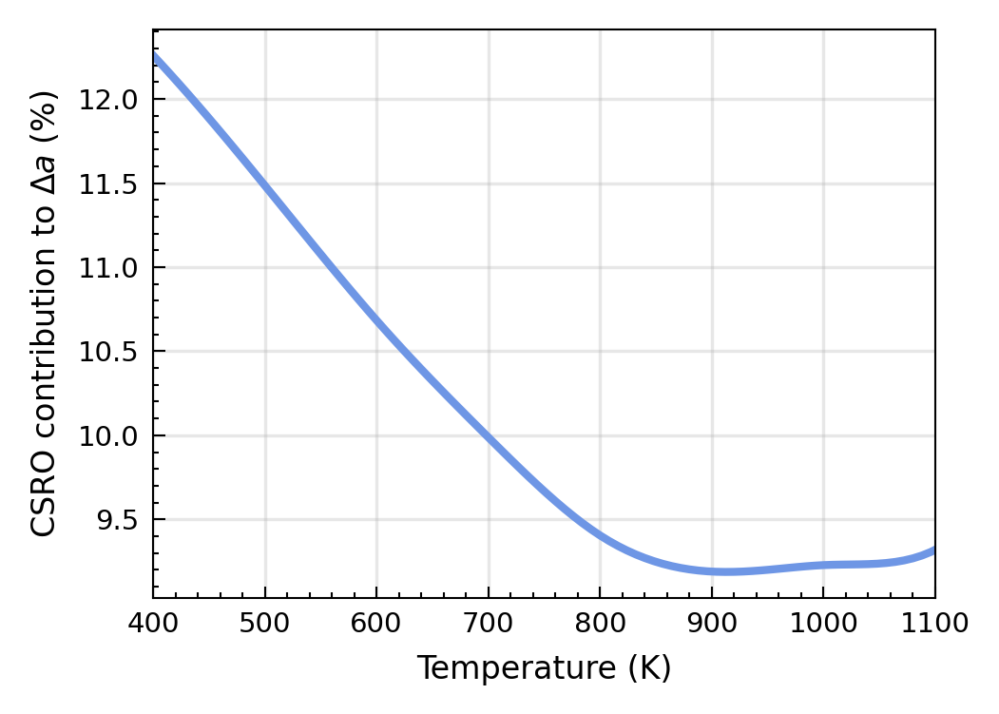
Extended Data Fig. 8 CSRO contribution to the relative lattice contraction. The relative fraction between lattice contraction caused by CSRO formation and thermal effects as a function of temperature between 400 K and 1100 K. The reference state is a random solid solution at the melting point (1660 K).

Extended Data Fig. 9 XRD and thermal analyses of a 316L stainless steel. a, XRD patterns (Cu Kα) of aged, quenched, and reheated samples. The reheated sample mimics the condition after the first heating cycle in DSC or dilatometry (following the protocol shown in Fig. 1a). It was prepared by heating an aged sample at 10 K/min up to 1073 K, holding for 10 minutes, and then water quenching. b,d,f, Cp (b), TEC (d), and volume (f) curves for the aged sample. c,e, Specific heat (c) and volume (e) curves for the quenched sample. The volume behavior of the aged sample between both heating cycles infers that the ‘CSRO-aging’ treatment, developed for CoCrNi, is nonoptimal for the 316L steel.

Extended Data Fig. 10 XRD and thermal analyses of a 625 Inconel nickel-based superalloy. a, XRD patterns (Cu Kα) of aged, quenched, and reheated samples. The reheated sample mimics the condition after the first heating cycle in DSC or dilatometry (following the protocol shown in Fig. 1a). It was prepared by heating an aged sample at 10 K/min up to 1073 K, holding for 10 minutes, and then water quenching. b,d,f, Cp (b), TEC (d), and volume (f) curves for the aged sample. c,e, Specific heat (c) and volume (e) curves for the quenched sample. The volume behavior of the aged sample between both heating cycles infers that the ‘CSRO-aging’ treatment, developed for CoCrNi, is nonoptimal for the 625 Inconel superalloy.

