Supplementary figures:
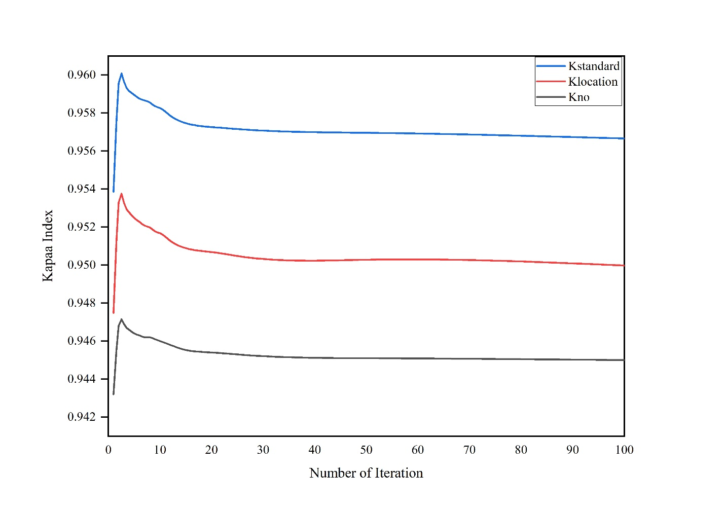
Figure S1: Illustrate the Kappa Index accuracy.

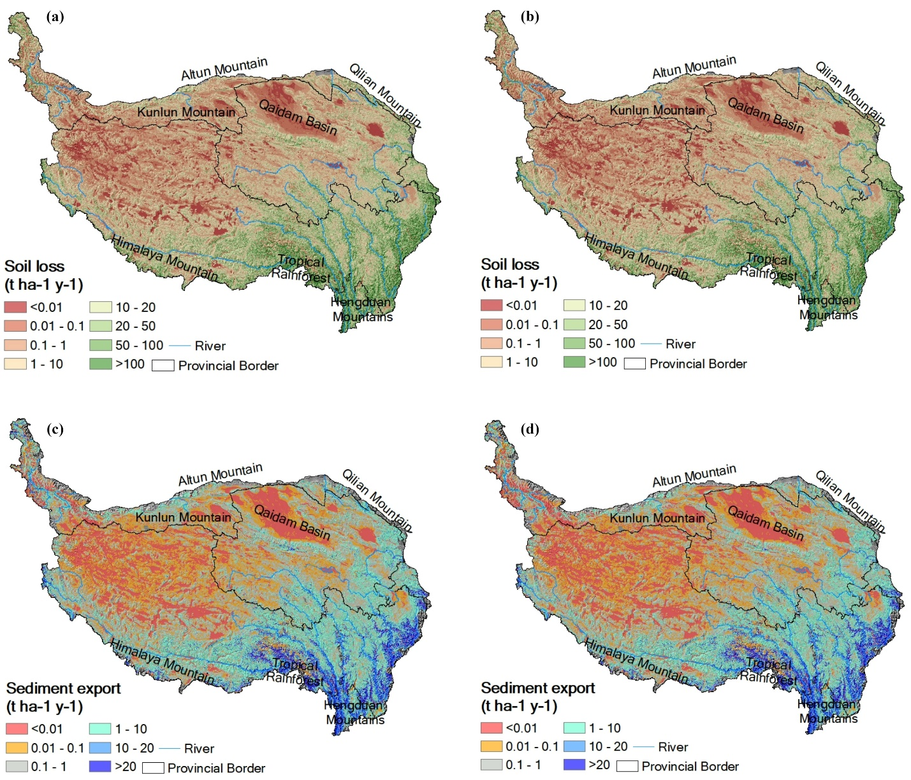

Figure S2: Maps of soil loss, sediment export, and soil loss grade in 2050 (a) and 2090 (b).

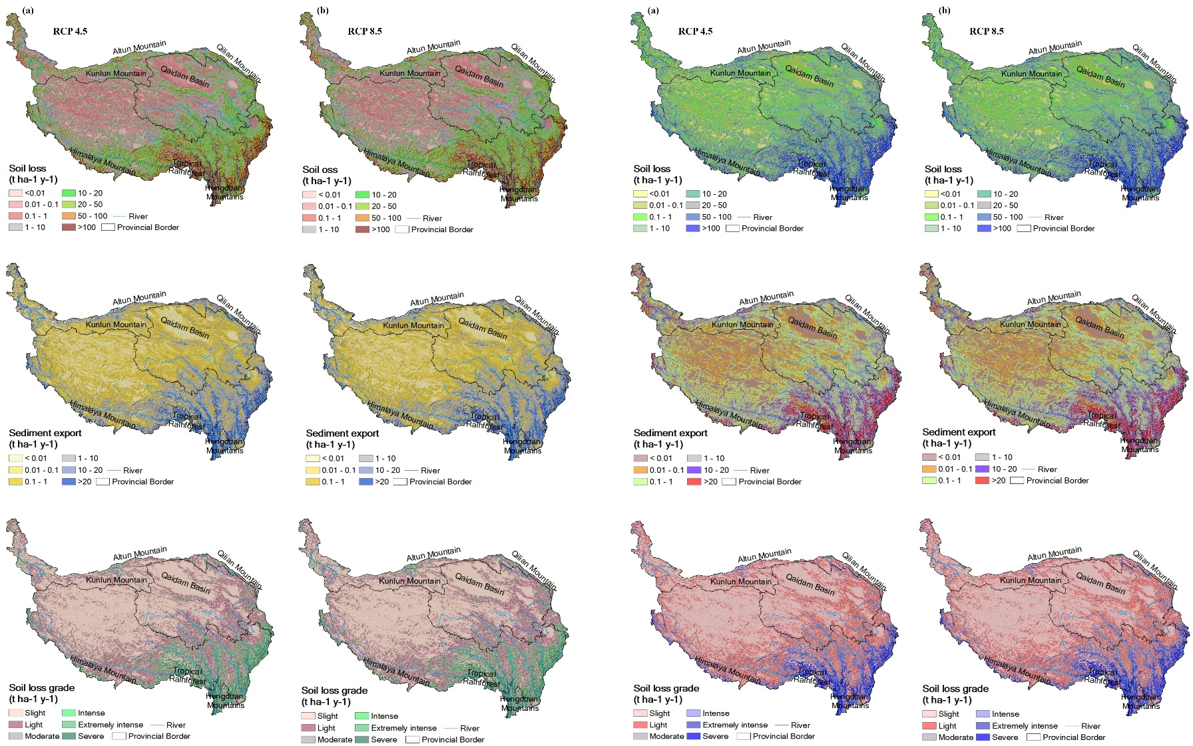

Figure S3: Maps of soil loss, sediment export, and soil loss grade under land use and climate change scenario in (a) 2050, and (b) 2090.

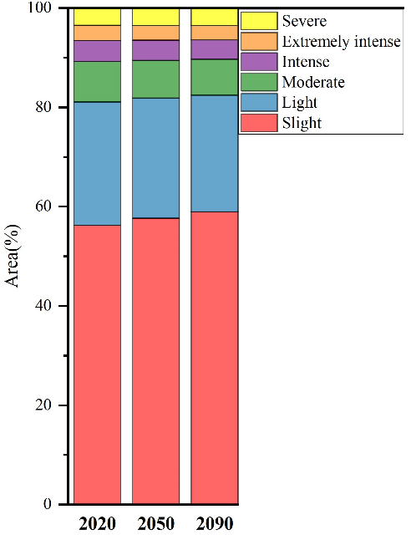
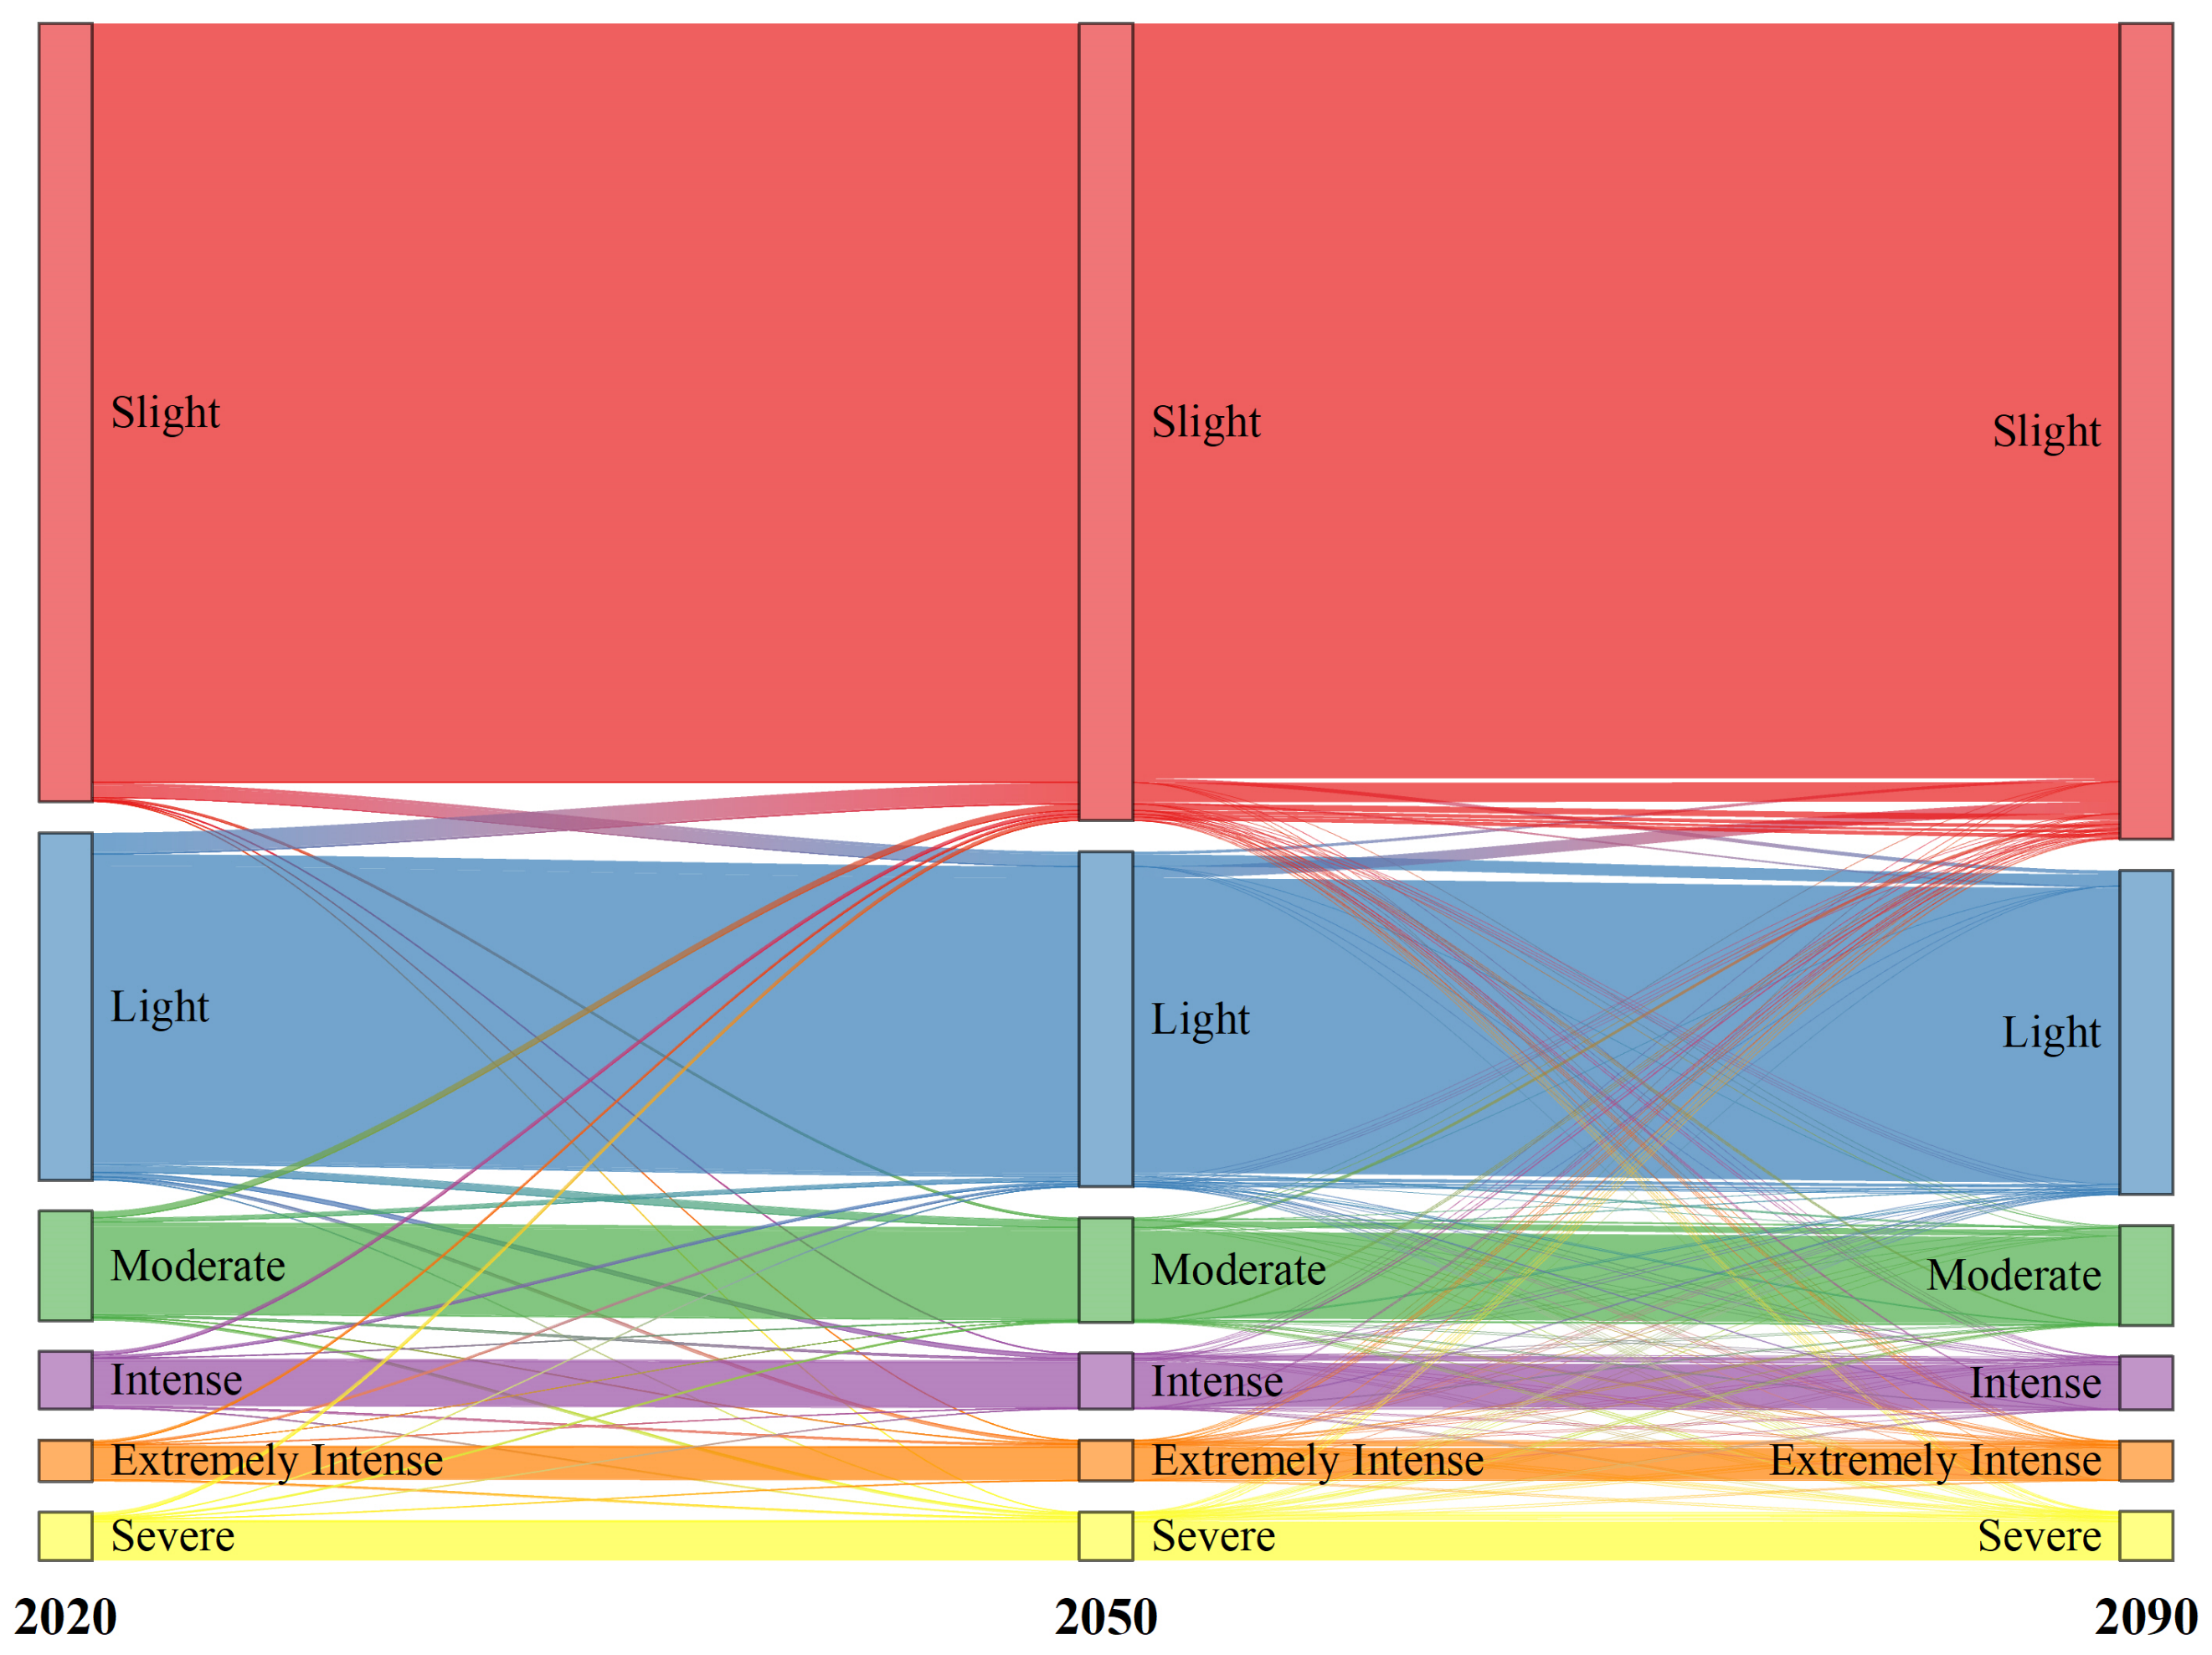
Figure S4: Soil loss grade class transformation and their ratio under land use scenario
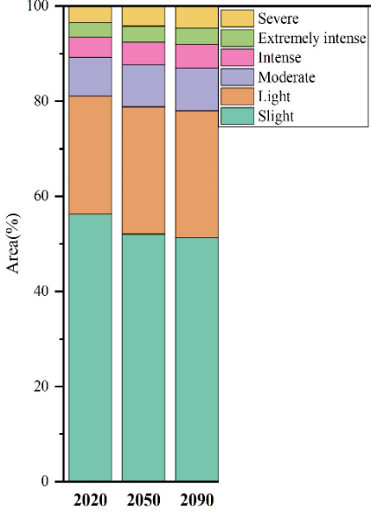
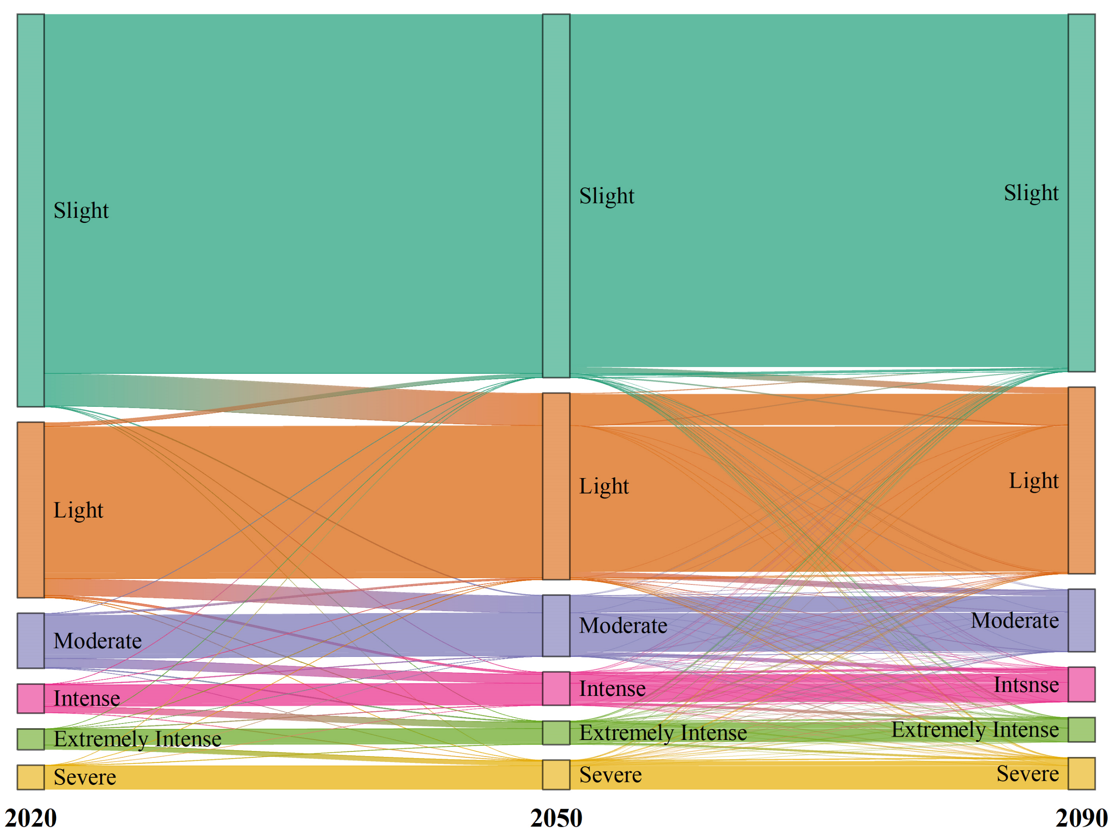
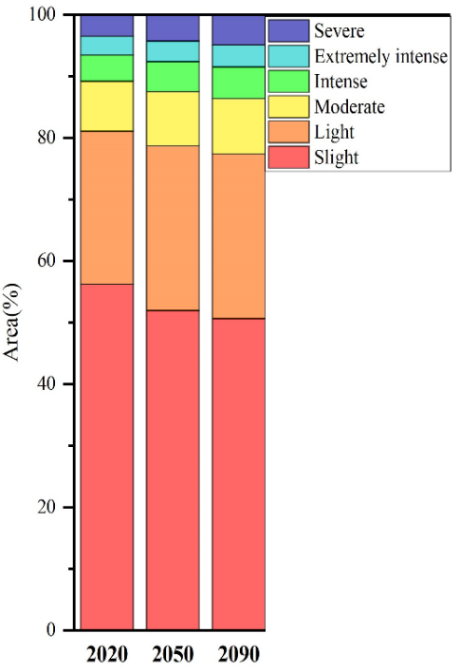
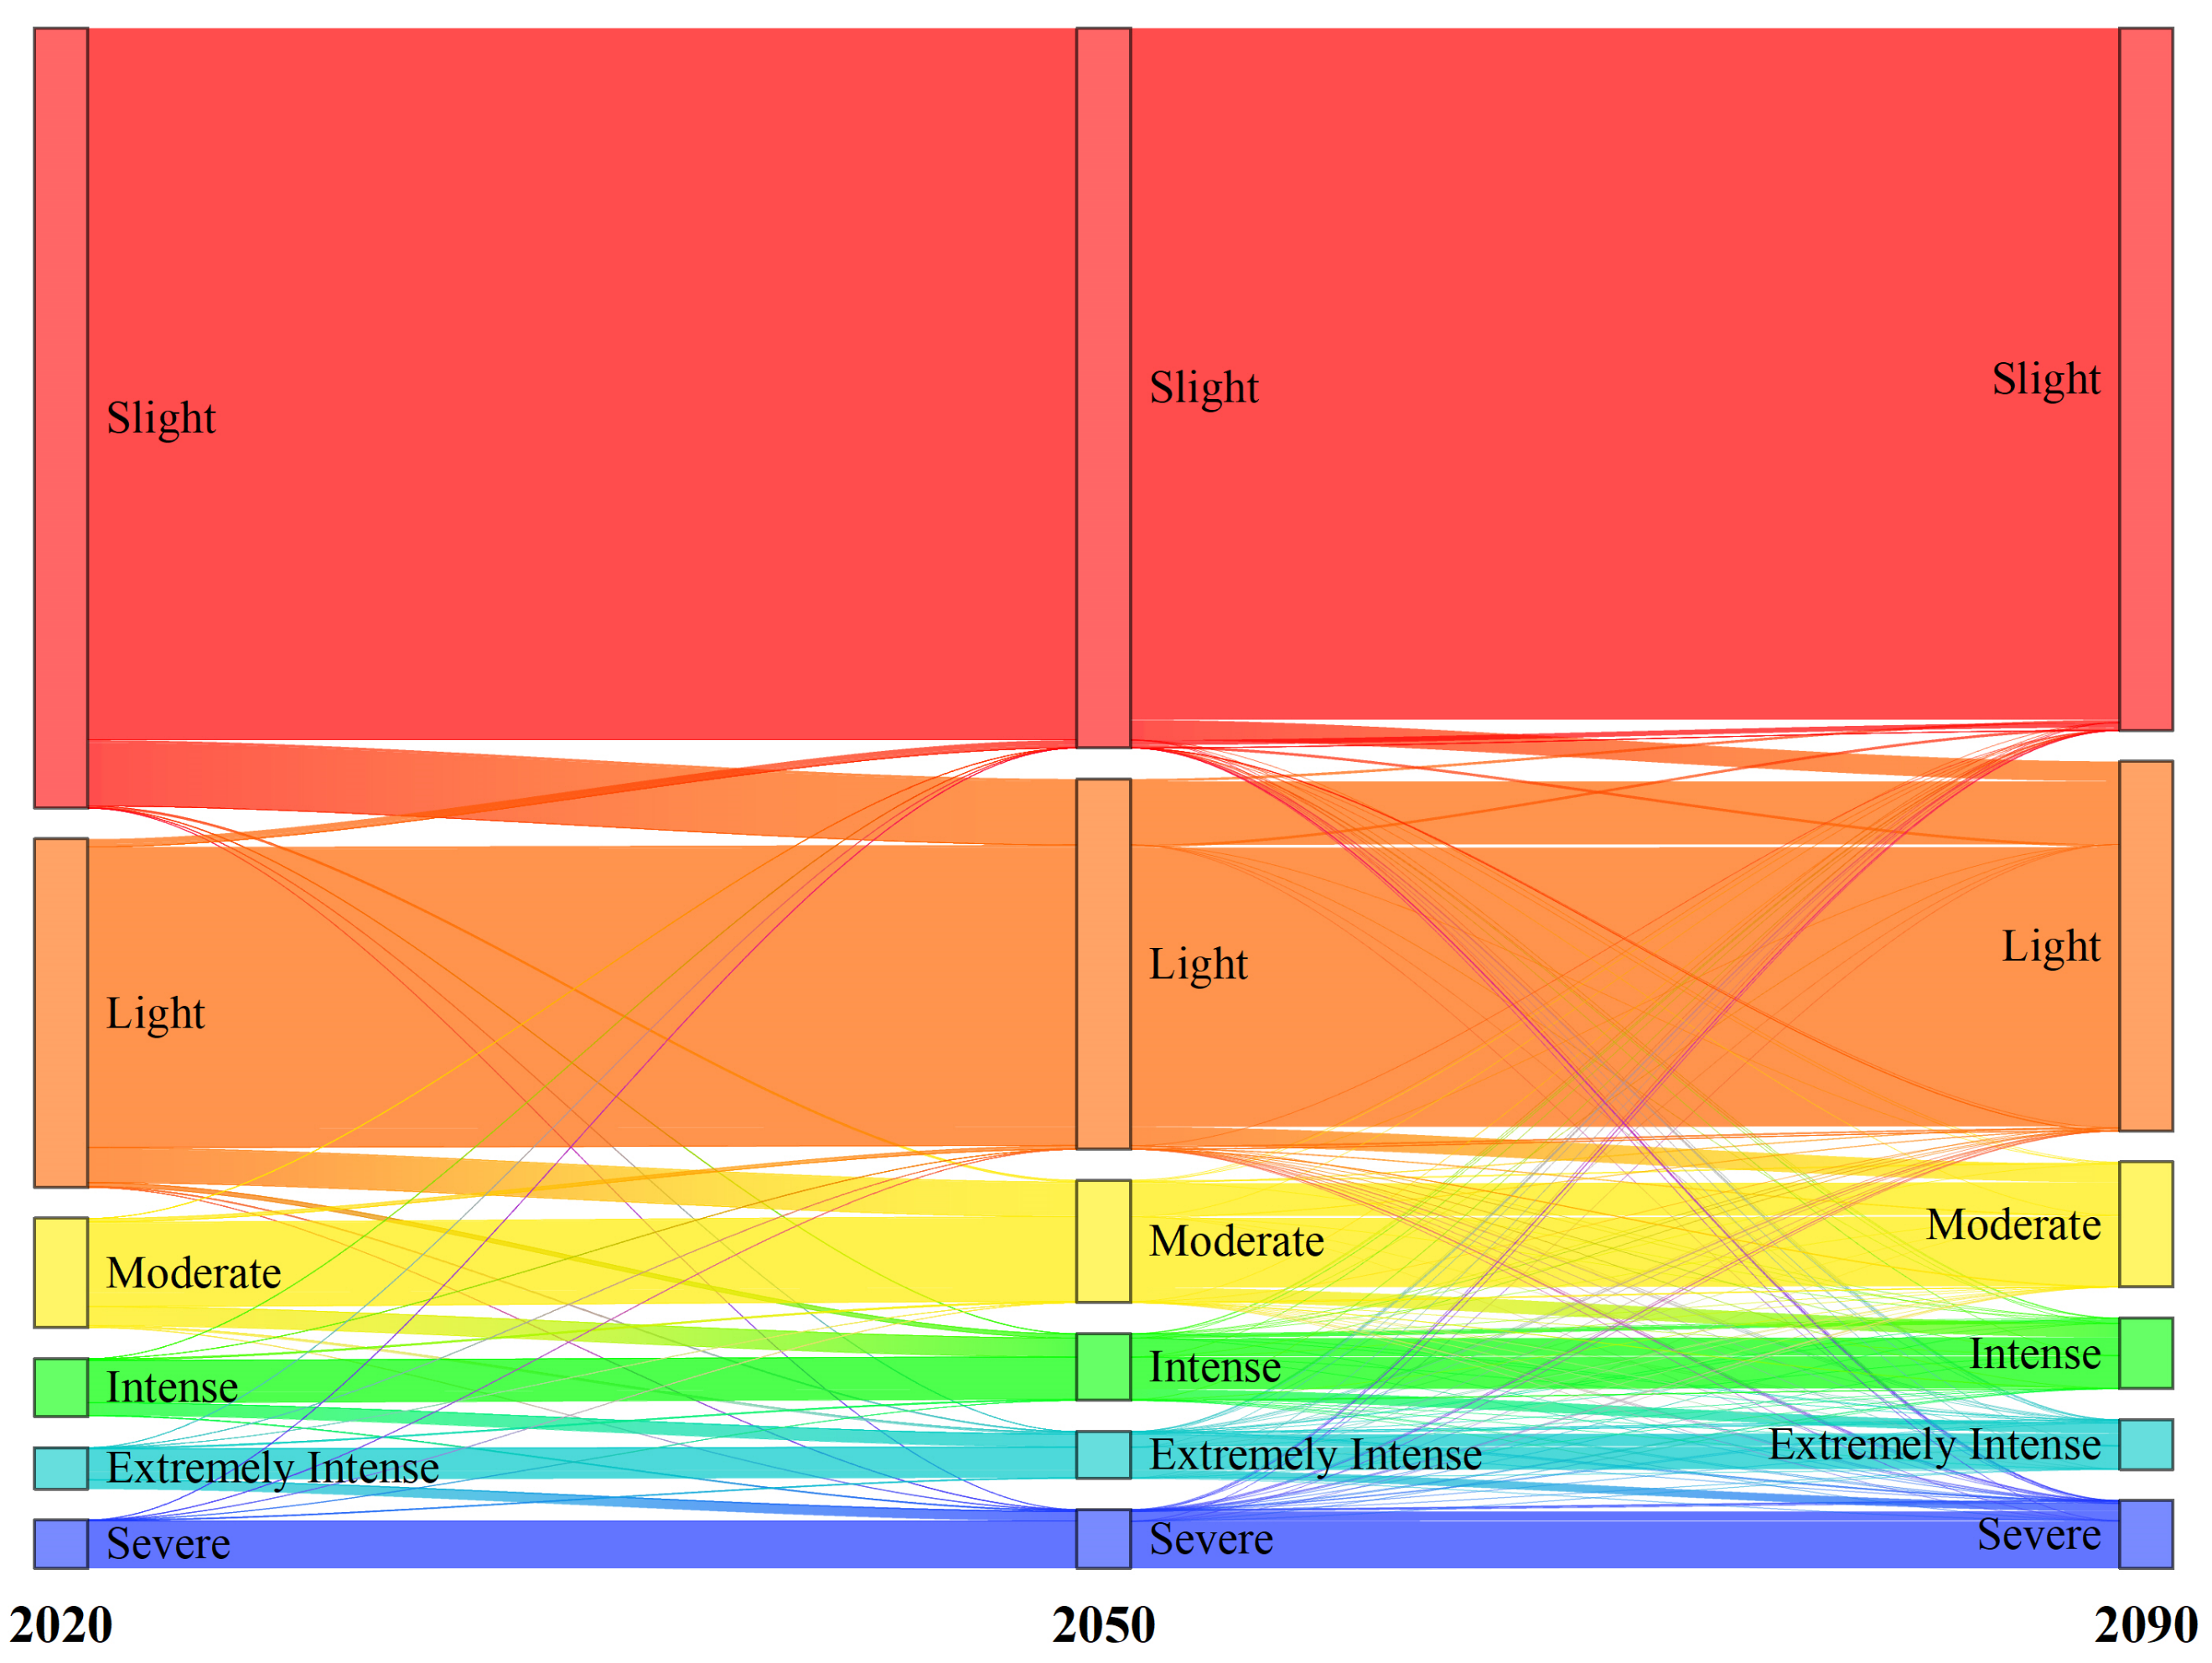
(a)
Figure S5: Soil loss grade class transformation and their ratio under (a) SSP2 4.5, and (b)SSP5 - 8.5 scenario
(b)

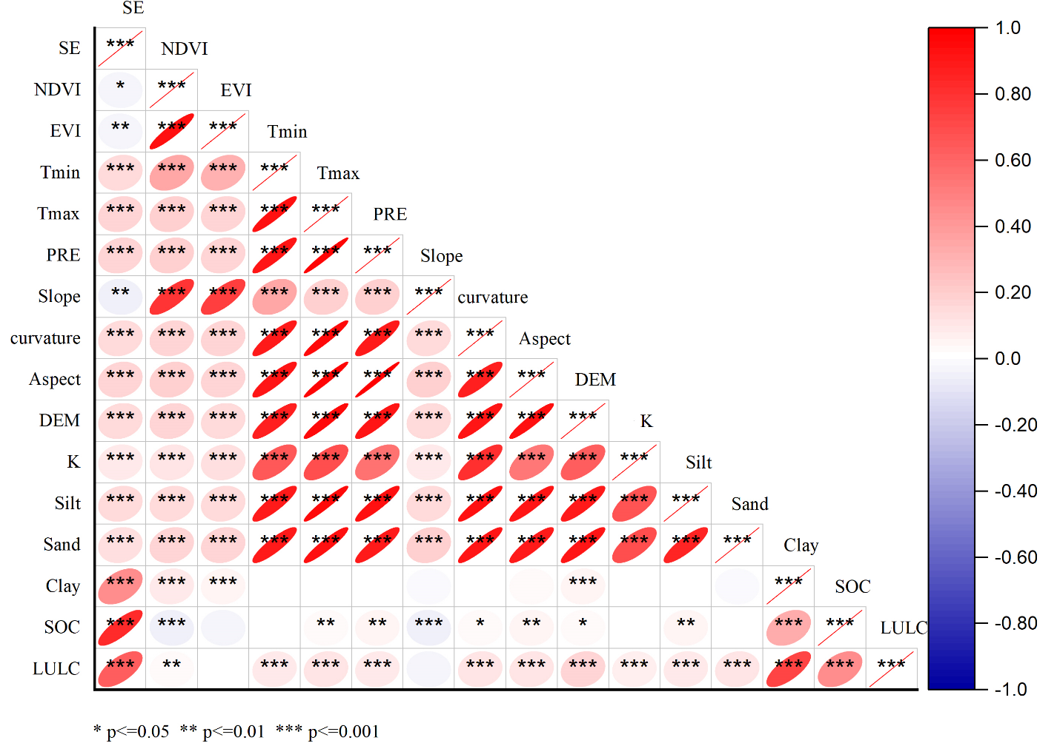
Figure S6: Pearson correlation between soil erosion and environmental variables.

Supplementary Tables:
Table S1. Summary of the five GCMs from CMIP6.
Model name | Institution | Country | Resolution
BCC-CSM2-MR | Beijing Climate Center, Beijing. | China | 2.8125°× 2.8125°
GISS-E2-1-G | Goddard Institute for Space Studies, New York. | USA | 2.5°×2°
IPSL-CM6A-LR | Institute Pierre Simon Laplace, Paris. | France | 3.75°×~1.9°
MRI-ESM2-0 | Meteorological Research Institute, Tsukuba. | Japan | 1.125 × 1.125
MPI-ESM1-2-HR | Max Planck Institute for Meteorology, Hamburg. | Germany | 1.875°×1.9°

Table S2. The C and P factor values of different land use types on the Tibetan Plateau.
Land use type | C value | Reference | P value | Reference
Cropland | 0.5 | Yang et al.,2003 | 0.5 | Yang et al.,2003
Forest | .09 | Yang et al.,2003; Bakker et al.,2008 | 0.8 | Xu et al.,2012
Shrub | .22 | Yang et al.,2003; Bakker et al.,2008 | 1 | Xu et al.,2012; Dai et al.,2013
Grassland | .06 | Du et al.,2016; Fu et al.,2005 | 1 | Zhang et al.,2016; Dai et al.,2013
Water | 0 | Xu et al., 2012 | 0 | Xu et al., 2012
Snow | .001 | Yang et al.,2003 | 1 | Yang et al.,2003
Barren | .35 | Li et al.,2013; Dai et al.,2013 | 1 | Zhang et al.,2016; Dai et al.,2013
Impervious | 0 | Du et al.,2016 | 1 | Xu et al.,2012
Wetland | .05 | Yang et al.,2003 | 1 | Yang et al.,2003

Table S3. Annual soil loss and sediment export for years 1985,2000,2010, and 2020.
Land use Type | 1985 |  |  | 2000 |  |  | 2010 |  |  | 2020
Land use Type | LC (%) | SL*10⁷ (t.y⁻¹) | SE*10⁷ (t.y⁻¹) | LC (%) | SL*10⁷ (t.y⁻¹) | SE*10⁷ (t.y⁻¹) | LC (%) | SL*10⁷ (t.y⁻¹) | SE*10⁷ (t.y⁻¹) | LC (%) | SL*10⁷ (t.y⁻¹) | SE*10⁷ (t.y⁻¹)
Cropland | 0.47 | 3.87 | 0.911 | 0.43 | 4.43 | 1.08 | 0.41 | 4.68 | 1.17 | 0.38 | 2.96 | 1.36
Forest | 7.04 | 159.03 | 31.818 | 7.5 | 174.11 | 34.9 | 7.68 | 164.17 | 32.56 | 7.81 | 168.01 | 33.14
Shrub | 0.52 | 5.73 | 1.07 | 0.25 | 0.99 | 0.22 | 0.25 | 1.002 | 0.22 | 0.24 | 3.05 | 0.17
Grassland | 64.74 | 232.49 | 33.15 | 63.64 | 202.48 | 28.26 | 63.61 | 187.05 | 25.63 | 63.6 | 220.85 | 25.15
Water | 1.63 | 1.28 | 0.203 | 1.72 | 0.00 | 0.00 | 2.03 | 0 | 0.00 | 2.18 | 2.08 | 0.00
Snow | 2.61 | 15.81 | 2.109 | 2.39 | 0.23 | 0.016 | 2.72 | 0.24 | 0.016 | 2.32 | 13.72 | 0.014
Barren | 22.92 | 73.43 | 10.699 | 24.01 | 132.01 | 20.15 | 23.25 | 149.08 | 22.97 | 23.41 | 79.79 | 19.99
Impervious | 0.005 | 0.003 | 0.001 | 0.008 | 0 | 0 | 0.001 | 0 | 0.00 | 0.001 | 0.01 | 0.00
Wetland | 0.0494 | 0.0093 | 0.001 | 0.03 | 0.0004 | 0 | 0.018 | 0.0001 | 0.00001 | 0.027 | 0.01 | 0.00004
QTP | 100 | 491.68 | 79.97 | 100 | 514.27 | 84.72 | 100 | 506.24 | 82.58 | 100 | 490.49 | 79.83
LC= Area of Land Cover ratio; SL=Annual Soil Loss; SE=Annual Sediment Export

Table S4. Projected land use type for 2050 and 2090 and their relative change.
Land use Type | Area (km²) | Area (%) | Relative change (%)  (2050 – 2020) | Area (km²) | Area (%) | Relative change (%)  (2090 – 2020)
Cropland | 11584 | 0.46 | 20.91 | 11796.22 | 0.47 | 23.13
Forest | 215676 | 8.55 | 9.52 | 233409.2 | 9.26 | 18.54
Shrub | 10090 | 0.40 | 66.75 | 11677.85 | 0.46 | 92.99
Grassland | 1538083 | 61.00 | - 4.09 | 1495252 | 59.31 | - 6.74
water | 85802 | 3.40 | 56.10 | 120890.3 | 4.80 | 119.95
Snow | 101302 | 4.02 | 73.18 | 132493.5 | 5.26 | 126.52
Barren | 558470 | 22.15 | -5.39 | 515235.2 | 20.44 | -12.70
Impervious | 44.82 | 0.002 | 4.56 | 87.64 | 0.003 | 104.50
Wetland | 358.93 | 0.01 | - 47.28 | 284.92 | 0.01 | -58.14

Table S5: Annual Soil loss and sediment export for 2050, and 2090 under land use change.
Land use Type | 2050 |  |  | 2090
Land use Type | LU (%) | SL*10⁷  (t.y⁻¹) | SE*10⁷  (t.y⁻¹) | LU (%) | SL*10⁷  (t.y⁻¹) | SE*10⁷  (t.y⁻¹)
Cropland | 0.45 | 7.7652 | 2.10 | 0.46 | 10.06 | 2.80
Forest | 8.55 | 176.62 | 36.51 | 9.25 | 189.56 | 39.05
Shrub | 0.40 | 12.53 | 3.25 | 0.46 | 14.09 | 3.39
Grassland | 61.00 | 176.40 | 26.40 | 59.30 | 159.35 | 23.09
Water | 3.4 | 2.94 | 0.51 | 4.79 | 3.30 | 0.57
Snow | 4.01 | 9.24 | 1.37 | 5.25 | 7.88 | 1.11
Barren | 22.14 | 101.62 | 17.15 | 20.43 | 94.87 | 15.77
Impervious | 0.002 | 0.015 | 0.003 | 0.003 | 0.029 | 0.007
Wetland | 0.014 | 0.0003 | 0.00001 | 0.011 | 0.0003 | 0.00002
QTP |  | 487.16 | 87.32 |  | 479.18 | 85.82
LU= Area of land cover ratio; SL=Annual Soil loss; SE=Annual Sediment Export

Table S6. Corresponding area for Soil loss grade ratios for 2050 and 2100 under land use change.
Soil loss classes  (t ha⁻¹yr⁻¹) | Value | 2050 |  |  |  | 2090
Soil loss classes  (t ha⁻¹yr⁻¹) | Value | LU% | SL*10⁷ | SL % | Relative change | LU% | SL*10⁷ | SL % | Relative change
< 5 | Slight | 57.65 | 16.17 | 3.32 | -2.89 | 59.00 | 15.93 | 3.32 | -4.40
5 - 25 | Light | 24.24 | 70.76 | 14.51 | -5.73 | 23.45 | 68.31 | 14.24 | -9.00
25 - 50 | Moderate | 7.58 | 68.54 | 14.05 | -5.83 | 7.25 | 65.51 | 13.65 | -10.00
50 - 80 | Intense | 4.04 | 63.86 | 13.09 | -4.85 | 3.87 | 61.18 | 12.75 | -8.86
80 - 125 | Extremely intense | 2.97 | 74.58 | 15.29 | -2.69 | 2.89 | 72.46 | 15.10 | -5.47
>125 | Severe | 3.53 | 193.88 | 39.74 | 3.01 | 3.55 | 196.42 | 40.94 | 4.36
LU%= Area of class ratio; SL= Annual Soil loss; SL% = Amount of Annual soil loss ratio
Relative Change = (SL _{(2050,2100)} – SL ₍₂₀₂₀₎) / SL ₍₁₉₈₅₎ *100

Table S7: prediction of annual soil loss and sediment export in 2050 and 2090 under SSP2-4.5 and SSP5-8.5
Land use Type | 2050 |  |  |  | 2090
Land use Type | SSP2-4.5 |  | SSP5-8.5 |  | SSP2-4.5 |  | SSP5-8.5
Land use Type | SL*10⁷  (t.y⁻¹) | SE*10⁷  (t.y⁻¹) | SL*10⁷  (t.y⁻¹) | SE*10⁷  (t.y⁻¹) | SL*10⁷  (t.y⁻¹) | SE*10⁷  (t.y⁻¹) | SL*10⁷  (t.y⁻¹) | SE*10⁷  (t.y⁻¹)
Cropland | 5.98 | 1.49 | 5.95 | 1.48 | 6.98 | 1.74 | 7.17 | 1.80
Forest | 187.74 | 39.86 | 187.81 | 39.88 | 210.17 | 44.42 | 220.62 | 46.76
Shrub | 6.30 | 1.50 | 6.29 | 1.49 | 7.05 | 1.59 | 7.34 | 1.67
Grassland | 203.16 | 30.94 | 204.98 | 31.22 | 199.12 | 29.84 | 209.40 | 31.47
Water | 8.66 | 1.61 | 8.71 | 1.62 | 14.48 | 2.62 | 15.17 | 2.76
Snow | 37.24 | 5.95 | 37.53 | 5.96 | 53.84 | 8.67 | 55.79 | 8.98
Barren | 119.84 | 21.05 | 120.67 | 21.20 | 108.62 | 19.08 | 114.28 | 20.04
Impervious | 0.031 | 0.005 | 0.03 | 0.005 | 0.059 | 0.014 | 0.06 | 0.014
Wetland | 0.0003 | 0.00003 | 0.0003 | 0.00003 | 0.0003 | 0.00003 | 0.0003 | 0.00003
QTP | 568.95 | 102.41 | 571.98 | 102.91 | 600.32 | 108.01 | 629.83 | 113.49
LU= Area of land cover ratio; SL=Annual Soil loss; SE=Annual Sediment Export

Table S8. Corresponding area for Soil loss grade ratios for 2050 and 2100 under 45 change.
Soil loss classes  (t ha⁻¹ yr⁻¹) | Value | 2050 |  |  |  | 2090
Soil loss classes  (t ha⁻¹ yr⁻¹) | Value | LU % | SL*10⁷ | SL % | Relative change | LU% | SL*10⁷ | SL % | Relative change (%)
< 5 | Slight | 52.08 | 17.03 | 2.94 | 2.22 | 51.26 | 16.82 | 2.75 | 0.96
5 - 25 | Light | 26.76 | 80.58 | 13.93 | 7.34 | 26.75 | 80.88 | 13.23 | 7.74
25 - 50 | Moderate | 8.80 | 81.60 | 14.10 | 12.10 | 8.95 | 82.93 | 13.56 | 13.93
50 - 80 | Intense | 4.77 | 77.14 | 13.33 | 14.91 | 4.97 | 80.37 | 13.14 | 19.72
80 - 125 | Extremely intense | 3.37 | 86.35 | 14.92 | 12.65 | 3.49 | 89.63 | 14.66 | 16.93
> 125 | Severe | 4.21 | 236.94 | 40.95 | 25.88 | 4.58 | 260.95 | 42.67 | 38.64
LU%= Area of class ratio; SL= Annual Soil loss; SL% = Amount of Annual soil loss ratio
Relative Change = (SL _{(2050,2100)} – SL ₍₂₀₂₀₎) / SL ₍₁₉₈₅₎ *100

Table S9: prediction of annual soil loss and sediment export in 2050 and 2090 under RCP 4.5 and RCP8.5 and land use change.
Land use Type | 2050 |  |  |  | 2090
Land use Type | RCP 4.5 |  | RCP8.5 |  | RCP 4.5 |  | RCP 8.5
Land use Type | SL*10⁷  (t.y⁻¹) | SE*10⁷  (t.y⁻¹) | SL*10⁷  (t.y⁻¹) | SE*10⁷  (t.y⁻¹) | SL*10⁷  (t.y⁻¹) | SE*10⁷  (t.y⁻¹) | SL*10⁷  (t.y⁻¹) | SE*10⁷  (t.y⁻¹)
Cropland | 8.34 | 2.28 | 8.31 | 2.27 | 10.91 | 3.08 | 11.20 | 3.17
Forest | 192.98 | 40.83 | 193.06 | 40.85 | 218.29 | 46.04 | 229.12 | 48.45
Shrub | 13.57 | 3.59 | 13.56 | 3.58 | 15.75 | 3.86 | 16.37 | 4.04
Grassland | 199.23 | 30.29 | 201.02 | 30.58 | 191.64 | 28.24 | 202.35 | 29.96
Water | 3.39 | 0.60 | 3.42 | 0.61 | 4.00 | 0.70 | 4.28 | 0.75
Snow | 11.05 | 1.67 | 11.15 | 1.68 | 10.03 | 1.44 | 10.67 | 1.53
Barren | 137.48 | 23.52 | 138.45 | 23.70 | 133.69 | 22.54 | 141.46 | 23.86
Impervious | 0.02 | 0.003 | 0.02 | 0.003 | 0.03 | 0.008 | 0.03 | 0.008
Wetland | 0.0003 | 0.00003 | 0.0003 | 0.0003 | 0.0003 | 0.00002 | 0.0003 | 0.00002
QTP | 566.06 | 102.78 | 568.98 | 103.26 | 584.35 | 105.90 | 615.46 | 111.76
SL=Annual Soil loss; SE=Annual Sediment Export

Table S10. Corresponding area for Soil loss grade ratios for 2050 and 2100 under SSP2-4.5 change and LULC.
Soil loss classes  (t ha⁻¹yr⁻¹) | Value | 2050 |  |  |  | 2090
Soil loss classes  (t ha⁻¹yr⁻¹) | Value | LU% | SL*10⁷ | SL % | Relative change | LU% | SL*10⁷ | SL % | Relative change
< 5 | Slight | 53.37 | 16.78 | 2.91 | 0.71% | 54.07 | 16.37 | 2.75 | -1.77
5 - 25 | Light | 26.08 | 78.01 | 13.55 | 3.92% | 25.38 | 76.09 | 12.80 | 1.36
25 - 50 | Moderate | 8.46 | 77.98 | 13.54 | 7.13% | 8.2 | 75.69 | 12.73 | 3.98
50 - 80 | Intense | 4.57 | 73.58 | 12.78 | 9.61% | 4.52 | 72.69 | 12.22 | 8.28
80 - 125 | Extremely intense | 3.31 | 84.41 | 14.66 | 10.12% | 3.28 | 83.96 | 14.12 | 9.54
> 125 | Severe | 4.22 | 245.17 | 42.57 | 30.26% | 4.55 | 269.90 | 45.38 | 43.39
LU%= Area of class ratio; SL= Annual Soil loss; SL% = Amount of Annual soil loss ratio
Relative Change = (SL _{(2050,2100)} – SL ₍₂₀₂₀₎) / SL ₍₁₉₈₅₎ *100

Table S11. Corresponding area for Soil loss grade ratios for 2050 and 2100 under SSP5-8.5 change and LULC.
Soil loss classes  (t ha⁻¹ yr⁻¹) | Value | 2050 |  |  |  | 2090
Soil loss classes  (t ha⁻¹ yr⁻¹) | Value | LU% | SL*10⁷ | SL % | Relative change | LU% | SL*10⁷ | SL % | Relative change
< 5 | Slight | 53.23 | 16.73 | 2.89 | -2.96 | 53.23 | 16.16 | 2.58 | -2.96
5 - 25 | Light | 26.08 | 78.02 | 13.48 | 1.26 | 26.08 | 76.015 | 12.14 | 1.26
25 - 50 | Moderate | 8.5 | 78.38 | 13.54 | 5.10 | 8.5 | 76.50 | 12.21 | 5.10
50 - 80 | Intense | 4.62 | 74.31 | 12.84 | 11.06 | 4.62 | 74.55 | 11.90 | 11.06
80 - 125 | Extremely intense | 3.32 | 84.86 | 14.66 | 11.91 | 3.32 | 85.78 | 13.70 | 11.91
>125 | Severe | 4.25 | 246.59 | 42.60 | 57.95 | 4.25 | 297.29 | 47.47 | 57.95
LU%= Area of class ratio; SL= Annual Soil loss; SL% = Amount of Annual soil loss ratio
Relative Change = (SL _{(2050,2100)} – SL ₍₂₀₂₀₎) / SL ₍₁₉₈₅₎ *100

