Supplementary Materials

Figure S1. PSA Response to Treatment Over Time
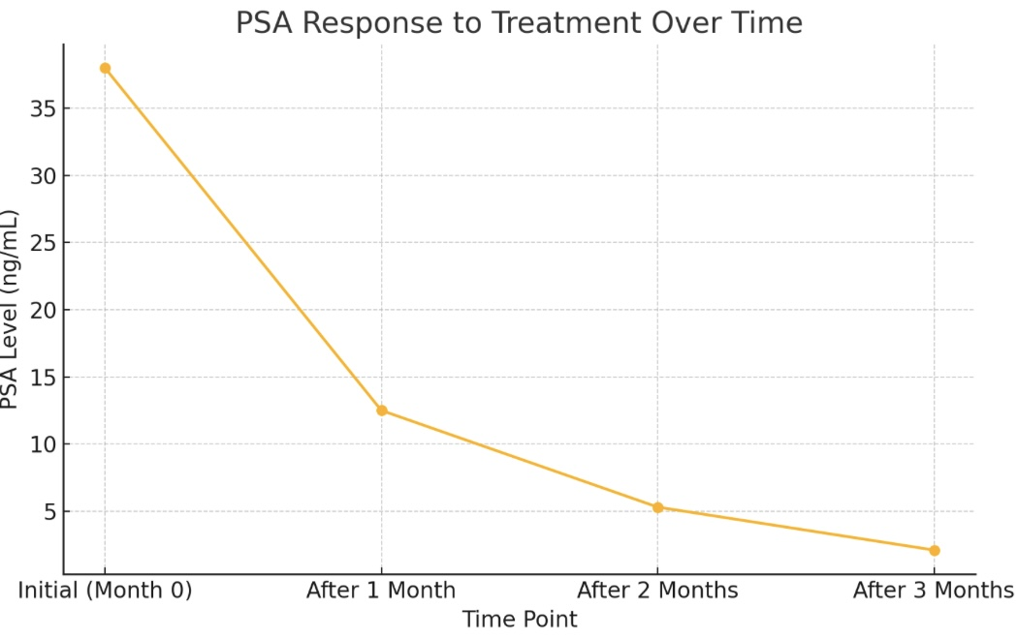
Serial PSA measurements show a significant reduction from 38 to 2.1 ng/mL over three months of ADT and Abiraterone-based therapy.

Figure S2. Family Pedigree

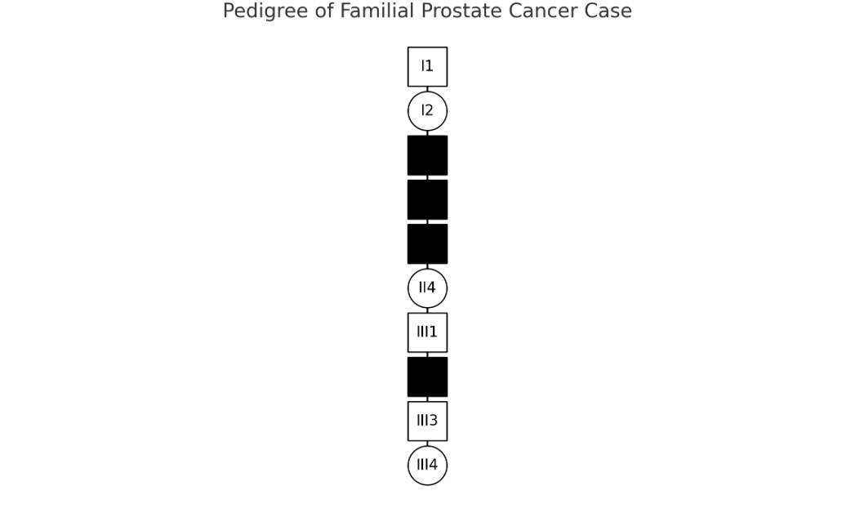
This pedigree illustrates the familial aggregation of prostate cancer in the patient's paternal lineage, consistent with autosomal dominant BRCA2 inheritance pattern.

