Conversion of Biochar from Chicken Manure with good Adsorption and Electro-catalytic performance
Zhangjie Ban¹ · Qianmin Cong¹ · Xingxing Zhu¹ · Yuetong Chang² · Mengyan Pei¹ · Zhengyu Cai^{2,}* · Yong Zhang³ · LizhaiPei^{1,}*
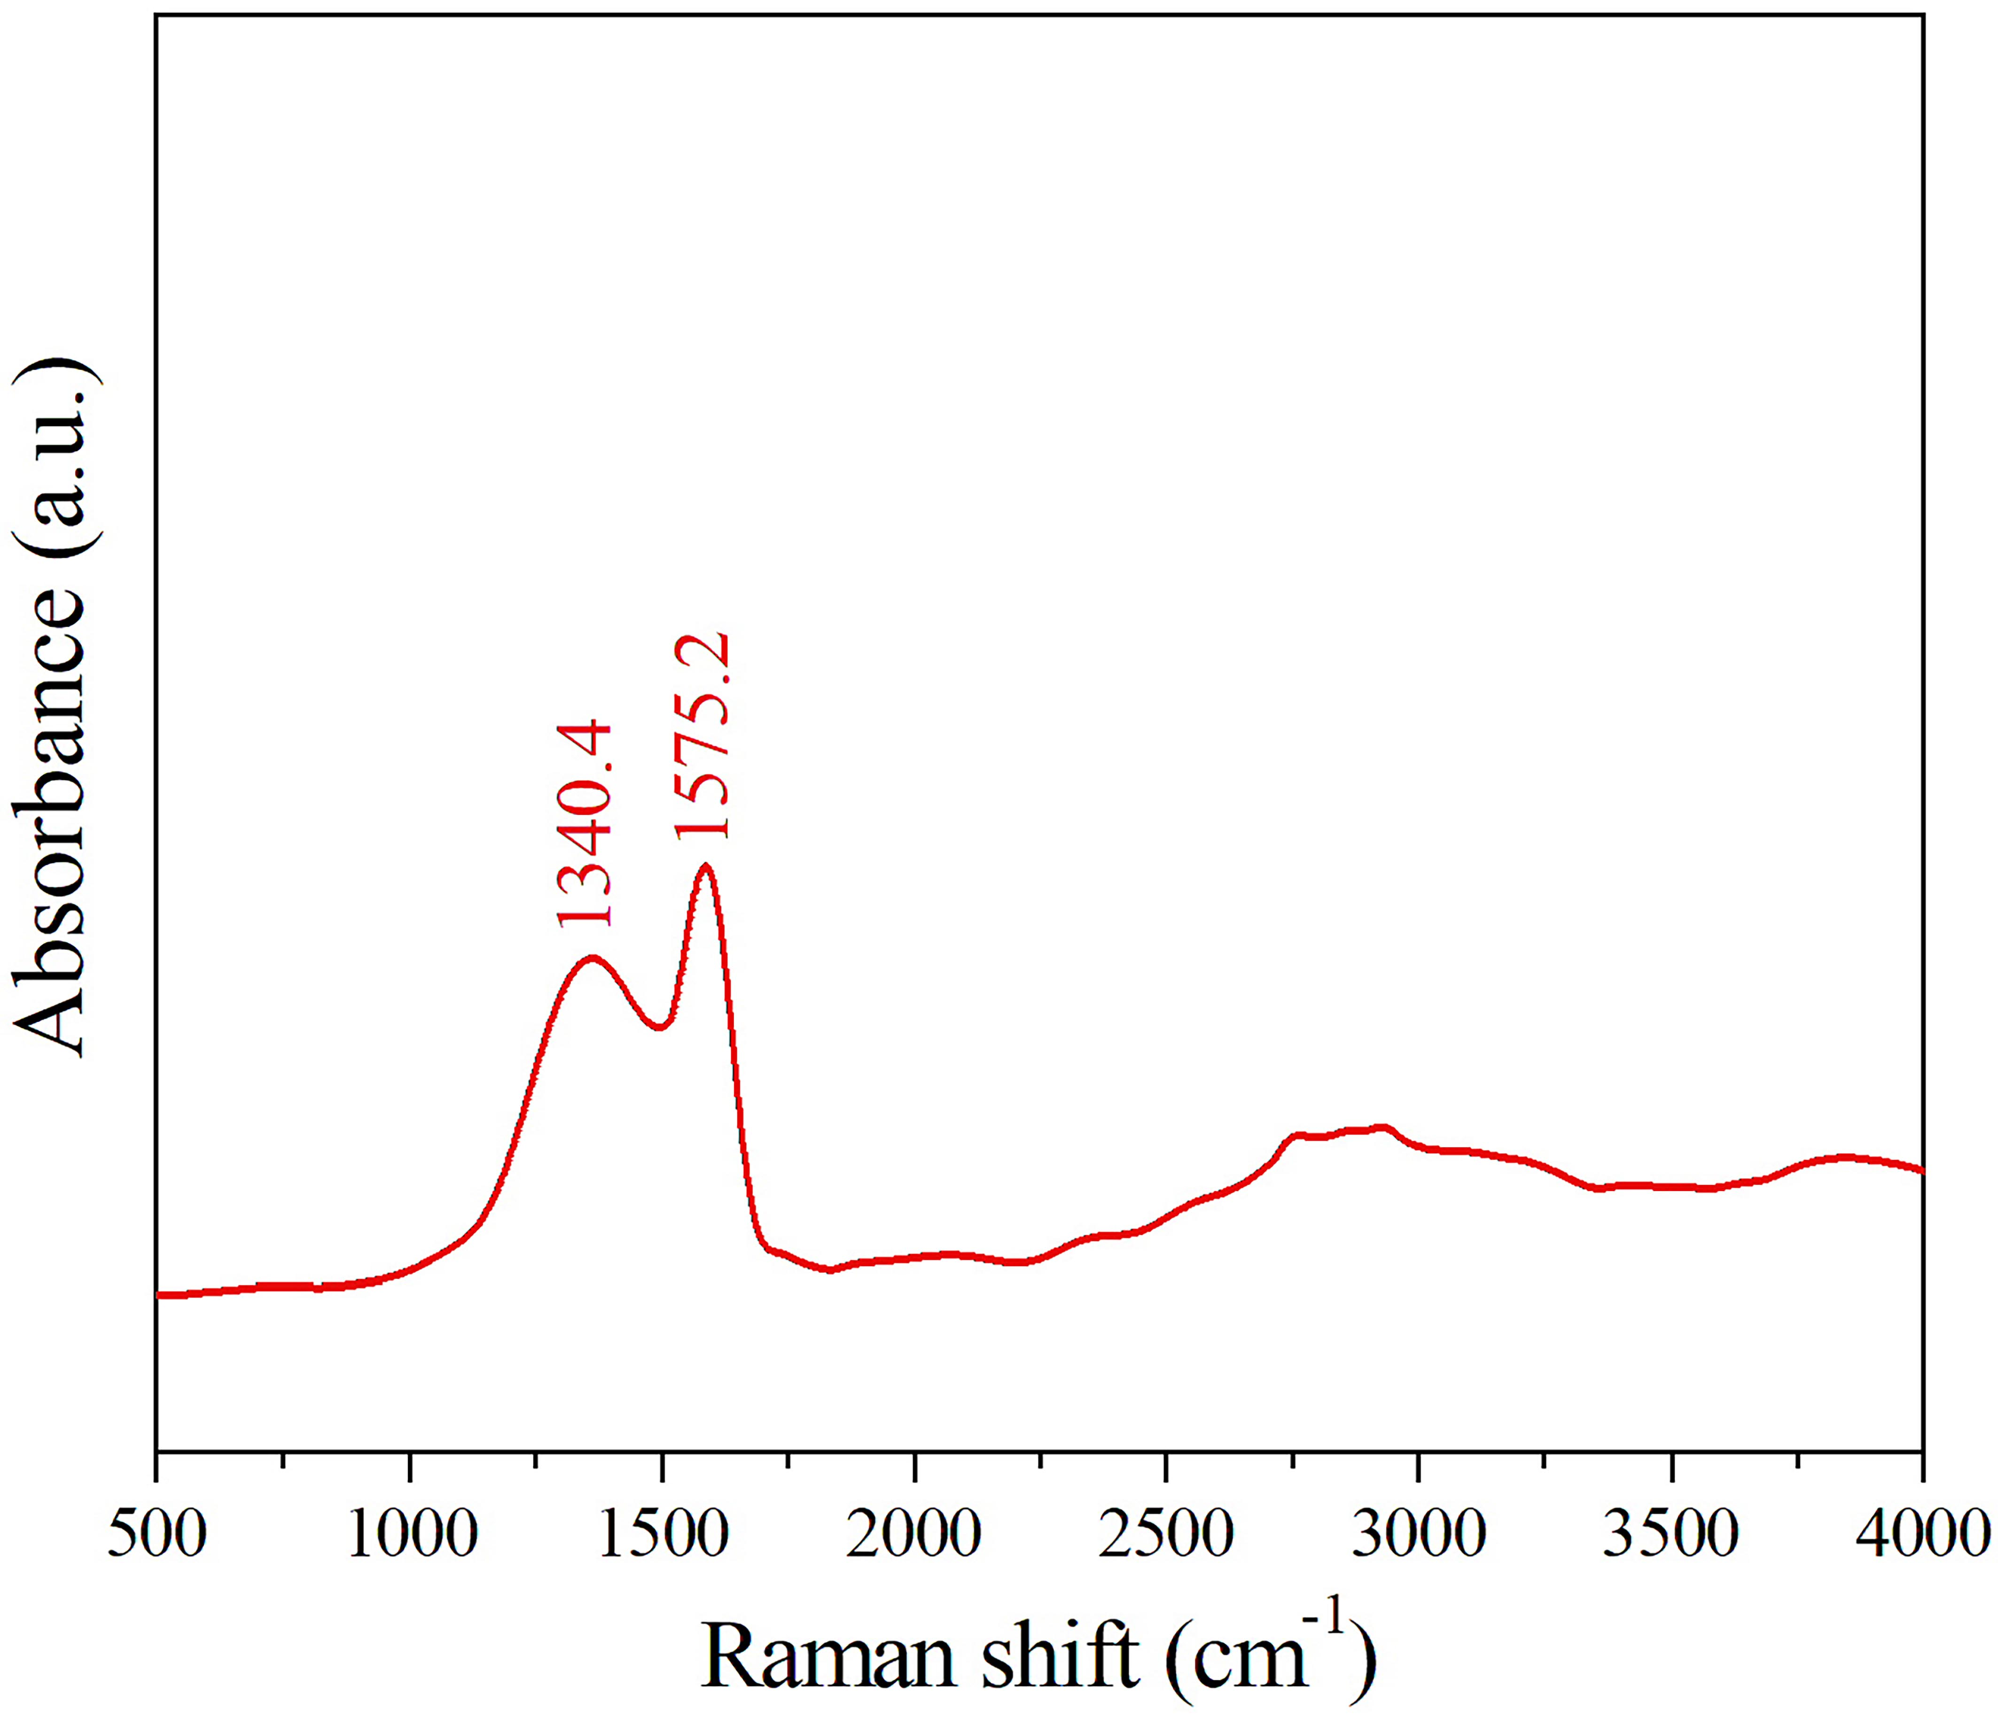
Fig. S1 Raman spectrum of the CMBC
Raman spectrum of the CMBC is shown in Fig. S1. Two Raman peaks are contributed to D peak (1340.4 cm^{–1}) and G peak (1575.2 cm^{–1}), respectively [1]. D peak and G peak correspond to the defect degree and graphite structure, respectively [2]. The ratio of the Raman intensity of D peak and G peak (I_{D}/I_{G}) represents the degree of the defect and disorder of carbon materials. The I_{D}/I_{G} value is 0.76 indicating definite graphitization and defect in the CMBC sample which is helpful for the adsorption of organic pollutants using the CMBC.
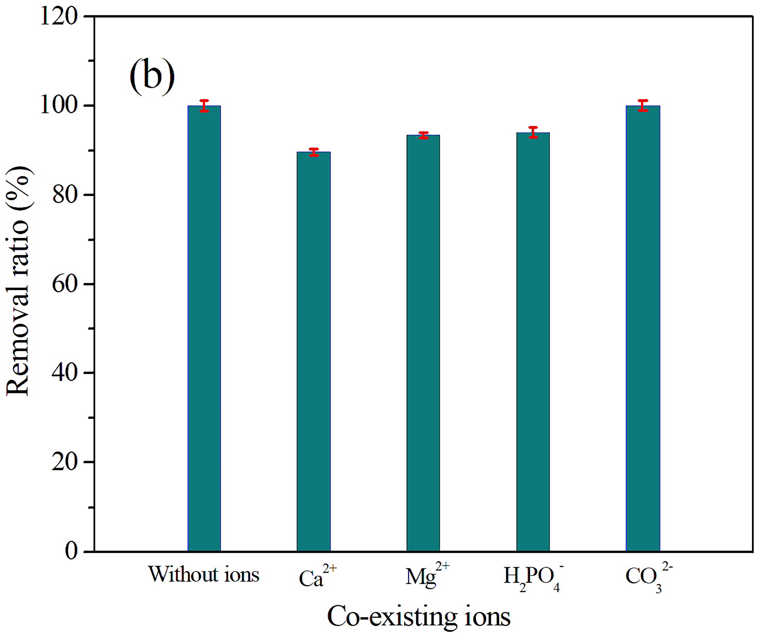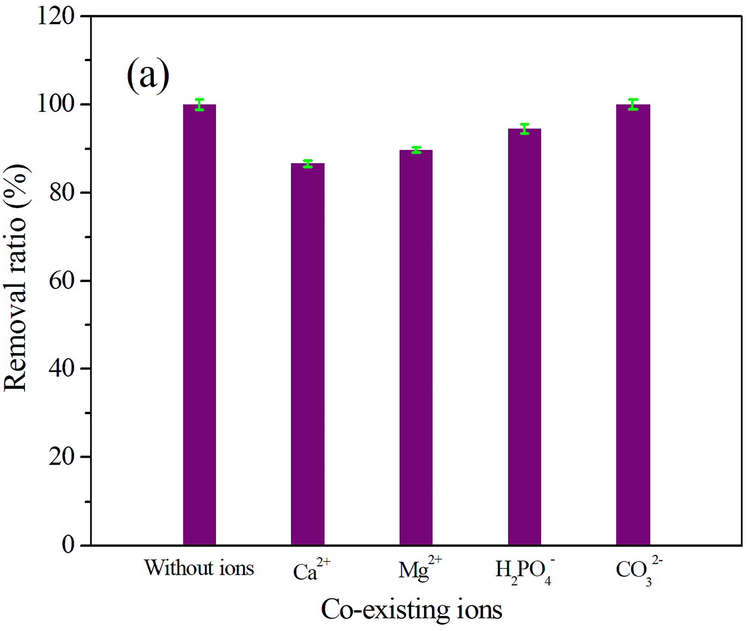The adsorption ability of the absorbents will be influenced by different species of ions in wastewater [3]. Therefore, the cations (Ca²⁺ and Mg²⁺) and anions (H₂PO₄⁻ and CO₃²⁻) were applied as co-existing ions. Fig. S2 shows the relationship between the co-existing ions against the dye removal efficiency. The cations Ca²⁺ and Mg²⁺ can occupy the adsorption active sites resulting in the decrease of the dye removal efficiency [4]. Obviously, the cations will inhibit the dye adsorption. The dye (RhB or MB) removal efficiency slightly decreases when H₂PO₄⁻ is used as co-existing ion owing to the dye reduction by the hydrolyzation of H₂PO₄⁻. RhB and MB can also be totally removed after the addition of CO₃²⁻. The influence of co-existing ions results are consistent with those reported by Zhuo et al. [2]. The dye removal efficiency still maintains about 90% indicating that the proposed CMBC has good anti-ion interference performance.
Fig. S2 Removal rate of the dyes adding the co-existing ions using the CMBC. a) CMBC-RhB, b) CMBC-MB. RhB or MB concentration, 10 mg·L⁻¹. CMBC dosage, 1.25 mg·mL⁻¹ dye solution. Time: CMBC-RhB, 15 min, CMBC-MB, 12 min
In order to analyze the re-usability, ethanol was applied to clean the CMBC-RhB and 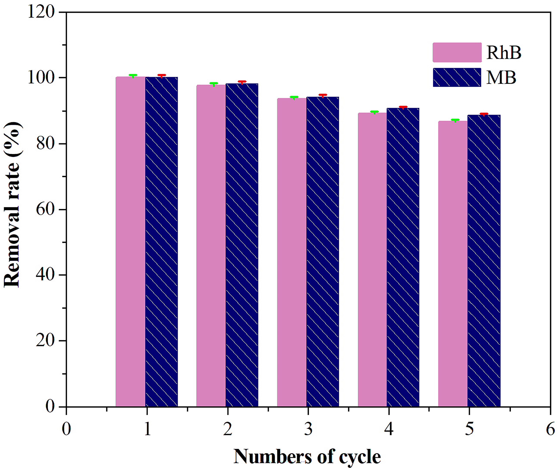CMBC-MB adsorbent, respectively. After washed using ethanol, CMBC sample was re-used and the adsorption cycling results are shown in Fig. S3. The RhB and MB removal efficiency are 86.7% and 88.6%, respectively. The result shows that the CMBC has good re-usability.
Fig. S3 Dyes removal rate by five cycles using CMBC. RhB or MB concentration, 10 mg·L⁻¹. CMBC dosage, 1.25 mg·mL⁻¹ dye solution.Time: CMBC-RhB, 15 min, CMBC-MB, 12 min
EIS can provide some information on the impedance change and interface performance of the CMBC-modified electrode surface [5, 6]. The electron transfer resistance depends on the semi-circular diameter of the EIS showing the dielectric and insulating characteristics at the interface between the electrode and electrolyte [7, 8]. As shown in Fig. S3, the EIS of the bare GCE is similar to that reported by Yu et al. [9] and Sajjan et al. [10]. The CMBC-modified electrode shows smaller semi-circular diameter than bare GCE demonstrating that the CMBC can act as good electron transfer interface elevating the active sites and electro-catalytic response for catechol detection. The addition of the CMBC significantly enhances the conductivity between the modified electrode and KCl solution which is consistent with the CV results.
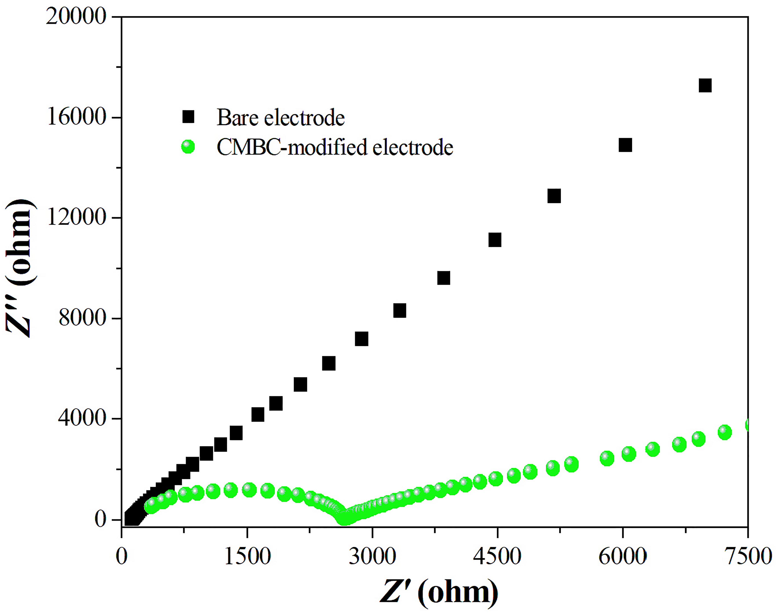Measurement parameters are essential for obtaining the optimum catechol detection performance using the CMBC-modified electrode. Thus, pH value, deposition potential, deposition time and standing time are optimized. Fig. S5a shows the relationship between the SWV peak current and pH value in the range of 2 to 7. For different pH values, the peak potential is same. However, the SWV peak current enhances from 16.1 μA (pH = 2) to 34.3 μA (pH = 7). When the electrolyte is acidic solution, H⁺ ions in the acidic solution protonate functional groups on the surface of the CMBC-modified electrode leading to the electrostatic repulsion of catechol against protonated functional groups [11]. In addition, H⁺ ions also occupy the active sites of the modified electrode resulting in the decrease of the adsorbed catechol molecules and stripping current. CMBC-modified electrode possesses the strongest current when the solution is neutral (pH = 7). Hence, 7 is selected as the optimum solution pH value.
Fig. S4 Experimental data of EIS of the bare GCE andCMBC-modified electrode
The dependence of the deposition potential on the SWV peak current in the potential of −1.5 ~ +1.5 V is shown in indicated in Fig. S5b. With prolonging the deposition potential, the SWV 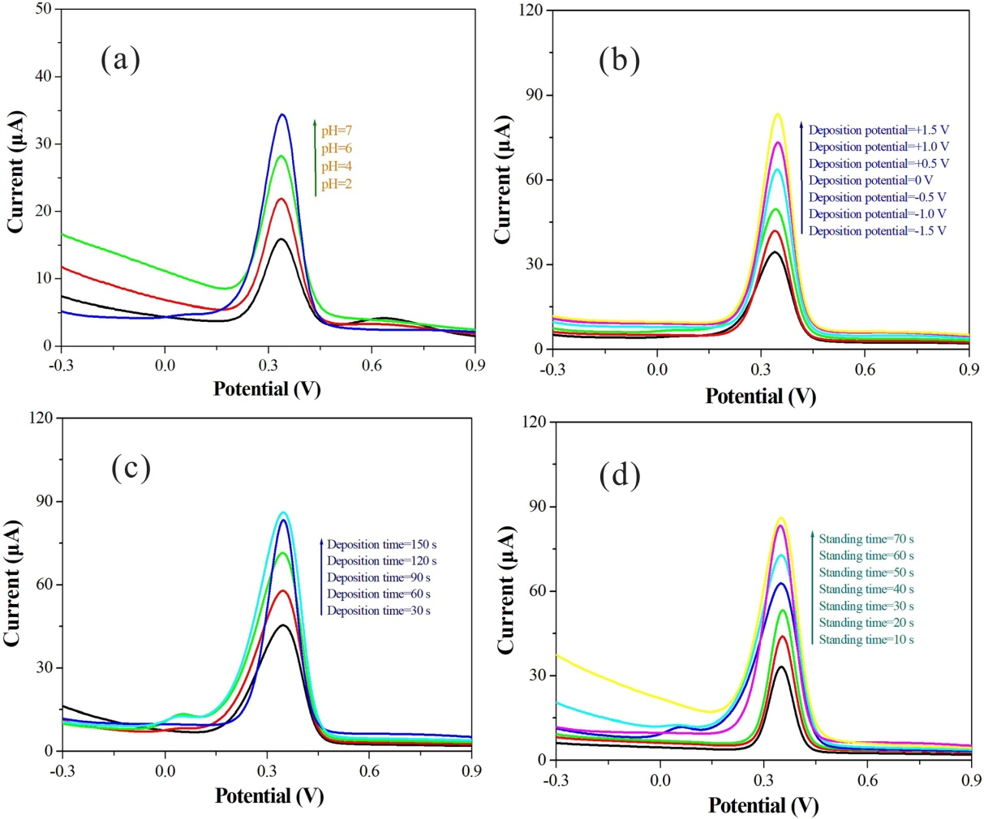peak current improves from 34.3 μA (−1.5 V) to 83.5 μA (+1.5 V). At +1.5 V, the maximum current is obtained which may be due to easier oxidation of catechol in more positive potential. Therefore, +1.5 V is considered to be the optimum deposition potential. The dependence of the deposition time (30 s to 150 s) against the SWV peak current is shown in Fig. S5c. The SWV peak current enhances from 45.6 μA (30 s) to 86.1 μA (150 s) as improving the deposition time. CMBC-modified electrode exhibits the strongest SWV peak current at 150 s due to the saturation of the adsorbed catechol. However, the SWV peak current at 120 s (83.5 μA) is close to that at 150 s (86.1μA). Therefore, the optimal deposition time is considered to be 120 s so as to decrease the deposition time during the electrochemical measurements.
Fig. S5 SWVs of 1 mM catecholand 0.1 M KCl solution using the CMBC-modified electrode using different measurement parameters. a) Solution pH value, b) deposition time, c) deposition potential, d) standing time
Fig. S5d shows the dependence of the standing time on the SWV peak current for the detection of catechol using the CMBC-modified electrode. The anodic peak current improves from 32.7 μA (10 s) to 85.7 μA (70 s). The anodic SWV peak current at 60 s (83.5 μA) and 70 s (85.7 μA) is close owing to the saturation of the adsorbed catechol at the surface of the CMBC-modified electrode. Therefore, 60 s is determined to be the optimal standing time. Based on the above results, pH value of 7, deposition potential of +1.5 V, deposition time of 120 s and standing time of 60 s are the optimized measurement parameters.
Fig. S6 shows the SWVs of the CMBC-modified electrode in 0.1 M KCl and 1 mM catechol solution adding different interference species.
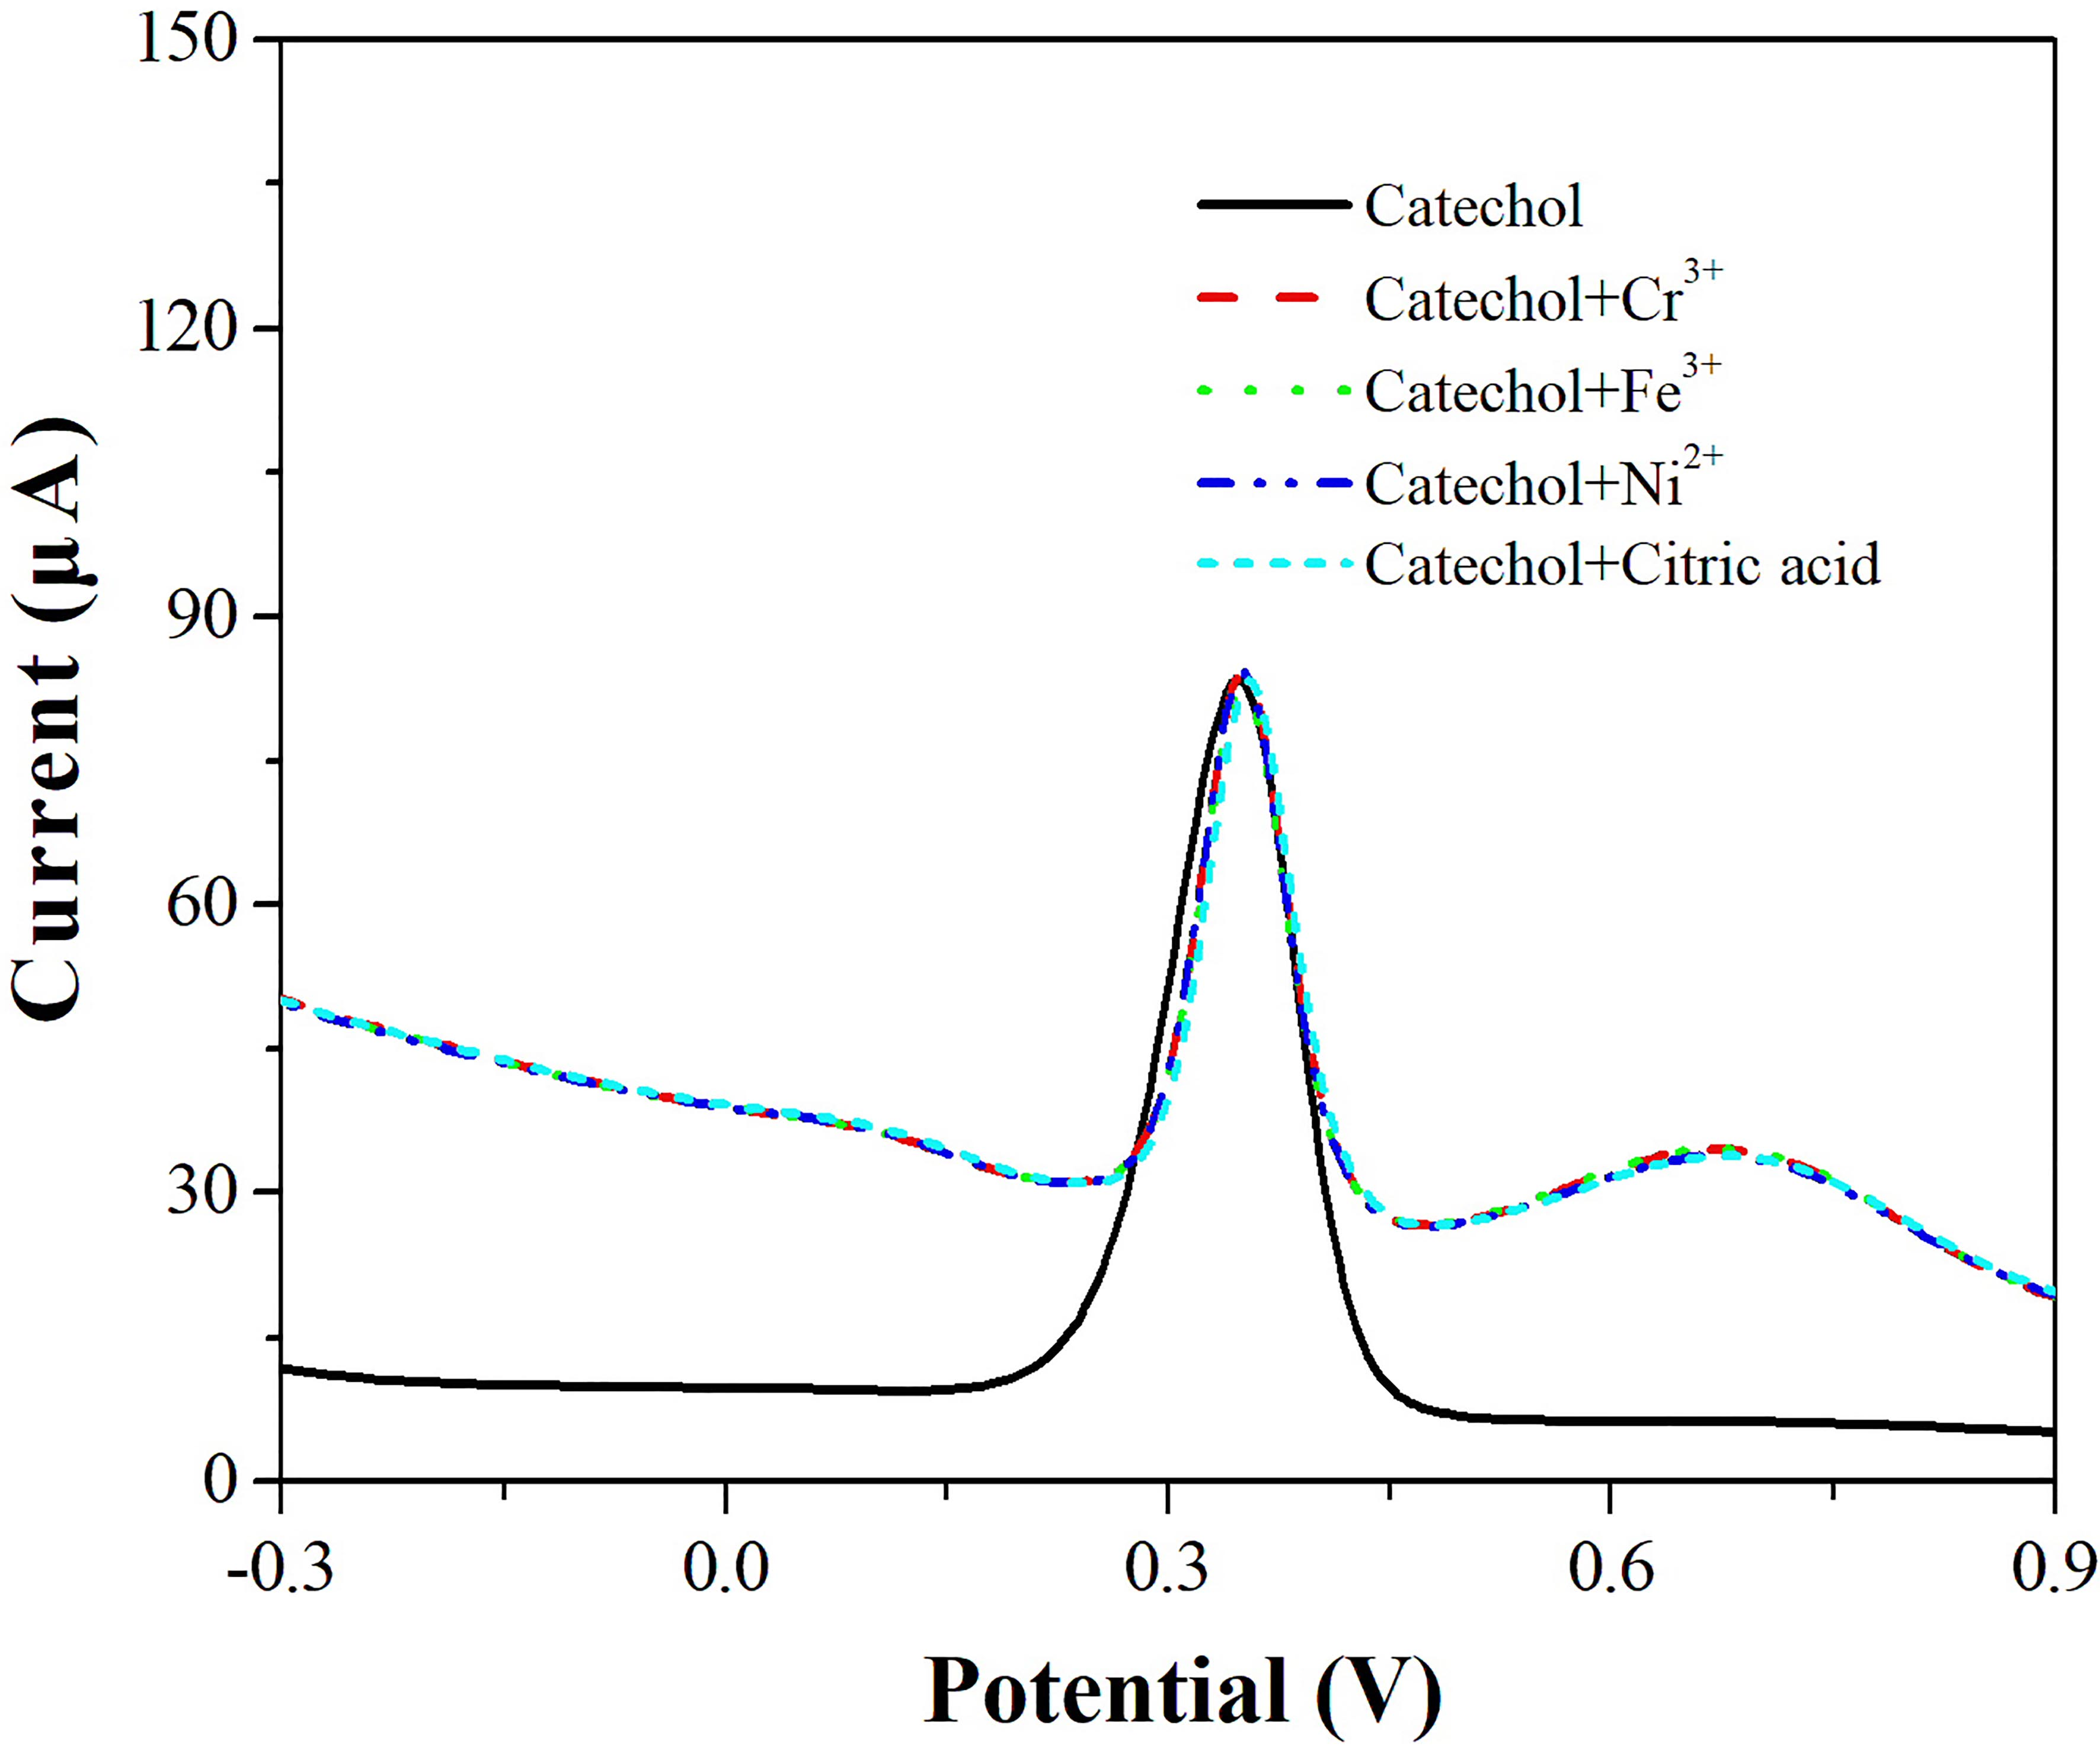
Fig. S6 SWVs of the CMBC-modified electrode in 0.1 M KCland 1 mM catechol solution with different interference species. Measurement parameters: pH value of 7, deposition potential of +1.5 V, deposition time of120 s and standing time of 60 s
Fig. S7 shows the SWVs of 1 mM catechol in 0.1 M KCl solution using five independent CMBC-modified electrode.
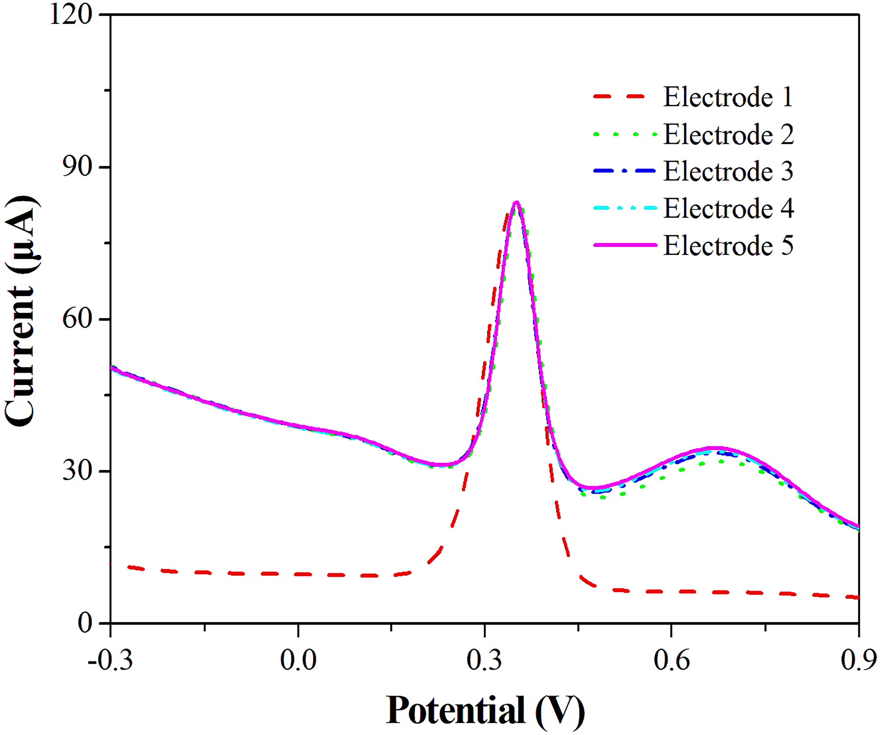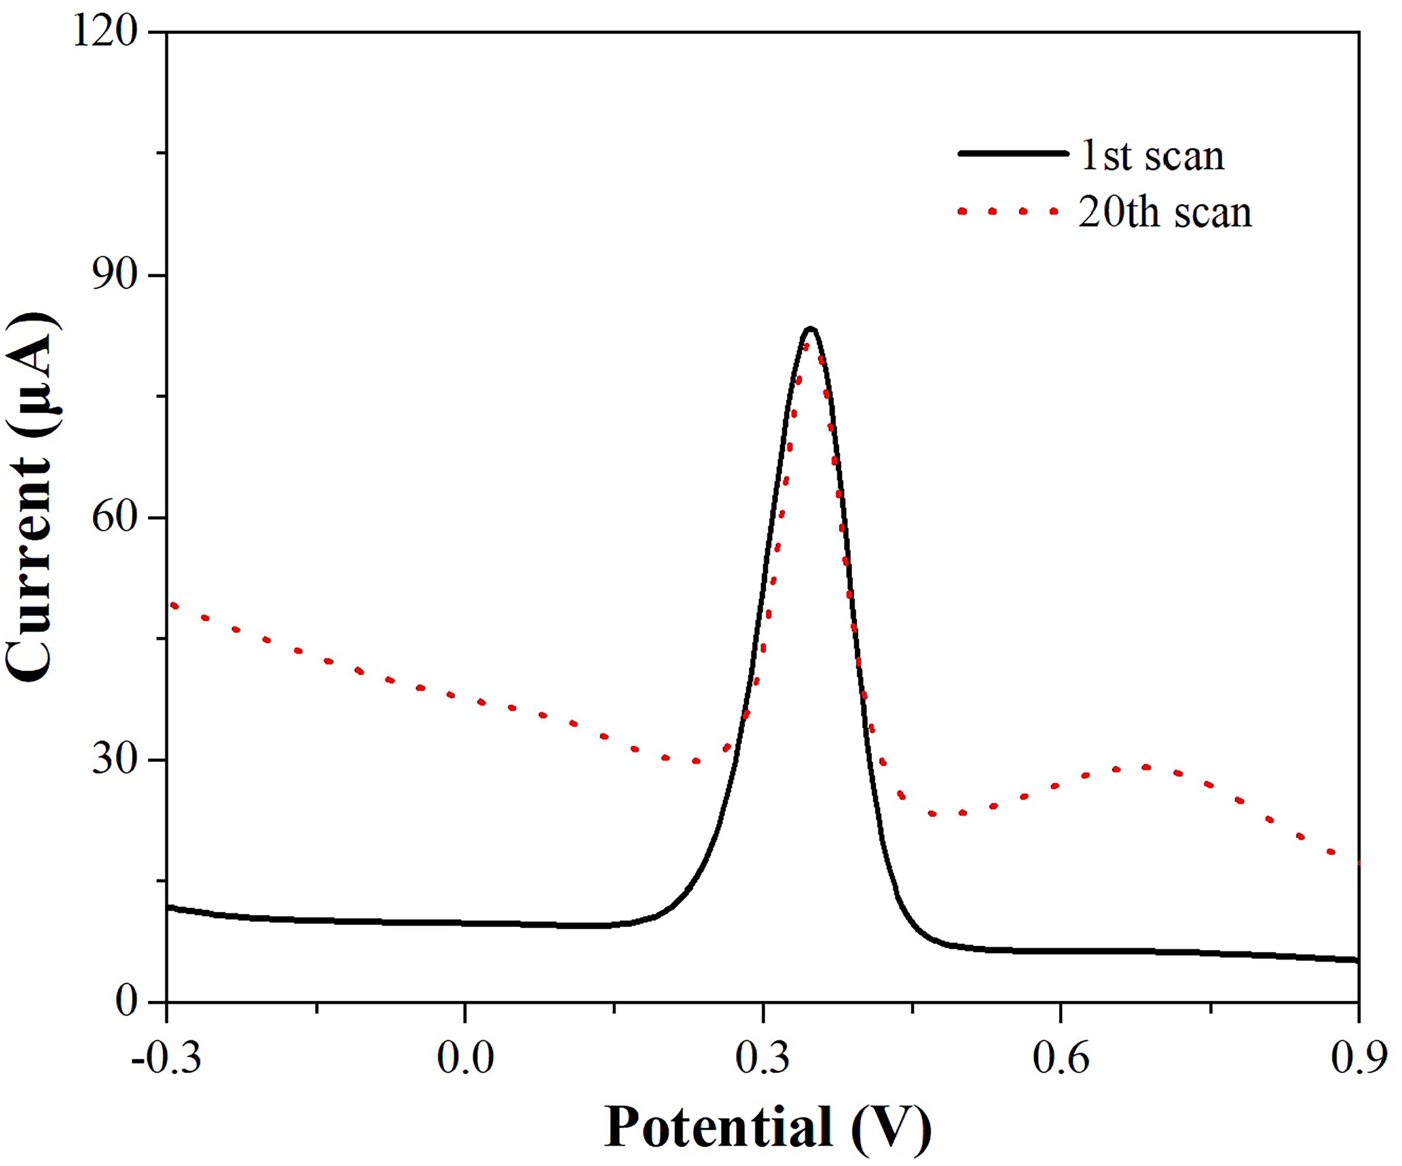Fig. S8 shows the SWVs of 1 mM catechol in 0.1 M KCl solution using the 1st and 20th scan, respectively at the CMBC-modified electrode.
Fig. S7 SWVs of 1 mM catechol in 0.1 M KCl solution using five independent CMBC-modified electrode. Measurement parameters are same to those in Fig. S5
Fig. S8 SWVs of 1 mM catecholin 0.1 M KCl solution using the 1st and 20th scan, respectively at the CMBC-modified electrode. Measurement parameters are same to those in Fig. S5
References
1. Zhang, Y., Wei, L., Liu, X., Ma, W., Wang, J., & Fan, S. (2021). N/O co-enriched graphene hydrogels as high-performance electrodes for aqueous symmetric supercapacitors. RSC Advances, 11, 19737−19746. https://doi.org/10.1039/D1RA01863A
2. Zhuo, S., Dai, T., Ren, H., & Liu, B. (2022). Simultaneous adsorption of phosphate and tetracycline by calcium modified corn stover biochar: performance and mechanism. Bioresource Technology, 359, 127477. https://doi.org/10.1016/j.biortech.2022.127477
3. Homagai, P., Poudel, R., Poudel, S., & Bhattarai, A. (2022). Adsorption and removal of crystal violet dye from aqueous solution by modified rice husk. Heliyon, 8, e09261. https://doi.org/10.1016/j.heliyon.2022.e09261
4. Huang, Z., Fang, X., Wang, S., Zhou, N., & Fan, S. (2023). Effects of KMnO₄ pre- and post-treatments on biochar properties and its adsorption of tetracycline. Journal of Molecluar Liquids, 373, 121257. https://doi.org/10.1016/j.molliq.2023.121257
5. Cong, Q. M., Wang, X. Y., Feng, C. X., Sun, Z. Z., Cai, C. X., Fan, C. G., & Pei, L. Z. (2024). Facile synthesis of neodymium vanadate nanoribbons and its application to highly efficient determination of cadmium ions. Journal of Chemical Technology and Biotechnology, 99(1), 109–119. https://doi.org/10.1002/jctb.7514
6. Feng, C. X., Wang, X. Y., Cong, Q. M., Sun, Z. Z., Cai, Z. Y., Fan, C. G., & Pei, L. Z. (2024). Facile synthesis ofSmvanadate nanowires and sensitive detection of cobalt ions. Journal of Solid State Electrochemistry, 28(1), 61–73. https://doi.org/10.1007/s10008-023-05659-8
7. Yang, S., Li, G., Qu, C., Wang, G., Wang, D. (2017). Simple synthesis of ZnO nanoparticles on N-doped reduced graphene oxide for the electrocatalytic sensing of L-cysteine. RSC Advances, 7, 35004. https://doi.org/10.1039/C7RA04052K
8. Guo, Q., Zhang, M., Zhou,G., Zhu, L., Feng, Y., Wang, H., Zhong, B., & Hou, H. (2016). Highly sensitive simultaneous electrochemical detection of hydroquinone and catechol with three-dimensional N-doping carbon nanotube ﬁlm electrode. Journal of Electroanalytical Chemistry, 760, 15−23. https://doi.org/10.1016/j.jelechem.2015.11.034
9. Yu, Z., Li, N., Hu, X., Dong, Y., Lin, Y., Cai, H., Xie, Z., Qu, D., & Li, X. (2019). Highly efficient electrochemical detection of lead ion using metal-organic framework and graphene as platform based on DNAzym. Synthetic Metals, 254, 164–171. https://doi.org/10.1016/j.synthmet.2019.06.017
10. Sajjan, V., Aralekallu, S., Nemakal, M., Palanna, M., Prabhu, C., & Sannegowda, C. (2020). Nanomolar detection of lead using electrochemical methods based on a novel phthalocyanine. Inorganic Chimica Acta, 506, 119564. https://doi.org/10.1016/j.ica.2020.119564
11. Kokab, T., Shah, A., Nisar, J., Khan, A., Khan, S., & Shah, A. (2020). Tripeptide derivative-modified glassy carbon electrode: A novel electrochemical sensor for sensitive and selective detection of Cd²⁺ ions. ACS Omega, 5(17), 10123–10132. https://doi.org/10.1021/acsomega.0c00760

Zhengyu Cai kyczx@ahut.edu.cn Lizhai Pei lzpei@ahut.edu.cn, lzpei1977@163.com ¹ School of Materials Science and Engineering, Anhui University of Technology, Ma’anshan, Anhui 243002, People’s Republic of China ² AHUT Engineering Research Institute, Anhui University of Technology, Ma’anshan, Anhui 243002, People’s Republic of China ³ Fujian Provincial Key Laboratory of Functional Materials and Applications, Xiamen University of Technology, Xiamen, Fujian 361024, People’s Republic of China

