Supplementary Information

for

Sequencing-based Spatial Transcriptomics with High Sensitivity

Renjie Liao¹, Defeng Fu¹, Zaoxu Xu¹, Han Liang¹, Xiaoran Zhou¹, Yiling Chen¹, Xueqi Liu¹, Jiajun Cheng¹, Chen Li¹, Huihua Xia¹, Gailing Li¹, Diewen Feng¹, Wei Chen¹, Yang Chen¹, Longchao Chen¹, Zihang Huang¹, Qingbin Chen¹, Dexia Chen¹, Shuguang Xuan¹, Changling Zhang¹, Yongyi Lu¹, Hui Wang¹, Taiqing Feng¹, Yuanye Bao¹, Luyang Zhao^{1，*}, Erkai Liu^{1,}*, and Gufeng Wang^{1,}*

1. Shenzhen Salus BioMed Inc. Ltd., Shenzhen, Guangdong, China,

*Corresponding Authors:
Luyang Zhao, zhaoly@salus-bio.com
Erkai Liu, liuek@salus-bio.com
Gufeng Wang, wanggf@salus-bio.com

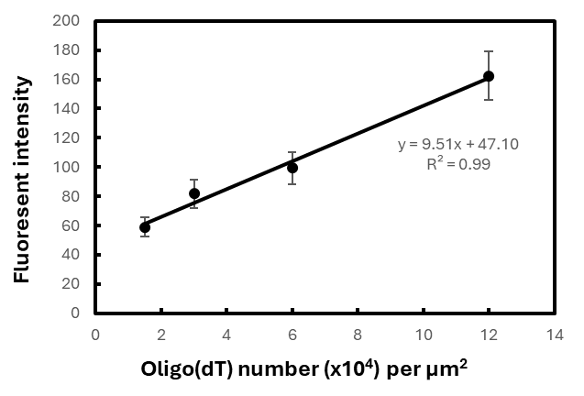

Figure S1. Calibration curve for characterizing probe density on capturing substrates. Fluorescent intensity of Oligo(dA)-cy5 vs Oligo(dT) number on chip surface. The actual loading of capture probes on a capture substrate surface was derived using this calibration curve.

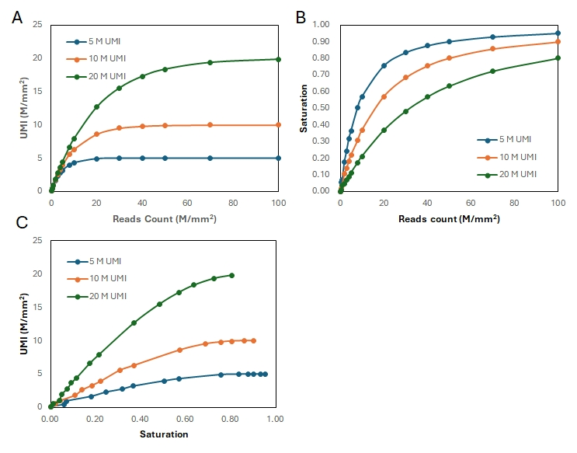

Figure S2. Relationship between number of reads, number of UMIs, and sequencing saturation using simulated data. In the figure, a total number of 5 million, 10 million, 20 million RNAs per mm² are captured, respectively, representing scenarios of different levels of capture efficiency. (A) Recovered UMIs at different number of sequencing reads. (B) Sequencing saturation at different number of sequencing reads. (C) Recovered UMIs at different saturation level.

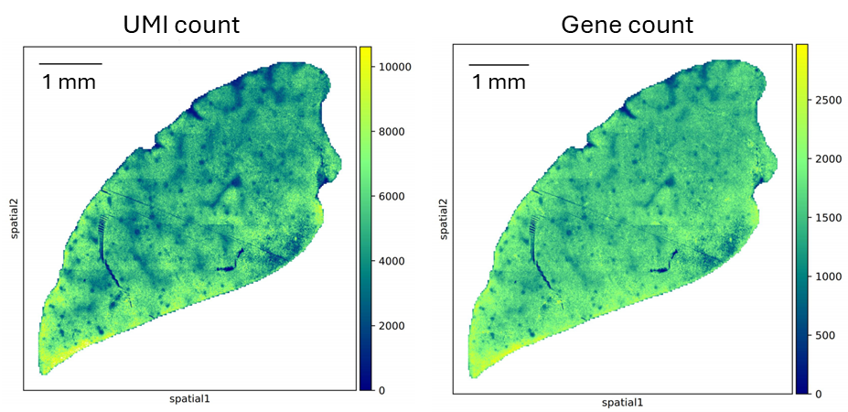

Figure S3. UMI and gene heatmaps of mouse liver sample.

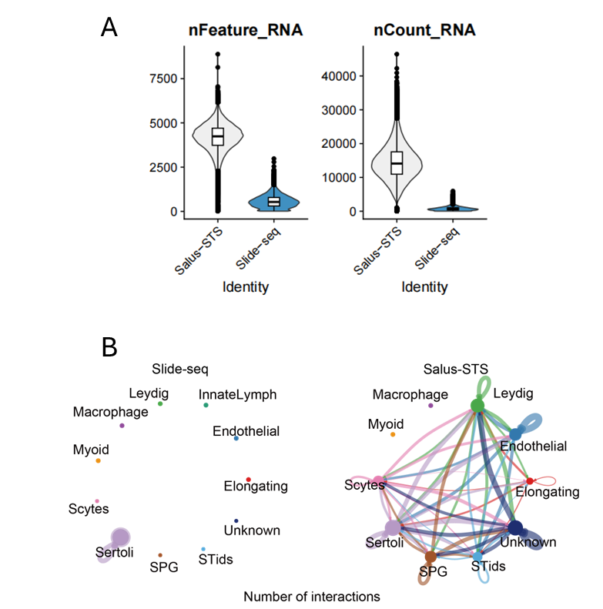

Figure S4. Comparison between Salus-STS and Slide-Seq. (A) Violin plots of number of genes (nFeatures) and UMIs (nCount) of mouse testis tissue detected by Salus-STS and slide-seq (10 x 10 μm² bins). (B) Cell-cell communication analysis from Slide-seq (left) and Salus-STS (right).

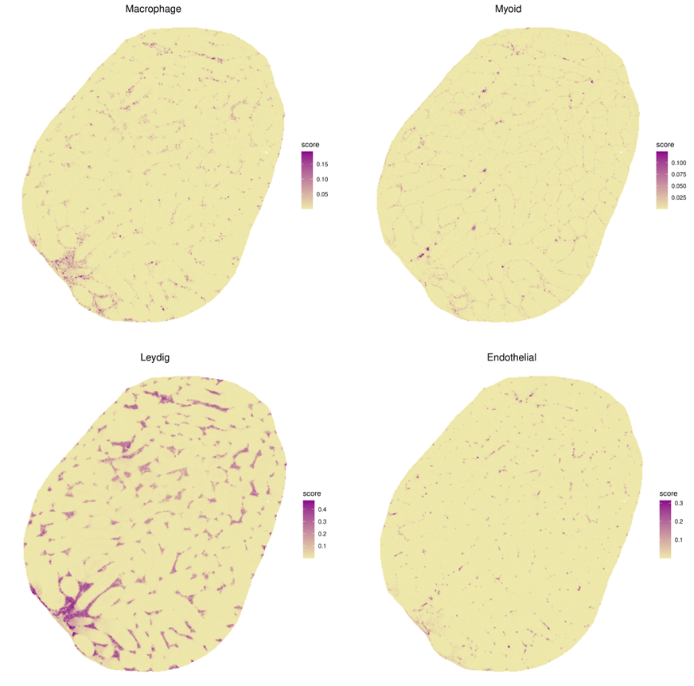

Figure S5. Spatial distributions of different cell types resolved by RCTD.

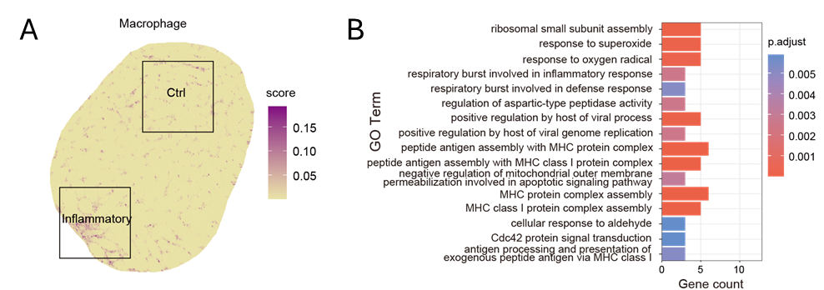

Figure S6. Region of interest and GO analysis. (A) Macrophage-Leydig colocalization and control regions for GO analysis. (B) Top biological processes from GO enrichment analysis (p.adjust < 0.001).

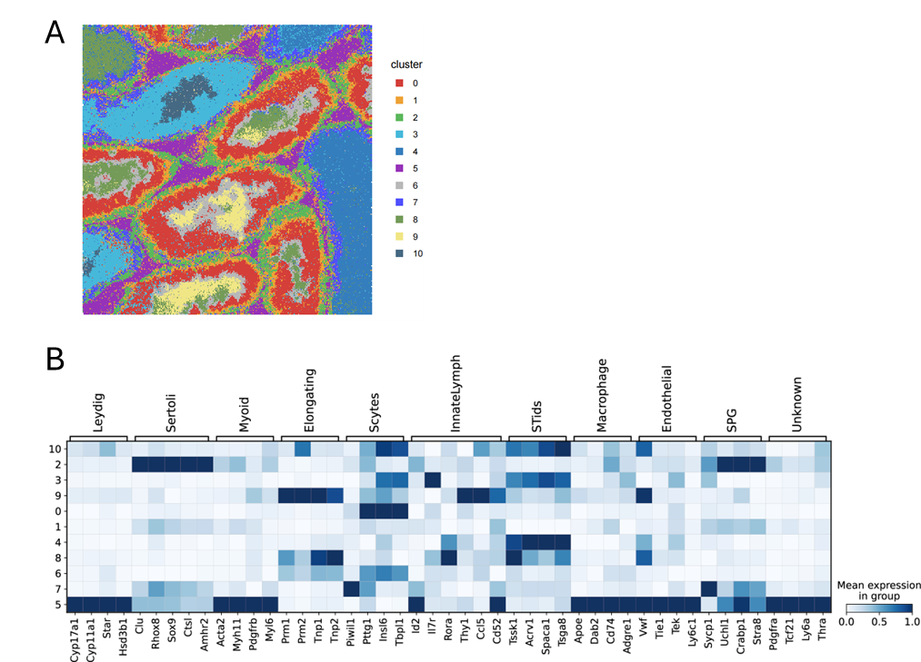

Figure S7. High resolution analysis at 2 μm bins. (A) Unsupervised clustering of 2 x 2 μm² bins. (B) Expression pattern of specific marker genes across clusters.
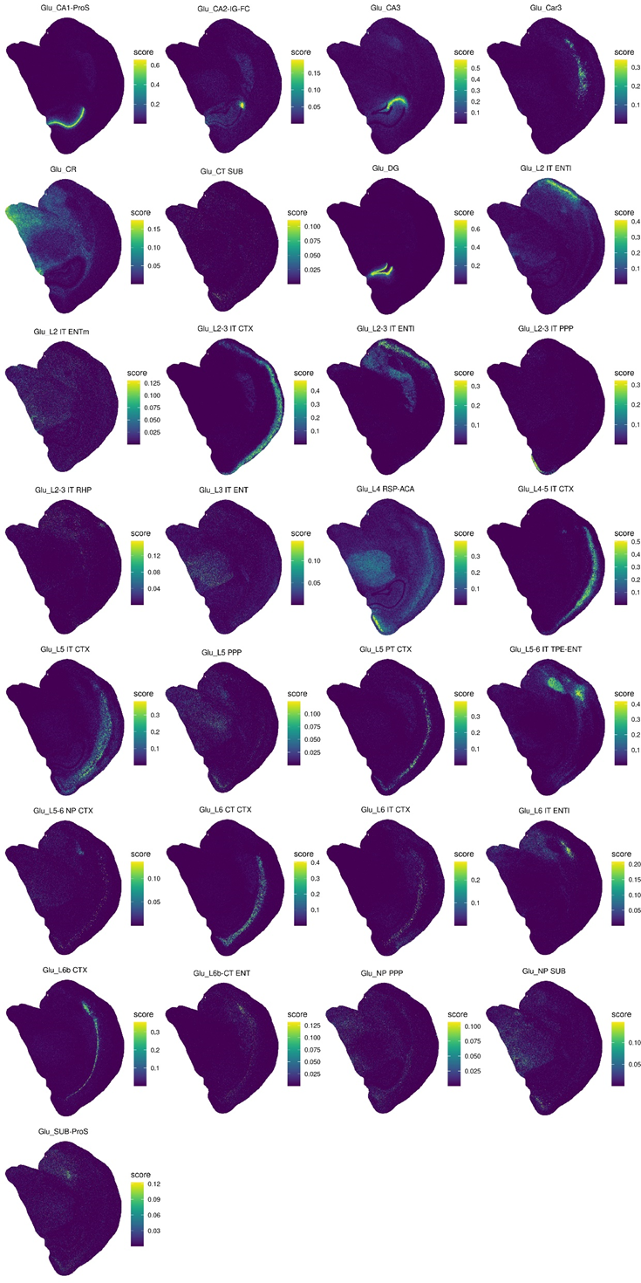

Figure S8. Spatial distributions of RCTD annotated Glutamatergic neurons.
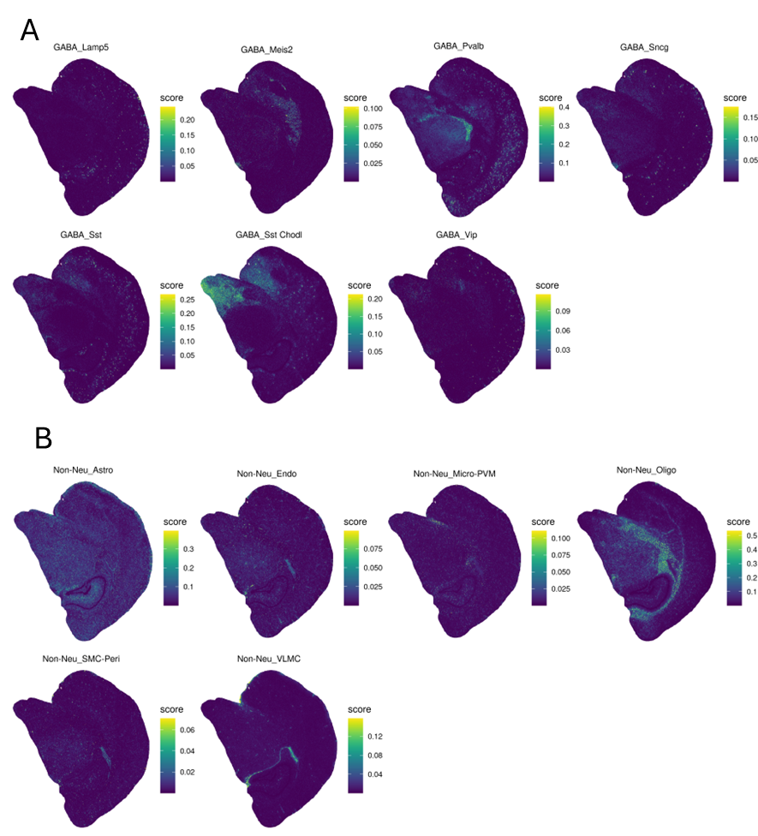

Figure S9. Spatial distributions of RCTD annotated (A) GABAergic neurons and (B) non-neuron cells.

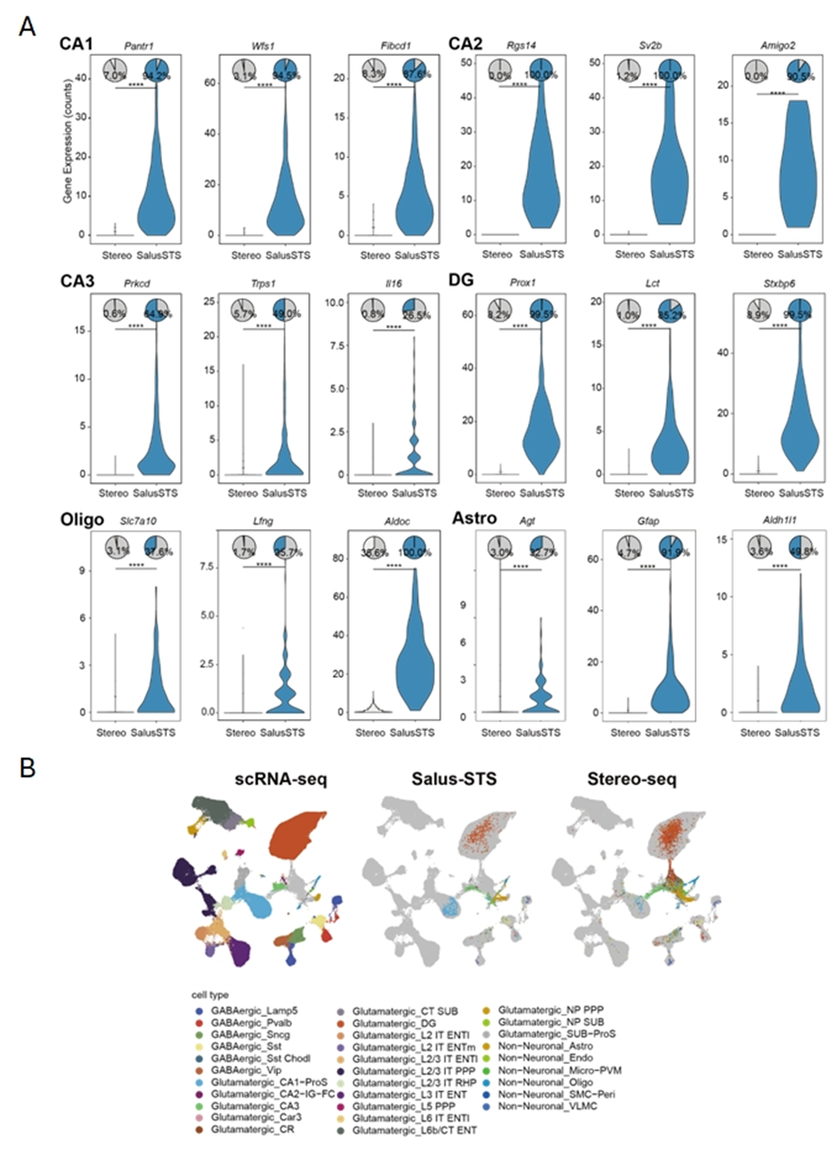

Figure S10. Comparison of mouse brain data between Salus-STS and Stereo-Seq. (A) Expression levels and detection ratio of cell type-specific markers of mouse brain datasets from Stereo-seq and Salus-STS. The top panel displays pie charts of representing gene detection rates of the corresponding cell type, while the bottom panel presents violin plots depicting gene expression levels. (B) UMAP analysis of mouse brain datasets from Salus-STS, Stereo-seq, and scRNA-seq. Hippocampal regions of Salus-STS and Stereo-seq were selected.

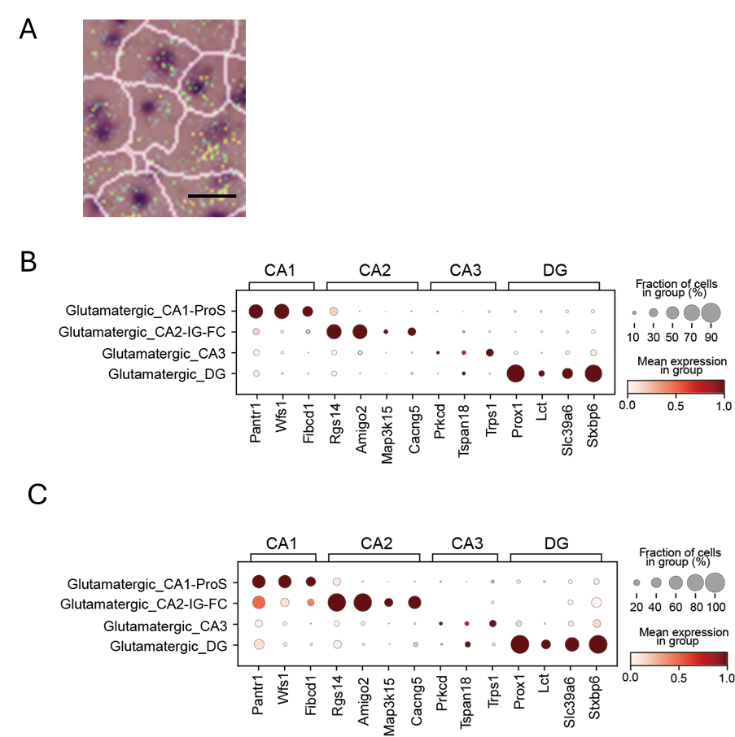

Figure S11. Comparison of unspliced mRNA-based and H&E image-based cell segmentation. (A) Cell boundaries defined by Salus Cellbins, overlapping with H&E staining images. Scale bar, 10 μm. (B) Maker gene expression matrix of cells segmented from the H&E image of mouse hippocampal region. (C) Marker gene expression matrix of cells segmented from unspliced mRNA signals of the same region as in (B).

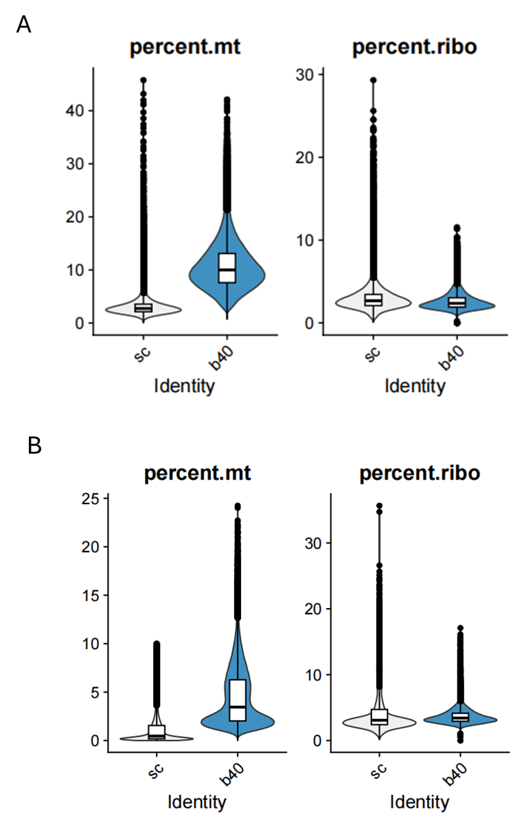

Figure S12. Mitochondrial and ribosomal RNA percentage for Salus-STS data and scRNA-seq data. (A) Mouse brain data; (B) Mouse testis data. mt: mitochondria; ribo: ribosome; sc: single cell; b40: Salus-STS 10 μm bin.

