Optical coherence tomography and visual evoked potentials in evaluation of optic chiasm decompression
Pavel Poczos, Tomáš Česák, Naďa Jirásková, Markéta Macháčková, Jaroslav Adamkov, Filip Gabalec, Jiří Soukup, Jan Kremláček
July, 21th, 2021
Table of Contents
Descriptive stat. 2
Age 2
Grade 2
Pre- vs post- treatment 3
RNFL before vs. 1 visit after surgery 3
RNFL before vs. 2 visit after surgery 4
RNFL before vs. 3 visit after surgery 5
GCL before vs. 1 visit after surgery 6
GCL before vs. 2 visit after surgery 7
GCL before vs. 3 visit after surgery 8
P100 peak time before vs. 1 visit after surgery 9
P100 peak time before vs. 2 visit after surgery 10
P100 peak time before vs. 3 visit after surgery 11
P100 amplitude before vs. 1 visit after surgery 12
P100 amplitude before vs. 2 visit after surgery 13
P100 amplitude before vs. 3 visit after surgery 14
N160 peak time before vs. 1 visit after surgery 15
N160 peak time before vs. 2 visit after surgery 16
N160 peak time before vs. 3 visit after surgery 17
N160 amplitude before vs. 1 visit after surgery 18
N160 amplitude before vs. 2 visit after surgery 19
N160 amplitude before vs. 3 visit after surgery 20
Visual acuity before vs. 1 visit after surgery 21
Visual acuity before vs. 2 visit after surgery 22
Visual acuity before vs. 3 visit after surgery 23
Perimetry before vs. 1 visit after surgery 24
Perimetry before vs. 2 visit after surgery 25
Perimetry before vs. 3 visit after surgery 26
Grade 27
RNFL 27
GCL 28
P100 peak time 30
P100 amplitude 31
N160 peak time 32
N160 amplitude 33
Visual acuity 34
Perimetry 35
Visual field change 37
RNFL 37
GCL 38
P100 peak time 39
P100 amplitude 40
N160 peak time 41
N160 amplitude 42
Visual acuity 43

Descriptive stat.

Age
Age
 | N | 25q | Median | 75q | Mean | SD | Min | Max | NaN
X1 | 32 | 44.94 | 53.615 | 62.67 | 51.939 | 11.86 | 23 | 66 | 96

Grade
Var1 | Freq
0 | 4
1 | 6
2 | 6
3 | 4
4 | 12

Pre- vs post- treatment
Paired comparisons. Values for VA = 0 were replaced by 0.01. The corresponding logMAR = 2 / by WHO it corresponds to blindness.

RNFL before vs. 1. visit after surgery
Two tail tests Anderson-Darling test: normality = TRUE
NO paired difference, ttest p= 0.8914139
Effect size and confidence limits, d = 0.04 [ -0.47 0.54 ]
Power of study with aforementioned effect, pwr = 0.05
RNFL before vs. (um) vs. RNFL 1. visit after surgery(um)
 | N | 25q | Median | 75q | Mean | SD | Min | Max | NaN
RNFL before vs. (um) | 30 | 56.25 | 65.0 | 73.00 | 63.93 | 18.11 | 27 | 105 | 0
RNFL 1. visit after surgery(um) | 30 | 56.75 | 65.5 | 73.75 | 63.90 | 18.44 | 27 | 106 | 0
Diff. | 30 | -1.00 | 0.0 | 1.00 | 0.03 | 1.33 | -2 | 3 | 0
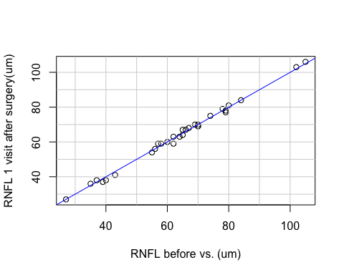

RNFL before vs. 2. visit after surgery
Two tail tests Anderson-Darling test: normality = TRUE
SIGNIFICANT paired difference, ttest p= 0.003574899
Effect size and confidence limits, d = 0.81 [ 0.27 1.36 ]
Power of study with aforementioned effect, pwr = 0.86
RNFL before vs. (um) vs. RNFL 2. visit after surgery(um)
 | N | 25q | Median | 75q | Mean | SD | Min | Max | NaN
RNFL before vs. (um) | 28 | 55.75 | 64.5 | 75 | 63.61 | 18.72 | 27 | 105 | 0
RNFL 2. visit after surgery(um) | 28 | 46.75 | 65.0 | 74 | 60.61 | 20.46 | 23 | 104 | 0
Diff. | 28 | 0.00 | 1.0 | 4 | 3.00 | 4.97 | -3 | 17 | 0
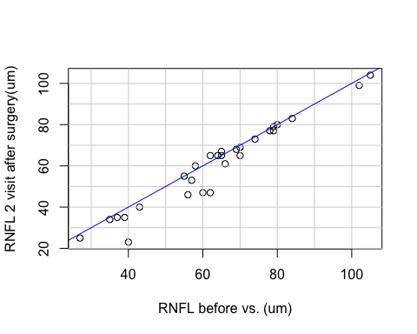

RNFL before vs. 3. visit after surgery
Two tail tests Anderson-Darling test: normality = TRUE
SIGNIFICANT paired difference, ttest p= 0.000553404
Effect size and confidence limits, d = 0.98 [ 0.43 1.54 ]
Power of study with aforementioned effect, pwr = 0.96
RNFL before vs. (um) vs. RNFL 3. visit after surgery(um)
 | N | 25q | Median | 75q | Mean | SD | Min | Max | NaN
RNFL before vs. (um) | 28 | 55.75 | 64.5 | 75.00 | 63.61 | 18.72 | 27 | 105 | 0
RNFL 3. visit after surgery(um) | 28 | 44.00 | 61.5 | 73.00 | 59.96 | 20.90 | 23 | 109 | 0
Diff. | 28 | 1.00 | 2.0 | 5.25 | 3.64 | 4.92 | -4 | 16 | 0
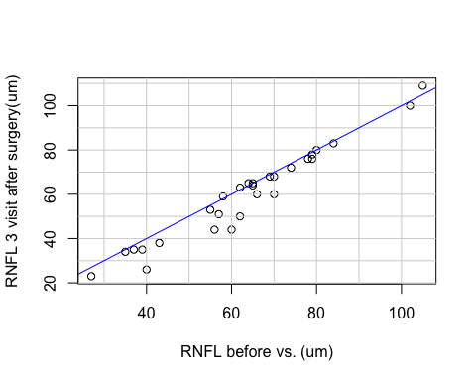

GCL before vs. 1. visit after surgery
Two tail tests Anderson-Darling test: normality = TRUE
NO paired difference, ttest p= 0.1840582
Effect size and confidence limits, d = 0.35 [ -0.16 0.86 ]
Power of study with aforementioned effect, pwr = 0.27
GCL before vs. (um) vs. GCL 1. visit after surgery(um)
 | N | 25q | Median | 75q | Mean | SD | Min | Max | NaN
GCL before vs. (um) | 30 | 35.47 | 43.45 | 46.65 | 40.57 | 8.41 | 22.7 | 52.7 | 0
GCL 1. visit after surgery(um) | 30 | 35.98 | 42.30 | 45.95 | 40.24 | 8.06 | 23.3 | 52.3 | 0
Diff. | 30 | -0.28 | 0.35 | 1.00 | 0.33 | 1.33 | -3.5 | 4.0 | 0
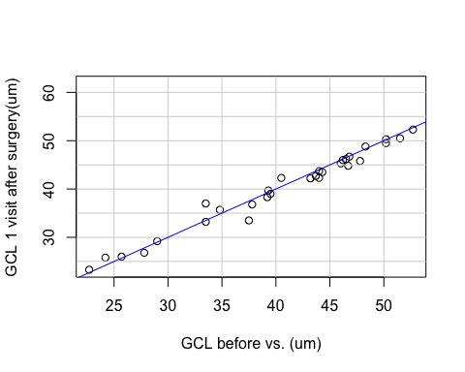

GCL before vs. 2. visit after surgery
Two tail tests Anderson-Darling test: normality = FALSE
SIGNIFICANT paired difference, Wilcoxon p= 0.002354281
Effect size and confidence limits, d = 0.85 [ 0.31 1.4 ]
Power of study with aforementioned effect, pwr = 0.89
GCL before vs. (um) vs. GCL 2. visit after surgery(um)
 | N | 25q | Median | 75q | Mean | SD | Min | Max | NaN
GCL before vs. (um) | 28 | 34.47 | 41.85 | 46.28 | 39.75 | 8.09 | 22.7 | 50.2 | 0
GCL 2. visit after surgery(um) | 28 | 30.45 | 41.35 | 46.50 | 38.11 | 9.46 | 20.8 | 51.5 | 0
Diff. | 28 | 0.15 | 0.70 | 1.67 | 1.64 | 3.19 | -1.3 | 11.8 | 0
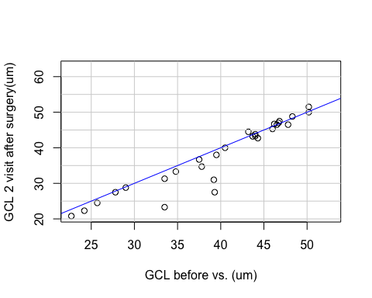

GCL before vs. 3. visit after surgery
Two tail tests Anderson-Darling test: normality = FALSE
SIGNIFICANT paired difference, Wilcoxon p= 0.04741625
Effect size and confidence limits, d = 0.54 [ 0.01 1.08 ]
Power of study with aforementioned effect, pwr = 0.52
GCL before vs. (um) vs. GCL 3. visit after surgery(um)
 | N | 25q | Median | 75q | Mean | SD | Min | Max | NaN
GCL before vs. (um) | 28 | 34.47 | 41.85 | 46.28 | 39.75 | 8.09 | 22.7 | 50.2 | 0
GCL 3. visit after surgery(um) | 28 | 30.18 | 42.15 | 45.92 | 38.37 | 9.09 | 21.3 | 53.2 | 0
Diff. | 28 | -0.32 | 0.50 | 1.73 | 1.38 | 3.53 | -4.0 | 12.1 | 0
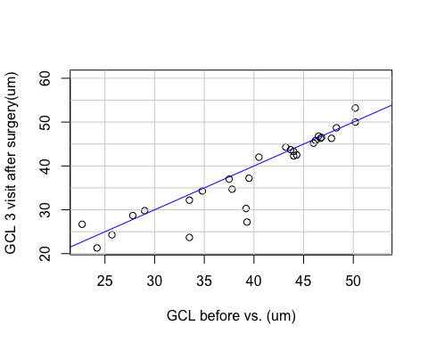

P100 peak time before vs. 1. visit after surgery
Two tail tests Anderson-Darling test: normality = FALSE
NO paired difference, Wilcoxon p= 0.9403642
Effect size and confidence limits, d = 0.02 [ -0.47 0.51 ]
Power of study with aforementioned effect, pwr = 0.05
P100 peak time before vs. (ms) vs. P100 peak time 1. visit after surgery(ms)
 | N | 25q | Median | 75q | Mean | SD | Min | Max | NaN
P100 peak time before vs. (ms) | 32 | 98.18 | 104.55 | 117.98 | 108.89 | 14.89 | 90.0 | 145.2 | 0
P100 peak time 1. visit after surgery(ms) | 32 | 99.22 | 105.60 | 115.72 | 109.99 | 15.38 | 90.6 | 153.9 | 0
Diff. | 32 | -7.80 | -0.15 | 6.00 | -1.10 | 16.58 | -49.8 | 33.1 | 0
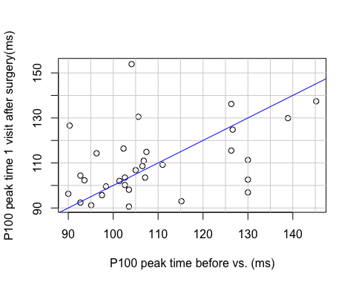

P100 peak time before vs. 2. visit after surgery
Two tail tests Anderson-Darling test: normality = FALSE
NO paired difference, Wilcoxon p= 0.7035488
Effect size and confidence limits, d = 0.1 [ -0.41 0.61 ]
Power of study with aforementioned effect, pwr = 0.07
P100 peak time before vs. (ms) vs. P100 peak time 2. visit after surgery(ms)
 | N | 25q | Median | 75q | Mean | SD | Min | Max | NaN
P100 peak time before vs. (ms) | 30 | 101.63 | 105.3 | 123.52 | 109.94 | 14.79 | 90.0 | 145.2 | 0
P100 peak time 2. visit after surgery(ms) | 30 | 100.88 | 107.7 | 114.15 | 109.48 | 13.14 | 91.2 | 143.4 | 0
Diff. | 30 | -2.62 | 0.6 | 10.05 | 0.46 | 18.37 | -39.3 | 35.8 | 0
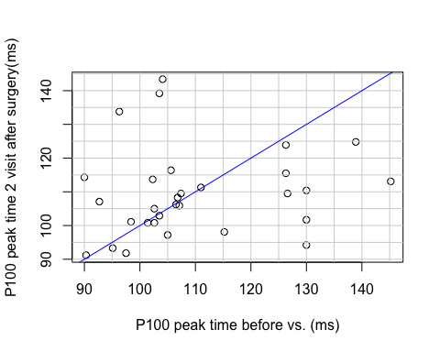

P100 peak time before vs. 3. visit after surgery
Two tail tests Anderson-Darling test: normality = FALSE
NO paired difference, Wilcoxon p= 0.1790633
Effect size and confidence limits, d = 0.35 [ -0.16 0.86 ]
Power of study with aforementioned effect, pwr = 0.27
P100 peak time before vs. (ms) vs. P100 peak time 3. visit after surgery(ms)
 | N | 25q | Median | 75q | Mean | SD | Min | Max | NaN
P100 peak time before vs. (ms) | 30 | 101.63 | 105.30 | 123.52 | 109.94 | 14.79 | 90.0 | 145.2 | 0
P100 peak time 3. visit after surgery(ms) | 30 | 99.90 | 105.15 | 111.52 | 106.63 | 12.40 | 79.2 | 142.8 | 0
Diff. | 30 | -1.50 | 1.65 | 10.20 | 3.31 | 16.19 | -27.6 | 32.1 | 0
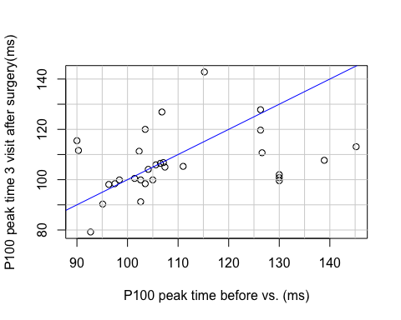

P100 amplitude before vs. 1. visit after surgery
Two tail tests Anderson-Darling test: normality = TRUE
NO paired difference, ttest p= 0.2834693
Effect size and confidence limits, d = 0.27 [ -0.22 0.76 ]
Power of study with aforementioned effect, pwr = 0.19
P100 amplitude before vs. (uV) vs. P100 amplitude 1. visit after surgery(uV)
 | N | 25q | Median | 75q | Mean | SD | Min | Max | NaN
P100 amplitude before vs. (uV) | 32 | 1.24 | 1.94 | 3.04 | 2.24 | 1.21 | 0.62 | 5.09 | 0
P100 amplitude 1. visit after surgery(uV) | 32 | 1.76 | 2.12 | 3.06 | 2.52 | 1.21 | 0.87 | 5.59 | 0
Diff. | 32 | -0.83 | -0.29 | 0.78 | -0.28 | 1.44 | -4.50 | 2.21 | 0
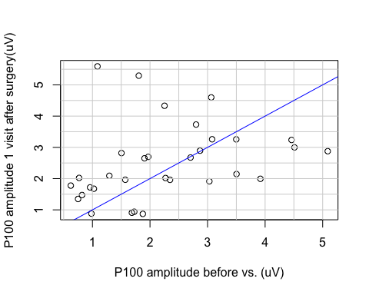

P100 amplitude before vs. 2. visit after surgery
Two tail tests Anderson-Darling test: normality = TRUE
NO paired difference, ttest p= 0.1036688
Effect size and confidence limits, d = 0.43 [ -0.08 0.94 ]
Power of study with aforementioned effect, pwr = 0.38
P100 amplitude before vs. (uV) vs. P100 amplitude .2 visit after surgery(uV)
 | N | 25q | Median | 75q | Mean | SD | Min | Max | NaN
P100 amplitude before vs. (uV) | 30 | 1.14 | 1.94 | 2.99 | 2.24 | 1.23 | 0.62 | 5.09 | 0
P100 amplitude 2. visit after surgery(uV) | 30 | 1.77 | 2.46 | 3.28 | 2.72 | 1.53 | 0.56 | 7.03 | 0
Diff. | 30 | -0.97 | -0.19 | 0.26 | -0.49 | 1.58 | -5.10 | 1.76 | 0
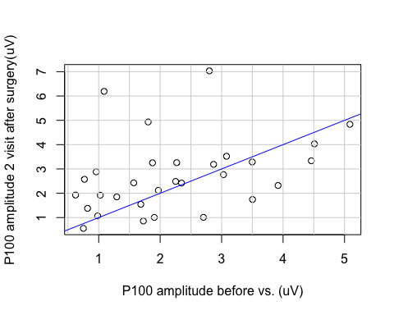

P100 amplitude before vs. 3. visit after surgery
Two tail tests Anderson-Darling test: normality = FALSE
NO paired difference, Wilcoxon p= 0.2449464
Effect size and confidence limits, d = 0.3 [ -0.21 0.81 ]
Power of study with aforementioned effect, pwr = 0.21
P100 amplitude before vs. (uV) vs. P100 amplitude 3. visit after surgery(uV)
 | N | 25q | Median | 75q | Mean | SD | Min | Max | NaN
P100 amplitude before vs. (uV) | 30 | 1.14 | 1.94 | 2.99 | 2.24 | 1.23 | 0.62 | 5.09 | 0
P100 amplitude 3. visit after surgery(uV) | 30 | 1.75 | 2.30 | 3.03 | 2.66 | 1.43 | 0.50 | 6.16 | 0
Diff. | 30 | -1.32 | -0.15 | 0.42 | -0.42 | 1.48 | -5.07 | 2.32 | 0
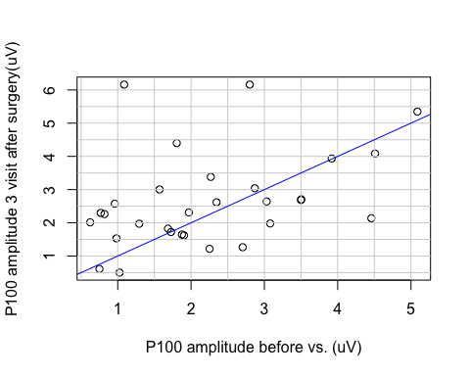

N160 peak time before vs. 1. visit after surgery
Two tail tests Anderson-Darling test: normality = TRUE
SIGNIFICANT paired difference, ttest p= 0.01223083
Effect size and confidence limits, d = 0.67 [ 0.15 1.19 ]
Power of study with aforementioned effect, pwr = 0.74
N160 peak time before vs. (ms) vs. N160 peak time 1. visit after surgery(ms)
 | N | 25q | Median | 75q | Mean | SD | Min | Max | NaN
N160 peak time before vs. (ms) | 30 | 156.98 | 172.80 | 184.57 | 172.46 | 19.10 | 137.1 | 218.7 | 0
N160 peak time 1. visit after surgery(ms) | 30 | 150.52 | 163.35 | 173.85 | 163.79 | 15.99 | 138.0 | 196.8 | 0
Diff. | 30 | -1.13 | 4.50 | 19.20 | 8.67 | 17.77 | -26.1 | 48.3 | 0
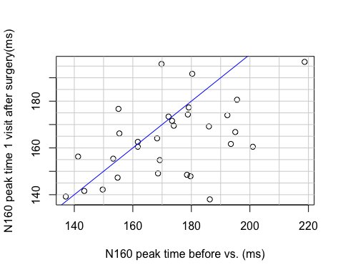

N160 peak time before vs. 2. visit after surgery
Two tail tests Anderson-Darling test: normality = TRUE
SIGNIFICANT paired difference, ttest p= 0.00789423
Effect size and confidence limits, d = 0.74 [ 0.2 1.28 ]
Power of study with aforementioned effect, pwr = 0.79
N160 peak time before vs. (ms) vs. N160 peak time 2. visit after surgery(ms)
 | N | 25q | Median | 75q | Mean | SD | Min | Max | NaN
N160 peak time before vs. (ms) | 28 | 161.70 | 173.7 | 186.07 | 174.76 | 17.57 | 141.3 | 218.7 | 0
N160 peak time 2. visit after surgery(ms) | 28 | 156.75 | 168.3 | 175.35 | 166.10 | 11.05 | 146.1 | 185.4 | 0
Diff. | 28 | 1.20 | 8.7 | 17.77 | 8.66 | 15.96 | -39.0 | 35.7 | 0
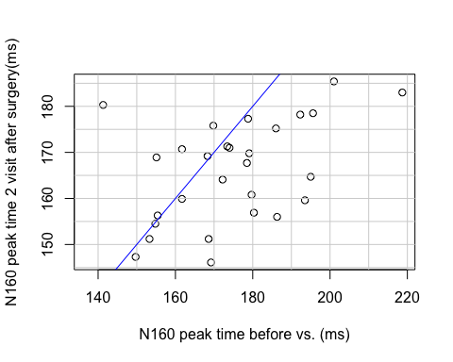

N160 peak time before vs. 3. visit after surgery
Two tail tests Anderson-Darling test: normality = TRUE
SIGNIFICANT paired difference, ttest p= 0.01517973
Effect size and confidence limits, d = 0.67 [ 0.13 1.21 ]
Power of study with aforementioned effect, pwr = 0.71
N160 peak time before vs. (ms) vs. N160 peak time 3. visit after surgery(ms)
 | N | 25q | Median | 75q | Mean | SD | Min | Max | NaN
N160 peak time before vs. (ms) | 28 | 161.70 | 173.70 | 186.07 | 174.76 | 17.57 | 141.3 | 218.7 | 0
N160 peak time 3. visit after surgery(ms) | 28 | 156.68 | 166.35 | 176.85 | 165.55 | 11.97 | 144.3 | 191.1 | 0
Diff. | 28 | -4.72 | 9.60 | 18.30 | 9.21 | 18.80 | -24.3 | 49.2 | 0
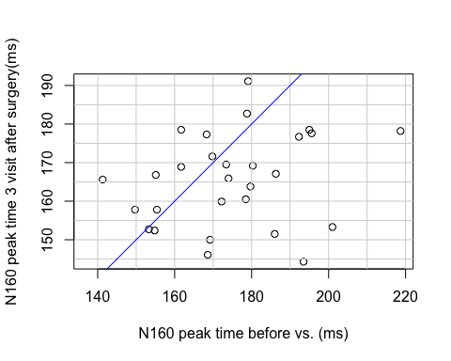

N160 amplitude before vs. 1. visit after surgery
Two tail tests Anderson-Darling test: normality = TRUE
NO paired difference, ttest p= 0.2895562
Effect size and confidence limits, d = 0.28 [ -0.23 0.78 ]
Power of study with aforementioned effect, pwr = 0.19
N160 amplitude before vs. (uV) vs. N160 amplitude 1. visit after surgery(uV)
 | N | 25q | Median | 75q | Mean | SD | Min | Max | NaN
N160 amplitude before vs. (uV) | 30 | 2.70 | 4.01 | 5.05 | 3.86 | 1.48 | 1.18 | 6.95 | 0
N160 amplitude 1. visit after surgery(uV) | 30 | 3.77 | 4.42 | 5.22 | 4.25 | 1.45 | 0.91 | 6.48 | 0
Diff. | 30 | -1.06 | -0.44 | 0.19 | -0.38 | 1.95 | -4.81 | 5.76 | 0
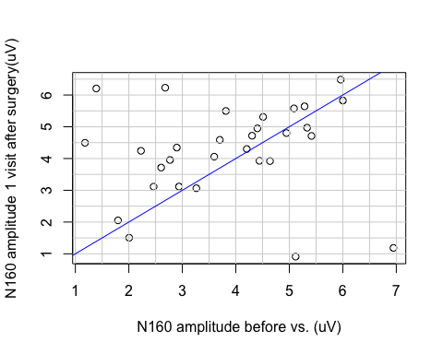

N160 amplitude before vs. 2. visit after surgery
Two tail tests Anderson-Darling test: normality = TRUE
SIGNIFICANT paired difference, ttest p= 0.03416781
Effect size and confidence limits, d = 0.58 [ 0.05 1.12 ]
Power of study with aforementioned effect, pwr = 0.58
N160 amplitude before vs. (uV) vs. N160 amplitude 2. visit after surgery(uV)
 | N | 25q | Median | 75q | Mean | SD | Min | Max | NaN
N160 amplitude before vs. (uV) | 28 | 2.66 | 4.01 | 4.98 | 3.82 | 1.46 | 1.18 | 6.95 | 0
N160 amplitude 2. visit after surgery(uV) | 28 | 2.93 | 4.26 | 5.11 | 4.26 | 1.48 | 1.32 | 7.78 | 0
Diff. | 28 | -0.73 | -0.21 | 0.18 | -0.44 | 1.03 | -3.39 | 1.13 | 0
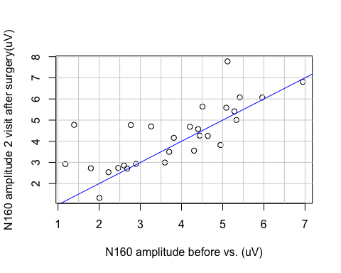

N160 amplitude before vs. 3. visit after surgery
Two tail tests Anderson-Darling test: normality = TRUE
NO paired difference, ttest p= 0.3463546
Effect size and confidence limits, d = 0.25 [ -0.27 0.78 ]
Power of study with aforementioned effect, pwr = 0.15
N160 amplitude before vs. (uV) vs. N160 amplitude 3. visit after surgery(uV)
 | N | 25q | Median | 75q | Mean | SD | Min | Max | NaN
N160 amplitude before vs. (uV) | 28 | 2.66 | 4.01 | 4.98 | 3.82 | 1.46 | 1.18 | 6.95 | 0
N160 amplitude 3. visit after surgery(uV) | 28 | 2.98 | 3.91 | 5.12 | 4.19 | 1.54 | 1.52 | 7.53 | 0
Diff. | 28 | -1.53 | -0.26 | 0.68 | -0.37 | 2.02 | -5.47 | 4.66 | 0
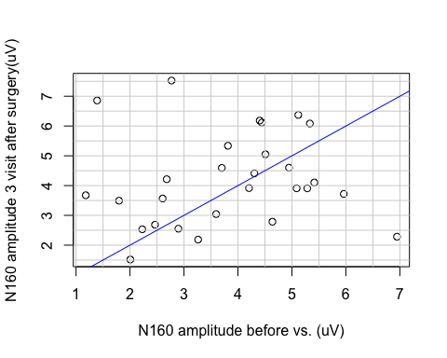

Visual acuity before vs. 1. visit after surgery
Two tail tests Anderson-Darling test: normality = FALSE
SIGNIFICANT paired difference, Wilcoxon p= 0.01009348
Effect size and confidence limits, d = 0.66 [ 0.16 1.17 ]
Power of study with aforementioned effect, pwr = 0.75
Visual acuity before vs. (logMAR) vs. Visual acuity 1. visit after surgery(logMAR)
 | N | 25q | Median | 75q | Mean | SD | Min | Max | NaN
Visual acuity before vs. (logMAR) | 32 | 0.1 | 0.40 | 0.72 | 0.48 | 0.47 | -0.20 | 1.4 | 0
Visual acuity 1. visit after surgery(logMAR) | 32 | 0.1 | 0.30 | 0.63 | 0.36 | 0.33 | -0.12 | 1.0 | 0
Diff. | 32 | 0.0 | 0.09 | 0.24 | 0.12 | 0.26 | -0.51 | 0.7 | 0
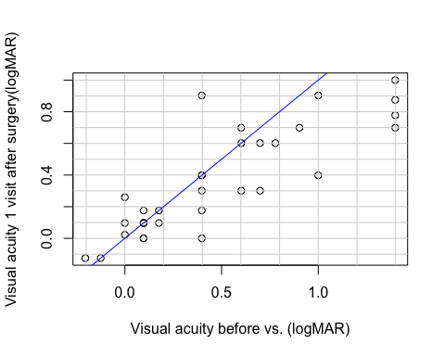

Visual acuity before vs. 2. visit after surgery
Two tail tests Anderson-Darling test: normality = FALSE
SIGNIFICANT paired difference, Wilcoxon p= 9.790719e-06
Effect size and confidence limits, d = 1.25 [ 0.7 1.8 ]
Power of study with aforementioned effect, pwr = 1
Visual acuity before vs. (logMAR) vs. Visual acuity 2. visit after surgery(logMAR)
 | N | 25q | Median | 75q | Mean | SD | Min | Max | NaN
Visual acuity before vs. (logMAR) | 30 | 0.1 | 0.40 | 0.76 | 0.51 | 0.48 | -0.20 | 1.40 | 0
Visual acuity 2. visit after surgery(logMAR) | 30 | 0.0 | 0.30 | 0.40 | 0.24 | 0.29 | -0.12 | 1.00 | 0
Diff. | 30 | 0.1 | 0.15 | 0.36 | 0.27 | 0.30 | -0.08 | 1.22 | 0
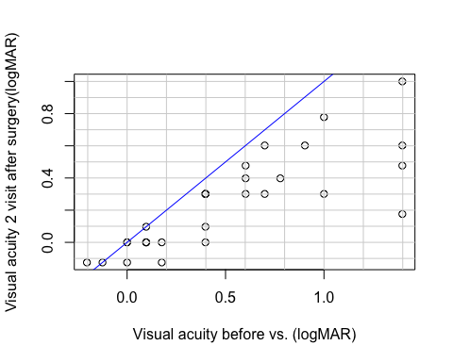

Visual acuity before vs. 3. visit after surgery
Two tail tests Anderson-Darling test: normality = TRUE
SIGNIFICANT paired difference, ttest p= 3.167806e-05
Effect size and confidence limits, d = 1.21 [ 0.64 1.78 ]
Power of study with aforementioned effect, pwr = 0.99
Visual acuity before vs. (logMAR) vs. Visual acuity 3. visit after surgery(logMAR)
 | N | 25q | Median | 75q | Mean | SD | Min | Max | NaN
Visual acuity before vs. (logMAR) | 28 | 0.1 | 0.40 | 0.81 | 0.54 | 0.48 | -0.2 | 1.40 | 0
Visual acuity 3. visit after surgery(logMAR) | 28 | 0.1 | 0.24 | 0.40 | 0.25 | 0.25 | -0.2 | 0.90 | 0
Diff. | 28 | 0.0 | 0.22 | 0.42 | 0.29 | 0.31 | -0.1 | 1.22 | 0
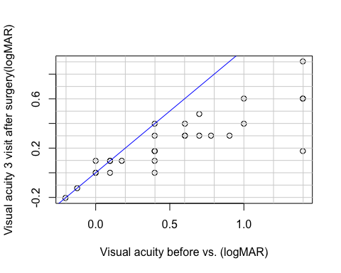

Perimetry before vs. 1. visit after surgery
Two tail tests Anderson-Darling test: normality = FALSE
SIGNIFICANT paired difference, Wilcoxon p= 1.259148e-06
Effect size and confidence limits, d = 1.46 [ 0.87 2.05 ]
Power of study with aforementioned effect, pwr = 1
Perimetry before vs. (MD) vs. Perimetry 1. visit after surgery(MD)
 | N | 25q | Median | 75q | Mean | SD | Min | Max | NaN
Perimetry before vs. (MD) | 28 | -14.25 | -4.82 | -1.84 | -8.69 | 8.32 | -27.18 | 0.02 | 0
Perimetry 1. visit after surgery (MD) | 28 | -6.06 | -2.68 | -0.79 | -4.77 | 5.68 | -22.79 | 0.92 | 0
Diff. | 28 | -4.60 | -2.32 | -0.54 | -3.92 | 5.80 | -24.27 | 2.57 | 0
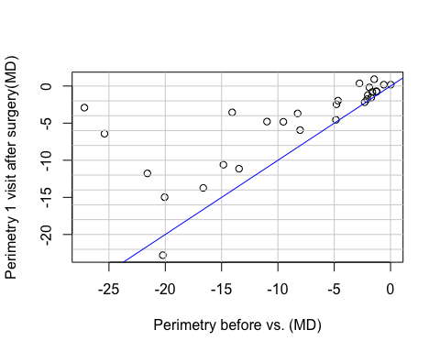

Perimetry before vs. 2l visit after surgery
Two tail tests Anderson-Darling test: normality = FALSE
SIGNIFICANT paired difference, Wilcoxon p= 3.539026e-08
Effect size and confidence limits, d = 1.64 [ 1.06 2.23 ]
Power of study with aforementioned effect, pwr = 1
Perimetry before vs. (MD) vs. Perimetry 2l visit after surgery (MD)
 | N | 25q | Median | 75q | Mean | SD | Min | Max | NaN
Perimetry before vs. (MD) | 30 | -13.91 | -4.73 | -1.69 | -8.24 | 8.23 | -27.18 | 0.02 | 0
Perimetry 2. visit after surgery (MD) | 30 | -3.40 | -0.99 | -0.37 | -2.63 | 3.90 | -18.35 | 0.50 | 0
Diff. | 30 | -8.56 | -2.48 | -1.14 | -5.60 | 6.88 | -26.35 | 0.65 | 0
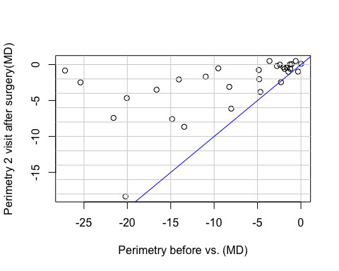

Perimetry before vs. 3. visit after surgery
Two tail tests Anderson-Darling test: normality = FALSE
SIGNIFICANT paired difference, Wilcoxon p= 2.607703e-08
Effect size and confidence limits, d = 1.66 [ 1.07 2.25 ]
Power of study with aforementioned effect, pwr = 1
Perimetry before vs. (MD) vs. Perimetry 3. visit after surgery (MD)
 | N | 25q | Median | 75q | Mean | SD | Min | Max | NaN
Perimetry before vs. (MD) | 30 | -13.91 | -4.73 | -1.69 | -8.24 | 8.23 | -27.18 | 0.02 | 0
Perimetry 3. visit after surgery (MD) | 30 | -2.93 | -1.17 | 0.21 | -2.07 | 4.95 | -19.04 | 11.83 | 0
Diff. | 30 | -9.28 | -2.50 | -0.96 | -6.16 | 7.33 | -25.82 | 0.64 | 0
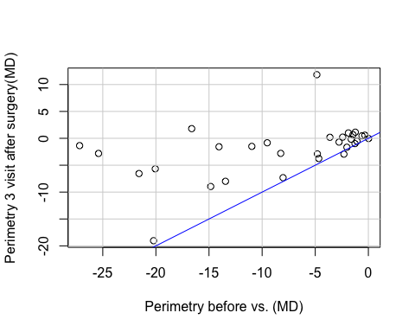

Grade

RNFL
 | N | 25q | Median | 75q | Mean | SD | Min | Max | NaN
Pre.lowG | 8 | 69.75 | 76.5 | 84.75 | 80.000 | 15.547 | 62 | 105 | 2
X1st.lowG | 10 | 71.25 | 76.0 | 81.00 | 79.900 | 13.988 | 63 | 106 | 0
X2nd.lowG | 10 | 70.00 | 76.5 | 82.00 | 79.300 | 12.936 | 65 | 104 | 0
X3rd.lowG | 10 | 69.00 | 76.0 | 81.00 | 79.200 | 14.589 | 63 | 109 | 0
Pre.hiG | 22 | 46.00 | 61.0 | 66.75 | 58.091 | 15.433 | 27 | 84 | 0
X1st.hiG | 22 | 44.25 | 59.5 | 67.75 | 57.955 | 15.756 | 27 | 84 | 0
X2nd.hiG | 20 | 38.75 | 54.0 | 65.00 | 53.150 | 17.670 | 23 | 83 | 2
X3rd.hiG | 20 | 37.25 | 52.0 | 64.25 | 52.250 | 17.363 | 23 | 83 | 2
Anderson-Darling test for normality
Bartlett test of variances homogeneity p = 0.9689196
Normality accepted = * FALSE *
SIGNIFICANT difference between groups, p= 1.797995e-07
- Wilcoxon rank sum test with continuity correction
 | Pre.lowG | 1st.lowG | 2nd.lowG | 3rd.lowG | Pre.hiG | 1st.hiG | 2nd.hiG
1st.lowG | 1.0000000 | NA | NA | NA | NA | NA | NA
2nd.lowG | 1.0000000 | 1.0000000 | NA | NA | NA | NA | NA
3rd.lowG | 1.0000000 | 1.0000000 | 1.0000000 | NA | NA | NA | NA
Pre.hiG | 0.0545542 | 0.0254829 | 0.0254829 | 0.0312590 | NA | NA | NA
1st.hiG | 0.0465923 | 0.0229683 | 0.0254829 | 0.0336247 | 1 | NA | NA
2nd.hiG | 0.0368338 | 0.0229683 | 0.0186767 | 0.0229683 | 1 | 1 | NA
3rd.hiG | 0.0336247 | 0.0196201 | 0.0129765 | 0.0196201 | 1 | 1 | 1
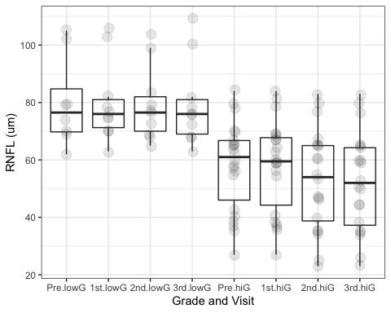

GCL
 | N | 25q | Median | 75q | Mean | SD | Min | Max | NaN
Pre.lowG | 8 | 43.925 | 46.25 | 48.775 | 46.175 | 3.383 | 40.5 | 50.2 | 2
X1st.lowG | 10 | 44.100 | 47.50 | 50.100 | 48.910 | 6.584 | 42.3 | 61.8 | 0
X2nd.lowG | 10 | 43.800 | 47.65 | 51.125 | 49.150 | 7.358 | 40.0 | 62.7 | 0
X3rd.lowG | 10 | 44.075 | 47.75 | 52.400 | 49.070 | 6.480 | 42.0 | 60.3 | 0
Pre.hiG | 22 | 33.500 | 39.25 | 45.725 | 38.532 | 8.806 | 22.7 | 52.7 | 0
X1st.hiG | 22 | 33.275 | 38.65 | 44.475 | 38.109 | 8.282 | 23.3 | 52.3 | 0
X2nd.hiG | 20 | 27.500 | 34.00 | 43.975 | 34.920 | 9.182 | 20.8 | 47.5 | 2
X3rd.hiG | 20 | 28.325 | 34.50 | 43.550 | 35.120 | 8.526 | 21.3 | 46.5 | 2
Anderson-Darling test for normality
Bartlett test of variances homogeneity p = 0.2637149
Normality accepted = * TRUE *
SIGNIFICANT difference between groups, anova p= 2.357888e-08
- t tests with pooled SD
 | Pre.lowG | 1st.lowG | 2nd.lowG | 3rd.lowG | Pre.hiG | 1st.hiG | 2nd.hiG
1st.lowG | 1.0000000 | NA | NA | NA | NA | NA | NA
2nd.lowG | 1.0000000 | 1.0000000 | NA | NA | NA | NA | NA
3rd.lowG | 1.0000000 | 1.0000000 | 1.0000000 | NA | NA | NA | NA
Pre.hiG | 0.3027050 | 0.0168646 | 0.0145282 | 0.0150182 | NA | NA | NA
1st.hiG | 0.2351235 | 0.0125087 | 0.0105299 | 0.0109936 | 1 | NA | NA
2nd.hiG | 0.0179970 | 0.0004334 | 0.0003566 | 0.0003812 | 1 | 1 | NA
3rd.hiG | 0.0204740 | 0.0005142 | 0.0004282 | 0.0004378 | 1 | 1 | 1
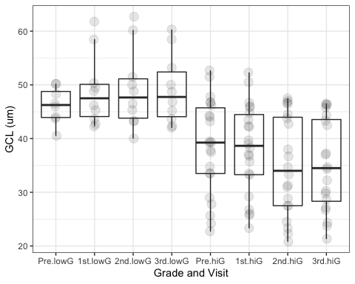

P100 peak time
 | N | 25q | Median | 75q | Mean | SD | Min | Max | NaN
Pre.lowG | 10 | 99.150 | 102.45 | 105.750 | 102.120 | 4.217 | 95.1 | 107.4 | 0
X1st.lowG | 10 | 99.750 | 102.75 | 109.125 | 103.800 | 8.112 | 91.2 | 116.4 | 0
X2nd.lowG | 10 | 100.800 | 103.05 | 107.700 | 103.020 | 6.913 | 91.8 | 113.7 | 0
X3rd.lowG | 10 | 98.775 | 100.20 | 106.350 | 103.020 | 10.571 | 90.3 | 126.9 | 0
Pre.hiG | 22 | 98.100 | 106.05 | 126.525 | 111.968 | 16.964 | 90.0 | 145.2 | 0
X1st.hiG | 22 | 99.150 | 108.90 | 126.150 | 112.800 | 17.165 | 90.6 | 153.9 | 0
X2nd.hiG | 20 | 102.600 | 110.85 | 118.275 | 112.710 | 14.422 | 91.2 | 143.4 | 2
X3rd.hiG | 20 | 100.575 | 106.20 | 113.700 | 108.435 | 13.090 | 79.2 | 142.8 | 2
Anderson-Darling test for normality
Bartlett test of variances homogeneity p = 0.000288476
Normality accepted = * FALSE *
NO intergroup difference, Kruskal-Wallis p= 0.2101178
|| || || ||
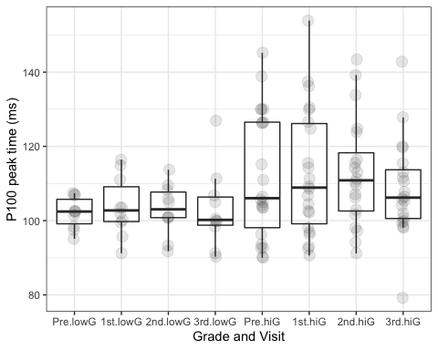

P100 amplitude
 | N | 25q | Median | 75q | Mean | SD | Min | Max | NaN
Pre.lowG | 10 | 2.276 | 2.868 | 3.502 | 3.013 | 1.170 | 1.294 | 5.088 | 0
X1st.lowG | 10 | 2.104 | 2.662 | 2.968 | 2.690 | 0.741 | 1.914 | 4.331 | 0
X2nd.lowG | 10 | 1.771 | 2.454 | 3.157 | 2.544 | 1.244 | 1.006 | 4.836 | 0
X3rd.lowG | 10 | 1.708 | 2.631 | 2.702 | 2.616 | 1.283 | 1.217 | 5.348 | 0
Pre.hiG | 22 | 0.993 | 1.706 | 2.668 | 1.891 | 1.073 | 0.624 | 4.459 | 0
X1st.hiG | 22 | 1.525 | 2.006 | 3.151 | 2.441 | 1.381 | 0.871 | 5.592 | 0
X2nd.hiG | 20 | 1.826 | 2.501 | 3.278 | 2.815 | 1.673 | 0.555 | 7.034 | 2
X3rd.hiG | 20 | 1.799 | 2.280 | 3.125 | 2.675 | 1.526 | 0.501 | 6.161 | 2
Anderson-Darling test for normality
Bartlett test of variances homogeneity p = 0.2323035
Normality accepted = * FALSE *
NO intergroup difference, Kruskal-Wallis p= 0.1950085
|| || || ||
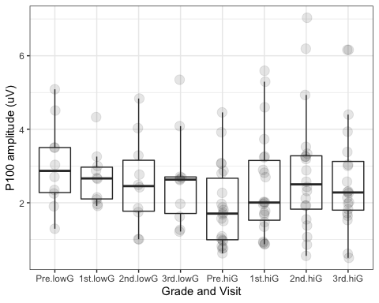

N160 peak time
 | N | 25q | Median | 75q | Mean | SD | Min | Max | NaN
Pre.lowG | 10 | 164.325 | 175.95 | 179.550 | 173.370 | 10.716 | 155.1 | 186.3 | 0
X1st.lowG | 10 | 151.500 | 165.90 | 172.950 | 162.570 | 13.665 | 138.0 | 177.3 | 0
X2nd.lowG | 10 | 161.625 | 168.30 | 170.475 | 166.440 | 6.023 | 156.0 | 175.2 | 0
X3rd.lowG | 10 | 161.325 | 166.95 | 169.350 | 167.760 | 10.854 | 151.5 | 191.1 | 0
Pre.hiG | 20 | 154.425 | 169.50 | 192.600 | 172.005 | 22.403 | 137.1 | 218.7 | 2
X1st.hiG | 20 | 153.375 | 162.90 | 174.075 | 164.400 | 17.336 | 139.2 | 196.8 | 2
X2nd.hiG | 18 | 154.950 | 166.95 | 177.975 | 165.917 | 13.216 | 146.1 | 185.4 | 4
X3rd.hiG | 18 | 152.850 | 165.75 | 177.150 | 164.317 | 12.677 | 144.3 | 182.7 | 4
Anderson-Darling test for normality
Bartlett test of variances homogeneity p = 0.002692955
Normality accepted = * FALSE *
NO intergroup difference, Kruskal-Wallis p= 0.5786729
|| || || ||
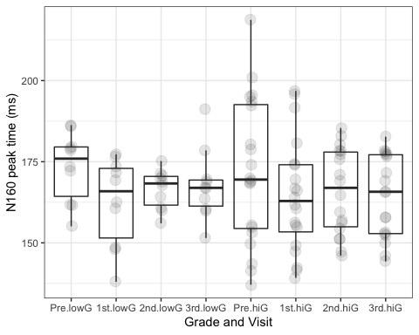

N160 amplitude
 | N | 25q | Median | 75q | Mean | SD | Min | Max | NaN
Pre.lowG | 10 | 3.098 | 4.059 | 5.271 | 4.134 | 1.297 | 2.227 | 5.961 | 0
X1st.lowG | 10 | 4.405 | 4.715 | 5.366 | 4.885 | 0.791 | 3.716 | 6.484 | 0
X2nd.lowG | 10 | 3.073 | 3.860 | 5.442 | 4.228 | 1.360 | 2.537 | 6.073 | 0
X3rd.lowG | 10 | 3.605 | 4.006 | 4.547 | 4.081 | 1.111 | 2.532 | 6.083 | 0
Pre.hiG | 20 | 2.626 | 3.900 | 4.715 | 3.729 | 1.575 | 1.180 | 6.947 | 2
X1st.hiG | 20 | 3.102 | 4.006 | 5.040 | 3.929 | 1.611 | 0.911 | 6.230 | 2
X2nd.hiG | 18 | 2.938 | 4.421 | 4.775 | 4.272 | 1.579 | 1.321 | 7.775 | 4
X3rd.hiG | 18 | 2.851 | 3.911 | 5.847 | 4.245 | 1.762 | 1.517 | 7.526 | 4
Anderson-Darling test for normality
Bartlett test of variances homogeneity p = 0.3349135
Normality accepted = * TRUE *
NO intergroup difference, anova p= 0.6960412
|| || || ||
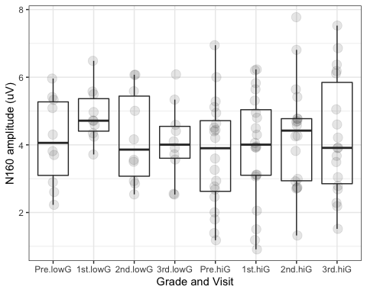

Visual acuity
 | N | 25q | Median | 75q | Mean | SD | Min | Max | NaN
Pre.lowG | 10 | 0.000 | 0.048 | 0.323 | 0.136 | 0.278 | -0.204 | 0.699 | 0
X1st.lowG | 10 | 0.041 | 0.137 | 0.239 | 0.128 | 0.172 | -0.125 | 0.398 | 0
X2nd.lowG | 10 | -0.094 | 0.000 | 0.073 | 0.032 | 0.159 | -0.125 | 0.301 | 0
X3rd.lowG | 10 | 0.000 | 0.097 | 0.097 | 0.054 | 0.144 | -0.204 | 0.301 | 0
Pre.hiG | 22 | 0.232 | 0.602 | 0.976 | 0.641 | 0.463 | 0.097 | 1.398 | 0
X1st.hiG | 22 | 0.117 | 0.500 | 0.699 | 0.465 | 0.335 | 0.000 | 1.000 | 0
X2nd.hiG | 20 | 0.156 | 0.301 | 0.508 | 0.349 | 0.284 | -0.125 | 1.000 | 2
X3rd.hiG | 18 | 0.207 | 0.301 | 0.457 | 0.352 | 0.230 | 0.000 | 0.903 | 4
Anderson-Darling test for normality
Bartlett test of variances homogeneity p = 0.0002388924
Normality accepted = * FALSE *
SIGNIFICANT difference between groups, p= 1.420894e-06
- Wilcoxon rank sum test with continuity correction
 | Pre.lowG | 1st.lowG | 2nd.lowG | 3rd.lowG | Pre.hiG | 1st.hiG | 2nd.hiG
1st.lowG | 1.0000000 | NA | NA | NA | NA | NA | NA
2nd.lowG | 1.0000000 | 1.0000000 | NA | NA | NA | NA | NA
3rd.lowG | 1.0000000 | 1.0000000 | 1.0000000 | NA | NA | NA | NA
Pre.hiG | 0.0421736 | 0.0436574 | 0.0026436 | 0.0054132 | NA | NA | NA
1st.hiG | 0.2377255 | 0.2475372 | 0.0173538 | 0.0506911 | 1.0000000 | NA | NA
2nd.hiG | 0.7960138 | 0.5026052 | 0.0598483 | 0.1121392 | 0.5810918 | 1 | NA
3rd.hiG | 0.5810918 | 0.2475372 | 0.0234720 | 0.0331735 | 0.6027325 | 1 | 1
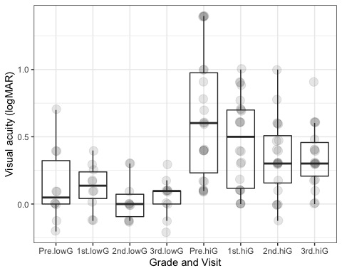

Perimetry
 | N | 25q | Median | 75q | Mean | SD | Min | Max | NaN
Pre.lowG | 10 | -3.320 | -1.535 | -1.110 | -2.504 | 2.367 | -8.03 | -0.33 | 0
X1st.lowG | 6 | -1.678 | -0.785 | -0.057 | -1.397 | 2.432 | -5.94 | 0.92 | 4
X2nd.lowG | 10 | -0.995 | -0.505 | 0.035 | -1.189 | 2.133 | -6.13 | 0.50 | 0
X3rd.lowG | 10 | -0.438 | 0.205 | 0.552 | -0.849 | 2.649 | -7.32 | 1.14 | 0
Pre.hiG | 22 | -16.183 | -8.885 | -2.135 | -10.265 | 8.657 | -27.18 | 0.02 | 0
X1st.hiG | 22 | -9.555 | -3.620 | -1.620 | -5.695 | 5.997 | -22.79 | 0.36 | 0
X2nd.hiG | 20 | -3.790 | -2.050 | -0.580 | -3.356 | 4.401 | -18.35 | 0.10 | 2
X3rd.hiG | 20 | -3.622 | -1.615 | -0.797 | -2.684 | 5.740 | -19.04 | 11.83 | 2
Anderson-Darling test for normality
Bartlett test of variances homogeneity p = 1.158681e-06
Normality accepted = * FALSE *
SIGNIFICANT difference between groups, p= 3.379486e-05
- Wilcoxon rank sum exact test
 | Pre.lowG | 1st.lowG | 2nd.lowG | 3rd.lowG | Pre.hiG | 1st.hiG | 2nd.hiG
1st.lowG | 1.0000000 | NA | NA | NA | NA | NA | NA
2nd.lowG | 0.8113282 | 1.0000000 | NA | NA | NA | NA | NA
3rd.lowG | 0.2791032 | 1.0000000 | 1.0000000 | NA | NA | NA | NA
Pre.hiG | 0.0880310 | 0.0807772 | 0.0117821 | 0.0021094 | NA | NA | NA
1st.hiG | 1.0000000 | 0.9677055 | 0.1745549 | 0.0401340 | 1.0000000 | NA | NA
2nd.hiG | 1.0000000 | 1.0000000 | 1.0000000 | 0.1110256 | 0.0868424 | 1 | NA
3rd.hiG | 1.0000000 | 1.0000000 | 1.0000000 | 0.9710741 | 0.0612408 | 1 | 1
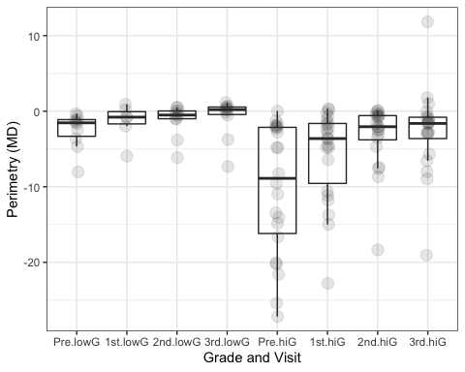

Visual field change

RNFL
Anderson-Darling test: normality = FALSE
SIGNIFICANT correlation between parameters, Spearman rho= -0.4622126 ; p = 0.01327357
Two tail test
Effect size and confidence limits, d = -1.04 [ -1.89 -0.19 ]
Power of study with aforementioned effect, pwr = 0.72
MD perim., visit 3-0 [-] vs. RNFL,Visit 0 (um)
 | N | 25q | 50q | 75q | Mean | SD | Min | Max | NaN
MD perim., visit 3-0 [-] | 30 | 0.96 | 2.5 | 9.28 | 6.16 | 7.33 | -0.64 | 25.82 | 2
RNFL,Visit 0 (um) | 30 | 56.25 | 65.0 | 73.00 | 63.93 | 18.11 | 27.00 | 105.00 | 2
## `geom_smooth()` using formula 'y ~ x'
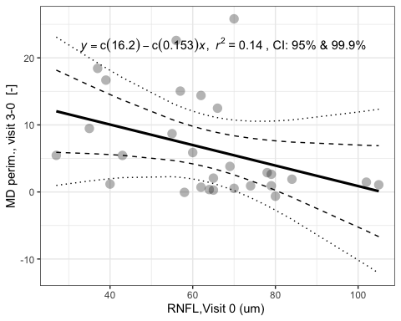

GCL
Anderson-Darling test: normality = FALSE
SIGNIFICANT correlation between parameters, Spearman rho= -0.6338125 ; p = 0.0002933081
Two tail test
Effect size and confidence limits, d = -1.64 [ -2.61 -0.66 ]
Power of study with aforementioned effect, pwr = 0.97
MD perim., visit 3-0 [-] vs. GCL,Visit 0 (um)
 | N | 25q | 50q | 75q | Mean | SD | Min | Max | NaN
MD perim., visit 3-0 [-] | 30 | 0.96 | 2.50 | 9.28 | 6.16 | 7.33 | -0.64 | 25.82 | 2
GCL,Visit 0 (um) | 30 | 35.47 | 43.45 | 46.65 | 40.57 | 8.41 | 22.70 | 52.70 | 2
## `geom_smooth()` using formula 'y ~ x'
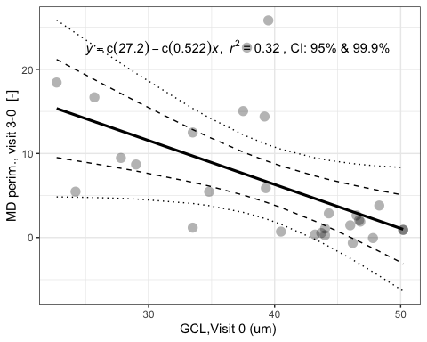

P100 peak time
Anderson-Darling test: normality = FALSE
NO significant relationship, Spearman rho= 0.2780809 ; p = 0.1367721
Two tail test
Effect size and confidence limits, d = 0.58 [ -0.18 1.34 ]
Power of study with aforementioned effect, pwr = 0.32
MD perim., visit 3-0 [-] vs. P100 peak time,Visit 0 (ms)
 | N | 25q | 50q | 75q | Mean | SD | Min | Max | NaN
MD perim., visit 3-0 [-] | 30 | 0.96 | 2.50 | 9.28 | 6.16 | 7.33 | -0.64 | 25.82 | 2
P100 peak time,Visit 0 (ms) | 32 | 98.18 | 104.55 | 117.98 | 108.89 | 14.89 | 90.00 | 145.20 | 0
## `geom_smooth()` using formula 'y ~ x'
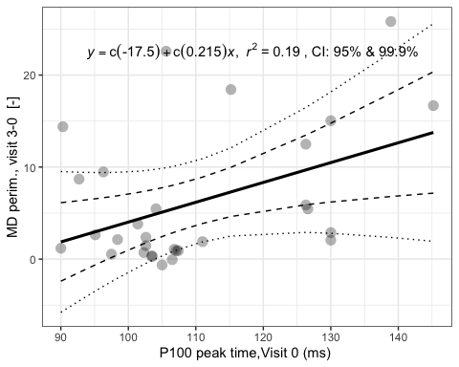

P100 amplitude
Anderson-Darling test: normality = FALSE
NO significant relationship, Spearman rho= -0.2622914 ; p = 0.1610272
Two tail test
Effect size and confidence limits, d = -0.54 [ -1.3 0.21 ]
Power of study with aforementioned effect, pwr = 0.29
MD perim., visit 3-0 [-] vs. P100 amplitude,Visit 0 (uV)
 | N | 25q | 50q | 75q | Mean | SD | Min | Max | NaN
MD perim., visit 3-0 [-] | 30 | 0.96 | 2.50 | 9.28 | 6.16 | 7.33 | -0.64 | 25.82 | 2
P100 amplitude,Visit 0 (uV) | 32 | 1.24 | 1.94 | 3.04 | 2.24 | 1.21 | 0.62 | 5.09 | 0
## `geom_smooth()` using formula 'y ~ x'
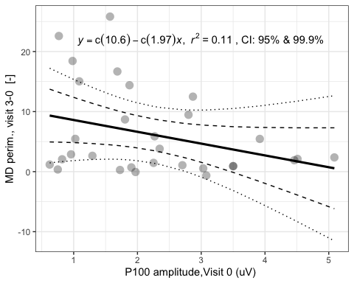

N160 peak time
Anderson-Darling test: normality = FALSE
NO significant relationship, Spearman rho= 0.3519912 ; p = 0.06621964
Two tail test
Effect size and confidence limits, d = 0.75 [ -0.05 1.56 ]
Power of study with aforementioned effect, pwr = 0.46
MD perim., visit 3-0 [-] vs. N160 peak time,Visit 0 (ms)
 | N | 25q | 50q | 75q | Mean | SD | Min | Max | NaN
MD perim., visit 3-0 [-] | 30 | 0.96 | 2.5 | 9.28 | 6.16 | 7.33 | -0.64 | 25.82 | 2
N160 peak time,Visit 0 (ms) | 30 | 156.98 | 172.8 | 184.57 | 172.46 | 19.10 | 137.10 | 218.70 | 2
## `geom_smooth()` using formula 'y ~ x'
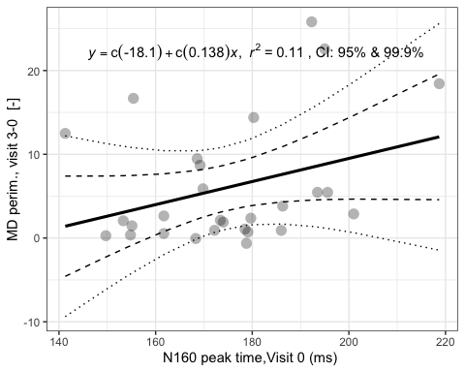

N160 amplitude
Anderson-Darling test: normality = FALSE
SIGNIFICANT correlation between parameters, Spearman rho= -0.3924466 ; p = 0.03974387
Two tail test
Effect size and confidence limits, d = -0.85 [ -1.67 -0.03 ]
Power of study with aforementioned effect, pwr = 0.56
MD perim., visit 3-0 [-] vs. N160 amplitude,Visit 0 (uV)
 | N | 25q | 50q | 75q | Mean | SD | Min | Max | NaN
MD perim., visit 3-0 [-] | 30 | 0.96 | 2.50 | 9.28 | 6.16 | 7.33 | -0.64 | 25.82 | 2
N160 amplitude,Visit 0 (uV) | 30 | 2.70 | 4.01 | 5.05 | 3.86 | 1.48 | 1.18 | 6.95 | 2
## `geom_smooth()` using formula 'y ~ x'
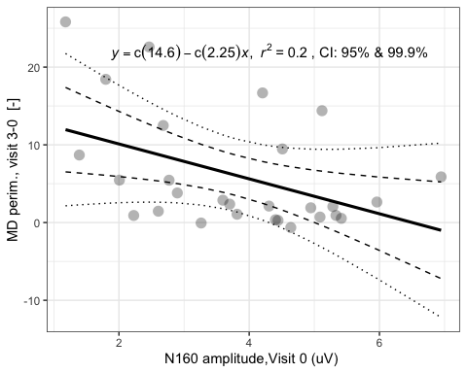

Visual acuity
Anderson-Darling test: normality = FALSE
SIGNIFICANT correlation between parameters, Spearman rho= 0.368903 ; p = 0.04484605
Two tail test
Effect size and confidence limits, d = 0.79 [ 0.01 1.58 ]
Power of study with aforementioned effect, pwr = 0.53
MD perim., visit 3-0 [-] vs. Visual acuity,Visit 0 (logMAR)
 | N | 25q | 50q | 75q | Mean | SD | Min | Max | NaN
MD perim., visit 3-0 [-] | 30 | 0.96 | 2.5 | 9.28 | 6.16 | 7.33 | -0.64 | 25.82 | 2
Visual acuity,Visit 0 (logMAR) | 32 | 0.10 | 0.4 | 0.72 | 0.48 | 0.47 | -0.20 | 1.40 | 0
## `geom_smooth()` using formula 'y ~ x'
