Supplementary figures
Intratumoural microbial metabolites in breast cancer: A longitudinal study on association with metastatic progression
Srinidhi Narayani Seenivasan^{1,2}, Samrat Ashok Vasudevan^{1,2}, Avinash Kumar Raghupathy¹, Firoz Rajan³, Ezhir Selvan³, Sangita Mehta Sharma⁴, Rajeswari K Muthusamy⁴, Lavanya Paramasivam⁴, Shobanaa Pechimuthubabu Seethalakshmi⁴, Sharmila Yogeswaran⁴, Velmurugan Ganesan¹*

¹Chemomicrobiomics Laboratory, Department of Biochemistry & Microbiology, KMCH Research Foundation, Coimbatore, Tamil Nadu, India.
²School of Chemical and Biotechnology, SASTRA (Deemed to be University), Thanjavur, Tamil Nadu, India.
³Department of Surgical Oncology, Comprehensive Cancer Center, Kovai Medical Center & Hospital, Coimbatore, Tamil Nadu, India.
⁴Department of Pathology, Kovai Medical Center & Hospital, Coimbatore, Tamil Nadu, India.

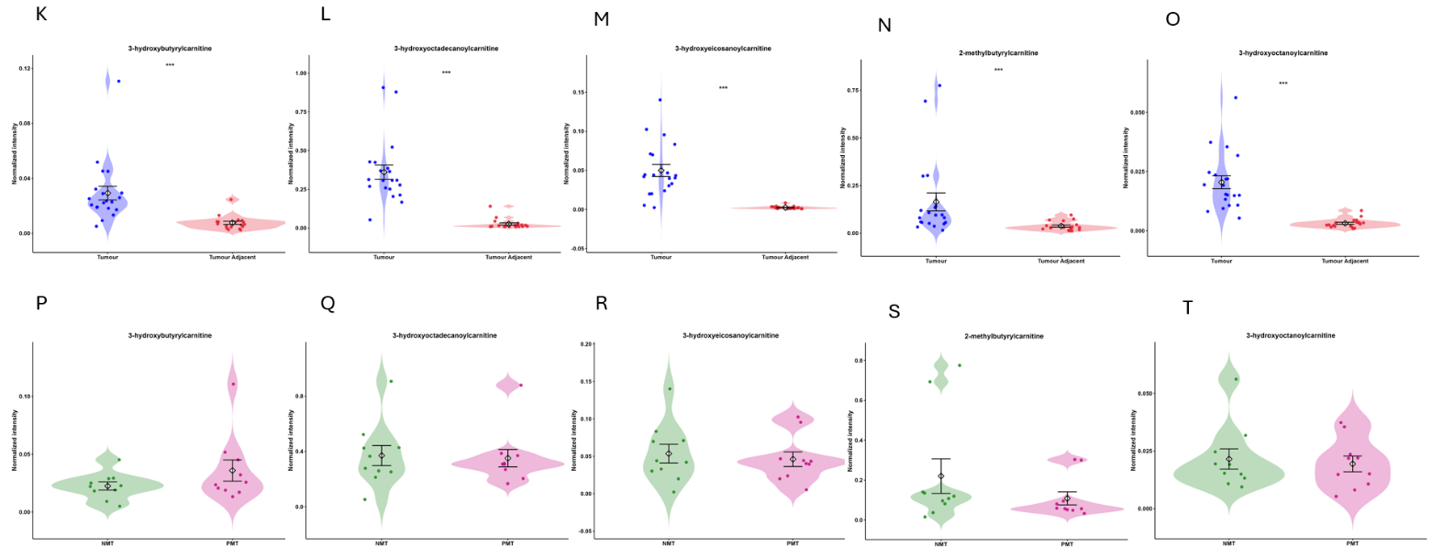
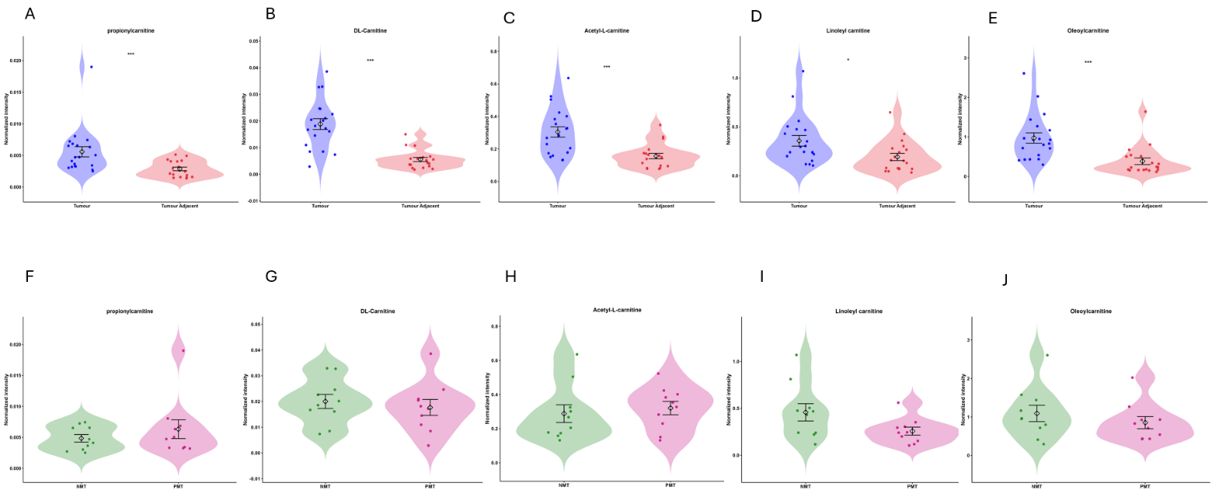

Figure S1: (A-T) Violin plots depicting the distribution and expression levels of carnitine derivatives between Tumour & tumour adjacent tissues and pre-metastatic & non-metastatic tumour. Propionyl carnitine, DL-carnitine, acetyl-carnitine, linoleyl carnitine, oleoyl carnitine, 3-hydrozybutryl carnitine, 3-hydroxyoctadecanoyl carnitine, 3-hydroxyeicosanoyl carnitine, 3-methylbutyryl carnitine, 3-hydroxyoctanoylcarnitine. Asterisks indicate statistical significance: *p < 0.05; **p < 0.01; ***p < 0.001. Error bars in violin-dot plots represents the mean±SEM.

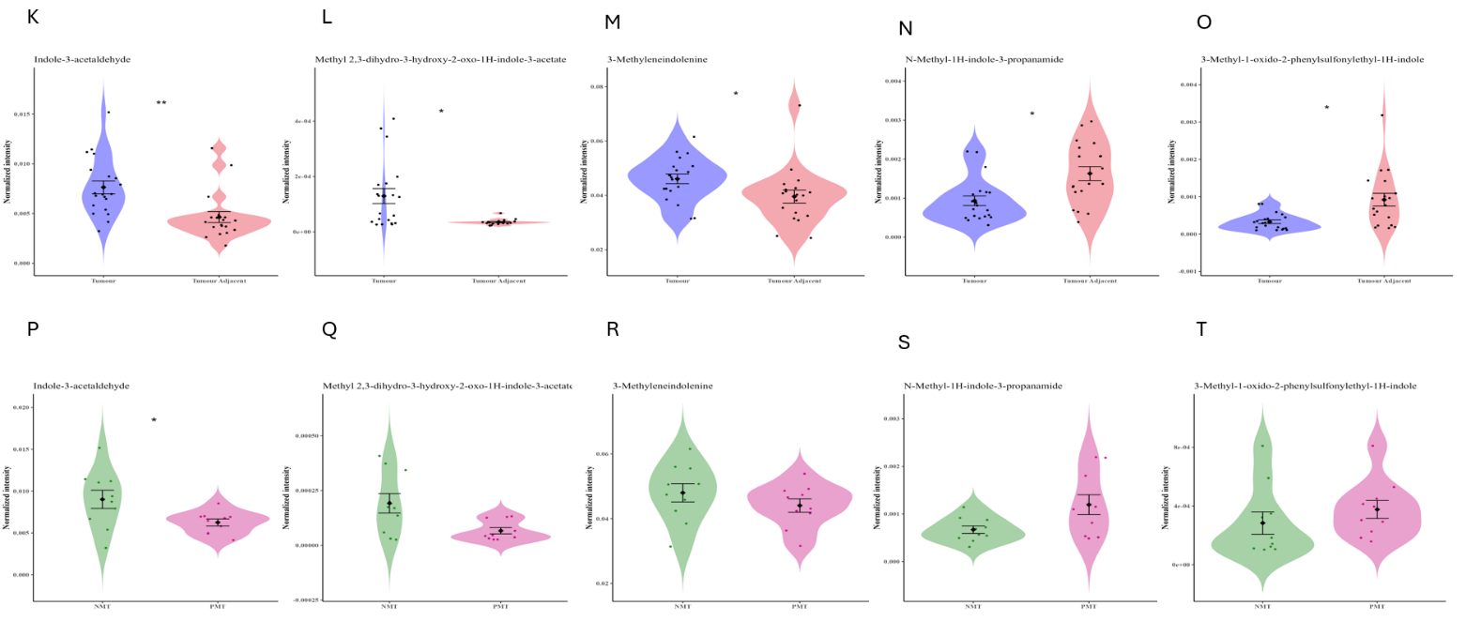
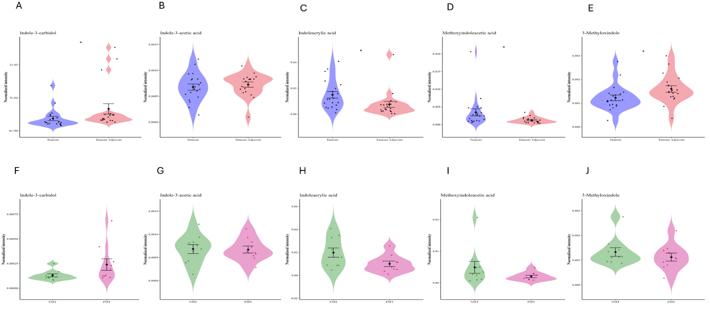
Figure S2: (A-T) Violin plots depicting the distribution and expression levels of indole derivatives between Tumour & tumour adjacent tissues and pre-metastatic & non-metastatic tumour. Indole-3-carbidol, indole-3-acetic acid, indoleacrylic acid, methoxyindoleacetic acid, 3-methyloxindole, indole-3-acetaldehyde, methyl2,3-dihydro-3-hydroxy-2-oxo-1H-indol-3-acetate, 3-methyleneindolenine, N-methyl-1H-indole-3-propanamide, 3-methyl-1-oxido-2-phenylsulfonylethyl-1H-indole. Asterisks indicate statistical significance: *p < 0.05; **p < 0.01; ***p < 0.001. Error bars in violin-dot plots represent the mean ± SEM.

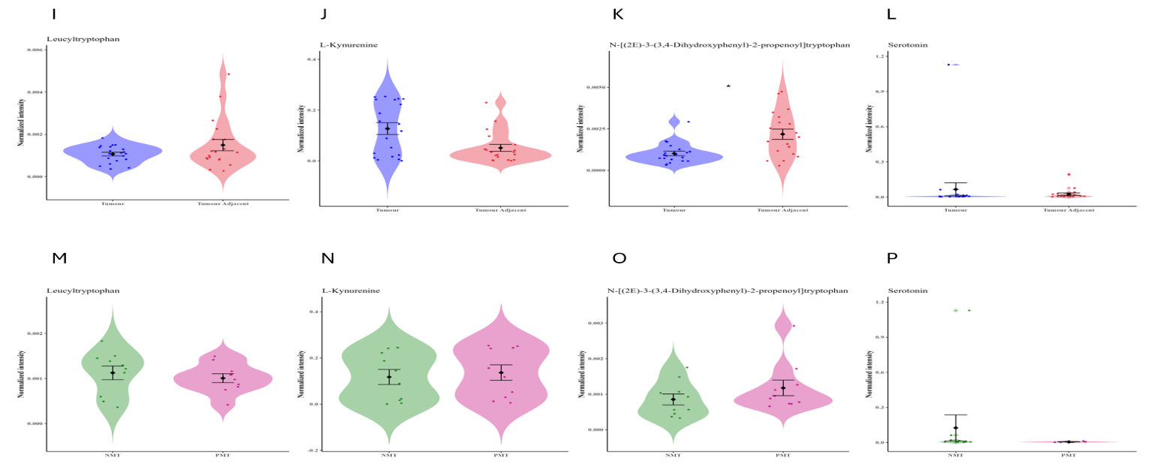
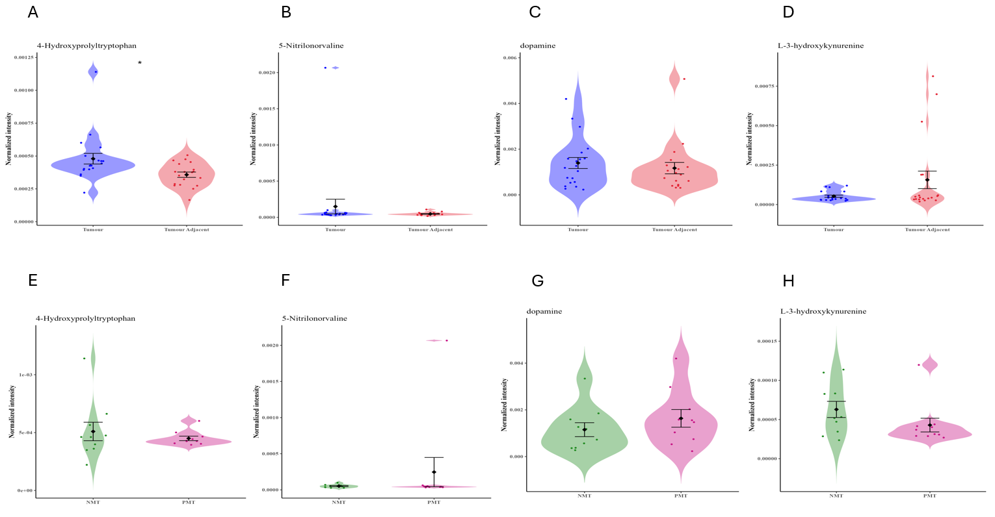
Figure S3: (A-P) Violin plots depicting the distribution and expression levels of tryptophan derivatives between Tumour & tumour adjacent tissues and pre-metastatic & non-metastatic tumour. 4-Hydroxyprolyltryptophan, 5-nitrilonorvaline, dopamine, L-3-hydroxykynurenine, leucyltryptophan, L-kynuernine, N-[(2E)-3-(3,4-Dihydroxyphenyl)-2-propenoyl] tryptophan, serotonin. Asterisks indicate statistical significance: *p < 0.05; **p < 0.01; ***p < 0.001. Error bars in violin-dot plots represent the mean ± SEM.
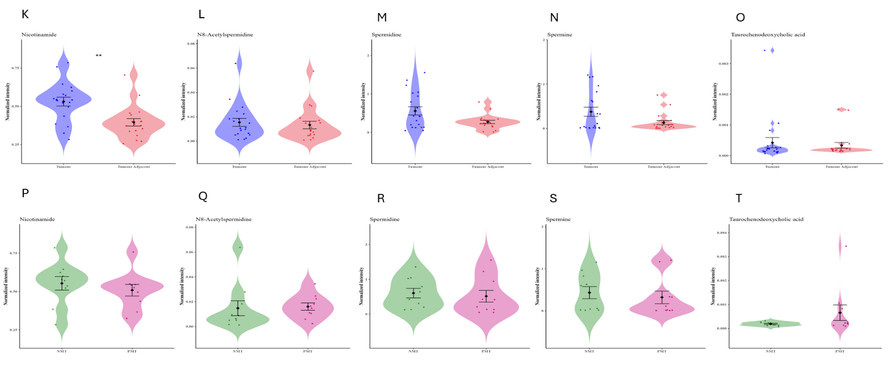
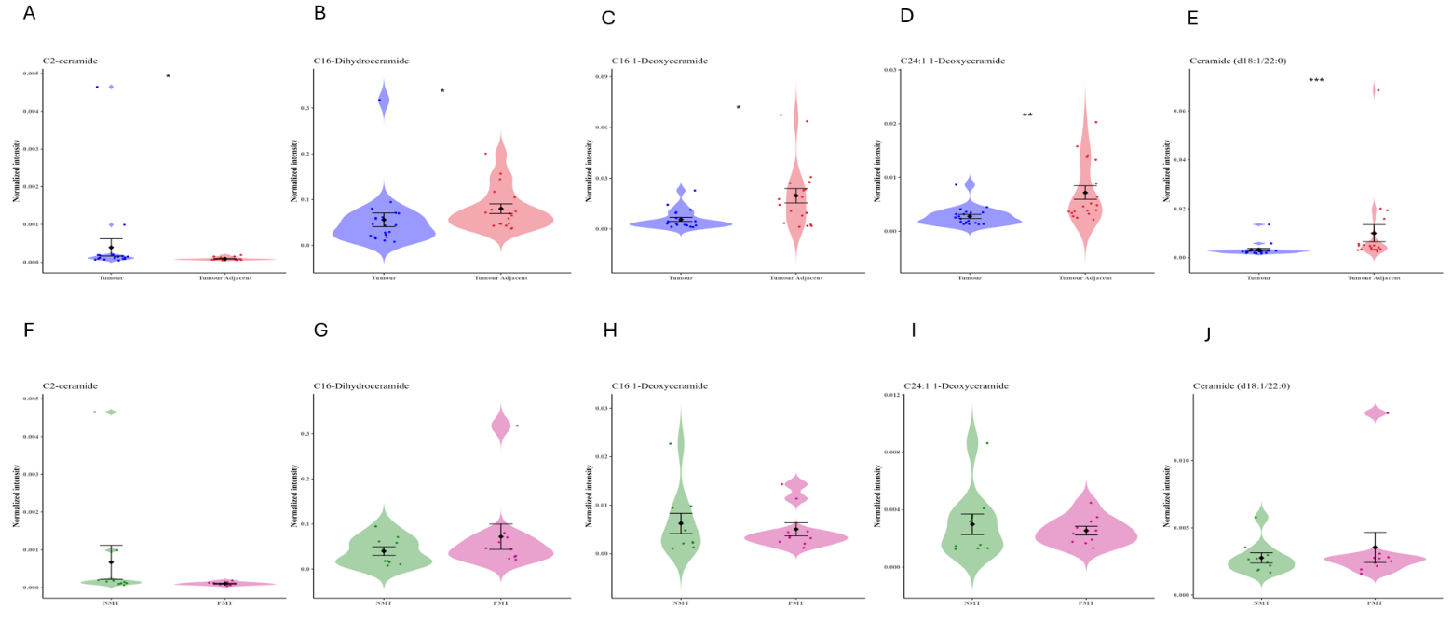
Figure S4: (A-T) Violin plots depicting the distribution and expression levels of ceramide, polyamines and bile acids between Tumour & tumour adjacent tissues and pre-metastatic & non-metastatic tumour. C2-ceramide, C16-dihydroceramide, C16 1-deoxyceramide, C24:1 1-deoxyceramide, ceramide (d18:1/22:0), nicotinamide, N8-acetylspermidine, spermidine, spermine, taurochenodeoxycholic aicd. Asterisks indicate statistical significance: *p < 0.05; **p < 0.01; ***p < 0.001. Error bars in violin-dot plots represent the mean ± SEM.

