Supplementary Material
Table of Contents

Supplementary Tables

Supplementary Table 1: Demographic and clinical details of subjects for each site of the FBIRN dataset.
Supplementary Table 2: The Peak coordinates of components and labels of the NeuroMark template.
Supplementary Table 3: Association between the subnetwork brain age gap and attention. vigilance
Supplementary Table 4: Association between the subnetwork brain age gap and working memory.

Supplementary Figures
Supplementary Figure 1: The NeuroMark independent component.

Supplementary Figure 2: Static and dynamic functional network connectivity.

Supplementary Figure 3: Brain age prediction model architecture.

Supplementary Figure 4: Sub-network brain age prediction model performance.

Supplementary Figure 5: STROBE flowchart reporting numbers of subjects and scans in the training dataset, including UKBB, HPC-YA, and HCP-A.

Supplementary Figure 6: STROBE flowchart reporting numbers of subjects and scans in the FBIRN dataset as the test dataset.

 |  | SZ | HC | P-value
FBRIN  Site 1 | Number | 21 | 28 | NA
FBRIN  Site 1 | Age | 30.04±8.60 | 34.78±9.40 | 0.1
FBRIN  Site 1 | Gender(M/F) | 17/4 | 21/7 | 0.99
FBRIN  Site 1 | PANSS (positive) | 15.72±5.57 | NA | NA
FBRIN  Site 1 | PANSS(negative) | 14.11±3.14 | NA | NA
FBRIN  Site 1 | Attention vigilance
FBRIN  Site 1 | Working memory
FBIRN  Site 2 | Number | 12 | 10 | NA
FBIRN  Site 2 | Age | 44.91±11.34 | 38.10±9.39 | 0.14
FBIRN  Site 2 | Sex (M/F) | 12/0 | 7/3 | 0.62
FBIRN  Site 2 | PANSS (positive) | 16.90±6.70 | NA | NA
FBIRN  Site 2 | PANSS negative) | 17.20±7.39 | NA | NA
FBIRN  Site 2 | Attention vigilance
FBIRN  Site 2 | Working memory
FBIRN  Site 3 | Number | 24 | 27 | NA
FBIRN  Site 3 | Age | 44.41±11.90 | 42.48±12.56 | 0.57
FBIRN  Site 3 | Sex (M/F) | 19/5 | 21/6 | 0.99
FBIRN  Site 3 | PANSS (positive) | 16.95±4.43 | NA | NA
FBIRN  Site 3 | PANSS negative) | 16.87±5.91 | NA | NA
FBIRN  Site 3 | Attention vigilance
FBIRN  Site 3 | Working memory
FBIRN  Site 4 | Number | 26 | 26 | NA
FBIRN  Site 4 | Age | 36.88±12.82 | 35.23±10.56 | 0.61
FBIRN  Site 4 | Sex (M/F) | 21/5 | 20/6 | 0.99
FBIRN  Site 4 | PANSS (positive) | 14.29±3.77 | NA | NA
FBIRN  Site 4 | PANSS (negative) | 13.41±4.64 | NA | NA
FBIRN  Site 4 | Attention vigilance
FBIRN  Site 4 | Working memory
FBIRN  Site 5 | Number | 14 | 15 | NA
FBIRN  Site 5 | Age | 36.64±10.27 | 37.53±9.76 | 0.81
FBIRN  Site 5 | Sex (M/F) | 9/5 | 10/5 | 0.99
FBIRN  Site 5 | PANSS (positive) | 13.14±4.46 | NA | NA
FBIRN  Site 5 | PANSS (negative) | 15±6.28 | NA | NA
FBIRN  Site 5 | Attention vigilance
FBIRN  Site 5 | Working memory
FBIRN  Site 6 | Number | 29 | 27 | NA
FBIRN  Site 6 | Age | 36.27±11.08 | 34.51±10.85 | 0.54
FBIRN  Site 6 | Gender(M/F) | 17/12 | 16/9 | 0.99
FBIRN  Site 6 | PANSS (positive) | 14.34±4.67 | NA | NA
FBIRN  Site 6 | PANSS (negative) | 11.93±4.06 | NA | NA
FBIRN  Site 6 | Attention vigilance
FBIRN  Site 6 | Working memory
FBIRN  Site 7 | Number | 25 | 27 | NA
FBIRN  Site 7 | Age | 39.56±11.80 | 37.56±10.75 | 0.52
FBIRN  Site 7 | Sex (M/F) | 20/5 | 20/7 | 0.99
FBIRN  Site 7 | PANSS (positive) | 16.12±5.41 | NA | NA
FBIRN  Site 7 | PANSS (negative) | 14.04±6.82 | NA | NA
FBIRN  Site 7 | Attention vigilance
FBIRN  Site 7 | Working memory
Total | Number | 151 | 160 | NA
Total | Age | 38.06±11.30 | 37.04±10.68 | 0.41
Total | Sex (M/F) | 115/36 | 115/45 | 0.99
Total | PANSS (positive) | 15.32±4.92 | NA | NA
Total | PANSS (negative) | 14.32±5.42 | NA | NA
 | Attention vigilance
 | Working memory

Supplementary Table 1.
Demographic and clinical details of subjects for each site of the FBIRN dataset

Supplementary Table 2.
The Peak coordinates of components and labels of the NeuroMark template

 | Selected Components as Regions of Interest | X | Y | Z
 | Subcortical network (SC)
1 | Caudate (1) | 6.5 | 10.5 | 5.5
2 | Subthalamus/hypothalamus (2) | -2.5 | -13.5 | -1.5
3 | Putamen (3) | -26.5 | 1.5 | -0.5
4 | Caudate (4) | 21.5 | 10.5 | -3.5
5 | Thalamus (5) | -12.5 | -18.5 | 11.5
 | Auditory network (AUD)
6 | Superior temporal gyrus ([STG], 6) | 62.5 | -22.5 | 7.5
7 | Middle temporal gyrus ([MTG], 7) | -42.5 | -6.5 | 10.5
 | Sensorimotor network (SM)
8 | Postcentral gyrus ([PoCG], 8) | 56.5 | -4.5 | 28.5
9 | Left postcentral gyrus ([L PoCG], 9) | -38.5 | -22.5 | 56.5
10 | Paracentral lobule ([ParaCL], 10) | 0.5 | -22.5 | 65.5
11 | Right postcentral gyrus ([R PoCG], 11) | 38.5 | -19.5 | 55.5
12 | Superior parietal lobule ([SPL], 12) | -18.5 | -43.5 | 65.5
13 | Paracentral lobule ([ParaCL], 13) | -18.5 | -9.5 | 56.5
14 | Precentral gyrus ([PreCG], 14) | -42.5 | -7.5 | 46.5
15 | Superior parietal lobule ([SPL], 15) | 20.5 | -63.5 | 58.5
16 | Postcentral gyrus ([PoCG], 16) | -47.5 | -27.5 | 43.5
 | Visual network (VIS)
17 | Calcarine gyrus ([CalcarineG], 17) | -12.5 | -66.5 | 8.5
18 | Middle occipital gyrus ([MOG], 18) | -23.5 | -93.5 | -0.5
19 | Middle temporal gyrus ([MTG], 19) | 48.5 | -60.5 | 10.5
20 | Cuneus (20) | 15.5 | -91.5 | 22.5
21 | Right middle occipital gyrus ([R MOG], 21) | 38.5 | -73.5 | 6.5
22 | Fusiform gyrus (22) | 29.5 | -42.5 | -12.5
23 | Inferior occipital gyrus ([IOG], 23) | -36.5 | -76.5 | -4.5
24 | Lingual gyrus ([LingualG], 24) | -8.5 | -81.5 | -4.5
25 | Middle temporal gyrus ([MTG], 25) | -44.5 | -57.5 | -7.5
 | Cognitive-control network (CC)
26 | Inferior parietal lobule ([IPL], 26) | 45.5 | -61.5 | 43.5
27 | Insula (27) | -30.5 | 22.5 | -3.5
28 | Superior medial frontal gyrus ([SMFG], 28) | -0.5 | 50.5 | 29.5
29 | Inferior frontal gyrus ([IFG], 29) | -48.5 | 34.5 | -0.5
30 | Right inferior frontal gyrus ([R IFG], 30) | 53.5 | 22.5 | 13.5
31 | Middle frontal gyrus ([MiFG], 31) | -41.5 | 19.5 | 26.5
32 | Inferior parietal lobule ([IPL], 32) | -53.5 | -49.5 | 43.5
33 | Right inferior parietal lobue ([R IPL], 33) | 44.5 | -34.5 | 46.5
34 | Supplementary motor area ([SMA], 34) | -6.5 | 13.5 | 64.5
35 | Superior frontal gyrus ([SFG], 35) | -24.5 | 26.5 | 49.5
36 | Middle frontal gyrus ([MiFG], 36) | 30.5 | 41.5 | 28.5
37 | Hippocampus ([HiPP], 37) | 23.5 | -9.5 | -16.5
38 | Left inferior parietal lobule ([L IPL], 38) | -47.5 | 5.5 | 22.5
39 | Middle cingulate cortex ([MCC], 39) | -15.5 | 20.5 | 37.5
40 | Inferior frontal gyrus ([IFG], 40) | 39.5 | 44.5 | -0.5
41 | Middle frontal gyrus ([MiFG], 41) | -26.5 | 47.5 | 5.5
42 | Hippocampus ([HiPP], 42) | -24.5 | -36.5 | 1.5
 | Default-mode network (DM)
43 | Precuneus (43) | -8.5 | -66.5 | 35.5
44 | Precuneus (44) | -12.5 | -54.5 | 14.5
45 | Anterior cingulate cortex ([ACC], 45) | -2.5 | 35.5 | 2.5
46 | Posterior cingulate cortex ([PCC], 46) | -5.5 | -28.5 | 26.5
47 | Anterior cingulate cortex ([ACC], 47) | -9.5 | 46.5 | -10.5
48 | Precuneus (48) | -0.5 | -48.5 | 49.5
49 | Posterior cingulate cortex ([PCC], 49) | -2.5 | 54.5 | 31.5
 | Cerebellar network (CB)
50 | Cerebellum ([CB], 50) | -30.5 | -54.5 | -42.5
51 | Cerebellum ([CB], 51) | -32.5 | -79.5 | -37.5
52 | Cerebellum ([CB], 52) | 20.5 | -48.5 | -40.5
53 | Cerebellum ([CB], 53) | 30.5 | -63.5 | -40.5

Supplementary Table 3. Association between the subnetwork brain age gap and attention vigilance

Network | Beta | SE | R | 95% CI (lower) | 95% CI (higher) | p value | FDR  p value
Subcortical (sFNC) | -0.1813 | 0.0655 | -0.2357 | -0.3111 | -0.0516 | 0.0065 | 0.0228
Subcortical (dFNC) | -0.2989 | 0.0896 | -0.2806 | -0.4763 | -0.1215 | 0.0011 | 0.0140
Auditory (sFNC) | -0.1086 | 0.0895 | -0.1057 | -0.2858 | 0.0685 | 0.2274 | 0.4548
Auditory (dFNC) | -0.0037 | 0.0292 | -0.0112 | -0.0616 | 0.0541 | 0.8977 | 0.9668
Sensorimotor (sFNC) | -0.0265 | 0.0285 | -0.0812 | -0.0831 | 0.0299 | 0.3541 | 0.5509
Sensorimotor (dFNC) | -0.2153 | 0.0769 | -0.2384 | -0.3675 | -0.0631 | 0.0059 | 0.0228
Visual (sFNC) | -0.0217 | 0.0224 | -0.0846 | -0.0661 | 0.0226 | 0.3347 | 0.5509
Visual (dFNC) | -0.0061 | 0.0245 | -0.0218 | -0.0546 | 0.0423 | 0.8032 | 0.9668
Cognitive control (sFNC) | -0.0353 | 0.0145 | -0.2081 | -0.0641 | -0.0065 | 0.0166 | 0.0465
Cognitive control (dFNC) | -0.2928 | 0.1523 | -0.1662 | -0.5942 | 0.0086 | 0.0568 | 0.1326
Default mode (sFNC) | 0.0007 | 0.0237 | 0.0026 | -0.0463 | 0.0477 | 0.9758 | 0.9758
Default mode (dFNC) | -0.1053 | 0.0333 | -0.2666 | -0.1713 | -0.0392 | 0.0020 | 0.0140
Cerebellar (sFNC) | 0.0285 | 0.0520 | 0.0479 | -0.0744 | 0.1315 | 0.5849 | 0.8188
Cerebellar (dFNC) | -0.0181 | 0.0838 | -0.0189 | -0.1840 | 0.1477 | 0.8288 | 0.9668

Supplementary Table 4. Association between the subnetwork brain age gap and working memory

Network | Beta | SE | R | 95% CI (lower) | 95% CI (higher) | p value | FDR  p value
Subcortical (sFNC) | -0.1050 | 0.0518 | -0.1724 | -0.2076 | -0.0020 | 0.0447 | 0.2088
Subcortical (dFNC) | -0.1473 | 0.0714 | -0.1754 | -0.2885 | -0.0060 | 0.0410 | 0.2088
Auditory (sFNC) | -0.1069 | 0.0699 | -0.1309 | -0.2453 | 0.0313 | 0.1286 | 0.3272
Auditory (dFNC) | -0.0123 | 0.0227 | -0.0467 | -0.0572 | 0.0326 | 0.5888 | 0.6341
Sensorimotor (sFNC) | -0.0187 | 0.0223 | -0.0721 | -0.0630 | 0.0255 | 0.4037 | 0.5139
Sensorimotor (dFNC) | -0.0799 | 0.0602 | -0.1138 | -0.1992 | 0.0392 | 0.1870 | 0.3272
Visual (sFNC) | -0.0199 | 0.0172 | -0.0990 | -0.0540 | 0.0142 | 0.2510 | 0.3514
Visual (dFNC) | -0.0249 | 0.0187 | -0.1138 | -0.0620 | 0.0122 | 0.1869 | 0.3272
Cognitive control (sFNC) | -0.0136 | 0.0115 | -0.1010 | -0.0365 | 0.0092 | 0.2417 | 0.3514
Cognitive control (dFNC) | -0.1639 | 0.1196 | -0.1174 | -0.4006 | 0.0728 | 0.1731 | 0.3272
Default mode (sFNC) | 0.0331 | 0.0183 | 0.1540 | -0.0031 | 0.0694 | 0.0734 | 0.2569
Default mode (dFNC) | -0.0662 | 0.0264 | -0.2114 | -0.1186 | -0.0139 | 0.0134 | 0.1884
Cerebellar (sFNC) | 0.0226 | 0.0405 | 0.0482 | -0.0574 | 0.1027 | 0.5766 | 0.6341
Cerebellar (dFNC) | 0.0286 | 0.0648 | 0.0380 | -0.0997 | 0.1569 | 0.6598 | 0.6598

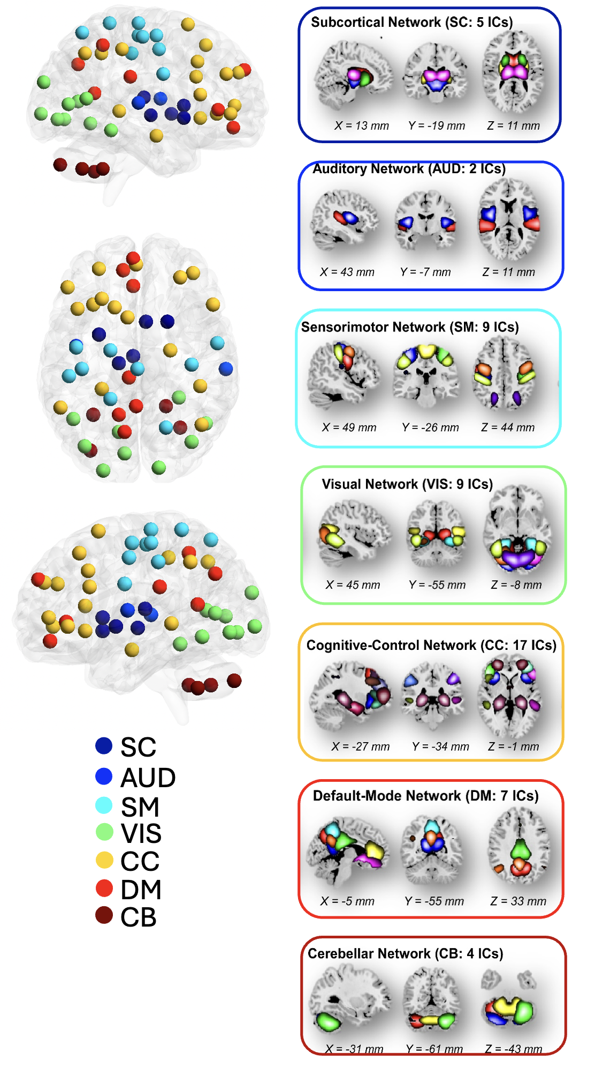

Supplementary Figure 1. The NeuroMark independent component: We utilized the NeuroMark pipeline to identify reliable intrinsic connectivity networks (ICNs), capturing a total of 53 components that are consistent across independent datasets. These 53 independent components were organized into seven distinct networks: subcortical (SC), auditory (AUD), visual sensory (VSN), sensorimotor (SM), cognitive control (CC), default mode DM), and cerebellar network (CB).

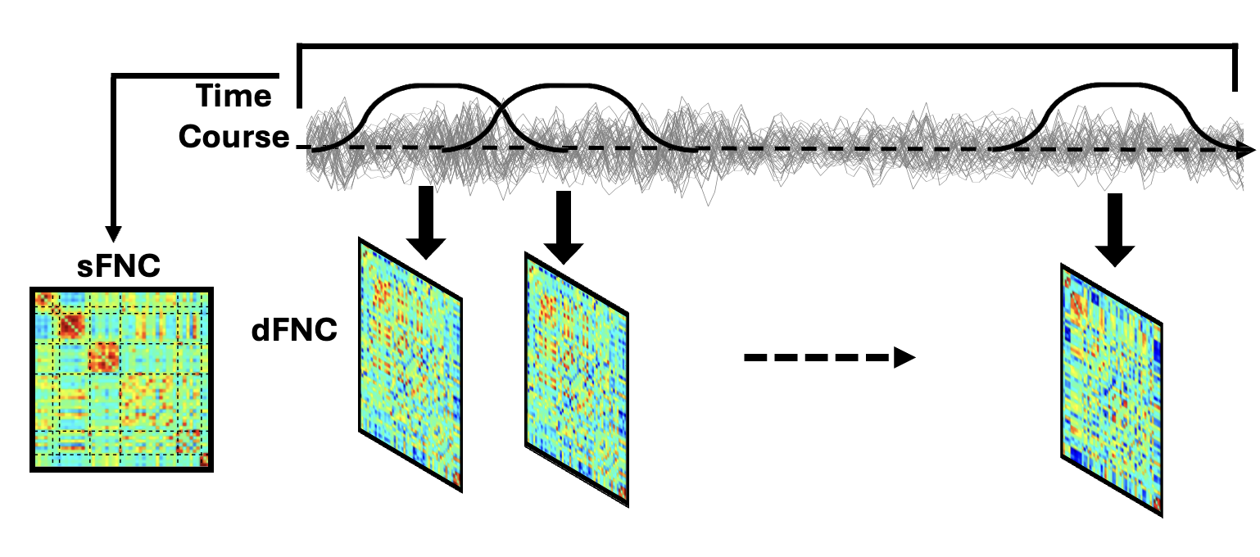
Supplementary Figure 2. Static and dynamic functional network connectivity. Static functional network connectivity (FNC) is calculated between any pair of regions across the entire recording period, while dynamic FNC is calculated between pairs of regions for each sliding window throughout the recording.

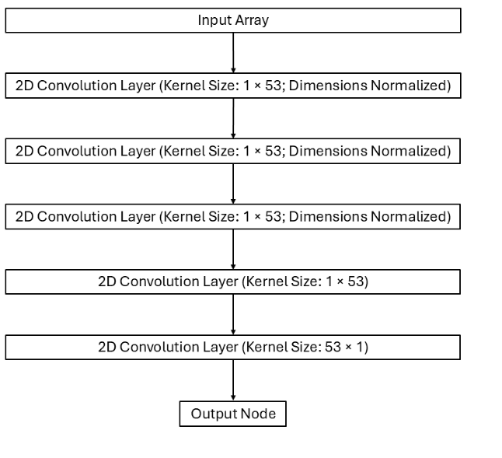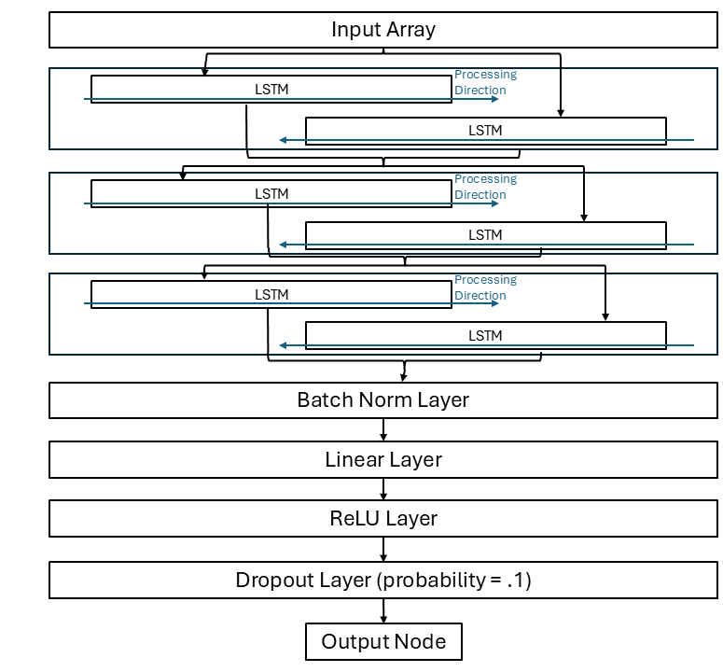
(B)
(B)x
Supplementary Figure 3. Brain age prediction model architecture. A) The architecture for the BCGCN model for the sFNC data. It consists of successive convolution layers. The first 3 layers have their dimensions normalized such that the output still consists of 53×53 matrices; these outputs are then used as input to 2 convolution layers which results in each 53×53 matrix becoming a single point. B) The architecture for the BiLSTM model for the dFNC data. The first 3 layers are each bidirectional LSTM layers, followed by a Batch Normalization layer, a Linear layer, a ReLU layer, and a Dropout layer (p=0.1), which produces the output.

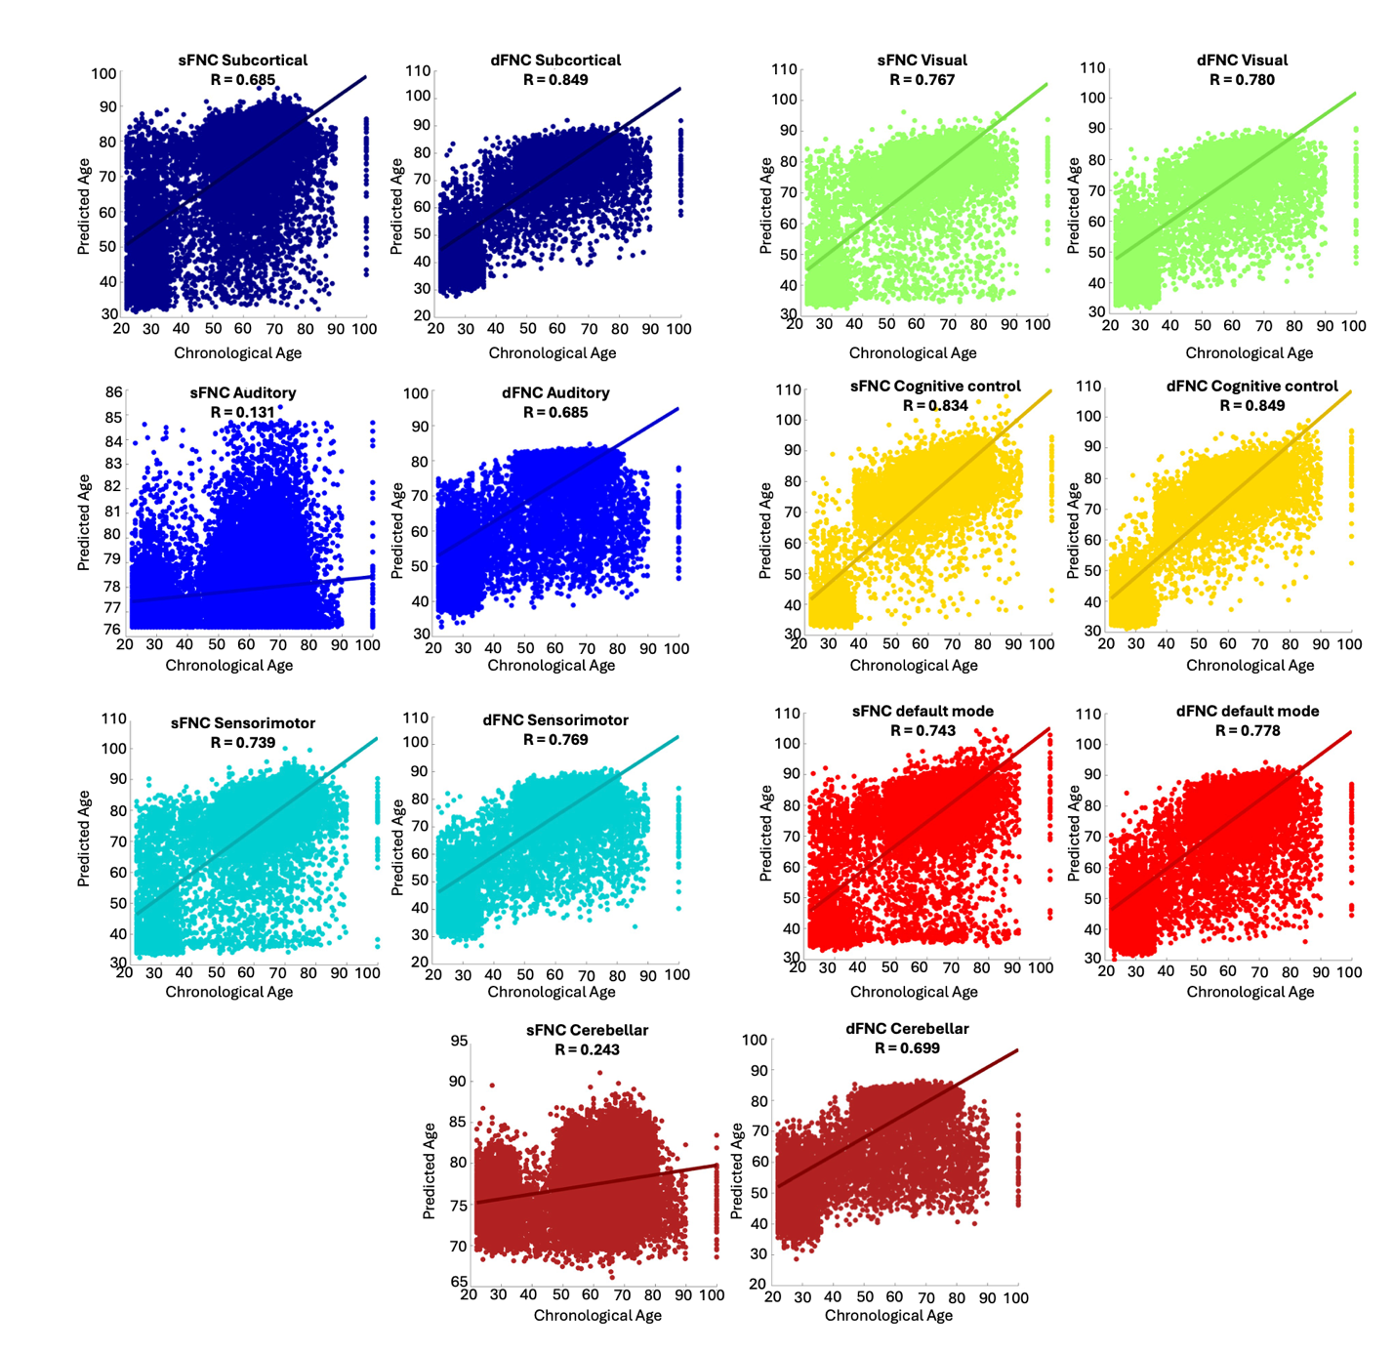

Supplementary Figure 4. Sub-network brain age prediction model performance. These graphs depict the individual’s chronological age against their model-predicted age for each subnetwork.

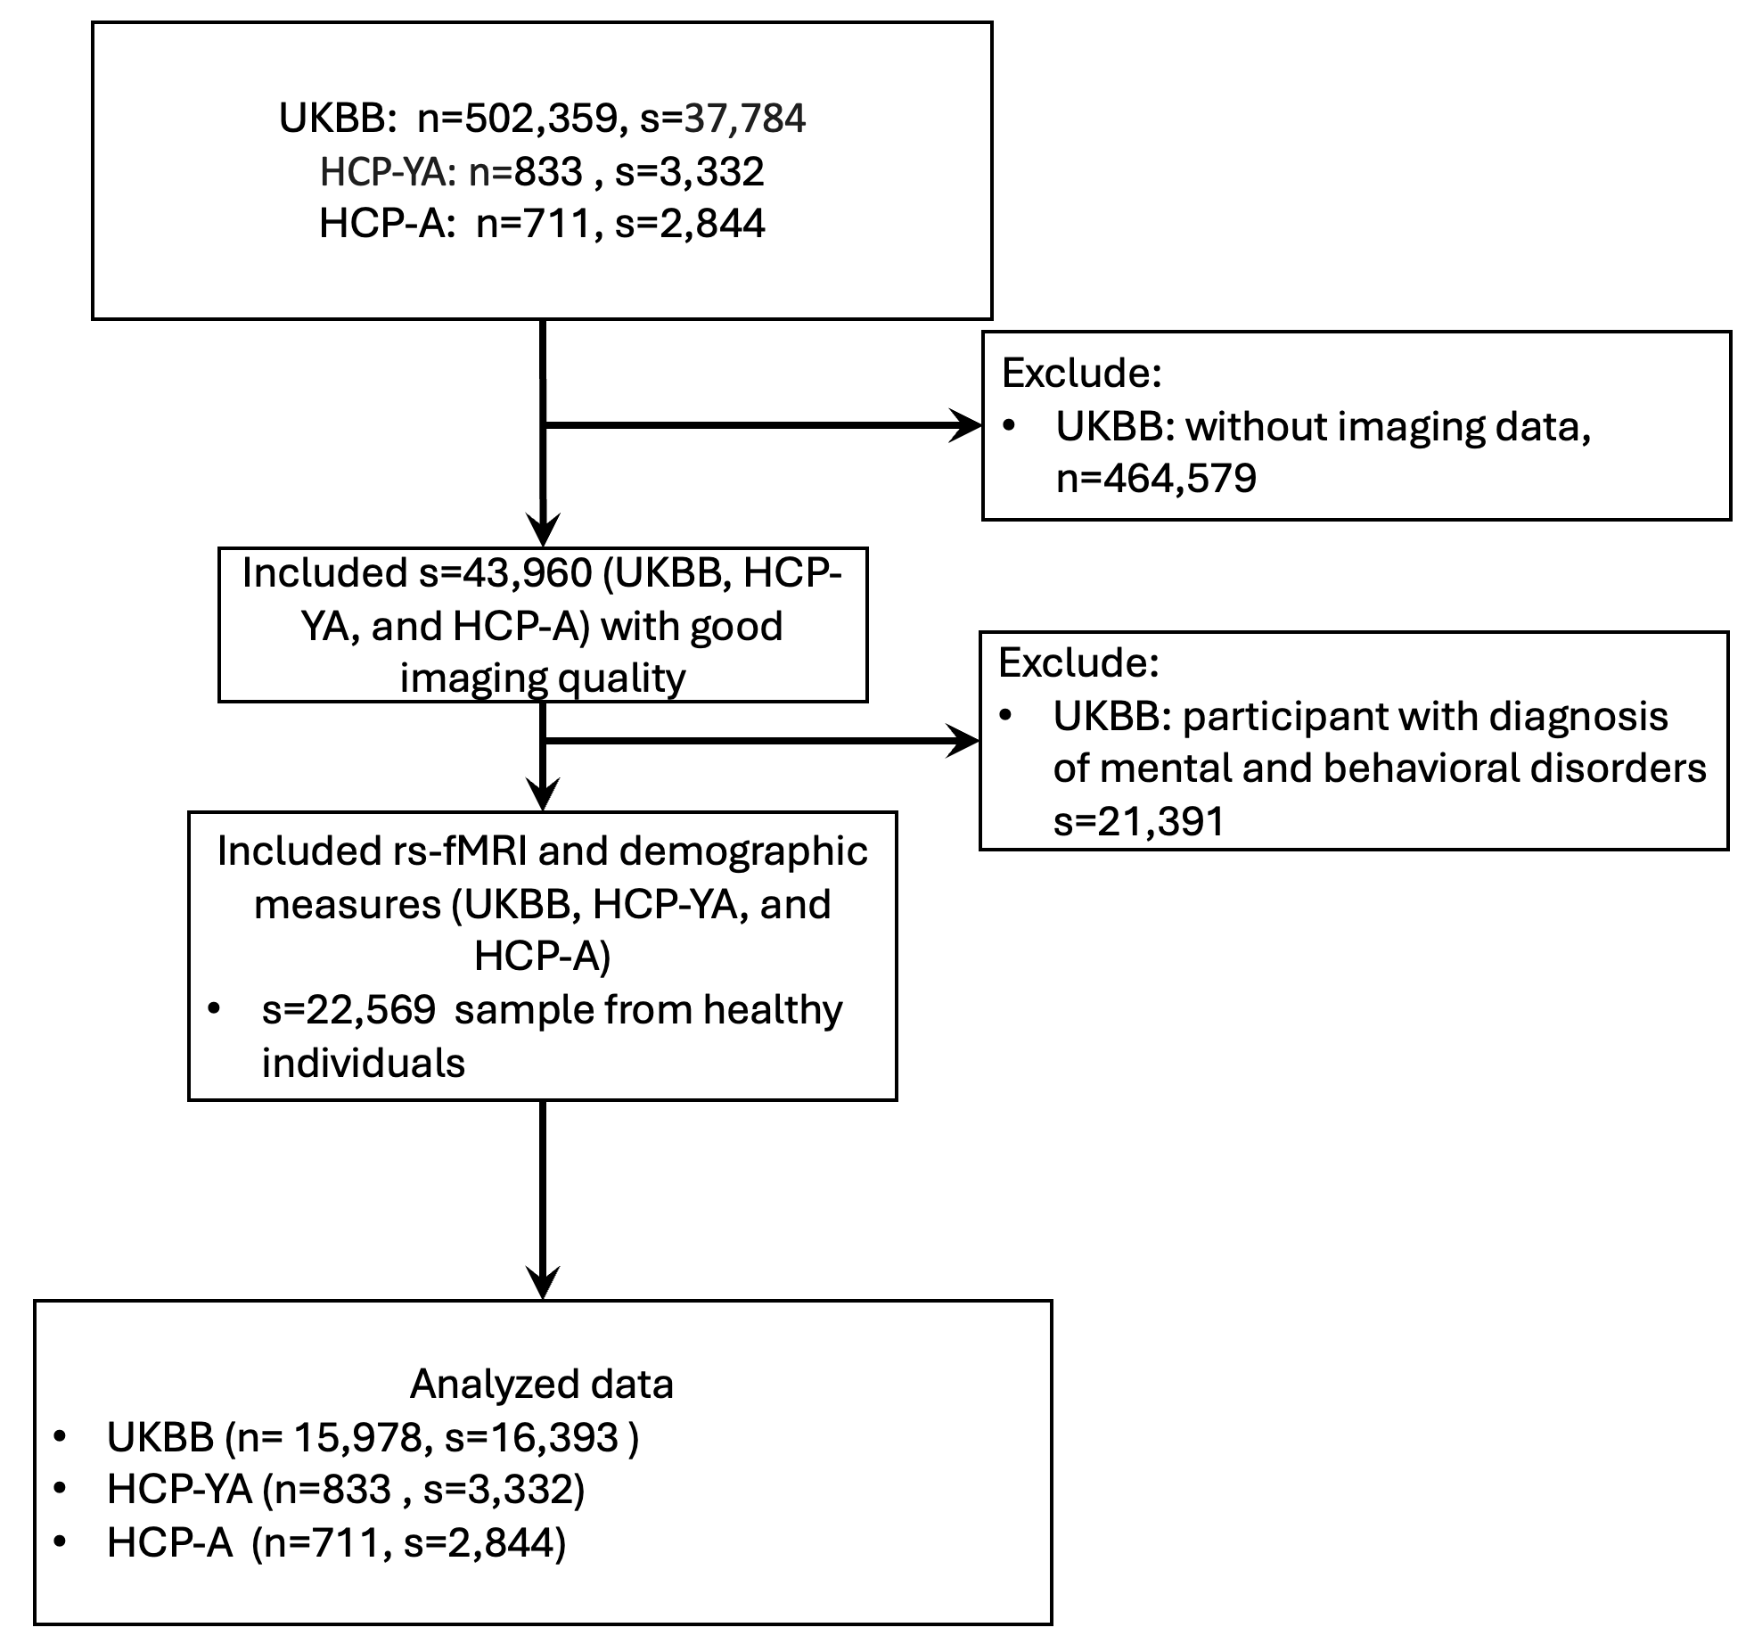
Supplementary Figure 5. STROBE flowchart reporting numbers of subjects and scans in the training dataset, including UKBB, HPC-YA, and HCP-A. The symbol 's' represents the number of resting-state fMRI scans, and 'n' indicates the number of individuals included in the analysis.

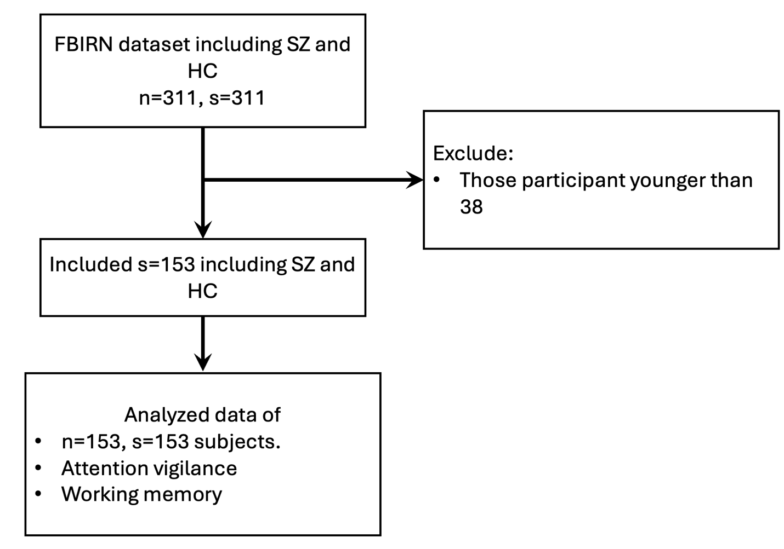
Supplementary Figure 6. STROBE flowchart reporting numbers of subjects and scans in the FBIRN dataset as the test dataset. The symbol 's' represents the number of resting-state fMRI scans, and 'n' indicates the number of individuals included in the analysis.

