Supplementary Material: Integrative Multiomic and Deep Learning Profiling of KRAS Mutant and Wildtype Genomes in Pancreatic Tumorigenesis
Zarlish Attique*¹, Hafiz Muhammad Faraz Azhar¹, Adnan Ahmed Ansari¹
¹National Center for Bioinformatics, Quaid-i-Azam University, Islamabad, 45320, Pakistan.
Table 1: Tissue Distribution of Pancreatic Tumor Samples
Tissue Origin | Number of Samples | Percentage (%)
Body of Pancreas | 15 | 8.11%
Head of Pancreas | 137 | 74.05%
Overlapping Lesion of Pancreas | 2 | 1.08%
Pancreas, NOS | 17 | 9.19%
Tail of Pancreas | 14 | 7.57%

Table 2: Summary of Paired RNA-Seq and WES-Seq data for patients with lung and liver metastases. Summary of WES-Seq data for normal patients
RNA-Seq | WE-Seq | Patients_No | Metastatic_Site | WE-Seq |  | Patients_No |  | Normal Site
SRR9697850 | SRR9697680 | Patient_1 | lung | SRR9697600 |  | Patient_1 |  | PBL
SRR9697614 | SRR9697833 | Patient_2 | lung | SRR9697661 |  | Patient_5 |  | PBL
SRR9697593 | SRR9697767 | Patient_3 | lung | SRR9697770 |  | Patient_3 |  | PBL
SRR9697594 | SRR9697768 | Patient_3 | lung | SRR9697829 |  | Patient_4 |  | PBL
SRR9697595 | SRR9697769 | Patient_3 | lung | SRR9697832 |  | Patient_2 |  | PBL
SRR9697633 | SRR9697828 | Patient_4 | liver
SRR9697716 | SRR9697660 | Patient_5 | liver | SRR9697876 | Patient 6 |  | PBL
PBL = peripheral blood leukocytes. This term refers to the white blood cells circulating in the bloodstream, which are often used as a reference or control in genomic studies, particularly when comparing normal and cancerous tissues.
Quality Control and Enhancement - Assessment
Fig 1: FASTQC report summarizing the quality metrics for the sequencing data, including base quality scores (A), GC content distribution (B), sequence length distribution (C), and adapter content (D).
Mapping and Alignment to Reference
Table 3: Read Mapping Summary of Samples
Sample | Input Reads | Average Input Read Length | Unique Reads | Multi-Mapping Reads
SRR9697850 | 87583775 | 300 | 50425480 | 7250383
SRR9697614 | 85091074 | 299 | 62940600 | 15886580
SRR9697593 | 93783232 | 290 | 67222730 | 21874295
SRR9697594 | 98328579 | 294 | 68111055 | 22068068
SRR9697595 | 1.03E+08 | 299 | 68999380 | 22261841
SRR9697633 | 44584124 | 281 | 34965692 | 6976502
SRR9697716 | 42454482 | 299 | 32211257 | 3582826

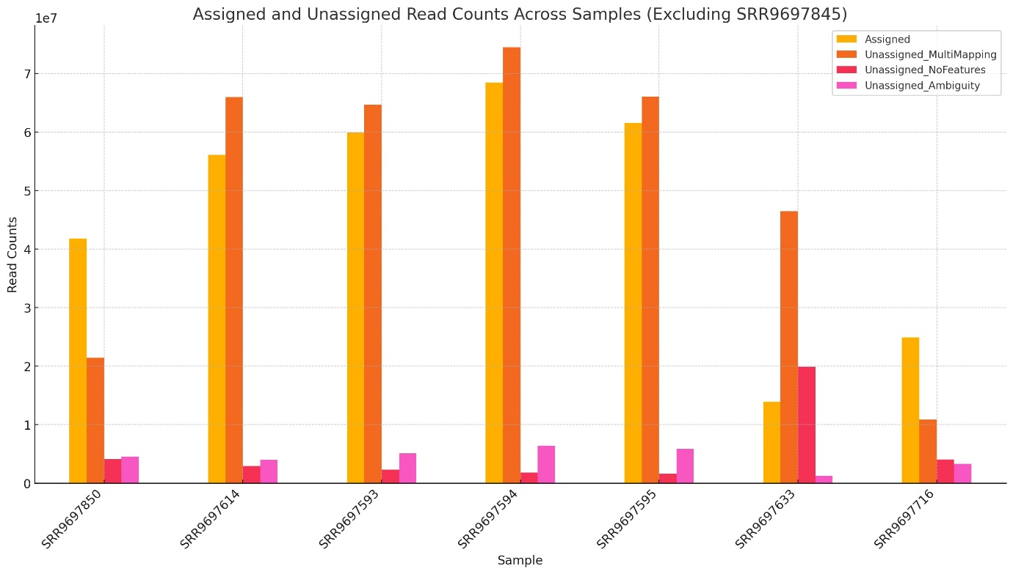
Fig 2: Distribution of Assigned and Unassigned Read Counts Across RNA-Seq Samples
Fig 3: Preprocessing and Normalization of In-House RNA-Seq Data
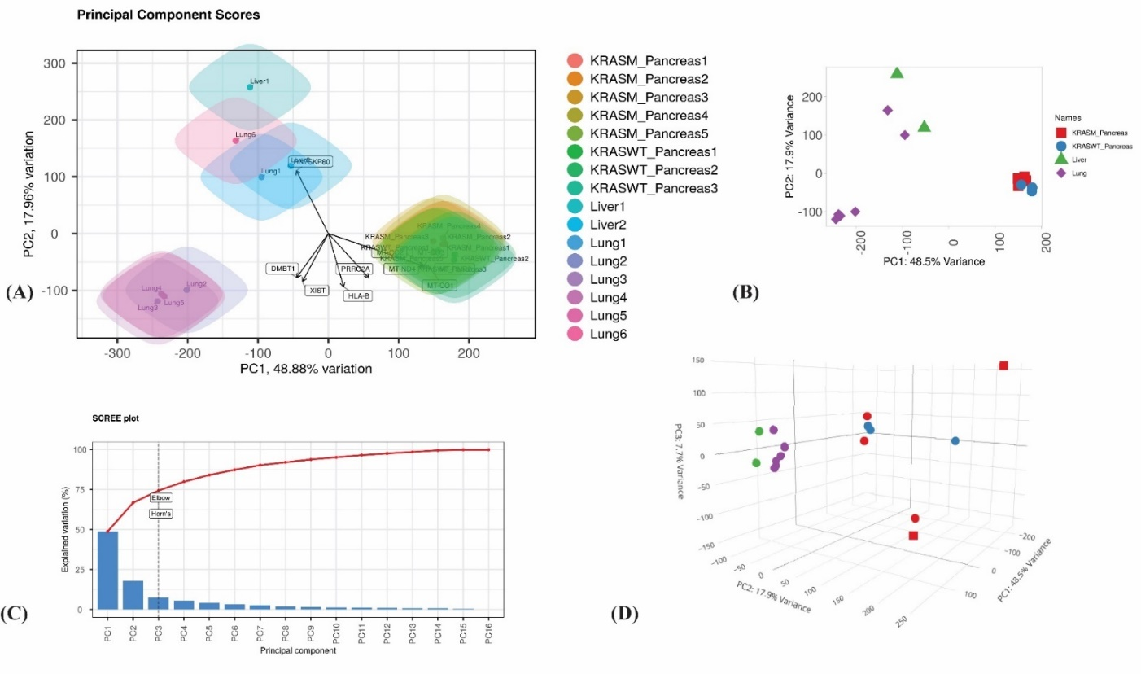
Fig 4: Principal Component Analysis (PCA) and Dimensionality Reduction of In-House RNA-Seq Data.(A) Distribution of Transformed Data: Boxplots showing the homogeneity and lack of notable outliers in the distribution of log2-transformed expression levels across several samples following normalization. (B) Total Raw Read Counts (Millions): This bar graph displays the total number of raw reads in millions across different samples, which reflects the depth of sequencing variations. (C) Mean against Standard Deviation: This scatter plot illustrates how, following normalization, the mean expression and standard deviation relate to one another, ensuring variance stability. (D) Density Plot of Transformed Data: Density plots verify consistent data processing and the lack of batch effects by comparing the transformed expression distributions across several groups.
Fig 5: Summary of PCA Statistics and Differential Gene Expression Analysis Across Pancreatic Cancer Samples
A) Volcano Plot of DEGs (Liver vs. Lung): The volcano plot highlights differentially expressed genes between liver and lung tissues, with genes significantly upregulated (in red) and downregulated (in blue). Notable genes such as MAGEC1 and CT47B1 are prominently downregulated, while APCS is significantly upregulated. (B) Expression Levels of Major Mutated Genes: Line plot displaying the normalized expression levels of key mutated genes (CDKN2A, KRAS, GNAS, SMAD4, TP53) across various pancreatic cancer samples and lung tissues, illustrating consistent expression patterns among different conditions. (C) Expression Levels of Positively Correlated Genes with KRAS: Line plot showing the raw counts of genes that are positively correlated with KRAS expression, indicating higher expression levels in lung tissues compared to pancreatic samples. (D) Expression Levels of Negatively Correlated Genes with KRAS: Line plot representing the raw counts of genes negatively correlated with KRAS expression, with distinct expression patterns between pancreatic and lung tissues, indicating possible regulatory interactions.
Fig 6: Differentially Expressed Genes (DEGs) analysis and Correlation of Key Genes with KRAS in Pancreatic Cancer Samples
Gene Set Enrichment Analysis
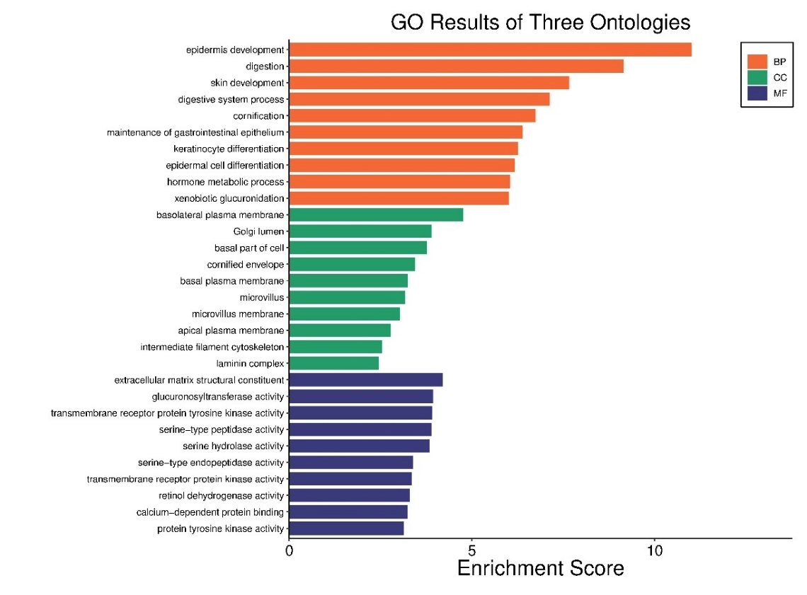
Fig 7: Gene Ontology (GO) enrichment analysis of differentially expressed genes (DEGs) in KRAS mutated versus wild-type pancreatic cancer samples.
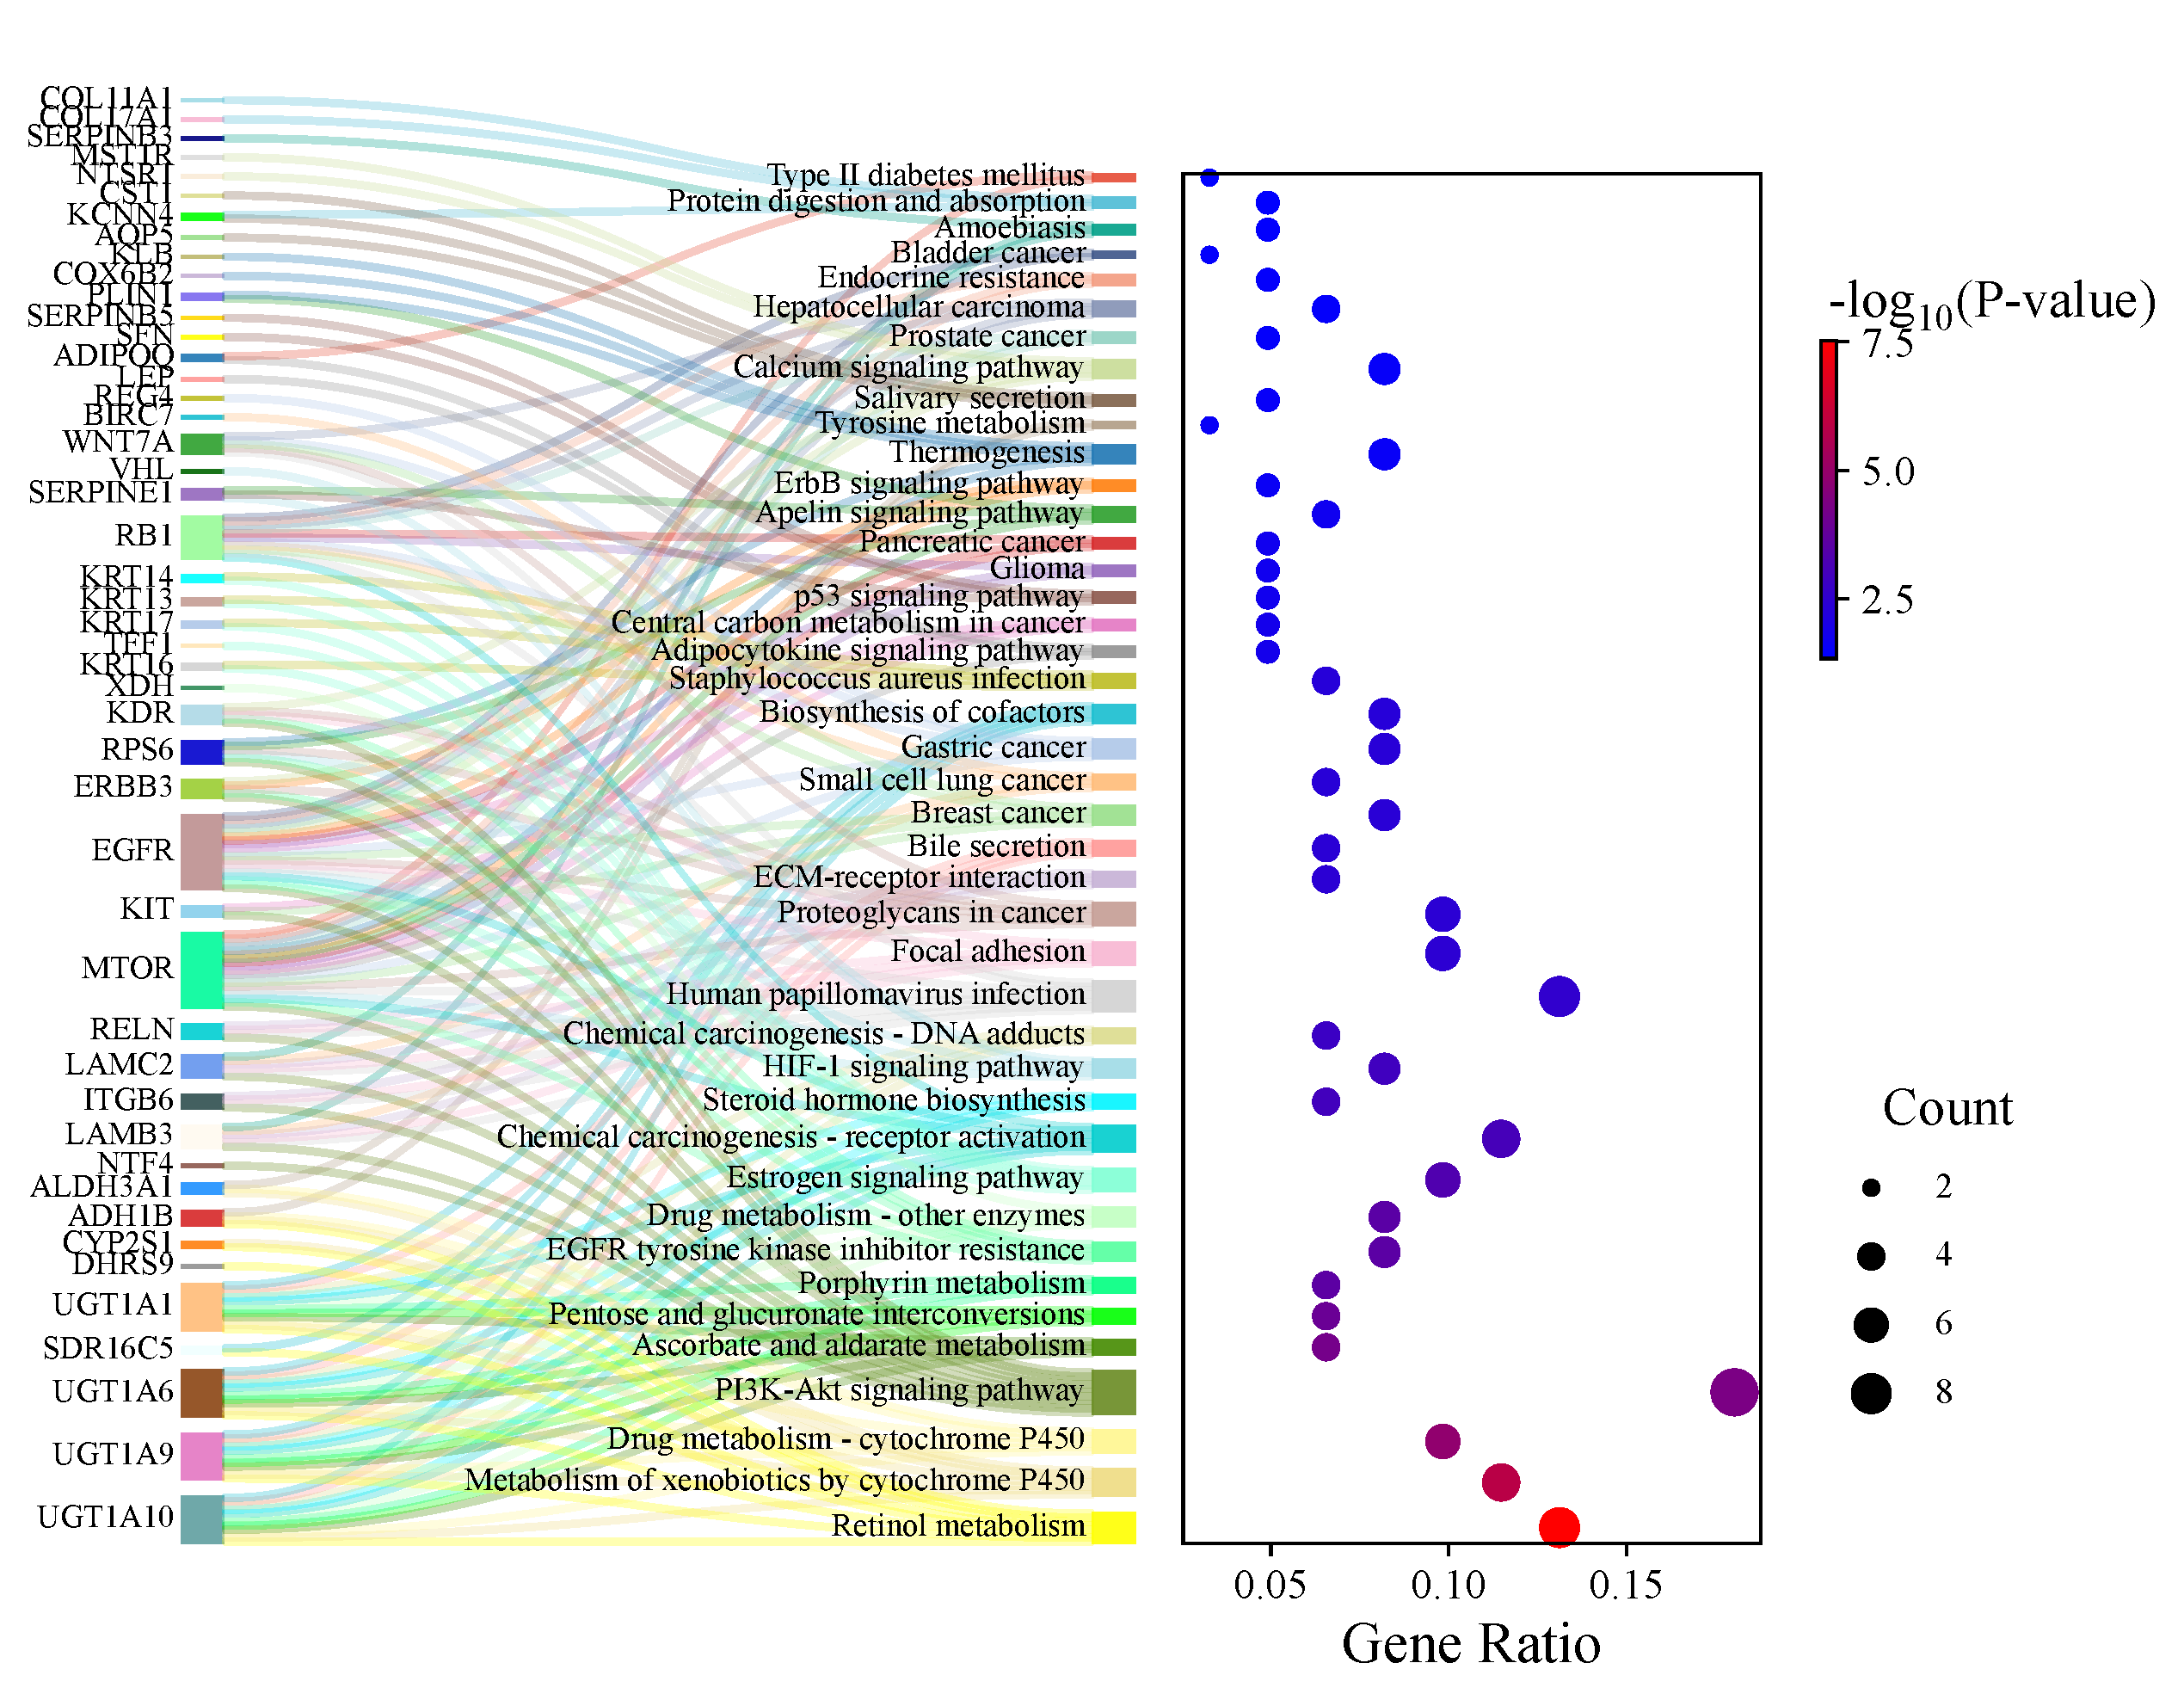
Fig 8: Pathway analysis of KRAS mutated versus wild-type pancreatic cancer samples DEGs through KEGG.

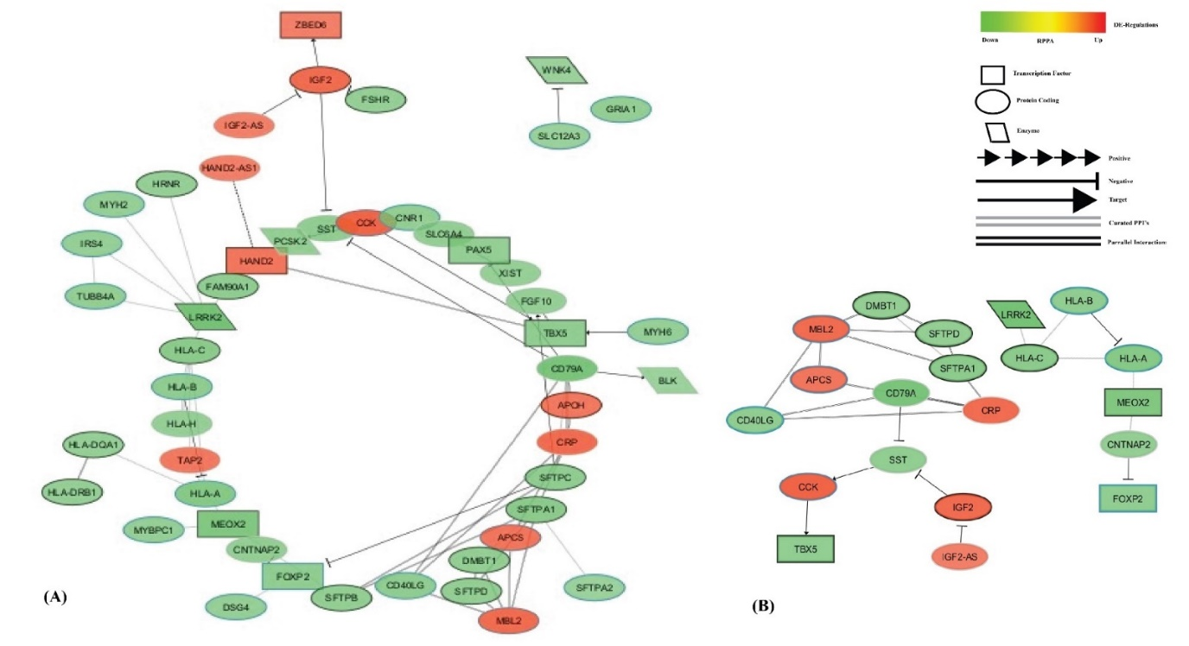
Fig 9: GRN of those expressed in liver and lung - In-House RNA-Seq Data Analysis: Gene Interaction Networks
Table 4: Distribution of Frameshift and Non-Frameshift Mutations in RNA-Seq Samples
 | Frameshift |  |  | Non-frameshift
Run – RNA | Frameshift | frameshift del | frameshift ins | Non Frameshift | nonframeshift del | nonframeshift ins | nonframeshift subs
SRR96978501 | 61 | 38 | 23 | 223 | 94 | 52 | 77
SRR9697614 | 141 | 105 | 36 | 417 | 130 | 88 | 199
SRR9697593 | 15 | 11 | 4 | 66 | 20 | 24 | 22
SRR96975941 | 98 | 74 | 24 | 360 | 168 | 82 | 110
SRR9697595 | 161 | 117 | 44 | 488 | 171 | 93 | 224
SRR96976331 | 54 | 39 | 15 | 231 | 91 | 56 | 84
SRR96977161 | 54 | 41 | 13 | 210 | 66 | 52 | 92
This table presents the total number of frameshift and non-frameshift mutations identified in seven RNA-Seq samples. The mutations are categorized into frameshift deletions, frameshift insertions, non-frameshift deletions, non-frameshift insertions, and non-frameshift substitutions.
Table 5: Distribution of Frameshift and Non-Frameshift Mutations in WES Samples with Panel of Normals (PON)
 | Frameshift |  |  | Non-frameshift
Run - WES + PON | Frameshift | frameshift del | frameshift ins | Non-Frameshift | Non-frameshift del | Non-frameshift ins | Non-frameshift subs
SRR9697600, SRR9697680 | 366 | 256 | 110 | 848 | 293 | 147 | 408
SRR9697832, SRR9697833 | 315 | 217 | 98 | 758 | 242 | 164 | 352
SRR9697770, SRR9697767 | 242 | 174 | 68 | 731 | 264 | 151 | 316
SRR9697768, SRR9697767 | 333 | 236 | 97 | 886 | 311 | 159 | 416
SRR9697769, SRR9697767 | 319 | 227 | 92 | 851 | 307 | 153 | 391
SRR9697829, SRR9697828 | 184 | 125 | 59 | 627 | 199 | 128 | 300
SRR9697661, SRR9697660 | 360 | 250 | 110 | 905 | 256 | 151 | 498

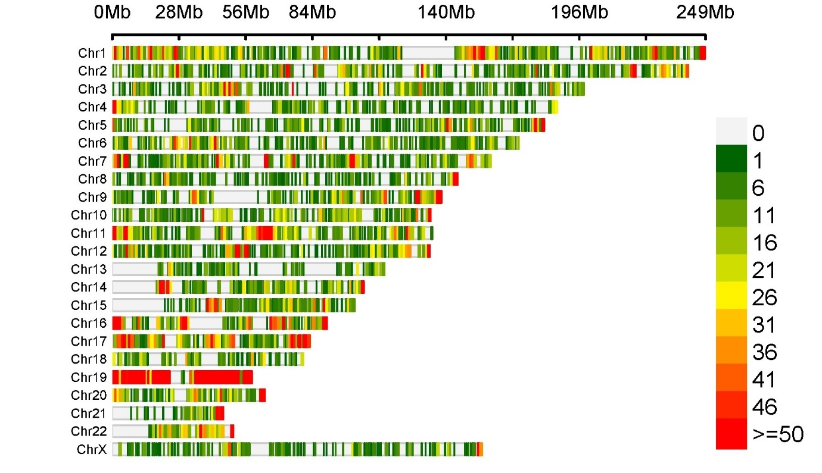
Fig 10: Distribution of common Exome and RNA SNPs in Metastatic Pancreatic Cancer Samples Across Human Chromosomes in 1Mb Window Sizes
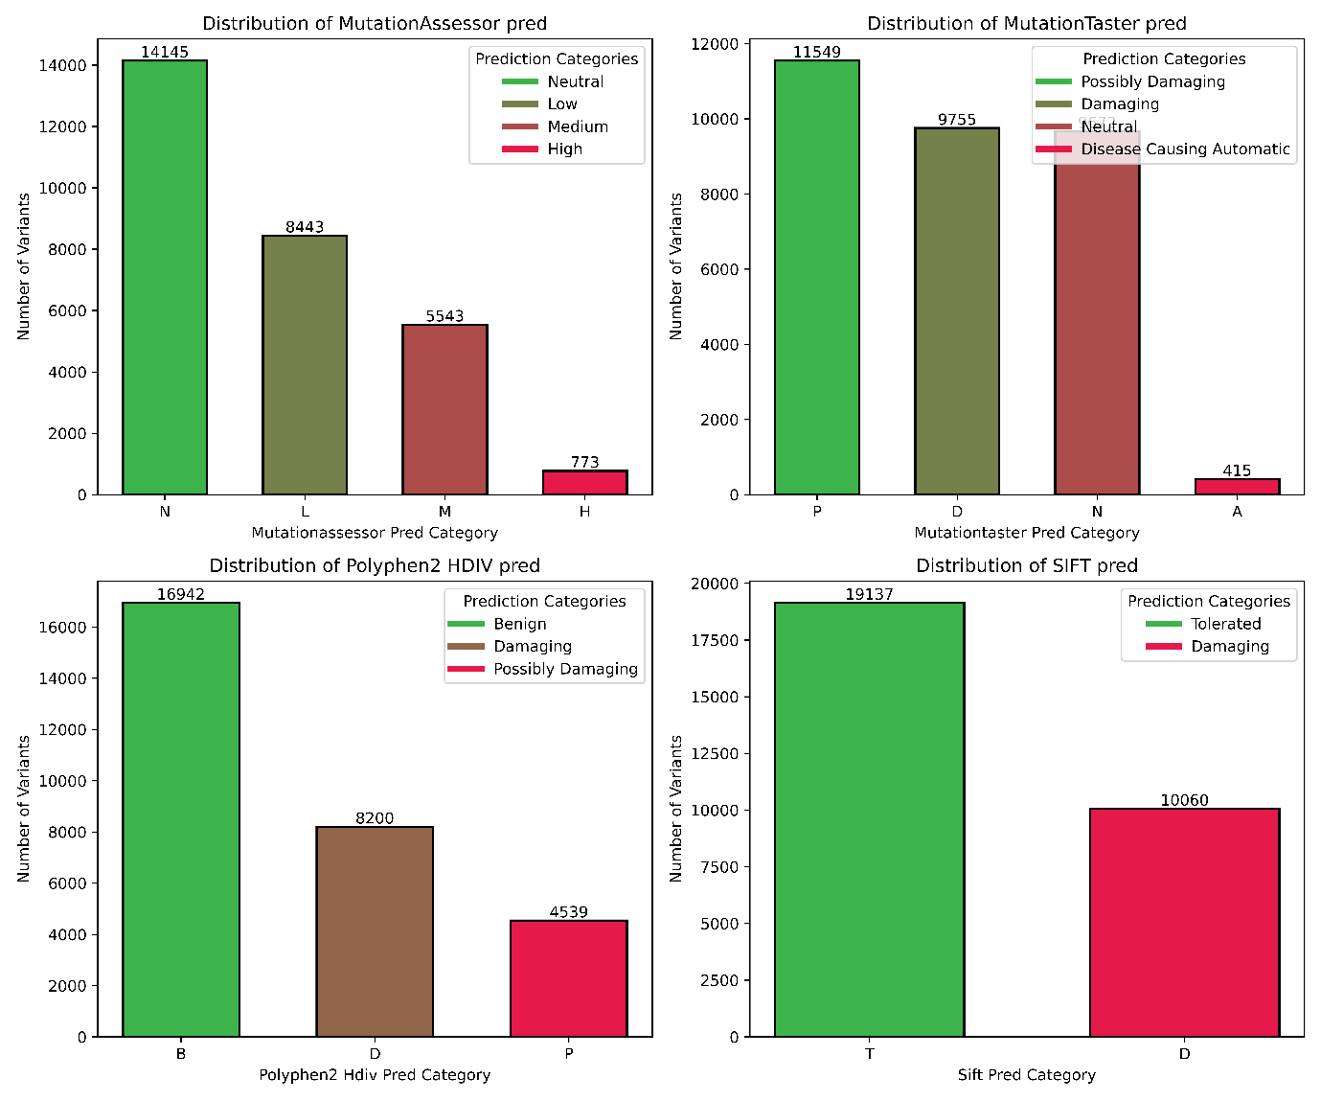
Fig 11: Distribution of Genetic Variants Across Different Predictive Tools
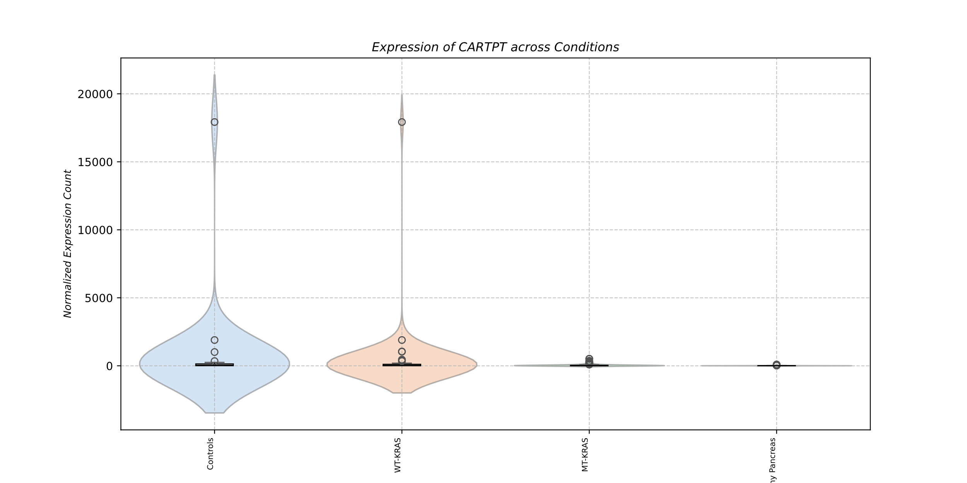
Fig 12: CARTPT is highly expressed in KRAS WT and Control (Mock) cancer, indicating that its overexpression might contribute to tumor development, especially in the absence of KRAS mutations.

